Supplementary information for
Research Article
Boosting the Oxygen Reduction Performance of Fe–N–C Catalyst Using Zeolite as an Oxygen Reservoir

Weihao Liu¹ · Qingtao Liu¹ · Xin Wan^{1, 2} · Jianglan Shui^{1, 3}

¹ School of Materials Science and Engineering, Beihang University, Beijing 100191, China
² School of Space and Environment, Beihang University, Beijing 102206, China
³ Tianmushan Laboratory, Hangzhou 311115, China

Received: 17 April 2024 / Revised: 10 June 2024 / Accepted: 25 June 2024 / Published online:

Correspondence to Xin Wan, E-mail: wanxin@buaa.edu.cn; Jianglan Shui, E-mail: shuijianglan@buaa.edu.cn

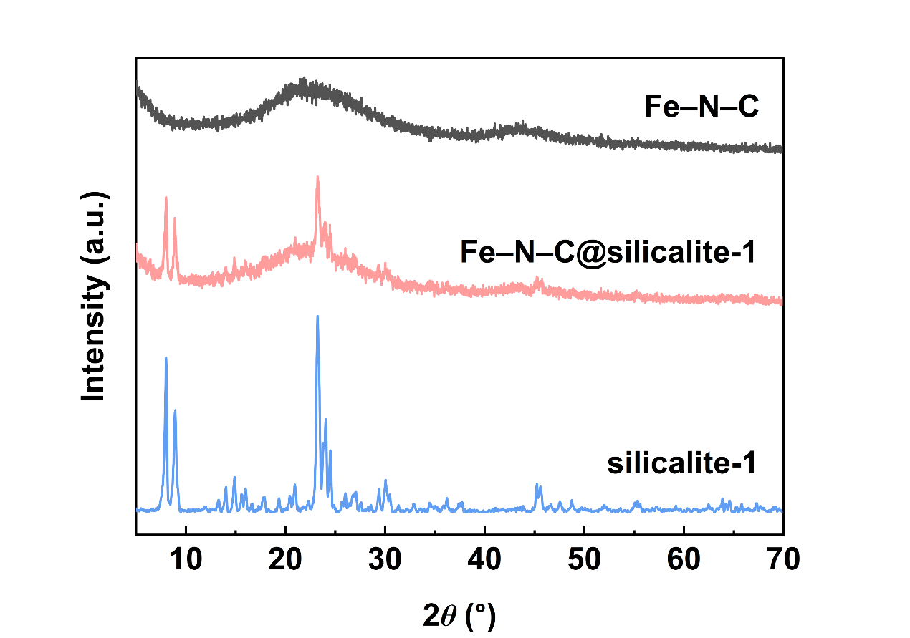
Fig. S1 XRD patterns of Fe–N–C, Fe–N–C@silicalite-1 and silicalite-1

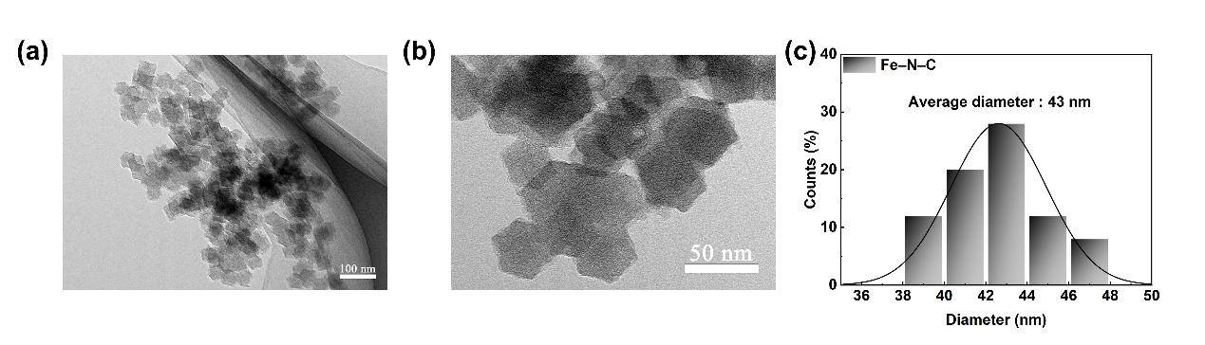
Fig. S2 a, b TEM images of Fe–N–C; c the diameter distribution of Fe–N–C

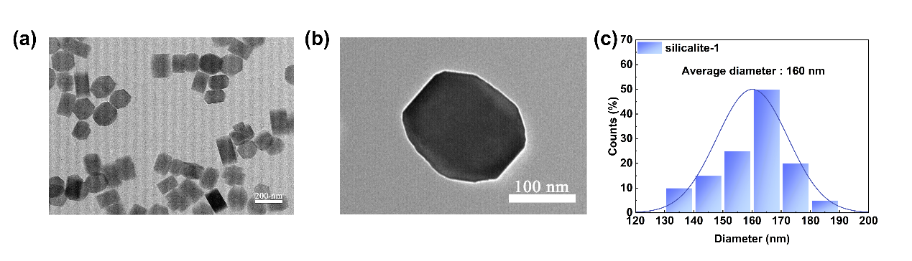
Fig. S3 a, b TEM images of silicalite-1; c the diameter distribution of silicalite-1

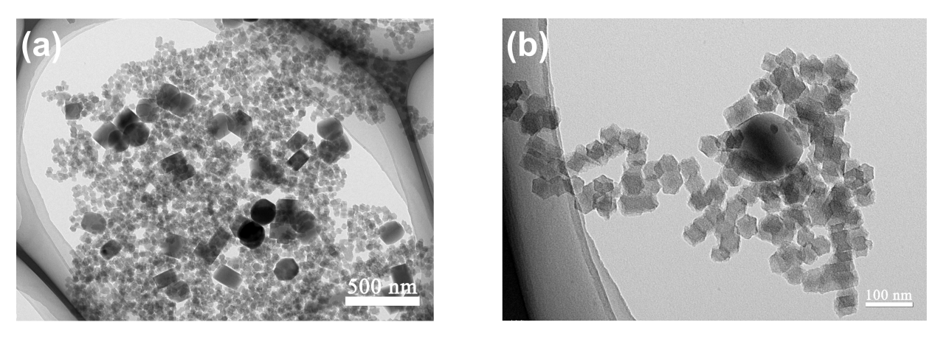
Fig. S4 a, b TEM images of Fe–N–C@silicalite-1

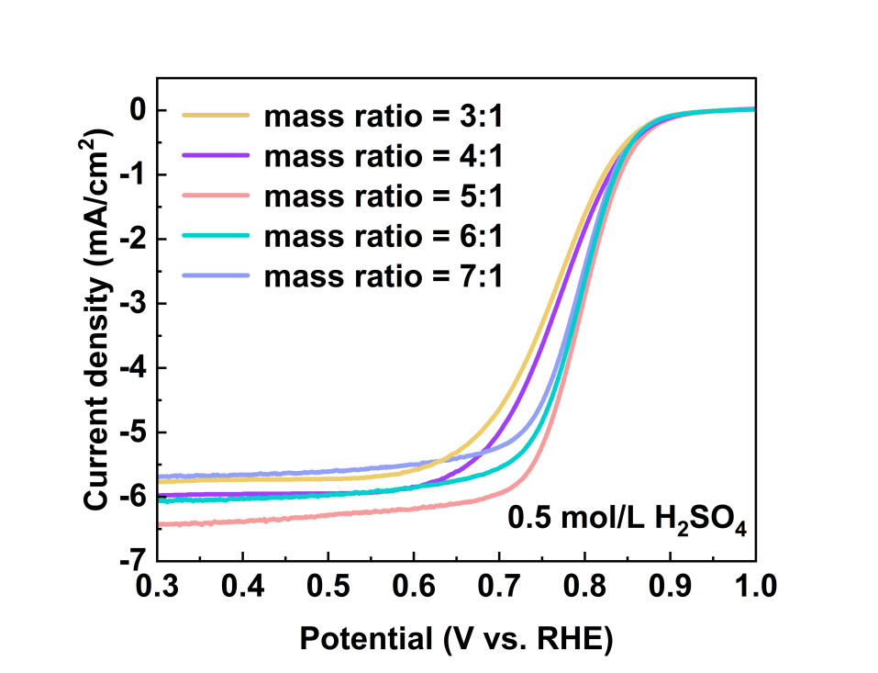
Fig. S5 ORR polarization curves of hybrid catalysts with different Fe–N–C/silicalite-1 mass ratios ranging from 3:1 to 7:1 in O₂-saturated 0.5 mol/L H₂SO₄ solution
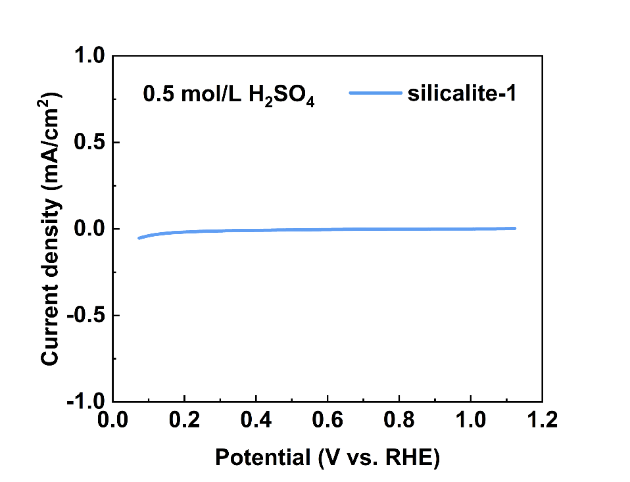
Fig. S6 ORR polarization curve of silicalite-1 in O₂-saturated 0.5 mol/L H₂SO₄ solution

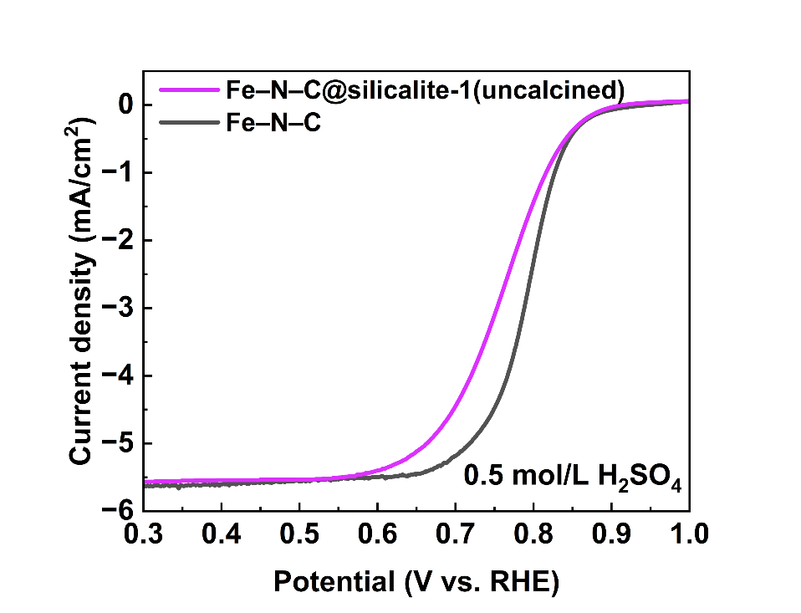
Fig. S7 ORR polarization curves of Fe–N–C and Fe–N–C@silicalite-1(uncalcined) in O₂-saturated 0.5 mol/L H₂SO₄ solution

Table 1 Comparison of ORR performance of Fe‒N‒C@silicalite-1 with other Fe–N–C catalysts
Sample | Test conditions | Loading (mg/cm²) | E_{1/2}  (V) | j_{lim} (mA/cm²) | Ref.
Fe‒N‒C@silicalite-1 | 0.5 mol/L H₂SO₄ | 0.4 | 0.792 | 6.4 | This work
FeNC-R | 0.1 mol/L HClO₄ | 0.25 | 0.75 | 5.1 | [1]
MesoS/MicroC-FeNC | 0.5 mol/L H₂SO₄ | 0.4 | 0.81 | 5.5 | [2]
TPI@Z8(SiO₂)-650-C | 0.5 mol/L H₂SO₄ | 0.4 | 0.823 | 5.5 | [3]
Fe-N-C-10%FG | 0.5 mol/L H₂SO₄ | 0.6 | 0.93 | 3.9 | [4]
Fe–N₃S₁/NC | 0.5 mol/L H₂SO₄ | 0.4 | 0.795 | 5.1 | [5]
Fe2-Z8-C | 0.5 mol/L H₂SO₄ | 0.4 | 0.805 | 5.5 | [6]
FeNC-1000 | 0.5 mol/L H₂SO₄ | 0.4 | 0.804 | 5.1 | [7]
FeNC-CVD-750 | 0.5 mol/L H₂SO₄ | 0.8 | 0.85 | 3.8 | [8]
Fe_{SA}/Fe_{AC}−2DNPC | 0.5 mol/L H₂SO₄ | 0.4 | 0.81 | 5.5 | [9]

References
- Zhao CX, Ren D, Wang J et al (2022) Regeneration of single-atom catalysts deactivated under acid oxygen reduction reaction conditions. J Energy Chem 73:478–484
- Chen L, Wan X, Zhao X et al (2022) Spatial porosity design of Fe–N–C catalysts for high power density PEM fuel cells and detection of water saturation of the catalyst layer by a microwave method. J Mater Chem A 10(14):7764–7772
- Wan X, Liu X, Li Y et al (2019) Fe–N–C electrocatalyst with dense active sites and efficient mass transport for high-performance proton exchange membrane fuel cells. Nat Catal 2:259–268
- Zeng Y, Li C, Li B et al (2023) Tuning the thermal activation atmosphere breaks the activity–stability trade-off of Fe–N–C oxygen reduction fuel cell catalysts. Nat Catal 6:1215–1227
- Liu W, He H, Liu Q et al (2024) Identification of the optimal doping position of hetero-atoms in chalcogen-doped Fe–N–C catalysts for oxygen reduction reaction. Particuology 89:99–108
- Liu Q, Liu X, Zheng L et al (2018) The solid-phase synthesis of an Fe–N–C electrocatalyst for high-power proton-exchange membrane fuel cells. Angew Chem Int Ed Engl 57(5):1204–1208
- Li Y, Liu X, Zheng L et al (2019) Preparation of Fe–N–C catalysts with FeN_{x} (x = 1, 3, 4) active sites and comparison of their activities for the oxygen reduction reaction and performances in proton exchange membrane fuel cells. J Mater Chem A 7(45):26147–26153
- Jiao L, Li J, Richard LL et al (2021) Chemical vapour deposition of Fe–N–C oxygen reduction catalysts with full utilization of dense Fe–N₄ sites. Nat Mater 20(10):1385–1391
- Wan X, Liu Q, Liu J et al (2022) Iron atom–cluster interactions increase activity and improve durability in Fe–N–C fuel cells. Nat Commun 13(1):2963

