Supporting Information
A Stable Ultrathin Porous Membrane based on Rigid Polymer by Phase Separation for Flow Batteries
Methods
Materials
3,3-diaminobenzidine (DAB, Acros Organics), 1,4-naphthalenedicarboxylic acid (NDA, Aladdin), phosphorus pentoxide (P₂O₅, Macklin), methane sulfonic acid (MSA, Aladdin), N, N-dimethylacetamide (DMAc, Aladdin), dimethyl sulfoxide (DMSO, Aladdin), N-heptane (HEP, Aladdin), isopropanol (IPA, Aladdin), VOSO₄·xH₂O (Shenyang Haizhongtian chemical engineering), MgSO₄ (Aladdin), H₂SO₄ (Aladdin).
Synthesis and Characterization of NPBI
In a 500 mL three-necked flask equipped with a mechanical stirrer and a nitrogen inlet, P₂O₅ (9.1 g, 0.064 mol) and MSA (45.46 g, 0.47 mol) were added and heated to 80 °C until P₂O₅ was completely dissolved. Subsequently, DAB (4.393 g, 0.02 mol) was introduced and allowed to fully dissolve, followed by the addition of NDA (4.432 g, 0.02 mol). The reaction mixture was stirred thoroughly for 30 min at 80 °C, and the temperature was then raised to 160 °C and maintained for an additional 30 min.
The chemical structure of the synthesized NPBI polymers was confirmed using ¹H NMR spectroscopy, recorded on a AVANCE III HD 700 MHz instrument. The analysis employed DMSO-d6 as the solvent and tetramethyl silane (TMS) as the internal standard. Attenuated Total Reflectance Fourier Transform Infrared Spectroscopy (ATR-FTIR) was performed using a NICOLET iS50 spectrometer from Thermo Fisher Co. Ltd. The ATR-FTIR spectra were collected in reflection mode, with a resolution of 4 cm^{–1}, over the range of 500 to 4000 cm^{–1}, and averaged over 48 scans to further validate the chemical structure of the synthesized NPBI polymers.
Preparation of Membrane
The synthesized polymer was dissolved in a mixed solvent of DMAc and DMSO at a ratio of 9:1 (w/w) to prepare an 8 wt% polymer solution. In a controlled drying chamber, the solution was casted onto a clean glass plate using an adjustable Bird Coater (Elcometer 3545/8) set to a thickness of 50 μm. The glass plate was then immersed in various non-solvent baths for 1 hour, including water, IPA and HEP. Finally, the membrane was carefully peeled off from the glass plate and thoroughly washed with water to remove residual solvents. The resulting membranes were designated as NPBI@Water, NPBI@IPA and NPBI@HEP, based on the nonsolvent used.
Morphology of Membrane
The cross-section morphologies of membranes were characterized by Focused Ion Beam-Scanning Electron Microscope (FIB-SEM, Helios G4 PFIB). The pore structure of membranes was studied by Wide Angle X-ray Scattering Instrument (Xenocs Xeuss 2.0).
Mechanical Properties
The mechanical stability of the membranes was characterized by SANS, Saxes M2.
Area Resistance
The area resistance of the membrane was tested using an H-shaped electrochemical cell. The test electrolyte is 3 mol/L H₂SO₄. The resistance was calculated from the slope of the current-voltage (I-V) curve. The resistance of the electrochemical cell with and without the membrane was measured separately, and the membrane resistance was calculated as the difference between these two values using the Eq. (1):
R_{A}=A×(R₁-R₂) (1)
where R_{A} is the area resistance; A is the effective area of the membrane; and R₁ and R₂ are the resistances of the cell with and without the membrane, respectively.
Vanadium Permeation
The permeation rate of vanadium ions was tested using a diffusion cell. The diffusion cell was divided into two half-cells by the membrane sample. Each half-cell containing 80 mL of electrolyte solution and VO²⁺(V(IV)) was chosen as the permeating ion. One half-cell contained a solution of 1.5 mol/L VOSO₄ and 3 mol/L H₂SO₄, while the other half-cell contained a solution of 1.5 mol/L MgSO₄ and 3 mol/L H₂SO₄ to balance the ionic strength and reduce osmotic pressure. The solutions in both half-cells were continuously stirred. After a period of time, a 3 mL sample was collected from the MgSO₄ side, and then 3 mL of the original MgSO₄ solution was added back. The concentration of V(IV) was determined using an ultraviolet-visible spectrophotometer (UV-2600I, CH, SHIMADZU). The permeation rate was calculated according to Fick's first law of diffusion of Eq. (2).
${\text{V}}_{\text{B}}\frac{{\text{d}\text{C}}_{\text{B}}\text{(}\text{t}\text{)}}{\text{d}\text{t}}\text{=A}\frac{\text{P}}{\text{L}}\text{(}{\text{C}}_{\text{A}}\text{-}{\text{C}}_{\text{B}}\text{(}\text{t}\text{))}$ (2)
where the subscripts A and B represent the two sides of the diffusion cell, where A corresponds to the VOSO₄ side and B corresponds to the MgSO₄ side. V_{B} is the volume of the solution on the MgSO₄ side; A is the effective area of the membrane; L is the thickness of the membrane; P is the permeability; C_{A} is the vanadium ion concentration on the VOSO₄ side; and C_{B} (t) is the ion concentration on the other side.
Wide Angle X-ray Diffraction (WAXS)
The pore size of the NPBI porous membrane was obtained through the WAXS test, which was calculated by Eq. (3):
$\text{ D}\text{=}\frac{\text{2π}}{\text{Q}}$ (3)
where D is the diameter and Q is the scattering vector.
Shrinkage Ratio and Water Uptake
The membranes were cut into 5 × 5 cm² pieces and soaked in different solutions until equilibrium was reached. The membranes were flattened using glass plates to facilitate measurement of dimensions. Subsequently, the surface solution of the membranes was blotted dry with lint-free paper and weighed quickly. After the water inside the membranes was evaporated, the dimensions and mass were measured again. The shrinkage ratio (SH) and water uptake (WU) were calculated using the following Eqs. (4) and (5):
$\text{SH}\text{=}\frac{{\text{D}}_{\text{wet}}\text{-}{\text{D}}_{\text{dry}}}{{\text{D}}_{\text{wet}}}$ (4)
where D_{wet} and D_{dry} are the average dimensions before and after drying, respectively.
$\text{WU}\text{=}\frac{{\text{W}}_{\text{wet}}\text{-}{\text{W}}_{\text{dry}}}{{\text{W}}_{\text{dry}}}$ (5)
where W_{wet} and W_{dry} are the weights of the membranes before and after drying, respectively.
Battery Performance
A VFB was fabricated with carbon felt electrodes exhibiting an effective reaction area of 48 cm² (6 cm width × 8 cm length). Nonporous graphite plates serving as bipolar current collectors were implemented without flow channel modifications. Both positive and negative electrolyte tanks maintained 60 mL of 3 mol/L H₂SO₄ solution containing 1.5 mol/L vanadium species in mixed valence states (V(III)/V(IV)). Charge-discharge cycling tests were performed using an Arbin BT-2000 electrochemical workstation, with operational voltage thresholds precisely regulated between 1.55 V and 1.00 V throughout the electrochemical process.
Density Functional Theory (DFT) Calculations
The initial configurations of NPBI, DMSO, DMAc, HEP, Water and IPA were optimized by density functional theory (DFT) at M06-2X [1] hybrid functional with def2-TZVP [2] basis set including the atom-pairwise dispersion correction (DFT-D3) [3, 4], using Gaussian 16 program. All optimized structures of the components were checked by harmonic vibrational frequencies to ensure that they were on the true minima on the potential energy surface. The basis set superposition error (BSSE) correction was applied when calculating the binding energy between fragments A and B. The binding energy was calculated by Eq. (6):
${\text{E}}_{\text{binding}}\text{=E}\left(\text{AB}\right)\text{-E}\left(\text{A}\right)\text{-E}\left(\text{B}\right)\text{+}{\text{E}}_{\text{BSSE}}$ (6)
Molecular electrostatic potential (ESP) on van der Waals surface was analyzed by wave function analyzer Multiwfn [5] and visualized by VMD [6] software. This analysis was employed to investigate the interactions between specific atoms.

Fig. S1 The synthetic route for NPBI polymer

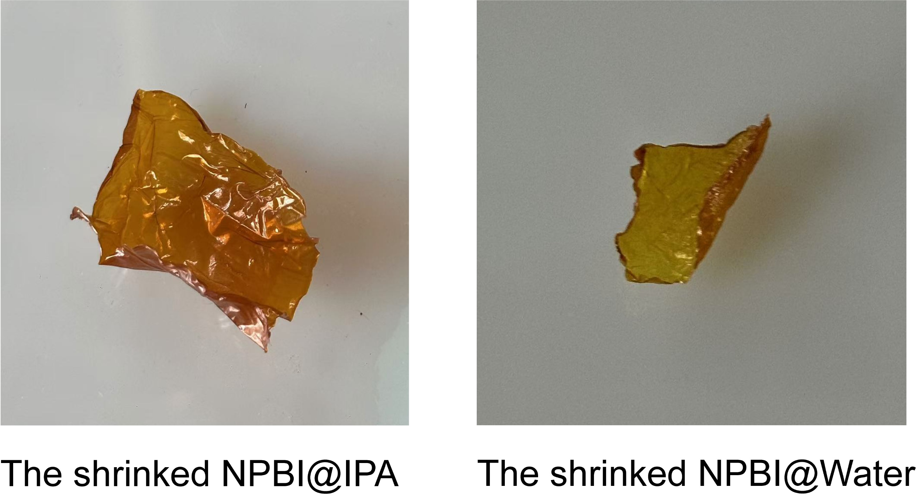
Fig. S2 The serious shrinkage of NPBI@IPA and NPBI@Water after the water within the membrane evaporates completely

Fig. S3 FT-IR spectrum of NPBI@HEP after the long cycle test

Table S1 ARs and VO²⁺ permeabilities of several typical membranes used in VFBs vs. our NPBI@HEP membrane
Membrane type | Thickness (μm) | AR  (Ω·cm²) | VO²⁺ permeability  (10^{‒6} cm²/h) | Ref.
NPBI@HEP | 1.4 | 0.015 | 0.237 | This work
Nafion 212 | 50 | 0.08 | 60.1 | This work
Dense polybenzimidazole (PBI) membrane | 34 | 0.1 | 9.61 | [7]
PBI/perfluorosulfonic acid (PFSA) membrane | 15 | 0.14 | 2.16 | [8]
Graphene oxide (GO)/Nafion | 57.4 | 0.89 | 4.92 | [9]
Sulfonated polyimide/MoS₂ nanosheets membrane | 57 | 0.113 | 3.9 | [10]
PBI/porous polyethylene (PE) composite membrane | 10 | 0.075 | 0.49 | [11]
MOF- sulfonated poly (ether ether ketone) (SPEEK) | 50 | 0.065 | 24.7 | [12]
PBI-EDB free standing porous membrane | 12 | 0.08 | 0.38 | [13]
Zeolite nanosheet-Nafion | 46 | 0.12 | 23.9 | [14]
Novel sulfonated polyimide membranes | 50 | 0.18 | 6 | [15]
MOF-PBI | 30 | 0.088 | 10.1 | [16]
Polytetrafluoroethylene (PTFE)/PFSA/WO₃@GO membrane | 46 | 0.266 | 18.6 | [17]
Zeolite nanosheets-SPEEK | 50.4 | 0.16 | 9.26 | [18]
Porous PBI membrane | 41 | 0.19 | 0.237 | [19]
Porous chloromethylated polysulfone (CMPSF)/trimethylamine (TMA) membrane | 45 | 0.91 | 1.11 | [20]
Composite PBI membrane | 30 | 0.052 | 0.733 | [21]
Crosslink-PBI membrane | 7.2 | 0.04 | 5.97 | [22]
Reference
1. Zhao Y, Truhlar DG (2008) Exploring the limit of accuracy of the global hybrid meta density functional for main-group thermochemistry, kinetics, and noncovalent interactions. J Chem Theory Comput 4(11):1849–1868
2. Weigend F, Ahlrichs R (2005) Balanced basis sets of split valence, triple zeta valence and quadruple zeta valence quality for h to rn: design and assessment of accuracy. Phys Chem Chem Phys 7(18):3297–3305
3. Grimme S (2004) Accurate description of van der waals complexes by density functional theory including empirical corrections. J Comput Chem 25(12):1463–1473
4. Grimme S, Ehrlich S, Goerigk L (2011) Effect of the damping function in dispersion corrected density functional theory. J Comput Chem 32(7):1456–1465
5. Lu T, Chen F (2012) Multiwfn: a multifunctional wavefunction analyzer. J Comput Chem 33(5):580–592
6. Humphrey W, Dalke A, Schulten K (1996) VMD: visual molecular dynamics. J Mol Graph 14(1):33–38
7. Xiao S, Xiong P, Sheng Z et al (2024) Overcoming the conductivity-selectivity trade-off in flow battery membranes via weak supramolecular interaction mediated pseudo-nanophase separation. Energy Storage Mater 66:103226
8. Geng K, Tang H, Li Y et al (2020) A facile strategy for disentangling the conductivity and selectivity dilemma enables advanced composite membrane for vanadium flow batteries. J Membr Sci 607:118177
9. Su L, Zhang D, Peng S et al (2017) Orientated graphene oxide/Nafion ultra-thin layer coated composite membranes for vanadium redox flow battery. Int J Hydrog Energy 42(34):21806–21816
10. Pu Y, Zhu S, Wang P et al (2018) Novel branched sulfonated polyimide/molybdenum disulfide nanosheets composite membrane for vanadium redox flow battery application. Appl Surf Sci 448:186–202
11. Zhang D, Zhang X, Luan C et al (2022) Zwitterionic interface engineering enables ultrathin composite membrane for high-rate vanadium flow battery. Energy Storage Mater 49:471–480
12. Xin L, Zhang D, Qu K et al (2021) Zr-MOF-enabled controllable ion sieving and proton conductivity in flow battery membrane. Adv Funct Mater 31(42):2104629
13. Shi M, Dai Q, Li F et al (2020) Membranes with well-defined selective layer regulated by controlled solvent diffusion for high power density flow battery. Adv Energy Mater 10(34):2001382
14. Xia Y, Cao H, Xu F et al (2022) Polymeric membranes with aligned zeolite nanosheets for sustainable energy storage. Nat Sustain 5(12):1080–1091
15. Li J, Liu J, Xu W et al (2022) Highly ion-selective sulfonated polyimide membranes with covalent self-crosslinking and branching structures for vanadium redox flow battery. Chem Eng J 437:135414
16. Luan C, Zhang D, Liu Z et al (2023) Advanced hybrid polybenzimidazole membrane enabled by a “linker” of metal-organic framework for high-performance vanadium flow battery. Chem Eng J 461:142032
17. Ye J, Zheng C, Liu J et al (2022) In situ grown tungsten trioxide nanoparticles on graphene oxide nanosheet to regulate ion selectivity of membrane for high performance vanadium redox flow battery. Adv Funct Mater 32(8):2109427
18. Xia Y, Wang Y, Xiao L et al (2023) Functional molecular cross-linked zeolite nanosheets heighten ion selectivity and conductivity of flow battery membrane. AIChE J 69(4):e17964
19. Qiao L, Zhang H, Lu W et al (2019) Advanced porous membranes with tunable morphology regulated by ionic strength of nonsolvent for flow battery. ACS Appl Mater Interfaces 11(27):24107–24113
20. Zhao Y, Zhang H, Xiao C et al (2018) Highly selective charged porous membranes with improved ion conductivity. Nano Energy 48:353–360
21. Wan YH, Sun J, Jiang HR et al (2021) A highly-efficient composite polybenzimidazole membrane for vanadium redox flow battery. J Power Sources 489:229502
22. Shi M, Lu W, Li X (2024) A sub-10 μm ion conducting membrane with an ultralow area resistance for a high-power density vanadium flow battery. ACS Appl Energy Mater 7(18):7576–7583

