Research Article
Phosphorus Doping for Enhanced Lithium Storage Performances over Multiscale Porous SiGeSnSbPAl Composite Anode
Qin Hao¹ · Zefang Ding¹ · Cuiping Li² · Fengxia Li², Li Li¹ · Rumeng Bai¹ · Junqiang Wei^{1*}· Jinfeng Dong¹ · Wenqing Ma¹ · Caixia Xu^{1,2*}· RuiQin Zhang³
¹Institute for Advanced Interdisciplinary Research, School of Chemistry and Chemical Engineering, Shandong Key Laboratory of Functional Materials for Integrated Lithium Niobate Photonic (under construction), University of Jinan, Jinan 250022, China
²College of Food Engineering, Qingdao Institute of Technology, Qingdao 266300, China
³Department of Physics, City University of Hong Kong, Hong Kong SAR, China
Received: 23 April 2025/ Revised: 2 May 2025 / Accepted: 23 June 2025 / Published online:
*Correspondence to Junqiang Wei, E-mail: junqiangwei@stu.ujn.edu.cn; Caixia Xu, E-mail: chm_xucx@ujn.edu.cn

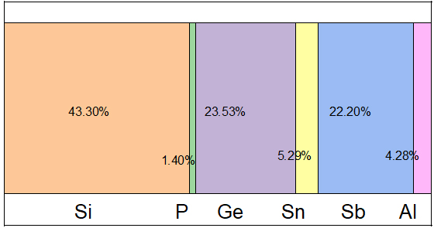

Fig. S1 Atomic proportions of each element in MP-SiGeSnSbPAl sample

