Supporting Information

MOF Derived Oxygen-Vacancy-Rich ZrO₂/UiO-66-NH₂ for Efficient Visible-Light-Driven Oxidation of Benzyl Alcohol
Yanyan Song^{1,2}· Zhichao Sun^{1,2} · Jiamin Sun³ · Ying-Ya Liu^{1,2} · Anjie Wang^{1,2} · Chong Peng^{1,2}
¹State Key Laboratory of Fine Chemicals, School of Chemical Engineering, Dalian University of Technology, Dalian 116024, China
²Liaoning Key Laboratory of Petrochemical Technology and Equipment, Dalian University of Technology, Dalian 116024, China
³Department of Chemistry, Division of Molecular Imaging and Photonics, KU Leuven, 3001, Leuven, Belgium

EPR analysis
Superoxide radical (•O₂⁻) Detection Procedure
5 mg sample was ultrasonically dispersed in 1 mL of anhydrous methanol for 5 min using a bath sonicator. The resulting suspension was subsequently treated with 40 μL of 5,5-dimethyl-1-pyrroline-N-oxide (DMPO) spin trap agent, followed by additional ultrasonication (3 min) to ensure complete homogenization. Approximately 50 μL of the homogeneous mixture was transferred into a capillary tube (0.5 mm i.d.) using a microsyringe, sealed with high-vacuum grease, and mounted in a 4 mm OD quartz EPR tube for measurement at 298 K.

Carbon-Centered Radical Testing Procedure
5 mg sample was ultrasonically dispersed in a benzyl alcohol/ acetonitrile (1:4 v/v) solution. Then, 40 μL of DMPO was added to the dispersion, followed by additional ultrasonication of 3 min to ensure homogeneity. Approximately 50 μL of the homogeneous mixture was transferred into a capillary tube (0.5 mm i.d.) using a microsyringe, sealed with high-vacuum grease, and mounted in a 4 mm OD quartz EPR tube for measurement at 298 K.

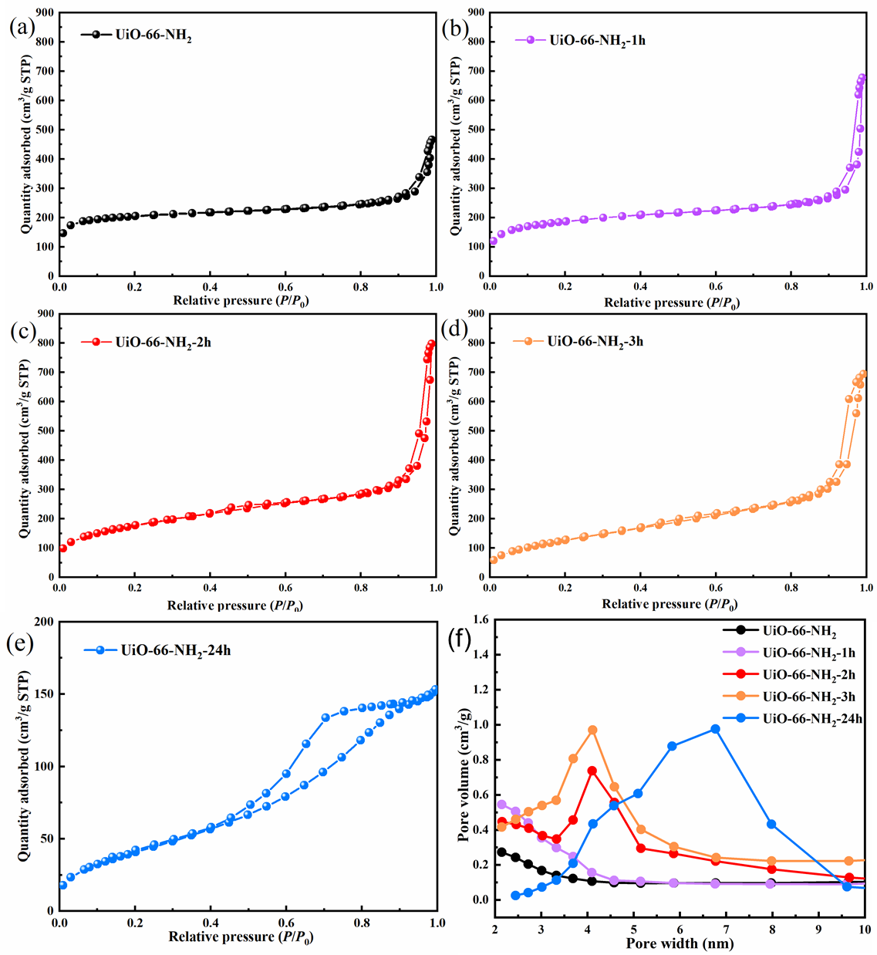
Fig. S1 The N₂ adsorption-desorption isotherms of a UiO-66-NH₂, b–d UiO-66-NH₂-1h–3h and e UiO-66-NH₂-24h; f Pore size distribution of the sample series

Table S1 Specific surface content data of UiO-66-NH₂, UiO-66-NH₂-2h and UiO-66-NH₂-24h
Sample | C 1s (atomic %) | N 1s  (atomic %) | Zr 3d (atomic %) | O 1s  (atomic %)
UiO-66-NH₂ | 61.40 | 5.92 | 4.23 | 28.45
UiO-66-NH₂-2h | 57.96 | 4.80 | 6.29 | 30.95
UiO-66-NH₂-24h | 42.80 | 3.57 | 13.20 | 40.43

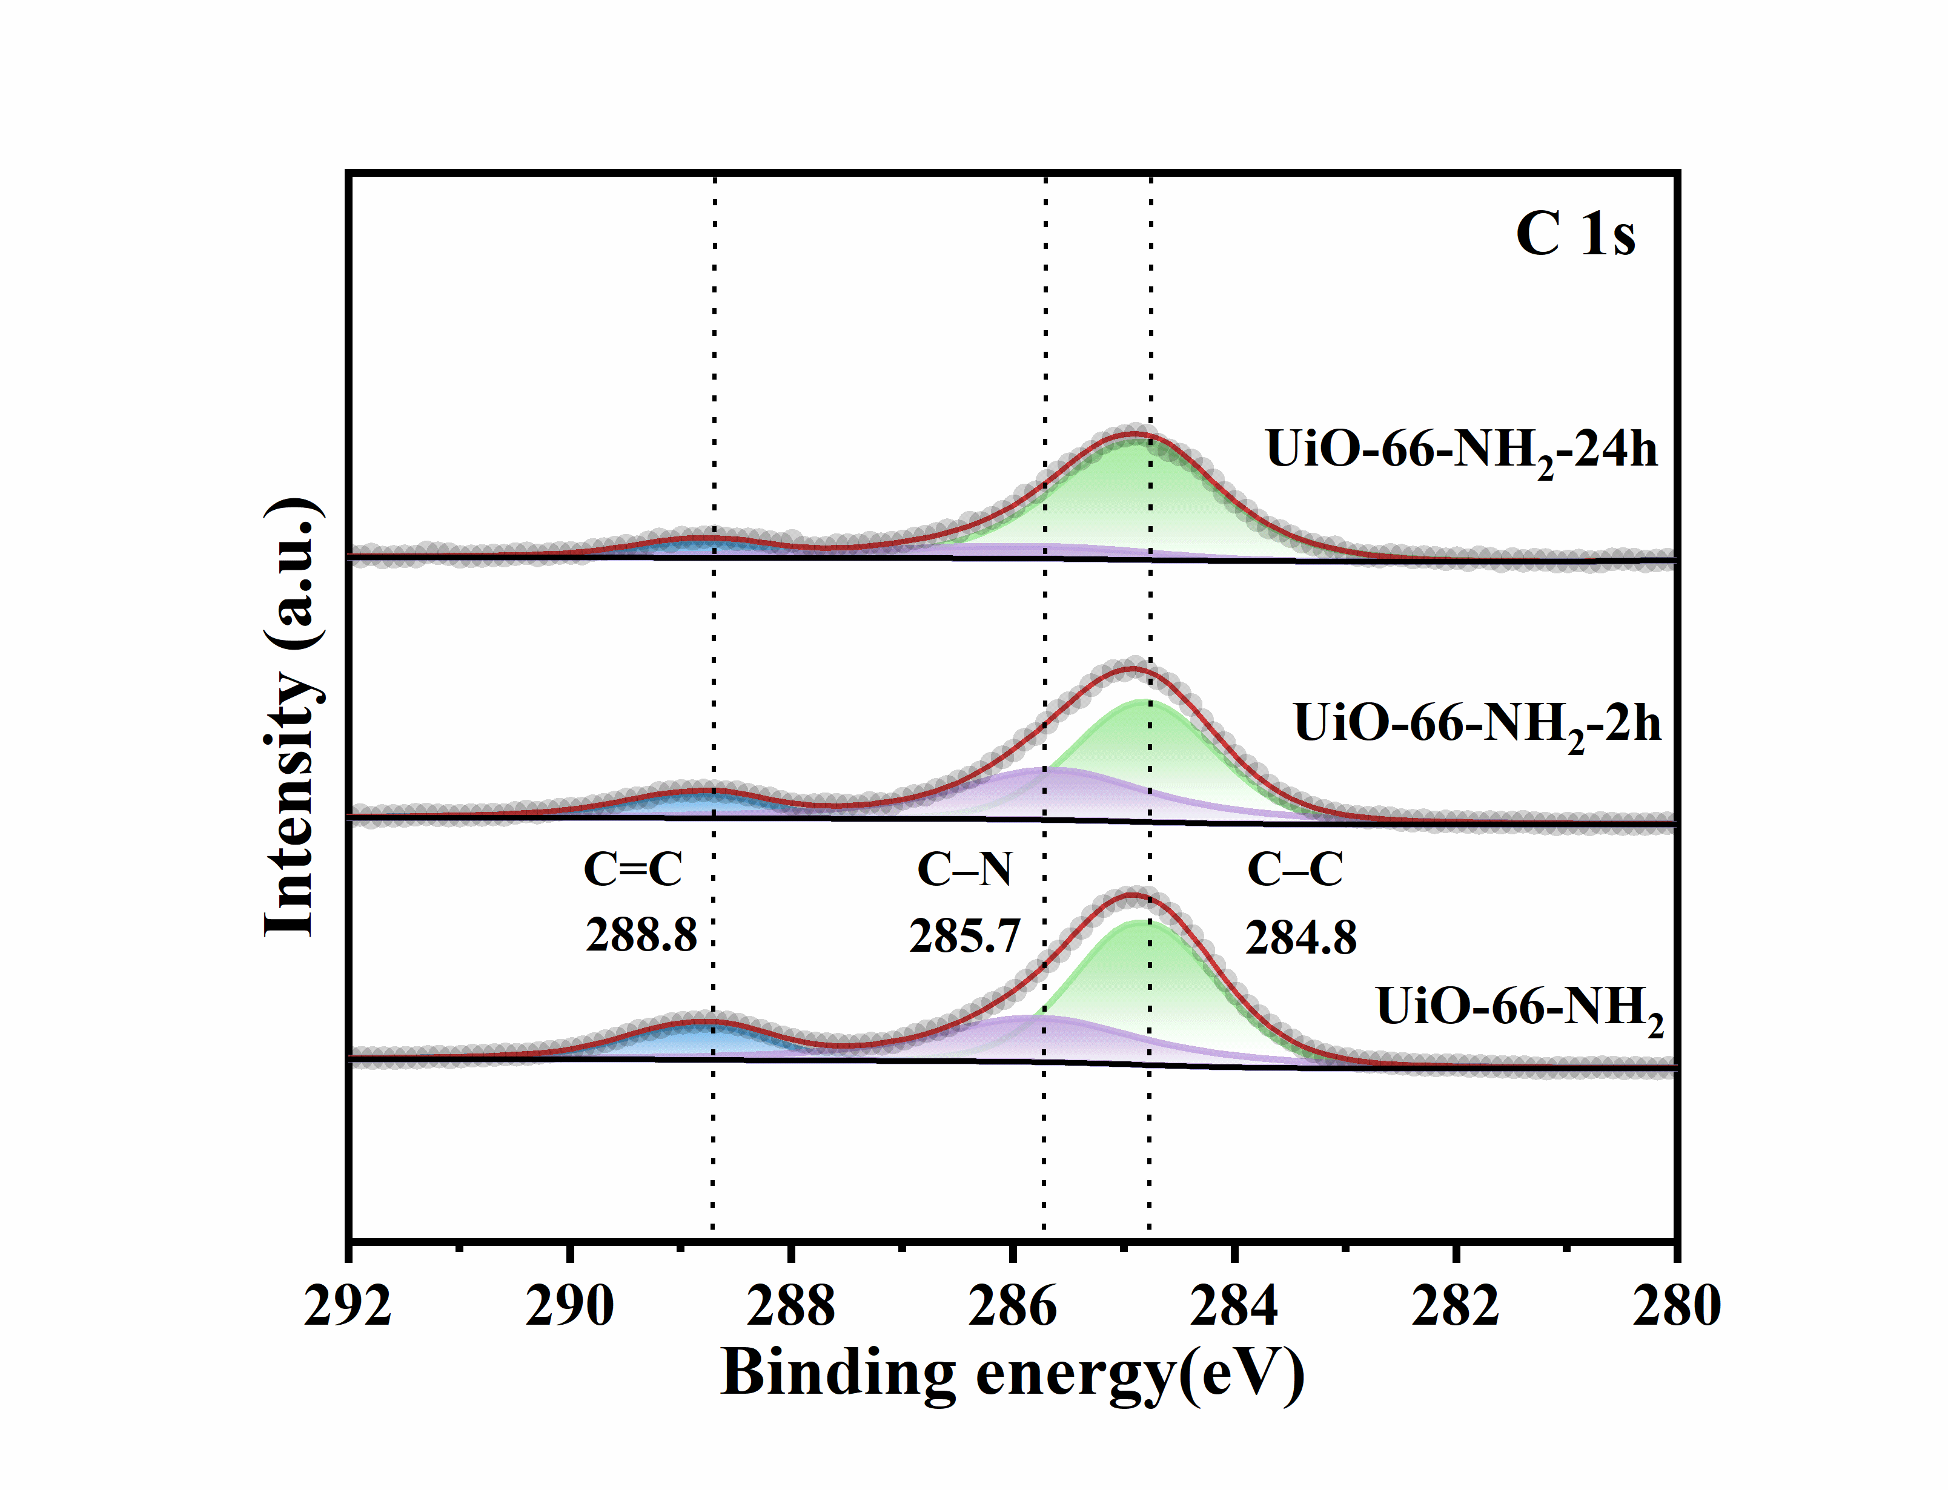
Fig. S2 The high resolution XPS spectra for C 1s in UiO-66-NH₂, UiO-66-NH₂-2h, UiO-66-NH₂-24h

Fig. S3 EPR spectra of samples under solvothermal and calcination treatment

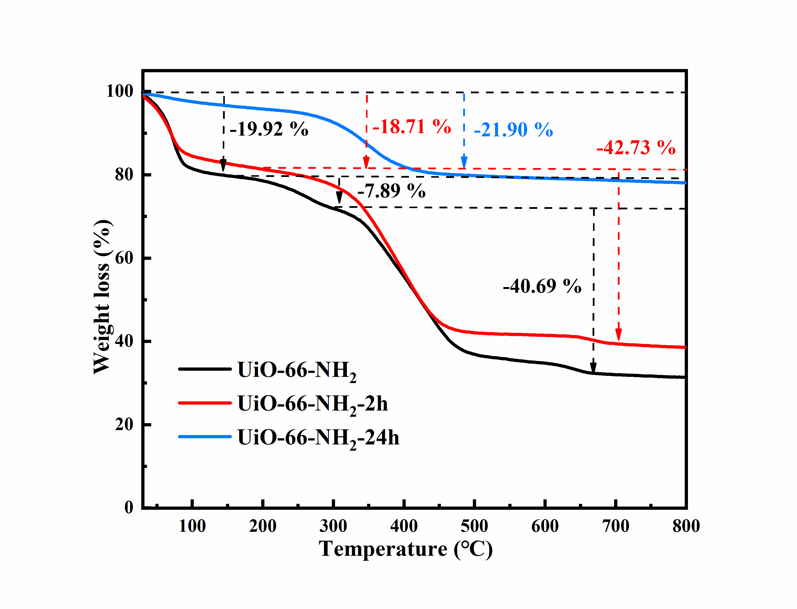Fig. S4 TGA profiles of UiO-66-NH₂ and UiO-66-NH₂-2h

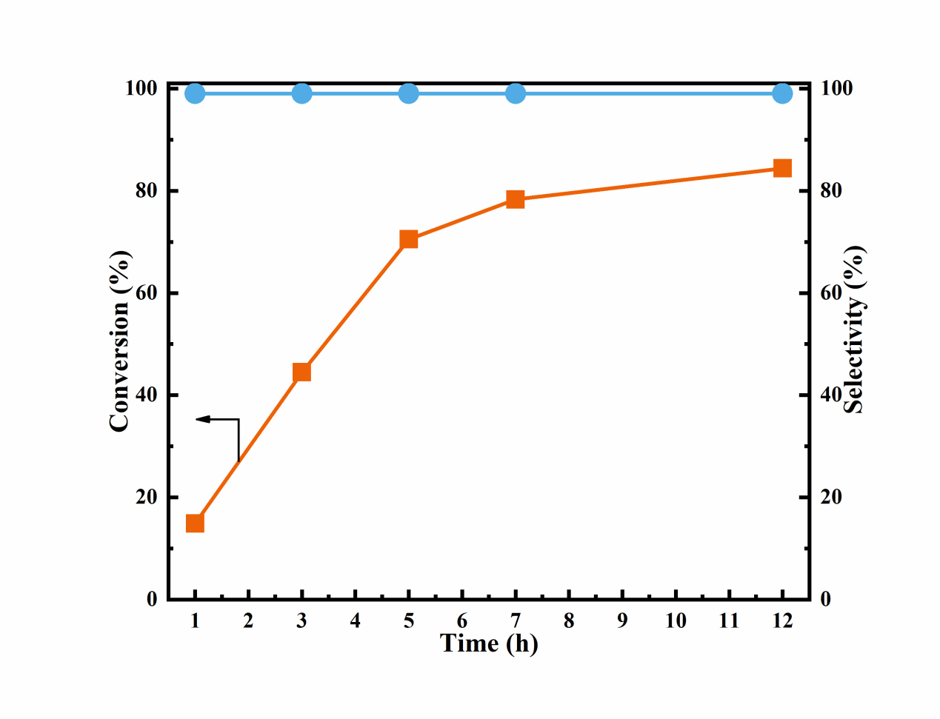
Fig. S5 The time-dependent performance profile of UiO-66-NH₂-2h

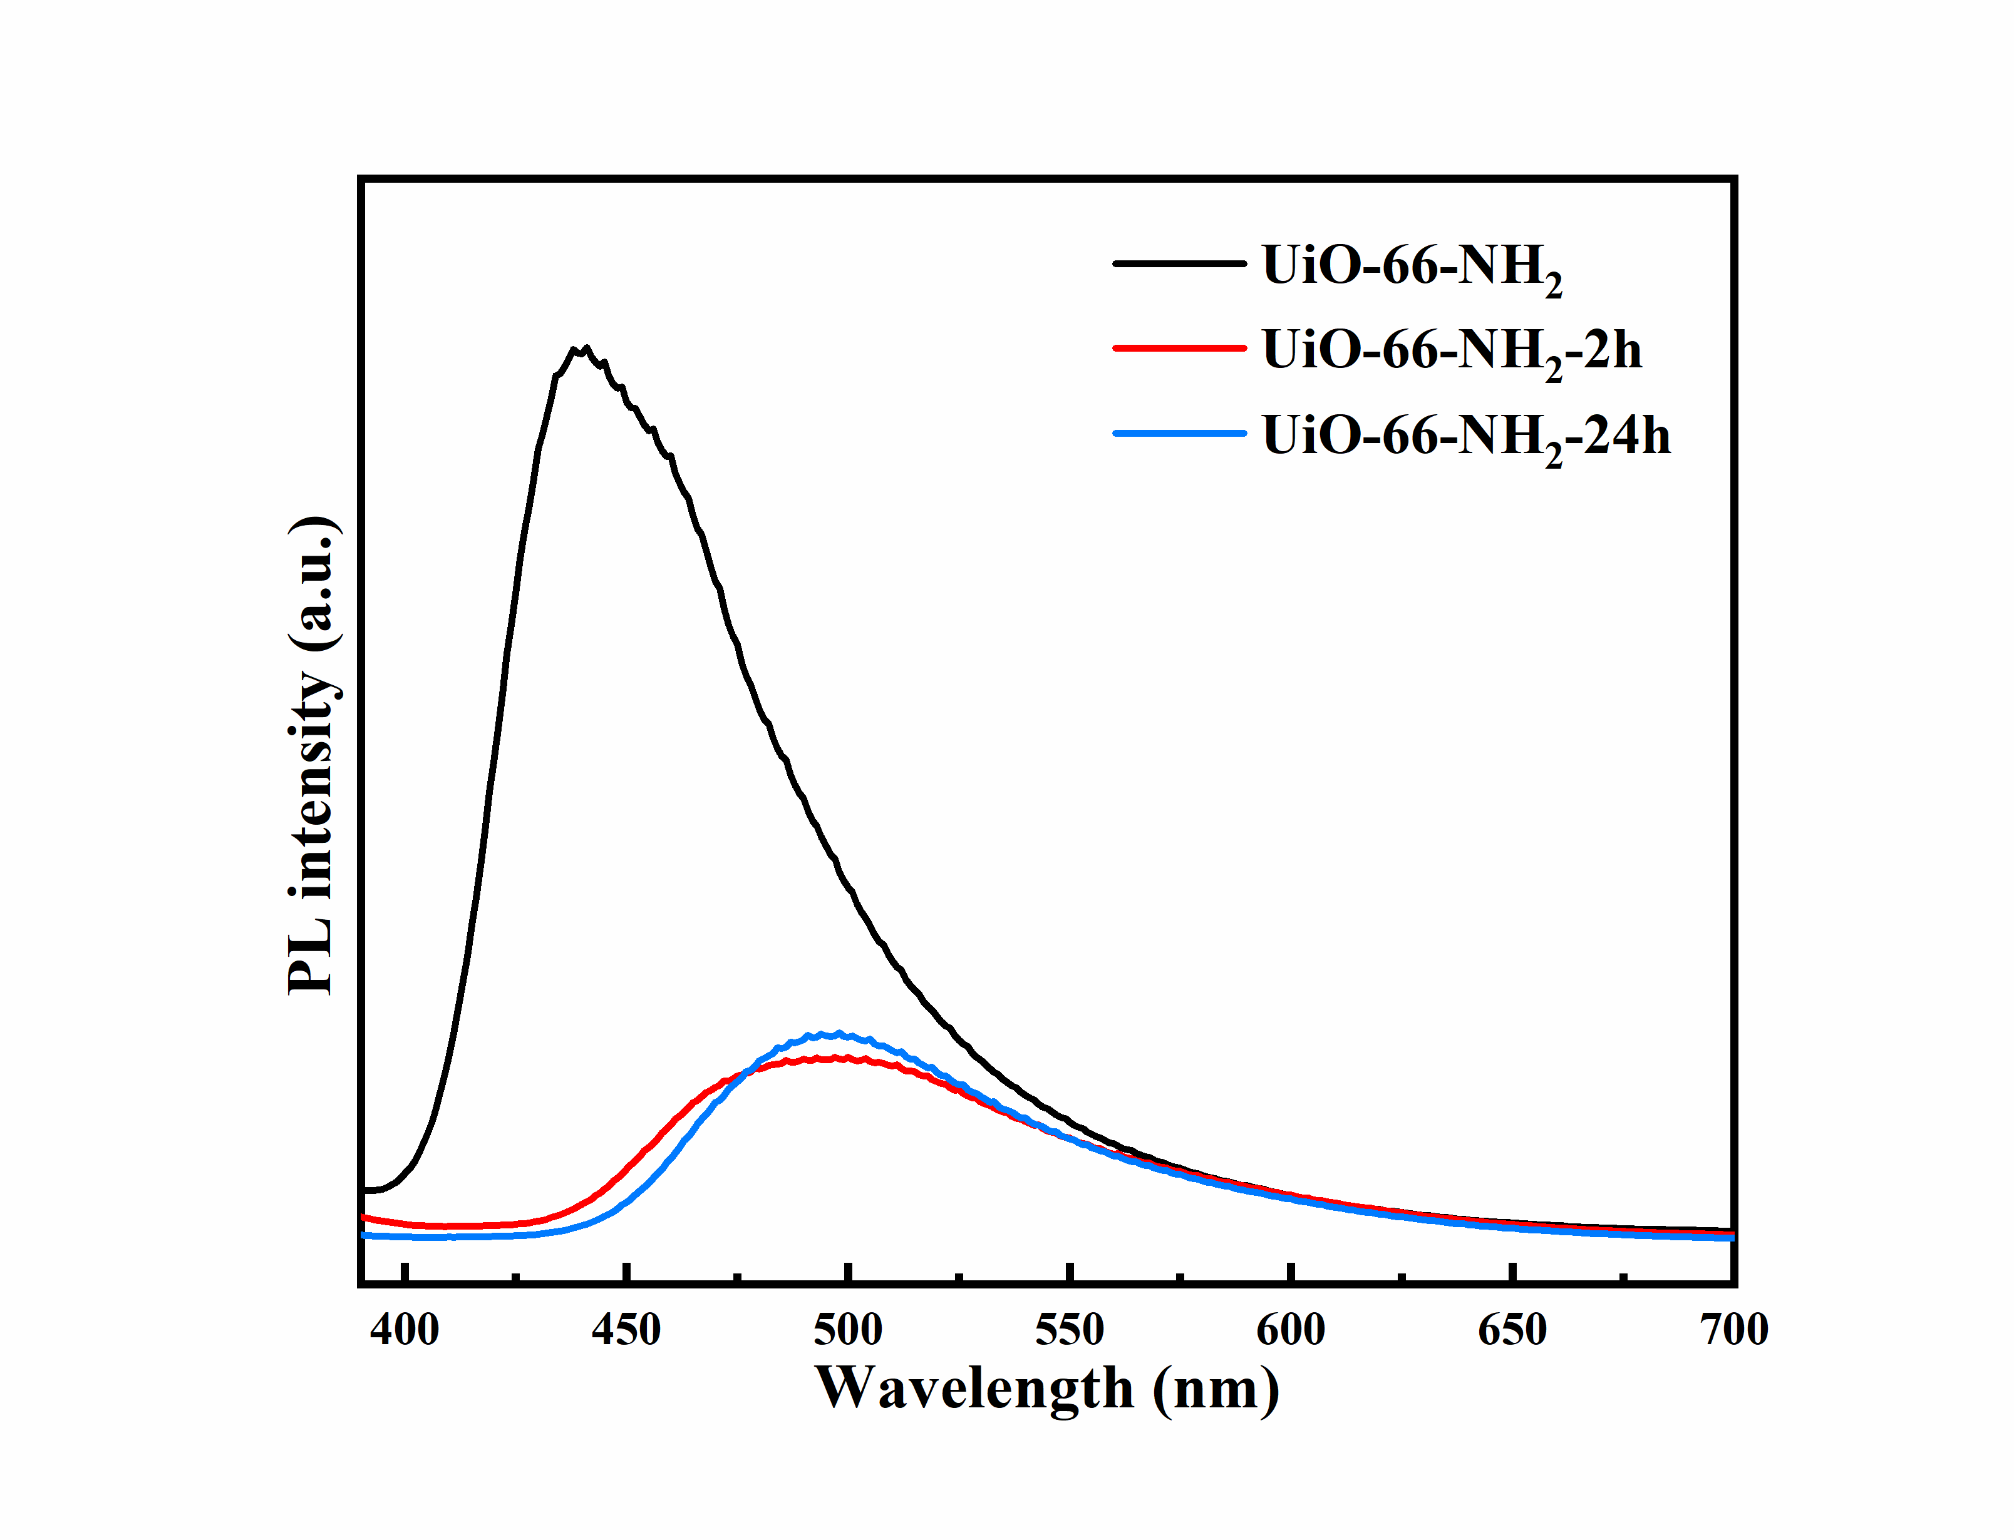
Fig. S6. PL emission spectra of UiO-66-NH₂, UiO-66-NH₂-2h, UiO-66-NH₂-24h (λ_{ex}=367 nm)

Table S2 Comparison of the performance of photocatalytic benzyl alcohol oxidation based on MOFs related catalysts
Catalyst | Reaction condition | Atmosphere | Light source | Conv.  (%) | Sel. (%) | Ref.
MIL-53-NH₂@ZnIn₂S₄ | 50 mg, 0.5 mmol benzyl alcohol, 20 mL toluene, 4 h | O₂ | 300 W Xe lamp  400~780 nm | 56 | >99 | [1]
ZnFe₂O₄/UiO-66-NH₂ | 20 mg, 0.2 mmol benzyl alcohol, 2 mL trifluorotoluene, 5 h | O₂ | 300 W Xe lamp  λ＞420 nm | 72 | 99 | [2]
CoFe₂O₄/Ce-UiO-66 | 100 mg, 1.0 mmol benzyl alcohol, 20 mL n-hexane, 6 h | air | visible-light | 75 | >99 | [3]
Bi_{3.43}Fe_{0.57}O₆/MIL-53 | 30 mg, 0.2 mmol benzyl alcohol, 3 mL acetonitrile, 3 h | O₂ | 300 W Xe lamp  λ≥400 nm | 58.5 | >99 | [4]
PANI/FeUiO-66 | 5 mg, 0.2 mmol benzyl alcohol, 6 mL ethyl acetate, 5 h | O₂ | 300 W Xe lamp  λ≥400 nm | 61 | 99 | [5]
NH₂-MIL-125@TAPB-PDA | 20 mg, 0.2 mmol benzyl alcohol, 3 mL acetonitrile, 30 h | O₂ | 5 W LED  420~780nm  150 mW/cm² | 94.7 | 99 | [6]
0.1%Cu/Cu@UiO-66 | 32 mg, 0.2 mmol benzyl alcohol, 3 mL acetonitrile, 3 h | O₂ | 300 W Xe lamp  λ≥400 nm | 49.5 | 99 | [7]
Au/UIO-66-NH₂  Pt/UIO-66-NH₂  Pd/UIO-66-NH₂  Ag/UIO-66-NH₂ | 100 mg, 1 mmol benzyl alcohol, 20 mL toluene, 4 h | O₂ | 300 W Xe lamp  350~780 nm | 30.5  9.3  30.3  19.4 | 95 | [8]
CdS-UiO-66(NH₂) | 8 mg, 0.1 mmol benzyl alcohol, 1.5 mL trifluorotoluene, 4 h | O₂ | 300 W Xe lamp  λ≥420 nm | 30.12 | 99 | [9]
Ni-doped NH₂-MIL-125 | 50 mg, 0.3 mmol benzyl alcohol. 6 mL trifluorotoluene, 10 h | O₂ | 300 W Xe lamp  420≤λ≤800 nm | 43.2 | >99 | [10]
Fe₂Co-MOF | 30 mg, 0.21 mmol benzyl alcohol, 2 mL acetonitrile, 12 h | TBHP (75 mg 70% in water) | 100 W LED  380~780 nm | 93.5 | >99 | [11]
CdS/Ni@NC(5) | 40 mg, 1mmol benzyl alcohol, 50 mL H₂O, 12 h | air | 300 W Xe lamp  λ≥420 nm | 78.1 | ~100 | [12]
UiO-66-NH₂-2h | 50 mg, 0.3 mmol benzyl alcohol, 5 mL acetonitrile, 5 h | O₂ | 30 W LED  420~800 nm  89 mW/cm² | 74.1 | >99 | This work

References
1. Zhang L, Qiu J, Xia G et al. (2023) Constructing a Z-scheme Fe-MOF-based heterostructure for visible-light-driven oxidation of aromatic alcohol in ambient air. J Mater Sci Technol, 138: 214–220
2. Liu J, Sun X, Jiang B et al. (2022) UiO-66-NH₂ octahedral nanocrystals decorated with ZnFe₂O₄ nanoparticles for photocatalytic alcohol oxidation. ACS Appl Nano Mater, 5(2): 2231–2240
3. Khosroshahi N, Karimi M, Taghvaei T et al. (2021) Ultrasound-assisted synthesis of CoFe₂O₄/Ce-UiO-66 nanocomposite for photocatalytic aerobic oxidation of aliphatic alcohols. Materials Today Chemistry, 22: 100582
4. Zhang Q, Liu J-B, Chen L et al. (2020) An etching and re-growth method for the synthesis of bismuth ferrite/MIL-53(Fe) nanocomposite as efficient photocatalyst for selective oxidation of aromatic alcohols. App Catal B: Environ, 264: 118529
5. Xu X, Liu R, Cui Y et al. (2017) PANI/FeUiO-66 nanohybrids with enhanced visible-light promoted photocatalytic activity for the selectively aerobic oxidation of aromatic alcohols. App Catal B: Environ, 210: 484–494
6. Lu G, Huang X, Li Y et al. (2020) Covalently integrated core-shell MOF@COF hybrids as efficient visible-light-driven photocatalysts for selective oxidation of alcohols. Journal of Energy Chemistry, 43: 8–15
7. Xiao L, Zhang Q, Chen P et al. (2019) Copper-mediated metal-organic framework as efficient photocatalyst for the partial oxidation of aromatic alcohols under visible-light irradiation: Synergism of plasmonic effect and schottky junction. App Catal B: Environ, 248: 380–387
8. Qiu J, Zhang X, Xie K et al. (2019) Noble metal nanoparticle-functionalized Zr-metal organic frameworks with excellent photocatalytic performance. J Colloid Interface Sci, 538: 569–577
9. Shen L, Liang S, Wu W et al. (2013) CdS-decorated UiO–66(NH2) nanocomposites fabricated by a facile photodeposition process: an efficient and stable visible-light-driven photocatalyst for selective oxidation of alcohols. Journal of Materials Chemistry A, 1(37): 11473–11482
10. Fu Y, Sun L, Yang H et al. (2016) Visible-light-induced aerobic photocatalytic oxidation of aromatic alcohols to aldehydes over Ni-doped NH₂-MIL-125(Ti). Applied Catalysis B: Environmental, 187: 212–217
11. Ghasempour H, Zarekarizi F, Habibi B et al. (2025) Sustainable synthesis of a mixed-metal MOF: a visible light responsive photocatalyst for the selective oxidation of benzyl alcohols. CrystEngComm, 27: 4826–4834
12. Yang H, Xia Y, Guo J et al. (2025) Highly-dispersed CdS nanoparticles coating hierarchical Ni@NC derived from ultrathin nanosheets NMOF-Ni: photocatalytic hydrogen evolution coupled with alcohol oxidation. Applied Catalysis B-Environment and Energy, 362: 124700

