Supporting Information
Molecular Coordination Engineering Enables Aminoethyl Phosphonic Acid as a Multifunctional Additive for High-Performance Zinc-Iodine Flow Batteries
Han Shi ¹ · Jing Cui ¹ · Zhikun Liu ¹ · Peng Kang ^{1*}
¹ School of Chemical Engineering and Technology, Tianjin University, Tianjin 300350, China

Received: 2 February 2026/ Revised: 10 April 2026/ Accepted: 20 April 2026/ Published online:

Correspondence to Peng Kang, E-mail: kang.peng@tju.edu.cn

1. Experimental Section

1.1. Materials
2-aminoethylphosphonic acid (AEP), Zinc sulfate (ZnSO₄) and ammoniu chloride (NH₄Cl) were purchased from Aladdin. Ammonium iodide (NH₄I) was purchase from Meryer Biochemical Technology Co., Ltd. The N115 membrane was purchased from Dupont. Deionized water (18.2 MΩ·cm) was obtained from HHitech water purification system. Porous carbon felt (CF) with a size of 2 cm × 2 cm and a thickness of 3 mm was used as the electrode for flow cell. Zn foil and Cu foil (thickness 0.2 mm) were purchased from Zhongnuo Advanced Material Technology Co., Ltd. Before use, Zn foil and Cu foil were washed with 0.5 mol/ HCl for 2 min to remove surface oxides, then rinsed with water.

1.2. Material Characterizations
The X-ray diffraction (XRD) patterns were collected on Bruke D8 Focus diffractometer wit Cu Kα radiation. The surface morphology and elemental components were analyzed by Regulus 8100 (Hitachi) scanning electron microscope (SEM). A Fourier Transform infrared spectroscopy (FTIR) spectrometer (iS50, FEI) was used to analyze the functional groups information of the samples. High-resolution mass spectrometers (HRMS, Thermo Scientific QE plus) was used to determine the mass-to-charge ratio of ions. Raman spectra of the electrolytes were acquired using laser confocal Raman spectrometer (Horiba Labram HR Evolution) equipped with a HeNe laser (532 nm excitation wavelength). The wettability of electrode surface was analyzed with a contact angle measurement system (JC2000D3M, Powereach).

1.4. Electrochemical Measurements
Cyclic voltammetry (CV) was performed using an electrochemical workstation (CHI 660E, Chenhua Instruments, China), linear scanning voltammetry (LSV), electrochemical impedance spectroscopy (EIS), Tafel curve (Tafel) and linear polarization (LP) were performed using an electrochemical station (Gamry Interface 1010E). CVs and Constant current deposition were conducted at a scanning rate of 10 mV/s in the electrolyte contained 0.1 mol/L ZnSO₄ with / without 5 mmol/L AEP. The corrosion current and potential were measured by Tafel plots derived from LP curves in 0.1 mol/L ZnSO₄ with / without 5 mmol/L AEP at 1.0 mV/s. EISs were obtained in a frequency range from 100 kHz to 0.1 Hz at open circuit potential (OCP) with 5 mV AC voltage.

1.5. Flow Cell Tests
In the flow cell, graphite plates were placed between the electrodes and gold-plated copper plates in each half-cell. An N115 membrane was used for separating two half-cells, and Teflon gaskets were employed to seal flow cell. The electrolyte of each half-cell was pumped into the cell by peristaltic pump (ZP200, Leirong, China) with a flow rate of 20 L/min. Galvanostatic charge-discharge tests were performed on a Neware CT-4008Tn battery tester at room temperature. In symmetric flow cell tests, same electrodes used as anode and cathode (active geometric area, 2 cm × 2 cm) with 20 mL 2 mol/L ZnSO₄-2 mol/L NH₄Cl as anolyte and catholyte, and current was 20 mA/cm² with capacity of 1 mAh/cm². To evaluate the long-term stability of full cell, a carbon felt was used as anode / cathode. The anolyte was 20 mL 2 mol/L ZnSO₄-2 mol/L NH₄Cl solution, while the catholyte was 20 mL 3 mol/L NH₄I - 3 mol/L NH₄Cl solution. The cell was charged for 15 min at 80 mA/cm² and discharged to 0.5 V.
The key parameters used to assess the full cell performance are calculated from the charge discharge curve using the following equations:
$$\text{Coulombic efficiency}\text{ =}\frac{\text{D}\text{ischarge capacity}}{\text{C}\text{harge capacity}}\text{×100\%}$$
$$\text{E}\text{nergy}\text{ efficiency}\text{ =}\frac{\text{D}\text{ischarge energy}}{\text{C}\text{harge energy}}\text{×100\%}$$
2. Computational Methods
2.1 DFT Calculations
The initial models of these systems with adsorbed molecules were constructed using Materials Studio (MS) software, and three-layer atomic model was employed for each Zn crystal plane. Geometry optimization calculations were carried out with the QUICKSTEP program as implemented in the CP2K package [1]. The geometry optimization were done with a convergence tolerance of 10⁻⁶ eV for the total energy and the bottom two substrate layers were fixed (atomic position) until the force convergence limit was satisfied: EPS_SCF: 1.0×10^{‒6}; MAX_DR: 3.0×10^{‒3}; RMS_DR: 1.5×10^{‒3}; MAX_FORCE：4.5×10^{‒4}; RMS_FORCE: 3.0×10^{‒4}. DFT-D3 method of Grimme was considered to better describe the van der Waals interaction [2]. The Gaussian and plane waves method was used with a cutoff energy of 400 eV. Only the Γ-point was sampled in the Brillouin zone to prioritize computational efficiency for the large supercell. The self-consistent field (SCF) convergence threshold was set to 10^{‒6} eV to ensure precise energy evaluations. The adsorption energies (E_{ads}) were calculated as E_{ads} = E_{ad/sub} - E_{ad} - E_{sub}, where E_{ad/sub}, E_{ad}, and E_{sub} are the total energies of the optimized adsorbate / substrate system, the adsorbate in the structure. and the clean substrate, respectively.
2.2 Molecular Dynamics Simulation
Multiwfn was used to fit the restrained electrostatic potential (RESP) charge [3, 4]. Atomic charges of all ions were multiplied by scale factor 0.8 to correct the polarization effect of ions. TIP3P [5] force field was used for water molecules. Other molecules bond and non-bond parameters were obtained via AuToFF software [6].
All-atom MD simulations were conducted using the GROMACS software package, version 2021.5 [7‒9]. The OPLASS force field [10, 11] was employed to describe the molecule. Subsequently, we randomly placed the optimized molecules into 6 nm × 6 nm × 6 nm cubic boxes. For ZS, 200 Zn²⁺ ions, 200 SO₄^{2‒} ions and 5556 Water molecules are randomly inserted into the box. For AEP, 200 Zn²⁺ ions, 200 SO₄^{2‒} ions, 10 mol molecules and 5556 Water molecules are randomly inserted into the box. Molecular dynamics simulations were then performed for these systems. Energy minimization was initially carried out for systems, employing the steepest descent method to address initial contact issues. Followed by a short simulation of 10 ns using the NPT system to make the box fully compressed. Subsequently, a 20 ns simulation was then performed under the NVT ensemble to relax the structure and achieve system equilibrium. The pressure was maintained at P = 1.0 bar using a Berendsen barostat, and the temperature was controlled at 298.15 K using a velocity-rescale thermostat with a coupling constant of τ = 0.1 ps. Nonbonded interactions were computed with a cutoff of 1.2 nm, and long-range electrostatic interactions were computed using the particle-mesh Ewald summation method. All hydrogen bonds were constrained using the LINCS algorithm [12]. Simulations were performed with a time step of 2 fs, and the neighbor list was updated every 10 steps. Periodic boundary conditions were applied in all three directions. PyMOL-3.0.3（http://www.pymol.org/pymol）was used for visualization.

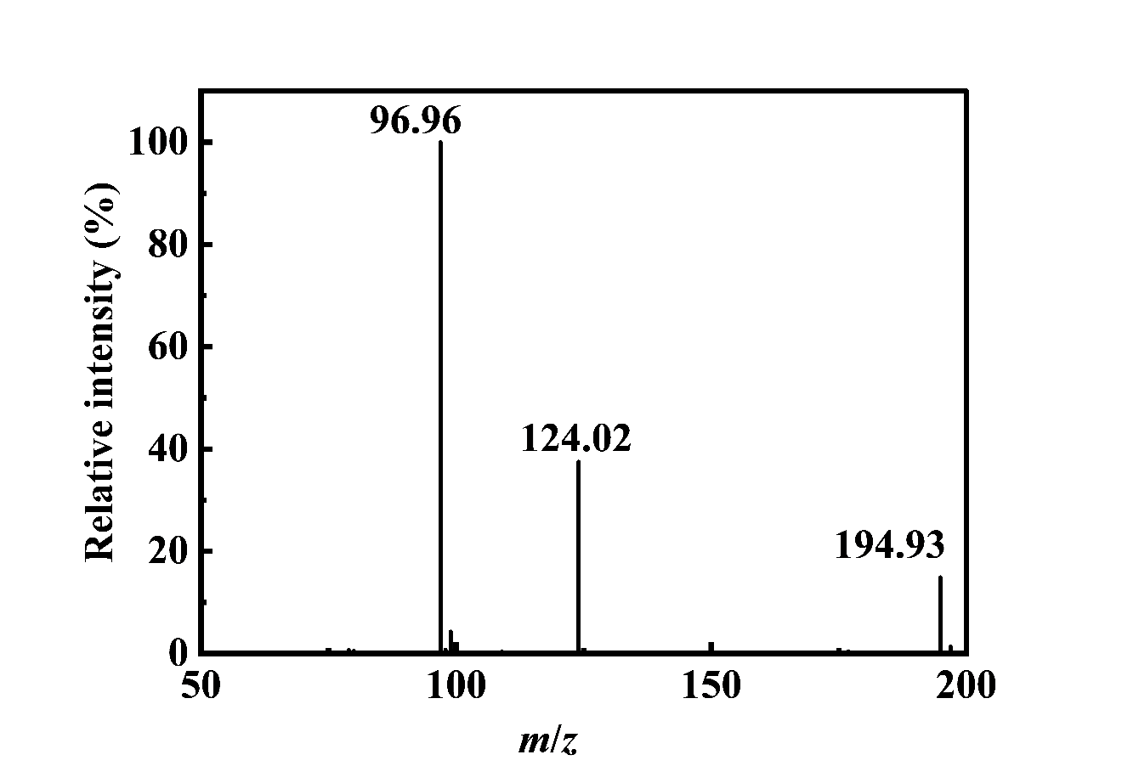
Fig. S1 The RDFs were collected from MD simulations in ZS electrolyte

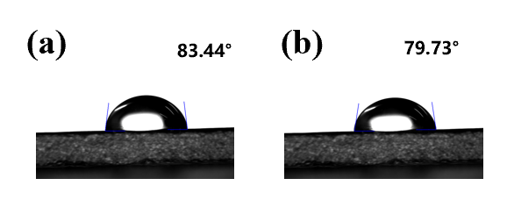
Fig. S2 Contact angle measurement in a ZS electrolyte and b AEP electrolyte

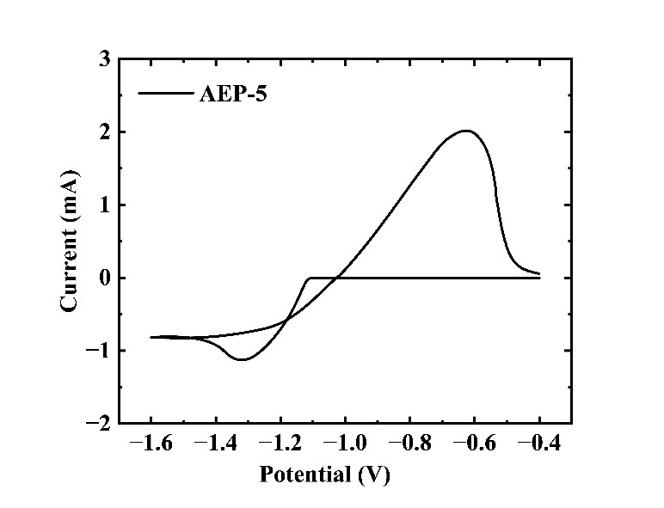
Fig. S3 Cyclic voltammograms of Zn/Zn²⁺ redox reactions in AEP-5 electrolyte

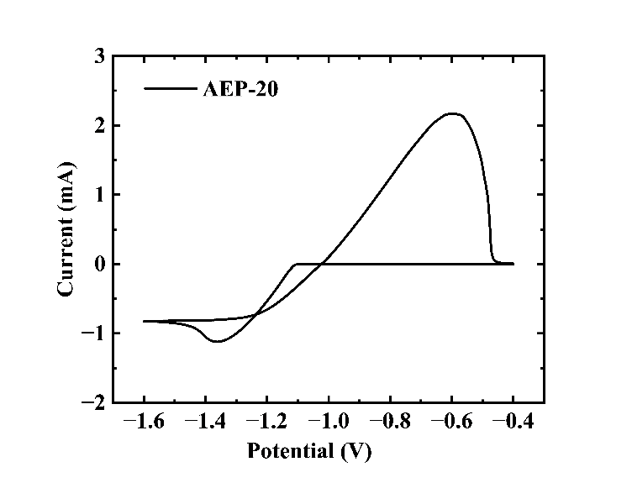
Fig. S4 Cyclic voltammograms of Zn/Zn²⁺ redox reactions in AEP-20 electrolyte
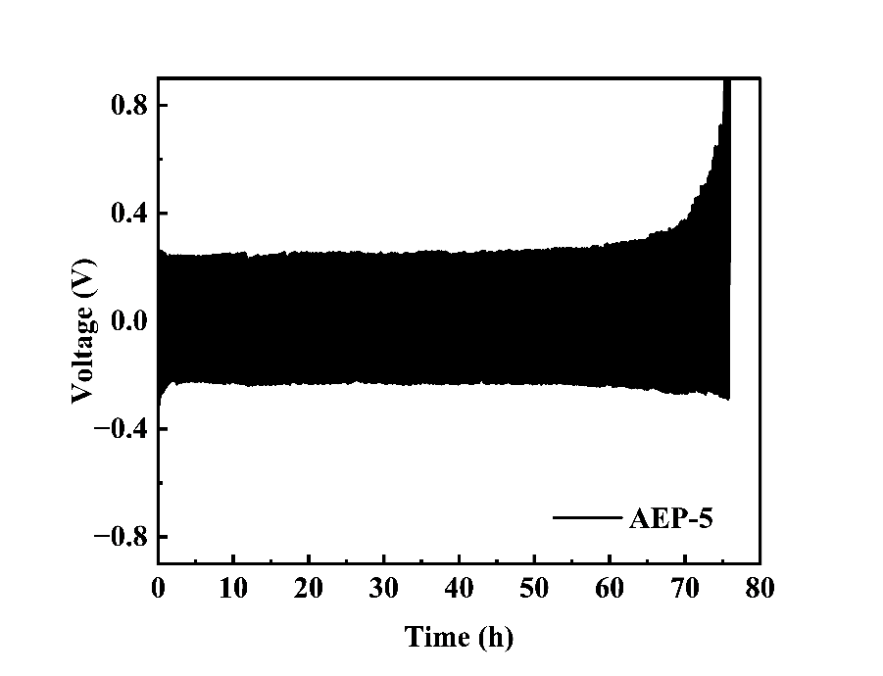

Fig. S5 Zn||Zn symmetric cells in AEP-5 electrolyte at current density and areal capacity of 20 mA/cm² at 1 mAh/cm²

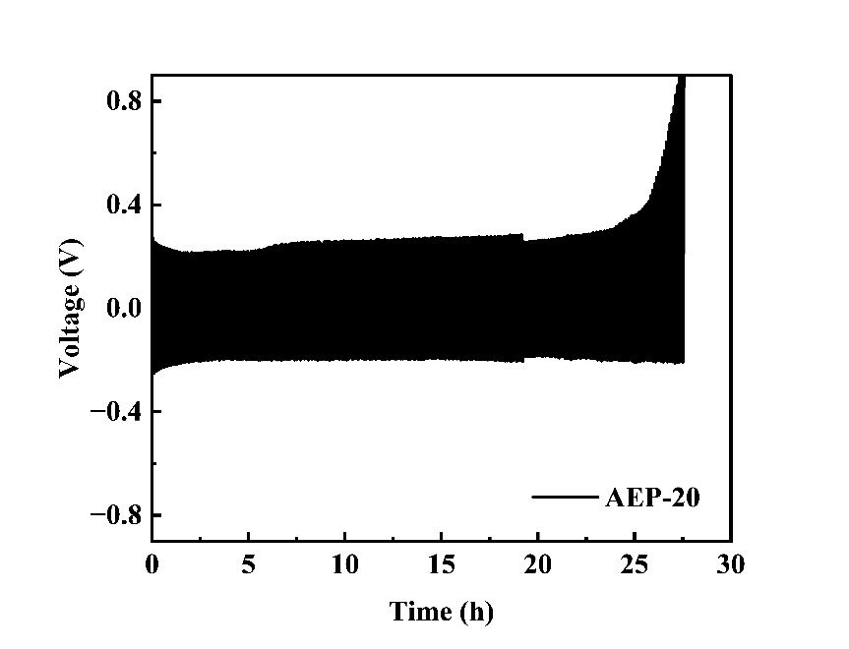
Fig. S6 Zn||Zn symmetric cells in AEP-20 electrolyte at current density and areal capacity of 20 mA/cm² at 1 mAh/cm²

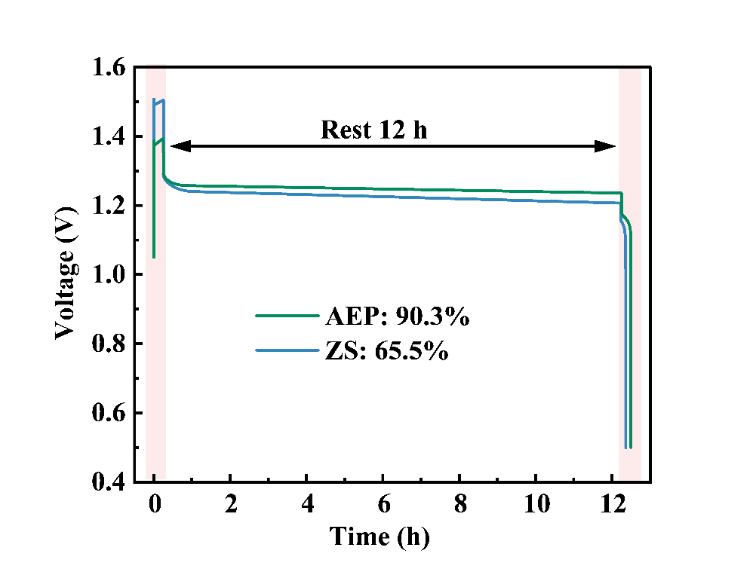
Fig. S7 Charge-rest-discharge tests of the AIRFBs in ZS and AEP electrolyte

Additive/Membrane | Current density  (mA/cm²) | Energy efficiency  (%) | Life  (h) | Refs.
AEP | 80 | 82.43 | 600 | This work
Acetonitrile | 100 | 60 | 136 | [13]
Dicyandiamide and  Phosphoric acid | 100 | 79.77 | 13 | [14]
Potassium sodium tartrate | 120 | 71.05 | 40 | [15]
Cl⁻ | 40 | 83 | 300 | [16]
UiO-66-CH₃ Membrane | 30 | 64 | 100 | [17]
Sucrose | 20 | 80 | 308 | [18]

Table S1 Recent literature reports on the performance comparison of zinc-iodine flow batteries

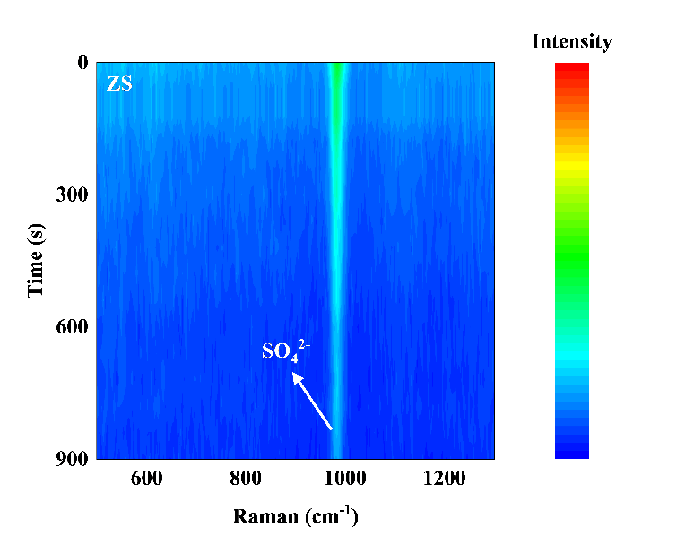
Fig. S8 In-situ Raman diagram of Zn||Zn symmetrical cell in ZS electrolyte

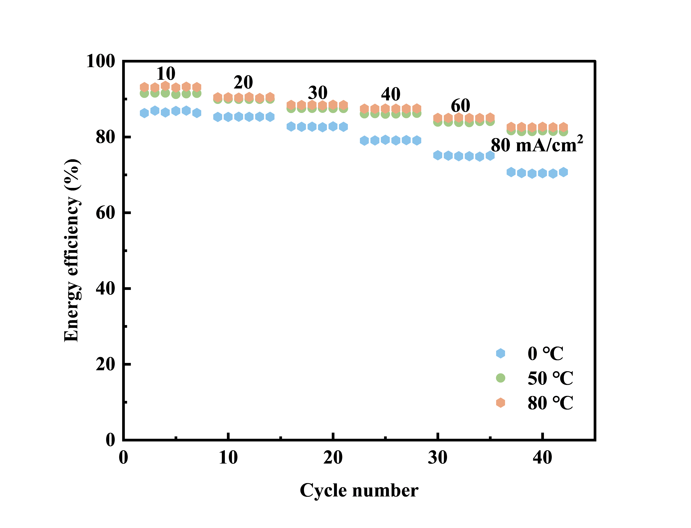
Fig. S9 The energy efficiency of zinc-iodine batteries at different current densities and temperatures

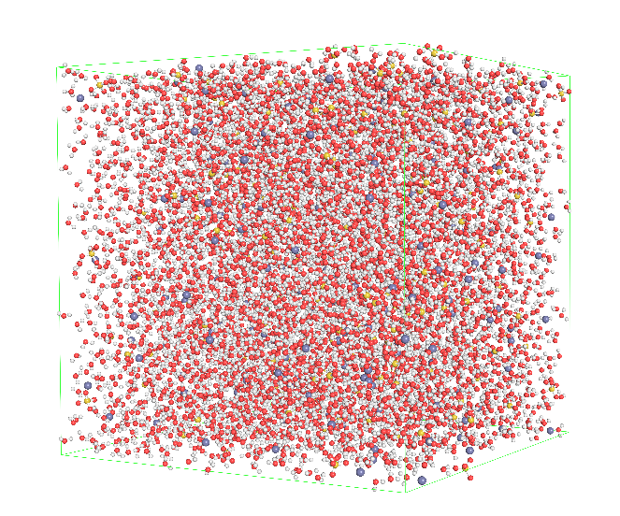
Fig. S10 MD simulation snapshots of the ZS electrolytes
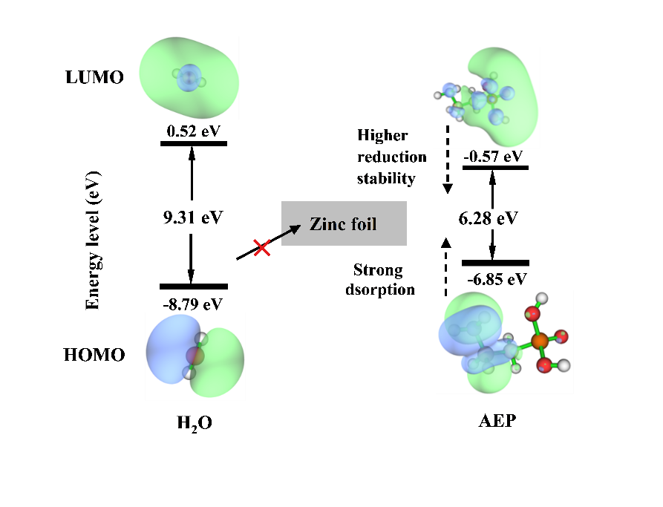
Fig. S11 LUMO, HOMO energy of the H2O and AEP molecules

References
[1] Vande VJ, Krack M, Chassaing T et al (2005) Quickstep: fast and accurate density functional calculations using a mixed Gaussian and plane waves approach. Computer Physics Communications167:103−128
[2] Wu X, Vargas M, Nayak S et al (2001) Towards extending the applicability of density functional theory to weakly bound systems. Journal of Chemical Physics115:8748−8757
[3] Lu T, Chen F (2012) Multiwfn: a multifunctional wavefunction analyzer. Journal of Computational Chemistry 33(5):580−592
[4] Bayly CI (1993) A well-behaved electrostatic potential based method using charge restraints for deriving atomic charges: the RESP model. The Journal of Physical Chemistry 97(40):10269−10280
[5] Jorgensen WL (1983) Comparison of simple potential functions for simulating liquid water. The Journal of Chemical Physics 79(2):926−935
[6] Wang C, Li W, Liao K et al (2023) AuToFF program, vesrion 1.0. hzwtech
[7] Van Der SD (2005) GROMACS: Fast, flexible, and free. Journal of Computational Chemistry 26(16):1701−1718
[8] Abraham MJ (2015) GROMACS: High performance molecular simulations through multi-level parallelism from laptops to supercomputers. Software 1-2:9−25
[9] Berendsen HC, Spoel D, Drunen R (1995) GROMACS: A message-passing parallel molecular dynamics implementation. Computer Physics Communications 91(1):43−56
[10] Kaminski GA (2001) Evaluation and reparametrization of the OPLS-AA force field for proteins via comparison with accurate quantum chemical calculations on peptides. The Journal of Physical Chemistry B105(28):6474−6487
[11] Jorgensen WL, Maxwell DS, Rives JT (1996) Development and resting of the OPLS all-atom force field on conformational energetics and properties of organic liquids. Journal of the American Chemical Society 118(45):11225−11236
[12] Hess B (1997) LINCS: A linear constraint solver for molecular simulations. Journal of Computational Chemistry 18(12):1463−1472
[13] Huang ZY, Chen X, Hou ZX et al (2025) Interfacial adsorption-enabled trace additives for stable zinc-based flow batteries. Journal of Materials Chemistry A13:20620
[14] Shi B, Zhu ZY, Wang D et al (2026) Engineering of p-n-type (B, N) and n-n-type (P, N) co-doped carbon felt electrodes for high-performance zinc-iodine flow batteries. Journal of Energy Storage 160:121906
[15] Yang J, Yan H, Zhang Q et al (2025) A high-voltage alkaline zinc−iodine flow battery enabled by a dual−functional electrolyte additive strategy. Advanced Functional Materials 35(48):2509931
[16] Nie R, Wu JJ, Nie YZ et al (2025) Anion-type solvation structure enables stable zinc-iodine flow batteries. Journal of Energy Storage 118:116260
[17] Li B, Liu J, Nie ZM et al (2016) Metal–Organic frameworks as highly active electrocatalysts for high-energy density, aqueous zinc-polyiodide redox flow batteries. Nano Letters 16 (7):4335-4340
[18] Dou HZ, Wu XR, XuM et al (2024) Steric-hindrance effect tuned ion solvation enabling high performance aqueous zinc ion batteries. Angewandte Chemie International Edition 63(21):e202401974

