Calvia G., Bonari G., Angiolini C., Farris E., Fenu G., Bacchetta G. Temporal increase in the extent of Sardinian pine formations. Rendiconti Lincei.

Supplementary material

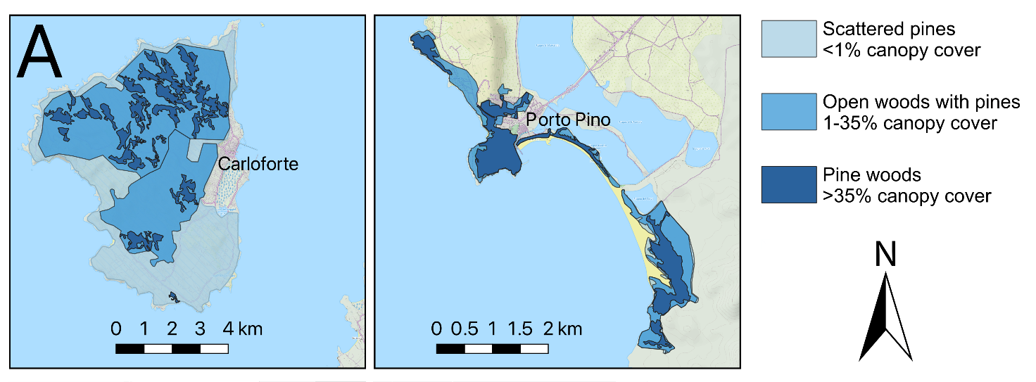
Figure S1A. Map of the current distribution of Pinus halepensis formations in south-western Sardinia.

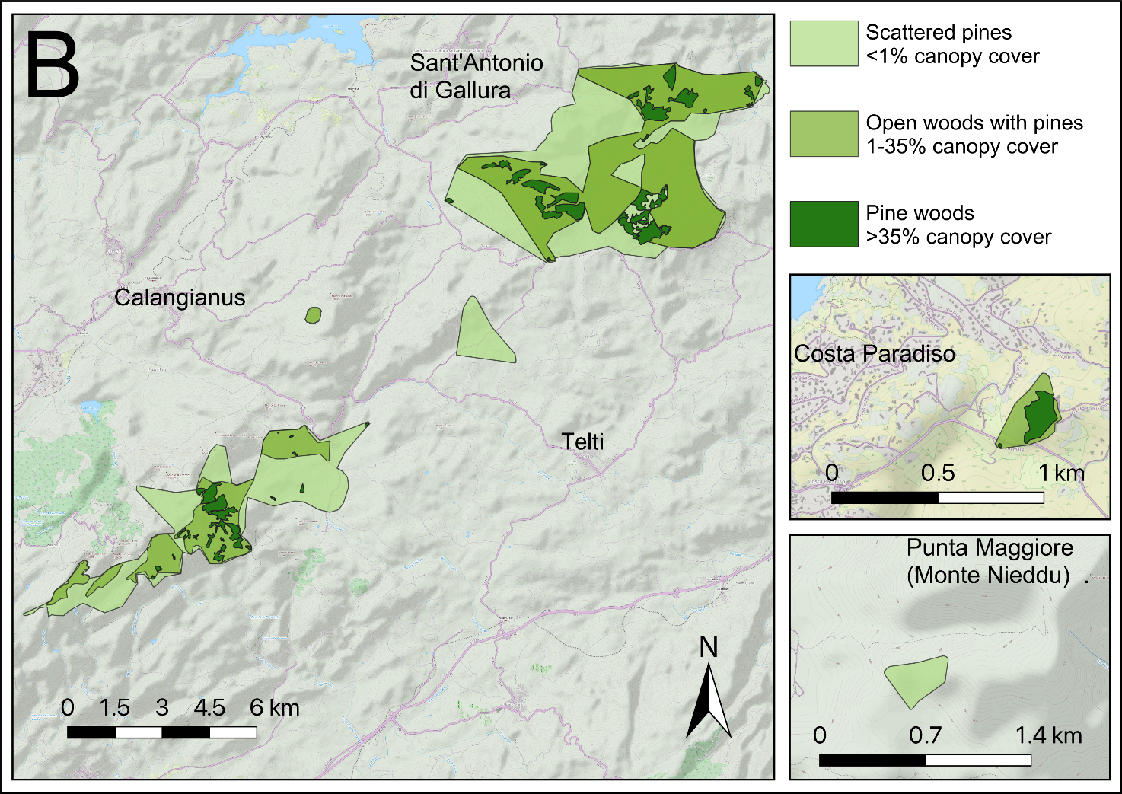
Figure S1B. Map of the current distribution of Pinus pinaster formations in north-eastern Sardinia.

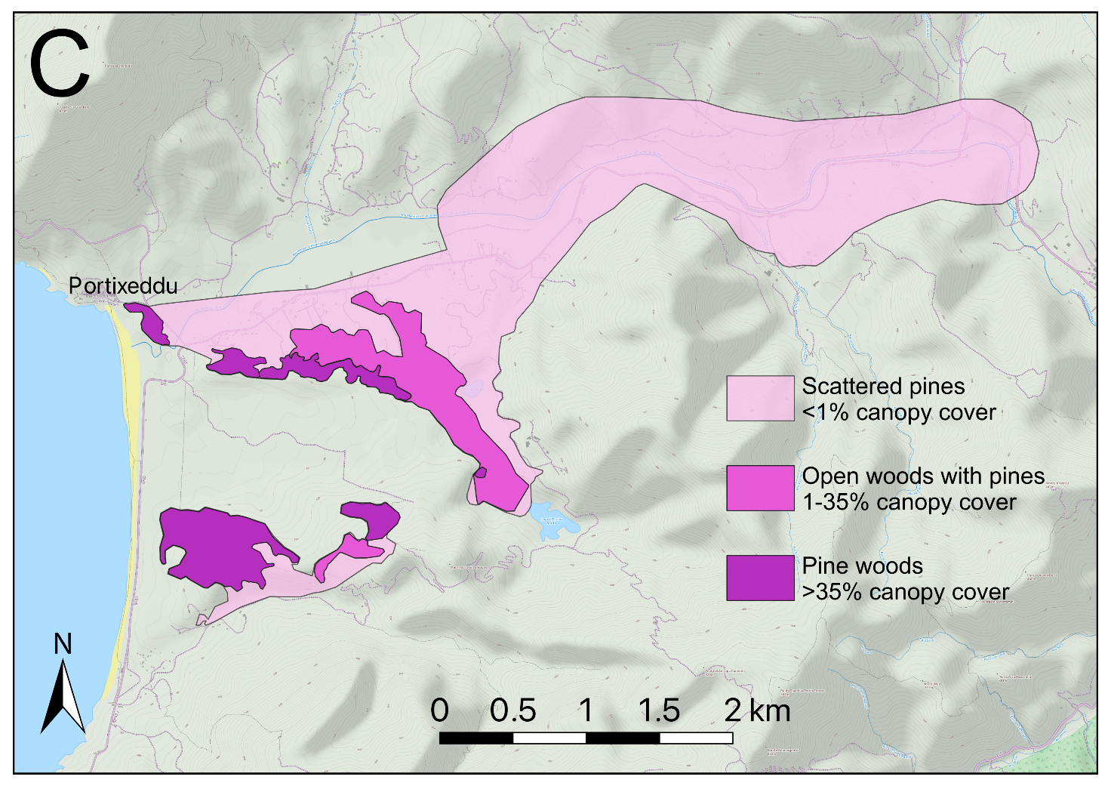
Figure S1C. Map of the current distribution of Pinus pinea formations in south-western Sardinia.
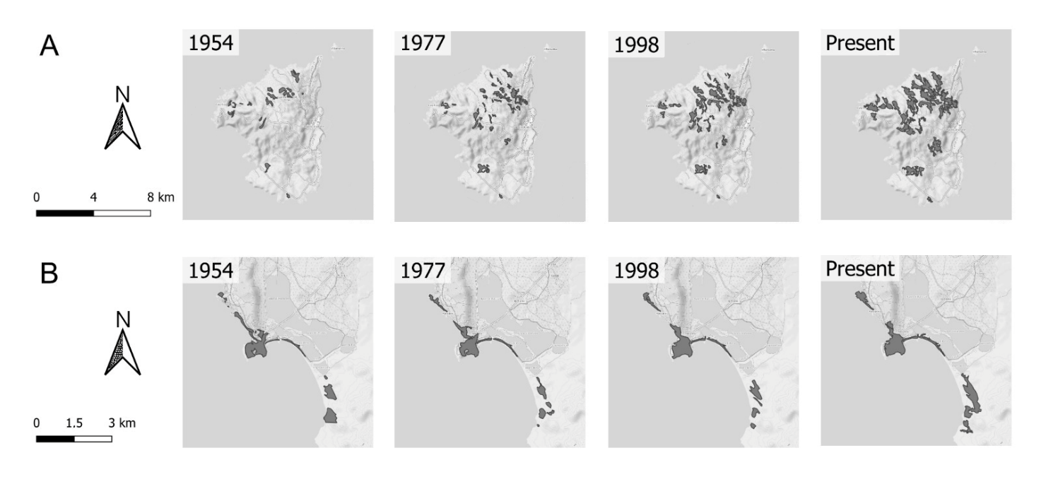
Figure S2. Map of the extent of Pinus halepensis formations in different years in south-western Sardinia. A = Island of San Pietro (Carloforte; Sud Sardegna); B = Porto Pino zone (Sant’Anna Arresi, Teulada; Sud Sardegna).
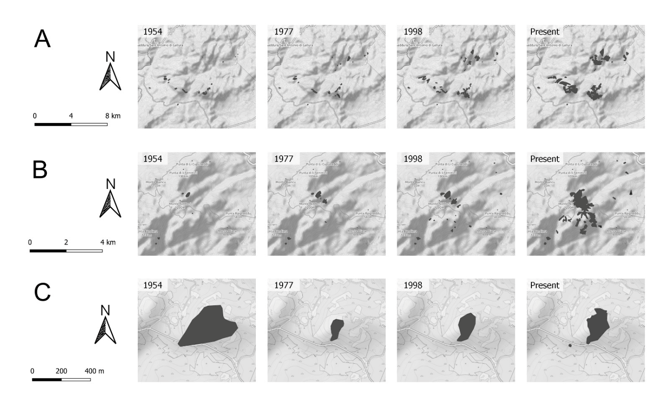
Figure S3. Map of the extent of Pinus pinaster formations in different years in north-eastern Sardinia. A = Mounts Ultana chain (Olbia, Sant’Antonio di Gallura, Telti; Sassari); B = Mount Limbara (Berchidda, Calangianus; Sassari); C = Costa Paradiso (Trinità d’Agultu; Sassari).

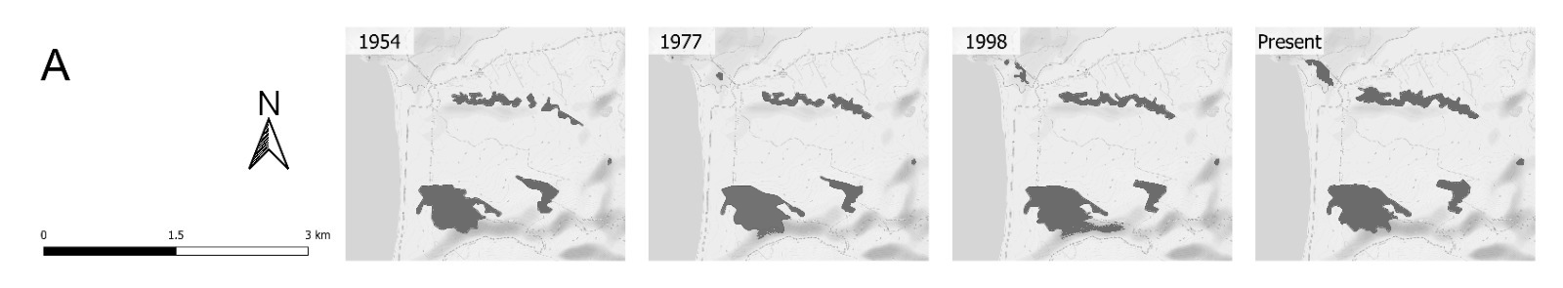
Figure S4. Map of the extent of Pinus pinea formations in different years in south-western Sardinia. A = Portixeddu dune system (Buggerru; Sud Sardegna).

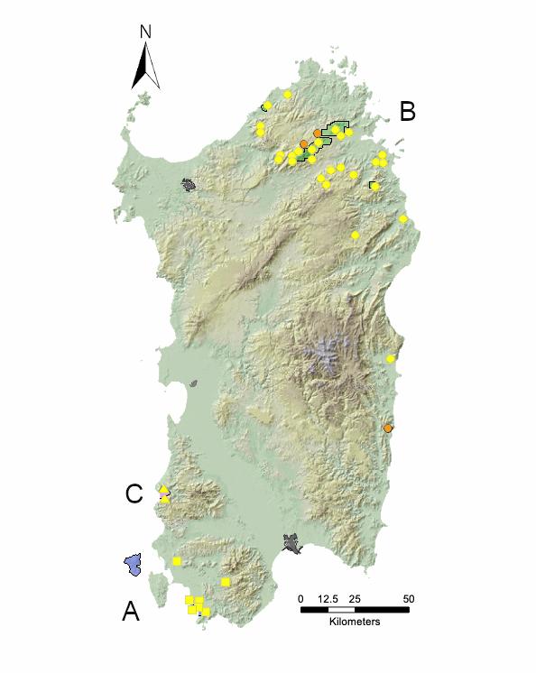
Figure S5. Map of toponyms referred to natural pine-related localities found in Sardinia. Toponyms related to planted pines and those referring to personal names were not mapped. Blue, green, and magenta areas represent the current extent of Pinus halepensis, P. pinaster and P. pinea, respectively. Yellow squares, circles and triangles indicate the toponyms related to each pine species (P. halepensis, P. pinaster, P. pinea, respectively) found in our study; orange circles identify the P. pinaster sites reported in the literature but currently extinct. Urban settlements of the main cities of Sardinia are reported in grey.

Table S1: List of the pine-related toponyms found during this research referring to natural stands.

Toponym | Municipality | Biogeographic sector | Biogeographic subsector | Coordinates (UTM) | Elevation range  (m a.s.l.) | Current status | Species | Sources
Pinuitteddu  (Small Pine) | Aglientu (SS) | Goceano-Logudorese | Gallurese | 507811.18 E –  4551455.05 N | 90-125 | Extinct | P. pinaster | 7
Monti di Lu Pinu  (Mount of the Pine) | Trinità d'Agultu (SS) | Goceano-Logudorese | Gallurese | 496840.07 E –  4544773.58 N | 150-230 | Extant | P. pinaster | 4, 6, 7
Punta di Pinu  (Peak of Pine) | Trinità d'Agultu (SS) | Goceano-Logudorese | Gallurese | 496189.56 E –  4534338.47 N | 490-500 | Extinct | P. pinaster | 7
Li Pini  (The Pines) | Viddalba (SS) | Goceano-Logudorese | Gallurese | 496243.61 E –  4533587.15 N | 400-460 | Extinct | P. pinaster | 7
Pinu Toltu  (Bent Pine) | Calangianus (SS) | Goceano-Logudorese | Gallurese | 522898.17 E –  4532341.02 N | 500-550 | Extinct | P. pinaster | 7
Monte Pino  (Mount of Pine) | Telti/Olbia (SS) | Goceano-Logudorese | Gallurese | 531484.94 E –  4532820.26 N | 500-720 | Extant | P. pinaster | 1, 3, 4, 7
Sarra di Monte Pino  (Ridge of Pine's Mount) | Olbia (SS) | Goceano-Logudorese | Gallurese | 532273.49 E –  4532301.38 N | 400-600 | Extant | P. pinaster | 5, 7
Campo di Pino  (Field of Pine) | Olbia (SS) | Goceano-Logudorese | Gallurese | 536515.28 E –  4532546.76 N | 120-150 | Extinct | P. pinaster | 7
Rio Lu Pinu  (Stream of the Pine) | Tempio Pausania (SS) | Goceano-Logudorese | Gallurese | 504775.14 E –  4519989.89 N | 350-500 | Extinct | P. pinaster | 7
Contra di Lu Pinu  (Crest of the Pine) | Tempio Pausania (SS) | Goceano-Logudorese | Gallurese | 504726.77 E –  4519796.85 N | 500-550 | Extinct | P. pinaster | 7
Monte Lu Pinu  (Mount of the Pine) | Berchidda (SS) | Goceano-Logudorese | Gallurese | 511968.57 E –  4520229.00 N | 1050-1100 | Extinct | P. pinaster | 7
Funtana 'e Su Pinu  (Fountain of the Pine) | Berchidda (SS) | Goceano-Logudorese | Gallurese | 512213.36 E –  4520442.13 N | 1050 | Extinct | P. pinaster | 8, 9
La Pineta  (The Pinewood) | Tempio Pausania (SS) | Goceano-Logudorese | Gallurese | 515197.84 E –  4523136.06 N | 1150-1200 | Extinct | P. pinaster | 7
Canale Su Pinazzu  (Creek of the Ruined Pine) | Berchidda (SS) | Goceano-Logudorese | Gallurese | 519106.93 E –  4520893.44 N | 530-580 | Extinct | P. pinaster | 7, 8
Scala di Li Pini  (Passageway of the Pines) | Calangianus (SS) | Goceano-Logudorese | Gallurese | 517996.41 E –  4523517.07 N | 900-1050 | Extant | P. pinaster | 8
Pinitteddi  (Small Pines) | San Teodoro (SS) | Goceano-Logudorese | Gallurese | 553755.25 E –  4520988.62 N | 170-200 | Extinct | P. pinaster | 7
Sarra di Lu Pinu  (Ridge of the Pine) | San Teodoro (SS) | Goceano-Logudorese | Gallurese | 551270.12 E –  4519626.26 N | 170-220 | Extinct | P. pinaster | 7
Punta di Lu Pinu  (Peak of the Pine) | San Teodoro (SS) | Goceano-Logudorese | Gallurese | 552286.30 E –  4519440.47 N | 350-390 | Extinct | P. pinaster | 4, 7
Su Pinu  (The Pine) | Berchidda (SS) | Goceano-Logudorese | Gallurese | 525291.64 E –  4510700.08 N | 540-560 | Extinct | P. pinaster | 7, 8
Rio Su Pinu  (Stream of the Pine) | Monti (SS) | Goceano-Logudorese | Gallurese | 525632.90 E –  4510268.78 N | 500-550 | Extinct | P. pinaster | 7
Punta Matta 'e Pinu  (Peak of the Pines' Grove) | Monti (SS) | Goceano-Logudorese | Gallurese | 528992.55 E –  4515598.71 N | 580-600 | Extinct | P. pinaster | 7, 8
Monte Pinigheddu  (Mount of the Small Pine) | Monti (SS) | Goceano-Logudorese | Gallurese | 531681.67 E –  4516615.02 N | 480-520 | Extinct | P. pinaster | 7
Monte di Pinu  (Mount of Pine) | Olbia (SS) | Goceano-Logudorese | Gallurese | 539021.05 E –  4512550.83 N | 480-700 | Extinct | P. pinaster | 7
Punta Sos Pinos  (Peak of the Pines) | Padru (SS) | Goceano-Logudorese | Gallurese | 547564.29 E –  4508395.73 N | 680-800 | Extant | P. pinaster | 6, 7
Cuccuru 'e Pinu  (Peak of Pine) | Onanì (NU) | Goceano-Logudorese | Nuorese | 539839.43 E –  4485901.58 N | 340-350 | Extinct | P. pinaster | 7
Su Pinu  (The Pine) | Siniscola (NU) | Supramontano | Baronico | 562551.72 E –  4493515.92 N | 5-10 | Extinct | P. pinaster | 1, 7
Su Oppinu  (The Pine) | Triei (NU) | Turritano-Campidanese | Ogliastrino | 556805.65 E –  4428984.82 N | 200-300 | Extinct | P. pinaster | 7
Is Compinxius  (The Pines) | Buggerru (SU) | Sulcitano-Iglesiente | Iglesiente | 450397.78 E –  4365485.89 N | 10-80 | Extant | P. pinea | 1, 7
Is Compinxeddus  (The Small Pines) | Buggerru (SU) | Sulcitano-Iglesiente | Iglesiente | 450144.11 E –  4364345.41 N | 40-120 | Extant | P. pinea | 8
Punta Su Pineddu  (Peak of the small pine) | Santadi (SU) | Sulcitano-Iglesiente | Sulcitano | 480530.03 E – 4324465.12 N | 489 | Extinct | P. halepensis | 2, 8
Bau Cumpingiu  (Ford of Pine) | San Giovanni Suergiu (SU) | Sulcitano-Iglesiente | Antioco-Carlofortino | 455534.93 E –  4333591.54 N | 40-50 | Extinct | P. halepensis | 8, 10
Porto Pino  (Pine's Harbour) | Sant'Anna Arresi (SU) | Sulcitano-Iglesiente | Antioco-Carlofortino | 464771.31 E –  4312964.64 N | 2-30 | Extant | P. halepensis | 1, 7
Porto Pinetto  (Harbour of the Small Pine) | Sant'Anna Arresi (SU) | Sulcitano-Iglesiente | Antioco-Carlofortino | 463844.29 E –  4313736.99 N | 5-30 | Extant | P. halepensis | 2, 7
Punta Su Pineddu  (Peak of the Small Pine) | Sant'Anna Arresi (SU) | Sulcitano-Iglesiente | Antioco-Carlofortino | 464460.30 E –  4313696.03 N | 30-50 | Extant | P. halepensis | 2, 7
Porto Pineddu  (Harbour of the Small Pine) | Sant'Anna Arresi (SU) | Sulcitano-Iglesiente | Antioco-Carlofortino | 464597.06 E –  4312422.41 N | 1-30 | Extant | P. halepensis | 2, 7
Funtana de is Opinos  (Fountain of the Pines) | Teulada (SU) | Sulcitano-Iglesiente | Antioco-Carlofortino | 467510.84 E –  4310891.39 N | 15-20 | Extant | P. halepensis | 7

Table S2: List of the pine-related toponyms found during this research referring to planted pines or personal names.
Toponym | Municipality | Biogeographic sector | Biogeographic subsector | Coordinates (UTM) | Elevation range  (m a.s.l.) | Status | Species | Sources
Stazzo di Lu Pinu  (The farm of the pine) | Arzachena (SS) | Goceano-Logudorese | Gallurese | 530234.18 E –  4548892.05 N | 140-150 | Planted | P. pinea | 7, 8
Lu Pinu  (The Pine) | Calangianus (SS) | Goceano-Logudorese | Gallurese | 516183.07 E –  4529653.58 N | 500 | Planted | P. pinea | 8
Tanca Su Pinu  (Acreage of the Pine) | Sassari (SS) | Turritano-Campidanese | Turritano | 467124.56 E –  4511322.47 N | 250 | Planted | Uncertain | 7
Punta di Lu Pinu  (Peak of the pine) | Loiri - Porto San Paolo (SS) | Goceano-Logudorese | Gallurese | 540834.23 E – 4521884.89 N | 43 | Planted | Uncertain | 8, 10
Rio Pretu e Pinu  (Stream of Peter and Joseph) | Lodè (NU) | Goceano-Logudorese | Nuorese | 548694.32 E – 4490085.09 N | 220-390 | Personal name |  | 7, 8
Riviera dei Pini  (Coast of the pines) | Budoni (NU) | Supramontano | Baronico | 563336.09 E – 4502053.19 N | 5 | Planted | P. pinea | 7
Mulino Su Pinu  (Mill of the pine) | Mamoiada (NU) | Goceano-Logudorese | Nuorese | 525309.34 E – 4452559.54 N | 640 | Planted | Uncertain | 10
Casa Pineddu  (Pineddu’s house | Cardedu (NU) | Campidanese-Turritano | Ogliastrino | 552658.17 E – 4404486.40 N | 37 | Surname |  | 7, 8
Poggio dei Pini  (Hill of the pines) | Capoterra (CA) | Campidanese-Turritano | Campidanese | 496868.39 E – 4332969.52 N | 75-110 | Planted | P. pinaster | 2
Su Pineddu  (The small pine) | Capoterra (CA) | Campidanese-Turritano | Campidanese | 494471.65 E – 4332337.64 N | 308 | Planted | P. pinaster | 10
Riva dei Pini  (Seashore of the pines) | Pula (CA) | Sulcitano-Iglesiente | Sulcitano | 493012.58 E – 4308520.49 N | 5 | Planted | P. pinea | 2, 7
Pinus Village | Pula (CA) | Sulcitano-Iglesiente | Sulcitano | 492107.16 E – 4307783,55 N | 10-60 | Planted | Pinus spp. | 2, 10

References
1 - Angius V (1851) Geografia, storia e statistica dell'Isola di Sardegna, voll. 17 bis, 18 ter, 18 quarter. In Casalis G, Ed. Dizionario geografico-storico-statistico-commerciale degli Stati di S. M. il Re di. Maspero e Marzorati, Torino

2 - Bacchetta G, Pontecorvo C, Mossa L (2000) Contributo alla conoscenza dei fitotoponimi del Sulcis (Sardegna sud-occidentale). Rend Sem Fac Sci Univ Cagliari 70:199-213

3 - De Buttet M. 1768. Relation sur la qualité et quantité des bois, qui sont sur les cotes du Royaume de Sardaigne. Archivio di Stato di Cagliari, vol. 1280

4 - Camarda I, Valsecchi F (2008) Alberi e arbusti spontanei della Sardegna. Carlo Delfino Editore, Sassari

5 - Desole L (1960) Il Pinus pinaster Sol. in Sardegna. Nuovo Giorn Bot Ital 67:24-62

6 - Desole L (1964) Ulteriore contributo alla conoscenza delle popolazioni sarde di Pinus pinaster Sol. Arch Bot Biogeogr It 40:284-297

7 - Maps edited by IGM (Istituto Geografico Militare)

8 - Interviews

9 - Old map edited in 1907

10 - RAS (Regione Autonoma della Sardegna) (2019) (http://dati.regione.sardegna.it/dataset - accessed on 2019 Octoberss

