Synthesis, characterization, and printing applications of heterocyclic pyrimidine azodyes on polyester fabrics as potential antibacterial agents
Hend A. Hekal^{1*}, Omar M. Hammad¹, Nasser R. El-Brollosy^{1*}, Mohamed Abdelraof², Elkhabiry Shaban ³
¹Chemistry Department, Faculty of Science, Tanta University, 31527-Tanta, Egypt
²Microbial Chemistry Department, Biotechnology Research Institute, National Research Centre, Cairo, 12622, Dokki, Egypt
³ Dyeing, Printing and Textile Auxiliaries Department, Textile Research Division, National Research Centre, Dokki, Giza 12622, Egypt.

Emails: hend.hekal@science.tanta.edu.eg ;ORCID ID: 0000-0002-7536-9545
, omar.hammad@science.tanta.edu.eg, brollosy@science.tanta.edu.eg, abdelraof87@gmail.com, shaban_nrc@yahoo.com

Running title: Pyrimidinone-dyes as Antimicrobial Agents

*Corresponding and Proof:
Prof. Dr. Nasser R. El-Brollosy
Chemistry Department
Faculty of Science
Tanta University
Tanta, Egypt
Email: brollosy@science.tanta.edu.eg

Dr. Hend A. Hekal
Chemistry Department
Faculty of Science
Tanta University
Tanta, Egypt
ORCID ID: 0000-0002-7536-9545
Email: hend.hekal@science.tanta.edu.eg

Fig.S1. FT-IR spectra of dye compounds 2 and 3a-3d.

Fig.S2. FT-IR spectra of dye compounds 3e-3i.
Fig.S3. FT-IR spectra of dye compounds 3j-3l.

Fig.S4. ¹H-NMR spectra of compound 2.

Fig.S5. D₂O-¹H-NMR spectra of compound 2.

Fig.S6. ¹H-NMR spectra of azo dye compound 3a.

Fig.S7. ¹H-NMR spectra of azo dye compound 3b.

Fig.S8. ¹H-NMR spectra of azo dye compound 3c.
Fig.S9. ¹H-NMR spectra of azo dye compound 3d.

Fig.S10. ¹H-NMR spectra of azo dye compound 3e.
Fig.S11. ¹H-NMR spectra of azo dye compound 3f.

Fig.S12. ¹H-NMR spectra of azo dye compound 3g.

Fig.S13. ¹H-NMR spectra of azo dye compound 3h.

Fig.S14. ¹H-NMR spectra of azo dye compound 3i.

Fig.S15. ¹H-NMR spectra of azo dye compound 3j.

Fig.S16. ¹H-NMR spectra of azo dye compound 3k.
Fig.S17. ¹H-NMR spectra of azo dye compound 3l.

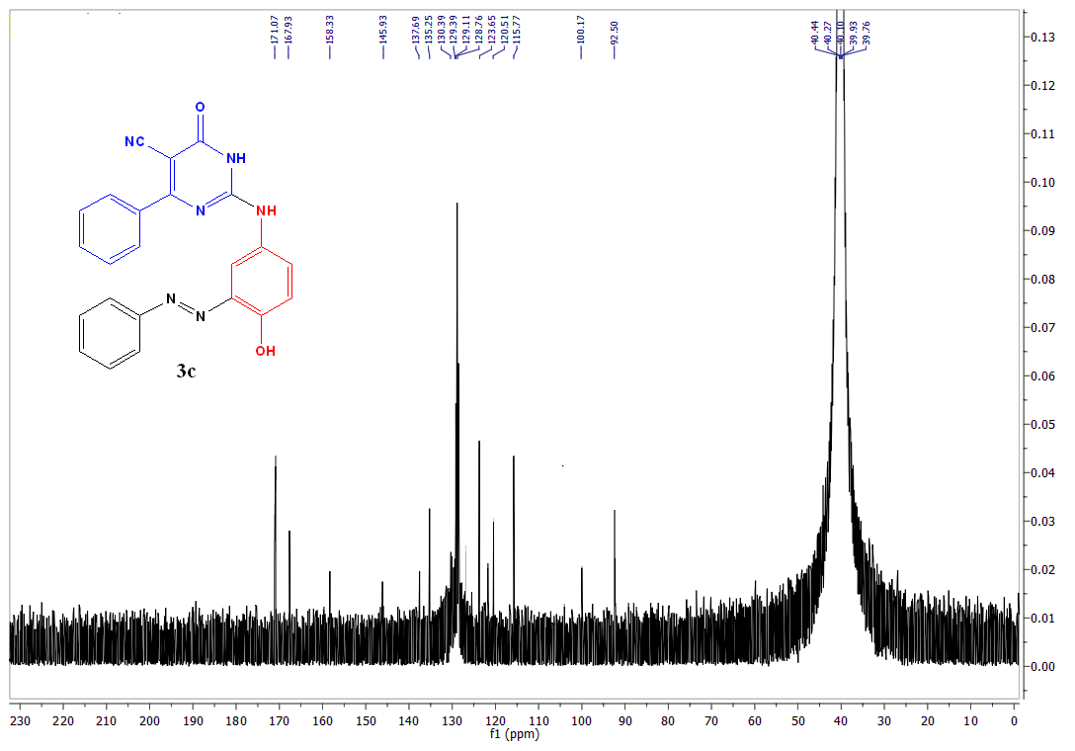
Fig.S18. ¹³C-NMR spectra of azo dye compound 3c.

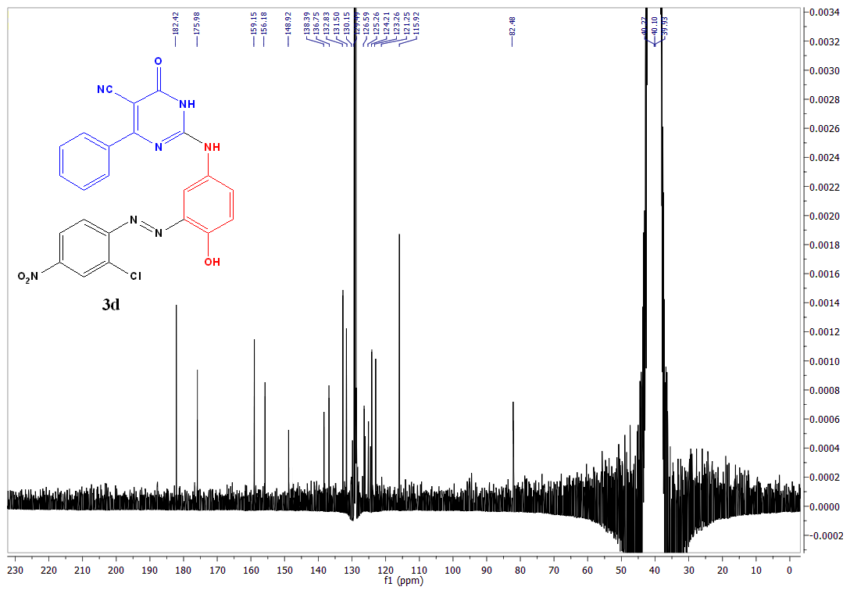
Fig.S19. ¹³C-NMR spectra of azo dye compound 3d.

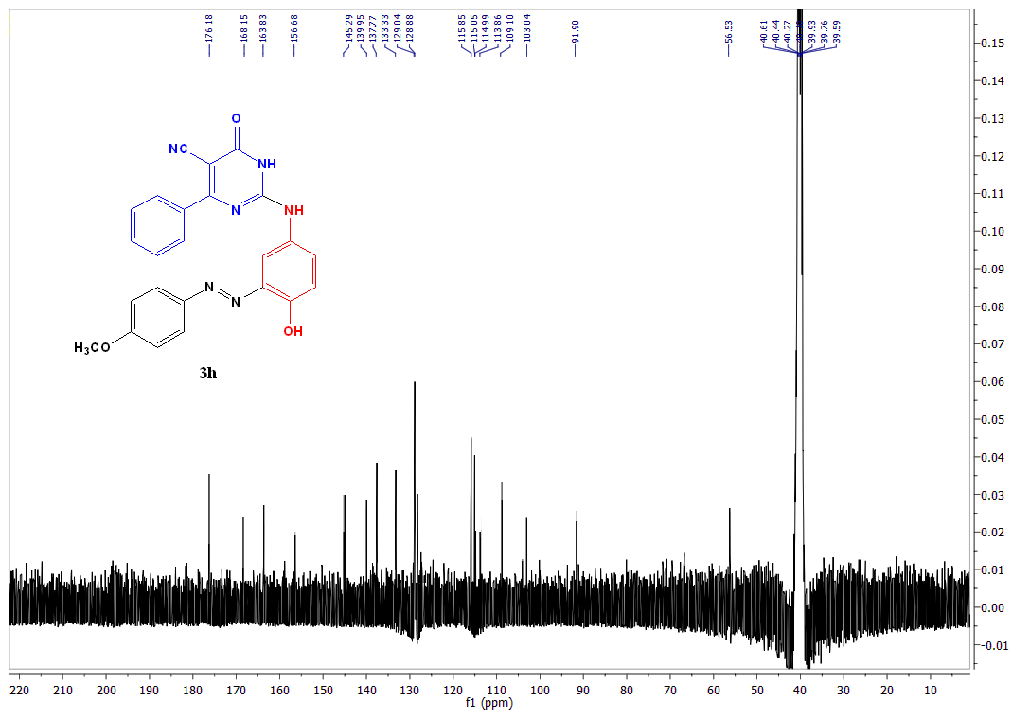
Fig.S20. ¹³C-NMR spectra of azo dye compound 3h.

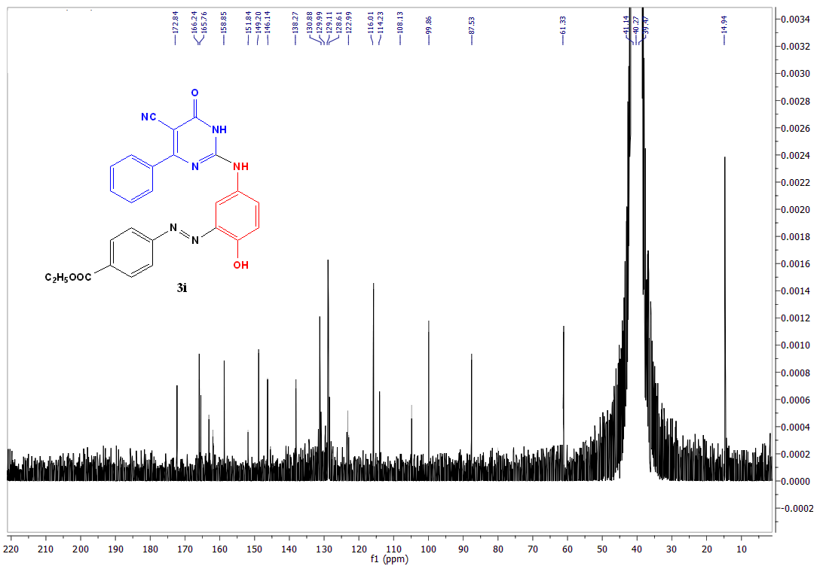
Fig.S21. ¹³C-NMR spectra of azo dye compound 3i.

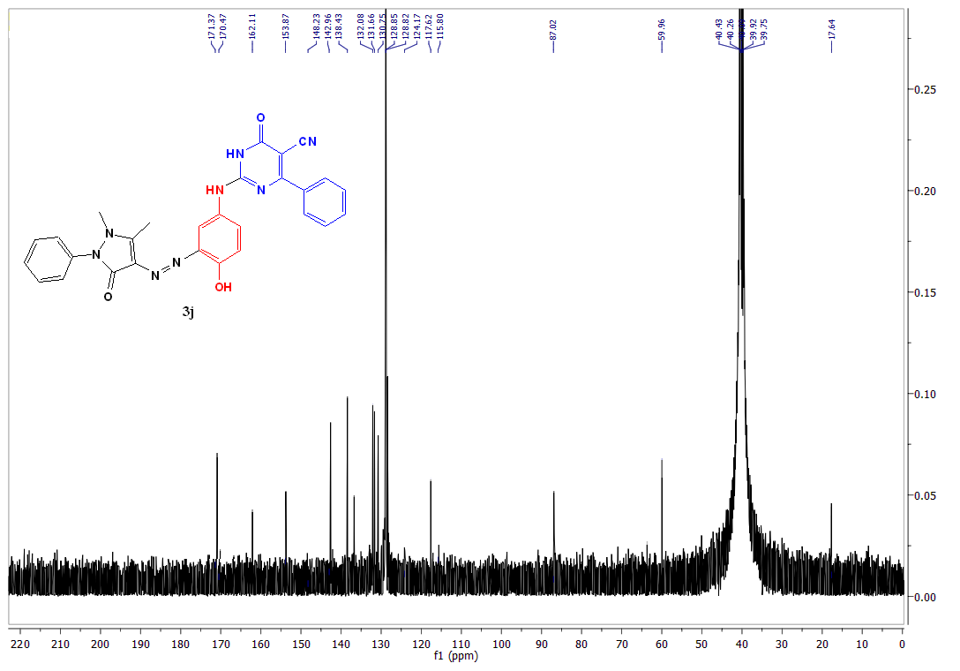
Fig.S22. ¹³C-NMR spectra of azo dye compound 3j.

Fig.S23. Mass spectra of azo dye compound 3a.

Fig.S24. Mass spectra of azo dye compound 3b.

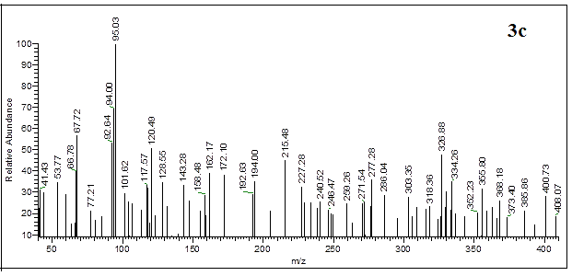
Fig.S25. Mass spectra of azo dye compound 3c.

Fig.S26. Mass spectra of azo dye compound 3d.

Fig.S27. Mass spectra of azo dye compound 3e.

Fig.S28. Mass spectra of azo dye compound 3f.

Fig.S29. Mass spectra of azo dye compound 3g.

Fig.S30. Mass spectra of azo dye compound 3h.

Fig.S31. Mass spectra of azo dye compound 3i.

Fig.S32. Mass spectra of azo dye compound 3j.

Fig.S33. Mass spectra of azo dye compound 3k.

Fig.S34. Mass spectra of azo dye compound 3l.

