Similar functional structure and encroaching dynamics in two Juniperus species with contrasting distribution patterns

Josep M. Ninot, Alba Anadon-Rosell, Aldo Molino, Oriol Grau, Moisès Caminal, Amanda Casanovas, Empar Carrillo

Electronic supplementary material
A – Field images

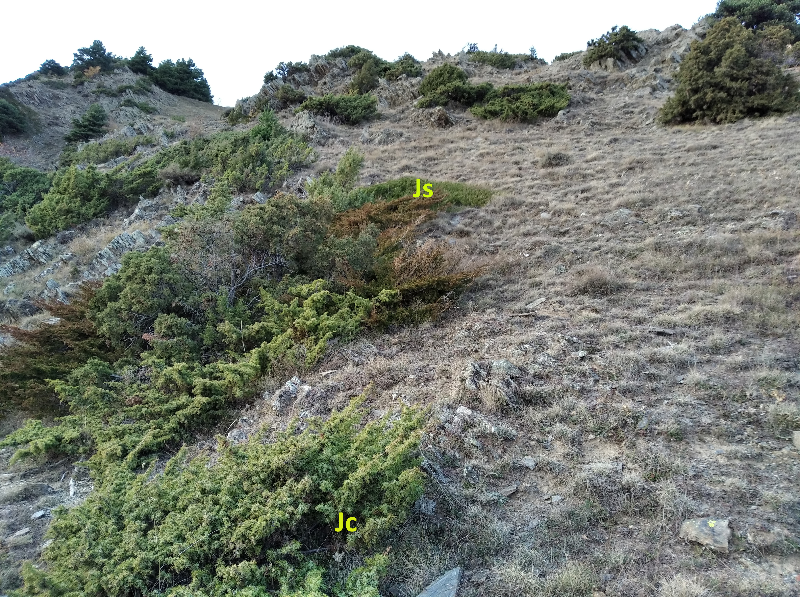
Fig. S1 View of the low-elevation site studied with mixed populations of diffuse J. communis L. (Jc, foreground and farther) and creeping J. sabina L. (Js, at the middle of the image) establishing on rocky terrain and xerophilous grasslands, near the village of Jou (1,350 m a.s.l.).
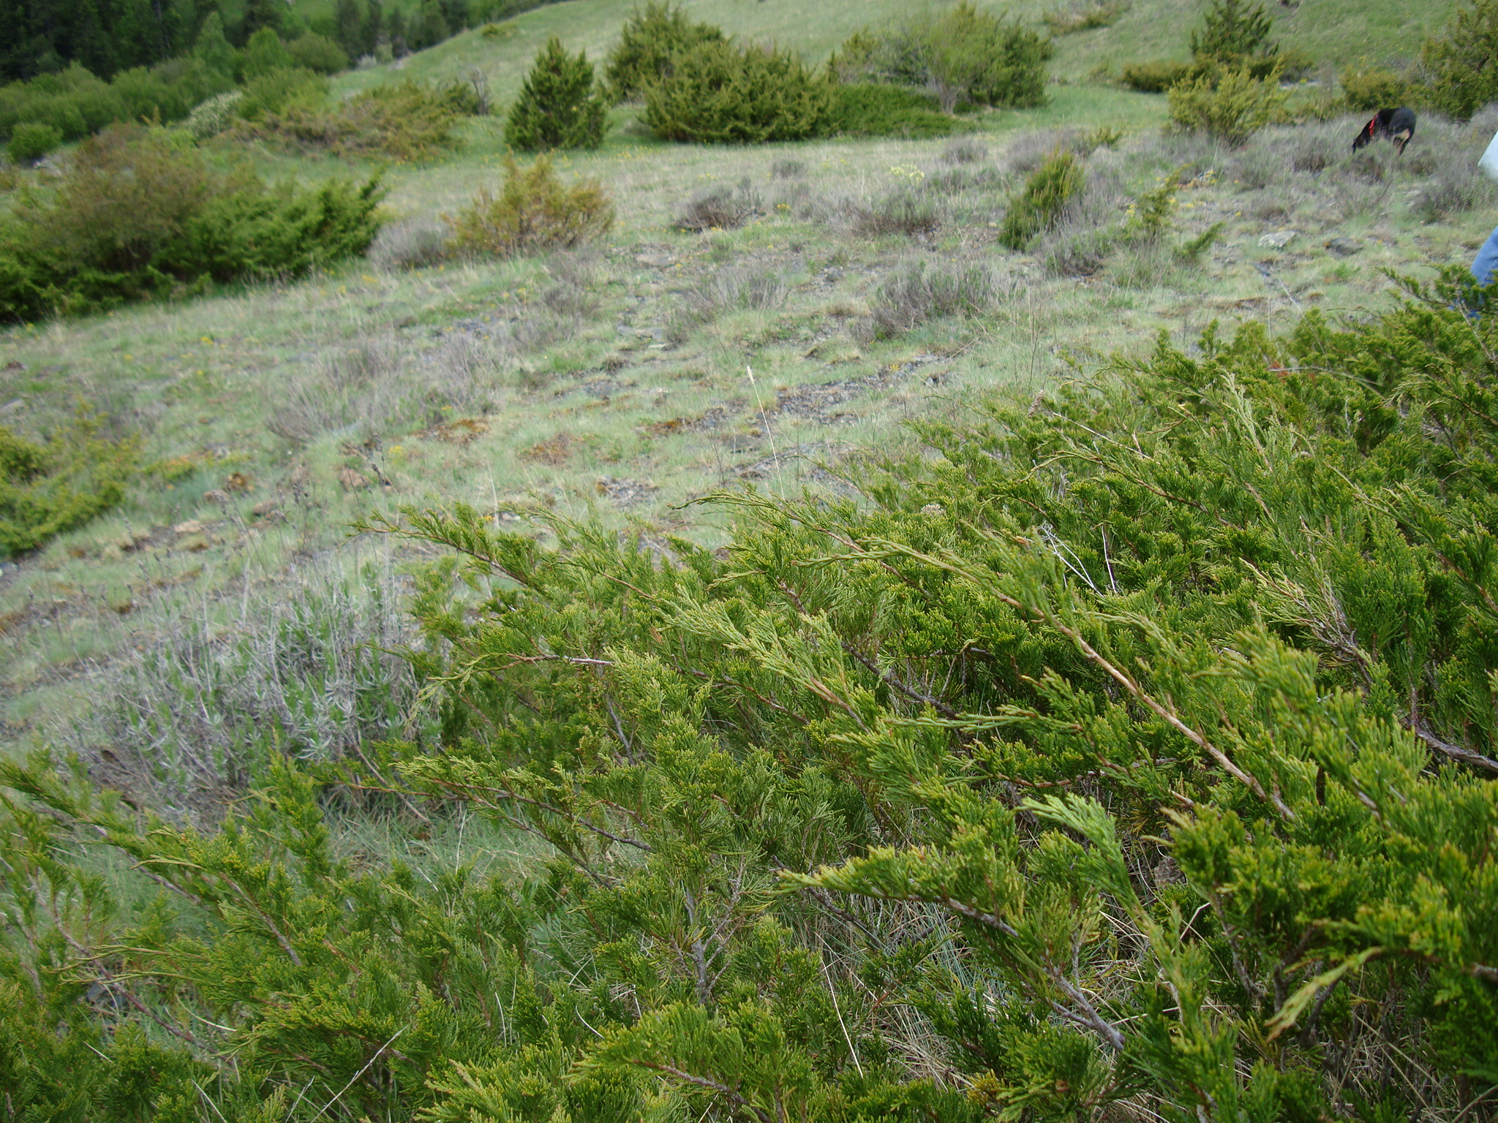
Fig. S2 Aspect of the mid-elevation site, near the village of Espot (1,600 m a.s.l.), a meso-xerophilous grassland spotted by J. sabina (foreground) and J. communis (farther), on a gentle slope.

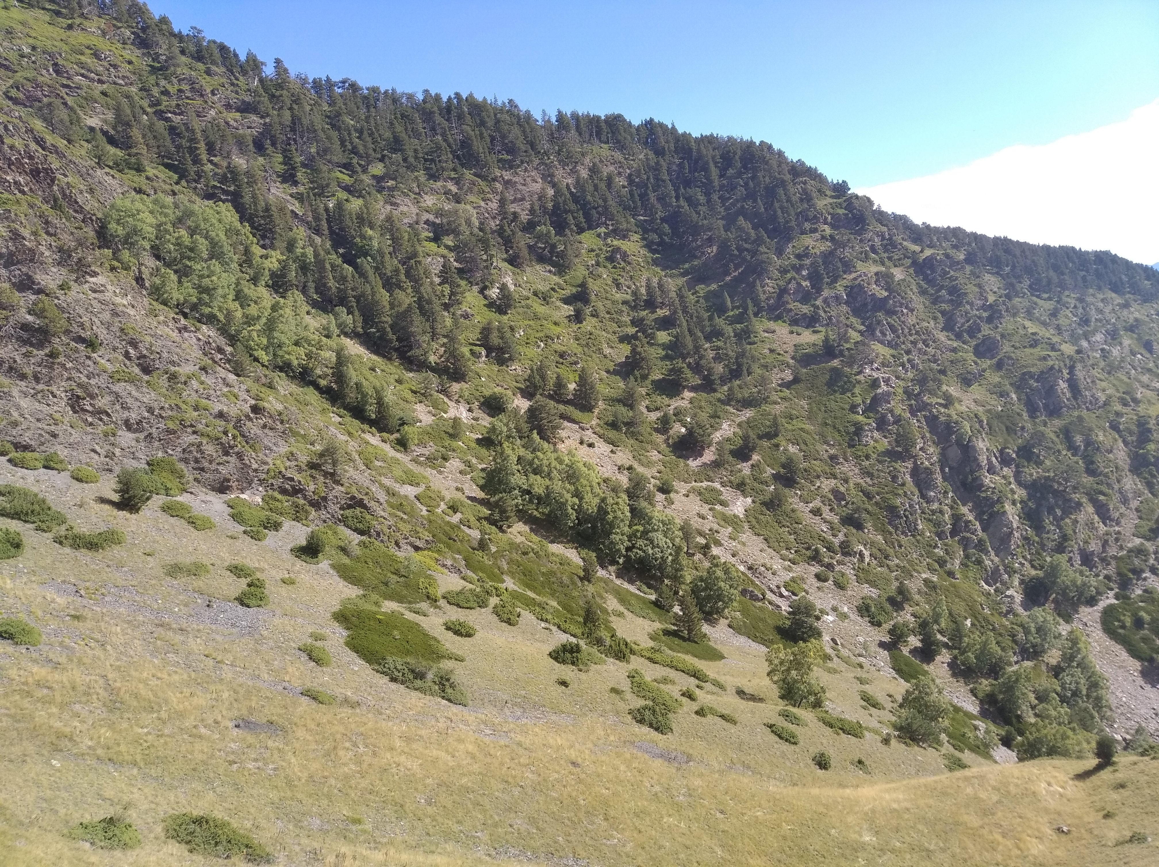
Fig. S3 General view of the high-elevation site, Fogueruix, over the village of Espot (2,050–2,100 m a.s.l.), with a varied relief sloping southwards, where the Juniperus sp. pl. shrubs encroach grassland areas together with Pinus uncinata Ramond ex DC. and Betula pendula Roth.

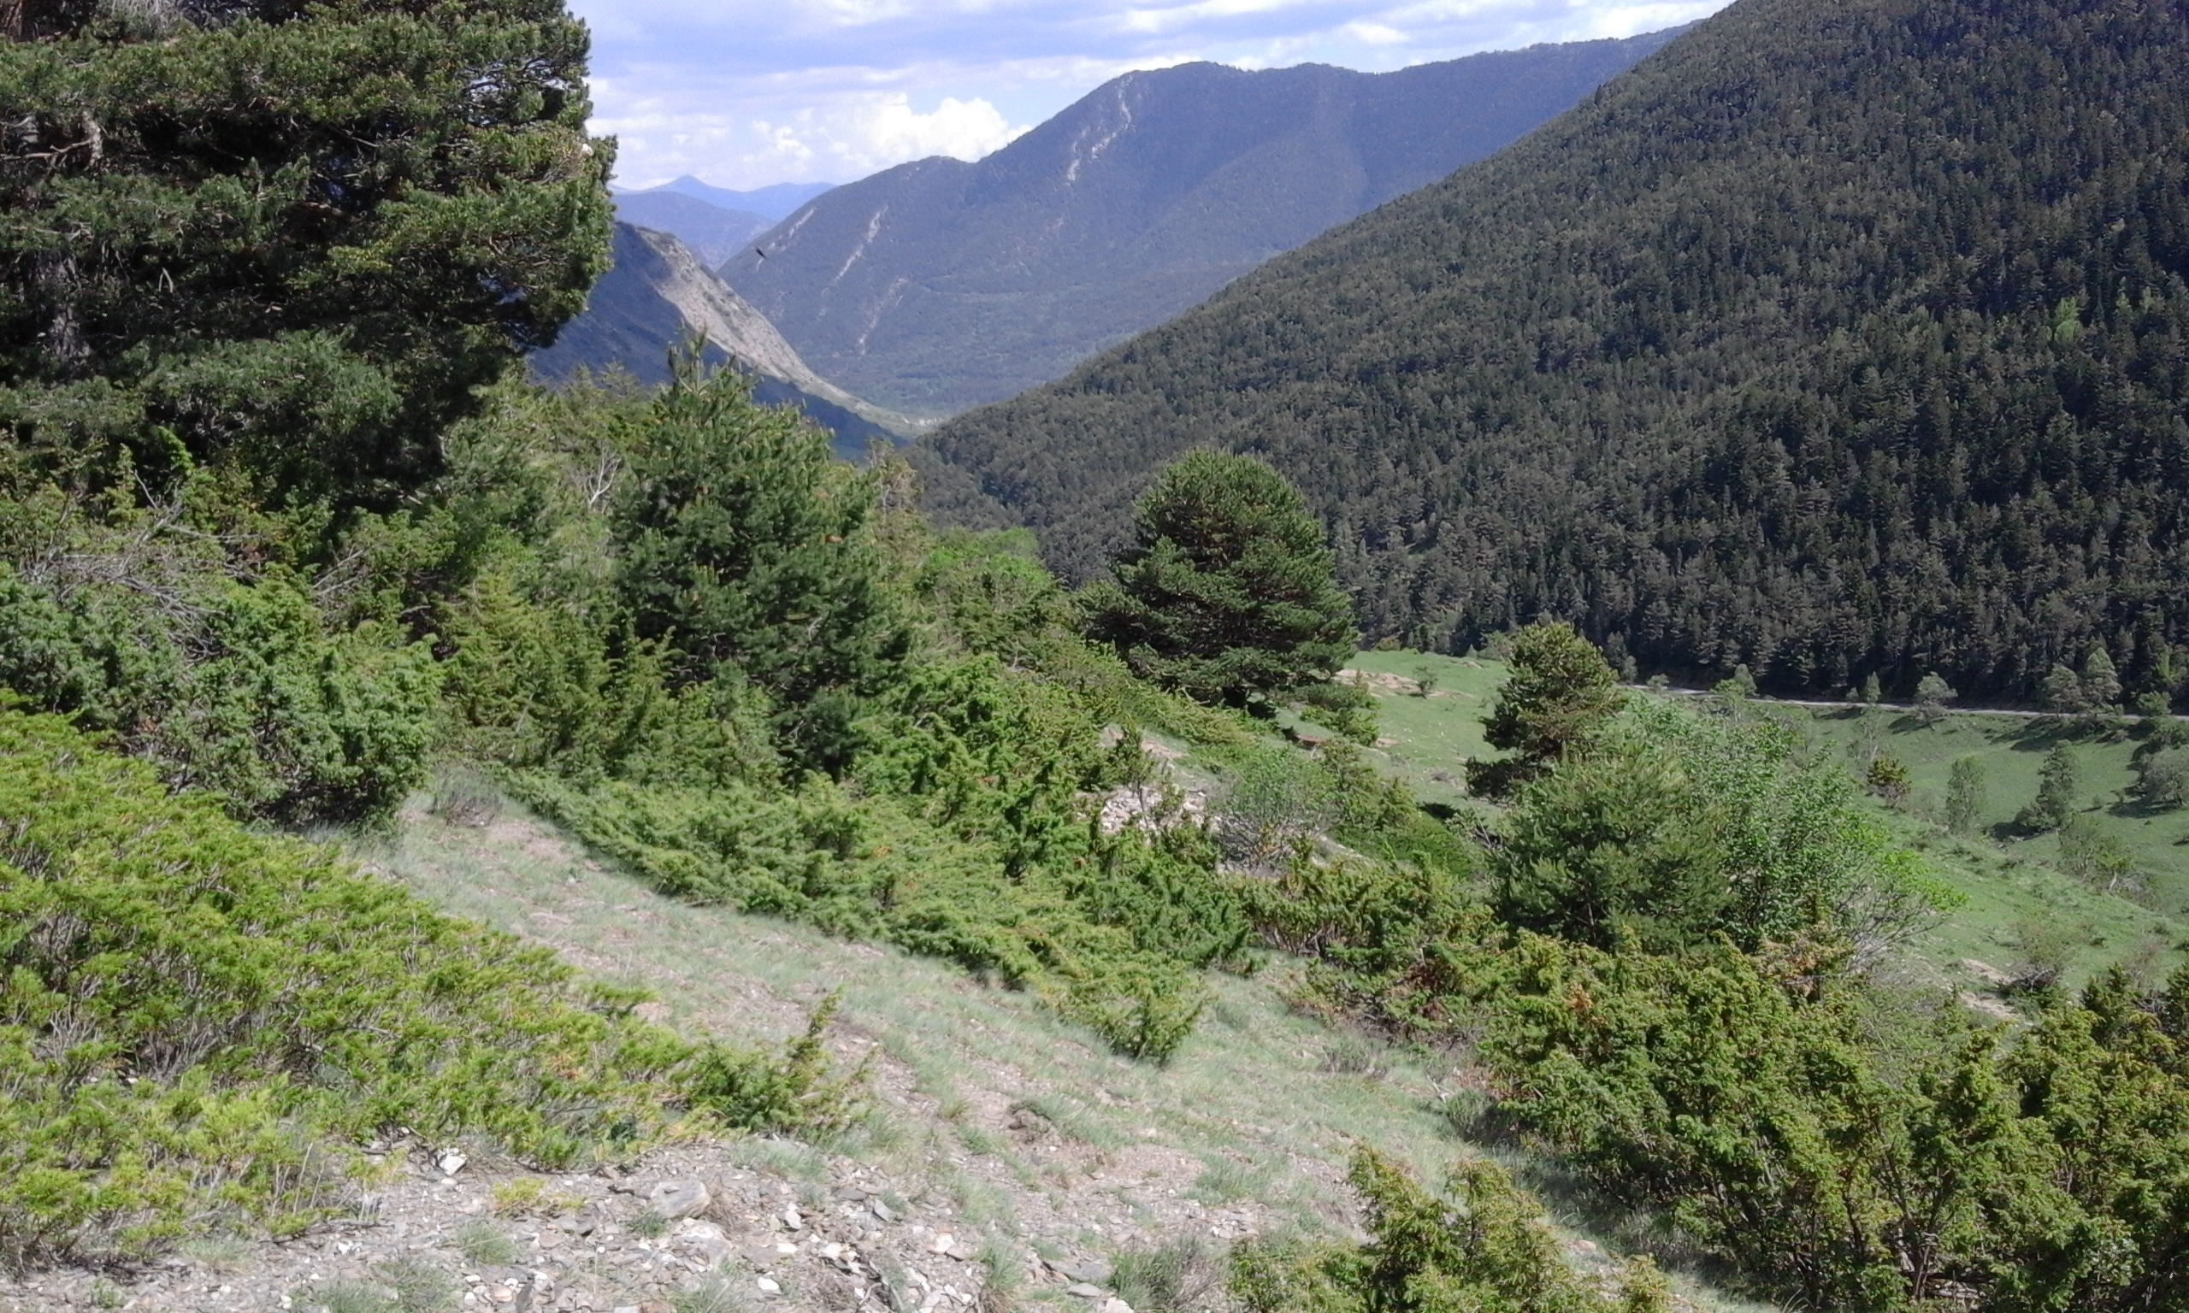
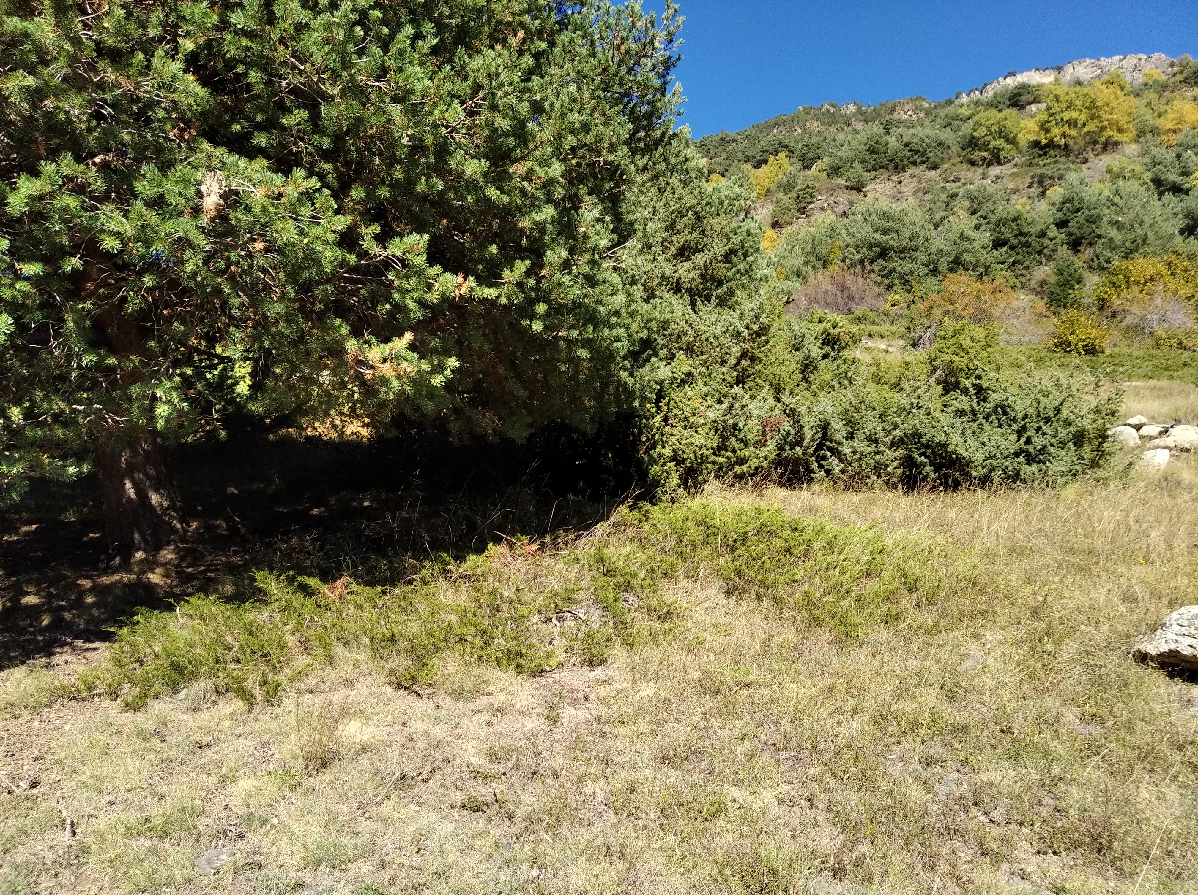
Fig. S4 Expanding canopies of tall shrubs and Pinus sylvestris L. reduce the extensive Juniperus sp. pl. scrub and meso-xerophilous grassland through light competence, and eventually build young pinewood.

B – Complementary figure and tables

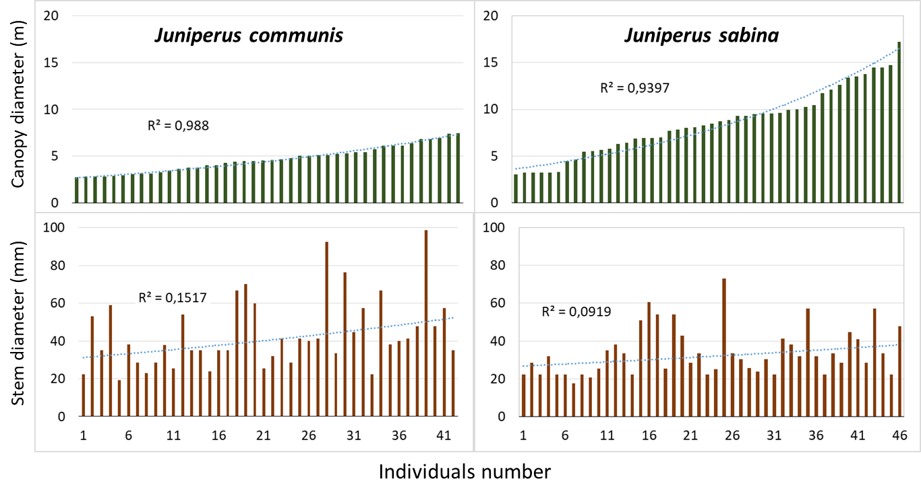

Fig. S5 Size distribution in the Juniperus communis and J. sabina shrubs sampled in terms of canopy diameter (upper panels) and of the diameter of their thickest stem (lower panels), with shrubs sorted from the smallest to the biggest canopy along the Y axes. While the stem diameter did not correlate with the canopy size in any case, J. sabina differs from J. communis in lacking thick stems, most evidently in the larger shrubs.

Table S1 Mean values (and standard deviation) for the traits analysed in the two study species, each sampled in three locations, at low-, mid- and high-elevation sites. The values refer to standard trait measures taken from distinct plants per site (see text for details). The ‘leaves’ of J. sabina correspond to the ultimate twigs covered by scaly leaves.
Species and location |  | SLA (mm² · mg⁻¹) | LDMC (mg · g⁻¹) | Canopy height (cm) | Seed mass (mg)
J. communis | low elevation | 4.81 (0.57) | 551 (24.9) | 67.29 (21.41) | 9.16 (2.04)
 | mid elevation | 6.34 (1.23) | 459 (42.9) | 79.17 (16.78) | 9.30 (2.65)
 | high elevation | 6.14 (0.96) | 464 (62.6) | 47.50 (8.35) | 9.75 (1.48)
J. sabina | low elevation | 5.26 (0.58) | 516 (18.2) | 56.70 (10.36) | 22.62 (9.82)
 | mid elevation | 3.37 (0.60) | 468 (26.1) | 51.50 (12.55) | 20.83 (2.74)
 | high elevation | 3.39 (0.10) | 472 (30.6) | 45.06 (15.04) | 16.89 (4.88)

Table S2 Mean values (and standard deviation) characterizing the two study species in terms of dry mass of aboveground structures (stems and leaves) in grammes per square metre of dense scrub, sampled once in the low-, mid- and high-elevation sites.
Species and location |  | Stems (g · m⁻²) | Leaves (g · m⁻²)
J. communis | low elevation | 1,737 (514) | 977 (245)
 | mid elevation | 1,719 (251) | 789 (82)
 | high elevation | 1,465 (350) | 538 (160)
J. sabina | low elevation | 1,182 (146) | 1,037 (160)
 | mid elevation | 2,836 (340) | 1,948 (168)
 | high elevation | 2,067 (580) | 1,651 (430)
Table S3 Mean values (and standard deviation) of annual primary growth, specifically elongation of stems or radial expansion of shrubs (in cm per year) of the two study species in the three elevation sites
Species and location |  | Radial expansion (cm · year⁻¹)
J. communis | low elevation | 5.84 (1.40)
 | mid elevation | 8.08 (1.37)
 | high elevation | 4.78 (1.46)
J. sabina | low elevation | 9.40 (1.12)
 | mid elevation | 9.85 (2.00)
 | high elevation | 6.62 (1.46)

Table S4 Characterization of the populations of Juniperus communis and J. sabina analysed in the three elevation sites, in terms of sex, ground cover, relevance within the local landscapes, habitat occupied, and inclusion of trees and taller shrubs. All the figures are percentages where no units are indicated. The species of trees or taller shrubs included occurred from high (+++) to low (+) frequency. The figures in the table and the relevance of species of trees or shrubs come from field shrub sampling, except those expressing cover (total cover and cover percentage), which were calculated through orthoimages analysis.

 | Low elevation |  | Mid elevation |  | High elevation
 | J. communis | J. sabina | J. communis | J. sabina | J. communis | J. sabina
Shrubs studied (individuals) | 31 | 33 | 36 | 32 | 30 | 30
Percentage of the population studied | 26 | 58 | 24 | 51 | 37 | 63
Males | 46.7 | 48.4 | 61.1 | 53.6 | 26.9 | 56.5
Females | 53.3 | 51.6 | 38.9 | 46.4 | 73.1 | 43.5
Total cover per site (in m²) | 2,617 | 4,454 | 4,051 | 8,980 | 2,162 | 5,806
Cover per site | 2.2 | 3.7 | 3.0 | 6.7 | 5.9 | 15.7
Shrubs on rocky areas | 41.9 | 54.5 | 0.0 | 7.1 | 13.3 | 23.3
Shrubs in xerophilous grassland | 54.8 | 45.5 | 27.8 | 53.6 | 46.7 | 46.7
Shrubs in mesophilous grassland | 3.2 | 0.0 | 72.2 | 39.3 | 40.0 | 30.0
Shrubs including trees or taller shrubs | 19.4 | 54.5 | 44.4 | 71.9 | 33.3 | 46.7
Relevant tree or shrub species
Pinus sylvestris L. | + |  |  | ++ |  | +
Pinus uncinata Ramond ex DC. |  |  |  |  |  | +
Abies alba Mill. |  |  |  | +
Betula pendula Roth |  |  |  |  |  | +
Juniperus communis L. | (+++) | ++ | (+++) | +++ | (+++) | +++
Rosa canina L. | + | + | + | ++ | + | ++
Rosa sicula Tratt. | + | ++ | + | ++ | + | +
Rosa glauca Pourr. |  |  |  |  | +
Prunus spinosa L. |  | + | ++ | ++
Corylus avellana L. |  |  | + | + |  | +
Amelanchier ovalis Medik. |  |  |  | + |  | +
Rhamnus cathartica L. |  |  | + | +
Viburnum lantana L. |  |  | + | +

C – Root structure and dynamics
In a parallel experiment performed at the high-elevation site, we evaluated the root density and structure of both Juniperus species through standard soil coring techniques (Vogt and Persson 1991). In July 2013 we took four soil cores with a steel cylinder of 4 cm diameter per 12 cm depth in dense stands of scrub of each species. In the laboratory, we dried out the soil samples and, by means of sieves and gravity sorting, we gathered the root segments from each soil core. Since this procedure neglected many tiny fragments of finer roots, we evaluated the neglected fine roots from subsamples analysed under a stereomicroscope. We ensured that these subsamples were representative by homogenizing each sample and taking as subsample at least 20% of each sample. Then, we washed all the root subsamples with distilled water to release clay or other mineral debris and separated all the root fragments obtained into two size classes: coarse roots (> 2 mm in diameter) and fine roots (< 2 mm). We obtained the dry weight of the roots after keeping them during 48 h at 70°C, and calculated it per ground area.
We evaluated the production of new roots by an infilling experiment, following Vogt and Persson (1991). We infilled the same holes made in 2013 when obtaining the soil cores with new soil obtained from the vicinity, after sieving it to avoid gravels and plant structures. This free soil was placed in cylindrical sheaths made of 1 mm plastic mesh, 4–5 cm diameter and 12 cm length. In October 2013, we recovered these cylindrical sheaths with soil and the summer production of new rootlets and filled the holes with new cylindrical sheaths containing new free soil as described above. These last cylinders were recovered one year later, in October 2014, and thus represented the root production in one year time. We air-dried all the soil samples in the laboratory, and then we sorted, washed and determined the dry weight of the root fragments, which were all fine (< 2 mm in diameter). Then, we obtained their dry weight per ground area, as described above.

Table S5 Mean values (and standard deviation) characterizing the two study species in terms of dry weight of roots per square metre of ground, sampled three times in the high-elevation site: in natural conditions (first and second columns, in early summer), after one summer of growth in free soil (third column) and after one year growing in free soil (fourth column).
Species | Coarse roots | Fine roots | Summer production | Yearly production
J. communis | 695 (505) | 2,106 (1135) | 1,009 (555) | 1,754 (1,040)
J. sabina | 564 (330) | 1,947 (876) | 479 (250) | 960 (204)

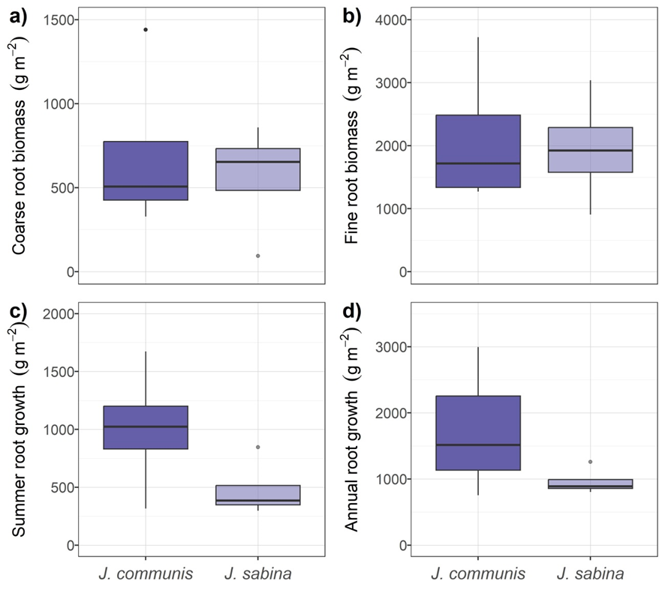
Fig. S6 Belowground biomass of the two Juniperus species at the high-elevation site, expressed as dry weight per square metre of ground, found in the shallow (0–12 cm) soil level. The upper half of the figure corresponds to coarse (a) and fine (b) roots found in undisturbed shrubs whereas the lower half shows the fine roots produced during summer (c) and yearly (d).

The root system was similarly dense in both species (root dry weight in the upper 12 cm soil level 2,801 g · m⁻² in J. communis and 2,512 g · m⁻² in J. sabina) and it was similarly partitioned into coarse and fine roots, fine roots amounting 75% dry weight in J. communis and 78% in J. sabina. Regarding growth, both species produced new roots actively, mostly during summer but also in other seasons. Juniperus communis seemed to be more active in producing new roots than J. sabina, although it also showed higher variability. All in all, there were no significant differences between the species due to the large data spread within each case (Table S5, fig. S6).

Vogt KA, Persson H (1991) Measuring growth and development of roots. In: Lassoie JP, Hinckley TM (ed) Techniques and approaches in forest tree ecophysiology. CRC Press Inc, Florida, pp 477–501.

