Investigating pathogenicity and the virulence genes txtAB, nec1, and tomA in Streptomyces isolates from Wisconsin potato systems

Supplementary File
Supplementary Figure 1. Electrophoresis PCR patterns from Streptomyces isolates and genetic screens on 1% Tris/acetic acid/EDTA (TAE) gel and imaged with Quantity One 1-D analysis software. (A) amplicons (1.5 kbp) of 16S rRNA sequence target region. Lane 1, known S. scabies isolate 87-22; lanes 2-10, representatives of Streptomyces strains isolated from scab lesions on various tuber samples collected from Wisconsin fields; lane 11, DNA blank. (B) intergenic transcribed spacer (ITS) regions of the 16S-23S operon (~700 bp) cut with Hpy99I restriction enzyme if restriction target region is present (note: additional Hpy99I target regions may exist among S. scabies to produce multiple restriction fragments) (Flores-Gonzalez et al., 2008). Lane 1, S. scabies (87-22) is Hpy99I+ and contains amplicon fragments ≤ 700 bp; lane 2, S. europascabiei (WI06-13D.2) is Hpy99I- due to absence of restriction site. Lanes 3-7, representatives of putative S. scabies isolates based on ITS + Hpy99I. Lane 8, a representative of putative S. europascabiei isolate based on ITS + Hpy99I.

A
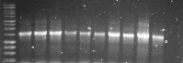
1 2 3 4 5 6 7 8 9 10 11
kb
8-
4-
2.5-
1.5-

0.5-

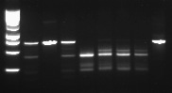
B
1 2 3 4 5 6 7 8
bp

300-

500-

700-

Supplementary Figure 2. Representative group of Streptomyces spp. isolates showing amplification of the txtAB gene (385 bp) with TxtAB1/TxtAB2 primers. Lane 1, highly virulent txtAB-positive S. scabies 87-22; lanes 2-4 and 6-11, txtAB-positive Streptomyces strains isolated from scab lesions on various tuber samples collected from Wisconsin fields in this study; lane 5, txtAB-negative Streptomyces strain isolated in this study; lane 12, DNA blank.

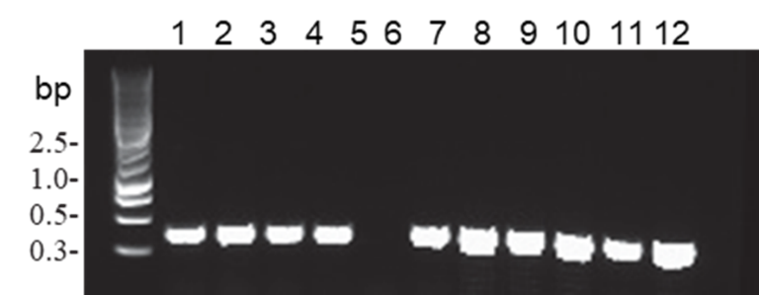

Supplementary Figure 3. Electrophoresis PCR patterns from Streptomyces isolates screened for nec1 (~700 bp) and tomA (~398 bp) amplicons and visualized on 1% Tris/acetic acid/EDTA (TAE) gel and imaged with Quantity One 1-D analysis software. Representative group of Streptomyces isolates showing amplification of nec1 with Nf/Nr primers and tomA with Tom3/Tom4 primers. Known positive and negative control Streptomyces isolates were courtesy of L. Wanner, USDA. (A) Lane 1, nec1-positive S. scabies WI06-19D; lane 2, nec1-negative strain WI06-23B; lanes 3-4 and 8-11, nec1-positive Streptomyces strains isolated from scab lesions on various tuber samples collected from Wisconsin fields in this study; lanes 5-7, nec1-negative Streptomyces strains isolated in this study; lane 12, DNA blank. (B) Lane 1, tomA-positive S. scabies WI06-19D; lane 2, tomA-negative strain WI06-23B; lanes 3-5 and 7-10, tomA-positive Streptomyces strains isolated in this study; lane 6, tomA-negative Streptomyces strain isolated in this study; lane 11, DNA blank.

A

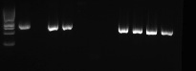
1 2 3 4 5 6 7 8 9 10 11 12
300-

700-

500-

bp

B

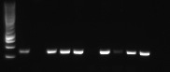
500-

1 2 3 4 5 6 7 8 9 10 11
700-

300-

bp

