LEITE ET AL: TRADE OF WILD EDIBLE PLANTS IN GUINEA-BISSAU
ELECTRONIC Supplemental Material

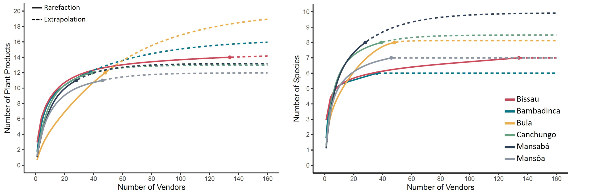
Figure 1. Rarefaction-extrapolation sampling curve of the wild edible plant products and species recorded in Bissau markets and each lumo visited considering the total number of vendors interviewed both before and after the rainy season.

Table 1. Description of the wild edible species and plant products sold at the Bissau markets and lumos (frequency corresponds to the percentage of vendors selling the product, based on the total sample of vendors selling wild edible plants in that location). Lumos refer to the sub-regional urban markets sampled in the northern region.
Species | Products | Use | Available season | Market availability | Traded in: | Bissau  Frequency (%) | Lumos  Frequency (%)
Adansonia digitata L. | Dry fruit pulp | Blended with sugar and water to make juice, ice lollies, mousse, and porridge; added in sauces and alcoholic beverages; ingredient in traditional dishes such as citi ku lite and cubamba | December-April | Year-round | Bissau, Bambadinca, Bula, Canchungo, Mansabá, Mansôa | 69 | 24
Adansonia digitata L. | Dry leaf powder | Used as an ingredient in many traditional dishes | May-November | Year-round | Bissau, Bambadinca, Bula, Canchungo, Mansabá, Mansôa | 10 | 7
Adansonia digitata L. | Dry fruit pulp powder | Blended with sugar and water to make juice, ice lollies, mousse, porridge | December-April | Year-round | Bissau, Bambadinca | 12 | 1
Borassus aethiopum Mart. | Fresh whole fruit | Pulp and seeds are eaten raw | October-March | Seasonal | Bula, Mansabá |  | 2
Cola cordifolia (Cav.) R. Br. | Fresh fruit pulp | Eaten raw | November-January | Seasonal | Mansôa |  | 1
Dialium guineense Willd. | Dry fruit pulp | Eaten raw as a snack or blended with sugar and water to make juice, ice lollies, or mousse; added in alcoholic beverages | May-July | Year-round | Bissau, Bambadinca, Bula, Canchungo, Mansabá, Mansôa | 69 | 11
Dialium guineense Willd. | Dry fruit pulp powder | Blended with sugar to make juice, ice lollies, mousse | May-July | Year-round | Bissau | 5
Dioscorea spp. | Tuber | Eaten boiled as a snack or side dish | August-December |  | Bissau, Mansabá | 1 | 3
Elaeis guineensis Jacq. | Fresh fruit pulp oil | Used in many traditional dishes such as caldo de tchebém, siga, futi, cite ku lite | March-May (extraction) | Year-round | Bissau, Bambadinca, Bula, Canchungo, Mansôa | 11 | 12
Elaeis guineensis Jacq. | Fresh whole fruit | Used to extract oil and make caldo de tchebém (traditional dish) | Year-round | Year-round | Bissau, Bambadinca, Bula, Canchungo, Mansabá, Mansôa | 4 | 16
Landolphia heudelotii A.DC. | Fresh whole fruit | Eaten raw and blended with sugar to make juice; used to make vinegar | October-January | Seasonal | Bula, Canchungo, Mansabá |  | 3
Parinari excelsa Sabine | Fresh whole fruit | Eaten raw | January-May | Seasonal | Bambadinca |  | 1
Parkia biglobosa (Jacq.) R.Br. ex G.Don | Dry fruit pulp | Eaten raw as a snack or blended with sugar and water to make juice, ice lollies; added in alcoholic beverages | May-July | Year-round | Bissau, Bambadinca, Bula, Canchungo, Mansabá, Mansôa | 55 | 23
Parkia biglobosa (Jacq.) R.Br. ex G.Don | netetu (fermented seeds) | Used as a seasoning in many traditional dishes such as futi, caldo branco, siga, tchep | May-July | Year-round | Bissau, Bambadinca, Bula, Canchungo, Mansabá, Mansôa | 18 | 8
Parkia biglobosa (Jacq.) R.Br. ex G.Don | Dry fruit pulp powder | Blended with sugar and water to make juice, ice lollies, porridge | May-July | Year-round | Bissau, Bambadinca, Bula, Mansabá | 1 | 2
Parkia biglobosa (Jacq.) R.Br. ex G.Don | Seed powder (from netetu) | Used as a seasoning in many traditional dishes such as futi, caldo branco, siga, tchep | May-July | Year-round | Bissau, Bambadinca, Bula, Canchungo, Mansabá, Mansôa | 6 | 5
Saba senegalensis (A.DC.) Pichon | Fresh whole fruit | Eaten raw or blended with sugar to make juice; added to alcoholic beverages; used to add flavour in many dishes | Almost year-round | Almost year-round | Bissau, Bambadinca, Bula, Canchungo, Mansabá, Mansôa | 4 | 16
Salacia senegalensis (Lam.) DC. | Fresh whole fruit | Eaten raw | October-January | Seasonal | Canchungo |  | 1
Tamarindus indica L. | Fresh whole fruit | Used to make juice; ingredient in traditional dishes such as caldo branco and tchep | January-March | Year-round | Bissau, Bula, Canchungo, Mansôa | 31 | 4

Table 2. Prices (5-years exchange rate average: 1 USD = 591.591 FCFA) per kilogram (or litre) and annual retail value (in thousands USD) sold at Bissau markets and lumos for the wild edible plant products sold by more than 10% of vendors. Lumos refer to the sub-regional urban markets sampled in the northern region.
Species | Products | Type of Vendor | Average price – Bissau  (USD/Kg or L) |  | Average price – Lumos  (USD/Kg or L) |  | Retail value  (in thousands USD)
Species | Products | Type of Vendor | Before rainy season | After rainy season | Before rainy season | After rainy season | Bissau | Lumos
Adansonia digitata L. | fruit pulp | Collector | - | - | 0.62 | 0.75 | 130 | 101
Adansonia digitata L. | fruit pulp | Retailer | 1.66 | 2.07 | 1.04 | 1.37 | 130 | 101
Adansonia digitata L. | fruit pulp | Total | 1.66 | 2.07 | 0.84 | 1.21 | 130 | 101
Adansonia digitata L. | leaf powder | Collector | - | - | - | - | 130 | 101
Adansonia digitata L. | leaf powder | Retailer | - | 4.89 | - | - | 130 | 101
Adansonia digitata L. | leaf powder | Total | - | 4.89 | - | - | 130 | 101
Adansonia digitata L. | fruit pulp powder | Collector | - | - | - | - | 130 | 101
Adansonia digitata L. | fruit pulp powder | Retailer | 3.49 | 3.53 | - | - | 130 | 101
Adansonia digitata L. | fruit pulp powder | Total | 3.49 | 3.53 | - | - | 130 | 101
Dialium guineense Willd. | fruit pulp | Collector | - | - | 1.90 | - | 134 | 39
Dialium guineense Willd. | fruit pulp | Retailer | 2.97 | 3.40 | 3.17 | 3.14 | 134 | 39
Dialium guineense Willd. | fruit pulp | Total | 2.97 | 3.40 | 2.85 | 3.14 | 134 | 39
Elaeis guineensis Jacq. | fruit oil | Collector | - | - | 2.37 | 2.68 | 51 | 110
Elaeis guineensis Jacq. | fruit oil | Retailer | 2.08 | 2.51 | 2.15 | 2.26 | 51 | 110
Elaeis guineensis Jacq. | fruit oil | Total | 2.08 | 2.51 | 2.24 | 2.51 | 51 | 110
Elaeis guineensis Jacq. | whole fruit | Collector | - | - | 0.40 | 0.63 | 51 | 110
Elaeis guineensis Jacq. | whole fruit | Retailer | - | - | 0.60 | 0.73 | 51 | 110
Elaeis guineensis Jacq. | whole fruit | Total | - | - | 0.49 | 0.67 | 51 | 110
Parkia biglobosa (Jacq.) R.Br. ex G.Don | fruit pulp | Collector | - | - | 0.56 | 0.63 | 91 | 29
Parkia biglobosa (Jacq.) R.Br. ex G.Don | fruit pulp | Retailer | 1.93 | 1.94 | 1.22 | 1.44 | 91 | 29
Parkia biglobosa (Jacq.) R.Br. ex G.Don | fruit pulp | Total | 1.93 | 1.94 | 0.83 | 1.12 | 91 | 29
Parkia biglobosa (Jacq.) R.Br. ex G.Don | seeds | Collector | - | - | - | - | 91 | 29
Parkia biglobosa (Jacq.) R.Br. ex G.Don | seeds | Retailer | 5.75 | 6.16 | - | - | 91 | 29
Parkia biglobosa (Jacq.) R.Br. ex G.Don | seeds | Total | 5.75 | 6.16 | - | - | 91 | 29
Saba senegalensis (Lam.) DC. | whole fruit | Collector | - | - | 0.38 | - | - | 3
Saba senegalensis (Lam.) DC. | whole fruit | Retailer | - | - | - | - | - | 3
Saba senegalensis (Lam.) DC. | whole fruit | Total | - | - | 0.38 | - | - | 3
Tamarindus indica L. | whole fruit | Collector | - | - | - | - | 19 | -
Tamarindus indica L. | whole fruit | Retailer | 2.31 | 3.29 | - | - | 19 | -
Tamarindus indica L. | whole fruit | Total | 2.31 | 3.29 | - | - | 19 | -

