Electronic Supplementary Material (ESM)

ESM 1: Interview guide
Interview market vendors (plants)
Location:____________ Date:___________ Interviewer: Vendor number:_____
Gender:____ Ethnic group: Age group (circle what applies): <30 30-50 51-70 >70
Overall question: Which changes (if any) have you observed over last 10 years
Name of plant | Type of plant  → tree, liana, herb… | Part of the plant sold  → seeds, bark... | Sold in which state  → dried, fresh... | What is it used for? | Price per unit  (e.g. per kg) | How many units sold per week? | Available season  dry, rainy, all year… | Origin - Vegetation type  → primary forest, fallow/ cultivated… | Geographic origin | Who has collected the plant? | Change in availability, price, origin,.... vs 10 years ago

ESM 2: Vendor characteristics
Table ESM 2: Vendor characteristics by location. Gender and age distribution are given in absolute numbers.
Location |  | Markets | Number | Gender |  | Age |  |  |  | Number of |  |  | Average WEP
County | City | surveyed | of vendors | F | M | <30 | 30-50 | 51-70 | >70 | ethnicities | Main ethnicity | All ethnicities | products per vendor
Montserrado | Monrovia | 10 | 62 | 53 | 9 | 12 | 36 | 14 | 0 | 13 | Bassa | Bassa, Gbandi, Gio, Gola, Grebo, Kissi, Kpelle, Kru, Loma, Mano, Sapo, Guinean, Nigerian | 2.79
Grandbassa | Buchanan | 11 | 39 | 31 | 8 | 9 | 22 | 8 | 0 | 5 | Bassa | Bassa, Gio, Kpelle, Mano, Nigerian | 2.92
Bong | Gbarnga | 5 | 28 | 28 | 0 | 4 | 14 | 10 | 0 | 3 | Kpelle, Lorma | Kissi, Kpelle, Loma | 2.96
Margibi | Kakata | 3 | 28 | 26 | 2 | 5 | 13 | 8 | 2 | 9 | Kpelle, Madingo | Gbandi, Gio, Kissi, Kpelle, Loma, Mandi, Madingo, Mano, Vai | 3.64
Bomi | Tubmanburg | 7 | 17 | 17 | 0 | 2 | 6 | 9 | 0 | 8 | Gola | Bassa, Gbandi, Gola, Kissi, Kpelle, Loma, Mende, Vai | 3.06
Total |  | 36 | 174 | 155 | 19 | 32 | 91 | 49 | 2 | 17 |  |  | 3.07

ESM 3: Species accumulation curves for different market locations
a) Monrovia (Montserrado)
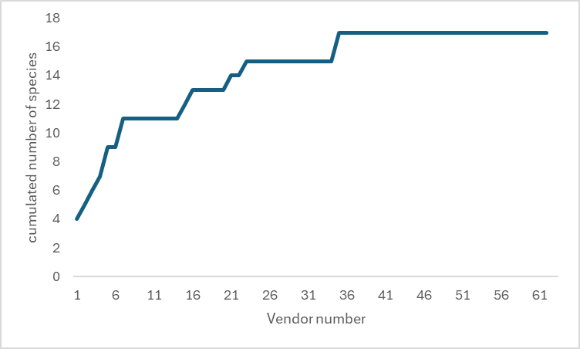
b) Gbarnga (Bong)
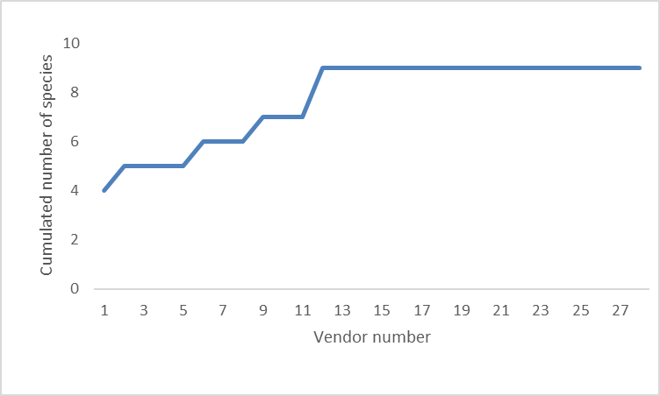
c) Kakata (Margibi)
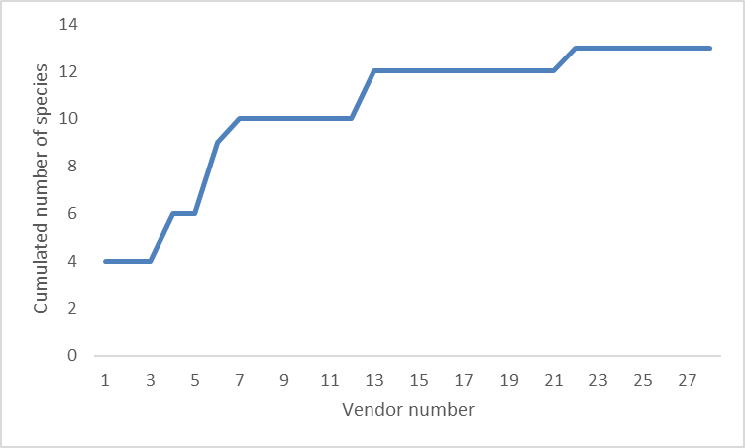

d) Buchanan (Grand Bassa)
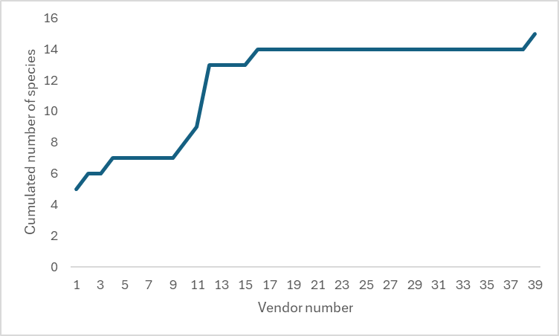
e) Tubmanburg (Bomi, Grand Cape Mount)
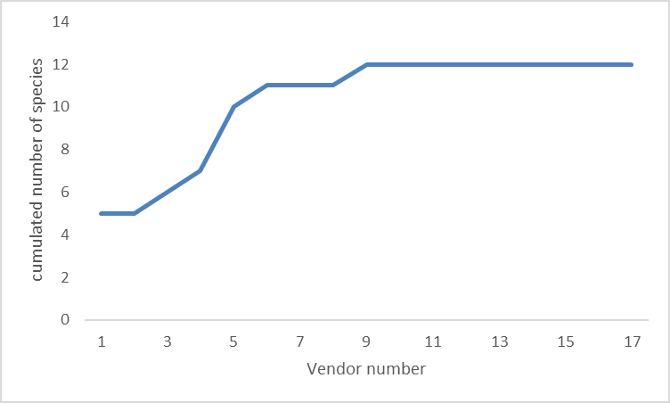
Figure ESM 3: Species accumulation curves for different market locations (new species encountered by additional vendors interviewed)
a) Monrovia, b) Buchanan (Grand Bassa), c) Gbarnga (Bong), d) Kakata (Margibi), e) Tubmanburg (Bomi, Grand Cape Mount). Note that the small market locations in Bomi and Grand Cape Mount County are pooled together under Tubmanburg.

ESM 4: Prices of wild edible plants traded
Table ESM 4: Prices per kilogram of frequently traded species (highest price printed in bold) compared between Monrovia (the capital), Kakata (third largest city), and regional markets in and around Tubmanburg. Highest price is printed in bold.

Species | Average price in [USD/kg] |  |  | Average price
 | Monrovia | Kakata | Tubmanburg
Beilschmiedia mannii (Meisn.) Benth. & Hook.f. ex B.D.Jacks. <LC> | 11.0 | 25.0 | 10.6 | 15.5
Cola nitida (Vent.) Schott & Endl. <LC> | 2.6 | 0.9 | 2.0 | 1.7
Garcinia kola Heckel <VU> | 32.3 | 31.3 | 17.9 | 27.2
Parkia spp. <LC> | 19.7 | 5.0 | 8.7 | 11.1
Piper guineense Thonn. <LC> | 27.6 | 25.6 | 49.5 | 34.2
Ricinodendron heudelotii (Baill.) Pierre ex Heckel <LC> | 13.2 | 14.7 | 20.2 | 16.0
Xylopia aethiopica (Dunal) A.Rich. <LC> | 5.0 | 7.2 | 9.6 | 7.3

