SUPPLEMENTARY MATERIAL

Figure S1. Cells needed to be restored before achieving 50% of maximum available filtration services by either directed or random filling of cells. Data are outcomes from simulations and differentiated by dry season (circles) and wet season (squares) among species.

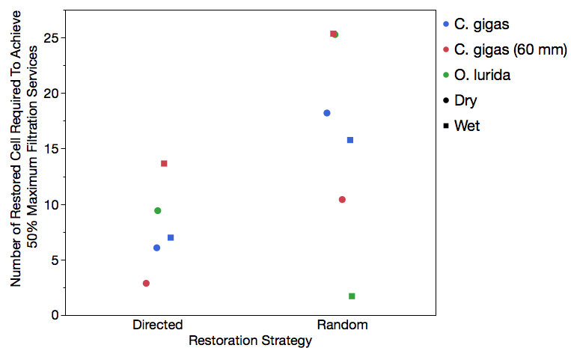

Table S1. Output from nonlinear regression analysis (equation 7) of the cell restored to achieve 50% of maximum filtration services (i.e. the greatest proportion of the bay that can be cleared by a fully restored population of oysters in historic habitat) by O. lurida, C. gigas and C. gigas with an average shell height of 60 mm.

Species | Season | Restoration Strategy | Parameter | Estimate | 50% Max Filtration | Cells To Be Restored
O. lurida | Dry | Directed | Asymptote | 0.280 | 0.1354 | 7.2
O. lurida | Dry | Directed | Scale | -0.254 | 0.1354 | 7.2
O. lurida | Dry | Directed | Growth Rate | -0.078 | 0.1354 | 7.2
O. lurida | Dry | Random | Asymptote | 0.356 | 0.175 | 29.0
O. lurida | Dry | Random | Scale | -0.363 | 0.175 | 29.0
O. lurida | Dry | Random | Growth Rate | -0.024 | 0.175 | 29.0
O. lurida | Wet | Directed | Asymptote | 0.005 | 0.0025 | 1.2
O. lurida | Wet | Directed | Scale | -0.005 | 0.0025 | 1.2
O. lurida | Wet | Directed | Growth Rate | -0.598 | 0.0025 | 1.2
O. lurida | Wet | Random | Asymptote | 0.005 | 0.0025 | 1.7
O. lurida | Wet | Random | Scale | -0.009 | 0.0025 | 1.7
O. lurida | Wet | Random | Growth Rate | -0.765 | 0.0025 | 1.7
C. gigas | Dry | Directed | Asymptote | 0.317 | 0.158 | 6.1
C. gigas | Dry | Directed | Scale | -0.281 | 0.158 | 6.1
C. gigas | Dry | Directed | Growth Rate | -0.094 | 0.158 | 6.1
C. gigas | Dry | Random | Asymptote | 0.367 | 0.1835 | 22.3
C. gigas | Dry | Random | Scale | -0.374 | 0.1835 | 22.3
C. gigas | Dry | Random | Growth Rate | -0.032 | 0.1835 | 22.3
C. gigas | Wet | Directed | Asymptote | 0.129 | 0.0645 | 7.0
C. gigas | Wet | Directed | Scale | -0.130 | 0.0645 | 7.0
C. gigas | Wet | Directed | Growth Rate | -0.099 | 0.0645 | 7.0
C. gigas | Wet | Random | Asymptote | 0.141 | 0.07 | 15.8
C. gigas | Wet | Random | Scale | -0.153 | 0.07 | 15.8
C. gigas | Wet | Random | Growth Rate | -0.049 | 0.07 | 15.8
C. gigas (60 mm) | Dry | Directed | Asymptote | 0.369 | 0.184 | 3.8
C. gigas (60 mm) | Dry | Directed | Scale | -0.314 | 0.184 | 3.8
C. gigas (60 mm) | Dry | Directed | Growth Rate | -0.140 | 0.184 | 3.8
C. gigas (60 mm) | Dry | Random | Asymptote | 0.390 | 0.1845 | 12.9
C. gigas (60 mm) | Dry | Random | Scale | -0.386 | 0.1845 | 12.9
C. gigas (60 mm) | Dry | Random | Growth Rate | -0.049 | 0.1845 | 12.9
C. gigas (60 mm) | Wet | Directed | Asymptote | 0.202 | 0.1005 | 6.0
C. gigas (60 mm) | Wet | Directed | Scale | -0.197 | 0.1005 | 6.0
C. gigas (60 mm) | Wet | Directed | Growth Rate | -0.111 | 0.1005 | 6.0
C. gigas (60 mm) | Wet | Random | Asymptote | 0.215 | 0.1052 | 13.4
C. gigas (60 mm) | Wet | Random | Scale | -0.229 | 0.1052 | 13.4
C. gigas (60 mm) | Wet | Random | Growth Rate | -0.055 | 0.1052 | 13.4

