Supplementary information
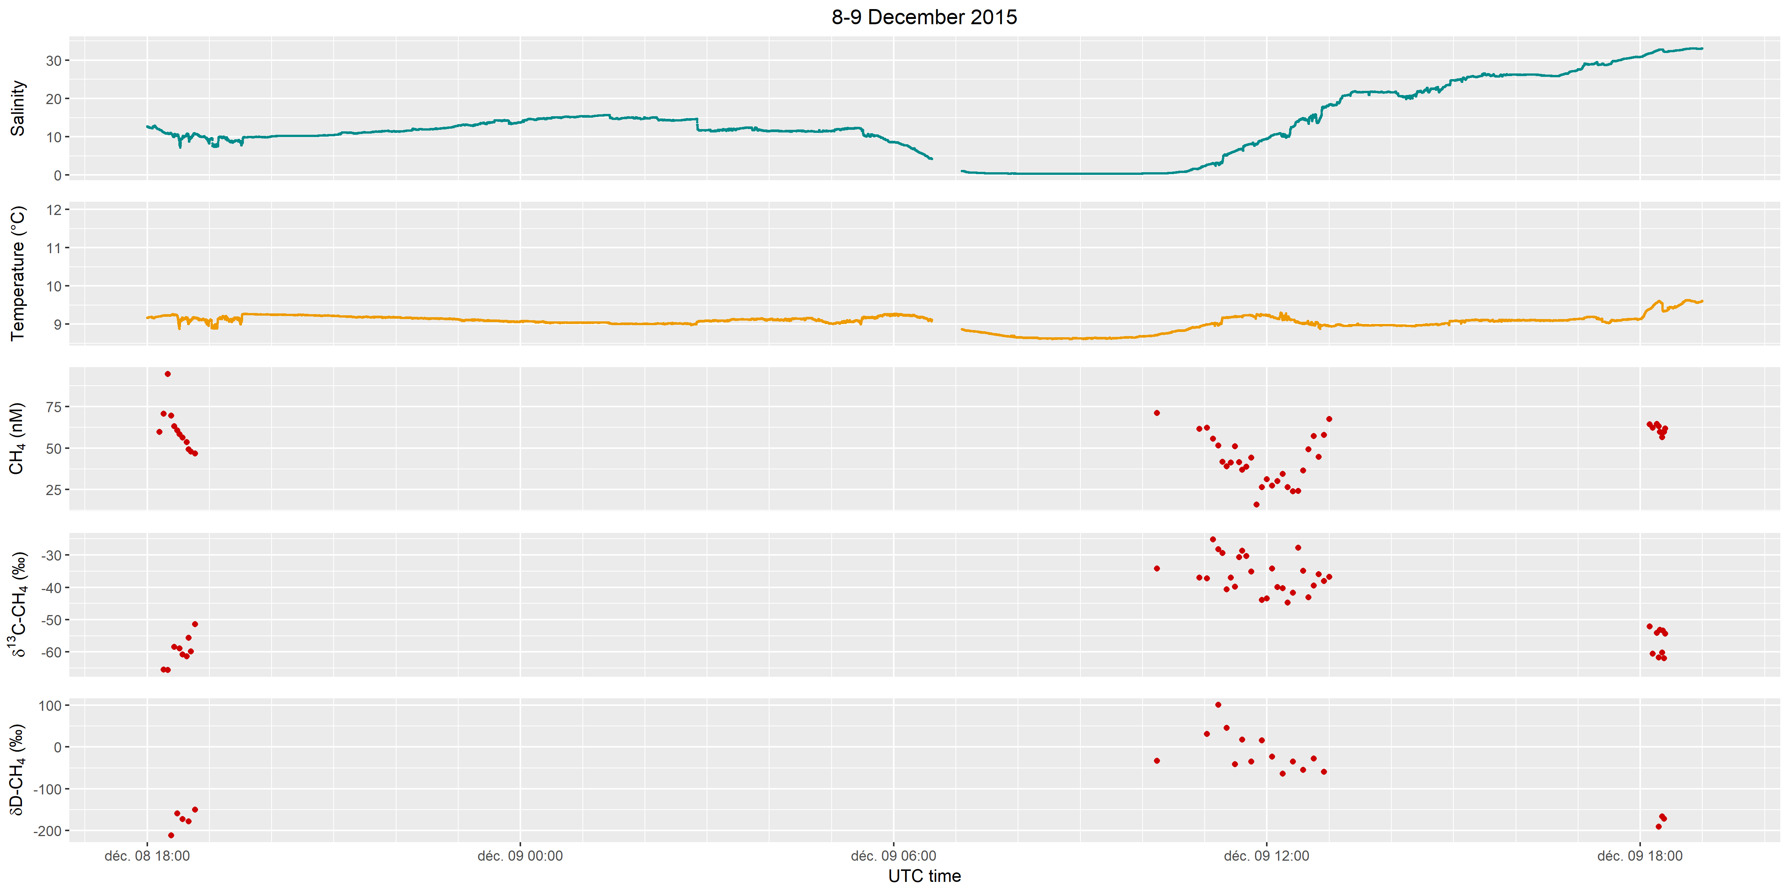
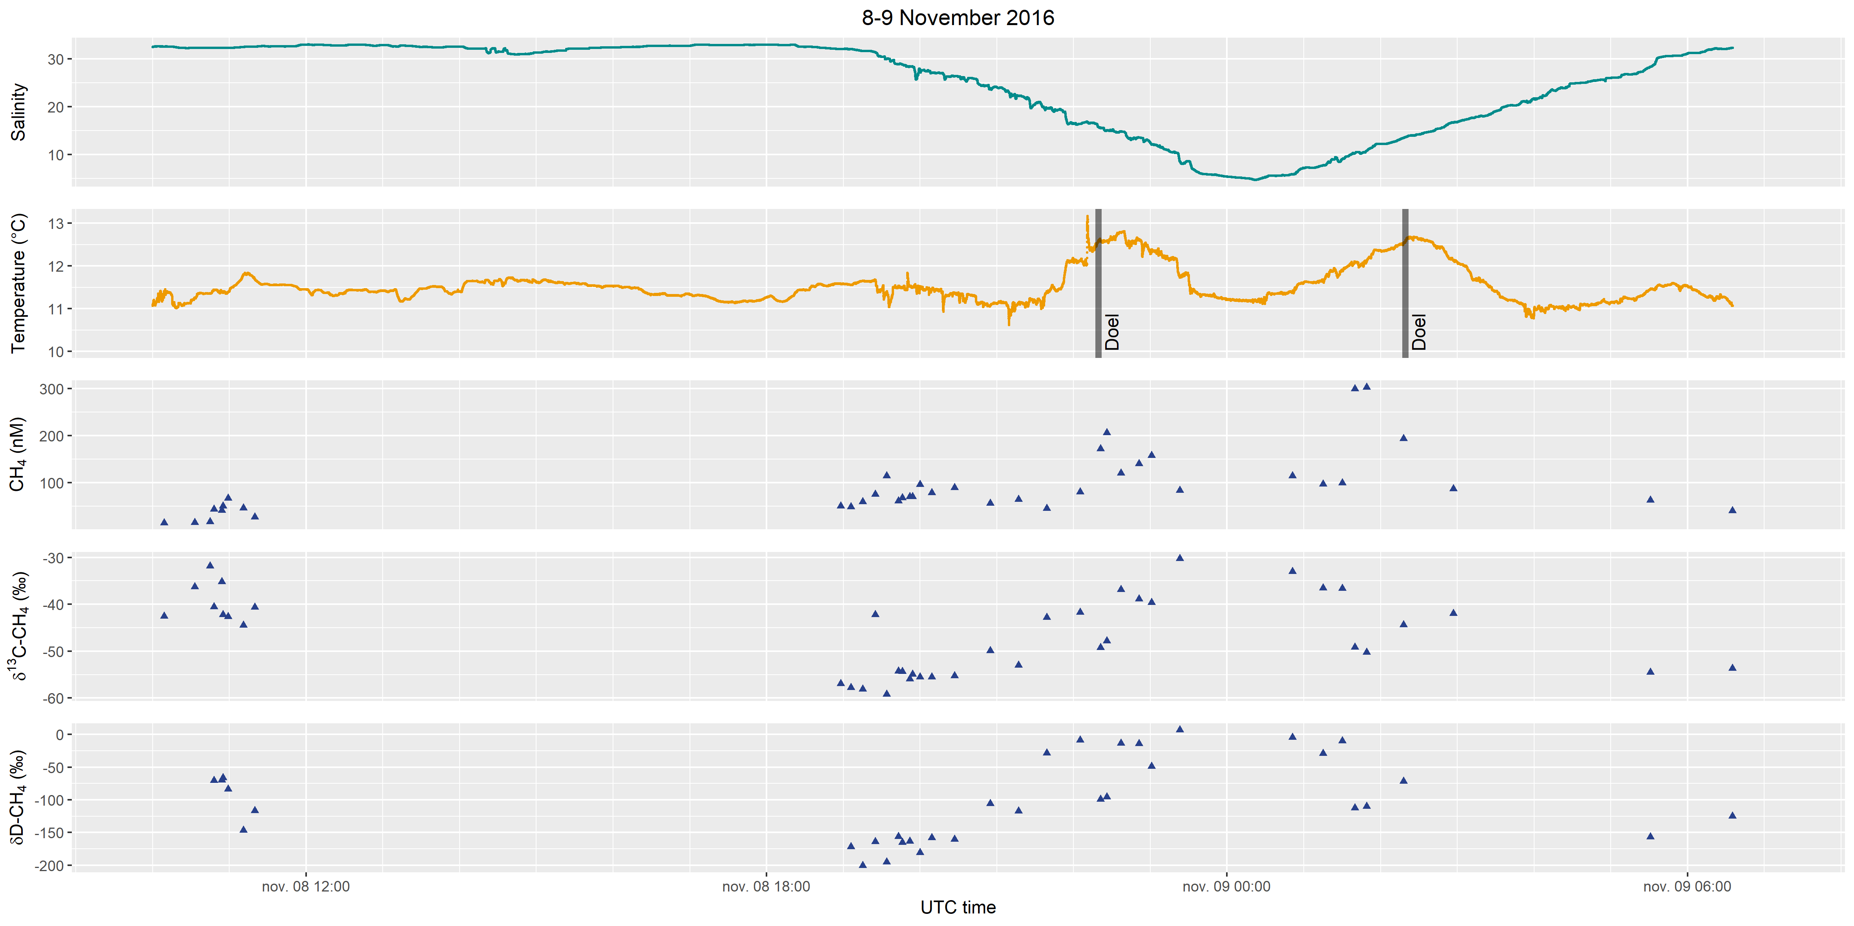
Figure S1: Evolution of sea surface salinity (psu), temperature (°C), dissolved CH₄ (nM), δ¹³C-CH₄ (‰ vs VPDB) and δD-CH₄ (‰ vs VSMOW) with time in (top) December 2015 and (bottom) November 2016.

Figure S2: Salinity in the Scheldt estuary in December 2015 (A) and November 2016 (B), with salinity contours (red dashed lines).

 | Zone | Station | Temperature | Salinity | CH₄ (nM) | Saturation ratio | δ¹³C-CH₄ (‰ vs VPDB) | δD-CH₄ (‰ vs VSMOW)
December 2015 | Lower estuary | 1 | 9.28 | 19.02 | 59.7 | 18.3
December 2015 | Lower estuary | 2 | 9.28 | 17.83 | 70.8 | 21.6 | -65.4
December 2015 | Lower estuary | 3 | 9.3 | 16.57 | 94.7 | 28.6 | -65.6
December 2015 | Lower estuary | 4 | 9.29 | 17.22 | 69.6 | 21.1 |  | -212.0
December 2015 | Lower estuary | 5 | 9.29 | 16.88 | 63.1 | 19.1 | -58.5
December 2015 | Lower estuary | 6 | 9.3 | 16.66 | 60.6 | 18.3 |  | -159.0
December 2015 | Lower estuary | 7 | 9.3 | 16.35 | 58.5 | 17.7 | -58.9
December 2015 | Lower estuary | 8 | 9.31 | 16.1 | 56.4 | 17.0 | -60.8 | -173.0
December 2015 | Lower estuary | 9 | 9.31 | 15.94 | 53.6 | 16.2 | -61.4
December 2015 | Lower estuary | 10 | 9.3 | 15.25 | 49.2 | 14.8 | -55.6 | -178.0
December 2015 | Lower estuary | 11 | 9.33 | 14.98 | 47.9 | 14.3 | -59.8
December 2015 | Lower estuary | 12 | 9.36 | 14.1 | 46.7 | 13.9 | -51.4 | -150.0
December 2015 | Upper estuary | 13 | 8.89 | 0.38 | 71.1 | 19.1 | -34.2 | -33.0
December 2015 | Upper estuary | 14 | 8.89 | 0.38 | 61.6 | 16.5 | -37.0
December 2015 | Upper estuary | 15 | 8.93 | 0.39 | 62.3 | 16.7 | -37.3 | 31.0
December 2015 | Upper estuary | 16 | 8.93 | 0.4 | 55.7 | 15.0 | -25.2
December 2015 | Upper estuary | 17 | 8.95 | 0.41 | 51.6 | 13.9 | -28.3 | 101.0
December 2015 | Upper estuary | 18 | 8.97 | 0.43 | 41.8 | 11.2 | -29.4
December 2015 | Upper estuary | 19 | 8.8 | 0.47 | 39.0 | 10.5 | -40.6 | 46.0
December 2015 | Upper estuary | 20 | 8.75 | 0.49 | 41.3 | 11.0 | -37.0
December 2015 | Upper estuary | 21 | 9.02 | 0.52 | 51.1 | 13.8 | -39.9 | -41.0
December 2015 | Upper estuary | 22 | 9.05 | 0.65 | 41.6 | 11.2 | -30.7
December 2015 | Upper estuary | 23 | 9.08 | 0.81 | 37.0 | 10.0 | -28.7 | 18.0
December 2015 | Upper estuary | 24 | 9.07 | 0.84 | 38.7 | 10.5 | -30.4
December 2015 | Upper estuary | 25 | 9.12 | 1.21 | 44.3 | 12.0 | -35.2 | -35.0
December 2015 | Upper estuary | 26 | 9.16 | 1.6 | 15.9 | 4.3
December 2015 | Upper estuary | 27 | 9.17 | 1.86 | 26.4 | 7.2 | -43.9 | 16.0
December 2015 | Upper estuary | 28 | 9.22 | 2.4 | 31.2 | 8.6 | -43.5
December 2015 | Upper estuary | 29 | 9.24 | 2.81 | 27.3 | 7.5 | -34.3 | -23.0
December 2015 | Upper estuary | 30 | 9.25 | 2.86 | 30.0 | 8.3 | -39.9
December 2015 | Upper estuary | 31 | 9.24 | 2.92 | 34.4 | 9.5 | -40.3 | -64.0
December 2015 | Upper estuary | 32 | 9.41 | 5.28 | 26.5 | 7.4 | -44.7
December 2015 | Upper estuary | 33 | 9.41 | 5.8 | 23.9 | 6.8 | -41.8 | -35.0
December 2015 | Upper estuary | 34 | 9.44 | 6.35 | 24.2 | 6.9 | -27.7
December 2015 | Upper estuary | 35 | 9.44 | 6.8 | 36.4 | 10.3 | -35.0 | -55.0
December 2015 | Upper estuary | 36 | 9.47 | 7.74 | 49.3 | 14.1 | -43.1
December 2015 | Upper estuary | 37 | 9.47 | 8.13 | 57.4 | 16.5 | -39.4 | -28.0
December 2015 | Upper estuary | 38 | 9.4 | 7.96 | 44.8 | 12.8 | -36.0
December 2015 | Upper estuary | 39 | 9.43 | 8.5 | 58.0 | 16.7 | -38.1 | -59.0
December 2015 | Upper estuary | 40 | 9.48 | 9.39 | 67.5 | 19.5 | -36.8
December 2015 | Lower estuary | 41 | 9.43 | 28.85 | 64.4 | 21.2 | -52.2
December 2015 | Lower estuary | 42 | 9.44 | 28.91 | 62.2 | 20.5 | -60.6
December 2015 | Lower estuary | 43 | 9.43 | 29.12 | 64.6 | 21.3 | -54.1
December 2015 | Lower estuary | 44 | 9.84 | 32.67 | 63.2 | 21.6 | -61.8 | -191.0
December 2015 | Lower estuary | 45 | 9.85 | 32.75 | 59.7 | 20.4 | -53.1
December 2015 | Lower estuary | 46 | 9.85 | 32.75 | 56.7 | 19.4 | -60.2 | -166.0
December 2015 | Lower estuary | 47 | 9.79 | 32.71 | 59.6 | 20.3 | -53.4
December 2015 | Lower estuary | 48 | 9.61 | 32.22 | 59.8 | 20.2 | -62.0 | -172.0
December 2015 | Lower estuary | 49 | 9.59 | 32.14 | 61.8 | 20.9 | -54.4
November 2016 | Coastal zone | 100 | 11.35 | 32.49 | 15.1 | 5.3 | -42.5
November 2016 | Coastal zone | 101 | 11.25 | 32.24 | 15.7 | 5.5 | -36.2
November 2016 | Coastal zone | 102 | 11.35 | 32.24 | 17.6 | 6.2 | -31.9
November 2016 | Coastal zone | 103 | 11.44 | 32.26 | 44.2 | 15.6 | -40.5 | -70.7
November 2016 | Coastal zone | 104 | 11.38 | 32.23 | 41.7 | 14.7 | -35.2 | -69.8
November 2016 | Coastal zone | 105 | 11.37 | 32.24 | 50.2 | 17.7 | -42.3 | -66.3
November 2016 | Coastal zone | 106 | 11.39 | 32.22 | 66.8 | 23.6 | -42.6 | -83.7
November 2016 | Coastal zone | 107 | 11.79 | 32.44 | 46.6 | 16.6 | -44.5 | -146.7
November 2016 | Coastal zone | 108 | 11.69 | 32.51 | 27.3 | 9.7 | -40.6 | -116.5
November 2016 | Lower estuary | 109 | 11.58 | 32.02 | 50.6 | 17.9 | -56.9
November 2016 | Lower estuary | 110 | 11.55 | 32.00 | 49.2 | 17.4 | -57.8 | -171.5
November 2016 | Lower estuary | 111 | 11.64 | 31.62 | 59.4 | 21.0 | -58.1 | -200.3
November 2016 | Lower estuary | 112 | 11.65 | 31.35 | 75.8 | 26.8 | -42.2 | -163.7
November 2016 | Lower estuary | 113 | 11.39 | 29.95 | 114.6 | 39.9 | -59.2 | -195.0
November 2016 | Lower estuary | 114 | 11.49 | 28.83 | 61 | 21.1 | -54.3 | -156.2
November 2016 | Lower estuary | 115 | 11.49 | 28.80 | 68.1 | 23.6 | -54.3 | -164.9
November 2016 | Lower estuary | 116 | 11.54 | 28.40 | 70.6 | 24.4 | -55.9 | -163.5
November 2016 | Lower estuary | 117 | 11.50 | 28.37 | 70.2 | 24.2 | -55.0
November 2016 | Lower estuary | 118 | 11.50 | 27.31 | 96.5 | 33.1 | -55.5 | -180.5
November 2016 | Lower estuary | 119 | 11.45 | 27.11 | 78.5 | 26.8 | -55.5 | -158.2
November 2016 | Lower estuary | 120 | 11.37 | 26.34 | 89.2 | 30.3 | -55.3 | -160.3
November 2016 | Lower estuary | 121 | 11.07 | 23.85 | 56.6 | 18.8 | -49.9 | -106.1
November 2016 | Lower estuary | 122 | 11.13 | 22.16 | 64.3 | 21.1 | -53.0 | -117.2
November 2016 | Lower estuary | 123 | 11.38 | 19.72 | 45.5 | 14.8 | -42.8 | -28.8
November 2016 | Upper estuary | 124 | 12.12 | 16.35 | 80.3 | 26.0 | -41.7 | -9.0
November 2016 | Upper estuary | 125 | 12.57 | 15.54 | 171.9 | 55.9 | -49.2 | -99.0
November 2016 | Upper estuary | 126 | 12.58 | 15.02 | 206 | 66.8 | -47.8 | -95.6
November 2016 | Upper estuary | 127 | 12.78 | 14.82 | 120.6 | 39.2 | -36.8 | -13.7
November 2016 | Upper estuary | 128 | 12.61 | 13.49 | 140.6 | 45.2 | -38.9 | -14.0
November 2016 | Upper estuary | 129 | 12.33 | 12.08 | 158 | 49.9 | -39.6 | -48.8
November 2016 | Upper estuary | 130 | 11.75 | 8.64 | 83.8 | 25.5 | -30.3 | 6.7
November 2016 | Upper estuary | «80» (1.5 m) | 11.24 | 5.15 | 169.7 | 49.9 | -39.0 | -52.0
November 2016 | Upper estuary | «80» (3.8 m) | 11.36 | 5.51 | 141.4 | 41.8 | -35.6 | -11.1
November 2016 | Upper estuary | «80» (7.5 m) | 11.44 | 5.82 | 117.1 | 34.8 | -37.4
November 2016 | Upper estuary | «78» (1.5 m) | 11.36 | 5.61 | 114.7 | 33.9 | -33.7 | -18.4
November 2016 | Upper estuary | «78» (7 m) | 11.40 | 5.72 | 118 | 35.0 | -34.1 | 4.1
November 2016 | Upper estuary | «78» (12.6 m) | 11.42 | 5.83 | 112.9 | 33.5 | -33.9 | 4.7
November 2016 | Upper estuary | 131 | 11.37 | 5.84 | 114.4 | 33.9 | -33.1 | -4.6
November 2016 | Upper estuary | «75» (1.5 m) | 11.61 | 7.29 | 84.5 | 25.4 | -30.2 | 29.1
November 2016 | Upper estuary | «75» (6.1 m) | 11.63 | 7.36 | 86.1 | 25.9 | -30.6
November 2016 | Upper estuary | «75» (10.8 m) | 11.68 | 7.65 | 79.2 | 23.9 | -30.8 | 64.4
November 2016 | Upper estuary | 132 | 11.65 | 7.68 | 96.9 | 29.3 | -36.5 | -29.0
November 2016 | Upper estuary | «71» (1.6 m) | 11.23 | 10.10 | 146.3 | 44.4 | -42.3
November 2016 | Upper estuary | «71» (4.6 m) | 11.87 | 10.24 | 171.4 | 52.9 | -44.4 | -99.6
November 2016 | Upper estuary | «71» (8.4 m) | 11.90 | 10.01 | 311.1 | 96.0 | -50.3 | -116.8
November 2016 | Upper estuary | 133 | 11.89 | 8.94 | 99.4 | 30.5 | -36.6 | -9.9
November 2016 | Upper estuary | «68» (1.4 m) | 12.16 | 10.76 | 355.6 | 111.0 | -49.6
November 2016 | Upper estuary | «68» (5.8 m) | 12.18 | 10.90 | 361.1 | 112.9 | -50.4 | -101.3
November 2016 | Upper estuary | «68» (10.2 m) | 12.22 | 11.06 | 398.8 | 124.9 | -50.2 | -133.8
November 2016 | Upper estuary | 134 | 12.10 | 10.22 | 299.2 | 92.9 | -49.2 | -112.4
November 2016 | Upper estuary | 135 | 12.08 | 10.73 | 302.6 | 94.2 | -50.2 | -109.7
November 2016 | Upper estuary | «65» (1.5 m) | 12.35 | 12.30 | 199.8 | 63.3 | -41.1 | -60.6
November 2016 | Upper estuary | «65» (5.2 m) | 12.37 | 12.31 | 205.5 | 65.1 | -41.2 | -99.7
November 2016 | Upper estuary | «65» (10.8 m) | 12.37 | 12.31 | 200.6 | 63.6 | -41.1
November 2016 | Upper estuary | 136 | 12.53 | 13.43 | 193.7 | 62.1 | -44.4 | -71.4
November 2016 | Lower estuary | 137 | 12.12 | 16.62 | 87.5 | 28.4 | -42.0
November 2016 | Lower estuary | «39» (1.6 m) | 11.20 | 20.46 | 42.7 | 13.9 | -33.8 | -50.6
November 2016 | Lower estuary | «39» (9.9 m) | 11.21 | 21.00 | 48.9 | 16.0 | -46.1 | -53.9
November 2016 | Lower estuary | «39» (15.2 m) | 11.14 | 21.00 | 52 | 16.9 | -45.1 | -82.8
November 2016 | Lower estuary | «19» (1.6 m) | 11.16 | 26.25 | 75 | 25.3 | -54.1 | -146.4
November 2016 | Lower estuary | «19» (16.5 m) | 11.21 | 26.75 | 79.3 | 26.9 | -53.9 | -147.5
November 2016 | Lower estuary | «19» (28.9 m) | 11.26 | 27.44 | 83.2 | 28.4 | -53.5 | -174.4
November 2016 | Lower estuary | 138 | 11.45 | 28.28 | 62.9 | 21.7 | -54.5 | --156.9
November 2016 | Lower estuary | «-2» (1.5 m) | 11.27 | 32.35 | 47.6 | 16.8 |  | -167.1
November 2016 | Lower estuary | «-2» (12.9 m) | 11.19 | 32.52 | 44.9 | 15.8 | -55.6 | -153.3
November 2016 | Lower estuary | «-2» (23.9 m) | 10.90 | 32.55 | 40.8 | 14.3 | -56.7 | -138.5
November 2016 | Lower estuary | 139 | 11.05 | 32.38 | 40.9 | 14.3 | -53.7 | -125.2
Table S1: CH₄ concentration and isotopic composition measured in water samples in December 2015 and November 2016

