ELECTRONIC SUPPLEMENTAL MATERIAL # 2
Estuaries and Coasts
12 October 2021
Spatiotemporal Variability in Environmental Conditions Influences the Performance and Behavior of Juvenile Steelhead in a Coastal California Lagoon

Rosealea M. Bond^{1*}, Joseph D. Kiernan^{2,3}, Ann-Marie K. Osterback¹, Cynthia H. Kern¹, Alexander E. Hay¹, Joshua M. Meko¹, Miles E. Daniels¹, and Jeffrey M. Perez¹.

Author affiliations:
¹ Fisheries Collaborative Program, Institute of Marine Sciences, University of California, Santa Cruz, affiliated with Southwest Fisheries Science Center, National Marine Fisheries Service, National Oceanic and Atmospheric Administration, 110 McAllister Way, Santa Cruz, California 95060, USA

² Fisheries Ecology Division, Southwest Fisheries Science Center, National Marine Fisheries Service, National Oceanic and Atmospheric Administration, 110 McAllister Way, Santa Cruz, California 95060, USA

³ Institute of Marine Sciences, University of California, Santa Cruz, 1156 High Street, Santa Cruz, California 95064, USA

*Corresponding author: Rosealea M. Bond, Email: lea.bond@noaa.gov,
Phone: 1-831-420-3918, Address: 110 McAllister Way, Santa Cruz, California 95060, USA.

Antenna detection efficiency
Autonomous passive integrated transponder (PIT) tag antenna arrays have been used extensively in aquatic systems to passively monitor fish behavior and performance. Robust interpretation of PIT antenna data requires an understanding of how effectively a given antenna array (i.e., station) detects PIT-tagged fish when they are present within the detection field, known as antenna detection efficiency (DE). DE is influenced by myriad factors including: (1) the size, shape, and number of loops constituting an array; (2) local electromagnetic and water quality conditions; and (3) the swim path, velocity, and orientation of each PIT-tagged fish (Connolly et al. 2008; Aymes and Rives 2009; Connolly 2010). In lotic (riverine) ecosystems, DE is routinely calculated by comparing the proportion of serial (i.e., sequential upstream-downstream, or vice versa) PIT tag detections among multiple loops of an antenna array (Zydlewski et al. 2006). This method is effective when fish movement is predominantly unidirectional and produces serial detections (e.g., during downriver migration events), or when the number of PIT-tagged fish moving past the array is known (e.g., large-scale fish release events; Connolly 2010).
By contrast, there are unique challenges associated with the operation and maintenance of PIT tag antenna systems in lentic and brackish environments, which compromise antenna performance and hinder robust assessment of DE. Non-migratory fish behaviors (e.g., milling, holding, or residency; hereafter collectively referred to as “milling events”) are especially problematic in lentic habitats and often yield a large number of single loop (i.e., non-serial) detections (Meynecke et al. 2008; McNatt et al. 2016; Osterback et al. 2018). Furthermore, non-migratory behaviors routinely place multiple fish in the detection field simultaneously, creating interference (all PIT tags operate at the same radio frequency, 134.2-kHz) that results in missed detections or incorrectly decoded tag information (termed PIT tag collision; O’Donnell et al. 2010; Schmidt et al. 2016). Of special concern for our study is the knowledge that fluctuating water quality—particularly temperature and salinity—can strongly influence the electrical properties of each loop’s detection field, temporarily reducing read range or inhibiting detections altogether (Barbour et al. 2010). Based on more than a decade of operating PIT tag antenna arrays in the Scott Creek estuary/lagoon (e.g., Bond et al. 2007; Hayes et al. 2011; Frechette et al. 2016; Osterback et al. 2018) we have found that non-serial tag detections predominate during the period of lagoon formation (Osterback et al. 2018), chiefly for the reasons outlined above. Consequently, DE at the Lagoon Array can rarely be assessed using methods applied in lotic ecosystems.
To provide a measure of system performance during our study, field personnel visited each antenna array approximately every nine days during the five-month study period to document antenna functionality and to quantify the strength and extent of the detection field for each loop using a test tag analog (Zydlewski et al. 2006). We classified the operational status of each antenna array as: (1) “fully functional,” when all loops had 100% detection coverage (i.e., full read range with no dead zones); (2) “partially functional,” when one or more loops had reduced read range and dead zones were present; or (3) “non-functional,” when the instrument’s power was turned off. For the Riverine and Interface arrays, we calculated DE (e.g., Zydlewski et al. 2006; Connolly 2010) over the entire 154-day study period using all PIT tag detection data at each station. For each antenna array we included salmonids tagged outside the temporal and (or) spatial scope of our study (i.e., in support of other research and monitoring efforts in the basin).
The Riverine Array was fully functional the majority (87.7%) of the study period and had a high overall DE estimate (80.3%; Table S1). The Interface Array was fully functional 59.7% of the time and also had a high DE estimate (99.4%; Table S1). Lastly, the Lagoon Array was fully functional 53.2% of the time, with unknown DE, and the majority of PIT tag detections at this station were classified as ambiguous movement (i.e., single loop detections; Table S1, Fig. S2). Reduced functionality at the Lagoon Array was a result of changes in antenna loop geometry, fish behavior, and episodic changes in salinity. Whereas channel width at the Lagoon Array was relatively wide (17.7 m), the system consisted of four independent antenna loops; two adjacent loops downstream to effectively span the entire channel and two more upstream for the same purpose. On several occasions, we documented reduced read range on one or more of the four antenna loops associated with changes in water level and (or) macroalgal/detrital accumulation that altered loop geometry, generated dead spots, and likely resulted in missed detections. Additionally, wave overtopping events delivered large amounts of saltwater to the lagoon during Phase 2 (13 July–8 August 2018), substantially attenuating each loop’s detection field (reduced detection field to 5–15 cm around each loop). Consequently, there were a relatively low number of total detections during this period (Fig. S2).
Despite these shortcomings, we are confident that our data allow us to draw robust inferences about juvenile steelhead movement. It is instructive to note that the Lagoon Array detected 1,521 (78.8%) of the 1,930 PIT-tagged juvenile steelhead handled during monthly sampling events over the course of the study (e.g., “recapture rate” discussed in Adams et al. 2006; Meynecke et al. 2008), indicating the system as a whole functioned well even with variable DE. Moreover, the timing of single loop detections at the Lagoon Array peaked at dawn and dusk, mirroring the patterns seen in the directional movement detections (Fig. S3). Since we could not explicitly take daily DE into account, our inferences were conservatively limited to directional movement patterns within each environmental phase—not between phases—as the latter could have been influenced by a combination of DE, fish behavior, environmental drivers, and (or) other variables not considered in our study. We also focused our efforts on peak movements rather than individual fish to illustrate the importance of movement timing as a population response similar to our monthly performance metrics from seining events.

Supplemental Table:
Table S1. Daily operational status and overall antenna detection efficiency (DE) of the three PIT tag antenna arrays operated in Scott Creek (CA, USA) during our 154-day study (20 June–20 November 2018). Data are presented as the number of days (N) and percentage (%) of the total study period each system was classified as fully functional, partially functional, or non-functional.

PIT tag antenna | Daily operational status
array | Fully functional |  | Partially functional |  | Non-functional |  | Overall DE
(Station ID) | N | % | N | % | N | % | (%)
Riverine | 135 | 87.7 | 18 | 11.7 | 1 | 0.6 | 80.3
Interface | 92 | 59.7 | 59 | 38.3 | 3 | 1.9 | 99.4
Lagoon | 82 | 53.2 | 65 | 42.2 | 7 | 4.5 | ---

Supplemental Figures:
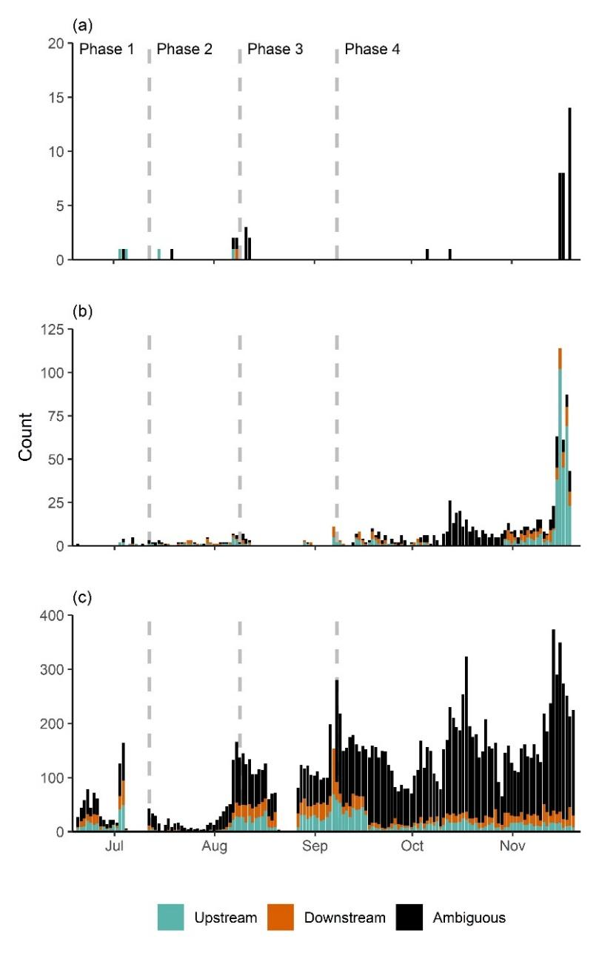
Fig. S2 Number of distinct juvenile steelhead movement events detected each day at the Riverine (a), Interface (b), and Lagoon PIT tag antenna arrays (c) operated in the Scott Creek (CA, USA) estuary/lagoon and lower mainstem creek, across the four environmental phases identified during the study period. Blue bars denote upstream movement, orange bars denote downstream movement, and black bars denote ambiguous movement (bin width = 1 day). Environmental phase dates (2018) were 20 June–12 July (Phase 1), 13 July–8 August (Phase 2), 9 August–7 September (Phase 3), 8 September–20 November (Phase 4). Note bars are stacked ontop of each other and there are different y-axis scales in each panel.
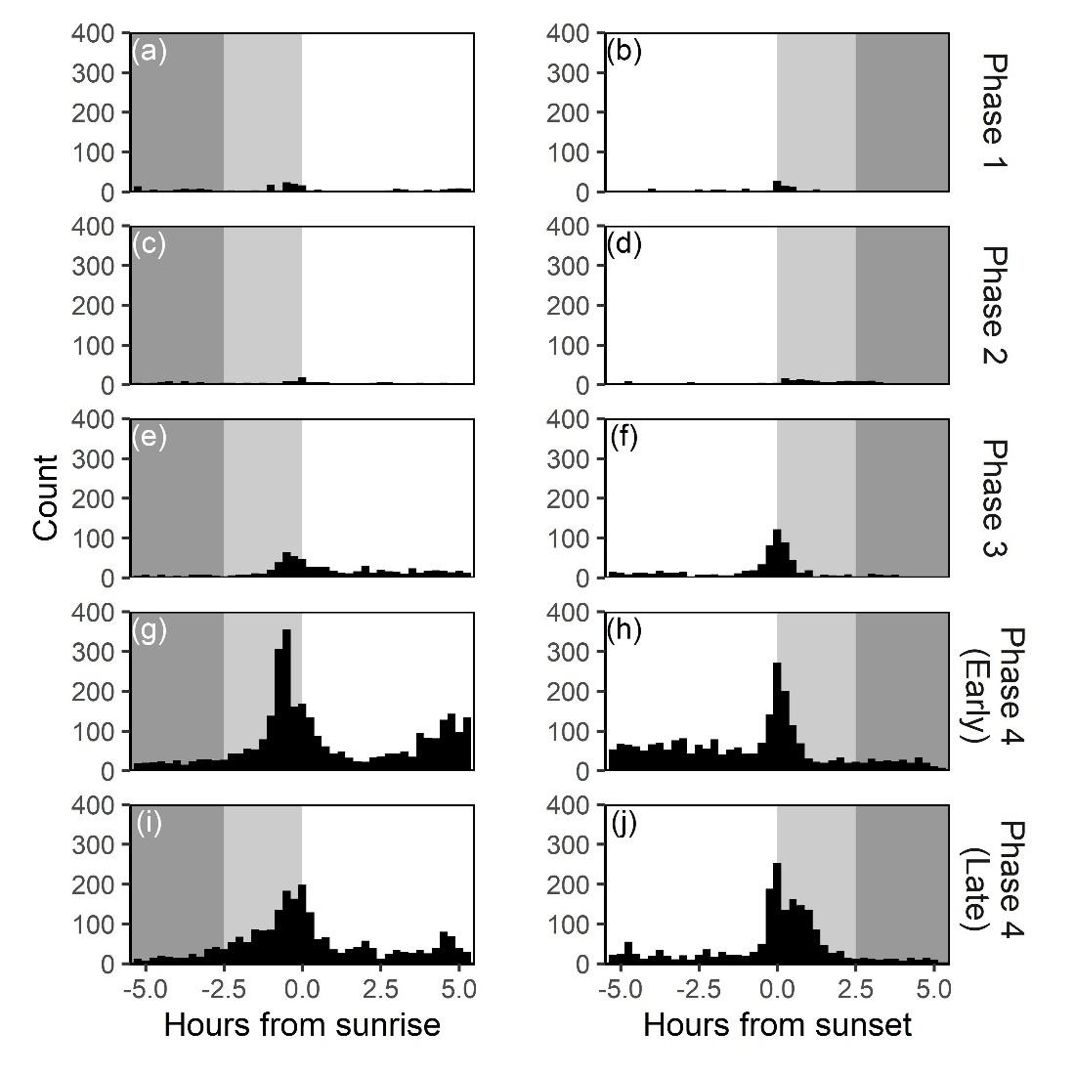
Fig. S3 Histograms of ambiguous juvenile steelhead movement events (i.e., single loop detections) at the Scott Creek (CA, USA) Lagoon PIT tag antenna array (Lagoon Array) relative to sunrise (left panels; a, c, e, g, i) and sunset (right panels; b, d, f, h, i) during each environmental phase (panel rows). Bin width = 0.25 hour. Dark background shading in each panel denotes nighttime, light shading represents dawn or dusk, and the unshaded region indicates daylight hours. Environmental phase dates (2018) were 20 June–12 July (Phase 1), 13 July–8 August (Phase 2), 9 August–7 September (Phase 3), 8 September–20 November (Phase 4)

Supplemental References:
Adams, A. J., R. K. Wolfe, W. E. Pine, and B. L. Thornton. 2006. Efficacy of PIT tags and an autonomous antenna system to study the juvenile life stage of an estuarine-dependent fish. Estuaries and Coasts 29:311–317.
Aymes, J. C. and J. Rives. 2009. Detection efficiency of multiplexed passive integrated transponder antennas is influenced by environmental conditions and fish swimming behaviour. Ecology of Freshwater Fish 18:507–513.
Barbour, A. B., A. J. Adams, D. C. Behringer, T. Yess, and R.K. Wolfe. 2010. PIT tag antenna arrays as fishery monitoring tools in tropical environments. Proceedings of the 63rd Gulf and Caribbean Fisheries Institute 63:118–124.
Bond, M. H., C. V. Hanson, R. Baertsch, S. A. Hayes, and R. B. MacFarlane. 2007. A new low cost in-stream antenna system for tracking passive integrated transponder (PIT) tagged fish in small streams. Transactions of the American Fisheries Society 136:562–566.
Connolly, P. J. 2010. Guidelines for calculating and enhancing detection efficiency of PIT tag interrogation systems. Chapter 7. In: Tagging, telemetry and marking measures for monitoring fish populations—A compendium of new and recent science for use in informing technique and decision modalities: Pacific Northwest Aquatic Monitoring Partnership Special Publication 2010-002. (Eds K.S. Wolf & J.S. O’Neal). Available at https://www.usbr.gov/pn/fcrps/rme/reports/uppercolumbia/Connolly_2010_Guidelines%20to%20indirectly%20measure%20and%20enhance%20detection%20efficiency%20of%20PIT%20tag%20interrogation.pdf. Last accessed 1 October 2021.
Connolly, P. J., I. G. Jezorek, K. D. Martens, and E. F. Prentice. 2008. Measuring the performance of two stationary interrogation systems for detecting downstream and upstream movement of PIT-tagged salmonids. North American Journal of Fisheries Management 28:402–417.
Frechette, D., W. H. Satterthwaite, A.-M. K. Osterback, and S. A. Hayes. 2016. Steelhead abundance in seasonally closed estuaries estimated using mark recapture methods. U.S. Dept. Commerce. NOAA Technical Memorandum NOAA-TM-NMFS-SWFSC-555.
Hayes, S. A., M. H. Bond, C. V. Hanson, A. W. Jones, A. J. Ammann, J. A. Harding, A. L. Collins, J. Perez, and R. B. MacFarlane. 2011. Down, up, down and “smolting” twice? Seasonal movement patterns by juvenile steelhead (Oncorhynchus mykiss) in a coastal watershed with a bar closing estuary. Canadian Journal of Fisheries and Aquatic Sciences 68(8):1341–1350.
McNatt, R. A., D. L. Bottom, and S. A. Hinton. 2016. Residency and movement of juvenile Chinook salmon at multiple spatial scales in a tidal marsh of the Columbia River estuary. Transactions of the American Fisheries Society 145:774–785.
Meynecke, J. -O., G. C. Poole, J. Werry, and S. Y. Lee. 2008. Use of PIT tag and underwater video recording in assessing estuarine fish movement in a high intertidal mangrove and salt marsh creek. Estuarine, Coastal and Shelf Science 79:168–178.
O’Donnell, M. J., G. E. Horton and B. H. Letcher. 2010. Use of portable antennas to estimate abundance of PIT-tagged fish in small streams: Factors affecting detection probability. North American Journal of Fisheries Management 30: 323–336.
Osterback, A.-M. K., C. H. Kern, E. A. Kanawi, J. M. Perez, and J. D. Kiernan. 2018. The effects of early sandbar formation on the abundance and ecology of coho salmon (Oncorhynchus kisutch) and steelhead trout (Oncorhynchus mykiss) in a central California coastal lagoon. Canadian Journal of Fisheries and Aquatic Sciences 75(12):2184–2197.
Schmidt, T., C. Löb, B. Schreiber, and R. Schulz. 2016. A pitfall with PIT tags: Reduced detection efficiency of half-duplex passive integrated transponders in groups of marked fish. North American Journal of Fisheries Management 36:951–957.
Zydlewski, G. B., G. Horton, T. Dubreuil, B. Letcher, S. Casey, and J. Zydlewski. 2006. Remote monitoring of fish in small streams: A unified approach using PIT tags. Fisheries 31:492–502.

