Electronic Supplemental Material

Carbon stocks in vegetation and soil and their relationship with plant community traits in a Mediterranean non-tidal salt marsh
Estuaries and Coasts
11th November 2022
Lorena Carrasco-Barea^{1*}, Dolors Verdaguer¹, Maria Gispert², Joan Font¹, Jordi Compte³, Laura Llorens¹

¹Plant Physiology Unit, Department of Environmental Sciences, Faculty of Sciences, University of Girona, Campus Montilivi, 17003 Girona, Spain

²Soil Science Unit, Department of Chemical Engineering, Agriculture, and Food Technology, University of Girona, Campus Montilivi, 17003 Girona, Spain
³GRECO, Institute of Aquatic Ecology, University of Girona, Campus Montilivi, 17003 Girona, Spain
*Corresponding author at Department of Environmental Sciences, Faculty of Sciences, University of Girona, Campus Montilivi, 17003 Girona, Spain. E-mail address: lorena.carrasco.barea@gmail.com

TABLES
TABLE S1. List of species found in the three studied habitats of La Pletera salt marsh. Species names are given according to Euro+Med PlantBase. The percentage of relative abundance (RA, mean ± SE) for each species and sampling year is also given. Dominant species of each habitat are marked in bold.
Halophilous scrub | 2015 | 2016
Sarcocornia fruticosa (L.) A. J. Scott  Limbarda crithmoides (L.) Dumort.  Halimione portulacoides (L.) Aellen  Limonium narbonense Mill.  Elytrigia atherica (Link) Kerguélen  Elytrigia elongata (Host) Nevski  Parapholis filiformis (Roth) C. E. Hubb. | 75.0 ± 13.5  7.0 ± 7.0  3.6 ± 1.2  6.7 ± 6.0  -  -  0.4 ± 0.4 | 69.3 ± 12.9  13.7 ± 11.2  12.4 ± 8.8  -  3.6 ± 3.6  0.5 ± 0.5  -
Salt meadow | 2015 | 2016
Elytrigia atherica (Link) Kerguélen  Halimione portulacoides (L.) Aellen  Phragmites australis Cav.  Juncus acutus L.  Limbarda crithmoides (L.) Dumort.  Limonium virgatum (Willd.) Fourr.  Dorycnium pentaphyllum subsp. gracile (Jord.) Rouy  Artemisia caerulescens subsp. gallica (Willd.) K. M. Perss.  Limonium narbonense Mill  Vicia hirsuta (L.) Gray  Dactylis glomerata L. | 60.4 ± 8.5  20.5 ± 7.0  8.6 ± 3.7  -  -  1.0 ± 1.0  0.4 ± 0.4  -  -  -  0.2 ± 0.2 | 60.7 ± 10.0  19.7 ± 9.0  7.2 ± 3.6  6.6 ± 4.8  4.3 ± 4.3  -  0.2 ± 0.4  0.4 ± 0.4  0.4 ± 0.4  0.3 ± 0.3  -
Glasswort sward | 2015 | 2016
Salicornia patula Duval-Jouve  Sarcocornia fruticosa (L.) A. J. Scott  Suaeda maritima (L.) Dumort.  Halimione portulacoides (L.) Aellen | 98.4 ± 1.2  -  1.6 ± 1.2  - | 73.2 ± 18.6  20.6 ± 19.9  5.2 ± 3.4  1.0 ± 1.0

TABLE S2. Estimated carbon (mean ± SE) stored in living, dead, total aboveground and belowground plant fractions, as well as in the litter and soil (0-20 cm depth), of the three habitats. HCI: Habitat of Community Interest. Data for the two sampling years has been pooled (n = 10). Different letters indicate significant differences among habitats for each fraction.
 | Carbon amount (g C m⁻²)
HCI | Plant fractions |  |  |  | Litter | Soil
HCI | Living aboveground | Standing dead aboveground | Total aboveground | Total belowground | Litter | Soil
Halophilous scrub | 808.1 ± 88.0  a | 654.7 ± 120.2  a | 1462.8 ± 178.8  a | 103.4 ± 9.0  a | 258.2 ± 45.5  a | 2248.4 ± 387.6  a
Salt meadow | 206.8 ± 51.4  b | 297.4 ± 40.2  a | 504.3 ± 60.7  b | 103.3 ± 12.3  a | 184.1 ± 29.8  a | 1774.5 ± 233.9  a
Glasswort sward | 59.3 ± 9.9  c | 36.4 ± 7.4  b | 95.7 ± 14.3  c | 18.2 ± 1.8  b | 15.1 ± 4.2  b | 896.6 ± 126.8  b

TABLE S3. Total aboveground biomass (%) of the most abundant species of each habitat (mean ± SE). HCI: Habitat of Community Interest. Differences between years were not significant for the halophilous scrub and salt meadow and data were pooled (n= 10), for the glasswort sward mean values are given for each year (n = 5). Different letters indicate significant differences among species within the same habitat (and year in the case of the glasswort sward). NP: not present.
HCI | Species | Total aboveground biomass (%)
Halophilous scrub | Sarcocornia fruticosa | 93.5 ± 2.9
Salt meadow | Elytrigia atherica | 68.4 ± 7.6 a
Salt meadow | Halimione portulacoides | 17.2 ± 6.7 b
Salt meadow | Other species | 14.4 ± 4.6 b
Glasswort sward |  | 2015 | 2016
Glasswort sward | Salicornia patula | 98.9 ± 0.5 | 71.8 ± 15.3 a
Glasswort sward | Sarcocornia fruticosa | NP | 21.3 ± 15.7 b

TABLE S4. Mean ± SE of soil salinity in ppt (n=8). HCI: Habitat of Community Interest. Different letters indicate significant differences among habitats.
HCI | Salinity  (ppt)
Halophilous scrub | 3.0 ± 0.5 a
Salt meadow | 0.6 ± 0.2 b
Glasswort sward | 2.9 ± 0.4 a

FIGURES
(a) | (b)
FIGURE S1. Monthly mean daily temperature (a) and total accumulated rainfall (b) for the two sampled years (2015, 2016) compared to the 30-year monthly average (1988–2017) of both variables (a, b). Climate data was obtained from l’Estartit meteorological station, located at 2.5 km from La Pletera salt marsh.

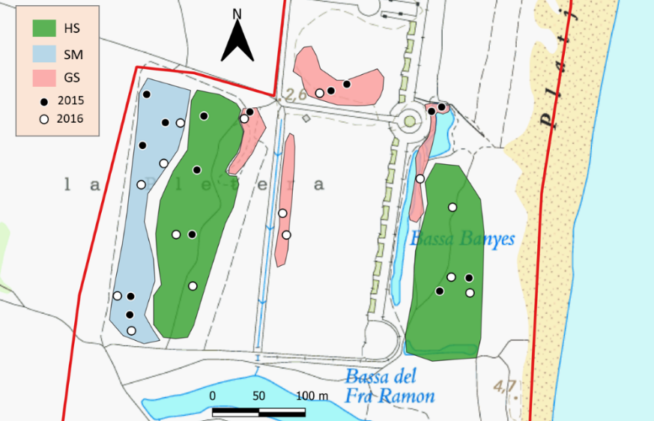
FIGURE S2. Location of the plots selected for our study within each of the three habitats (HS: halophilous scrub; SM: salt meadow; GS: glasswort sward). Black dots represent the plots sampled in 2015, while white dots represent those sampled in 2016.

