Electronic Supplementary Material

Article title: The ability of Ruppia polycarpa to regenerate from seed depends on seasonal porewater salinity dynamics and winter-rainfall decline could delay recovery

Journal name: Estuaries and Coasts
Authors’ names and affiliations:

Chanelle L. Webster^{1*}, Paul S. Lavery¹, Simone Strydom^{1,2}, Jessica Billinghurst¹ and Kathryn McMahon¹

1 Edith Cowan University, Western Australia, WA 6027
2 Department of Biodiversity, Conservation and Attractions, Kensington, WA 6151
*Correspondence author; tel: +614 3410 8362; email: chanelle.webster@ecu.edu.au

Re-submission date: 15 March 2023

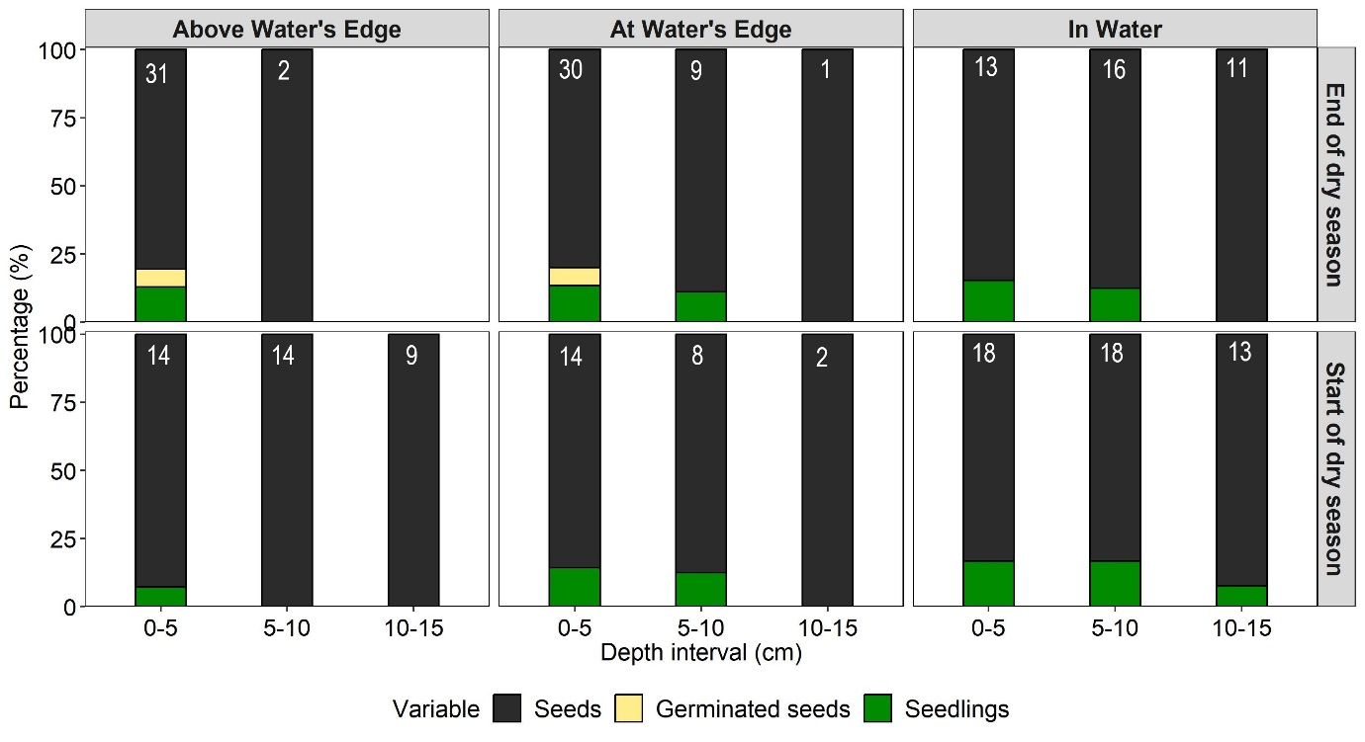
Figure 1: mean proportion of seeds, germlings and seedlings Ruppia polycarpa per m⁻³ of sediment. Values in white text indicates the total number of seeds, germinated seeds and seedlings found across all six cores. Data was collected from three replicate cores (9.6cm Ø) at the end (June 2019) and start (January 2020) of the dry season from two sites in the Vasse estuary, southwestern Australia (n=1 per site in each month).

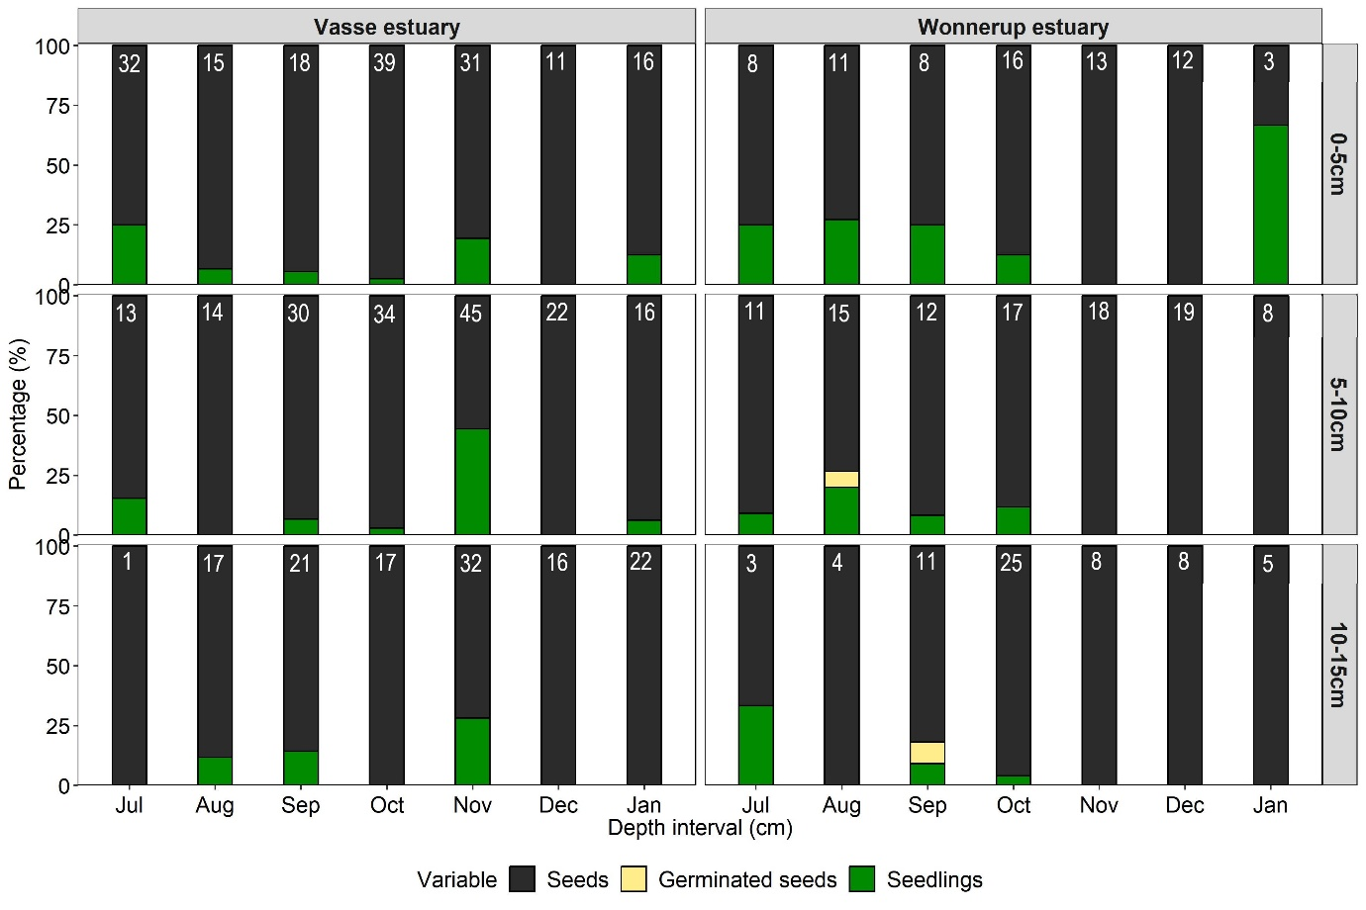
Figure 2. mean proportion of seeds, germinated seeds and seedlings of Ruppia polycarpa at different sediment depths (0-5cm; 5-10cm; 10-15cm) and over time. Values in white text indicates the total number of seedbank, germlings and seedlings across the three cores collected per m⁻³ of sediment. Data was collected from July 2019 to January 2020 from cores (9.6cm Ø) at three sites (n=3/ month) where seagrass was observed within the Vasse and Wonnerup estuaries, southwestern Australia.

