Supporting information

Macrofauna community dynamics and food webs in the canopy-forming
macroalgae and the associated detrital subsidies

 |  | TC (%) |  |  | TN (%) |  |  | C:N
Source | df | MS | Pseudo-F |  | MS | Pseudo-F |  | MS | Pseudo-F
Habitat (Ha) | 1 | 0.02 | 20.86 |  | 0.25 | 19.88* |  | 0.85 | 20.86*
Date (Da) | 2 | 0.01 | 5.83 |  | 0.09 | 5.31* |  | 0.27 | 5.84*
HaxDa | 2 | 0.00 | 0.88 |  | 0.01 | 0.78 |  | 0.04 | 0.89
Res | 18 | 0.00 |  |  | 0.02 |  |  | 0.05
Total | 23
Table S1. Results of PERMANOVA on the total carbon, total nitrogen and the C:N ratio of Fucus vesiculosus between habitats (canopy vs detritus) over three sampling dates (June 2017, September 2017, and May 2018). Permutation (4999) of residuals under unrestricted permutation of raw data (SS Type III, SS) were based on Euclidean distances. Significant effects (*p < 0.05) were investigated through pairwise comparisons (see Figure 2).

Table S2. Summary of the mean (± standard error) macrofauna abundance (individuals m⁻²) and biomass (g m⁻²) of the main species found in the canopy and detritus sites over time (June 2017, September 2017, and May 2018).
 |  | Abundance |  |  |  |  |  |  |  | Biomass
 |  | Canopy |  |  |  | Detritus |  |  |  | Canopy |  |  |  | Detritus
Species |  | Jun 17 | Sep 17 | May 18 |  | Jun 17 | Sep 17 | May 18 |  | Jun 17 | Sep 17 | May 18 |  | Jun 17 | Sep 17 | May 18
Mytilus trossulus | mean | 153 | 451 | 194 |  | 938 | 644 | 631 |  | 10.85 | 27.66 | 12.81 |  | 57.92 | 28.34 | 33.94
Mytilus trossulus | se | 103 | 113 | 105 |  | 317 | 141 | 123 |  | 5.92 | 6.31 | 6.86 |  | 20.76 | 10.84 | 7.58
Theodoxus fluviatilis | mean | 218 | 383 | 1440 |  | 231 | 113 | 40 |  | 4.06 | 10.51 | 50.09 |  | 9.82 | 16.31 | 0.77
Theodoxus fluviatilis | se | 105 | 116 | 858 |  | 72 | 33 | 12 |  | 1.55 | 2.95 | 30.27 |  | 3.20 | 12.13 | 0.32
Lymnaea peregra | mean | 2 | 4 | 0 |  | 431 | 6194 | 0 |  | 0.09 | 0.06 | 0.00 |  | 10.04 | 74.20 | 0.00
Lymnaea peregra | se | 2 | 4 | 49 |  | 209 | 1905 | 6 |  | 0.09 | 0.06 | 0.00 |  | 4.69 | 24.31 | 0.00
Gammarus sp. | mean | 342 | 1687 | 216 |  | 184 | 3109 | 9 |  | 1.68 | 18.52 | 1.08 |  | 0.49 | 29.57 | 0.01
Gammarus sp. | se | 146 | 522 | 49 |  | 80 | 624 | 6 |  | 0.52 | 6.09 | 0.37 |  | 0.24 | 6.63 | 0.01
Idotea sp. | mean | 36 | 1001 | 169 |  | 119 | 869 | 13 |  | 0.69 | 4.96 | 2.44 |  | 1.79 | 3.45 | 0.17
Idotea sp. | se | 13 | 354 | 80 |  | 35 | 224 | 9 |  | 0.25 | 1.79 | 1.13 |  | 0.59 | 0.90 | 0.13
Macoma balthica | mean | 0 | 0 | 0 |  | 0 | 0 | 9 |  | 0.00 | 0.00 | 0.00 |  | 0.00 | 0.00 | 1.01
Macoma balthica | se | 0 | 0 | 0 |  | 0 | 0 | 6 |  | 0.00 | 0.00 | 0.00 |  | 0.00 | 0.00 | 0.67
Jaera alba | mean | 27 | 0 | 0 |  | 3 | 0 | 4 |  | 0.02 | 0.00 | 0.00 |  | 0.002 | 0.00 | 0.002
Jaera alba | se | 12 | 0 | 0 |  | 3 | 0 | 4 |  | 0.01 | 0.00 | 0.00 |  | 0.002 | 0.00 | 0.002
Hydrobia sp. | mean | 2 | 0 | 0 |  | 0 | 0 | 0 |  | 0.004 | 0.00 | 0.00 |  | 0.00 | 0.00 | 0.00
Hydrobia sp. | se | 2 | 0 | 0 |  | 0 | 0 | 0 |  | 0.004 | 0.00 | 0.00 |  | 0.00 | 0.00 | 0.00
Marenzelleria sp. | mean | 0 | 0 | 0 |  | 3 | 0 | 9 |  | 0.00 | 0.00 | 0.00 |  | 0.08 | 0.00 | 0.16
Marenzelleria sp. | se | 0 | 0 | 0 |  | 3 | 0 | 9 |  | 0.00 | 0.00 | 0.00 |  | 0.08 | 0.00 | 0.16
Total | mean | 781 | 3525 | 2018 |  | 1909 | 10928 | 714 |  | 17.39 | 61.71 | 66.43 |  | 80.14 | 151.87 | 36.05
Total | se | 263 | 835 | 1015 |  | 679 | 1674 | 124 |  | 7.25 | 11.78 | 36.72 |  | 28.09 | 39.70 | 7.78

Figure S1. Total macrofauna dry weight biomass and biomass of the main species (Mytilus trossulus, Theodoxus fluviatilis, Lymnaea peregra, Gammarus sp., Idotea sp.) in the canopy and detritus sites over time (June 2017, September 2017, and May 2018).
Table S3. Results of PERMANOVA on the total biomass and the biomass of the main species (Mytilus trossulus, Theodoxus fluviatilis, Lymnaea peregra, Gammarus sp., Idotea sp.) between habitats (canopy vs detritus) over three sampling dates (June 2017, September 2017, and May 2018). Permutation (4999) of residuals under unrestricted permutation of raw data (SS Type III, SS) were based on Euclidean distances. Significant effects (*p < 0.05) were investigated through pairwise comparisons.

 |  | Total |  |  | M. trossulus |  |  | T. fluviatilis |  |  | L. peregra |  |  | Gammarus sp. |  |  | Idotea sp.
Source | df | MS | Pseudo-F |  | MS | Pseudo-F |  | MS | Pseudo-F |  | MS | Pseudo-F |  | MS | Pseudo-F |  | MS | Pseudo-F
Habitat (Ha) | 1 | 4.26 | 4.57 |  | 6.08 | 2.72 |  | 1.51 | 0.37 |  | 22.34 | 3.25 |  | 0.70 | 0.50 |  | 0.35 | 0.19
Date (Da) | 2 | 3.41 | 6.74* |  | 0.62 | 1.09 |  | 0.58 | 1.21 |  | 8.11 | 54.14*** |  | 10.91 | 65.87*** |  | 1.81 | 12.66***
HaxDa | 2 | 0.93 | 1.84 |  | 2.23 | 3.97 |  | 4.07 | 8.51** |  | 6.88 | 45.99*** |  | 1.42 | 8.55*** |  | 1.86 | 13.05***
Res | 42 | 0.51 |  |  | 0.56 |  |  | 0.48 |  |  | 0.15 |  |  | 0.17 |  |  | 0.14
Total | 47
pairwise comparisons
Da |  |  | May18<Sep17>Jun17 |  | Jun17; May18: |  |  | May18: |  |  | Jun17, Sep17: |  |  | May18: |  |  | May18:
HaxDa |  |  |  |  | Canopy > Detritus |  |  | Canopy > Detritus |  |  | Canopy < Detritus |  |  | Canopy > Detritus |  |  | Canopy > Detritus

Figure S2. Daily (mean ±se) temperature and illuminance (lux) measured by HOBO data loggers during two months in the mesh-bag Fucus degradation experiment comparing the shallow (3 m) and deep (6 m) sedimentary sites.

Table S4. A summary of the overall mean (± SD) δ¹³C and δ¹⁵N signatures of epigrazer species and food source macrophytes in the canopy and detritus habitats over three sampling dates. The replicate number is 4. For biplots, see Fig. S3.

 |  | June 2017 |  |  |  |  | September 2017 |  |  |  |  | May 2018
 |  | δ¹³C |  | δ¹⁵N |  |  | δ¹³C |  | δ¹⁵N |  |  | δ¹³C |  | δ¹⁵N
 |  | Mean | SD | Mean | SD |  | Mean | SD | Mean | SD |  | Mean | SD | Mean | SD
Canopy habitat | Macrophytes
Canopy habitat | Fucus vesiculosus | -14.8 | 2.3 | 4.3 | 0.3 |  | -14.7 | 0.5 | 5.3 | 0.5 |  | -12.0 | 1.5 | 4.6 | 1.3
Canopy habitat | Pilayella littoralis | -22.3 | 0.7 | 4.5 | 0.3 |  | - | - | - | - |  | - | - | - | -
Canopy habitat | Macrofauna
Canopy habitat | Theodoxus fluviatilis | -16.3 | 0.3 | 7.1 | 0.2 |  | -16.5 | 0.5 | 6.4 | 0.2 |  | -16.8 | 0.5 | 7.2 | 0.2
Canopy habitat | Lymnaea peregra (n=1) | -19.3 |  | 6.2 |  |  | - | - | - | - |  | - | - | - | -
Canopy habitat | Gammarus sp. | -19.3 | 0.6 | 6.6 | 0.3 |  | -18.7 | 0.4 | 5.8 | 0.2 |  | -18.4 | 0.6 | 6.4 | 0.6
Canopy habitat | Idotea sp. | -17.4 | 0.6 | 7.1 | 0.4 |  | -16.5 | 0.5 | 5.6 | 0.8 |  | -15.7 | 1.5 | 6.3 | 0.1
Detritus habitat | Macrophytes
Detritus habitat | Fucus vesiculosus | -16.0 | 1.5 | 5.6 | 0.5 |  | -15.9 | 2.6 | 4.6 | 1.1 |  | -17.31 | 2.34 | 5.21 | 0.59
Detritus habitat | Ceramium sp. | - | - | - | - |  | -21.6 | 2.1 | 4.6 | 0.5 |  | - | - | - | -
Detritus habitat | Macrofauna
Detritus habitat | Theodoxus fluviatilis | -15.8 | 0.4 | 8.2 | 0.1 |  | -17.2 | 0.2 | 6.3 | 0.1 |  | -15.4 | 0.7 | 7.4 | 0.2
Detritus habitat | Lymnaea peregra | -18.6 | 0.1 | 7.9 | 0.2 |  | -20.0 | 0.4 | 5.8 | 0.2 |  | - | - | - | -
Detritus habitat | Gammarus sp. | -18.6 | 0.3 | 6.4 | 1.5 |  | -18.9 | 0.3 | 4.6 | 0.6 |  | - | - | - | -
Detritus habitat | Idotea sp. | -16.8 | 0.8 | 6.9 | 0.5 |  | -17.9 | 0.2 | 5.4 | 0.4 |  | -16.0 | 0.8 | 6.9 | 0.5

Figure S3. Biplots showing δ¹³C and δ¹⁵N signatures of consumer fauna in the Fucus canopy (A) and detritus accumulation (B) habitats over three sampling dates, and a mixing polygon simulation with probability areas for the whole dataset (Smith et al. 2013) (C). In panels A and B, the mean (± SD) signatures of ephemeral algae (Pilayella + Ceramium) and F.vesiculosus are also presented (the applied trophic enrichment factors of carbon and nitrogen are included). In panel C, the mean signatures of food sources over the three sapling dates in both habitats are presented.

B
A
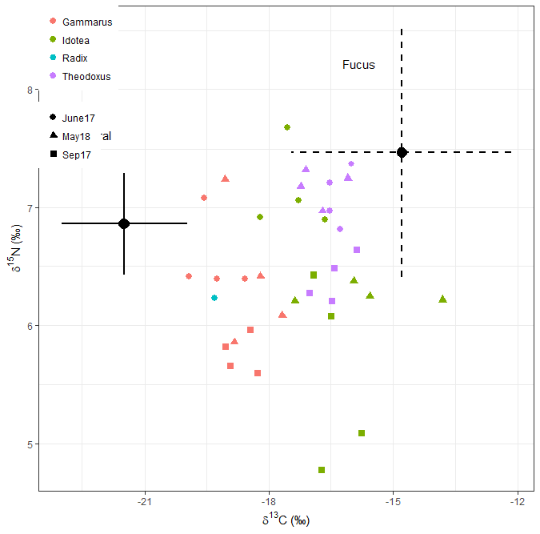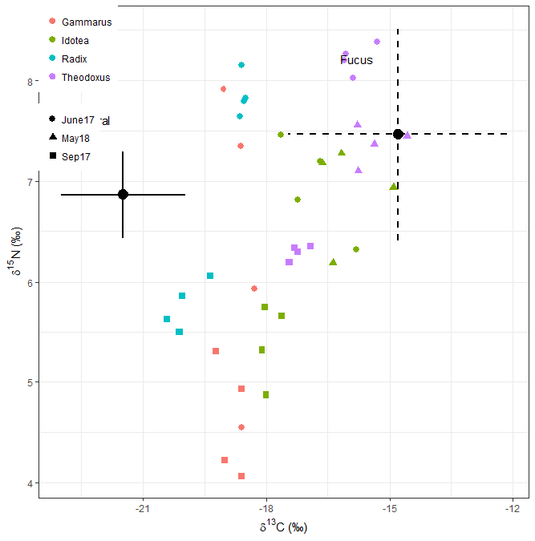
Gammarus
Idotea
Lymnaea
Theodoxus
Gammarus
Idotea
Lymnaea
Theodoxus
Figure S3 (Continuation). Biplots showing δ¹³C and δ¹⁵N signatures of consumer fauna in the Fucus canopy (A) and detritus accumulation (B) habitats over three sampling dates, and a mixing polygon simulation with probability areas for the whole dataset (Smith et al. 2013) (C). In panels A and B, the mean (± SD) signatures of ephemeral algae (Pilayella + Ceramium) and F.vesiculosus are also presented (the applied trophic enrichment factors of carbon and nitrogen are included). In panel C, the mean signatures of food sources over the three sapling dates in both habitats are presented.
C
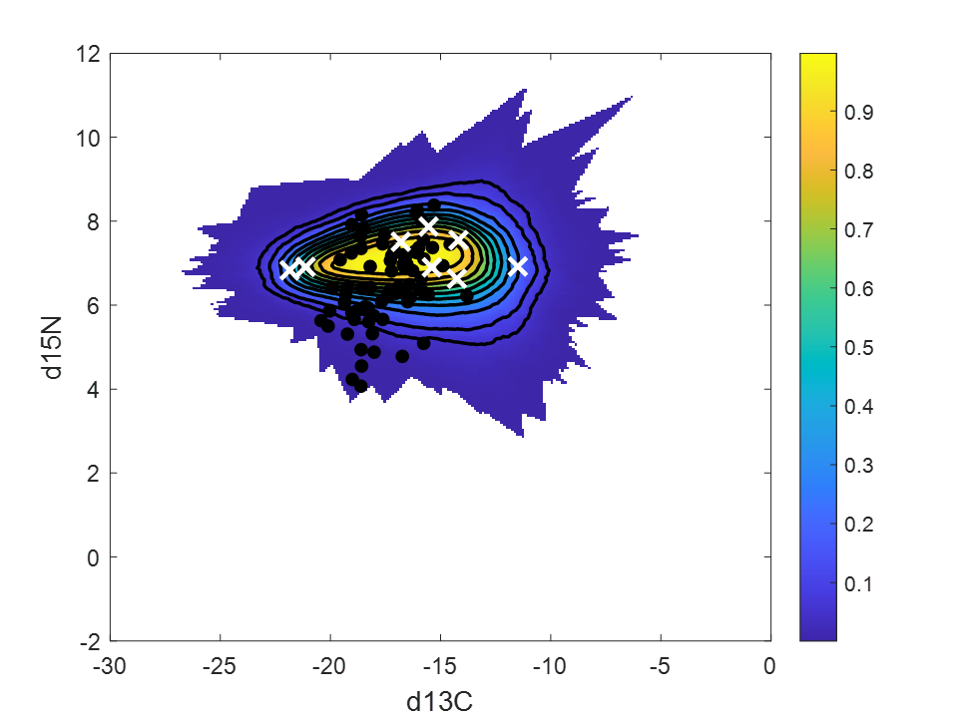

Figure S4. Median dietary proportions of Fucus vesiculosus (brown), Pilayella littoralis (green) and seston POM/DOM (blue) in the diet of (Gammarus sp., Idotea balthica, Theodoxus fluviatilis, Lymnaea peregra, Mytilus trossulus, Macoma balthica, Hediste diversicolor and Chironomid larvae) as an overall mean including all observations across the two-month incubation time at shallow (3 m) and deep (6 m) sites. Bayesian credibility intervals (50 %, 90 % and 95 %) are presented.

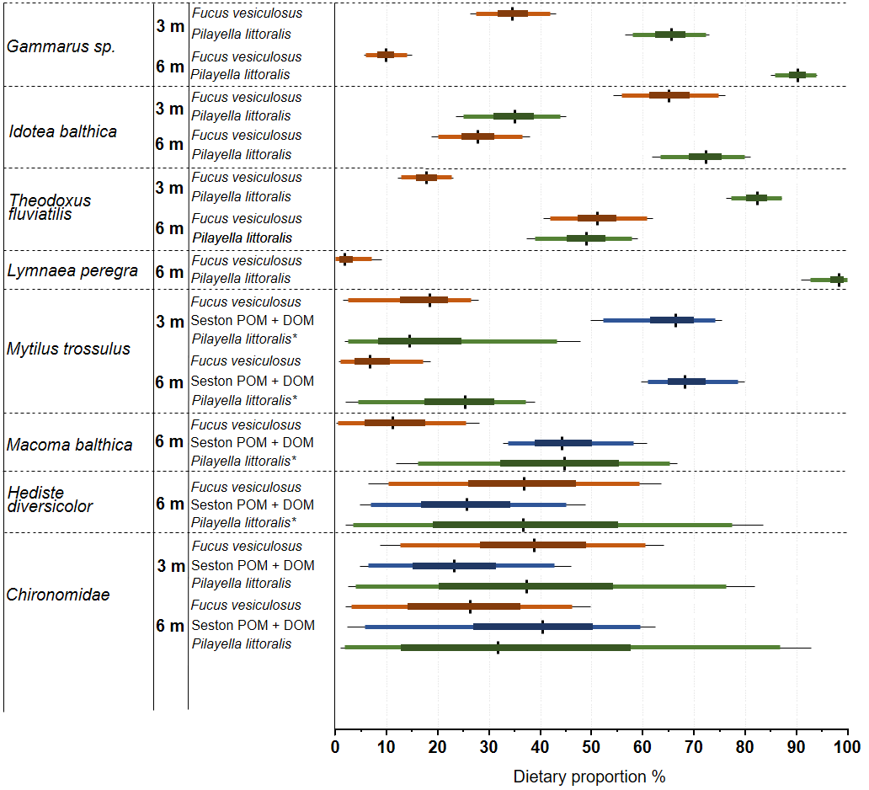
*Might include sedimentary detrital matter in addition to P. littoralis

Table S5. Summary of the abundance of the main invertebrate species (i.e. Gammarus sp., Idotea sp., Macoma balthica, Mytilus trossulus, Theodoxus fluviatilis, Lymnaea peregra, Chironomid larvae, Marenzelleria spp., and Hediste diversicolor) found in the mesh-bag Fucus degradation experiment comparing the shallow (3 m) and deep (6 m) sites. The number of individuals is a composite between the epifauna associated to the algae within the mesh bag and the macroinfauna (benthic core) living in the sediment under the bag.
 |  | Gammarus sp. |  | Idotea sp. |  | M. balthica |  | M. trossulus |  | T. fluviatilis
Site | Date | Mean | SE | Mean | SE | Mean | SE | Mean | SE | Mean | SE
Shallow | 08.06.18 | 17.0 | 4.6 | 2.8 | 1.0 | 0.2 | 0.2 | 1.4 | 1.4 | 0.0 | 0.0
Shallow | 12.06.18 | 17.2 | 6.6 | 4.0 | 1.9 | 0.2 | 0.2 | 0.2 | 0.2 | 0.0 | 0.0
Shallow | 27.06.18 | 29.2 | 4.4 | 1.4 | 0.7 | 6.8 | 1.6 | 0.0 | 0.0 | 1.6 | 0.5
Shallow | 07.08.18 | 1.0 | 0.3 | 0.2 | 0.2 | 0.0 | 0.0 | 0.2 | 0.2 | 0.0 | 0.0
Deep | 08.06.18 | 3.0 | 1.1 | 3.2 | 0.5 | 0.4 | 0.4 | 57.4 | 7.8 | 4.0 | 0.8
Deep | 12.06.18 | 3.2 | 1.3 | 12.6 | 2.2 | 1.4 | 0.7 | 151.2 | 16.8 | 10.8 | 1.3
Deep | 27.06.18 | 51.4 | 12.6 | 3.6 | 0.7 | 2.4 | 0.6 | 344.4 | 61.2 | 26.0 | 5.0
Deep | 07.08.18 | 20.0 | 6.4 | 0.6 | 0.2 | 1.2 | 0.7 | 21.4 | 3.7 | 4.4 | 1.6
 |  | L. peregra |  | Chironomidae |  | Marenzelleria sp. |  | H. diversicolor |  | Total
Site | Date | Mean | SE | Mean | SE | Mean | SE | Mean | SE | Mean | SE
Shallow | 08.06.18 | 0.0 | 0.0 | 0.0 | 0.0 | 0.0 | 0.0 | 0.0 | 0.0 | 21 | 6
Shallow | 12.06.18 | 0.0 | 0.0 | 0.0 | 0.0 | 0.0 | 0.0 | 0.0 | 0.0 | 22 | 8
Shallow | 27.06.18 | 0.2 | 0.2 | 0.0 | 0.0 | 0.0 | 0.0 | 0.0 | 0.0 | 39 | 3
Shallow | 07.08.18 | 0.0 | 0.0 | 0.8 | 0.4 | 0.0 | 0.0 | 0.0 | 0.0 | 2 | 0
Deep | 08.06.18 | 0.0 | 0.0 | 0.0 | 0.0 | 0.2 | 0.2 | 0.0 | 0.0 | 68 | 8
Deep | 12.06.18 | 1.0 | 0.8 | 0.0 | 0.0 | 0.4 | 0.2 | 0.0 | 0.0 | 181 | 18
Deep | 27.06.18 | 0.6 | 0.2 | 0.0 | 0.0 | 0.0 | 0.0 | 0.4 | 0.2 | 429 | 55
Deep | 07.08.18 | 0.0 | 0.0 | 1.6 | 0.7 | 0.0 | 0.0 | 0.4 | 0.2 | 50 | 9

Table S6. Summary (mean ± standard deviation) of the stable isotopes and C and N contents of the main food sources in the mesh bag experiment comparing the shallow (3 m) and deep (6 m) sites over time. Samples for F. vesiculosus at t₀ were taken two days before starting the experiment (06.06.18). Sediment controls are sediment samples adjacent to the bags.
*= the values have been calculated from 5 randomly selected mesh bags from each depth.
 |  |  |  |  |  |  |  |  |  | Sediment
 |  |  |  | Fucus vesiculosus |  |  | Pilayella littoralis |  |  | Control |  | Bag
 | Site | Date | Time | Mean | SD |  | Mean | SD |  | Mean | SD | Mean | SD
δ¹³C |  | 06.06.18 | t₀ | -11.89 | 2.20 |  | - | - |  | - | - | - | -
δ¹³C | Shallow | 08.06.18 | t₁ | -14.22 | 1.80 |  | -20.26 | 0.29 |  | -20.89 | 0.14 | -20.33 | 0.09
δ¹³C | Shallow | 12.06.18 | t₂ | -11.82 | 1.45 |  | -18.87 | 1.33 |  | -20.44 | 0.10 | -20.84 | 0.08
δ¹³C | Shallow | 27.06.18 | t₃ | -12.93 | 1.65 |  | -20.01 | 0.86 |  | -20.91 | 0.05 | -20.44 | 0.12
δ¹³C | Shallow | 07.08.18 | t₄ | -15.78 | 1.11 |  | -17.69 | 0.80 |  | -20.48 | 0.02 | -20.30 | 0.18
δ¹³C |  | 06.06.18 | t₀ | -14.40 | 2.18 |  | - | - |  | - | - | - | -
δ¹³C | Deep | 08.06.18 | t₁ | -14.19 | 2.16 |  | -20.49 | 0.41 |  | -22.84 | 0.05 | -22.84 | 0.05
δ¹³C | Deep | 12.06.18 | t₂ | -11.52 | 2.74 |  | -20.17 | 0.63 |  | -22.31 | 0.06 | -22.45 | 0.04
δ¹³C | Deep | 27.06.18 | t₃ | -13.49 | 1.30 |  | -20.90 | 0.51 |  | -22.33 | 0.06 | -22.41 | 0.03
δ¹³C | Deep | 07.08.18 | t₄ | -15.68 | 0.53 |  | -20.56 | 0.80 |  | -22.43 | 0.02 | -22.21 | 0.05
δ¹⁵N |  | 06.06.18 | t₀ | 3.28 | 0.72 |  | - | - |  | - | - | - | -
δ¹⁵N | Shallow | 08.06.18 | t₁ | 3.52 | 0.98 |  | 4.02 | 1.13 |  | 4.83 | 0.02 | 4.57 | 0.10
δ¹⁵N | Shallow | 12.06.18 | t₂ | 3.46 | 0.87 |  | 3.76 | 0.44 |  | 4.91 | 0.10 | 4.30 | 0.18
δ¹⁵N | Shallow | 27.06.18 | t₃ | 3.74 | 0.63 |  | 4.39 | 0.50 |  | 4.35 | 0.06 | 4.51 | 0.10
δ¹⁵N | Shallow | 07.08.18 | t₄ | 1.98 | 0.24 |  | 2.78 | 0.33 |  | 3.67 | 0.10 | 4.35 | 0.13
δ¹⁵N |  | 06.06.18 | t₀ | 3.03 | 0.74 |  | - | - |  | - | - | - | -
δ¹⁵N | Deep | 08.06.18 | t₁ | 2.57 | 0.96 |  | 3.85 | 0.18 |  | 5.68 | 0.03 | 5.68 | 0.03
δ¹⁵N | Deep | 12.06.18 | t₂ | 3.45 | 0.82 |  | 4.75 | 0.59 |  | 5.98 | 0.03 | 5.35 | 0.07
δ¹⁵N | Deep | 27.06.18 | t₃ | 2.82 | 0.79 |  | 4.27 | 0.28 |  | 5.64 | 0.17 | 4.96 | 0.06
δ¹⁵N | Deep | 07.08.18 | t₄ | 3.67 | 0.52 |  | 3.88 | 1.08 |  | 4.34 | 0.04 | 4.60 | 0.06
C:N |  | 06.06.18* | t₀ | 25.74 | 3.69 |  | - | - |  | - | - | - | -
C:N | Shallow | 08.06.18 | t₁ | 24.08 | 5.59 |  | 10.36 | 1.39 |  | 6.13 | 0.17 | 7.41 | 0.34
C:N | Shallow | 12.06.18 | t₂ | 25.15 | 6.13 |  | 11.47 | 1.78 |  | 7.38 | 0.35 | 6.90 | 0.26
C:N | Shallow | 27.06.18 | t₃ | 14.60 | 3.11 |  | 11.88 | 1.10 |  | 7.19 | 0.47 | 6.68 | 0.35
C:N | Shallow | 07.08.18 | t₄ | 9.85 | 0.44 |  | 6.76 | 0.47 |  | 8.06 | 0.21 | 6.64 | 0.14
C:N |  | 06.06.18* | t₀ | 28.06 | 5.06 |  | - | - |  | - | - | - | -
C:N | Deep | 08.06.18 | t₁ | 29.30 | 6.05 |  | 10.25 | 1.92 |  | 6.37 | 0.15 | 6.37 | 0.15
C:N | Deep | 12.06.18 | t₂ | 19.53 | 0.79 |  | 10.38 | 1.93 |  | 7.71 | 0.23 | 7.12 | 0.09
C:N | Deep | 27.06.18 | t₃ | 17.75 | 3.82 |  | 12.90 | 2.44 |  | 7.32 | 0.18 | 7.19 | 0.14
C:N | Deep | 07.08.18 | t₄ | 9.54 | 0.60 |  | 6.82 | 0.78 |  | 7.05 | 0.23 | 7.61 | 0.33

 |  |  |  | Fucus vesiculosus |  |  | Pilayella littoralis
 | Site | Date | Time | Mean | SD |  | Mean | SD
C % |  | 06.06.18* | t₀ | 36.1 | 1.0
C % | Shallow | 08.06.18 | t₁ | 35.8 | 0.2 |  | 29.3 | 4.1
C % | Shallow | 12.06.18 | t₂ | 34.3 | 1.0 |  | 29.8 | 2.5
C % | Shallow | 27.06.18 | t₃ | 35.0 | 1.2 |  | 32.5 | 5.5
C % | Shallow | 07.08.18 | t₄ | 39.8 | 1.3 |  | 28.7 | 2.6
C % |  | 06.06.18* | t₀ | 36.1 | 1.0
C % | Deep | 08.06.18 | t₁ | 35.2 | 0.9 |  | 26.8 | 7.1
C % | Deep | 12.06.18 | t₂ | 33.9 | 2.3 |  | 32.9 | 2.6
C % | Deep | 27.06.18 | t₃ | 35.4 | 1.1 |  | 30.7 | 4.2
C % | Deep | 07.08.18 | t₄ | 38.6 | 1.2 |  | 25.4 | 2.7
N % |  | 06.06.18* | t₀ | 1.4 | 0.2
N % | Shallow | 08.06.18 | t₁ | 1.6 | 0.4 |  | 2.9 | 0.7
N % | Shallow | 12.06.18 | t₂ | 1.4 | 0.3 |  | 2.7 | 0.6
N % | Shallow | 27.06.18 | t₃ | 2.5 | 0.5 |  | 2.7 | 0.5
N % | Shallow | 07.08.18 | t₄ | 4.0 | 0.1 |  | 4.1 | 0.1
N % |  | 06.06.18* | t₀ | 1.3 | 0.2
N % | Deep | 08.06.18 | t₁ | 1.2 | 0.3 |  | 2.8 | 1.1
N % | Deep | 12.06.18 | t₂ | 1.7 | 0.1 |  | 3.3 | 0.7
N % | Deep | 27.06.18 | t₃ | 2.1 | 0.4 |  | 2.4 | 0.3
N % | Deep | 07.08.18 | t₄ | 4.1 | 0.2 |  | 3.6 | 0.2

Table S7. Summary of the stable isotopes (mean ± standard deviation) of the main invertebrate species found in the mesh bags at two depths (3 vs 6 m, shallow vs deep sites) over time (sampling dates). For biplots, see Fig. S5.

 |  |  | Gammarus sp. |  |  | Idotea balthica
 | Site | Date | Mean | SD |  | Mean | SD
δ¹³C | Shallow | 08.06.18 | -18.60 | 1.10 |  | -15.89 | 1.05
δ¹³C | Shallow | 12.06.18 | -17.61 | 0.92 |  | -15.27 | 0.41
δ¹³C | Shallow | 27.06.18 | -16.96 | 0.18 |  | -15.68 | 1.21
δ¹³C | Shallow | 07.08.18 | -16.93 | 1.86 |  | -14.22 | 0.00
δ¹³C | Deep | 08.06.18 | -18.68 | 0.09 |  | -18.32 | 0.59
δ¹³C | Deep | 12.06.18 | -18.81 | 0.50 |  | -17.02 | 0.40
δ¹³C | Deep | 27.06.18 | -18.79 | 0.57 |  | -18.31 | 0.79
δ¹³C | Deep | 07.08.18 | -18.46 | 0.36 |  | -17.39 | 0.26
δ¹⁵N | Shallow | 08.06.18 | 6.62 | 0.25 |  | 6.69 | 0.47
δ¹⁵N | Shallow | 12.06.18 | 6.11 | 0.25 |  | 6.10 | 0.47
δ¹⁵N | Shallow | 27.06.18 | 5.28 | 0.29 |  | 6.36 | 1.80
δ¹⁵N | Shallow | 07.08.18 | 5.11 | 0.70 |  | 5.14 | 0.00
δ¹⁵N | Deep | 08.06.18 | 6.50 | 0.51 |  | 6.50 | 0.49
δ¹⁵N | Deep | 12.06.18 | 6.49 | 0.51 |  | 5.84 | 0.49
δ¹⁵N | Deep | 27.06.18 | 6.61 | 0.57 |  | 6.51 | 0.53
δ¹⁵N | Deep | 07.08.18 | 5.51 | 0.73 |  | 3.19 | 0.06

Table S7 (continuation). Summary of the stable isotopes (mean ± standard deviation) of the main invertebrate species found in the mesh bags at two depths (3 vs 6 m, shallow vs deep sites) over time (sampling dates). For biplots, see Fig. S5.
 |  |  | M. baltica |  |  | M. trossulus |  |  | T. fluviatilis
 | Site | Date | Mean | SD |  | Mean | SD |  | Mean | SD
δ¹³C | Deep | 08.06.18 | -21.84 | 0.00 |  | -22.27 | 0.36 |  | -19.36 | 0.38
δ¹³C | Deep | 12.06.18 | -21.38 | 0.09 |  | -22.01 | 0.35 |  | -19.21 | 0.35
δ¹³C | Deep | 27.06.18 | -21.70 | 0.57 |  | -22.62 | 0.37 |  | -19.03 | 1.00
δ¹³C | Deep | 07.08.18 | -21.86 | 0.20 |  | -22.29 | 0.67 |  | -16.61 | 0.97
δ¹⁵N | Deep | 08.06.18 | 6.83 | 0.09 |  | 7.34 | 0.19 |  | 8.00 | 0.39
δ¹⁵N | Deep | 12.06.18 | 7.06 | 0.09 |  | 7.45 | 0.19 |  | 7.86 | 0.39
δ¹⁵N | Deep | 27.06.18 | 7.08 | 0.31 |  | 7.63 | 0.34 |  | 8.00 | 0.44
δ¹⁵N | Deep | 07.08.18 | 6.62 | 0.37 |  | 6.78 | 0.33 |  | 6.35 | 0.41

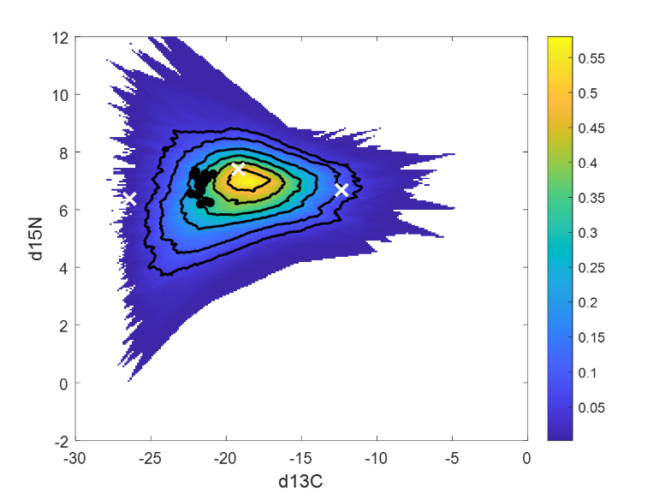
Figure S5. Biplots showing δ¹³C and δ¹⁵N signatures of consumer fauna found in the mesh bags: epigrazers at two depths (3 vs. 6 m) (A), M. balthica (B) at 6 m and M. trossulus (C) at 6 m. In panel A, the mean (± SD) signatures of ephemeral algae (Pilayella) and F.vesiculosus are also presented. In panels B and C, three-source mixing polygon simulations with probability areas are presented (Smith et al. 2013). The applied trophic enrichment factors of carbon and nitrogen are included.
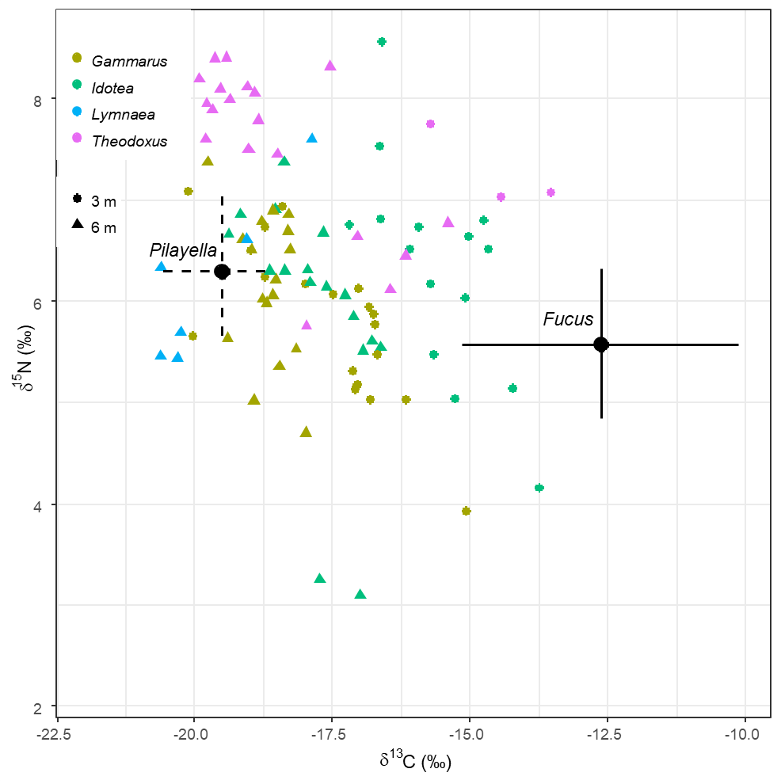
A
B
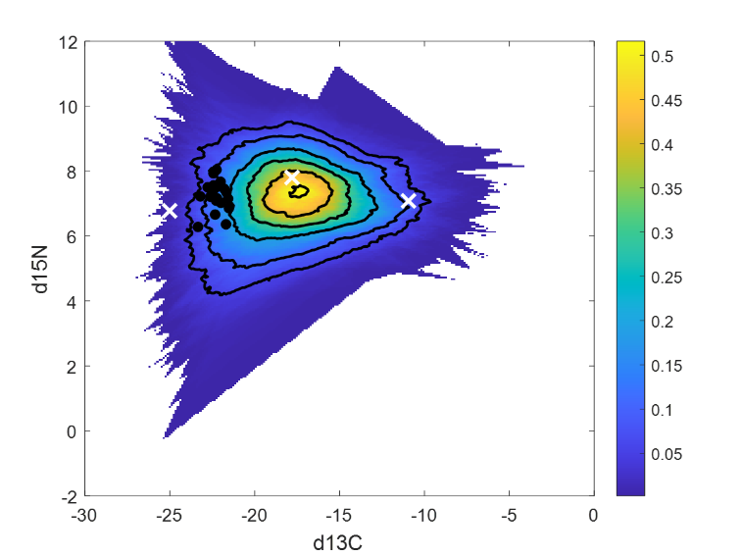
C

