Supplementary Information
Table S1 Model candidate sets and model evaluation scores. Models are ordered from best to worst based on mean prediction error. *indicates interaction term. Elevation and distance to tidal creek are not used in combination due to collinearity (0.785 correlation coefficient).
Model | Variables |  |  |  |  |  |  |  |  |  |  |  |  | Evaluation scores
Model | Random effect (1|Site) | Elevation | Vegetation | Distance to high water (m) | Distance to tidal creek (m) | Soil Texture | Tidal inundation period | Elevation * Soil texture | Elevation * Vegetation | Tidal inundation period * Elevation | Tidal inundation period * Veg | Tidal inundation period * Soil | Elevation * highwater | Bayes R² | Mean Prediction Error | Leave one out | WAIC
25 | ✓ |  | ✓ | ✓ | ✓ | ✓ | ✓ |  |  |  |  |  |  | 0.82 | 13.45 | 648.18 | 646.71
21 | ✓ |  |  |  |  |  |  |  | ✓ |  |  | ✓ |  | 0.78 | 13.53 | 659.30 | 657.09
24 | ✓ | ✓ | ✓ | ✓ |  | ✓ | ✓ |  |  |  |  |  |  | 0.79 | 14.75 | 656.48 | 654.96
15 | ✓ |  |  |  |  |  |  | ✓ |  |  |  |  |  | 0.74 | 15.27 | 659.42 | 657.83
19 | ✓ |  |  |  |  |  |  |  |  |  |  | ✓ |  | 0.75 | 15.87 | 659.79 | 657.90
14 | ✓ |  | ✓ |  |  | ✓ |  |  |  |  |  |  |  | 0.77 | 15.93 | 657.52 | 656.45
13 | ✓ | ✓ |  |  |  | ✓ |  |  |  |  |  |  |  | 0.75 | 16.11 | 656.58 | 655.60
12 | ✓ |  |  |  |  | ✓ | ✓ |  |  |  |  |  |  | 0.74 | 16.76 | 656.78 | 656.21
5 | ✓ |  |  |  |  | ✓ |  |  |  |  |  |  |  | 0.71 | 18.53 | 661.31 | 660.71
6 | ✓ |  |  |  |  |  |  |  | ✓ |  |  |  |  | 0.63 | 21.19 | 673.84 | 672.96
18 | ✓ |  |  |  |  |  |  |  |  |  | ✓ |  |  | 0.62 | 21.37 | 683.61 | 682.81
23 | ✓ |  | ✓ | ✓ | ✓ |  | ✓ |  |  |  |  |  |  | 0.62 | 21.40 | 682.28 | 681.76
22 | ✓ |  | ✓ |  | ✓ |  |  |  |  |  |  |  |  | 0.59 | 21.89 | 679.78 | 679.39
9 | ✓ |  | ✓ |  |  |  | ✓ |  |  |  |  |  |  | 0.59 | 22.56 | 681.66 | 681.37
2 | ✓ |  | ✓ |  |  |  |  |  |  |  |  |  |  | 0.58 | 22.62 | 679.52 | 679.19
8 | ✓ | ✓ | ✓ |  |  |  |  |  |  |  |  |  |  | 0.58 | 22.82 | 680.96 | 680.68
20 | ✓ |  |  |  |  |  |  |  |  |  |  |  | ✓ | 0.57 | 25.13 | 675.92 | 675.61
16 | ✓ | ✓ |  | ✓ |  |  |  |  |  |  |  |  |  | 0.49 | 25.68 | 687.42 | 687.05
10 | ✓ |  |  | ✓ |  |  | ✓ |  |  |  |  |  |  | 0.46 | 26.29 | 688.01 | 687.61
3 | ✓ |  |  | ✓ |  |  |  |  |  |  |  |  |  | 0.46 | 26.33 | 690.24 | 689.91
1 | ✓ | ✓ |  |  |  |  |  |  |  |  |  |  |  | 0.42 | 27.65 | 690.65 | 690.38
11 | ✓ |  |  |  | ✓ |  | ✓ |  |  |  |  |  |  | 0.39 | 27.66 | 689.85 | 689.37
4 | ✓ |  |  |  | ✓ |  |  |  |  |  |  |  |  | 0.38 | 28.06 | 689.85 | 689.60
17 | ✓ |  |  |  |  |  |  |  |  | ✓ |  |  |  | 0.44 | 28.14 | 689.08 | 688.73
7 | ✓ |  |  |  |  |  | ✓ |  |  |  |  |  |  | 0.35 | 29.46 | 694.44 | 694.12
0 | ✓ |  |  |  |  |  |  |  |  |  |  |  |  | 0.19 | 31.77 | 706.75 | 706.58

Figure S1 Plots of predictive error of soil organic carbon stocks (t/ha) (y axis for all plots) split by variables (x axis) to investigate systematic error. Boxplots for categorical variables (A and B) and scatter plots for continuous variables (C, D and E) with a fitted line (blue) and standard error (grey shading).
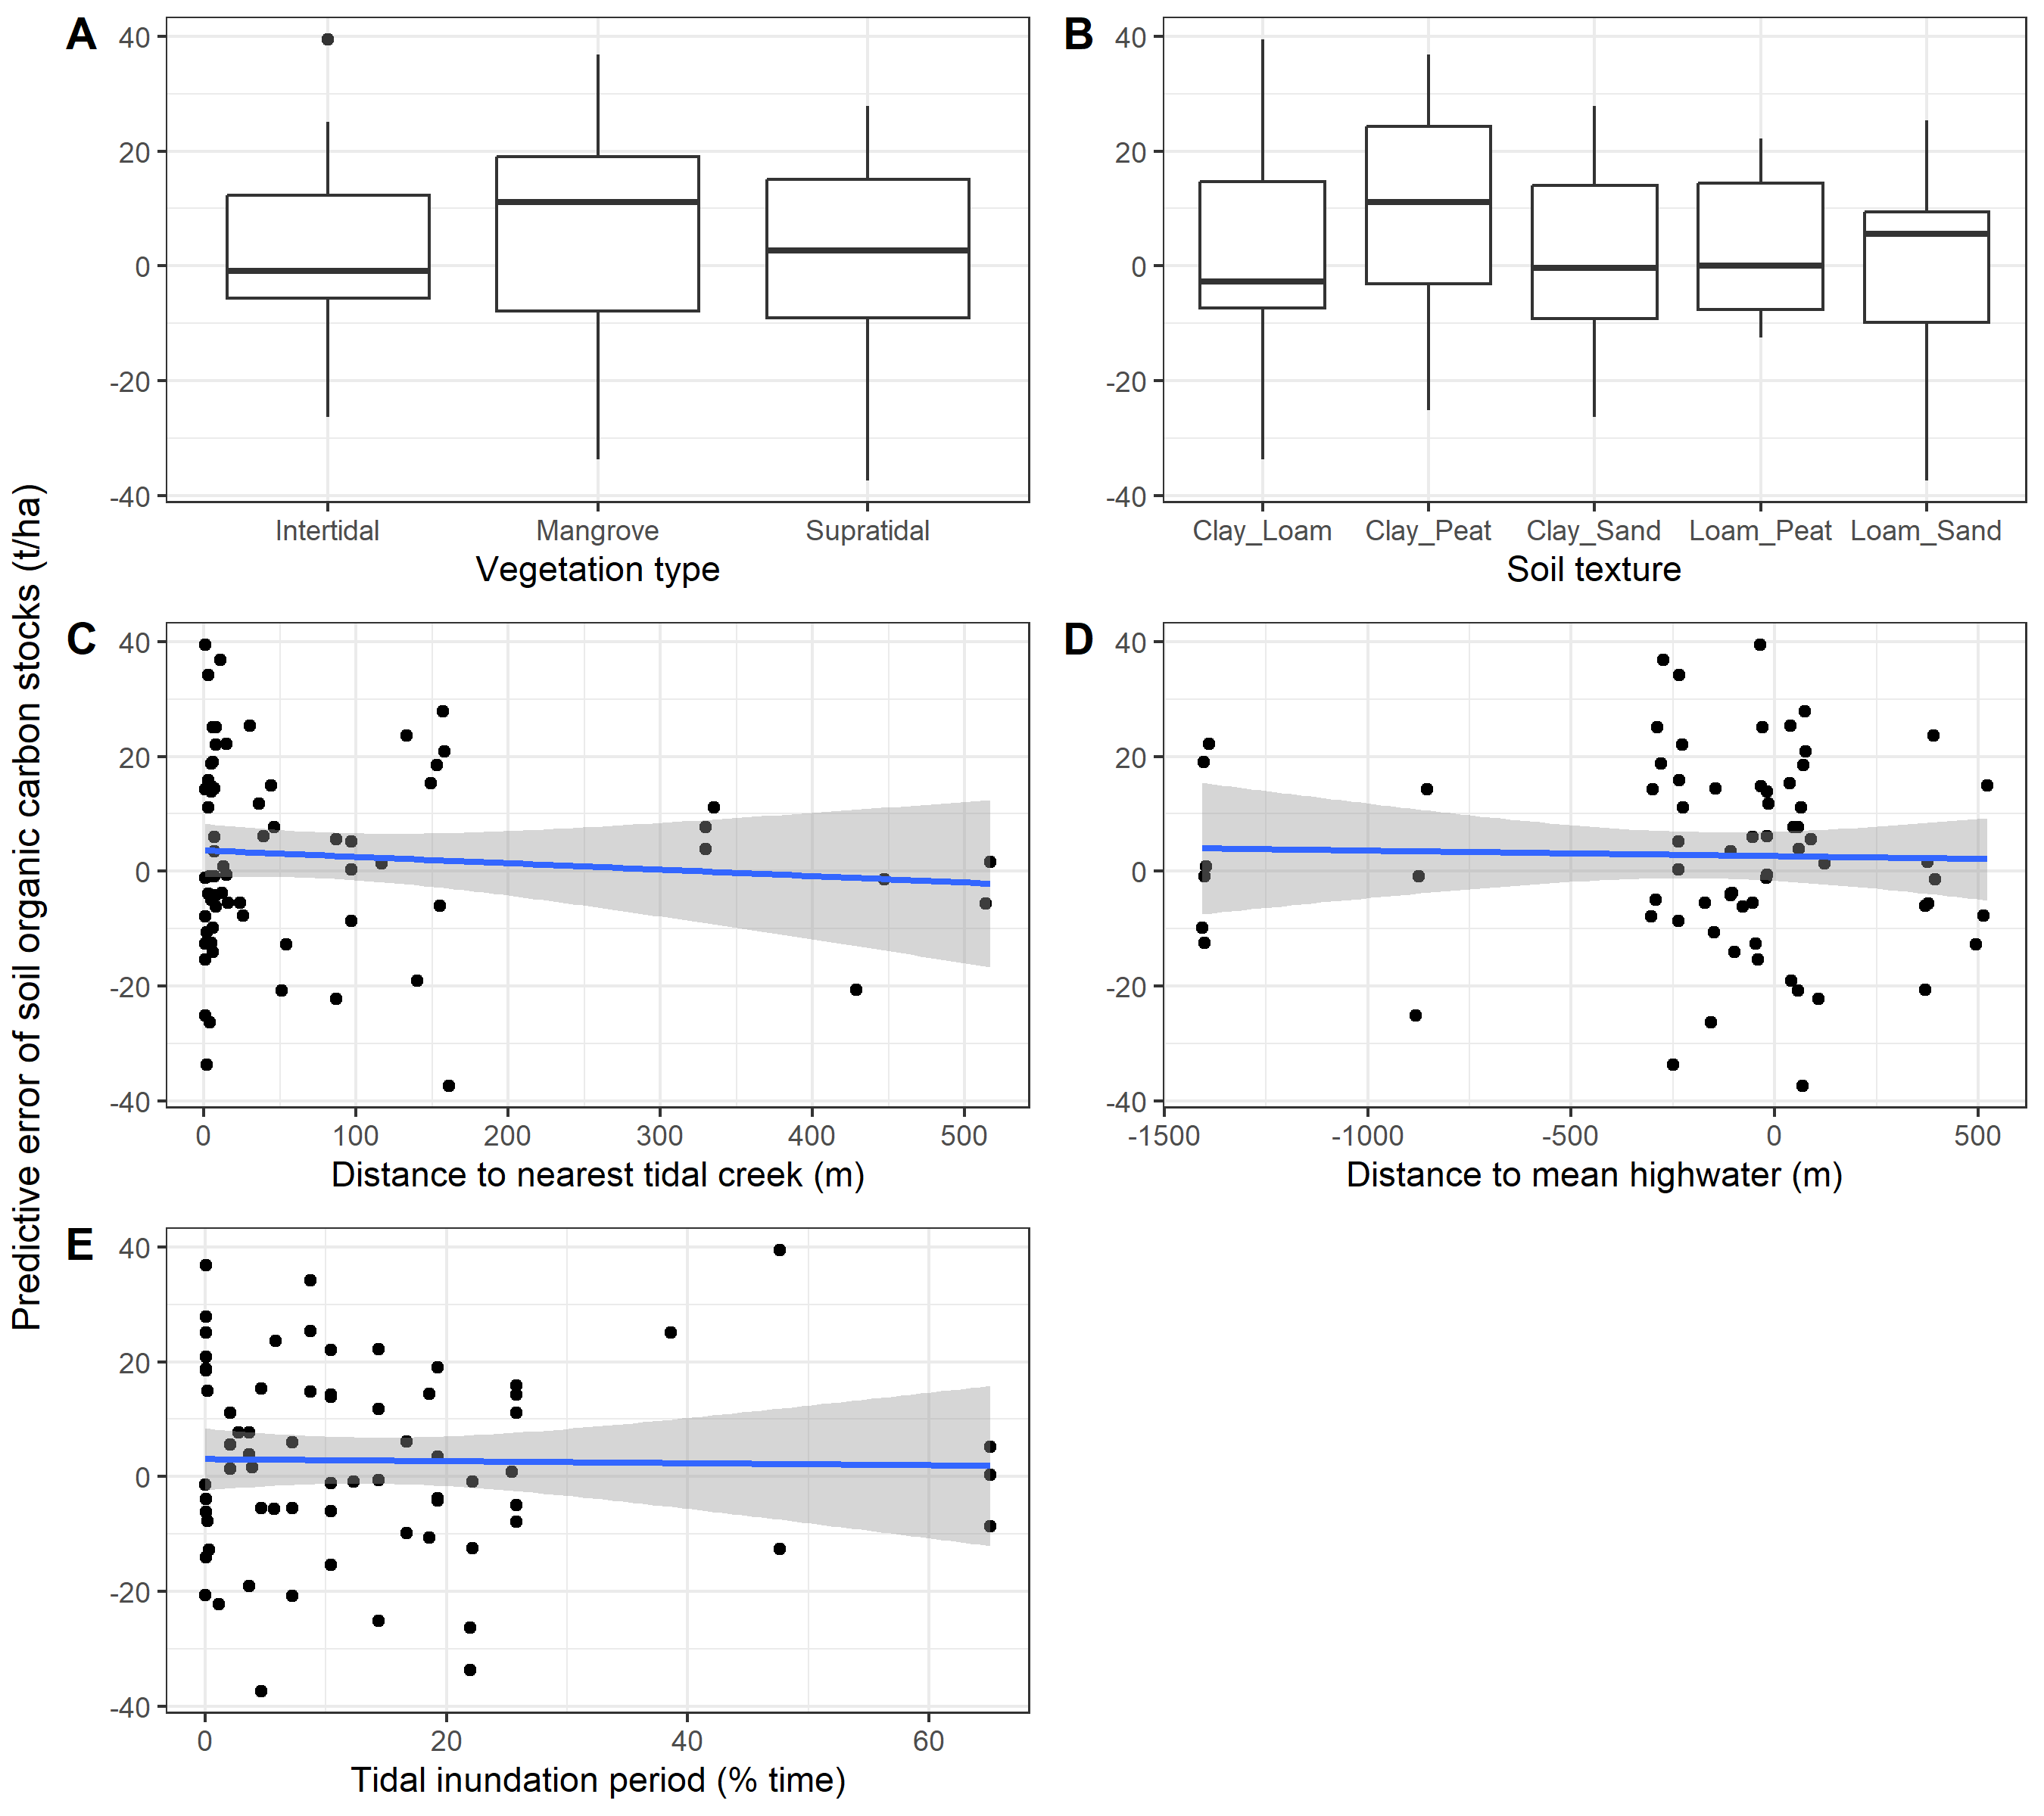

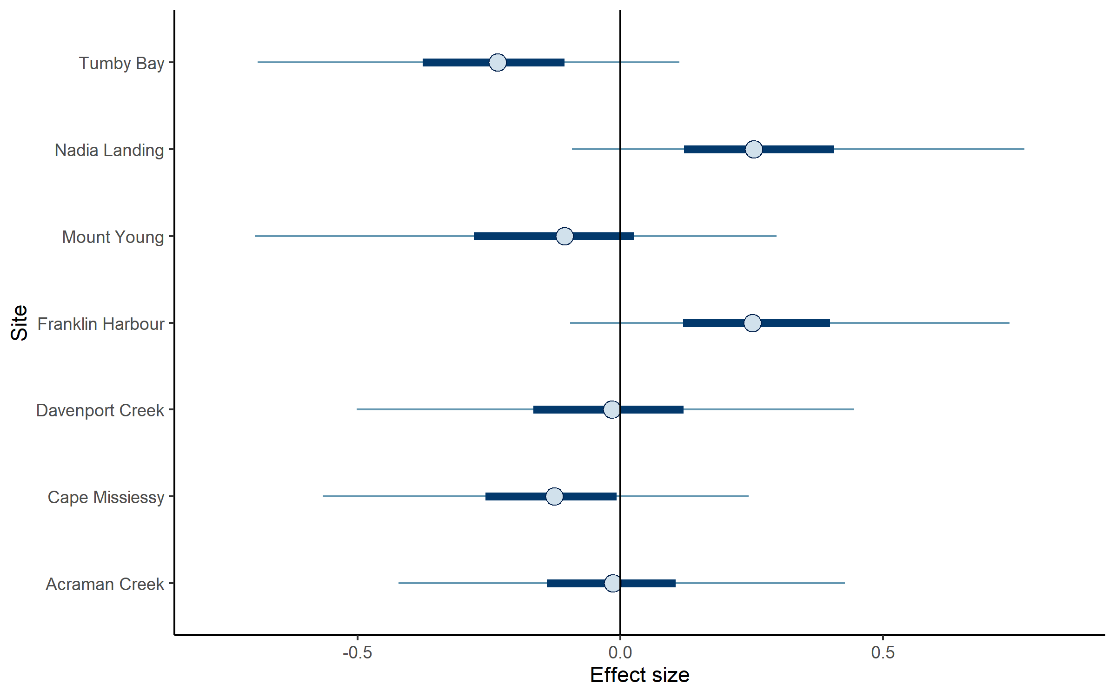
Figure S2 Random effect size plot of sites on soil organic carbon stocks. Parameter estimates are Bayesian posterior median values, 95% highest posterior density uncertainty (thin lines) and 50% uncertainty intervals (thick lines). All intervals cross zero and are non-significant.

