Relative importance of macroalgae and phytoplankton to nearshore consumers and growth across climatic conditions in the northern Gulf of Alaska Electronic Supplemental Material
Katherine Corliss^{1*}, Vanessa von Biela², Heather Coletti³, James Bodkin², Daniel Esler², Katrin Iken¹
¹University of Alaska Fairbanks, College of Fisheries and Ocean Science, PO Box 757220, Fairbanks, AK 99709, USA
²U.S. Geological Survey, Alaska Science Center, 4210 University Dr, Anchorage, AK, 99508, USA
³National Park Service, Inventory and Monitoring Program, Southwest Alaska Network, 240 W 5th Ave., Anchorage, AK, 99501, USA
*kcorliss@alaska.edu
Submitted to Estuaries and Coasts
Revisions submitted on March 25, 2023
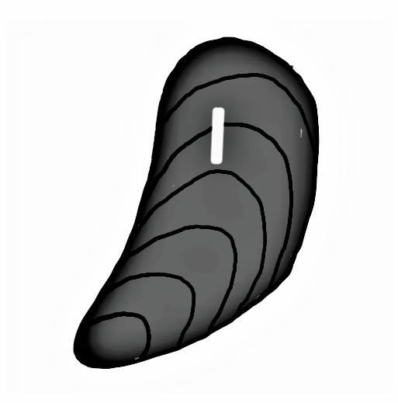
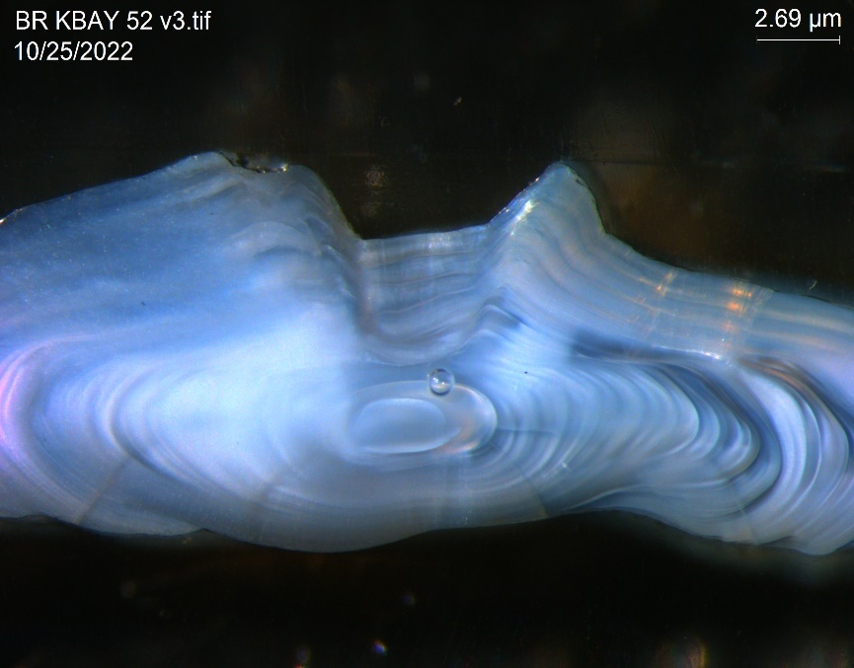
Fig. S1. Hard parts used for growth measurements for (a) mussels and (b) fish otoliths. (a) Tagged mussel growth increments (dashed red line) began at the end of the tag (white tag edge) to the edge of the shell, representing one year of growth from summer to summer. Surface ridge growth increments (solid red line) were measured between the two last complete annual surface ridges, representing the previous winter to winter growth. (b) Black Rockfish otolith growth increments (solid red line) were measured from the outer edge of the most distal dark growth ring to the beginning of the previous dark growth ring. Same methods used for Kelp Greenling otoliths. Growth data generated are available in Iken (2024b).
a.
b.
Tag

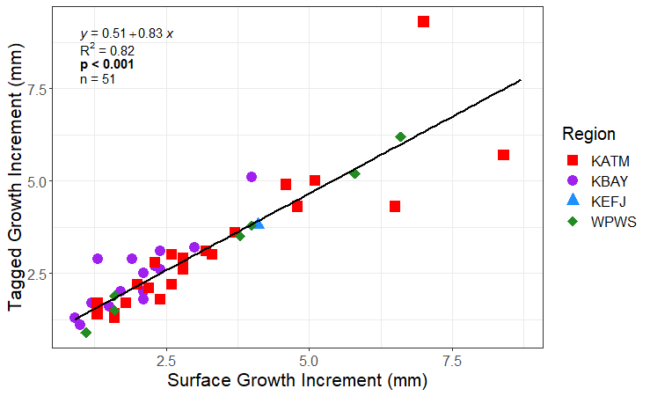
Fig. S2. Mussel growth measurement comparison between surface growth increments (mm) taken for the last complete year of growth between winter surface growth rings (major surface ridges) compared to tagged growth increments (mm) taken from the edge of a tag glued onto mussels in summer 2021 to the edge of the mussel shell collected in summer 2022. Katmai National Park and Preserve: KATM red squares, Kachemak Bay: KBAY purple circles, Kenai Fjords National Park: KEFJ blue triangle, Western Prince William Sound: WPWS green diamonds. n = 51 mussels total across regions. Growth data generated are available in Iken (2024b).

Table S1. Macroalgal and POM δ13C by region per year and averaged across all years. Isotope values are separated by region, macroalgal group, and species. P values refer to the difference between overall macroalgal and POM values per region and year (t-test, bolded where significant). Raw stable isotope values were unavailable for 2012 and 2013, so t-tests were performed on averages. Years considered warmer than average are highlighted in grey, including the heat spike in 2019, which was not included in the analyses. Dashes (-) mark species that were not sampled in that year. Katmai National Park and Preserve: KATM, Kachemak Bay: KBAY, Kenai Fjords National Park: KEFJ, and Western Prince William Sound: WPWS. Data is available in Iken (2024a).

Region | Group | Species | 2012 | 2013 | 2014 | 2015 | 2016 | 2017 | 2018 | 2019 | 2020 | 2021 | Overall
KATM | Brown algae | Agarum clathratum | -18.07 | - | - | - | - | - | - | - | - | - | -18.07
 |  | Alaria marginata | -19.74 | - | - | - | - | - | - | -16.95 | - | -19.26 | -18.65
 |  | Fucus distichus | -17.60 | -15.03 | -16.37 | -15.95 | - | - | - | -13.24 | - | -14.56 | -15.46
 |  | Hedophyllum negripes | - | - | - | - | - | - | - | - | - | -12.45 | -12.45
 |  | Laminaria spp. | -15.98 | -13.60 | -15.59 | -17.22 | - | - | - | -13.05 | - | - | -15.09
 |  | Nereocystis luetkeana | -17.37 | - | - | - | - | - | - | - | - | - | -17.37
 |  | Saccharina latissima | - | - | - | - | - | - | - | -12.75 | - | - | -12.75
 | Green algae | Acrosiphonia spp. | - | - | - | - | - | - | - | - | - | -17.31 | -17.31
 |  | Cladophora sp. | - | - | - | - | - | - | - | - | - | -15.87 | -15.87
 |  | Ulva lactuca | -19.36 | -21.67 | -21.05 | - | - | - | - | -19.26 | - | -19.59 | -20.19
 | Red algae | Devaleraea callophylloides | - | - | - | - | - | - | - | - | - | -19.42 | -19.42
 |  | Halosaccion glandiforme | - | - | - | - | - | - | - | - | - | -16.35 | -16.35
 |  | Neorhodomela spp. | -20.12 | -22.27 | -21.29 | - | - | - | - | - | - | -22.42 | -21.52
 |  | Odonthalia floccosa | - | - | - | - | - | - | - | -18.63 | - | -20.58 | -19.61
 |  | Palmaria hecatensis | - | - | - | - | - | - | - | - | - | -17.40 | -17.40
 |  | Polyostea/  Polysiphonia | - | - | - | - | - | - | - | -19.05 | - | - | -19.05
 |  | Pyropia spp. | - | - | - | - | - | - | - | - | - | -20.55 | -20.55
 |  | Savoiea bipinnata | - | - | - | - | - | - | - | - | - | -20.60 | -20.60
 |  | Total Macroalgae | -18.32 | -18.14 | -18.58 | -16.58 | - | - | - | -16.13 | - | -18.18 | -17.66
 | POM | POM offshore | -18.85 | -21.16 | -22.50 | -21.68 | -22.94 | -22.46 | -22.13 | -20.39 | - | - | -21.51
 |  | P value | 0.923 | 0.148 | 0.007 | < 0.001 | - | - | - | < 0.001 | - | < 0.001 | < 0.001
 |  | POM nearshore | -18.45 | -21.25 | -20.68 | -20.70 | -22.41 | -19.82 | -21.80 | - | - | - | -20.73
 | Mussels | Mytilus trossulus | -18.82 | -17.59 | -18.72 | -18.38 | -18.57 | -18.00 | -18.83 | -18.63 |  | -18.10 | -18.40

Table S1. Continued.
Region | Group | Species | 2012 | 2013 | 2014 | 2015 | 2016 | 2017 | 2018 | 2019 | 2020 | 2021 | Overall
KBAY | Brown algae | Alaria marginata | - | - | - | - | - | - | - | -16.57 | -18.11 | -17.59 | -17.42
 |  | Desmarestia virdis | - | - | - | - | - | - | - | - | - | -22.03 | -22.03
 |  | Fucus distichus | - | - | - | - | - | - | - | -15.27 | -15.77 | -16.70 | -15.91
 |  | Hedophyllum sessile | - | - | - | - | - | - | - | - | -14.17 | -15.95 | -15.06
 |  | Melanosiphon intestinalis | - | - | - | - | - | - | - | - | - | -16.61 | -16.61
 |  | Saccharina sp. | - | - | - | - | - | - | - | - | -15.61 | - | -15.61
 |  | Saccharina latissima | - | - | - | - | - | - | - | -16.67 | -19.26 | -15.84 | -17.26
 |  | Scytosiphon lomentaria | - | - | - | - | - | - | - | - | - | -15.98 | -15.98
 | Green algae | Acrosiphonia spp. | - | - | - | - | - | - | - | -17.97 | -17.68 | -17.87 | -17.84
 |  | Monostroma grevillei | - | - | - | - | - | - | - | - | - | -19.86 | -19.86
 |  | Ulva lactuca | - | - | - | - | - | - | - | -18.44 | -20.69 | -19.77 | -19.63
 | Red algae | Devaleraea mollis | - | - | - | - | - | - | - | -15.88 | - | -16.65 | -16.27
 |  | Neorhodomela spp. | - | - | - | - | - | - | - | - | -20.88 | -19.87 | -20.37
 |  | Odonthalia floccosa | - | - | - | - | - | - | - | -19.67 | -20.98 | -20.05 | -20.23
 |  | Palmaria hecatensis | - | - | - | - | - | - | - | - | -17.49 | -16.71 | -17.10
 |  | Pyropia spp. | - | - | - | - | - | - | - | - | -20.20 | - | -20.20
 |  | Savoiea bipinnata | - | - | - | - | - | - | - | - | -18.07 | -23.00 | -20.53
 |  | Total Macroalgae | - | - | - | - | - | - | - | -17.21 | -18.24 | -18.30 | -17.92
 | POM | POM offshore | - | - | - | - | - | -21.16 | -20.90 | -19.97 | -20.81 | -20.54 | -20.68
 |  | P value | - | - | - | - | - | - | - | < 0.001 | < 0.001 | < 0.001 | < 0.001
 |  | POM nearshore | - | - | - | - | - | -20.88 | -20.44 | - | - | - | -20.66
 | Mussels | Mytilus trossulus | - | - | - | - | - | -18.10 | -18.40 | -18.89 | -18.20 | -18.72 | -18.46

Table S1. Continued.
Region | Group | Species | 2012 | 2013 | 2014 | 2015 | 2016 | 2017 | 2018 | 2019 | 2020 | 2021 | Overall
KEFJ | Brown algae | Agarum clathratum | -16.94 | - | - | - | - | - | - | - | - | - | -16.94
 |  | Alaria marginata | -16.10 | - | - | - | - | - | - | -17.93 | - | -21.31 | -18.45
 |  | Fucus distichus | -18.41 | -16.52 | -17.39 | -15.41 | - | - | - | -16.40 | - | -16.88 | -16.83
 |  | Hedophyllum negripes | - | - | - | - | - | - | - | - | - | -15.50 | -15.50
 |  | Laminaria spp. | -14.42 | -15.74 | -15.72 | -14.51 | - | - | - | - | - | - | -15.10
 |  | Nereocystis luetkeana | -15.39 | - | - | - | - | - | - | - | - | - | -15.39
 |  | Saccharina latissima | - | - | - | - | - | - | - | -15.82 | - | -19.49 | -17.65
 |  | Scytosiphon lomentaria | - | - | - | - | - | - | - | - | - | -14.41 | -14.41
 | Green algae | Acrosiphonia spp. | - | - | - | - | - | - | - | - | - | -18.65 | -18.65
 |  | Ulva lactuca | -19.94 | -20.18 | -19.65 | - | - | - | - | -20.76 | - | -22.83 | -20.67
 | Red algae | Halosaccion glandiforme | - | - | - | - | - | - | - | - | - | -17.71 | -17.71
 |  | Neorhodomela spp. | -20.83 | -21.36 | -20.05 | - | - | - | - | - | - | -22.04 | -21.07
 |  | Odonthalia floccosa | - | - | - | - | - | - | - | -22.50 | - | -22.46 | -22.48
 |  | Palmaria hecatensis | - | - | - | - | - | - | - | -19.75 | - | -17.26 | -18.50
 |  | Pyropia spp. | - | - | - | - | - | - | - | - | - | -23.62 | -23.62
 |  | Savoiea bipinnata | - | - | - | - | - | - | - | - | - | -22.60 | -22.60
 |  | Total Macroalgae | -17.91 | -18.45 | -18.20 | -14.96 | - | - | - | -18.86 | - | -19.60 | -18.00
 | POM | POM offshore | -23.60 | -22.97 | -25.04 | -25.18 | -23.74 | -22.89 | -24.02 | -23.92 | - | -24.98 | -24.04
 |  | P value | 0.005 | < 0.001 | < 0.001 | < 0.001 | - | - | - | < 0.001 | - | < 0.001 | < 0.001
 |  | POM nearshore | -19.68 | -21.43 | -23.67 | -24.57 | -24.50 | -22.22 | -21.66 | - | - | - | -22.53
 | Mussels | Mytilus trossulus | -20.25 | - | -20.27 | -20.98 | -20.50 | -18.88 | -19.72 | -20.38 | - | -19.47 | -20.06

Table S1. Continued.
Region | Group | Species | 2012 | 2013 | 2014 | 2015 | 2016 | 2017 | 2018 | 2019 | 2020 | 2021 | Overall
WPWS | Brown algae | Agarum clathratum | -19.65 | - | - | - | - | - | - | - | - | - | -19.65
 |  | Fucus distichus | -15.87 | -14.12 | -17.41 | -15.46 | - | - | - | -13.84 | -14.83 | -16.53 | -15.44
 |  | Laminaria spp. | - | -14.97 | -15.50 | -14.92 | - | - | - | - | - | - | -15.13
 |  | Melanosiphon intestinatis | - | - | - | - | - | - | - | - | - | -15.32 | -15.32
 |  | Nereocystis luetkeana | -17.49 | - | - | - | - | - | - | - | - | - | -17.49
 |  | Saccharina latissima | - | - | - | - | - | - | - | -13.89 | -16.54 | - | -15.22
 | Green algae | Acrosiphonia spp. | - | - | - | - | - | - | - | - | -19.44 | - | -19.44
 |  | Cladophora sp. | - | - | - | - | - | - | - | - | -18.20 | -17.23 | -17.71
 |  | Ulva lactuca | -18.61 | -18.66 | -22.09 | - | - | - | - | -20.50 | -22.60 | -21.24 | -20.62
 | Red algae | Cryptosiphonia woodii | - | - | - | - | - | - | - | - | - | -20.22 | -20.22
 |  | Devaleraea callophylloides | - | - | - | - | - | - | - | - | - | -15.29 | -15.29
 |  | Gloiopeltis furcata | - | - | - | - | - | - | - | - | - | -20.23 | -20.23
 |  | Halosaccion glandiforme | - | - | - | - | - | - | - | - | - | -18.74 | -18.74
 |  | Mastocarpus spp. | - | - | - | - | - | - | - | - | - | -14.70 | -14.70
 |  | Neorhodomela spp. | -22.24 | -23.08 | -20.82 | - | - | - | - | - | - | -17.96 | -21.03
 |  | Odonthalia floccosa | - | - | - | - | - | - | - | -21.99 | - | -22.33 | -22.16
 |  | Odonthalia/Neorhodomela | - | - | - | - | - | - | - | - | -22.71 | - | -22.71
 |  | Palmaria hecatensis | - | - | - | - | - | - | - | -16.95 | -19.84 | - | -18.40
 |  | Polyostea/  Polysiphonia | - | - | - | - | - | - | - | - | - | -26.04 | -26.04
 |  | Ptilota spp. | - | - | - | - | - | - | - | - | -31.84 | - | -31.84
 |  | Tokidadendron bulligera | - | - | - | - | - | - | - | - | - | -32.06 | -32.06
 |  | Total Macroalgae | -18.55 | -17.71 | -18.95 | -15.19 | - | - | - | -17.43 | -20.75 | -19.84 | -18.35
 | POM | POM offshore | -22.62 | -21.60 | -23.18 | -23.48 | -22.92 | -23.76 | -23.96 | -24.46 | - | -23.63 | -23.29
 |  | P value | < 0.001 | 0.003 | < 0.001 | < 0.001 | - | - | - | < 0.001 | - | < 0.001 | < 0.001
 |  | POM nearshore | -21.20 | -21.15 | -21.84 | -22.51 | -22.69 | -22.88 | -21.91 | - | - | - | -22.03
 | Mussels | Mytilus trossulus | -18.58 | - | -19.62 | -19.91 | -19.73 | -18.92 | -19.47 | -19.75 | -19.51 | -19.42 | -19.43

References
Iken, K. 2024a. Stable carbon and nitrogen isotope data of nearshore producers and consumers in four regions of the Gulf of Alaska, 2014-2023. Research Workspace, https://doi.org/10.24431/rw1k8e2.
Iken, K. 2024b. Growth measurements of mussels and fish in the Gulf of Alaska, 2014-2021. Research Workspace, https://doi.org/10.24431/rw1k8e3.

