Supplementary material for: Controls on Oxygen Variability and Depletion in the Patuxent River Estuary
Allison Dreiss, Amir Reza Azarnivand, Anna Hildebrand, Seyedeh Fardis Pourreza Ahmadi, Syeda Sadia Ali, Veronica Malabanan Lucchese, Qian Zhang, Laura L. Lapham, Ryan J. Woodland, Lora Harris, Jeremy M. Testa

Table S1. Grab sampling diversity of benthic invertebrate species during spring and summer (1985-2021) at fixed stations 71, 74, and 77 in Patuxent River estuary. The table shows the species in each functional group; bivalves, small crustaceans, and worms.

Category | Species
Bivalves | Bivalvia, Corbicula fluminea, Gemma gemma, Geukensia demissa, Lyonsia hyalina, Macoma balthica, Macoma mitchelli, Mulinia lateralis, Musculium spp., Musculium transversum, Mya arenaria, Mytilopsis leucophaeata, Pisidium spp., Rangia cuneata
Small crustaceans | Ameroculodes species complex, Ampelisca abdita, Apocorophium lacustre, Chiridotea almyra, Cyathura polita, Edotea triloba, Gammarus daiberi, Gammarus spp., Leptocheirus plumulosus, Melita nitida, Mucrogammarus mucronatus, Synidotea laticauda
Worms | Aulodrilus pigueti, Boccardiella ligerica, Branchiura sowerbyi, Dero spp., Eteone foliosa, Eteone heteropoda, Glycinde solitaria, Harnischia spp., Heteromastus filiformis, Hobsonia florida, Leitoscoloplos fragilis, Leitoscoloplos robustus, Leitoscoloplos spp., Limnodrilus udekemianus, Loimia medusa, Manayunkia aestuarina, Marenzelleria viridis, Mediomastus ambiseta, Microphthalmus aberrans, Nais communis, Nais variabilis, Neanthes succinea, Nephtyidae, Oligochaeta, Parahesione luteola, Paraprionospio pinnata, Pectinaria gouldii, Podarkeopsis levifuscina, Polydora cornuta, Polydora websteri, Sabellaria vulgaris, Sigambra tentaculata, Streblospio benedicti, Tubificidae imm. without capilliform chaetae, Tubificoides spp.
All of the species | Acteocina canaliculata, Americamysis almyra, Americamysis bigelowi, Americamysis spp., Ameroculodes species complex, Ampelisca abdita, Ampelisca abdita-vadorum complex, Amphiporus bioculatus, Anthozoa, Apocorophium lacustre, Aulodrilus pigueti, Balanus improvisus, Bivalvia, Boccardiella ligerica, Brachyuran zoea, Carinoma tremaphoros, Ceratopogonidae, Chaoborus punctipennis, Chiridotea almyra, Chironomidae, Chironomidae pupae, Chironomus spp., Coelotanypus spp., Cryptochironomus spp., Cyathura polita, Cyclaspis varians, Cymothoidae, Dero spp., Diadumene leucolena, Edotea triloba, Edwardsia elegans, Eteone foliosa, Eteone heteropoda, Gammarus daiberi, Gammarus spp., Gemma gemma, Geukensia demissa, Glycinde solitaria, Haminoea solitaria, Hargeria rapax, Harnischia spp., Heteromastus filiformis, Hobsonia florida, Hydrobiidae, Leitoscoloplos fragilis, Leitoscoloplos robustus, Leitoscoloplos spp., Leptocheirus plumulosus, Leucon americanus, Limnodrilus udekemianus, Littoridinops tenuipes, Loimia medusa, Lyonsia hyalina, Macoma balthica, Macoma mitchelli, Marenzelleria viridis, Mediomastus ambiseta, Melita nitida, Microphthalmus aberrans, Micrura leidyi, Mucrogammarus mucronatus, Mulinia lateralis, Mya arenaria, Mysidae, Mytilopsis leucophaeata, Nais communis, Nais variabilis, Neanthes succinea, Nemertea spp., Nemertina, Neomysis americana, Nephtyidae, Odostomia engonia, Oligochaeta, Oligochaeta spp., Palaemonetes spp., Parahesione luteola, Paraprionospio pinnata, Pectinaria gouldii, Phoronis spp., Podarkeopsis levifuscina, Polydora cornuta, Polypedilum halterale group, Procladius (Holotanypus) spp., Procladius spp., Rangia cuneata, Rhithropanopeus harrisii, Rictaxis punctostriatus, Sabellaria vulgaris, Saccoglossus kowalevskii, Sigambra tentaculata, Streblospio benedicti,Stylochus ellipticus, Tubificidae imm. without capilliform chaetae, Tubificoides spp., Turbellaria, Turbellaria spp.

Table S2. Linear regression models between HVD and log_{e}-transformed benthic biomass. The exponential models are obtained from linear equations.

Response variable (y) | Linear regression model | R² | p-value | Exponential model
Total benthic biomass | $$ln y =-0.59HVD -3.69$$ | 0.34 | < 0.01 | $$y = 0.025 e^{-0.59HVD}$$
Bivalves biomass | $$ln y =-0.58HVD -5.06$$ | 0.24 | < 0.01 | $$y = 0.006 e^{-0.58HVD}$$
Small crustaceans biomass | $$ln y =-0.24HVD -8.53$$ | 0.10 | 0.25 | $$y = 0.0002 e^{-0.24HVD}$$
Worms biomass | $$ln y =-0.38HVD -5.18$$ | 0.14 | 0.03 | $$y = 0.006 e^{-0.38HVD}$$

Supplemental Material Section 1: Seasonally-averaged rates of nutrient load and river discharge over time
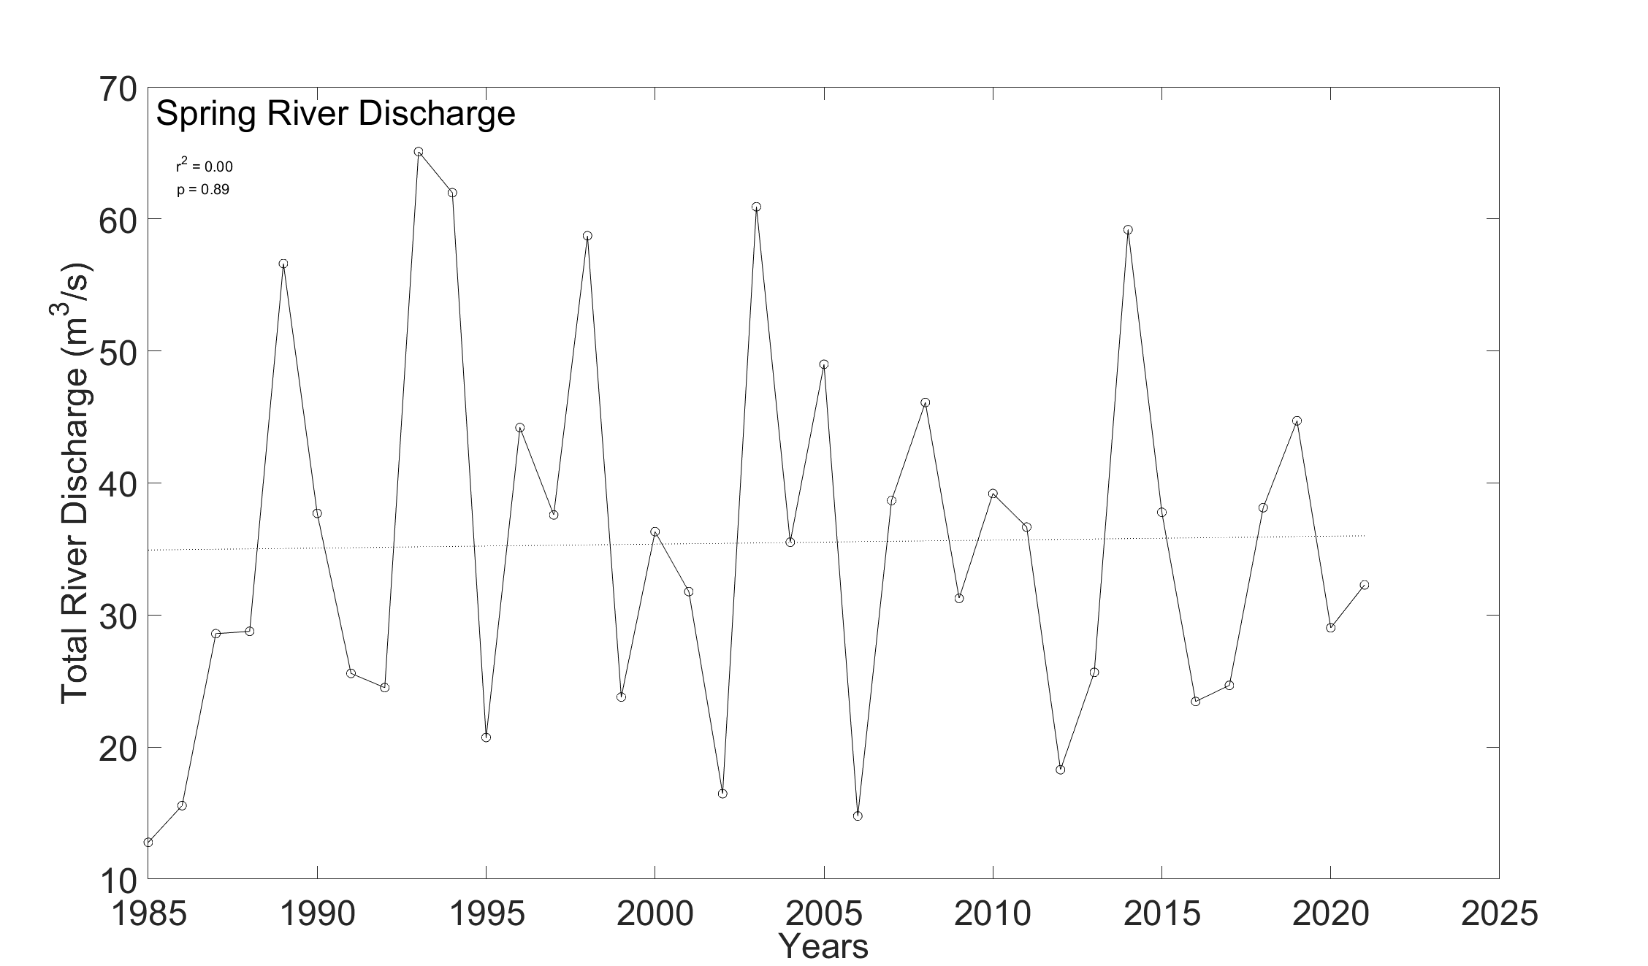
Figure S1.1. Total river discharge during the spring (March-May) from 1985-2021. Overall, flow during the spring has experienced large variations but there was no trend.

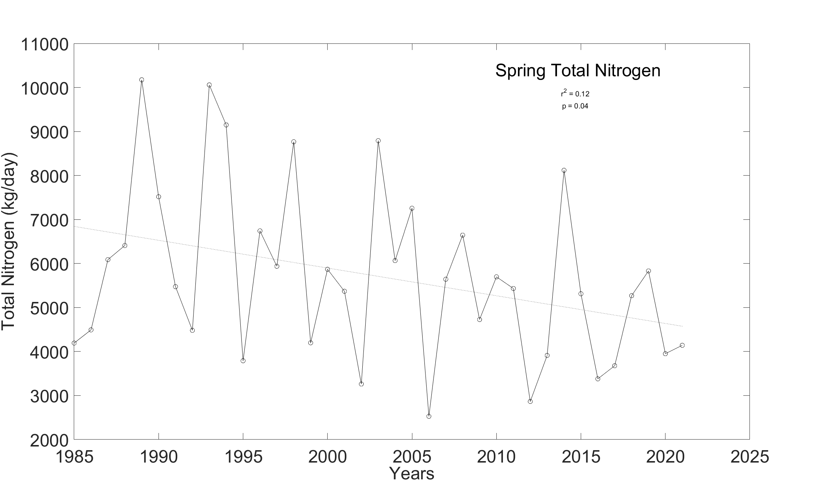
Figure S1.2. Total nitrogen load during the spring (March-May) from 1985-2021. Total nitrogen has experienced large variation in loads but the overall load has decreased over time.

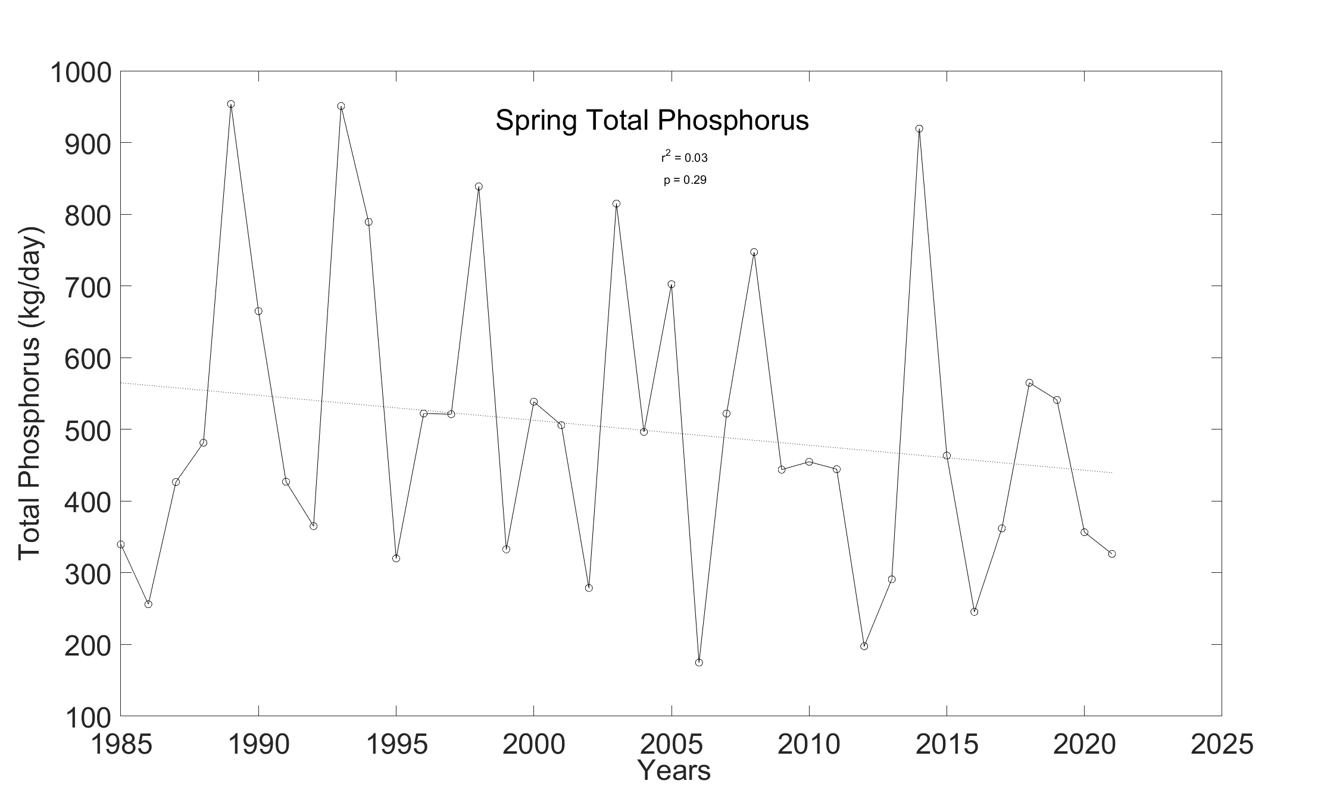
Figure S1.3. Total phosphorus load during the spring (March-May) from 1985-2021. Although the trend is slightly decreasing it is not significant by the standards documented within Table 1, p>0.1.

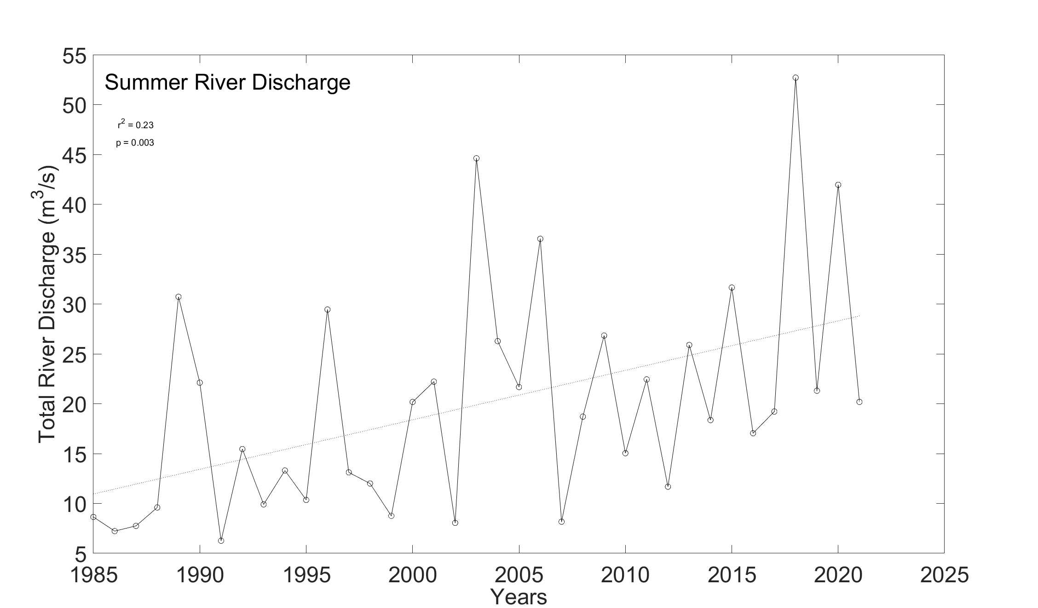
Figure S1.4. Total river discharge during the summer (June-August) from 1985-2021. Overall, flow during the summer has increased over time.

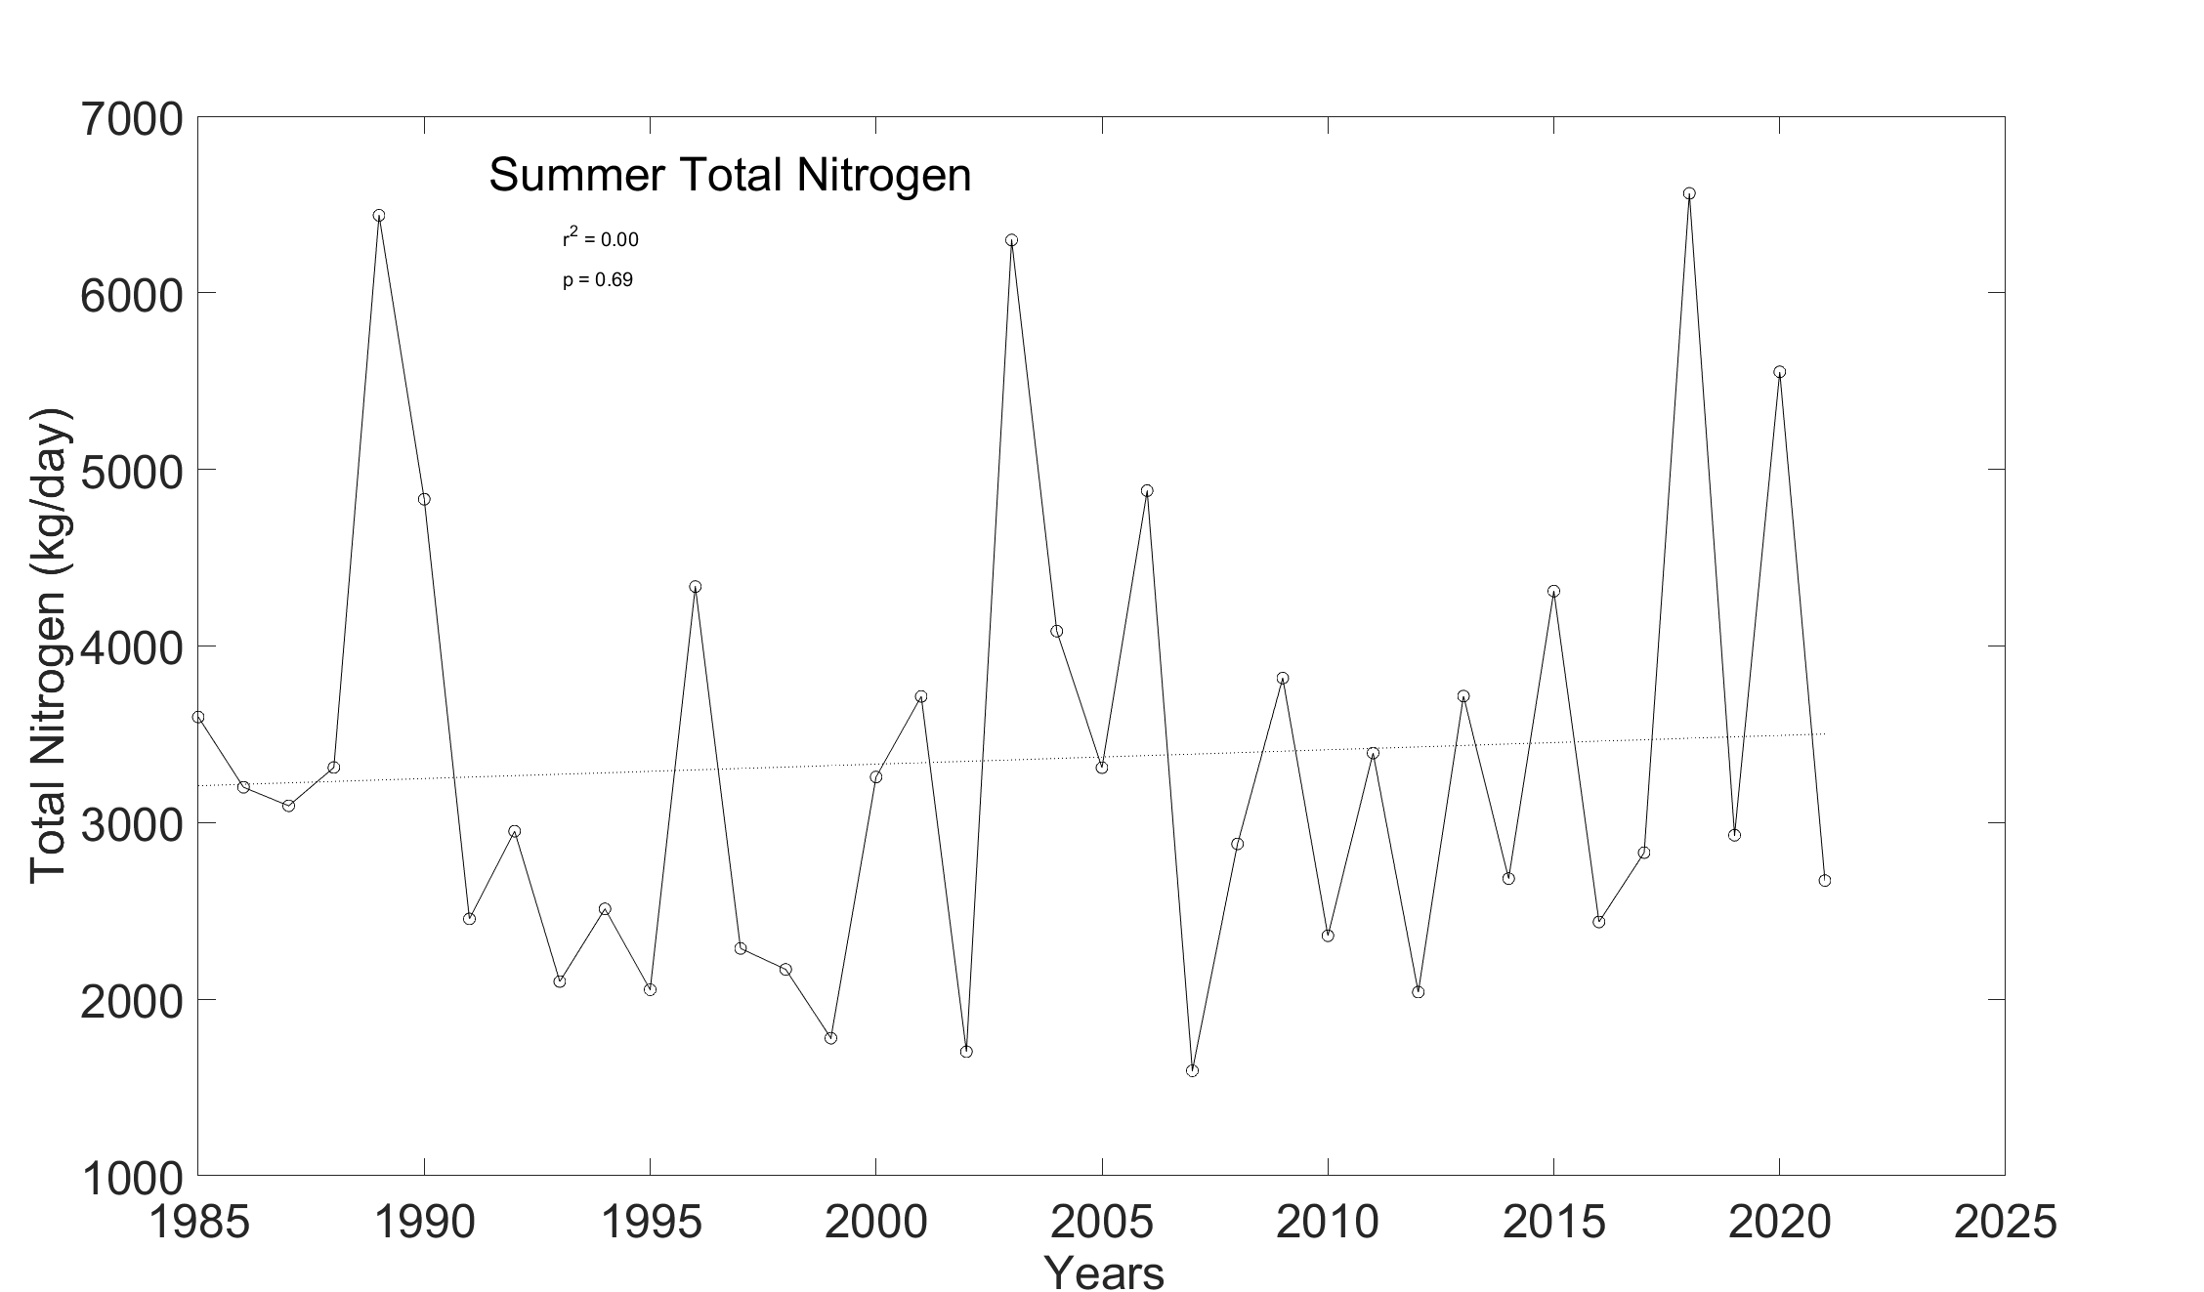
Figure S1.5. Total nitrogen load during the summer (June-August) from 1985-2021. Total nitrogen has experienced large variation in loads but there was no overall trend.

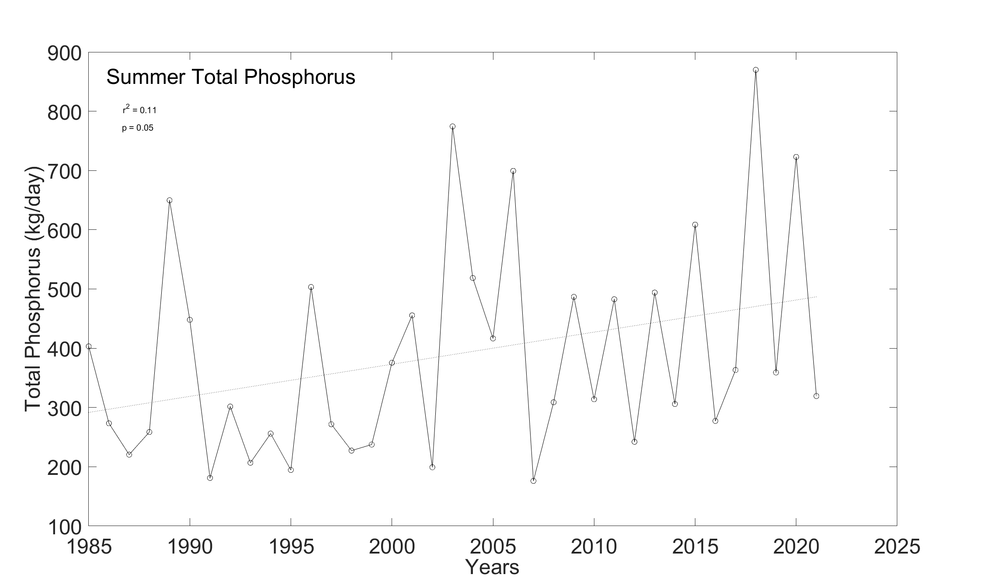
Figure S1.6. Total phosphorus load during the summer (June-August) from 1985-2021. Overall, phosphorus during the summer has increased over time.
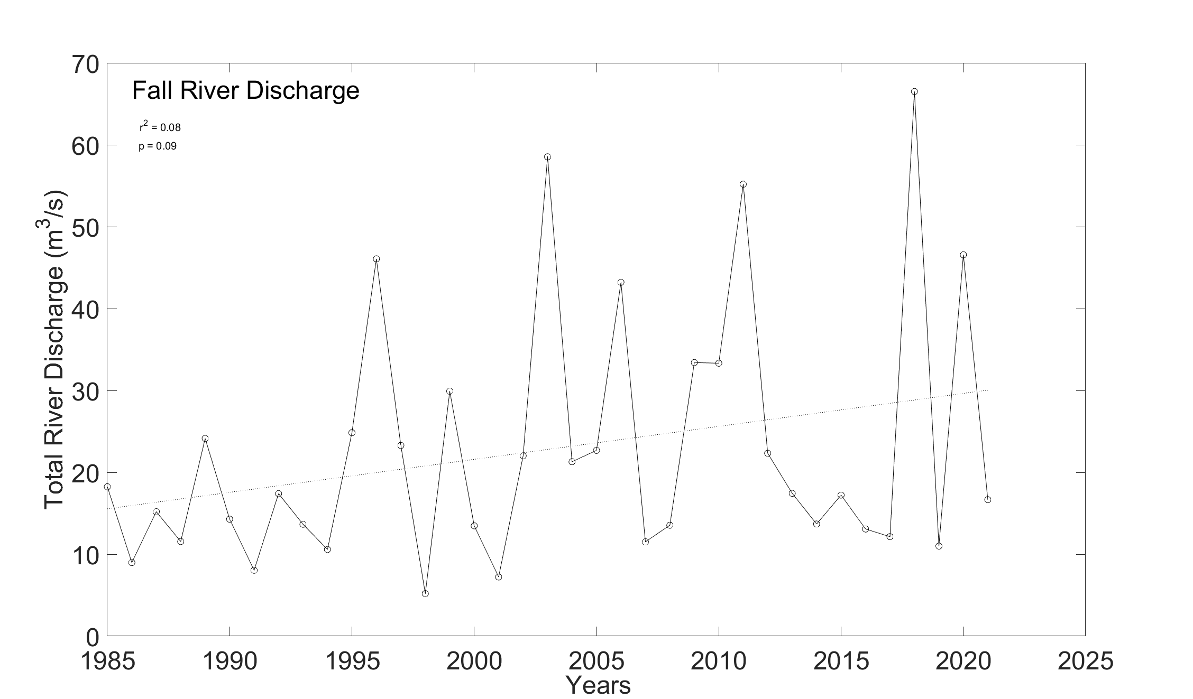
Figure S1.7. Total river discharge during the fall (September-November) from 1985-2021. Overall, flow during the fall has increased over time.

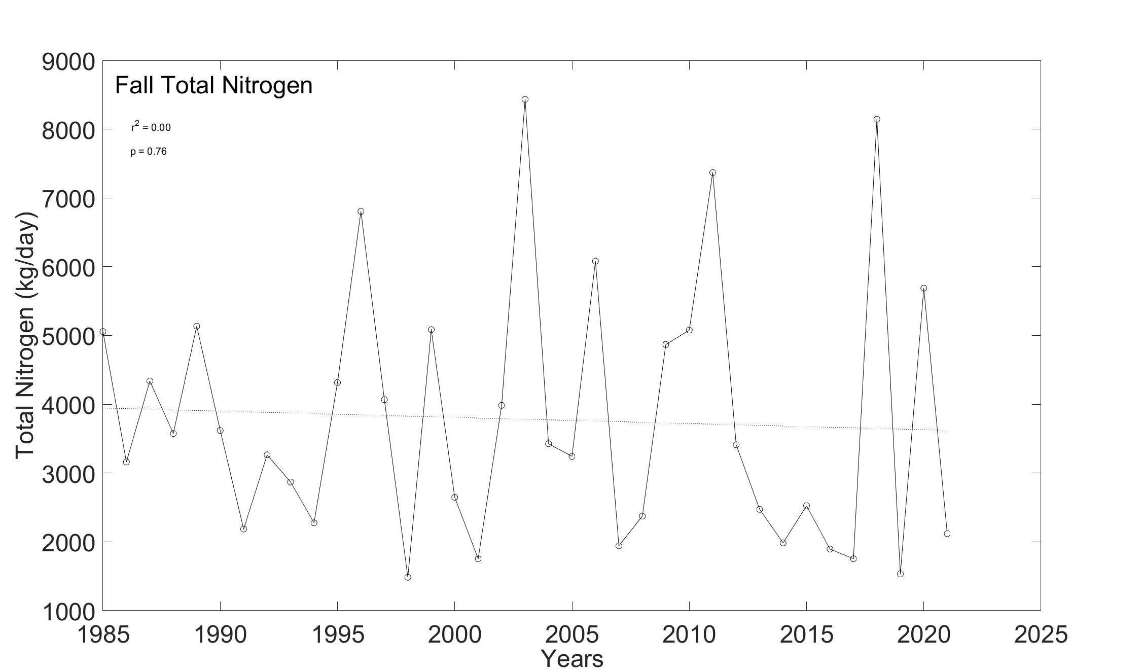
Figure 1.8. Total nitrogen load during the fall (September-November) from 1985-2021. Although the trend is slightly decreasing it is not significant by the standards documented within Table 1, p > 0.1.

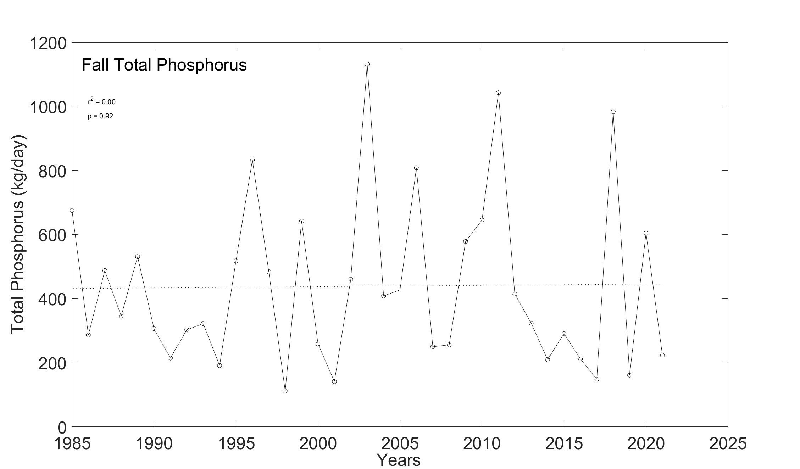
Figure S1.9. Total phosphorus load during the fall (September-November) from 1985-2021. Variation within the total phosphorus each follows the fluxes within the total river discharge but has remained consistent despite an increase in river discharge during the fall.

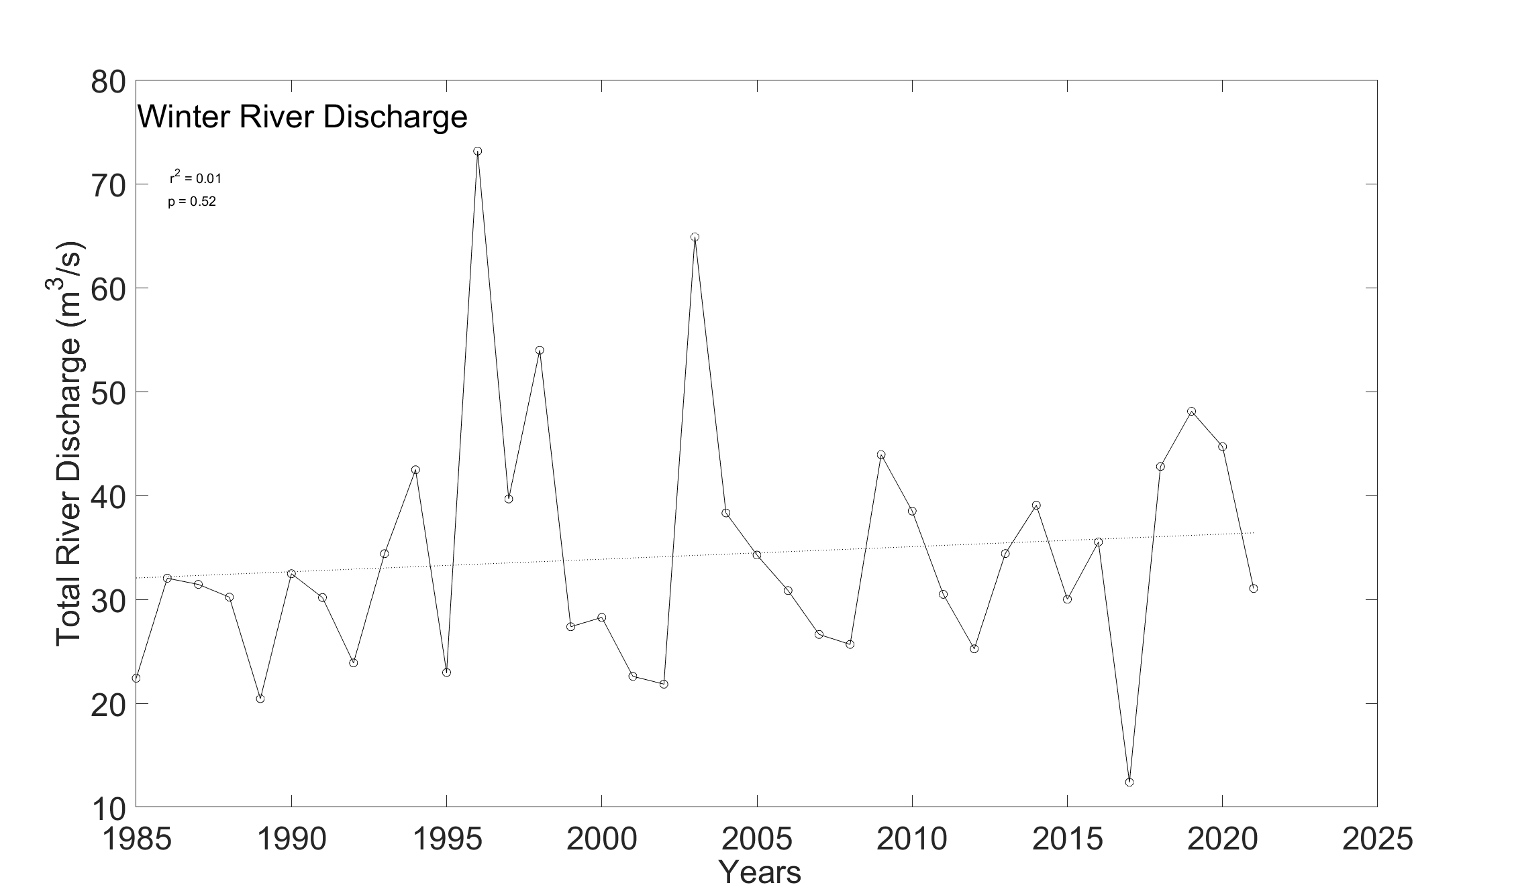
Figure S1.10. Total river discharge during the winter (December- February) from 1985-2021. Although the trend is slightly increasing it is not significant by the standards documented within Table 1, p > 0.1.

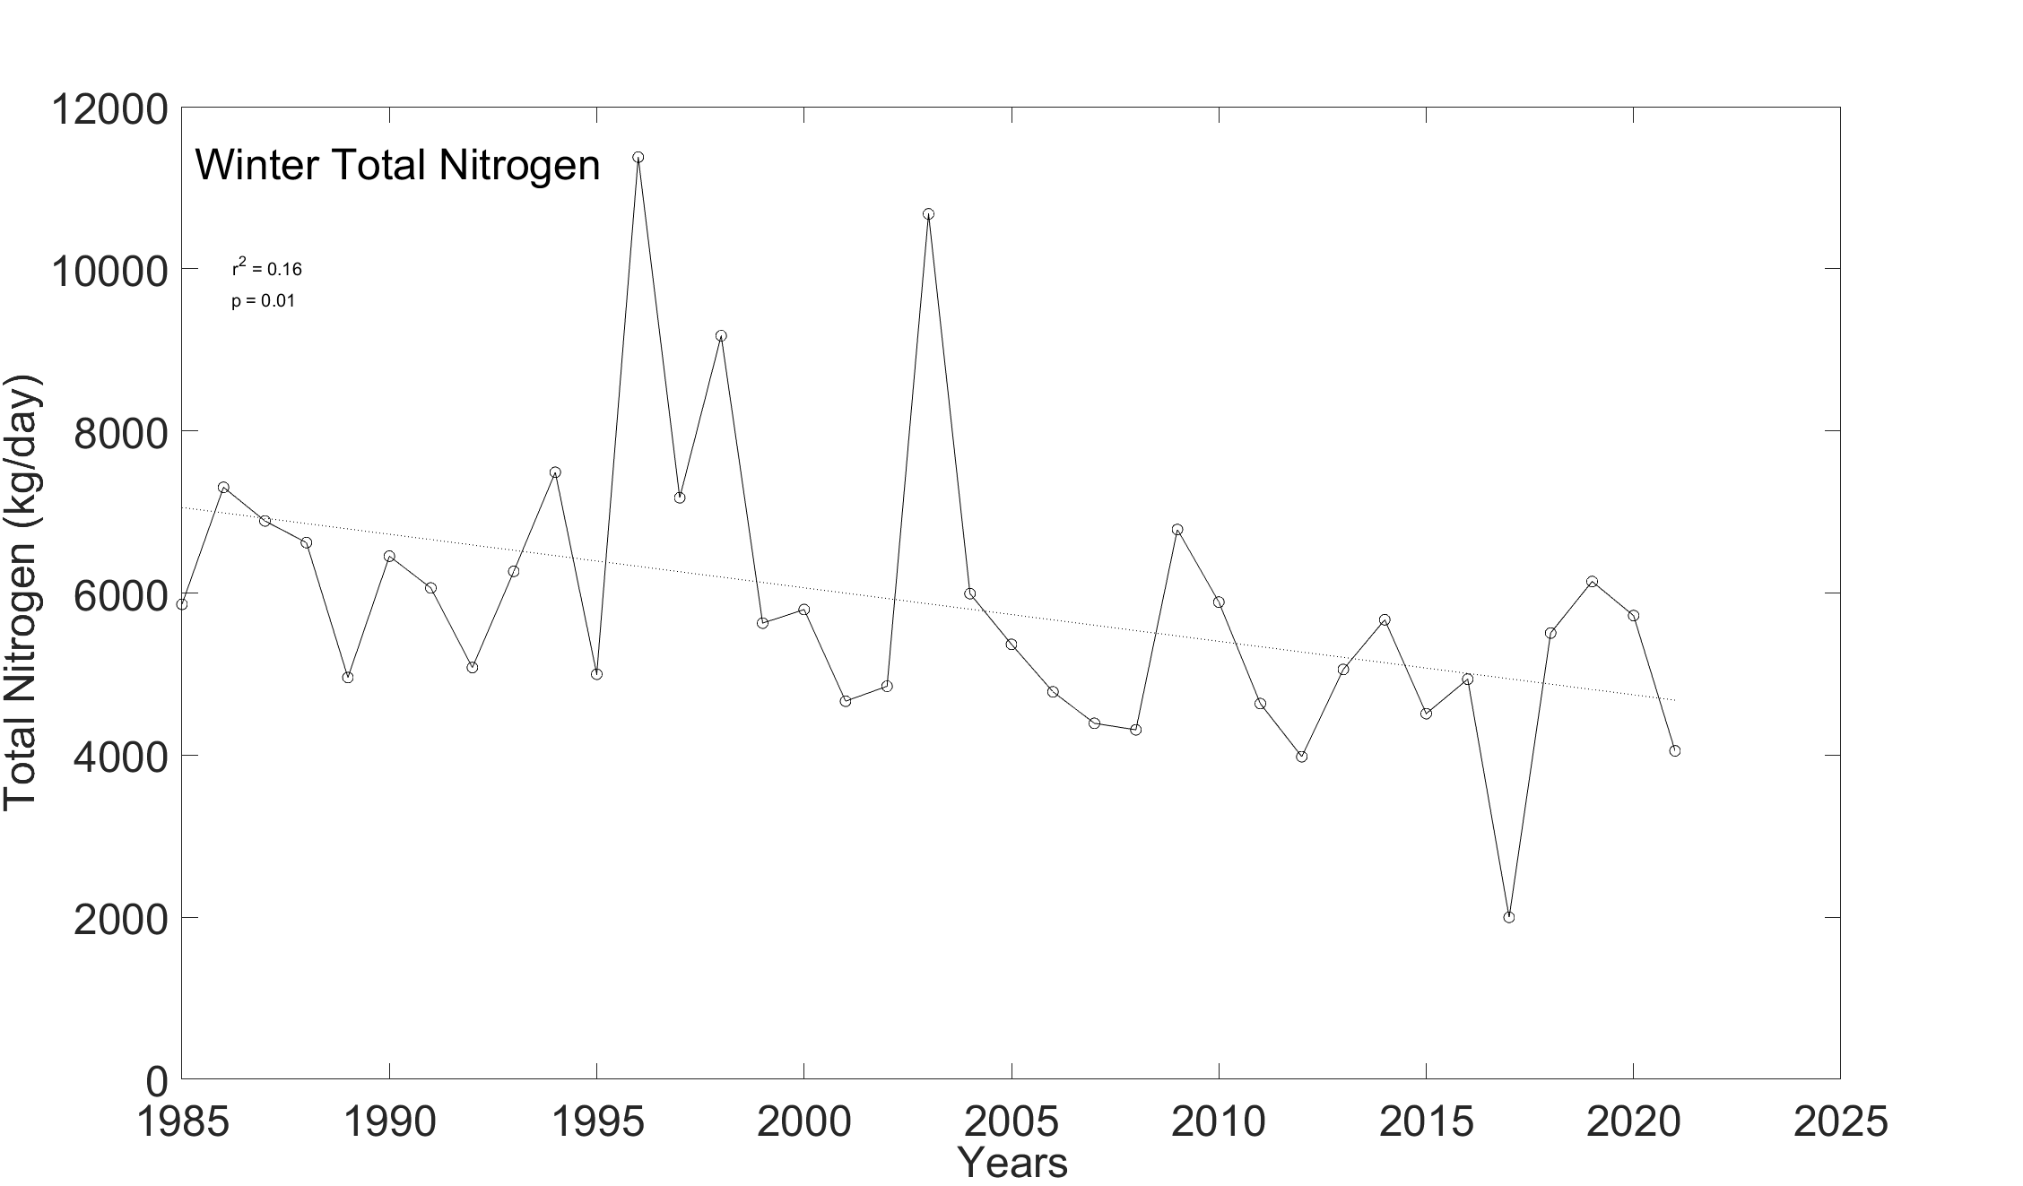
Figure S1.11. Total nitrogen load during the winter (December- February) from 1985-2021. Overall, nitrogen during the winter has decreased over time.

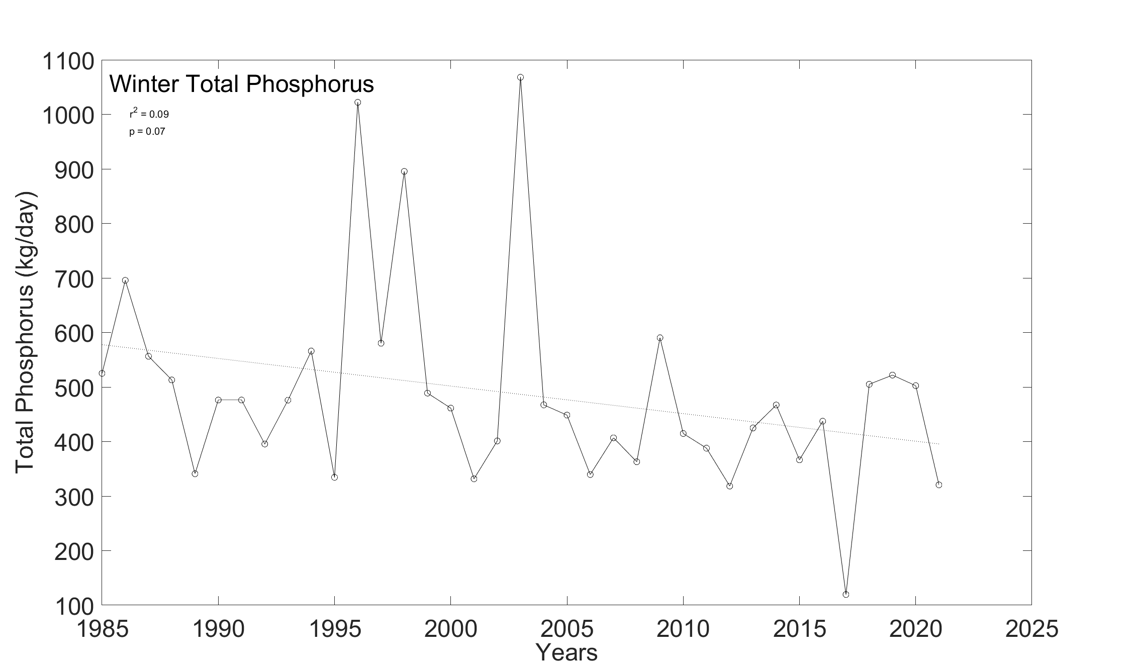
Figure S1.12. Total phosphorus load during the winter (December- February) from 1985-2021. Overall, phosphorus during the winter has decreased over time.

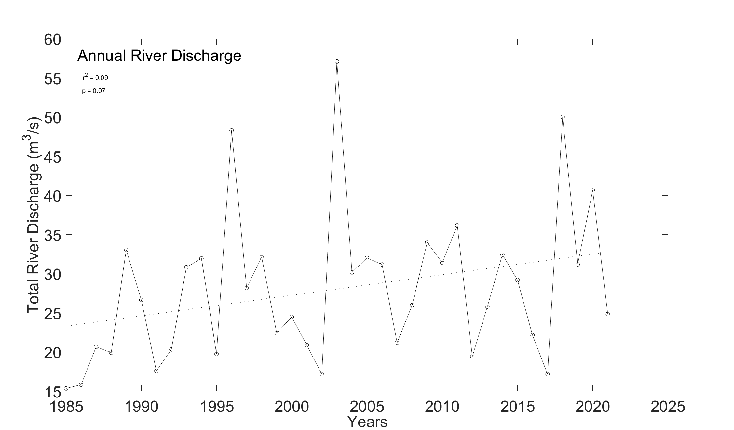
Figure S1.13. Total river discharge averaged on an annual scale from 1985-2021. Overall, flow has increased over time.

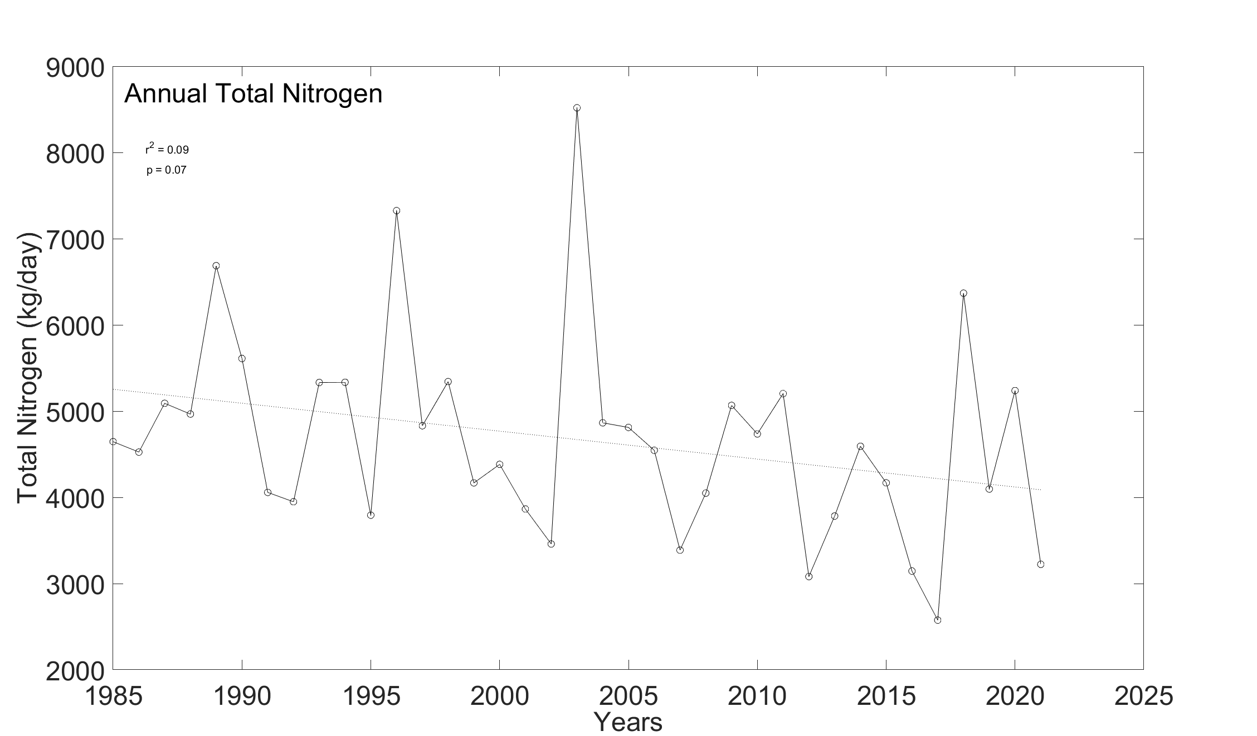
Figure S1.14. Total nitrogen averaged on an annual scale from 1985-2021. Overall, nitrogen has decreased over time.

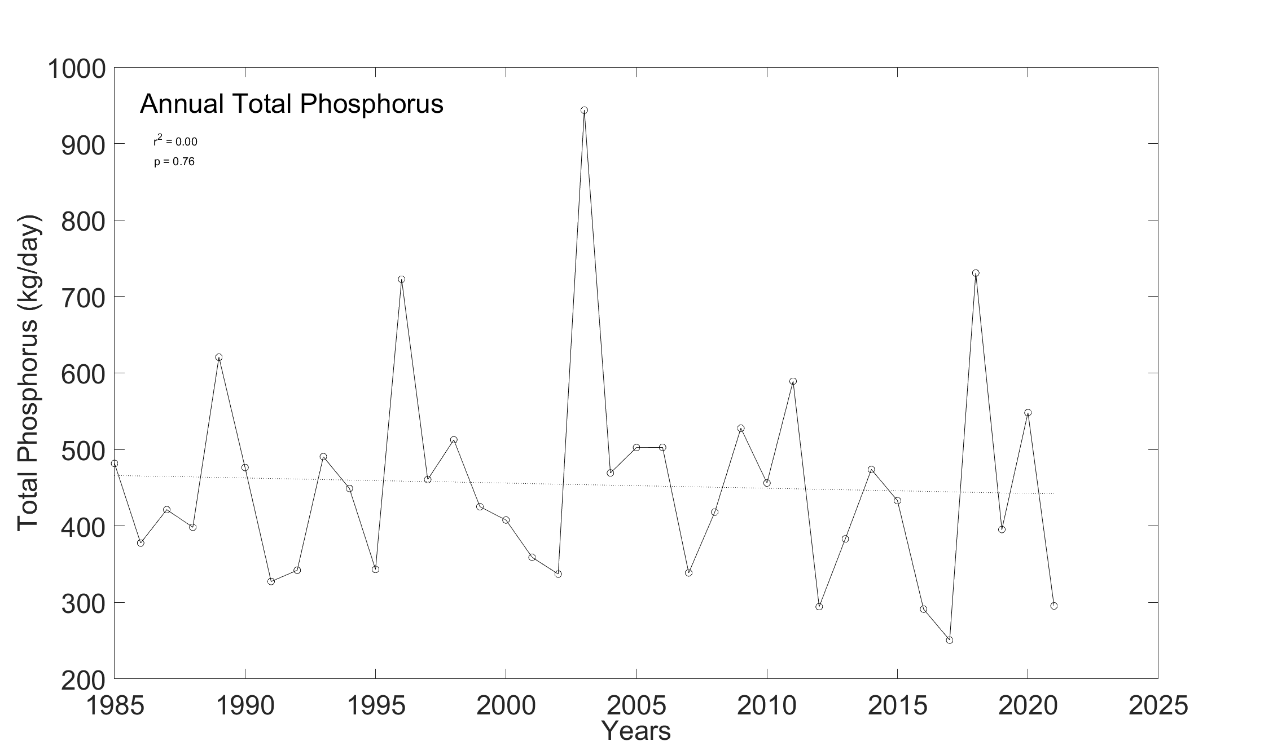
Figure S1.15. Total phosphorus load averaged on an annual scale from 1985-2021. Overall, phosphorus has not changed over time.

Supplemental Material Section 2: Sensitivity tests and detailed calculations in support of hypoxic volume days and hypoxia duration.
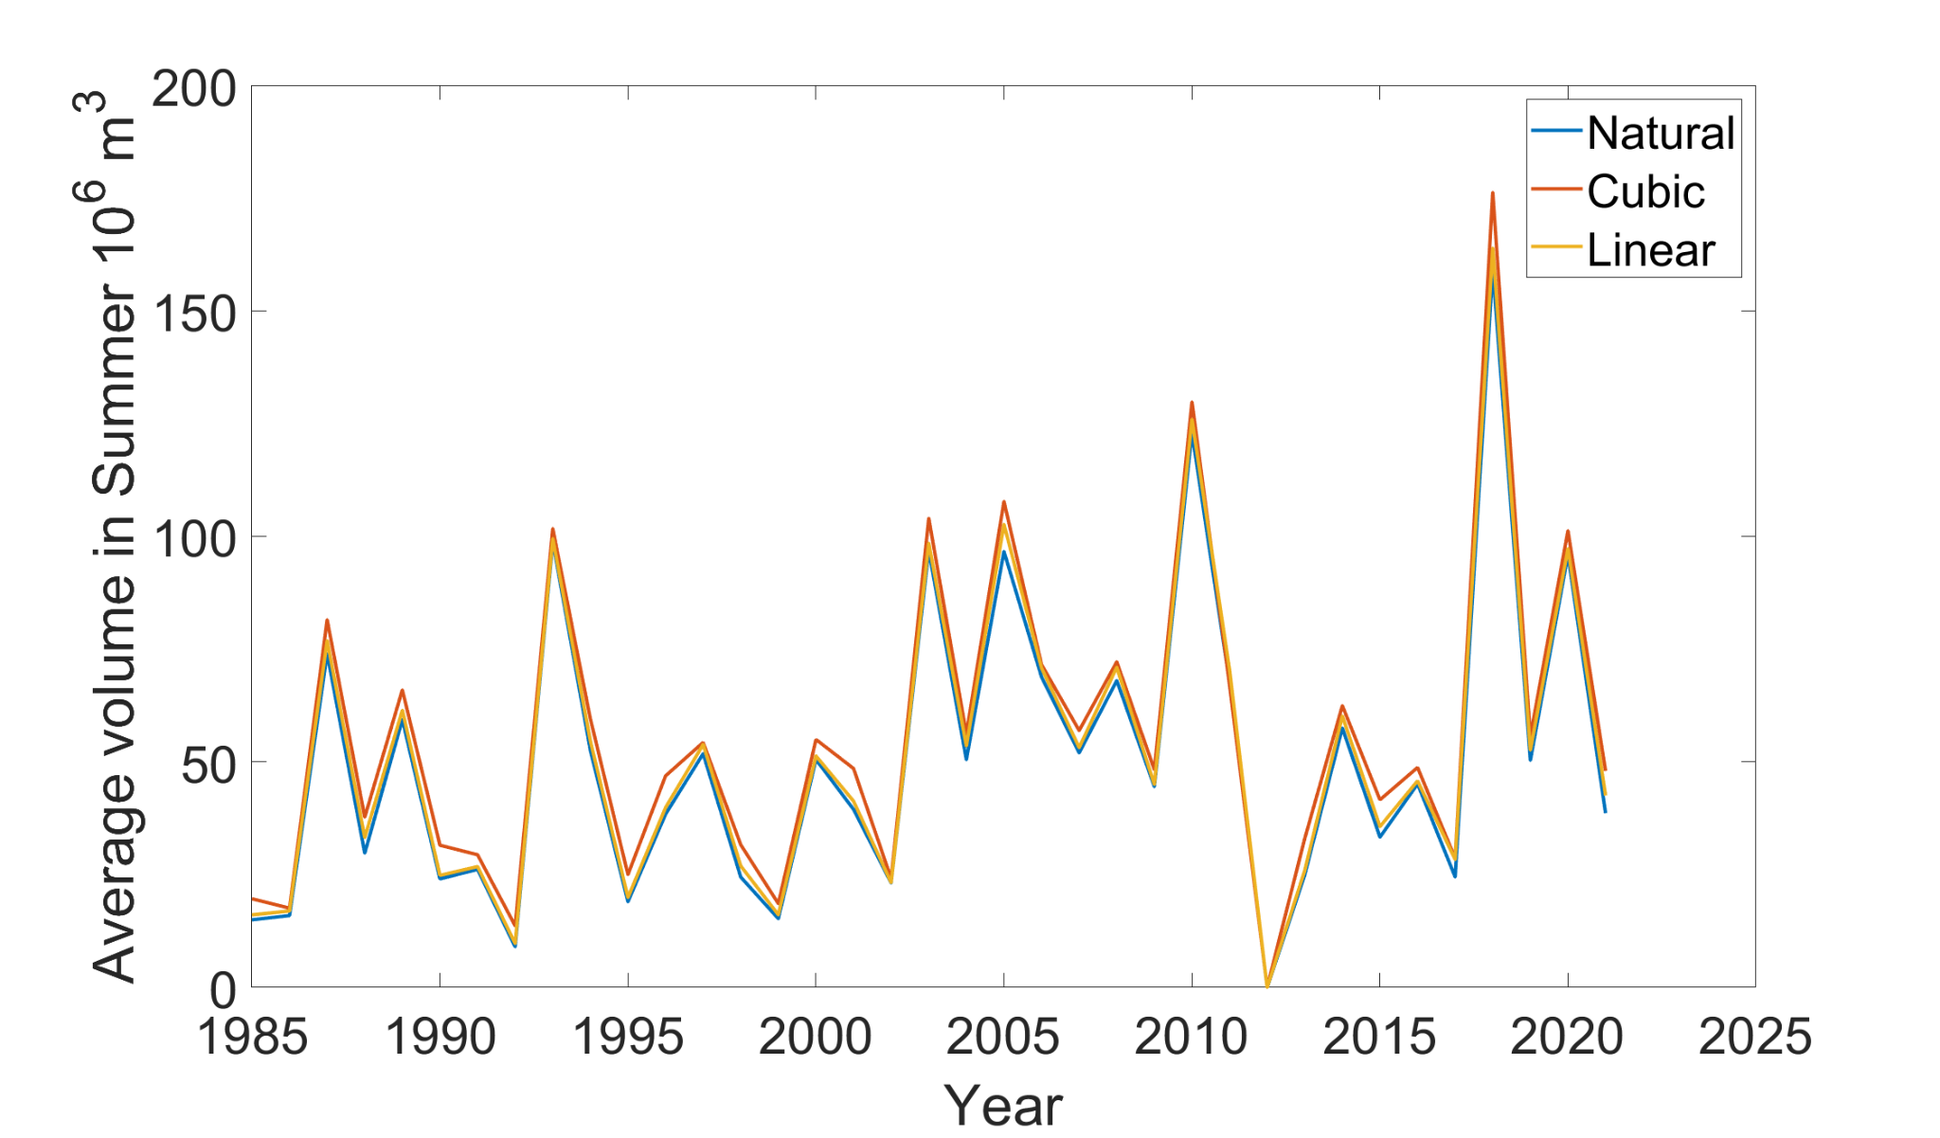
Figure S2.1. Summer average of hypoxic volume from 1985-2021 for different interpolation methods used. Over time, summer volume has followed a similar pattern and is closely correlated to the overall trend in HVD.

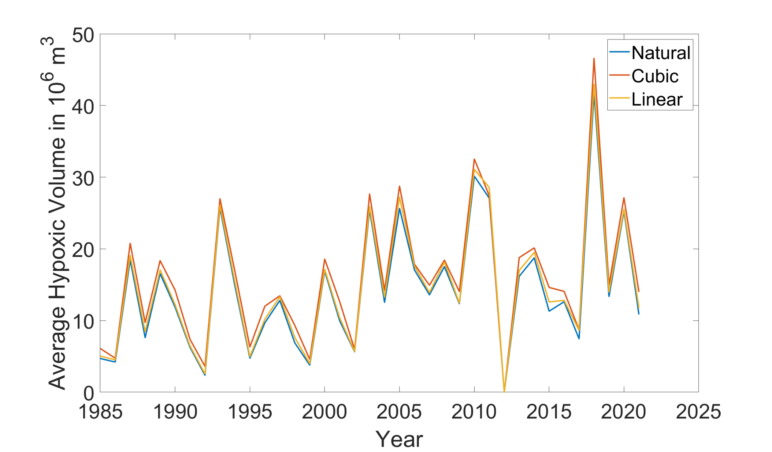
Figure S2.2. The annual average of hypoxic volume for different interpolation methods used. Over time, annual hypoxic volume has followed a similar pattern and is closely correlated to the overall trend in HVD and the summer average.

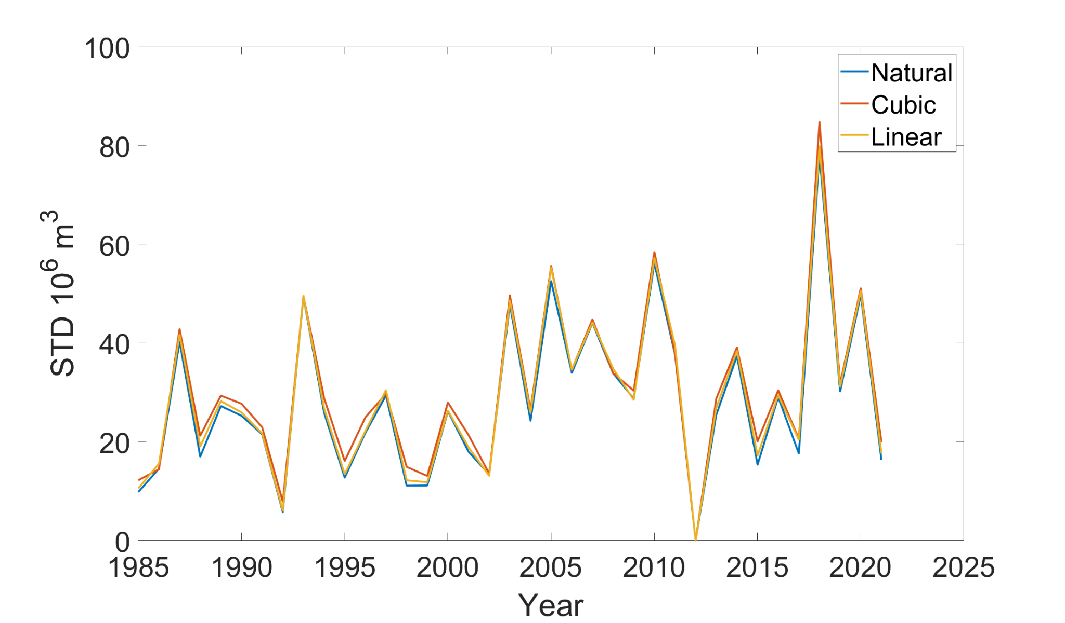
Figure S2.3. Annual standard deviation of hypoxic volume from 1985-2021 for each interpolation method used. Over time, standard deviation has become more varied but follows the same trend in HVD.

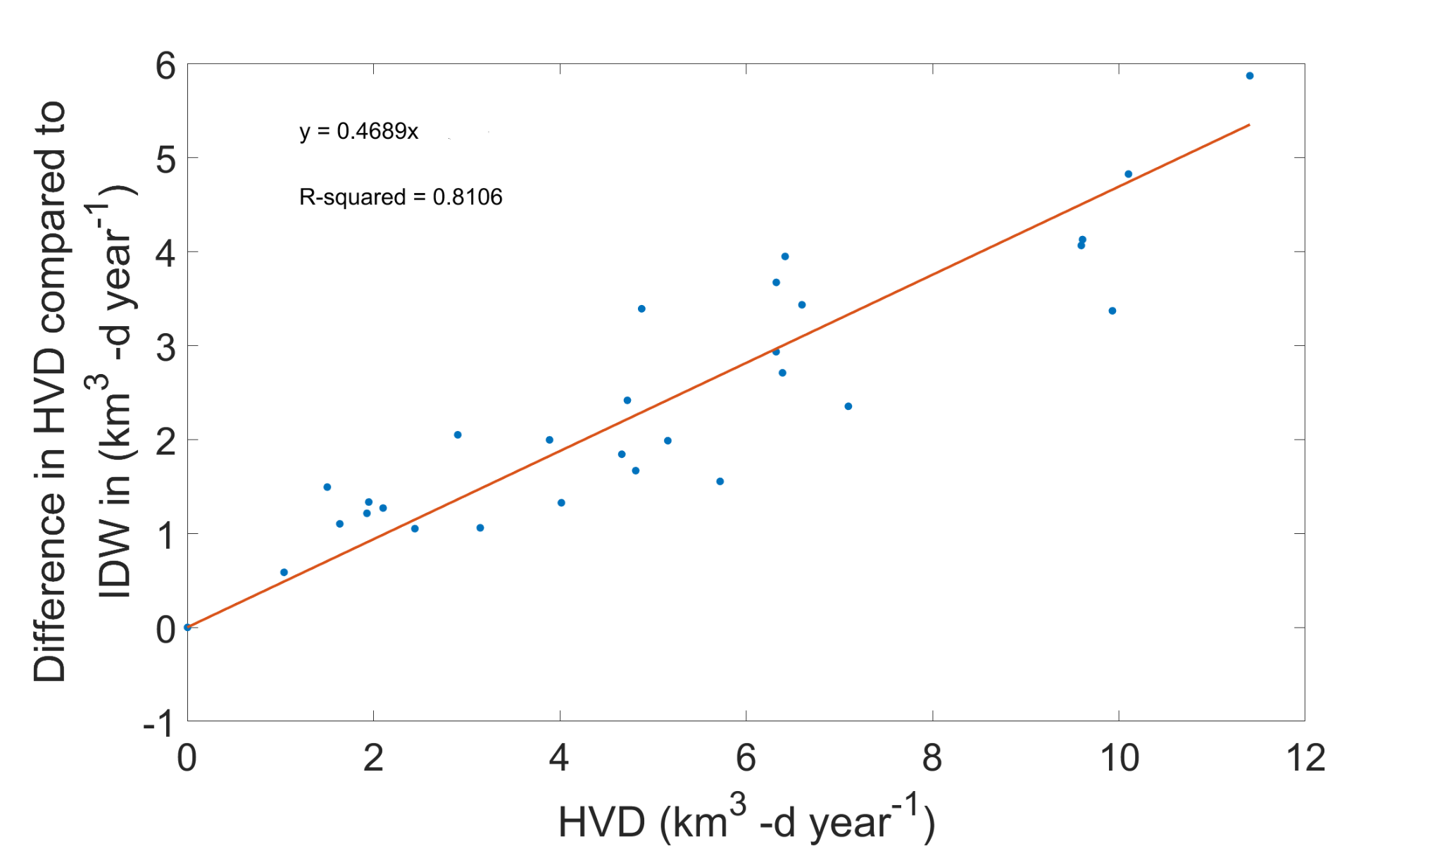
Figure S2.4. A correlation between HVD shown in Fig 2, and the difference between those HVD estimates and independent estimates made with IDW. The difference is highly correlated which suggests the magnitude is different but not the overall temporal trend.

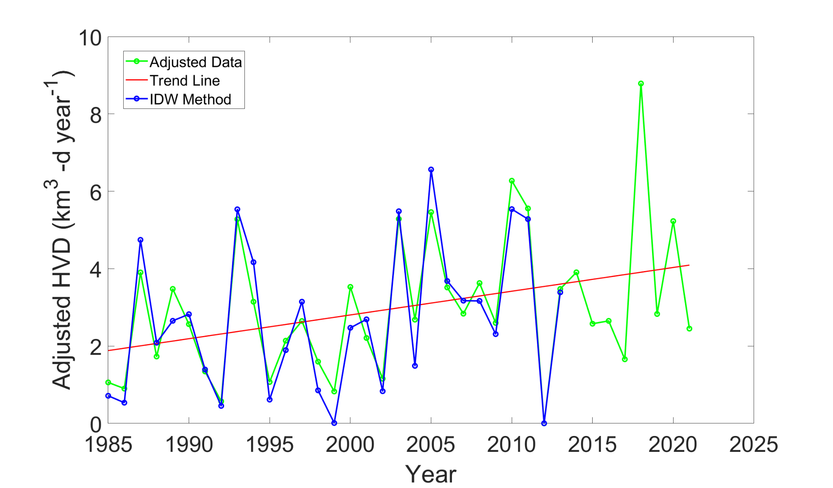
Figure S2.5. The adjusted HVD after removing the bias, compared to the inverse distance weighting methods used by the Chesapeake Bay Program.

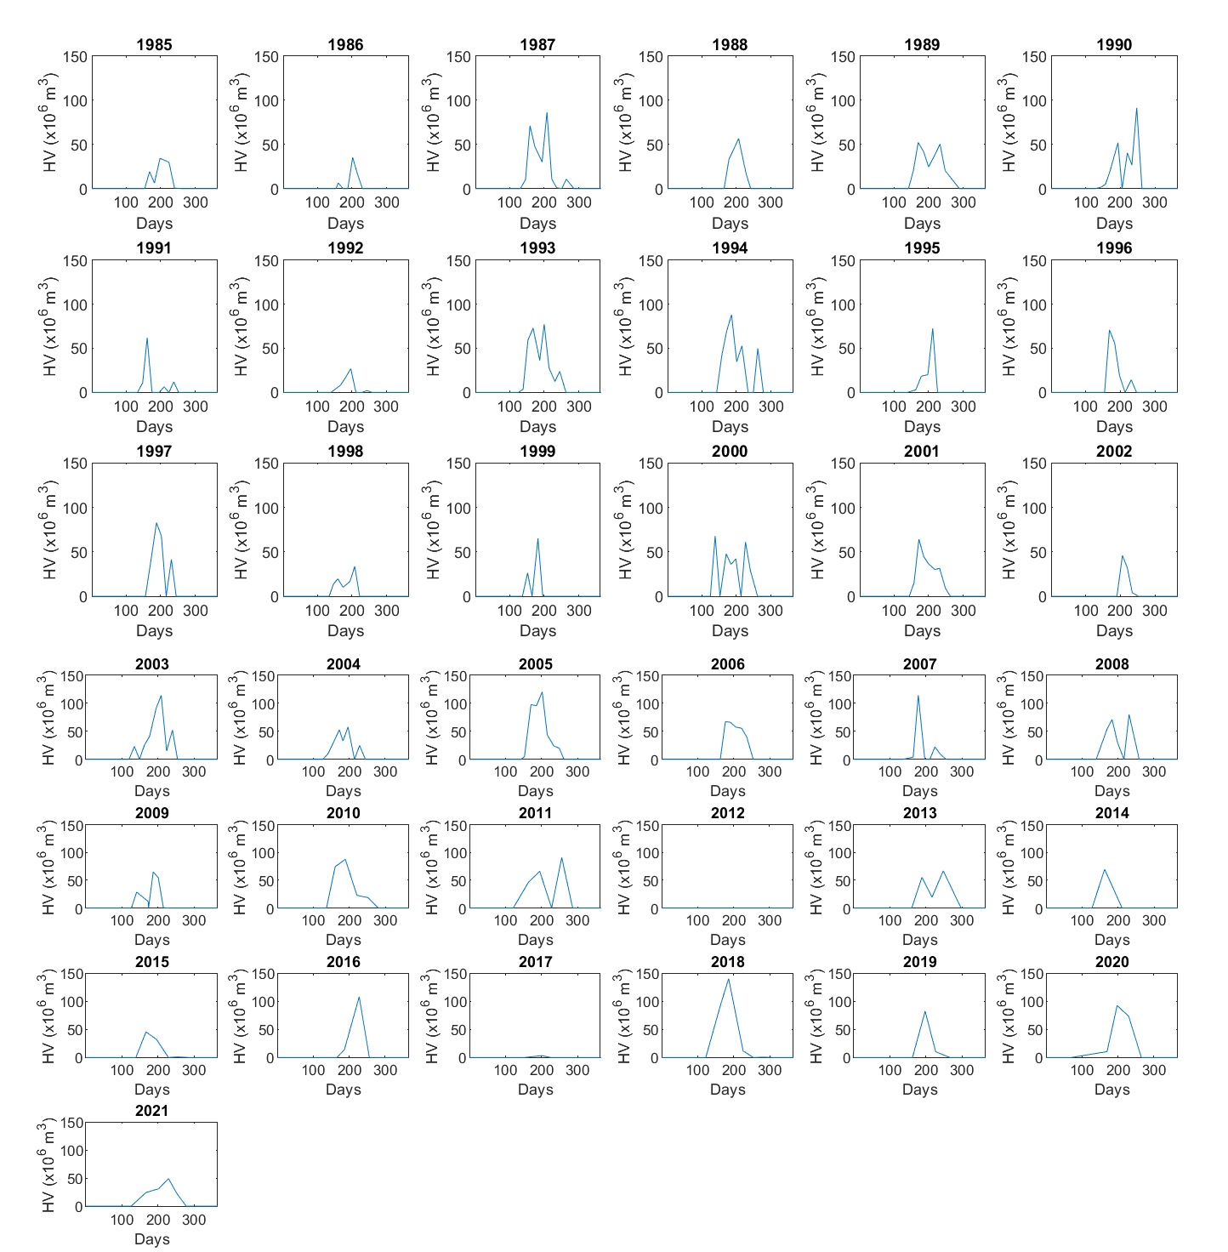
Figure S2.6. Daily hypoxic volumes for each year in 1985-2021. These graphs were used to calculate hypoxia duration.

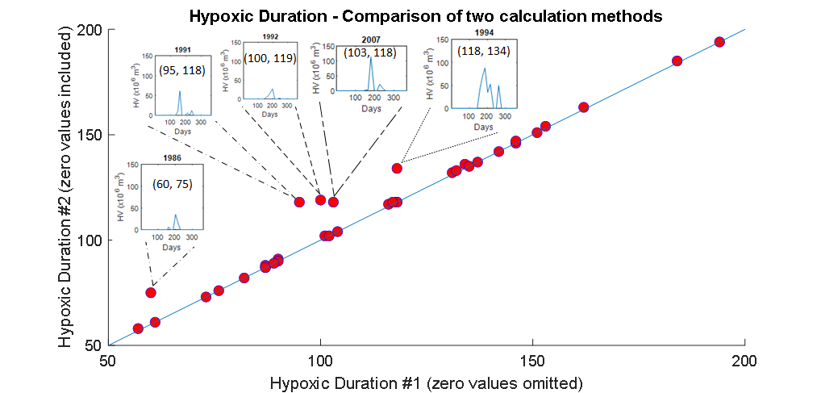
Figure S2.7. Correlation plot between two ways of calculating hypoxic duration. In approach #1 we skipped the zero values and in approach #2, we counted the number of days between the first and last hypoxic day including the zero values. Outliers have graphs showing two distinct hypoxic volumes.

Supplemental Material Section 3: Detailed illustrations and analyses supporting computations of hypoxia duration and oxygen depletion rates

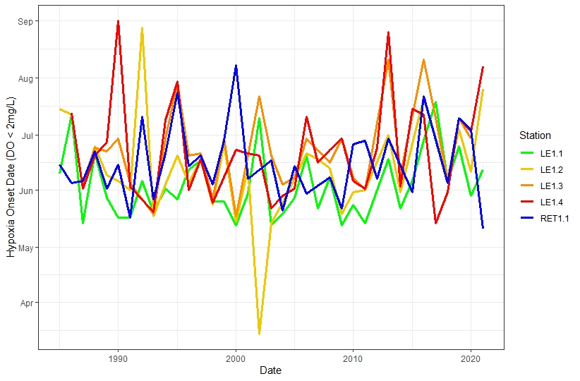
Figure S3.1. Time-series of the date of hypoxia onset from 1985-2021 for stations that undergo hypoxia. There was not a trend in any of the stations (p>0.05).

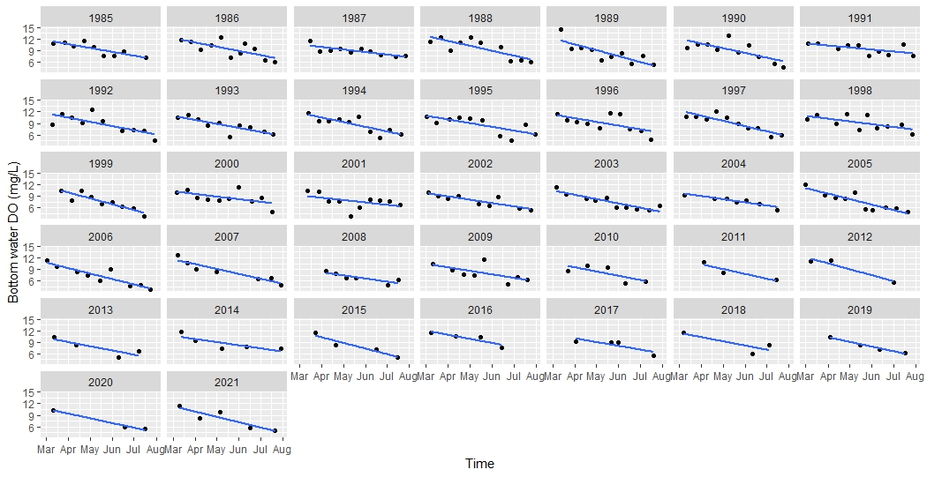
Figure S3.2. Bottom water O₂ depletion at TF1.5 from 1985-2021.
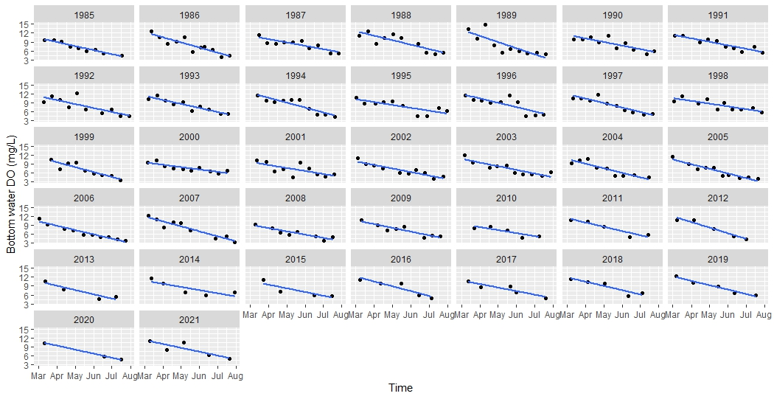Figure S3.3. Bottom water O₂ depletion at TF1.6 from 1985-2021.

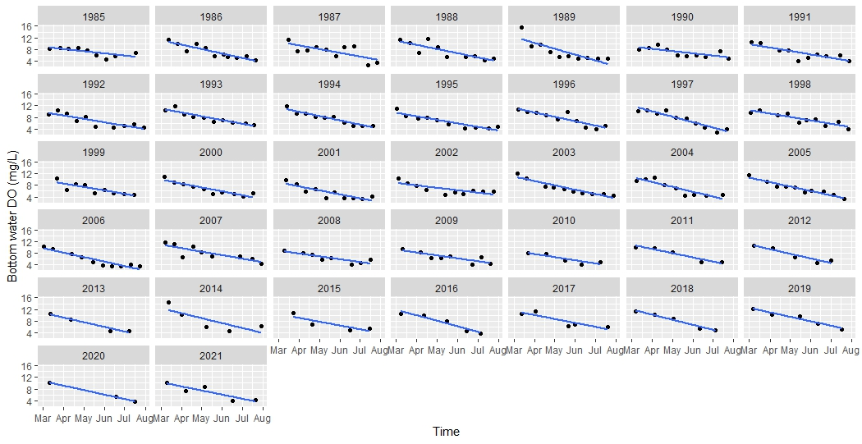
Figure S3.4. Bottom water O₂ depletion at TF1.7 from 1985-2021.

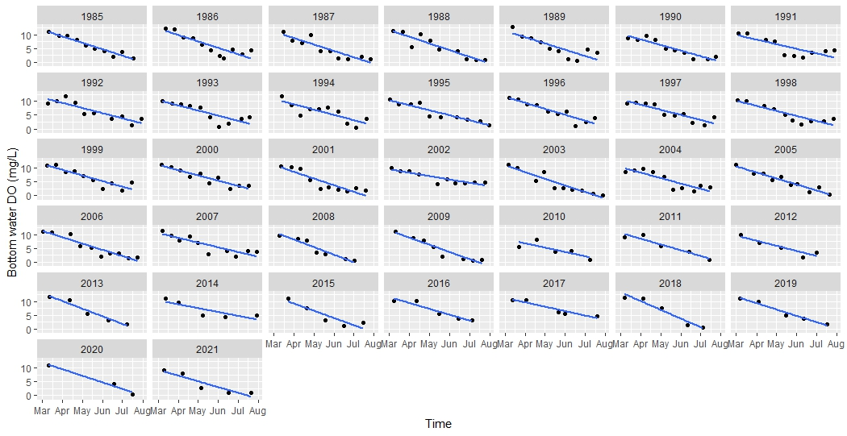
Figure S3.5. Bottom water O₂ depletion at RET1.1 from 1985-2021.

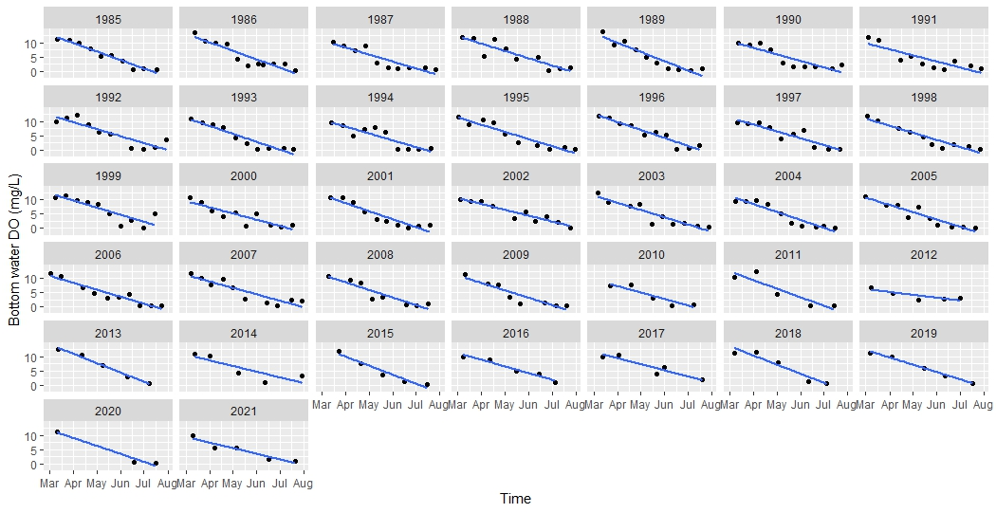
Figure S3.6. Bottom water O₂ depletion at LE1.1 from 1985-2021.

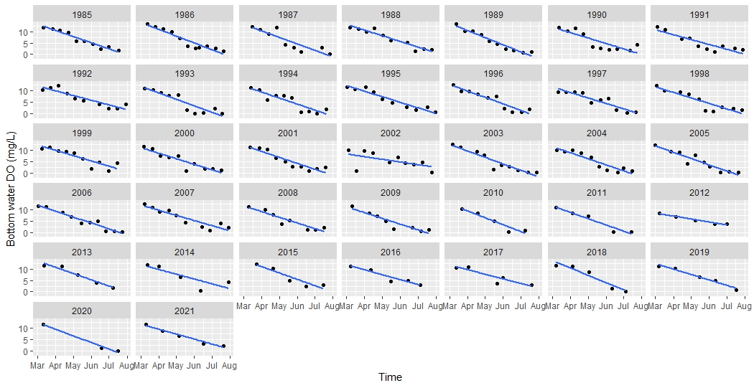
Figure S3.7. Bottom water O₂ depletion at LE1.2 from 1985-2021.
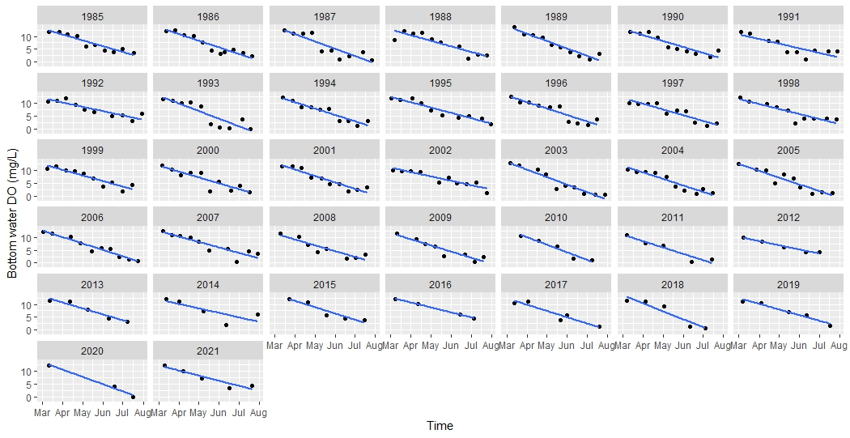
Figure S3.8. Bottom water O₂ depletion at LE1.3 from 1985-2021.

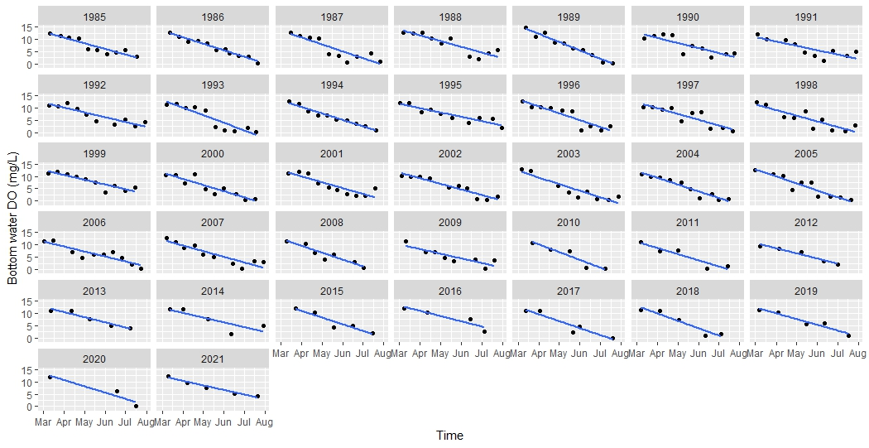
Figure S3.9. Bottom water O₂ depletion at LE1.14 from 1985-2021.

Supplemental Material Section 4: Correlations between winter-spring oxygen depletion rates and selected variables.

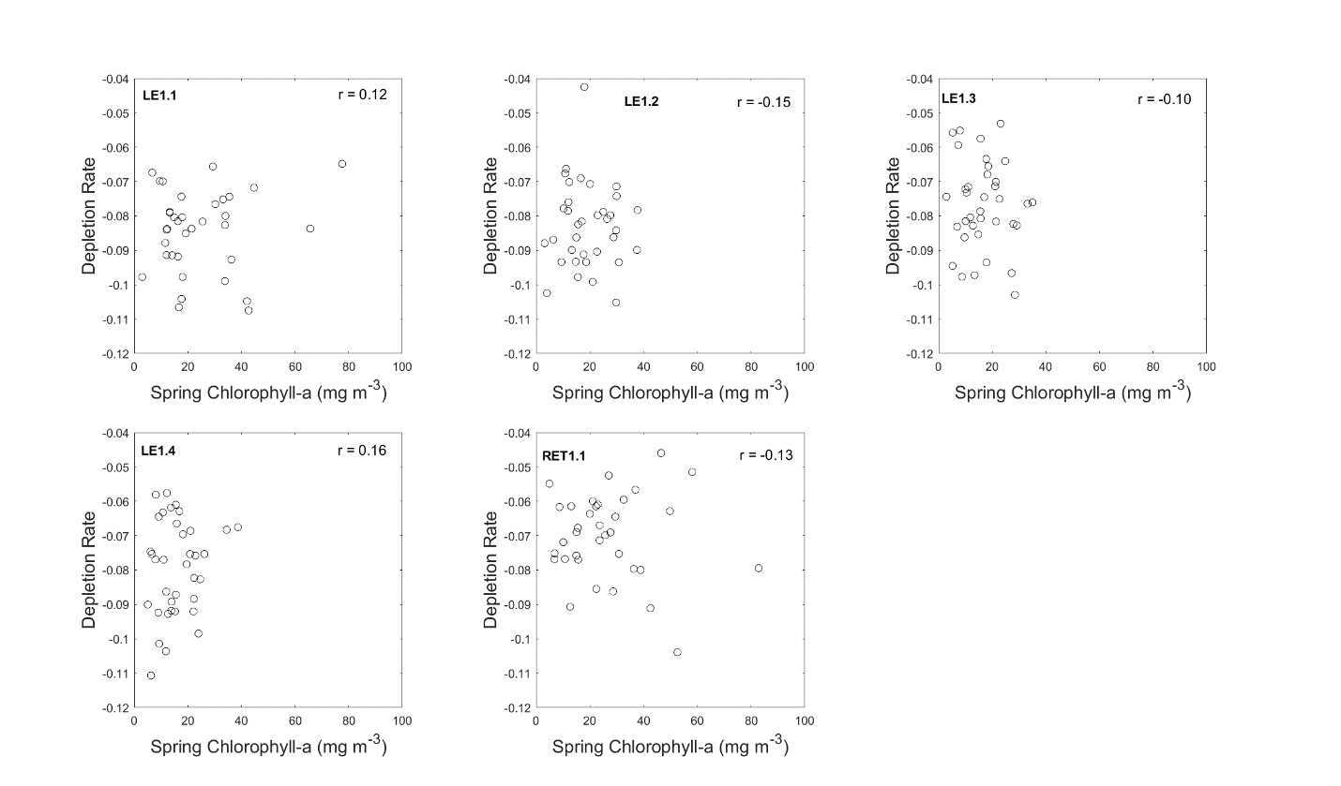
Figure S4.1. Correlation between depletion rate and spring chlorophyll-a for stations in the lower and middle Patuxent River.

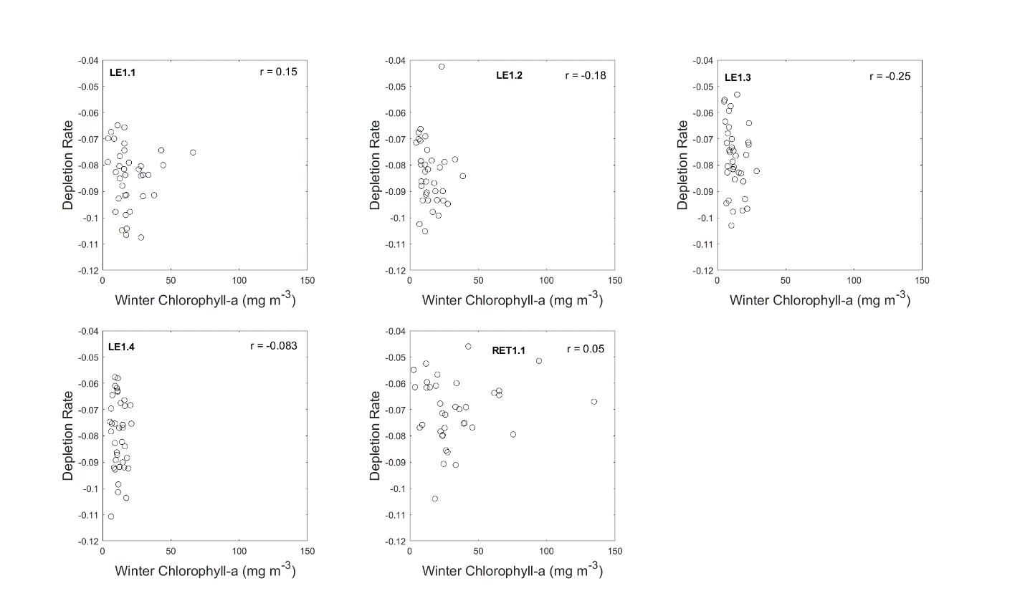
Figure S4.2. Correlation between depletion rate and winter chlorophyll-a for stations in the lower and middle Patuxent River.

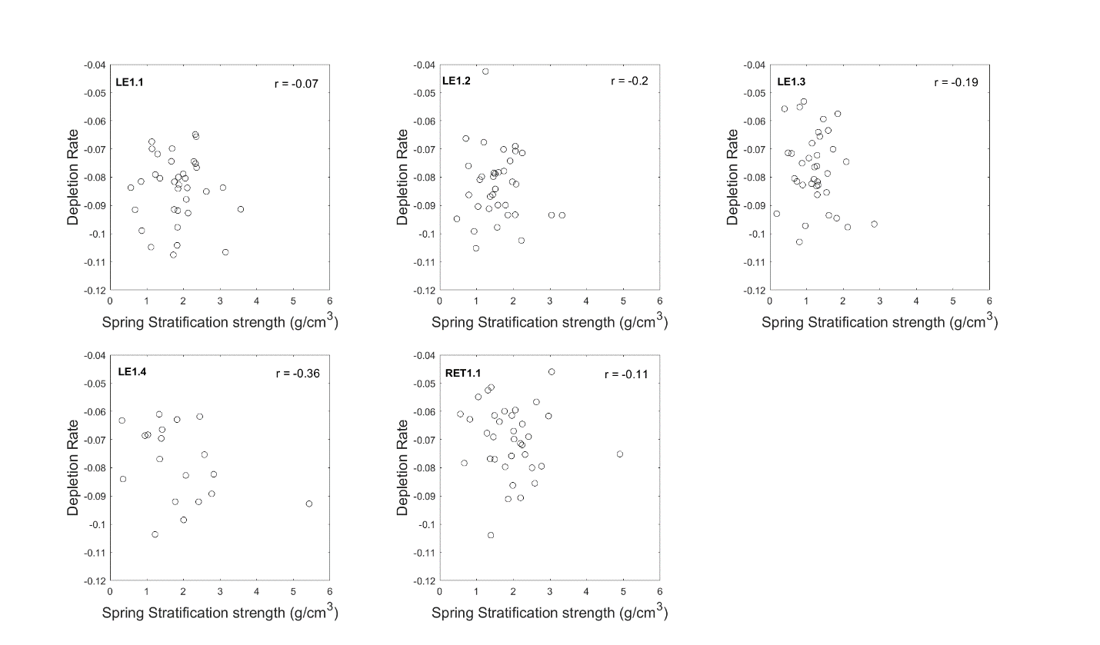
Figure S4.3. Correlation between depletion rate and spring stratification strength for stations in the lower and middle Patuxent River.

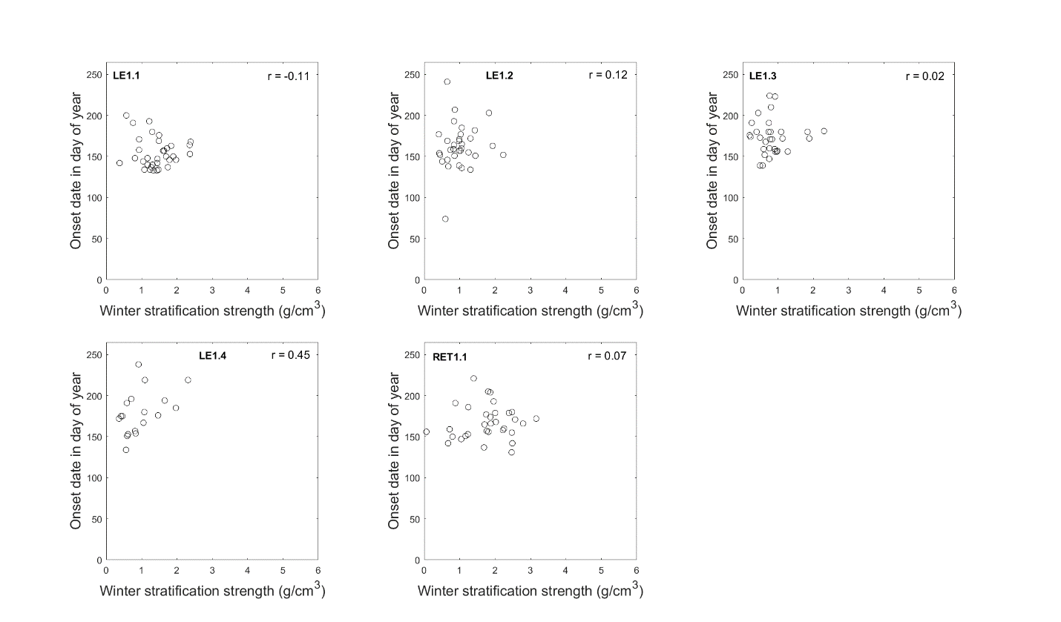
Figure S4.4. Correlation between onset date and winter stratification strength for stations in the lower and middle Patuxent River.

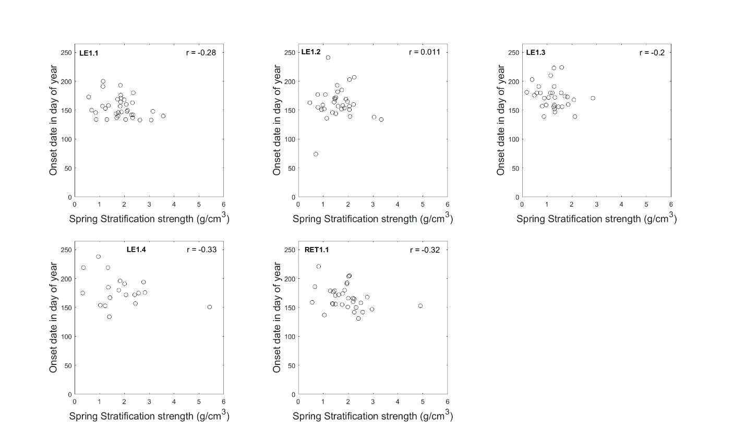
Figure S4.5. Correlation between onset date and spring stratification strength, for stations in the lower and middle Patuxent River.

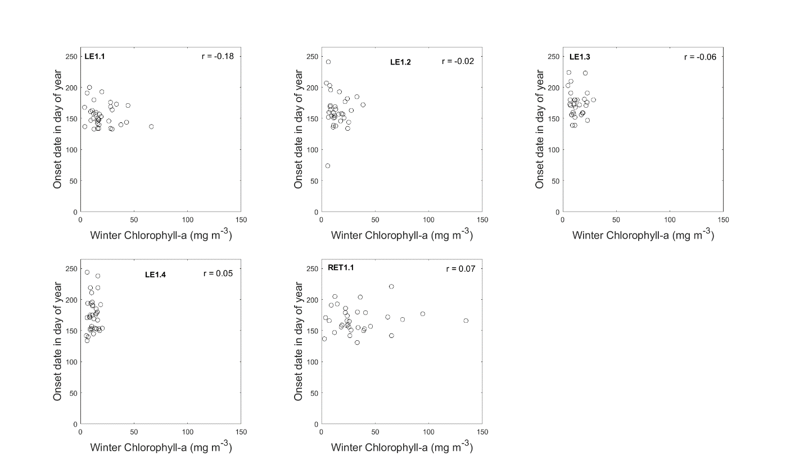
Figure S4.6. Correlation between onset date and winter chlorophyll-a for stations in the lower and middle Patuxent River.

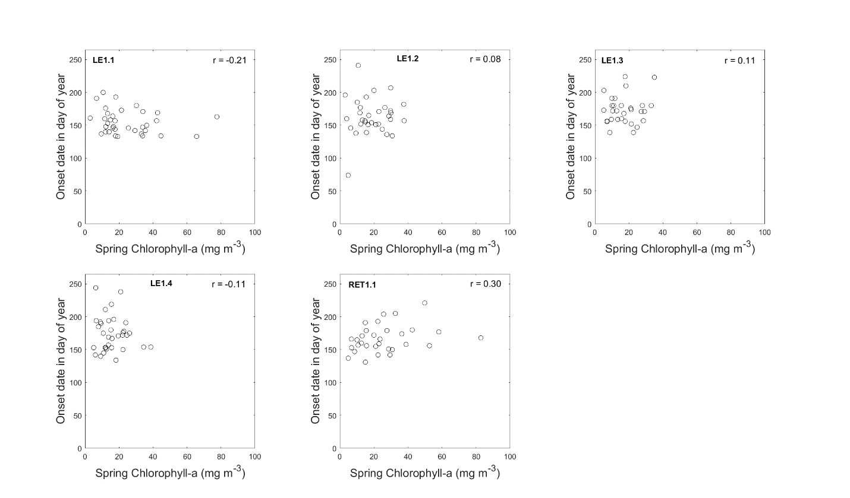
Figure S4.7. Correlation between onset date and spring chlorophyll-a for stations in the lower and middle Patuxent River.

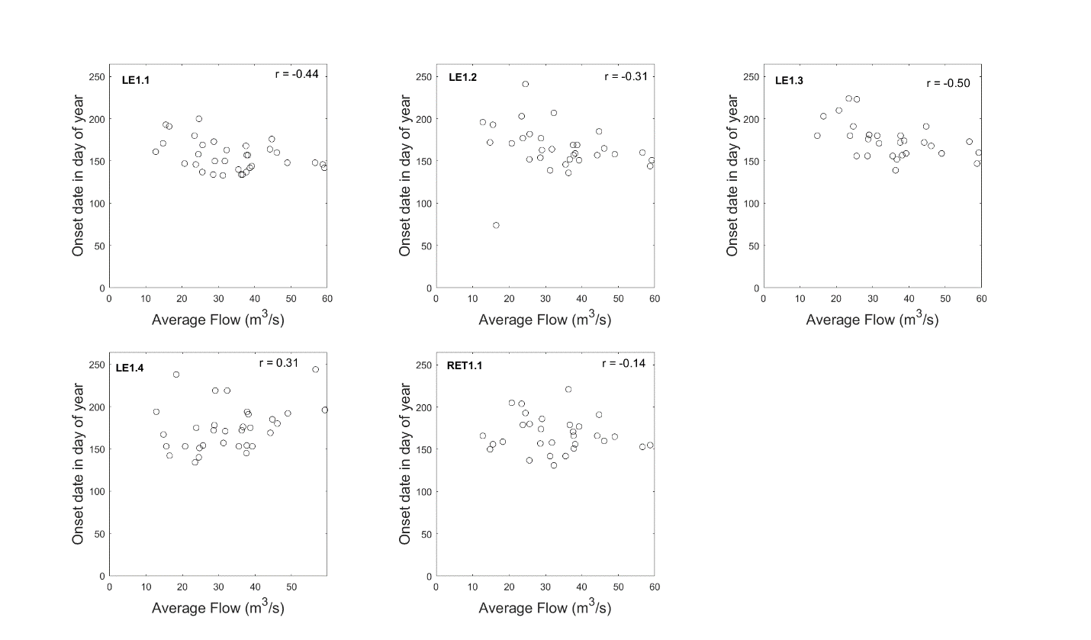
Figure S4.8. Correlation between onset date and yearly average flow, for stations in the lower and middle Patuxent River.

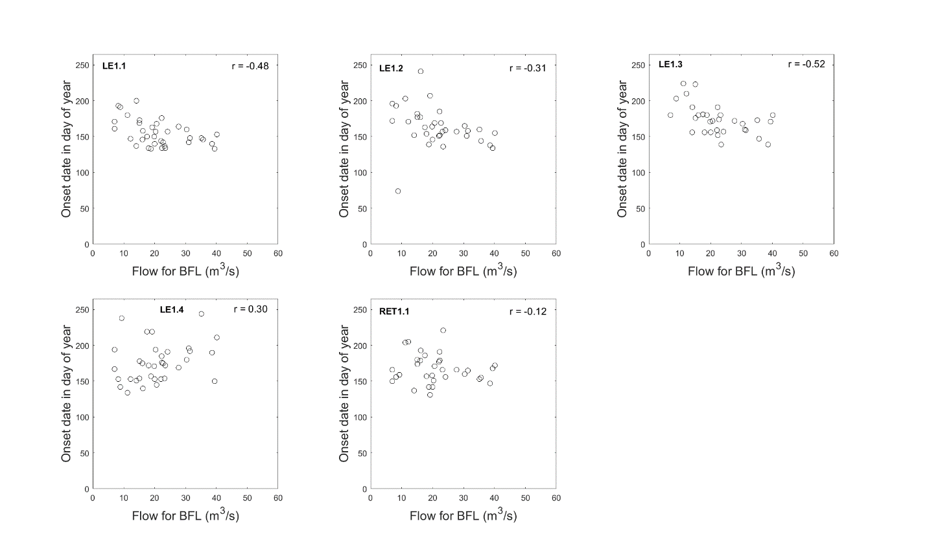
Figure S4.9. Correlation between onset date and yearly average flow for below the fall line, for stations in the lower and middle Patuxent River.

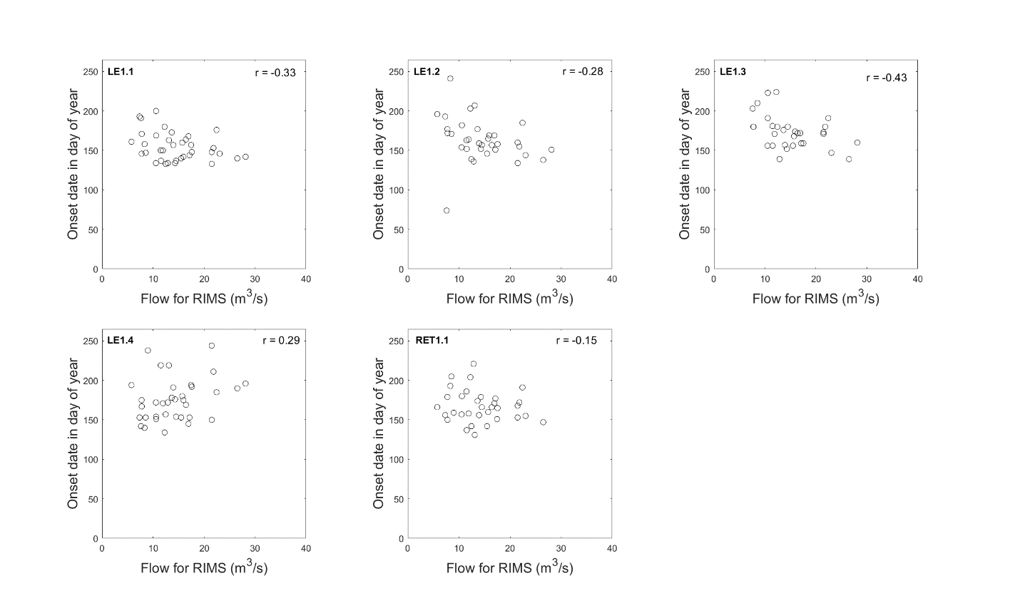
Figure S4.10. Correlation between onset date and yearly average flow for river input monitoring, for stations in the lower and middle Patuxent River.

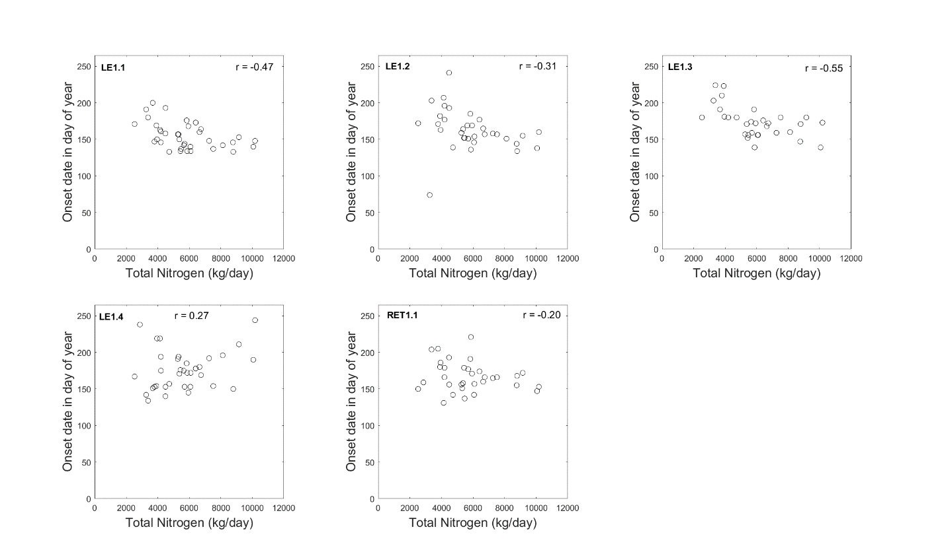
Figure S4.11. Correlation between onset date and yearly total nitrogen , for stations in the lower and middle Patuxent River.

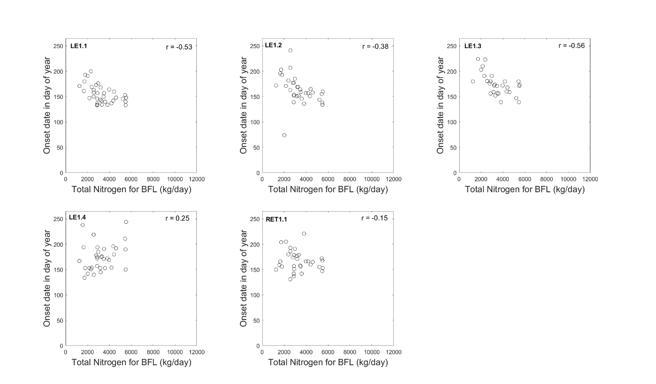
Figure S4.12. Correlation between onset date and yearly total nitrogen for below the fall line, for stations in the lower and middle Patuxent River.

Supplemental Material Section 5: Time-series and temporal trends in water temperature, salinity, stratification, and chlorophyll-a.

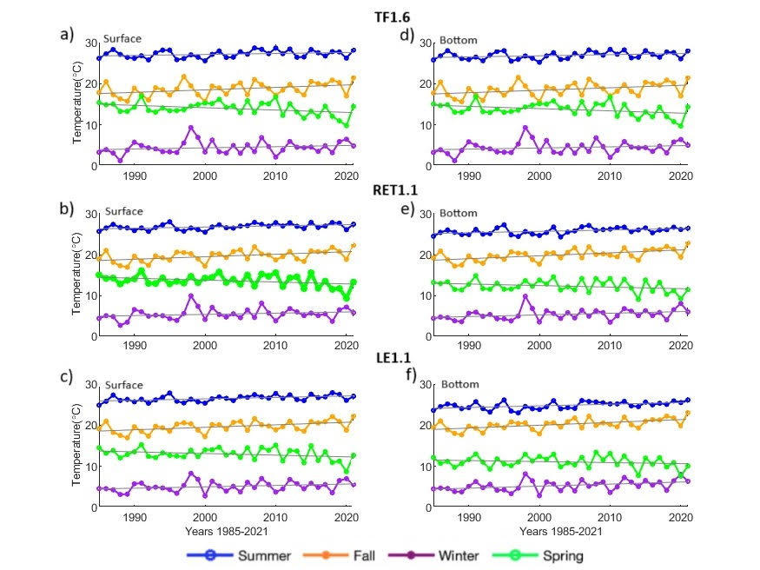
Figure S5.1. Mean temperature time series for each season from 1985 to 2021, spanning the tidal freshwater seaward to the mesohaline region. Summer was defined from June-August, fall from September-November, winter from December-February, and spring from March-May. Surface (a-c) and bottom temperature (d-f) are included for each of three representative stations along the estuarine axis.

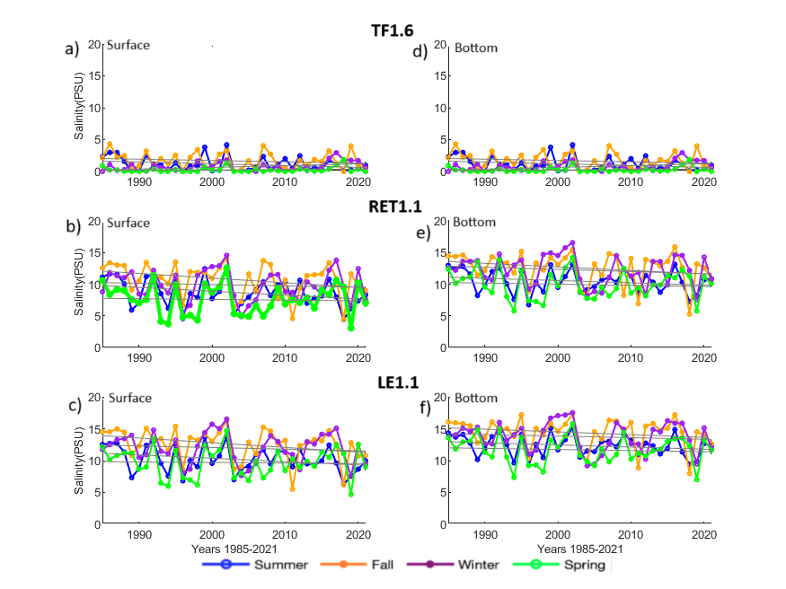
Figure S5.2. Mean salinity time series for each season from 1985 to 2021, spanning the tidal freshwater seaward to the mesohaline region. Summer was defined from June-August, fall from September-November, winter from December-February, and spring from March-May. Surface (a-c) and bottom salinity (d-f) are included for each of three representative stations along the estuarine axis.

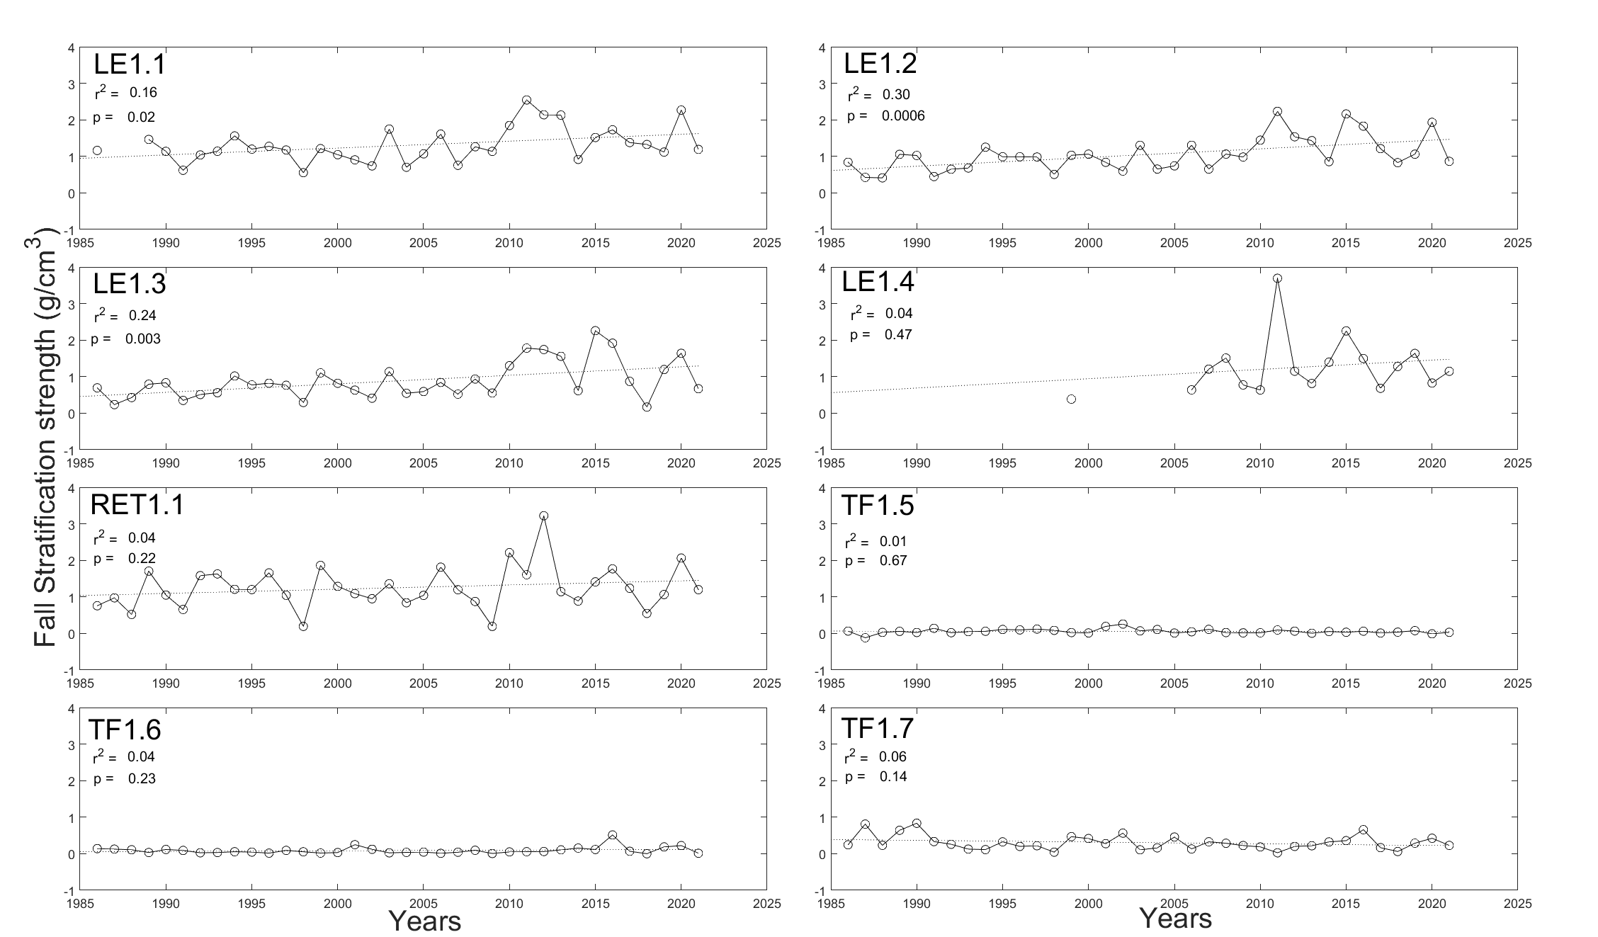
Figure S5.3. Fall stratification strength across all the stations. Stations LE 1.1, LE1.2, LE1.3, and RET1.1 have seen increasing trends in fall stratification strength. All other stations do not have a trend where p>0.1.

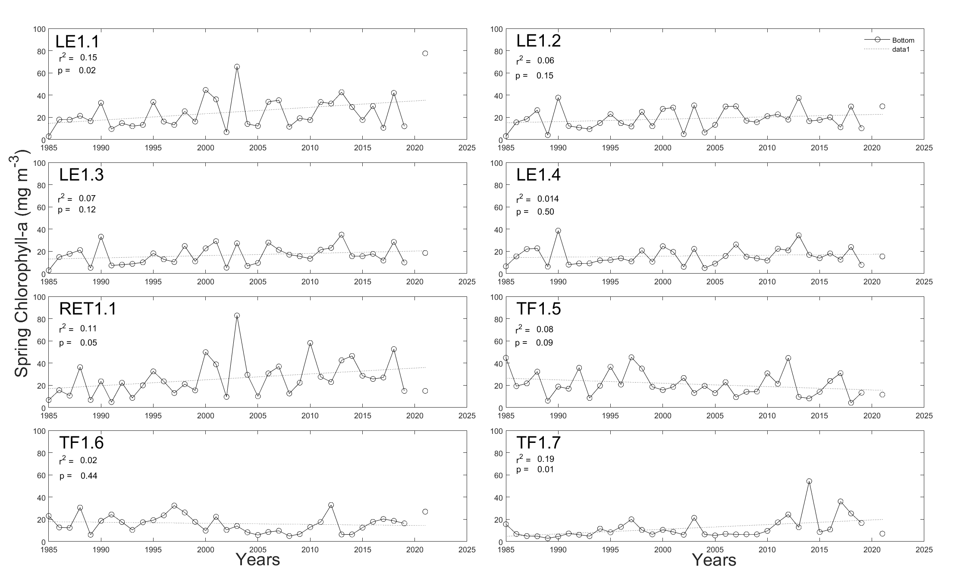
Figure S5.4. Bottom spring chlorophyll concentrations across all the stations. Stations LE 1.1, RET1.1, TF1.7 have seen increasing trends in chlorophyll-a, while TF1.5 has seen a decreasing trend. All other stations do not have a trend where p>0.1.

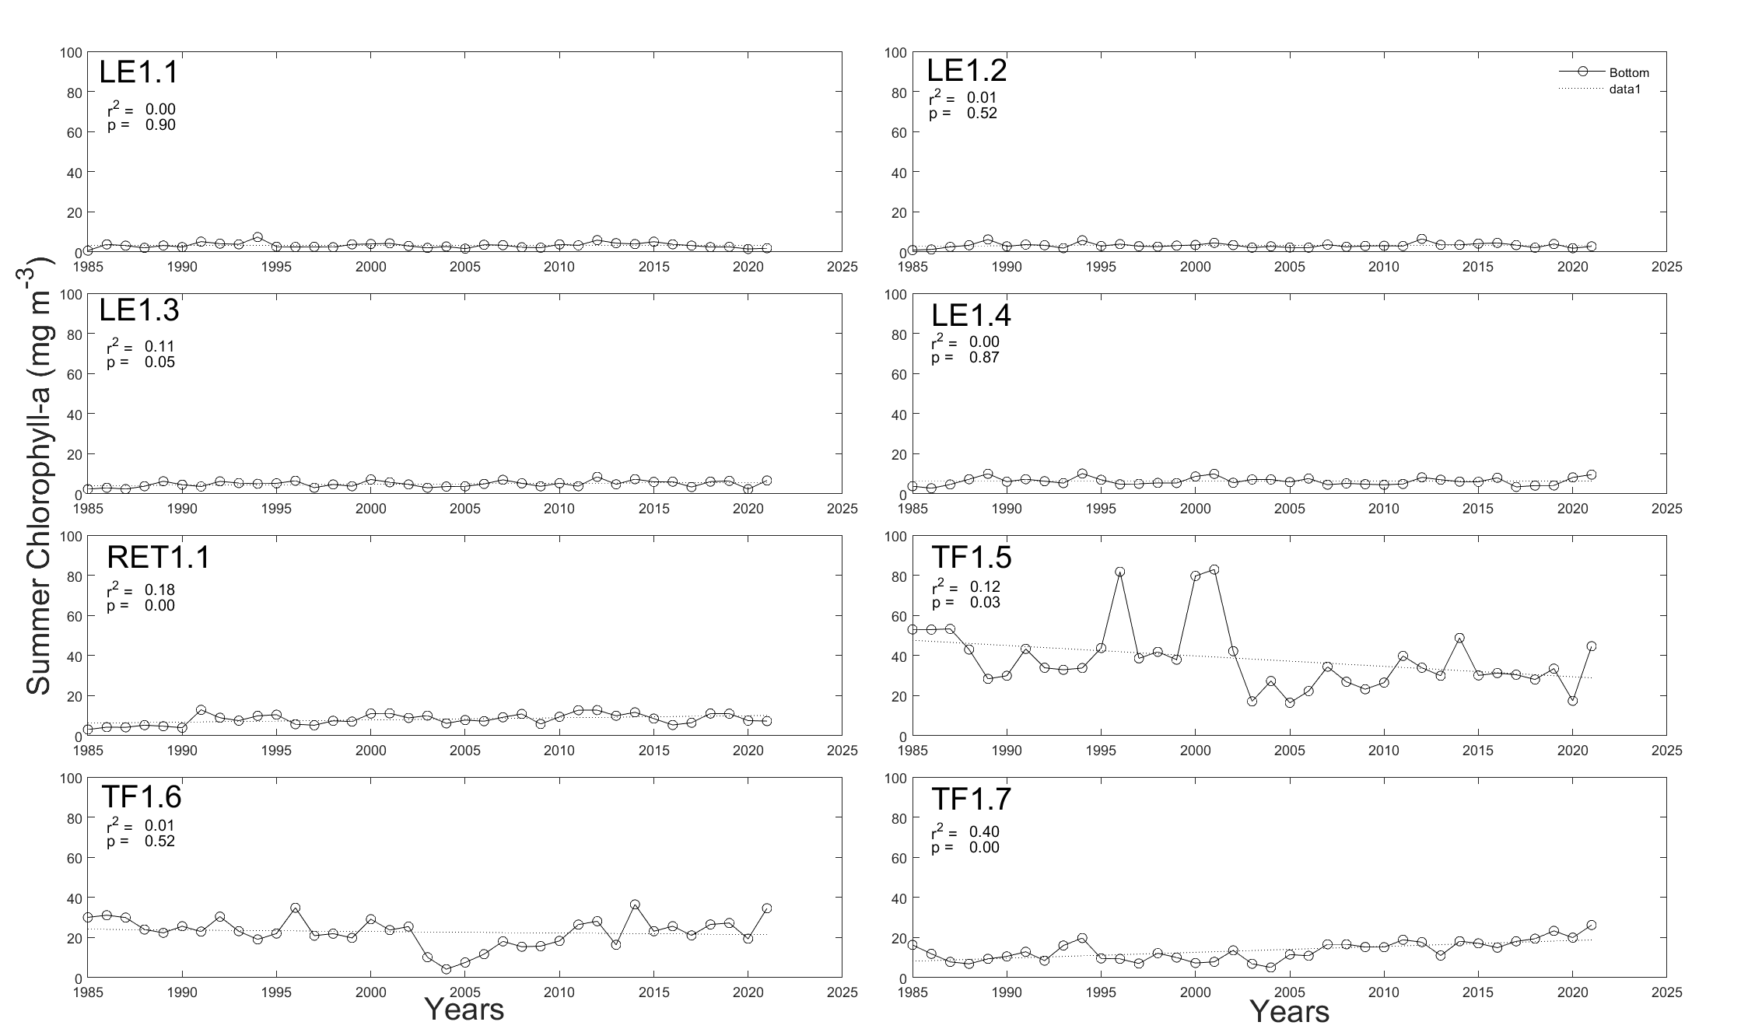
Figure S5.5. Bottom summer chlorophyll concentrations across all the stations. Stations LE 1.3, RET1.1, TF1.7 have seen increasing trends in chlorophyll-a, while TF1.5 has seen a decreasing trend. All other stations do not have a trend where p>0.1.

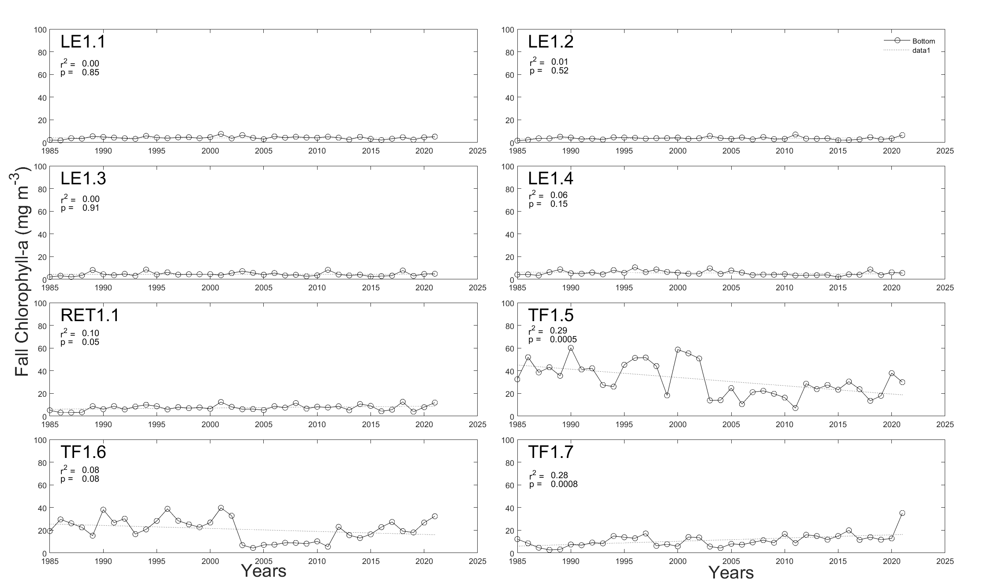
Figure S5.6. Bottom fall chlorophyll concentrations across all the stations. Stations RET1.1 and TF1.7 have seen increasing trends in chlorophyll-a, while TF1.5 and TF1.6 have seen a decreasing trend. All other stations do not have a trend where p>0.1.

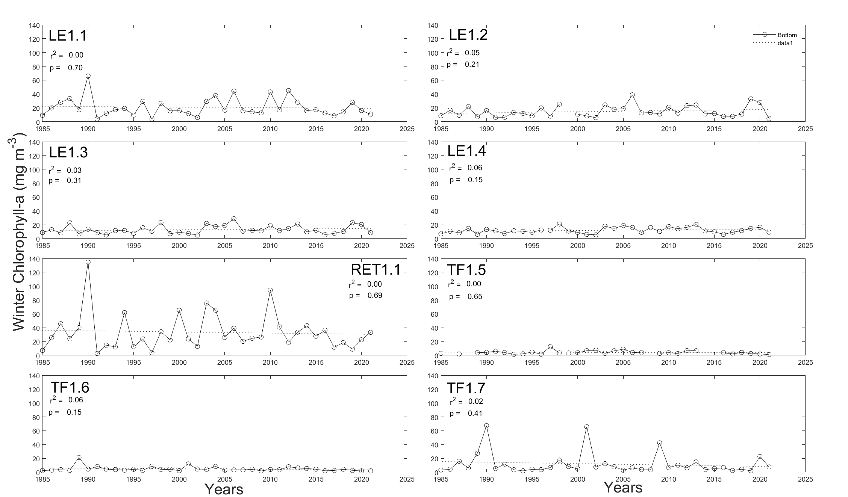
Figure S5.7. Bottom winter chlorophyll concentrations across all the stations. All stations do not have a trend where p>0.1.

Supplemental Material Section 6: Correlation matrix for watershed loading variables and hypoxic volume days (HVD).

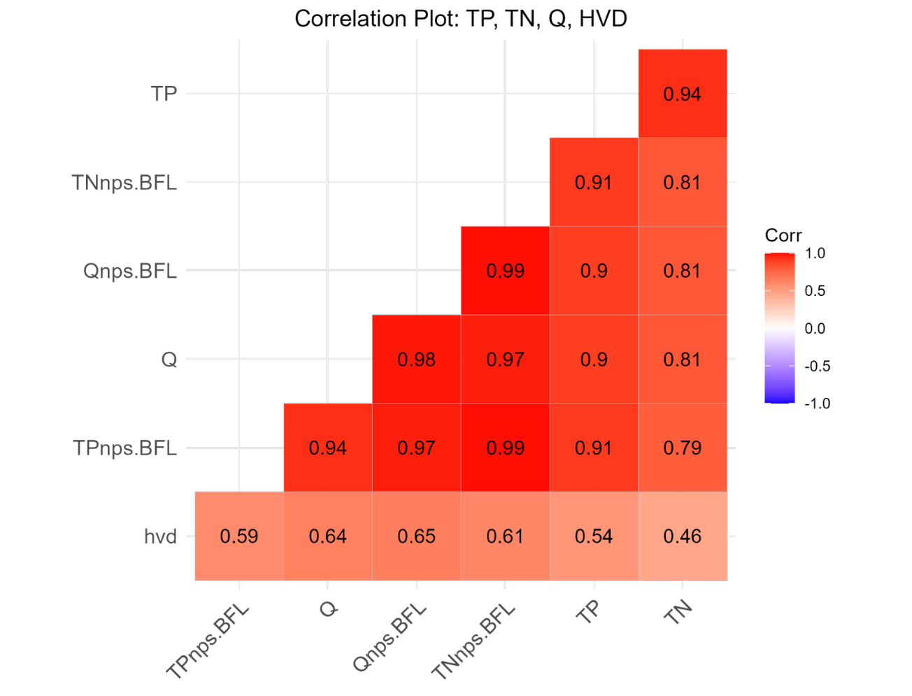

Figure S6.1. Pearson correlation coefficients for select nutrient load, river flow, and HVD. Q = freshwater discharge, TN = total nitrogen load, TP = total phosphorus load, nps.BFL = non-point source loading below the fall line, and HVD = hypoxic volume days. Darker coloration indicates a stronger correlation.

