Electronic Supplementary Material
Title: Structure and function of restored and natural salt marshes: implications for ecosystem resilience and adaptive potential
Author Affiliations and Addresses:
Corresponding Author: Sarah C. Crosby, Director of Conservation and Policy, The Maritime Aquarium at Norwalk, 10 North Water Street, Norwalk CT 06854; phone: 203-852-0700 (x2304), fax: 203- 855-0829, email: sarah.corman.crosby@gmail.com
David M. Hudson, Remote Ecologist, Inc., Darien CT 06820
A. Randall Hughes, Northeastern University, Nahant, MA 01908
Anna Bartholet, Northeastern University, Nahant, MA 01908
Kasey T. Burns, Harbor Watch at Earthplace, Inc., Westport CT 06880
Mary K. Donato, Harbor Watch at Earthplace, Inc., Westport CT 06880
Devan S. Healy, HDR, Inc., White Plains, NY 10604
Rebha Raviraj, The Maritime Aquarium at Norwalk, Norwalk CT 06854
Katherine Sperry, Northeastern University, Nahant, MA 01908
Nicole C. Spiller, Harbor Watch at Earthplace, Inc., Westport CT 06880
Justin Susarchick, The Maritime Aquarium at Norwalk, Norwalk CT 06854

Submission Date: October 17, 2023

Abstract: Salt marshes have ecological and economic value, but shoreline development, the increasing rate of sea-level rise, and other human impacts have caused significant loss of salt marshes. As a result, restoration of these ecosystems is widespread. For restoration and management to be effective, it is imperative to improve our understanding of marsh-building plants that serve as the ecological foundation of these habitats. Given the observed differences in characteristics between populations of smooth cordgrass, Spartina alterniflora, restoration plantings may impact the biodiversity and resilience of restored ecosystems. Understanding differences in the structural and functional outcomes of active planting of restoration sites will enable the long-term success of restoration efforts to be improved. Natural and restored salt marshes in Long Island Sound were studied in 2021-2022 for S. alterniflora genetics, biomass, and biometrics, and faunal community composition. The average genotypic diversity of S. alterniflora was more than 4 times higher in restored than in natural marshes, and differentiation between each restored site and natural sites decreased with time. No difference was observed in live S. alterniflora belowground biomass, however, mean dead belowground biomass in natural marshes was more than 3 times greater than in restored marshes. Marsh platform invertebrates differed between the restored and natural sites, with natural marsh edge habitats having 9 times higher density of Geukensia demissa and 3 times as many crab burrows than in restored marshes, but there was no detected difference in species richness or abundance of nekton at high tide. With restoration practitioners seeking resilient, self-sustaining ecosystems, it is important to evaluate whether restored marsh characteristics are consistent with those goals and modify restoration planning accordingly to incorporate genetics, structure, and function.
Supp. Table 1. Frequency and timing of sampling for each parameter. Months indicated in column headings are approximate; actual dates of sampling were April 29-May 6, 2021, July 13-20, 2021, September 27-October 4, 2021, April 25-May 5, 2022, July 5-July 12, 2022, and September 28-October 5, 2022
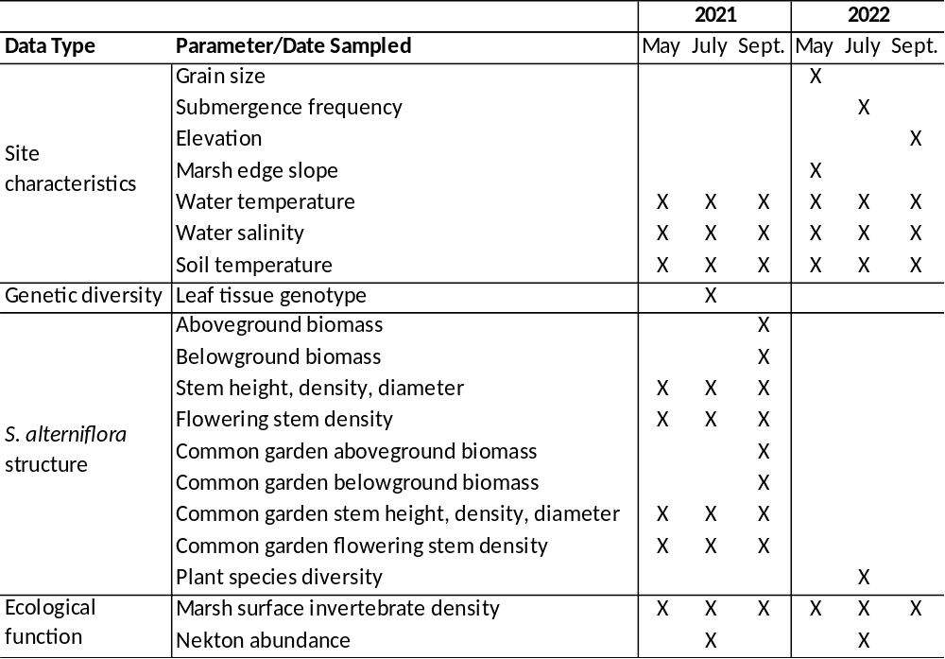

Supp. Table 2. Dissolved oxygen concentrations (mg/L) as measured at each site during plant and animal sampling events.
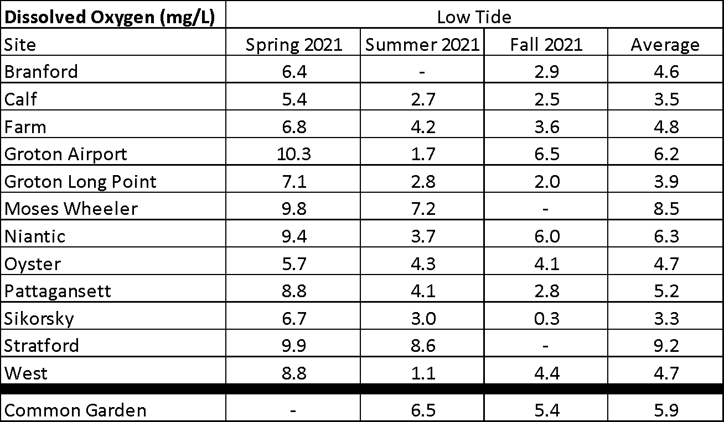

Supp. Table 3. Salinity (ppt) as measured at each site during plant and animal sampling events.
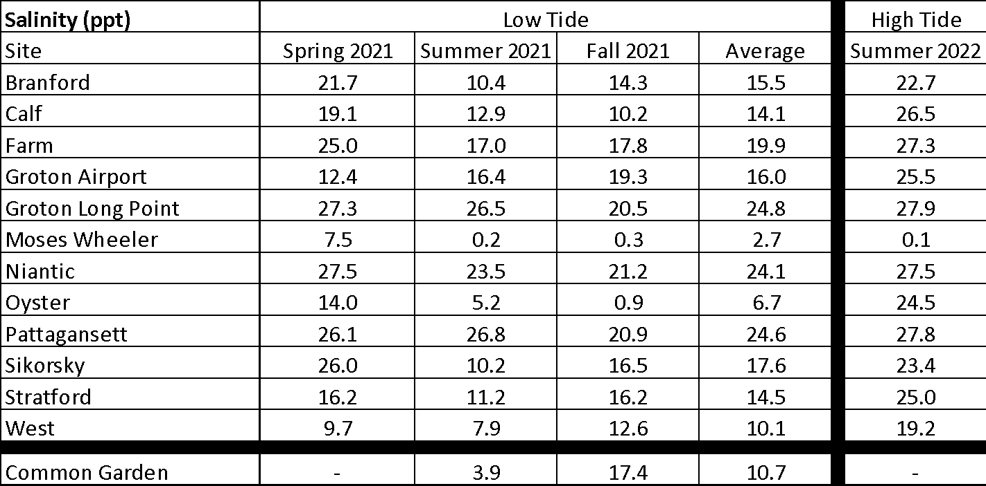

Supp. Table 4. Soil temperature (°C) as measured at each site during plant and animal sampling events.
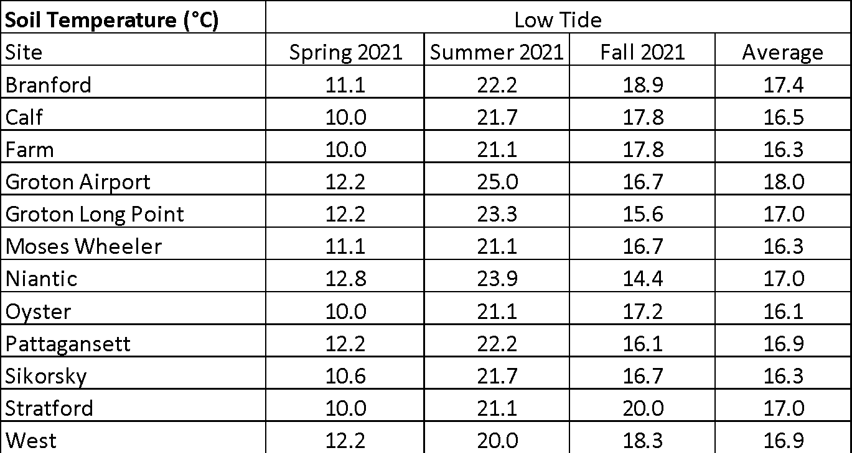

Supp. Table 5. Water temperature (°C) as measured at each site during plant and animal sampling events.
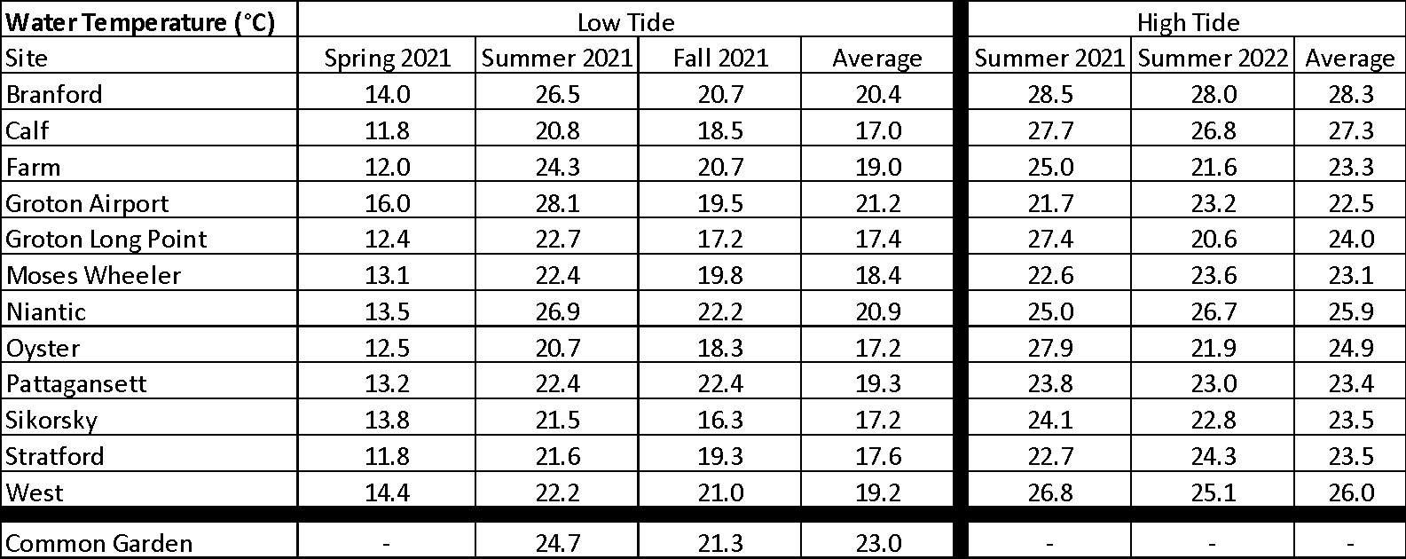

Supp. Table 6. Marsh edge slope (0-2 m) as measured at each site at the vegetation sampling plots (n = 10).
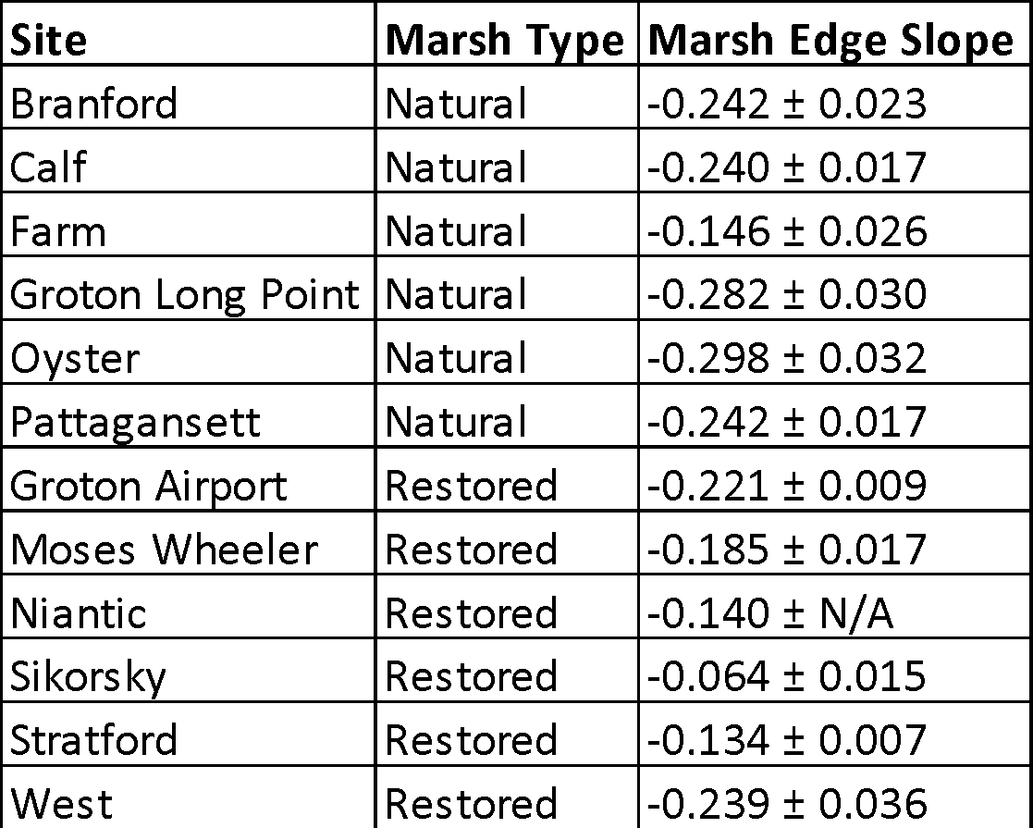

Supp. Table 7. Mean grain size fractions at each site (n = 3).
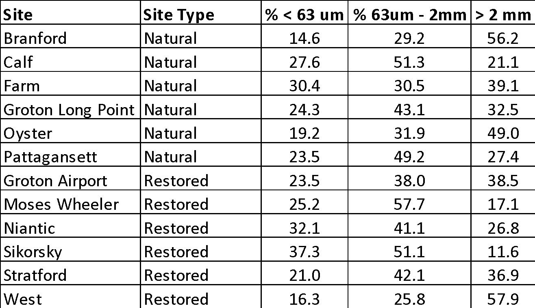

Supp. Table 8. Flooding frequency as measured (n = 20) at each site. Tidal range as reported by nearest NOAA tide gauge (tidesandcurrents.noaa.gov).
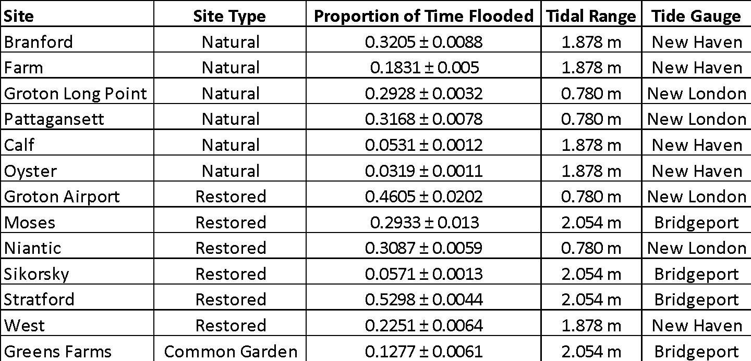

Supp. Figure 1. Location of natural (black circles) and restored (grey circles) salt marshes along northern coast of Long Island Sound in Connecticut, USA, with inset map showing an example of how survey plot locations were established within each marsh (natural site “Calf” is shown at Calf Pen Meadow Creek, Milford, Connecticut). At each marsh, a primary creek suspected to include the target habitat (monoculture of S. alterniflora) was traced in ArcMap (ArcGIS, Esri, Redlands, California USA) and 20 points were randomly distributed along its length in ascending order. In the field, these numbered maps were used for reference to orient the sampling team, and the establishment of the plots was conducted after the random selection of a number along the line (0-19) as the starting point for the 40 m transect.
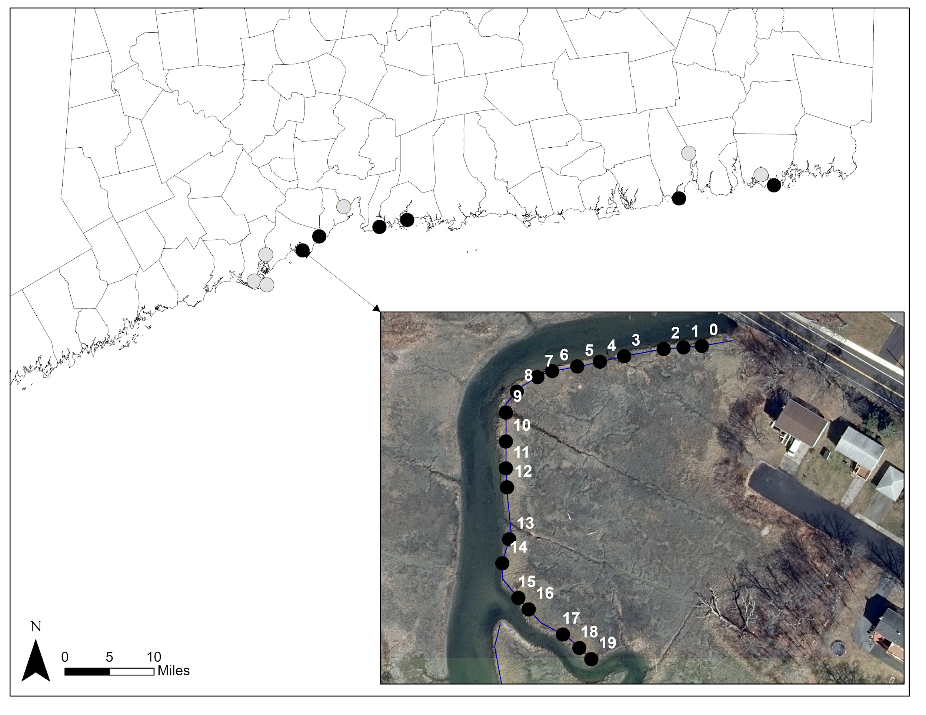
Supp. Figure 2. To measure marsh edge, a flexible meter tape with a weight attached to the end was fed through a PVC tube (2.663 m in length). The PVC tube was laid flat on the marsh surface adjacent to each of the plots and the weighted end of the meter tape was gently lowered from the end of the PVC tube to the sediment at distances of 0.5 m, 1 m, 1.5 m, and 2 m from the end of the vegetated marsh edge. Measurements were taken from the horizontal plane of the vegetated marsh surface to the un-vegetated marsh edge bottom at these distances, as shown by letters A, B, C, and D. The first measurement was taken at A, after which the PVC tube was extended 0.5 m further out from the edge, at which time measurement B was taken. This was repeated in 0.5 m increments until all 4 measurements were collected. The PVC tube placement was checked to ensure that it was vertically level as it was extended to each measurement point using a smartphone (placed on top of the PVC tube) level application, which uses the phones accelerometer to ensure that the phone is on a level surface.
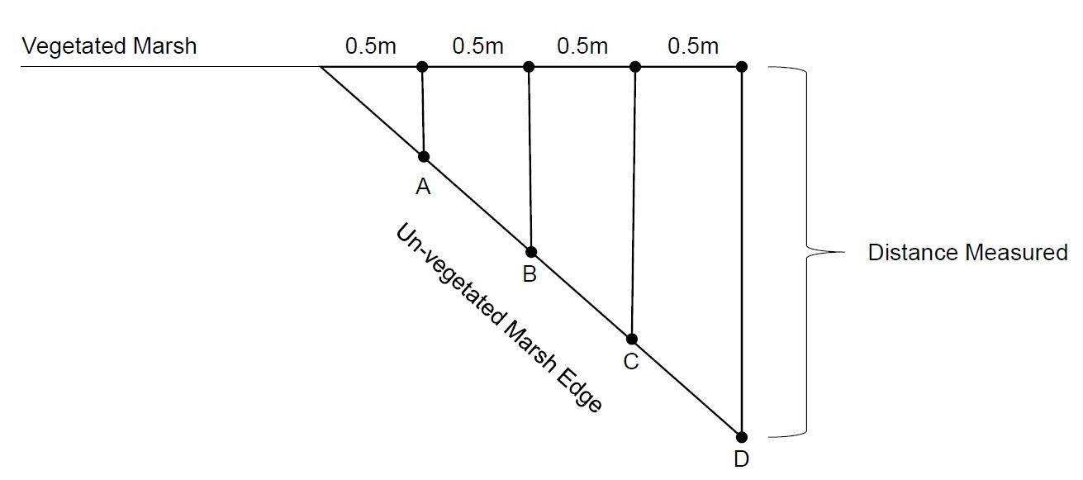

Supp. Figure 3. Live stem density as measured in each vegetation survey plot (n = 10) at each site in the spring, summer, and fall of 2021. Natural marshes are shown in black bars and restored marshes are shown in grey. Error bars represent standard error. Differences between restored and natural marshes were observed in spring (X² = 30.32, df = 1, p < 0.0001), summer (X² = 28.33, df = 1, p < 0.0001), and fall (X² = 25.24, df = 1, p < 0.0001) sampling events in 2021.
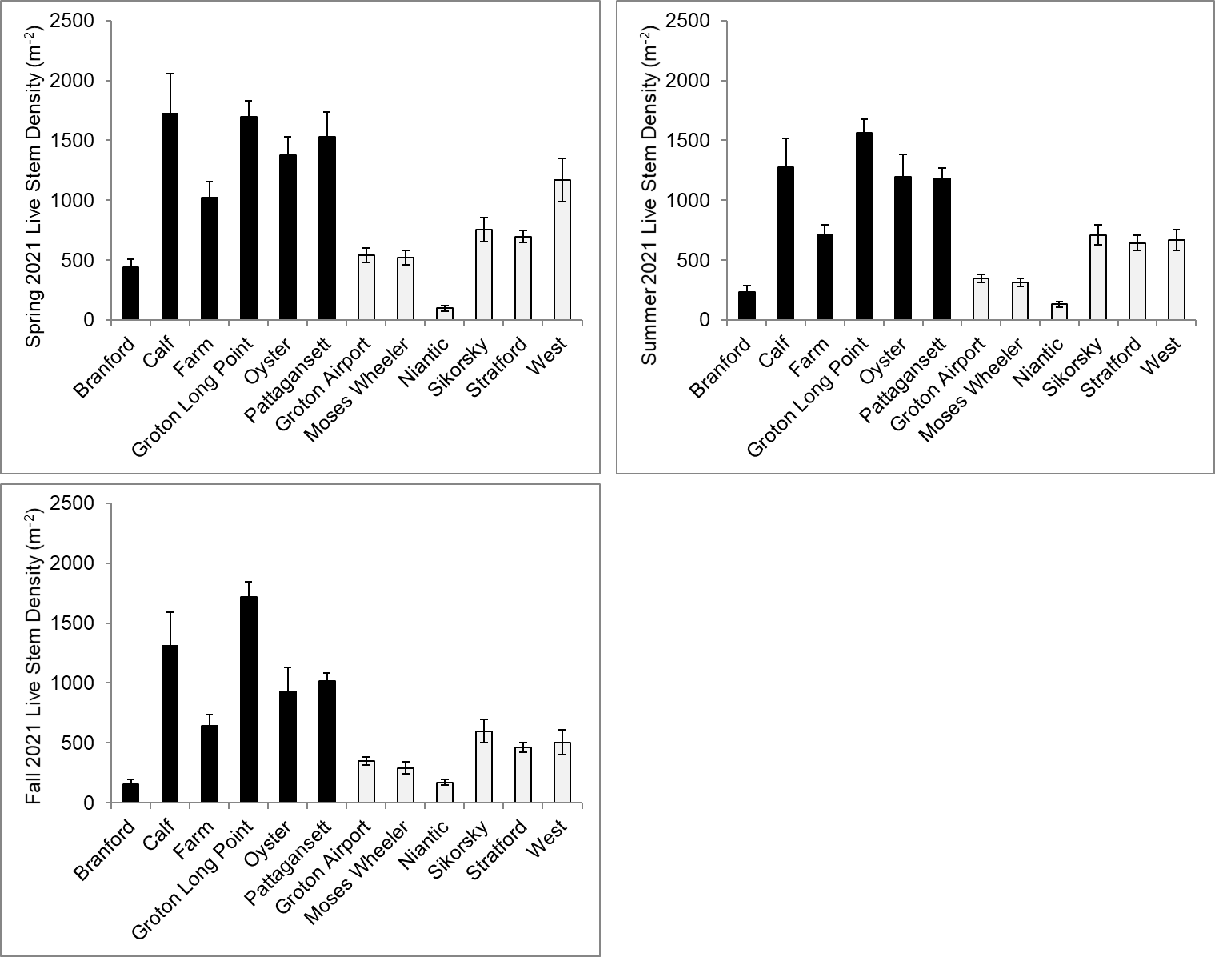

Supp. Figure 4. Live stem height as measured in each vegetation survey plot (n = 10 stems per plot, n = 10 plots per site) at each site in the spring, summer, and fall of 2021. Natural marshes are shown in black bars and restored marshes are shown in grey. Error bars represent standard error. Differences between restored and natural marshes were observed in spring (X² = 12.61, df = 1, p = 3.839e⁻⁴), summer (X² = 33.50, df = 1, p < 0.0001), and fall (X² = 30.03, df = 1, p < 0.0001) sampling events in 2021.
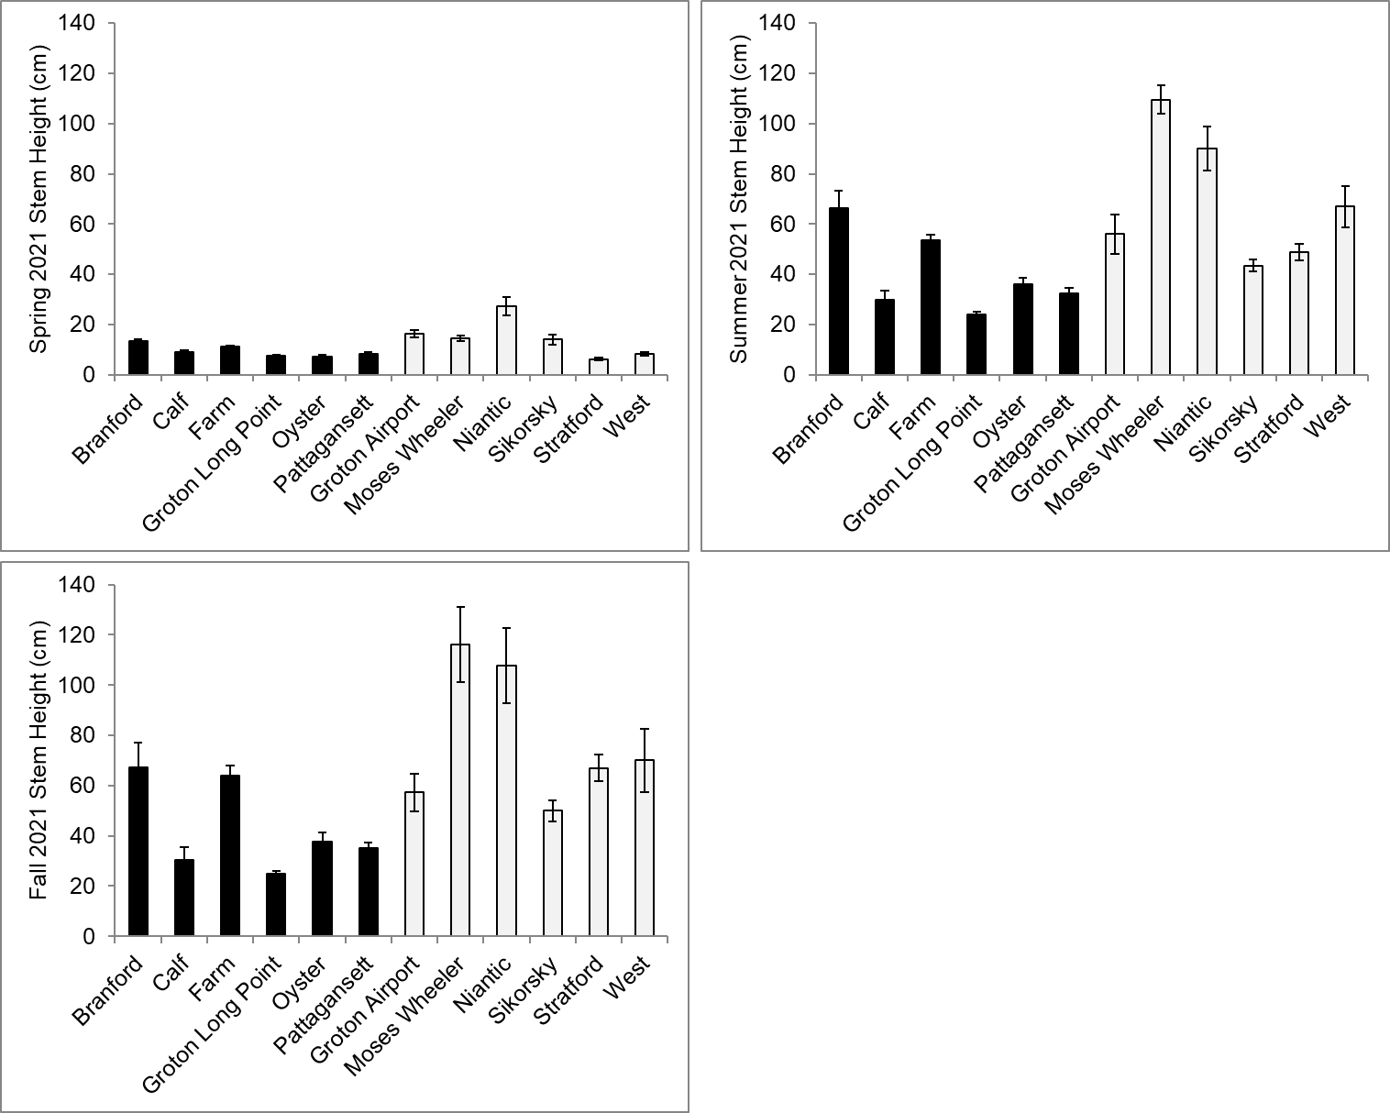

Supp. Figure 5. Live stem diameter as measured in each vegetation survey plot (n = 10 stems per plot, n = 10 plots per site) at each site in the spring, summer, and fall of 2021. Natural marshes are shown in black bars and restored marshes are shown in grey. Error bars represent standard error. Differences between restored and natural marshes were observed in spring (X² = 30.55, df = 1, p < 0.0001), summer (X² = 22.71, df = 1, p < 0.0001), and fall (X² = 25.88, df = 1, p < 0.0001) sampling events in 2021.

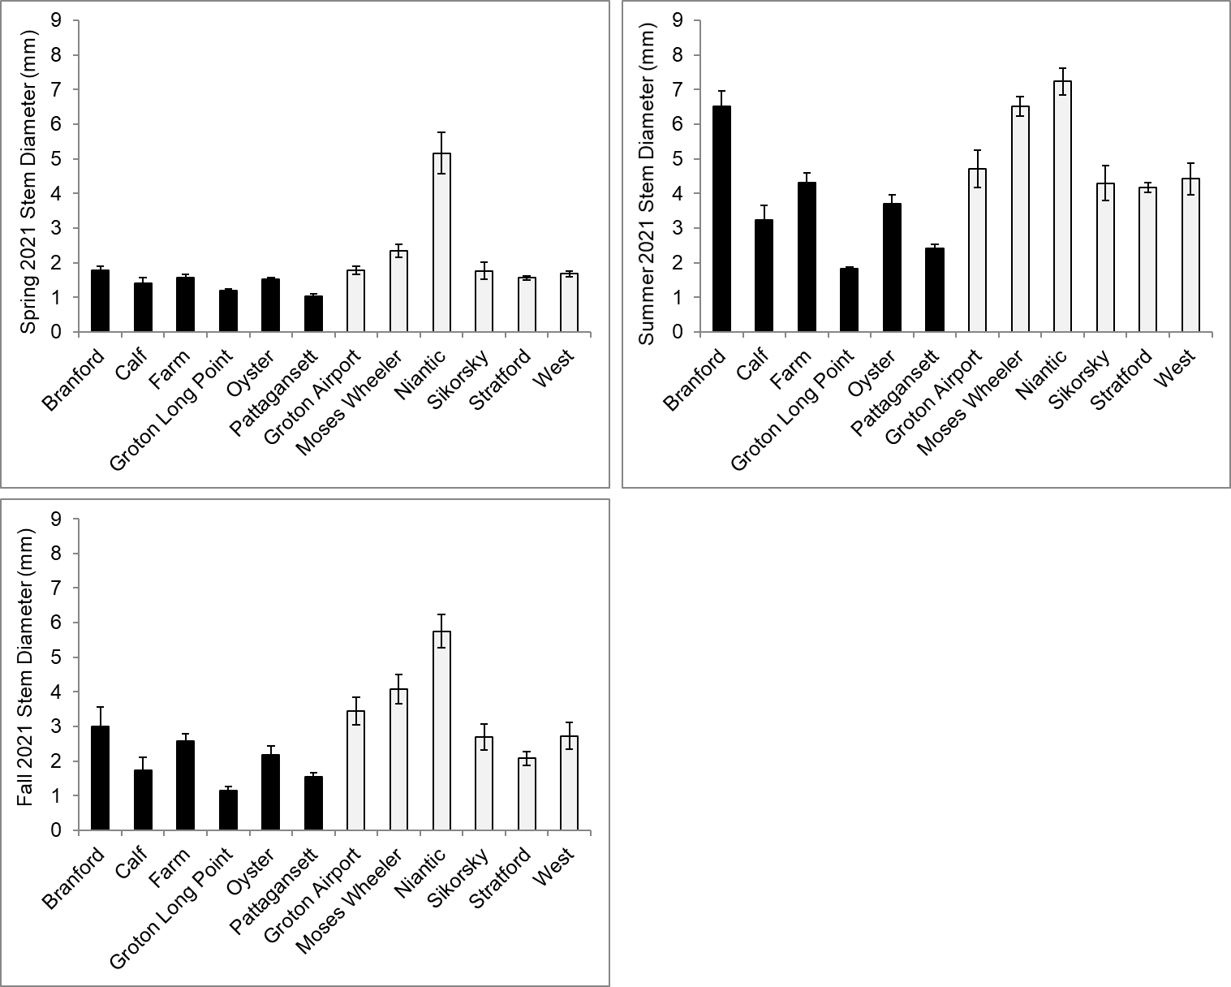

Supp. Figure 6. Percent cover by plant species (and un-vegetated) at 0.5 m² plots taken at 0, 3, 10, and 30 m inland from the marsh edge (n = 9 per distance inland per site) in July 2022 at the same locations as the faunal surveys. For sites where the inland border of the marsh or proximity to the next nearest source of tidal flooding was less than 30 m, then that length was omitted from that transect. Natural marshes are shown in black bars and restored marshes are shown in grey. Error bars represent standard error.
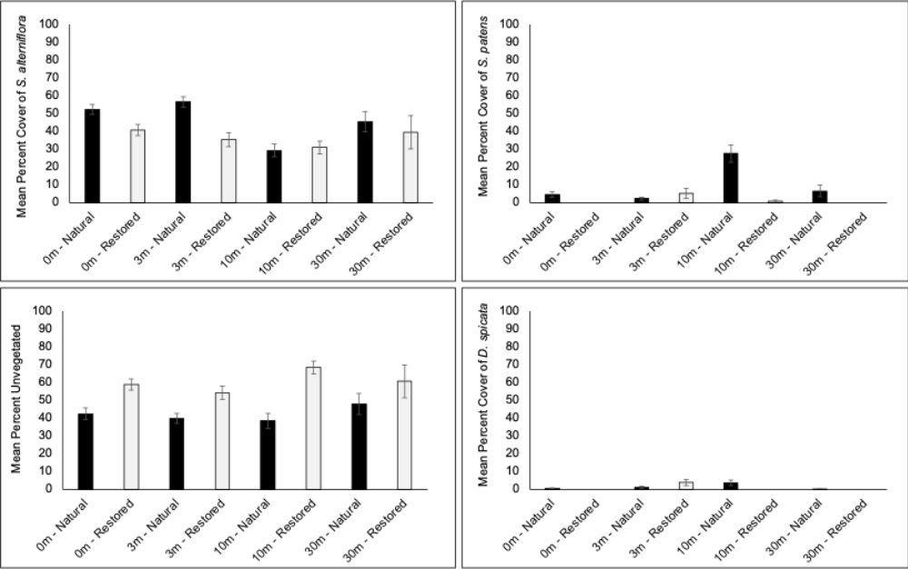

Supp. Figure 7. Plant species richness (number of species) at 0.5 m² plots taken at 0, 3, 10, and 30 m inland from the marsh edge (n = 9 per distance inland per site) in July 2022 at the same locations as the faunal surveys. For sites where the inland border of the marsh or proximity to the next nearest source of tidal flooding was less than 30 m, then that length was omitted from that transect. Natural marshes are shown in black bars and restored marshes are shown in grey. Error bars represent standard error.

Additional Results Beyond the Scope of this Paper, Common Garden Study:
A difference was observed between the field and common garden biomass for each site when the shallow (0-10 cm) and deep (10-20 cm) depth fractions were considered separately for only the natural sites, with live belowground biomass in the 0-10 cm depth showing a difference (Tukey HSD, p = 0.0003466; Figure 2).

Yet, individual sites did show differences in growth between the field site and the common garden. Eleven of the twelve study sites had less live belowground biomass at the common garden than at their respective field sites (except for Stratford Point). However, the transplant controls did not differ from the common garden site controls, suggesting that these decreases may not be due to a transplantation effect. Average differences between the field and common garden were relatively small: 24.7% for live 0-10 cm depth belowground biomass and 35.4% for dead 0-20 cm depth belowground biomass. Live belowground biomass decreased on average by 31.8% for natural marshes and 17.5% for restored marshes with common garden transplantation. Dead belowground biomass decreased on average by 10.5% for natural marshes, but increased by 81.2% for the restored marshes with common garden transplantation.

Differences in live aboveground biomass were greater overall, with an average of 72.2% difference in live aboveground biomass between the field and common garden; unlike the larger magnitude and/or directional differences observed for belowground biomass, live aboveground biomass showed a more similar change in the restored (-66.6%) and natural (-77.8%) marshes when moved to the common garden. This is likely related to the differences in height that were correlated with the corresponding changes in salinity and flooding with transplantation across sites.​

Overall, there were no differences in the change in stem density or diameter between restored and natural​ marshes in the common garden, and the observed changes in height with transplantation were largely explained by corresponding changes in salinity and flooding frequency between each field site and the common garden’s conditions. In the common garden, there was an interaction between marsh type (natural or restored) and time (spring, summer, and fall of growing season) for stem height (mixed ANOVA, F = 6.253, df = 1, p = 0.0152; rank transformation applied), but not for stem diameter, live stem density, or flowering stem density (mixed ANOVA, p > 0.05). At each site, fall stem height within a plot was not related to plot elevation (rank-based estimation regression, p > 0.05). ​However, fall stem height at the plot level was correlated with flooding frequency as quantified at the site level (linear regression, rank-transformation applied; F = 13.97, df = 1, 116, p = 0.0002875, R² = 0.1059).

Additional Details for Flooding Frequency Calculation
Plastic plant garden stakes (n = 20) were painted with Elmer’s glue dyed with food coloring and allowed to dry. All stakes were then inserted into the marsh vertically in a haphazard arrangement around the 10 vegetation survey plots approximately 1-3 hours before high tide. After one high tide, as soon as the water began to recede from the marsh, the height above the marsh surface of glue removed from each stake was measured in cm using a meter stick. The height of flooding on each stake was compared to local tide gauge records from the prior 12 months to determine flooding frequency as described below.

Supp. Table 9. Raw data (example) from 1 site (Greens Farms, common garden study location).
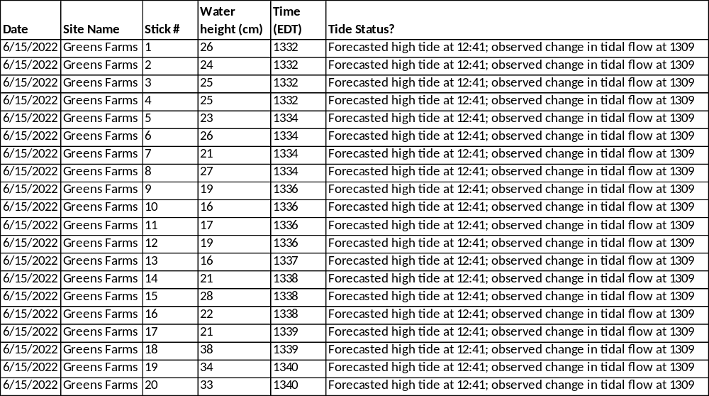

To determine the height of the water at high tide on the marsh relative to the height of the water at the nearest NOAA tide gauge (Bridgeport, New Haven, or New London, CT USA for the study sites nearest to each location), the 6-minute tide gauge data for the preceding 24 hours was accessed and downloaded.

Supp. Table 10. Nearest National Oceanic and Atmospheric Administration (NOAA, United States of America) tide gauge for each study site (https://tidesandcurrents.noaa.gov/stations.html?type=Water+Levels).
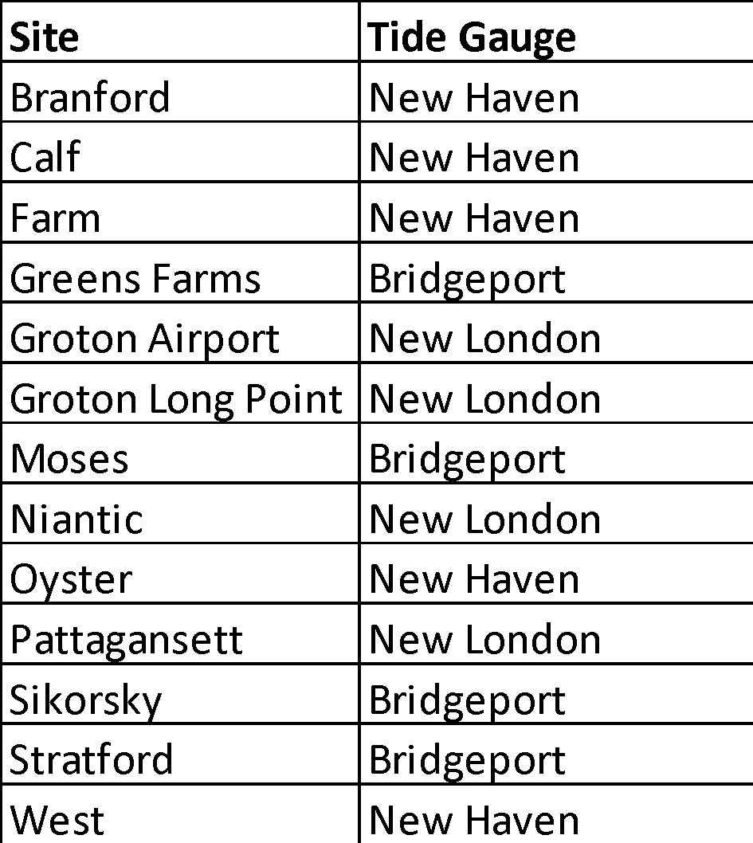

The height of the water at high tide during the specific tidal cycle that had been measured in the field was determined for that tide gauge. For a hypothetical example, if the height of the water on the marsh at a certain tide (e.g., on 6/15/22 at ~1pm) was measured to be 10 cm and the maximum height of the water at the tide gauge for the tide at that same time was 100 cm, then we can assume that the marsh surface begins to flood when the height of the water at the tide gauge exceeds 90 cm (100 cm – 10 cm). This calculation was made for each of the 20 tide sticks at each of the 12 marshes for the respective high tide sampled at each.

Supp. Table 11. Tide gauge 6-minute data (example) showing the maximum height of the water at the tide gauge for the high tide sampled at the site above.
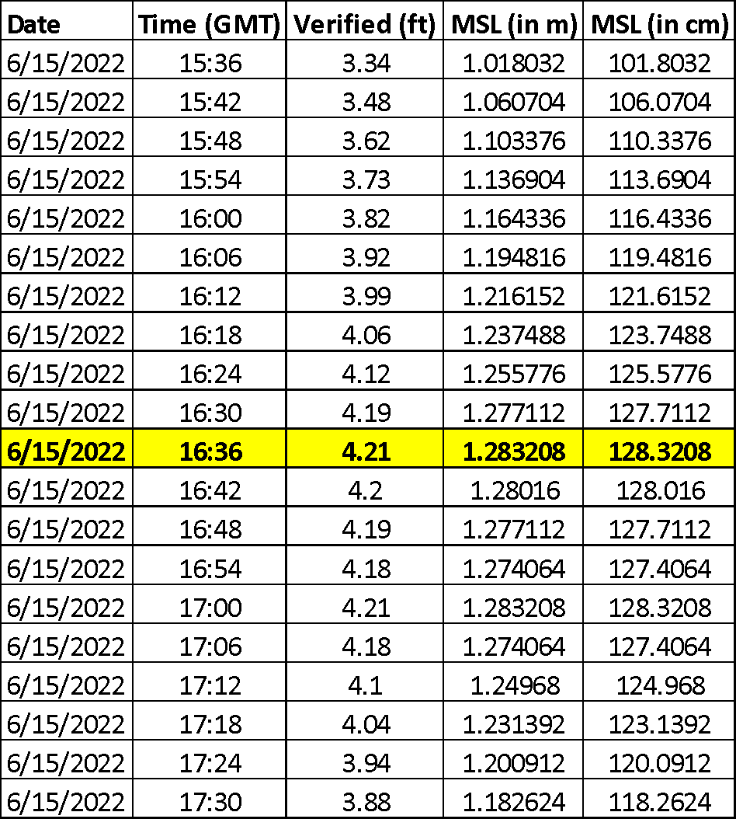

Thus, for Stick #1 at this site, the relative height of the marsh surface to the tide gauge was calculated to be 102.32 cm (128.32 cm – 26 cm). A relative height was calculated in this way for all 20 sticks per site, using the nearest 6-minute data-point to high tide sampled. Next, a 1-year record (July 2021- July 2022) of hourly data overlapping the field measurement date for each of the 3 tide stations (Bridgeport, New Haven, or New London, CT USA) was accessed and downloaded. For each site, the relative height of the marsh at each tide stick was compared to each water height measurement for each hour over the course of that 1-year period. From this, the number of hours where the tide height exceeded the marsh height was counted, and the number of hours where the tide height was lower than the marsh height was counted. The flooding frequency was then calculated for each stick as the percentage of flooded hours out of the total hours included during the 1-year tide gauge record. The mean and standard error were then calculated for each site and used to represent flooding frequency at the site level.

Supp. Table 12. Table showing data used for calculation of % of time submerged for each tide stick at 1 of the study sites. The methods described above were repeated for all 12 field study sites (in addition to this site, for the common garden).
