Electronic Supplementary Material

Influence of rivers, tides, and tidal wetlands on estuarine carbonate system dynamics

Fei Da^{a,b}, Marjorie A.M. Friedrichs^{b}, Pierre St-Laurent^{b}, Raymond G. Najjar^{c},
Elizabeth H. Shadwick^{d}, and Edward G. Stets^{e}

ªNow at: Department of Geoscience, Princeton University, Princeton, NJ, USA
^{b}Virginia Institute of Marine Science, William & Mary, Gloucester Point, VA, USA
^{c}Department of Meteorology and Atmospheric Science, The Pennsylvania State University, University Park, PA, USA
^{d}CSIRO Oceans and Atmosphere, Hobart, TAS, Australia
^{e}United States Geological Survey, Mounds View, MN, USA

Corresponding authors: Fei Da (fd6996@princeton.edu; feida6996@gmail.com), and Marjorie Friedrichs (marjy@vims.edu)

Initial submission date: February 26, 2024

Introduction and contents of this file
This supporting information contains technical details on our methodology for implementing net sulfate reduction in sediment to the 3-D biogeochemistry model embedded in Regional Ocean Modeling System (ROMS). Figure S1 shows the seasonality used for parameterization of wetland fluxes. Figure S2 summarizes model skill of the reference simulation in a Target diagram. Figures S3 and S4 include model-data comparisons at six Continuous Monitoring stations. Figure S5 presents the evaluation of modeled pelagic gross primary production (GPP). Figure S6 shows model-data comparisons for total suspended solids and light attenuation coefficient. Figures S7 provide supporting model results without tidal wetlands. Figure S8 shows daily average model results on days with strong vs. weak tides. Figure S9 shows annual mean DIC and TA budgets where biological sinks and sources of the carbonate system are deactivated. Table S1 shows biogeochemical sinks/sources at the bottom due to net sulfate reduction in sediments. Table S2 includes monthly-varying linear relationships between USGS historical observations of log₁₀(discharge) and WRTDS log₁₀(TA) for the Mattaponi and Pamunkey tributaries. Table S3 includes model skill without tidal wetlands, for comparison with the corresponding table in the main text (Table 1) that shows model skill including tidal wetlands.

Inclusion of net sulfate reduction in sediment in ROMS
Biogeochemical sources and sinks in the model’s bottom vertical level are modified to account for the impacts of net sulfate reduction in the sediments. Particulate organic matter reaching the seabed is either resuspended back into the bottom water, buried, or decomposed via aerobic and anaerobic respiration. In the original nitrogen-based model (St-Laurent et al., 2020), aerobic and anaerobic respiration processes in the estuarine sediment are represented by coupled nitrification-denitrification reactions, which assume that 86% of the respiration is due to aerobic respiration and 14% is due to coupled nitrification-denitrification in sediment (Fennel et al., 2006). The new boundary condition in this study assumes that 70% of the organic matter decomposition in sediment is associated with sulfate reduction (Mackin and Swider, 1989), and the remaining 30% is due to aerobic respiration and coupled nitrification-denitrification as in the original model. Since sulfur is not a state variable in the model, the following equations and stoichiometry are only used to compute the changes in existing biogeochemical variables due to net sulfate reduction.
The organic matter decomposed by sulfate (${SO}_{4}^{2-}$) reduction, and the subsequent oxidation of hydrogen sulfide ($H_{2}S$) follow Mackin and Swider (1989) and Jørgensen (1996), respectively:

$${(CH_{2}O)}_{106}{(NH_{3})}_{16}H_{3}PO_{4}+ 53{SO}_{4}^{2-}+106H^{+} →106{CO}_{2}+ 53H_{2}S+ {16NH}_{3}+H_{3}PO_{4}+106H_{2}O$$ | (S1)

$${{NH}_{4}^{+}+2H}_{2}S+4O_{2} →{NO}_{3}^{-}{ + S_{2}O}_{3}^{2-}+2H_{2}O+4H^{+}$$ | (S2)

$$8{NO}_{3}^{-}{ + 5S_{2}O}_{3}^{2-}+H_{2}O→{10SO}_{4}^{2-}+2H^{+}+4N_{2}$$ | (S3)

Together, (S2) and (S3) are summed to represent $H_{2}S$ oxidation:

$${\frac{1}{2}{NH}_{4}^{+}+H}_{2}S+2O_{2}+\frac{3}{10}{NO}_{3}^{-} →\frac{2}{5}N_{2}+{SO}_{4}^{2-}+\frac{9}{10}H_{2}O+\frac{22}{10}H^{+}$$ | (S4)

Following Roden and Tuttle (1993), this study assumes that 1/3 of the $H_{2}S$ produced during sulfate reduction is buried, and the remaining 2/3 is oxidized via equation S4. The model uses Michaelis-Menten kinetics for $H_{2}S$ oxidation by oxygen (i.e., $1-L_{BO2}$; see the supporting information of St-Laurent et al., 2020 and Feng et al., 2015 for details). Therefore, adding S1 and 2/3 $×\left(1-L_{BO2}\right)×$S4 will yield the reaction for net sulfate reduction with a limitation factor by oxygen:
$${(CH_{2}O)}_{106}{(NH_{3})}_{16}H_{3}PO_{4}+ \frac{106}{2}×\left[1-\frac{2}{3}×(1-L_{BO2})\right]{SO}_{4}^{2-}+106×\left[1-\frac{11}{10}×\frac{2}{3}×(1-L_{BO2})\right]H^{+}+106×\frac{2}{3}×\left(1-L_{BO2}\right)O_{2}+ \frac{106}{6}×\left(1-L_{BO2}\right){NH}_{4}^{+} + \frac{106}{10}×\left(1-L_{BO2}\right){NO}_{3}^{-} →106{CO}_{2}+ \frac{106}{2}×\left[1-\frac{2}{3}×(1-L_{BO2})\right]H_{2}S+ {16NH}_{3}+H_{3}PO_{4}+106{×[1+\frac{3}{10}×(1-L_{BO2})]H}_{2}O+\frac{2}{15}{×106×(1-L_{BO2})N}_{2}$$ | (S5)

Total alkalinity (TA) is defined as:

$$TA=\left[{HCO}_{3}^{-}\right]+2\left[{CO}_{3}^{2-}\right]+\left[{OH}^{-}\right]-\left[H^{+}\right]-\left[HSO_{4}^{-}\right]+\left[B{\left(OH\right)}_{4}^{-}\right]+2\left[{PO}_{4}^{2-}\right]+\left[H{PO}_{4}^{-}\right]-\left[H_{3}{PO}_{4}\right]+\left[SiO{\left(OH\right)}_{3}^{-}\right]+\left[HS^{-}\right]+\left[NH_{3}\right]+organic alkalinity$$ | (S6)

Based on S5 and S6, changes in DIC, TA and other biogeochemical variables due to net sulfate reduction in the model’s bottom level are summarized in Table S1.
Table S1. Biogeochemical sinks/sources at the bottom due to net sulfate reduction in sediments
Variable (Symbol) | Source / Sink
Dissolved Inorganic Carbon  ($DIC$) | $$0.7×OC$$
Total alkalinity  ($TA$) | $$\{\left[1-\frac{11}{15}×\left(1-L_{BO2}\right)\right]+\frac{15}{106}\}×0.7×OC$$
Oxygen  ($O_{2}$) | $$-\frac{2}{3}×\left(1-L_{BO2}\right)×0.7×OC$$
Ammonium  (${NH}_{4}^{+}$) | $$[1-\frac{106}{96}×\left(1-L_{BO2}\right)]×0.7×ON$$
Nitrate  (${NO}_{3}^{-}$) | $$-\frac{106}{160}×\left(1-L_{BO2}\right)×0.7×ON$$
Nitrogen gas  ($N_{2}$) | $$\frac{106}{60}×\left(1-L_{BO2}\right)×0.7×ON$$
$OC$ and $ON$ refer to the portion of particulate organic carbon and nitrogen that reach the seabed and are neither resuspended nor buried. The factor $L_{BO2}$ is the bottom oxygen limitation factor as in St-Laurent et al. (2020), with $L_{BO2}$ ~ 1 if oxygen is depleted, and $L_{BO2}$ ~ 0 if oxygen is saturated. The ratio of TA to DIC production via net sulfate reduction ranges from 0.41 to 1.14, with lower bottom oxygen concentrations resulting in a higher ratio. Note that the maximum ratio (i.e., 1.14) represents the scenario without $H_{2}S$ oxidation (i.e., ${SO}_{4}^{2-}$ reduction alone; Cai et al., 2020).

Table S2. Monthly-varying linear relationships between USGS historical observations of log₁₀(discharge) and WRTDS log₁₀(TA) for the Mattaponi and Pamunkey tributaries. The unit of discharge is m³ s^{–1}, and the unit of TA is mmol m^{–3}.
Month | Mattaponi |  | Pamunkey
Month | Intercept | Slope | Intercept | Slope
January | 2.32 | –0.18 | 2.86 | –0.25
February | 2.26 | –0.12 | 2.83 | –0.23
March | 2.48 | –0.26 | 2.85 | –0.23
April | 2.52 | –0.26 | 2.87 | –0.23
May | 2.52 | –0.24 | 2.89 | –0.23
June | 2.55 | –0.25 | 2.91 | –0.24
July | 2.54 | –0.27 | 2.92 | –0.25
August | 2.51 | –0.25 | 2.94 | –0.26
September | 2.48 | –0.24 | 2.94 | –0.26
October | 2.44 | –0.21 | 2.94 | –0.26
November | 2.39 | –0.19 | 2.93 | –0.27
December | 2.36 | –0.20 | 2.90 | –0.26

Table S3. Summary of model skill metrics calculated for the sensitivity simulation without tidal wetlands
Variable |  | Mean ± standard deviation |  | Bias | Unbiased RMSD^{c} | RMSD
 |  | Model | Observation/Estimate | Bias | Unbiased RMSD^{c} | RMSD
Temperature  (°C) | Wª | 18.0 ± 8.2 | 17.9 ± 8.4 | 0.0 | –1.3 | 1.3
Temperature  (°C) | C^{b} | 17.4 ± 8.3 | 17.4 ± 8.6 | 0.0 | –1.5 | 1.5
Salinity | W  C | 16.0 ± 6.9 | 16.1 ± 5.8 | –0.0 | 2.4 | 2.4
Salinity | W  C | 10.8 ± 9.1 | 11.2 ± 8.7 | –0.5 | 1.5 | 1.6
Oxygen  (mmol m^{–3}) | W | 251 ± 68 | 239 ± 81 | 11 | –36 | 38
Oxygen  (mmol m^{–3}) | C | 286 ± 49 | 260 ± 70 | 25 | –38 | 45
pH (NBS) | W | 7.8 ± 0.4 | 7.7 ± 0.4 | 0.1 | 0.3 | 0.3
pH (NBS) | C | 7.8 ± 0.5 | 7.6 ± 0.5 | 0.2 | –0.2 | 0.3
TA  (mmol m^{–3}) | W | 1463 ± 439 | 1504 ± 376^{d} | –41 | 158.2 | 163.3
TA  (mmol m^{–3}) | C | 1073 ± 601 | 1182 ± 569^{d} | –108 | 111.3 | 155.2
DIC  (mmol m^{–3}) | W | 1410 ± 351 | 1501 ± 349e | –91 | 160.7 | 184.8
DIC  (mmol m^{–3}) | C | 1047 ± 518 | 1211 ± 471e | –164 | 140.8 | 215.8
ªW refers to discrete Water Quality Monitoring Program data collected at seven stations (Fig. 1) throughout the water column over the years 2017-2018.
^{b}C refers to daily mean Continuous Monitoring data collected at six stations (Fig. 1) at roughly 1 m depth over the years 2017–2018.
^{c}RMSD refers to root-mean squared difference. Unbiased RMSD represents the RMSD after removing the mean (Jolliff et al., 2009).
^{d}Since TA observations are not available, estimates are calculated from in situ salinity observations and a linear TA:salinity relationship
^{e}Since DIC observations are not available, estimates are derived from TA estimates together with in situ observations of pH, temperature and salinity.
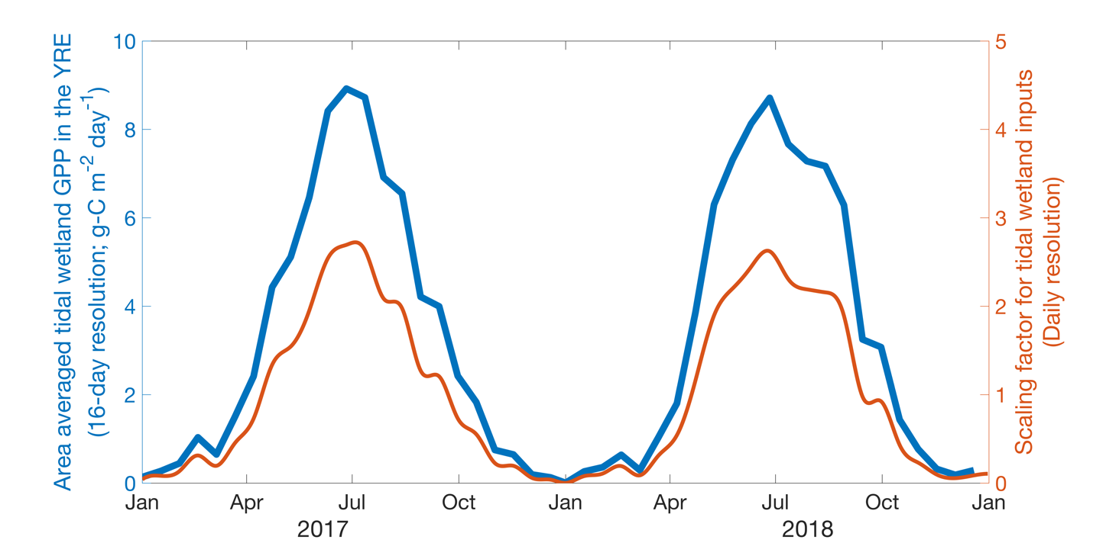
Figure S1. Area averaged tidal wetland gross primary production (GPP) data in the York River Estuary (YRE) clipped from Feagin et al. (2020) and daily scaling factor used for superimposing seasonality to empirical tidal wetland inputs in the model. The long-term average of the scaling factor (orange curve) is equal to one. The same scaling factor is used for DON, DOC, DIC and TA. Note that the entire continental United States wetland GPP data in 2017 and 2018 at 16-day resolution are clipped to the extent of the YRE region to calculate daily area-averaged primary production using spline interpolation. These daily wetland primary production data are then scaled by the annual mean values to obtain a daily-varying factor for superimposing seasonality to empirical wetland inputs of DON, DOC, DIC and TA.
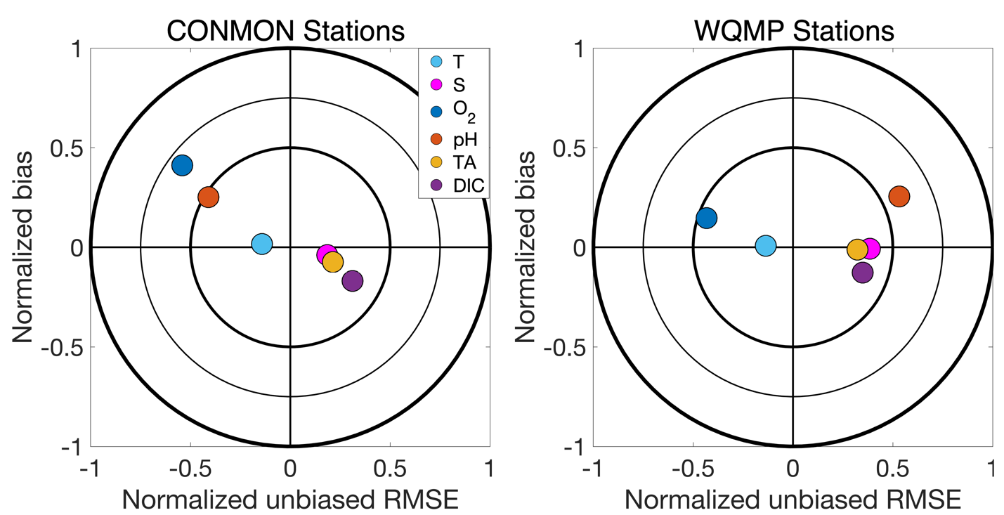
Figure S2. Target diagrams illustrating spatio-temporal model skill at (a) six CONMON stations with daily mean data at ~1 m depth, and (b) seven WQMP stations with discrete monthly data sampled throughout the water column from January 2017 to December 2018 (CONMON, 2022; WQMP, 2022; see Figure 1 for station locations). Positive unbiased RMSD denotes that the standard deviation of the model results is greater than that of the observations. All skill metrics are normalized by the standard deviation of the observations.
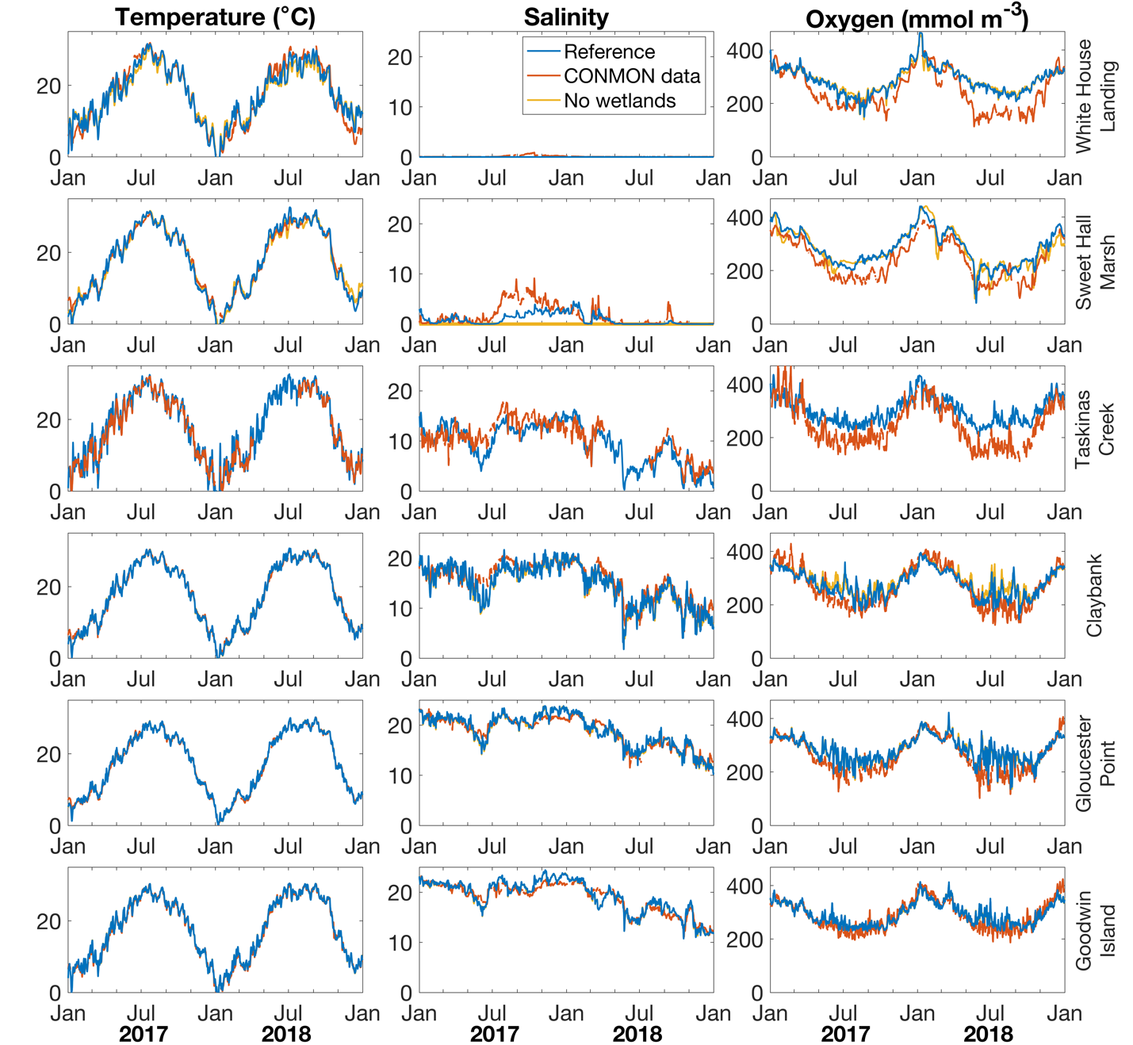
Figure S3. Daily time series of observations and two model runs (reference and no wetlands) at six CONMON stations from 2017 to 2018 for water temperature, salinity, and dissolved oxygen concentrations at ~1 m. See Figure 1 for station locations and Methods for data details. Note that the station Taskinas Creek is not available in the model case without wetlands.

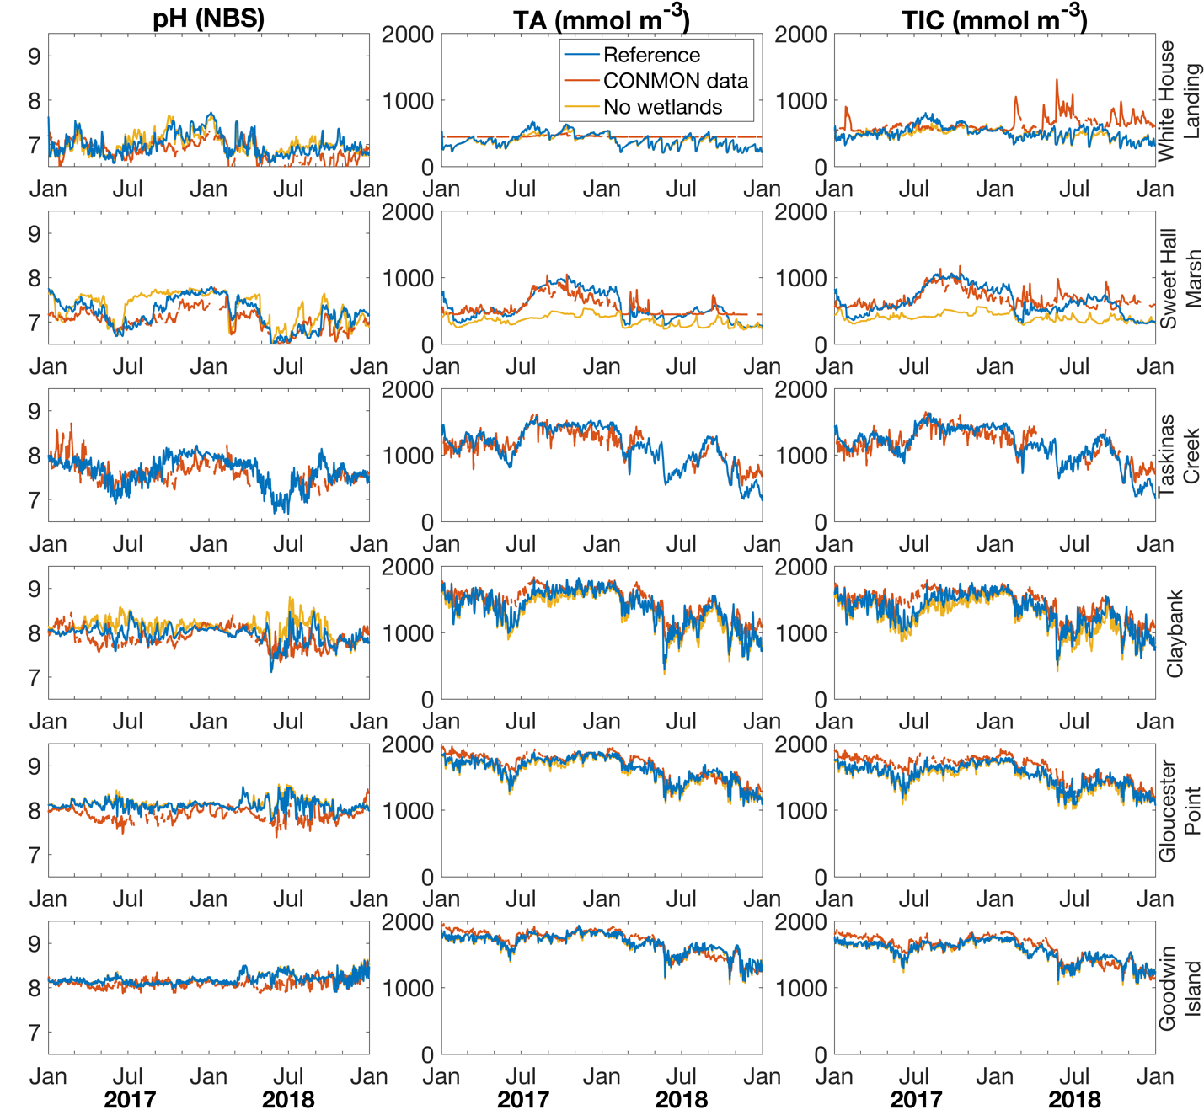
Figure S4. Daily time series of observations and two model runs (reference and no wetlands) at six CONMON stations from 2017 to 2018 for pH (NBS), total alkalinity (TA), and dissolved inorganic carbon (DIC) concentrations at ~1 m. See Figure 1 for station locations and Methods for data details. Note that the station Taskinas Creek is not available in the model case without wetlands.

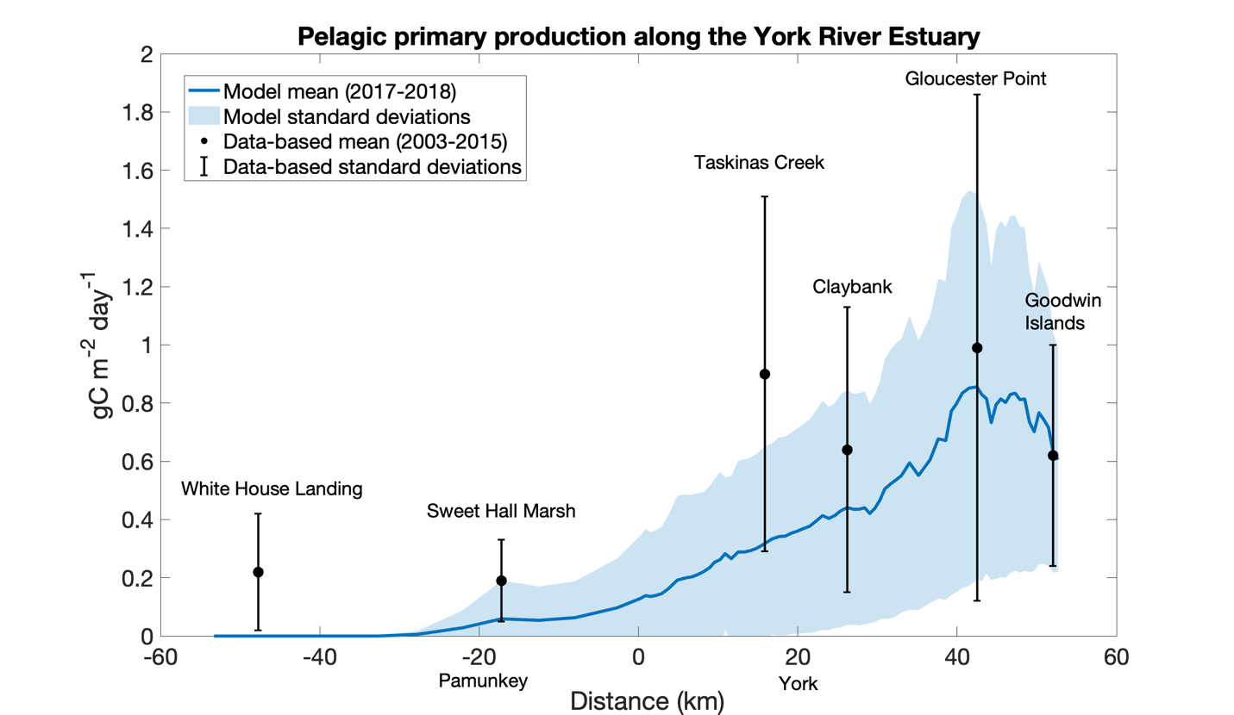
Figure S5. Annual averages of pelagic gross primary production (GPP) along the Pamunkey-York axis of the YRE. Negative distances correspond to the Pamunkey River, and positive distances correspond to the York River. The locations of stations are shown in Figure 1. Black dots represent long-term averages of data-based estimates of pelagic PP at six Continuous Monitoring (CONMON) stations where chl-a data are available (Qin and Shen, 2019). The error bars represent one standard deviation (i.e., seasonal and year-to-year variability). The blue line shows the average of modeled pelagic PP along the York River Estuary (YRE), with blue shading representing one standard deviation (i.e., seasonal and year-to-year variability).

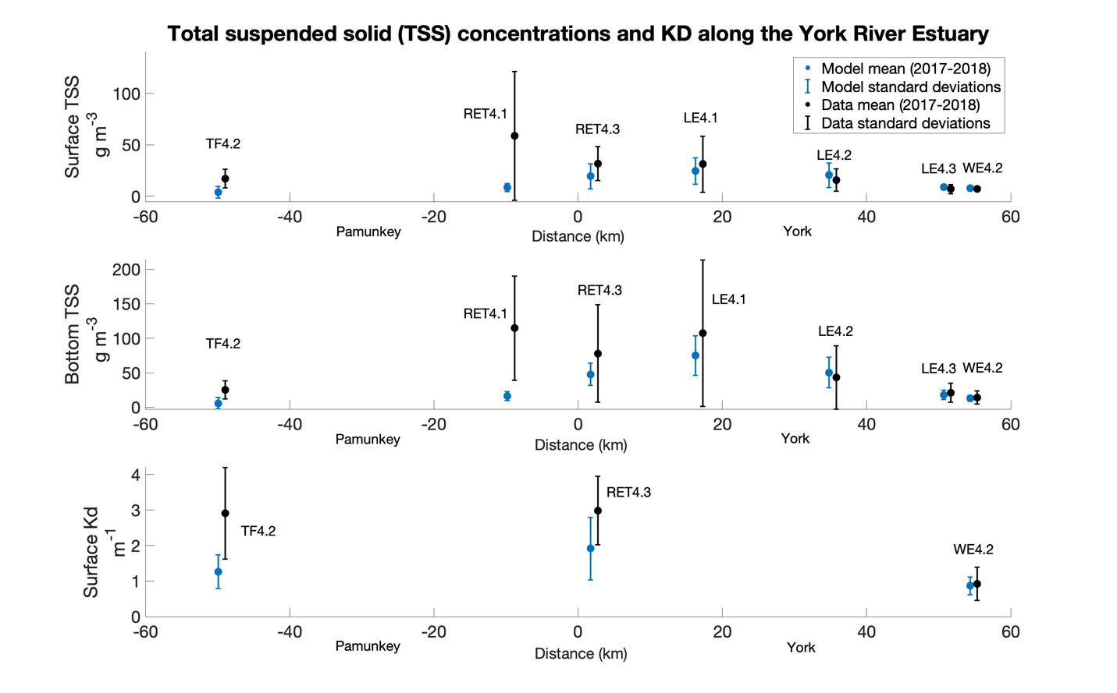
Figure S6. Total suspended solid (TSS) concentrations and light attenuation coefficient (Kd) along the Pamunkey-York axis of the YRE. Negative distances correspond to the Pamunkey River, and positive distances correspond to the York River. Locations of stations are shown in Figure 1. Black dots represent annual mean observations, and blue dots represent annual mean model results from days when observations were available in 2017 and 2018. Error bars indicate one standard deviation. Daily averaged model values are used for annual mean calculations, while observed TSS values are snapshots of specific times.
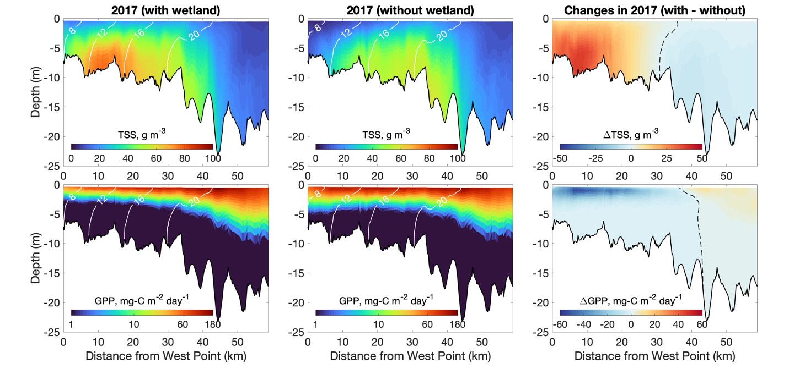Figure S7. Annual mean (2017) total suspended sediment (TSS) concentrations and GPP downstream of West Point in the reference run (with tidal wetlands) and the sensitivity simulation (without tidal wetlands). The last column shows the changes in TSS and GPP after including tidal wetlands to the model.

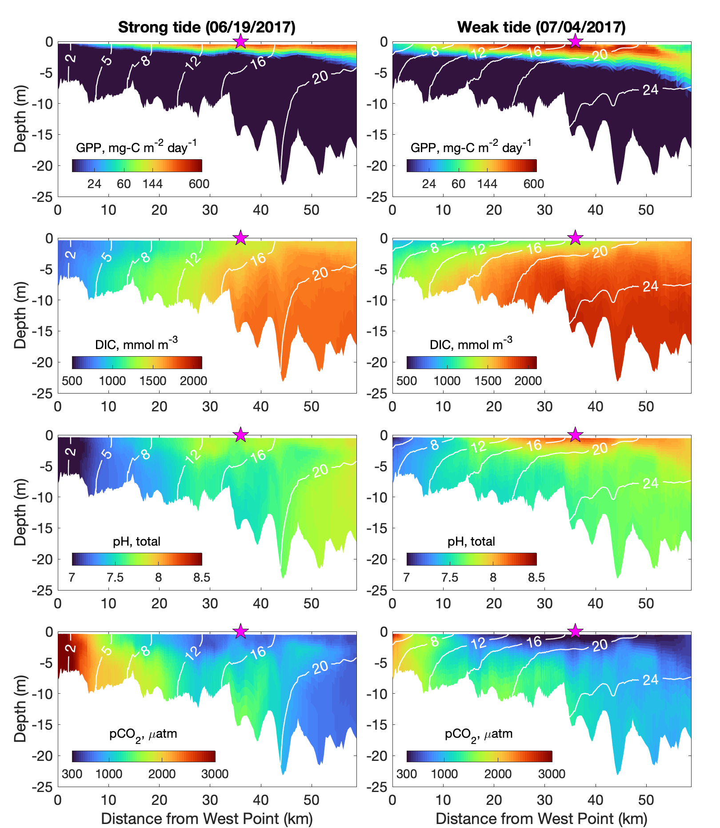Figure S8. GPP, DIC, pH and pCO₂ averaged over a 24-hour period with strong tides (left column, June 19, 2017) and with weak tides (right column, July 4, 2017) along the deepest channel downstream of West Point. White lines are salinity contours. The pink star refers to station LE4.2 (Fig. 1).
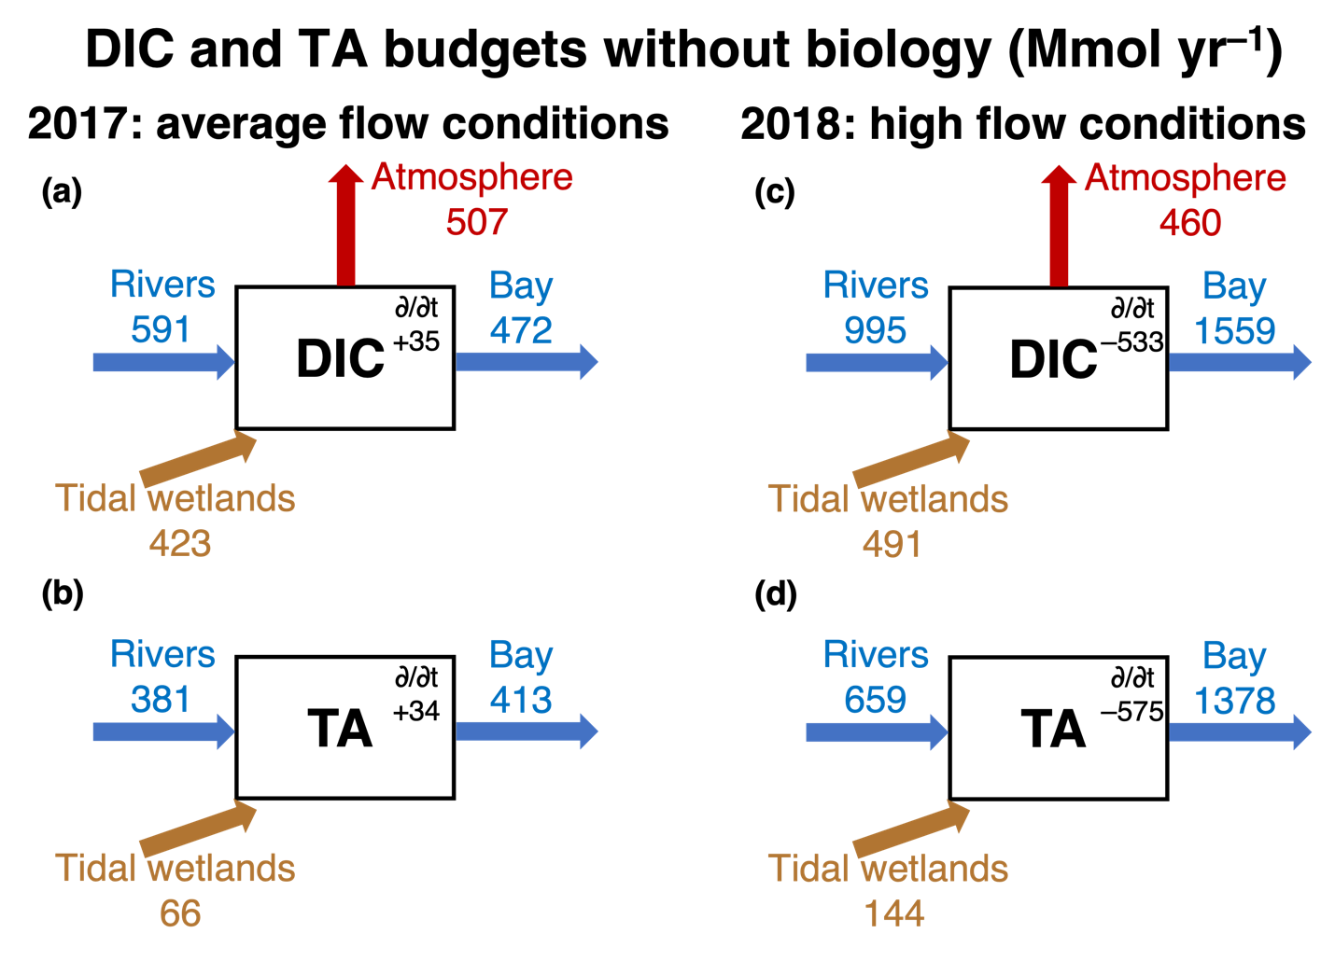
Figure S9. Annual mean dissolved inorganic carbon (DIC) and total alkalinity (TA) budgets of the York River Estuary in 2017 (a, b) and 2018 (c, d) with biological sinks/sources of DIC and TA deactivated. Arrows represent sources and sinks associated with rivers, tidal wetlands, net biology, advection to the Chesapeake Bay, and outgassing to atmosphere (for DIC only). The annual mean DIC and TA time tendency term is given by $∂$/$∂$t. All budgets are closed (with the small mismatch caused by rounding errors).

