Online supplementary material S1. Fish sampling scheme
Species | n | Collected month | Collected year
Achoerodus virids | 1 | February | 2021
- | 1 | June | 2021
- | 2 | August | 2021
- | 6 | September | 2021
- | 4 | October | 2021
- | 1 | April | 2022
- | 1 | June | 2022
- | 20 | August | 2022
- | 2 | September | 2022
- | 1 | November | 2022
Chrysophryrus auratus | 7 | January | 2021
- | 5 | March | 2021
- | 1 | April | 2021
- | 2 | May | 2021
- | 4 | October | 2021
- | 10 | November | 2021
- | 4 | December | 2021
- | 12 | January | 2022
- | 2 | February | 2022
- | 5 | March | 2022
- | 9 | April | 2022
- | 23 | June | 2022
- | 14 | July | 2022
- | 2 | August | 2022
- | 2 | September | 2022
- | 8 | October | 2022
- | 1 | December | 2022

Online supplementary material S2. Gut contents classification scheme

Urchin species | Character 1 | Character 2 | Character 3 | Character 4
C. rodgersii | Hollow internal structure | Brittle spines with square ends | Purple, brown, black, deep red | Dye present
H. erythrogramma | Solid internal structure | Thin spines with pointed ends | Green, purple, brown, white, grey | Dye not present
H. tuberculata | Solid internal structure | Thick spines with square ends | Brown, red, orange | Dye not present
P. parvispinus | Solid internal structure | Thick spines with round ends | Brown, black, grey | Dye not present
Group | Character 1 | Character 2 | Character 3 | Character 4
Echinoid | Internal spine structure | External spine structure | Spine hue | Test pores present
Ophiuroid | Dorsal test plating | Ventral ambulacral zone | Tube feet present | NA
Gastropod | Mixed colours | Many shell whorls | Fibrous hairs | Nacre present
Bivalve | Light inner, dark outer | Few shell whorls | Fibrous hairs | Nacre present
Decapod | Manipulative appendages | 10 appendages | Fibrous hairs | CaCO₃ based
Amphipod | Locomotive appendages | 15 appendages | No hairs | Translucent body
Cirripede | Mixed colours | No whorls | Honeycomb-like structure | Nacre absent
Teleost | Fine, ray-like structure | Slightly translucent | Presence of blood or scales | CaCO₃ based
Cephalopod | Suckers present | 8-10 appendages | Beak present | Chromatophores present
Polychaete | Chaetae present | Cirri present | Segmented body | NA
Detritus | Biogenic origin | Flocculated | NA | NA
Algae | Green/red/brown pigments | Organelles present | Plant cell wall present | NA
Soft prey | Body pores | Organs present | Animal cell wall present | NA
Other | Egg structures | Plastic pollution | NA | NA

References
Ab Lah, R., Bucher, D., Savins, D., Dowell, A., and Benkendorff, K. (2019). Temporal variation in condition index and meat quality of Lunella undulata (Turbinidae), in relation to the reproductive cycle. Mollusc. Res. 39, 122–139. doi:10.1080/13235818.2018.1514241
Bownes, S., Barker, N. P., and McQuaid, C. D. (2008). Morphological identification of primary settlers and post-larvae of three mussel species from the coast of South Africa. Afr. Journ. Mar. Sci. 30, 233–240. doi:10.2989/AJMS.2008.30.2.3.553
Byrne, M. M., and Hendler, G. L. (1988). “Arm structures of the ophiomyxid brittlestars (Echinodermata: Ophiuroidea: Ophiomyxidae)”, in Echinoderm Biology: Proceedings of the Sixth International Echinoderm Conference. Eds R. D. Burke, P. V. Mladenov, P. Lambert, and R. L. Parsley, 23–28 (Balkema: Rotterdam, Netherlands.)
Clements, R., Liew, T. S., Vermeulen, J. J., and Schilthuizen, M. (2008). Further twists in gastropod shell evolution. Biol. Lett. 4, 179–182. doi:10.1098/rsbl.2007.0602
Haug, J. T., Maas, A., Haug, C., and Waloszek, D. (2012). “Evolution of crustacean appendages”, in The Natural History of the Crustacea. Eds L. Watling and M. Thiel. 34–73 (Oxford University Press: New York, NY, USA.)
Hoek, C., Mann, D., Jahns, H. M., and Jahns, M. (1995). “Algae: an Introduction to Phycology”, 1st edn. (Cambridge University Press: New York, NY, USA.)
Hughes, L.E., Smith, S.D. and Simpson, R. (2007). Biodiversity of Amphipods in the Solitary Islands New South Wales, Australia. PhD Thesis, University of New England https://hdl.handle.net/1959.11/6434
Jones, D.S. (2012). Australian barnacles (Cirripedia: Thoracica), distributions and biogeographical affinities. Integr. Comp. Biol. 52, 366-387. doi:10.1093/icb/ics100
Lawry, J. V. (1967). Structure and function of the parapodial cirri of the polynoid polychaete, Harm.. Zeit. Zellfor. Mikroskop. Anat. 82, 345–361. doi:10.1007/BF00323859
Nottage, J.D., West, R.J., Montgomery, S.S. and Graham, K. (2007). Cephalopod diversity in commercial fisheries landings of New South Wales, Australia. Rev. Fish Biol. Fish. 17, 271-281. doi: 10.1007/s11160-006-9032-8
Novikoff, A. B., and Holtzman, E. (1970). “Cell organelles”, in Cells and Organelles, 2nd edn. 105–106 (Holt, Rinehart and Winston: New York, NY, USA.)
Penney, R. W., Hart, M. J., and Templeman, N. D. (2007). Shell strength and appearance in cultured blue mussels Mytilus edulis, M. trossulus, and M. edulis × M. trossulus hybrids. N. Amer. J. Aquac. 69, 281–295. doi:10.1577/A06-044.1
Rowan, K. S. (1989). ‘Photosynthetic Pigments of Algae.’ (Cambridge University Press: Cambridge, UK.)
Stock, S.R., Ebert, T.A., Ignatiev, K. and De Carlo, F., (2006). “Structures, structural hierarchy, and function in sea urchin spines”, in: Developments in X-ray Tomography V, 74-77. (SPIE).
Thuy, B., and Stöh, S. (2011). Lateral arm plate morphology in brittle stars (Echinodermata: Ophiuroidea): new perspectives for ophiuroid micropalaeontology and classification. Zootaxa, 3013, 1–47. doi:10.11646/zootaxa.3013.1.1
Tsafnat, N., Fitz Gerald, J.D., Le, H.N. and Stachurski, Z.H. (2012). Micromechanics of sea urchin spines. PLOS ONE 7, e44140. https://doi.org/10.1371/journal.pone.0044140
Tsakiris, D. P., Menciassi, A., Sfakiotakis, M., La Spina, G., and Dario, P. (2004). “Undulatory locomotion of polychaete annelids: mechanics, neural control and robotic prototypes”, in Annual Computational Neuroscience Meeting, 1–3. (Foundation for Research and Technology.)
Watson, B.D. (1965).The fine structure of the body-wall in a free-living nematode, Euchromadora vulgaris. J. Cell Sci. 3, 75–81.
Wilkie, I. C. (1992). Variable tensility of the oral arm plate ligaments of the brittlestar Ophiura ophiura (Echinodermata: Ophiuroidea). J. Zool. 228, 5–26. doi:10.1111/j.1469-7998.1992.tb04429.x
Williams, M. J. (1981). Methods for analysis of natural diet in portunid crabs (Crustacea: Decapoda: Portunidae). J. Exp. Mar. Biol. Ecol. 52, 103–113. doi:10.1016/0022-0981(81)90174-X
Witten, P. E., Huysseune, A., and Hall, B. K. (2010). A practical approach for the identification of the many cartilaginous tissues in teleost fish. J. Appl. Ichth. 26, 257–262. doi:10.1111/j.1439-0426.2010.01416.x
Zrzavý, J., and Štys, P. (1997). The basic body plan of arthropods: insights from evolutionary morphology and developmental biology. J. Evol. Biol. 10, 353–367. doi:10.1007/s000360050029

Supplementary material S3. Food items within Achoerodus viridis guts
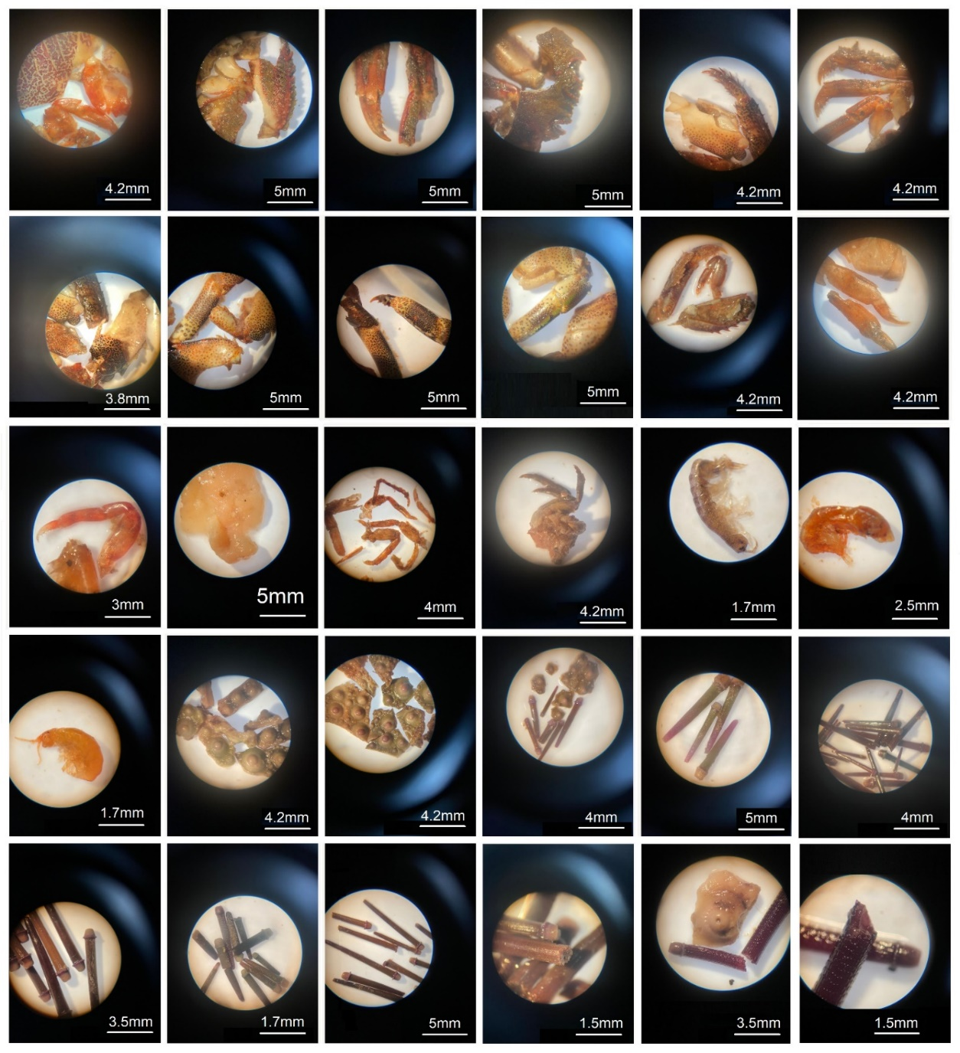
Figure S3A. Top to bottom; remains of the Xanthid crabs Plagusia chabrus and Leptograspus variegatus, parts of smaller crabs thought to include Halicarcinus ovatus, various unidentified amphipods, pieces of test and spines belonging to Heliocidaris erythrogramma showing the characteristic solid insides, small fragments of Centrostephanus rodgersii spines and pieces of test showing the characteristic hollow insides.
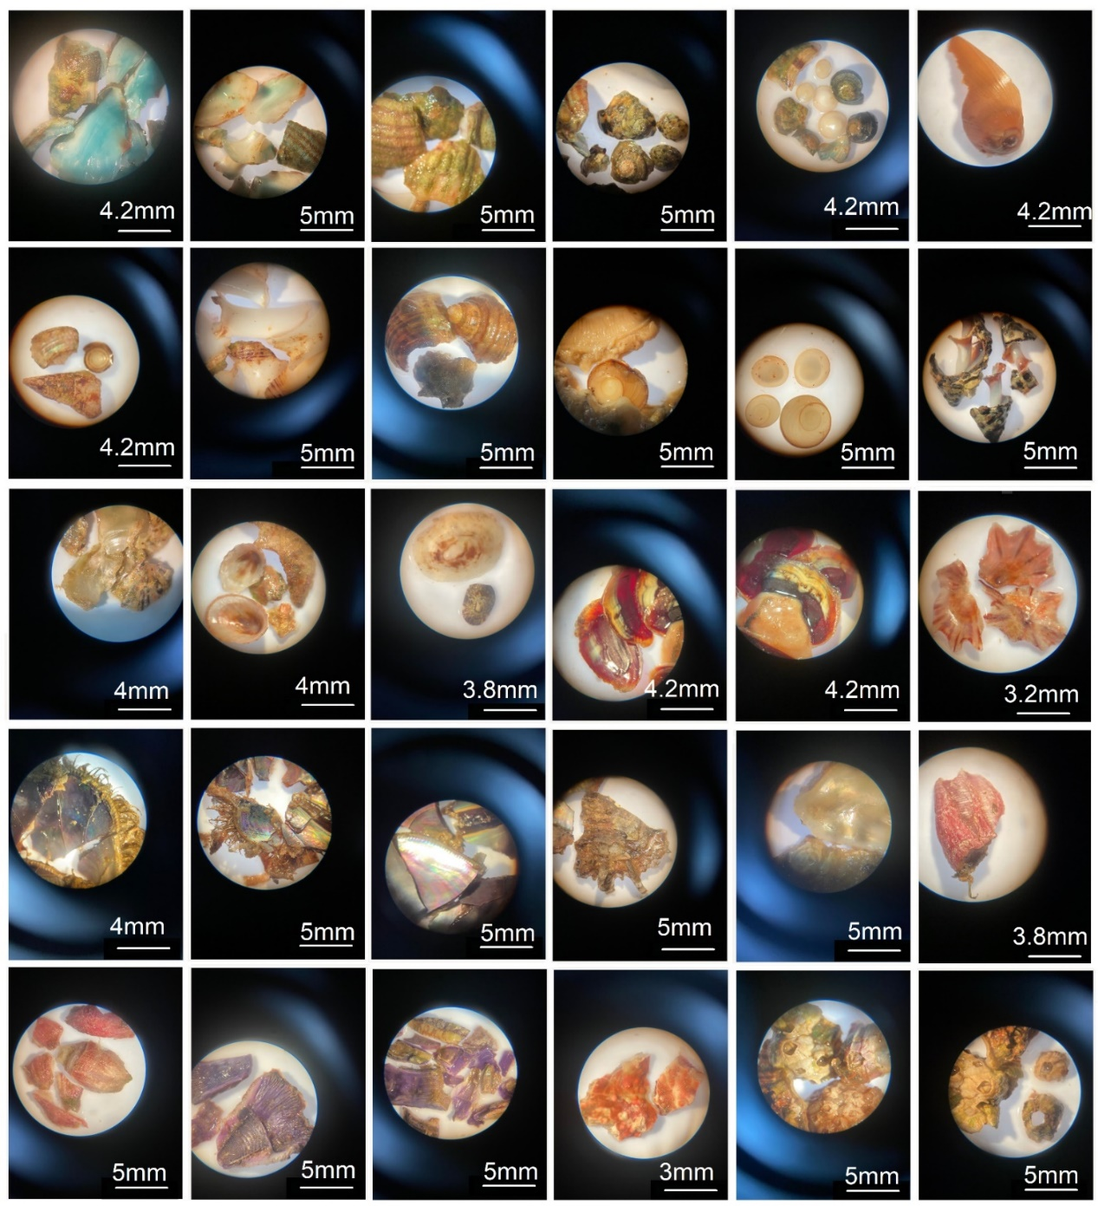
Figure S3B. Top to bottom; parts of Polyplacophora spp. dorsal plating, broken pieces of Lunellid snails thought to include Lunella torquata and L. undulata (lightning warrener snail), Dicathais orbita, mollucs operculum coverings thought to be of Lunellid (genus: Lunella) origin, Morula marginalba, Cellana spp. including Tugali cicatricosa, Polyplacophora spp. pieces, Scutellastra chapmani, Trichomya hirsuta or Mytlius galloprovencialis, Ostrea angasi and pieces of Tesseropora rosea. Austrobalanus imperator and Chamaesipho tasmanica, Balanustrigatus sp.
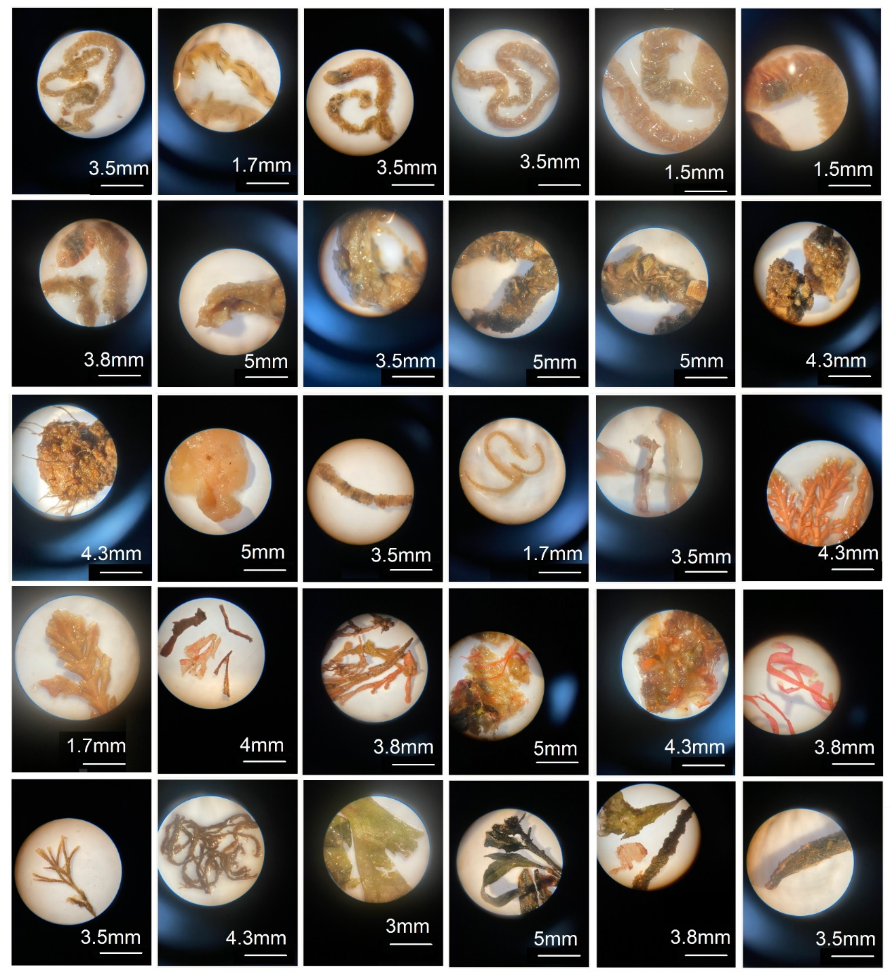
Figure S3C. Top to bottom; unidentified Polychaete spp. showing the identifying elongated body and chetae/setae, remains thought to belong to Diopatra dentata, soft material thought to have come from Pyura stolonerifera, Ophiuroidea sp. remains, unidentified Teleost parts, coralline algae including Amphiroa and Corallina spp., fleshy red, brown and green algae including Ulva sp.

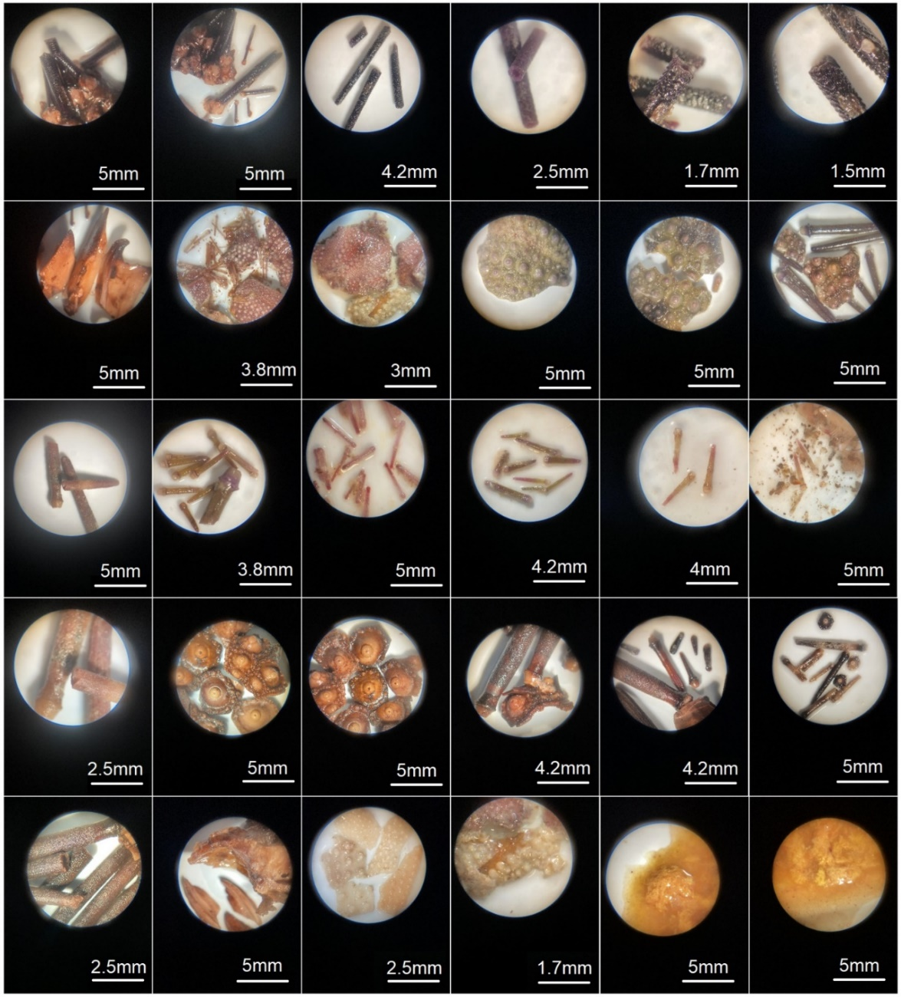
Supplementary material S4. Food items within Chrysophyrus auratus guts
Figure S4A. Top to bottom; remains of Centrostephanus rodgersii urchins showing spines still attached to pieces of test and broken spines showing the identifying hollow internal structure and pieces of aristotle’s lantern, remains of Heliocidaris erythrogramma urchins showing identifiable pieces of test, different coloured intact spines and broken spines showing the identifying solid internal structure, and remains of Penicillatus parvispinus urchins showing identifiable pieces of test, intact and broken spines showing the identifying solid internal structure as well as pieces of aristotle’s lantern. Pieces of urchin test and sections of urchin roe not identifiable to species are also shown.
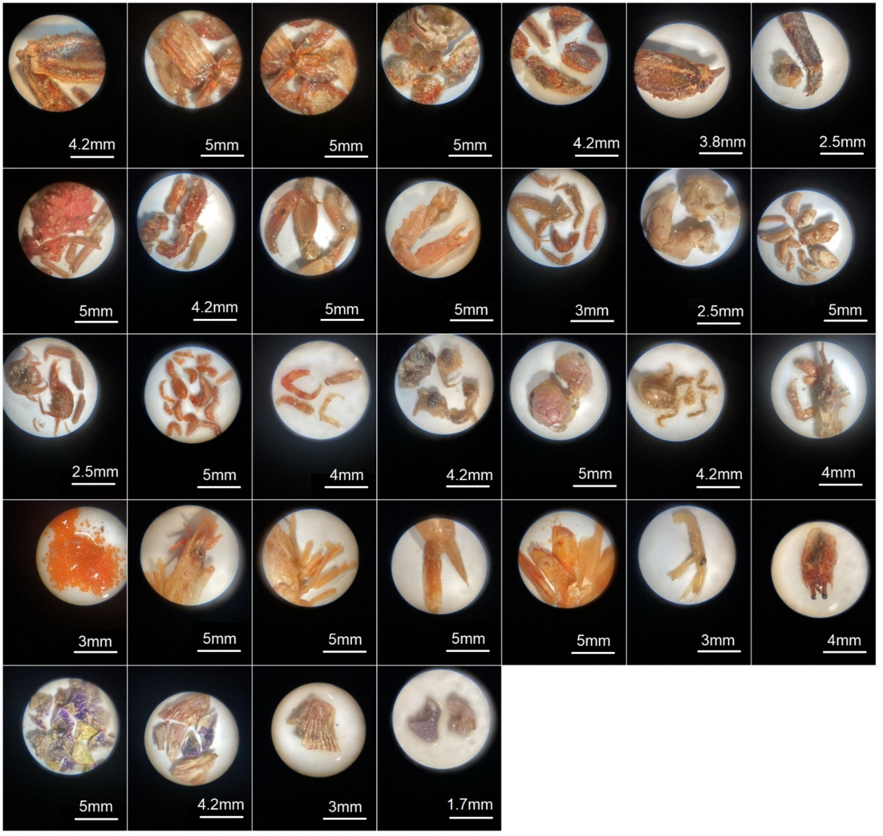
Figure S4B. Top to bottom: remains of the Xanthid crabs Plagusia chabrus, mixed crab parts thought to include Ranina ranina, Ovalipes australiensis, Ozius truncatus and smaller crabs like Mictyris longicarpus, crab roe material, remains of Penaeid sp. prawn showing head, swimmerettes, telson and uropod, Trypaea australiensis, unidentified prawn parts and barnacle remains thought to include Austrobalanus imperator, Tesseropora rosea, Balanustrigatus sp.
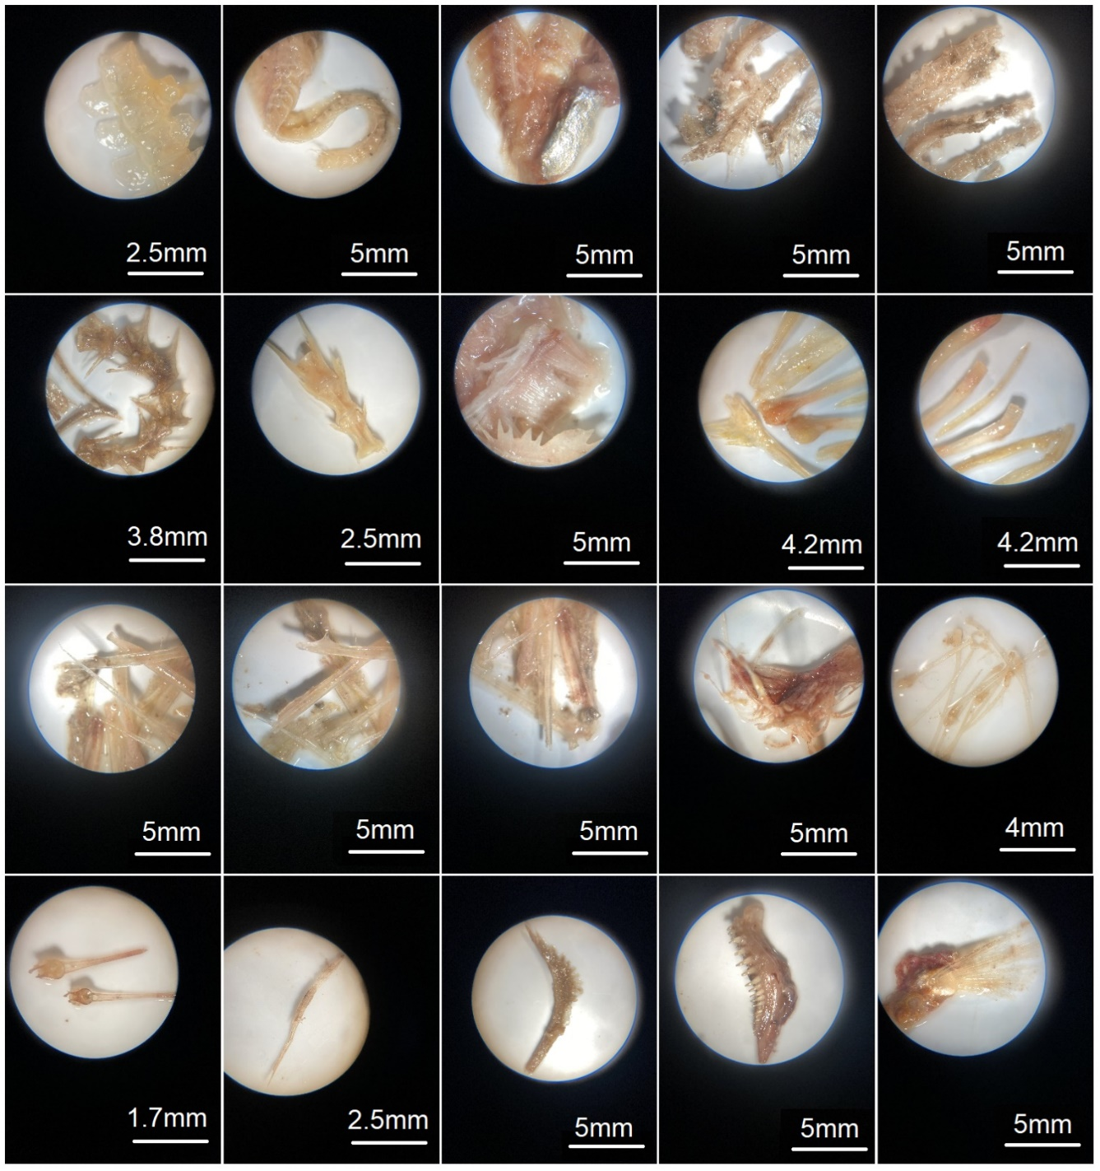
Figure S4C. Top to bottom: remains of fish vertebrae, gills, spinal rays, gill rakers, mouthparts and fin rays. Remains of Clupeidae sp. In some cases fish parts appeared to have been eaten recently but in the majority of cases fish parts were well-digested, prohibiting identification

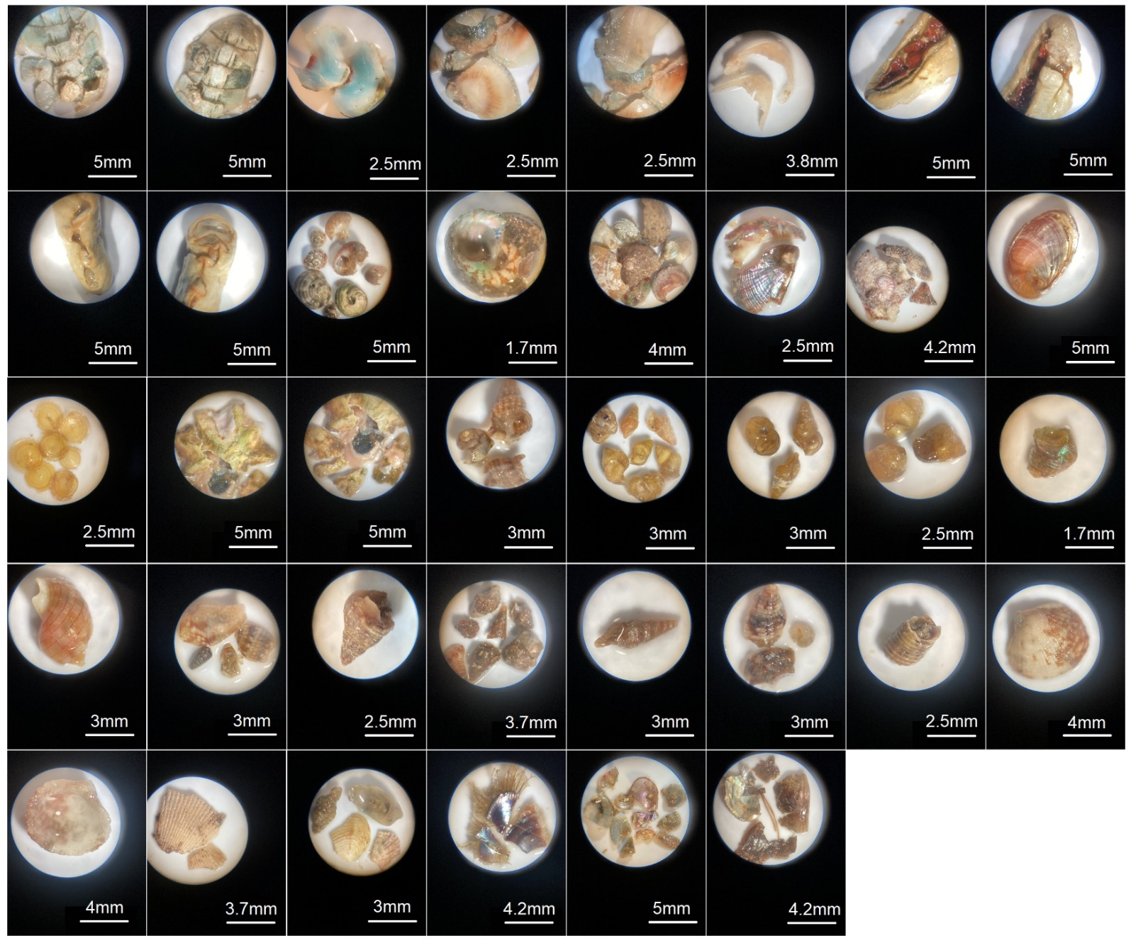
Figure S4D. Top to bottom; Polyplacophora spp. including Acanthochitonidae or Cryptoplax sp. showing dorsal plating in-tact and in pieces, soft parts of chitons shown from the ventral and dorsal views, Lunella undulata, Haliotis, Trochidae, Runellidae or Buccinidae sp., operculum coverings from large and small gastropods, Tugali cicatricosa, Scutellastra chapmani, Bullina lineata (red-lined bubble shell) and bivalves including Trichomya hirsuta or Mytilus galloprovencialis.

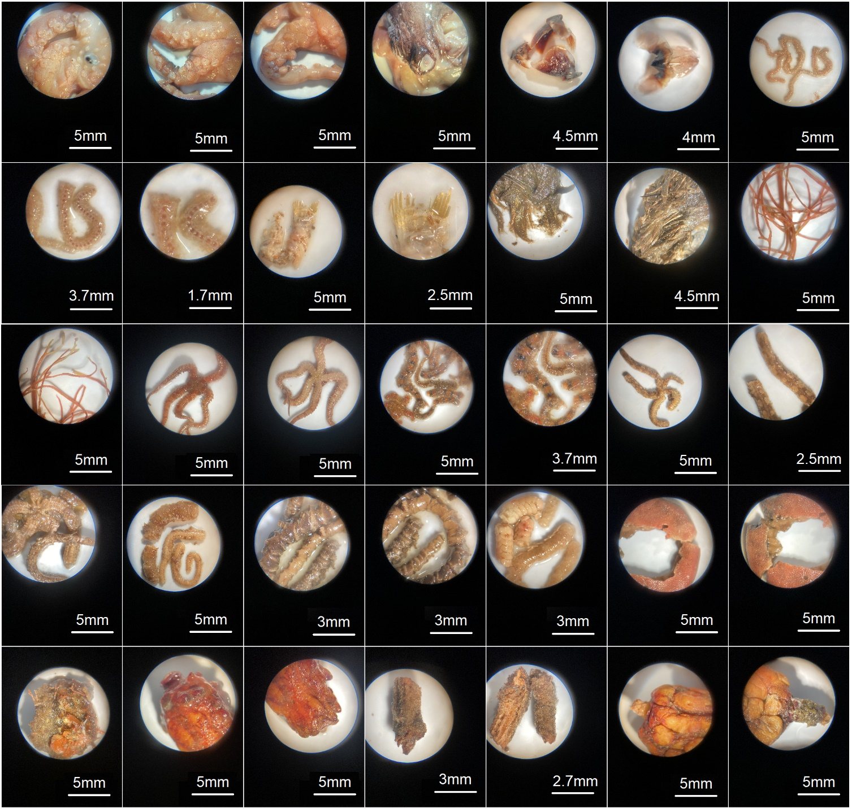
Figure S4E. Top to bottom: Octopoda sp. bodies and beaks, Lumbrinereid, Nereidae, Eunicidae, Aphrodita, Serpulidae sp. polychaetes, Ophiuroidea spp. as whole pieces, arm segments or oral disc, Pyura stolonifera and P. gibbosa.

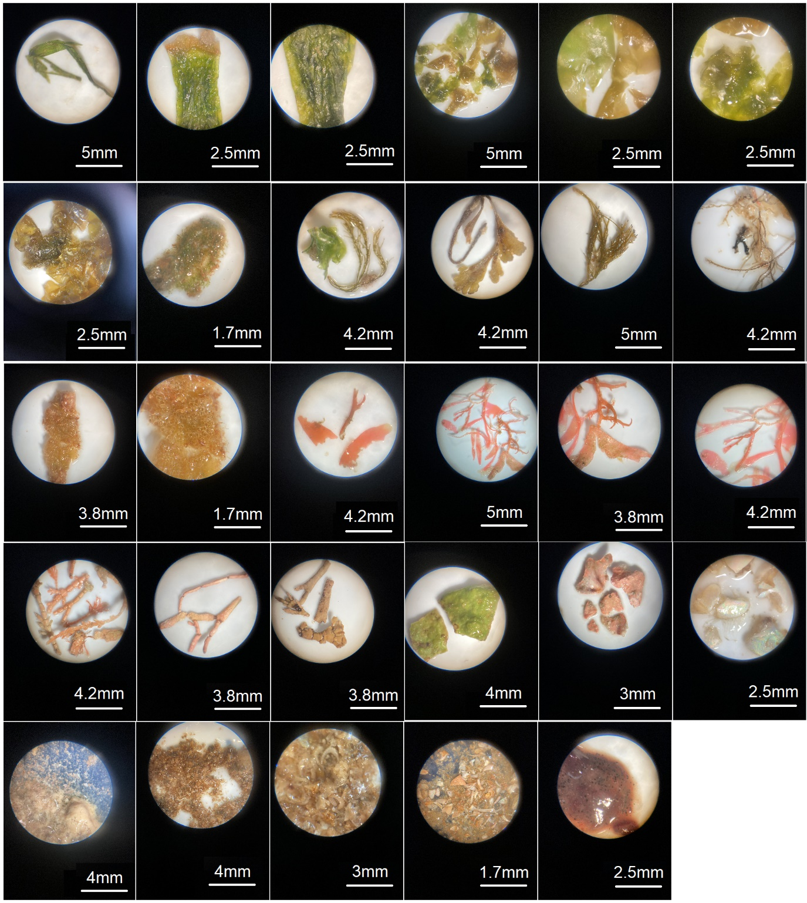
Figure S4F. Top to bottom: green, brown, red and coralline algae, unknown hard parts, biogenic detritus, microplastics including plastic pieces, fishing wire and nurdles (plastic beads).

Online supplementary material S5. Full models
Modelling results for (A) Achoerodus viridis and (B) Chrysophyrus auratus using Likelihood Ratio Testing (LRT) within Generalized Linear Models (GLM’s) for A. viridis and Generalized Linear Mixed Models (GLMM’s) for C. auratus. Here, the full model including terms included in interactions as single parameters are included.
(A)
Model | Parameter | Df | Model estimate | SE | X²₁ | P
urchin ~ size * latitude + GFI | GFI | 1 | -0.02 | 0.02 | 1.52 | 0.2169
- | size | 1 | -0.06 | 0.06 | 0.77 | 0.3803
- | latitude | 1 | -0.07 | 0.90 | 0.01 | 0.9346
- | size * latitude | 1 | 0.01 | 0.01 | 0.89 | 0.3464
(B)
Model | Parameter | Df | Model estimate | SE | X²₁ | P
urchin ~ size * sex + GFI + (1|location) | GFI | 1 | 0.03 | 0.02 | 3.91 | 0.0479
- | size | 1 | -0.01 | 0.01 | 0.02 | 0.8926
- | sex | 1 | -1.90 | 2.46 | 0.60 | 0.4389
- | size * sex | 1 | 0.01 | 0.01 | 0.80 | 0.3724

Online supplementary material S6. Observed urchin presence and fish morphometry.
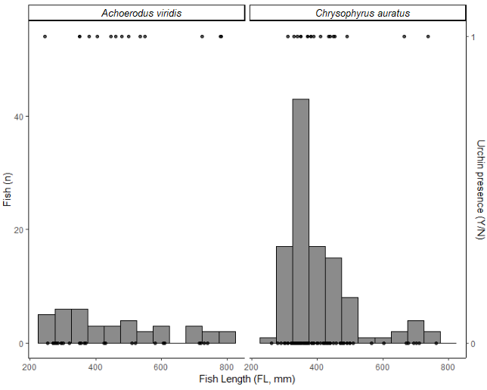

Figure S6.1. Bar chart showing the frequency of urchin parts in guts of Achoerodus viridis (eastern blue groper) and Chrysophyrus auratus (pink snapper). Counts of fish are shown by their size and whether urchins were present in the guts or not is shown by decimals (1 = present, 0 = not present) in an overlaid point plot.

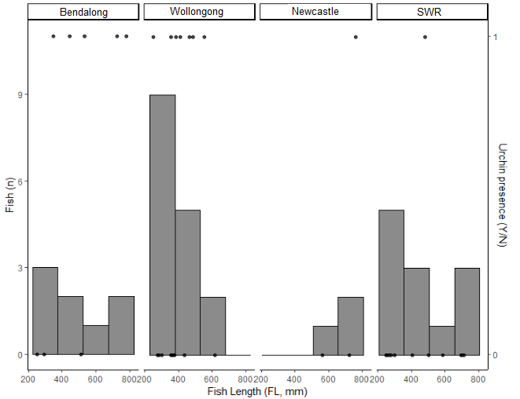
Figure S6.2. Bar chart showing the frequency of urchin parts in guts of Achoerodus viridis (eastern blue groper) faceted by pooled locations. Counts of fish are shown by their size and whether urchins were present in the guts or not is shown by decimals (1 = present, 0 = not present) in an overlaid point plot.

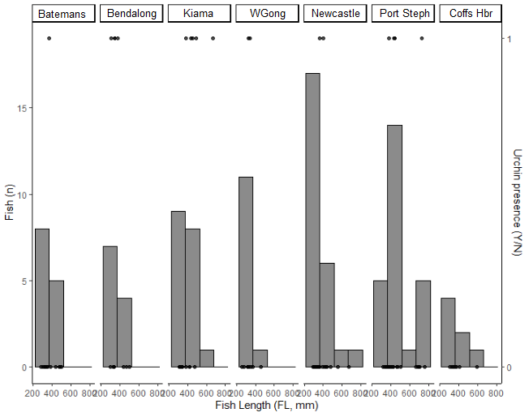
Figure S6.3. Bar chart showing the frequency of urchin parts in guts of Chrysophyrus auratus (pink snapper) faceted by pooled locations. Counts of fish are shown by their size and whether urchins were present in the guts or not is shown by decimals (1 = present, 0 = not present) in an overlaid point plot.

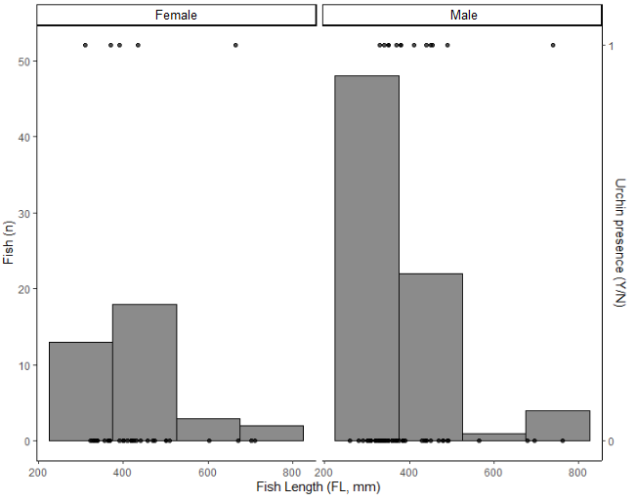
Figure S6.4. Bar chart showing the frequency of urchin parts in guts of Chrysophyrus auratus (pink snapper) faceted by sex. Counts of fish are shown by their size and whether urchins were present in the guts or not is shown by decimals (1 = present, 0 = not present) in an overlaid point plot.

