Supplementary Information
Appendix 1
Evaluating Potential Changes from Nitrogen to Phosphorus Nutrient Limitation of Phytoplankton Growth in North Inlet Estuary, SC
Catherine Schlenker, James L. Pinckney
Submission Date: 15 May 2024
Resubmission: 4 September 2024, 11 February 2025
Estuaries and Coasts

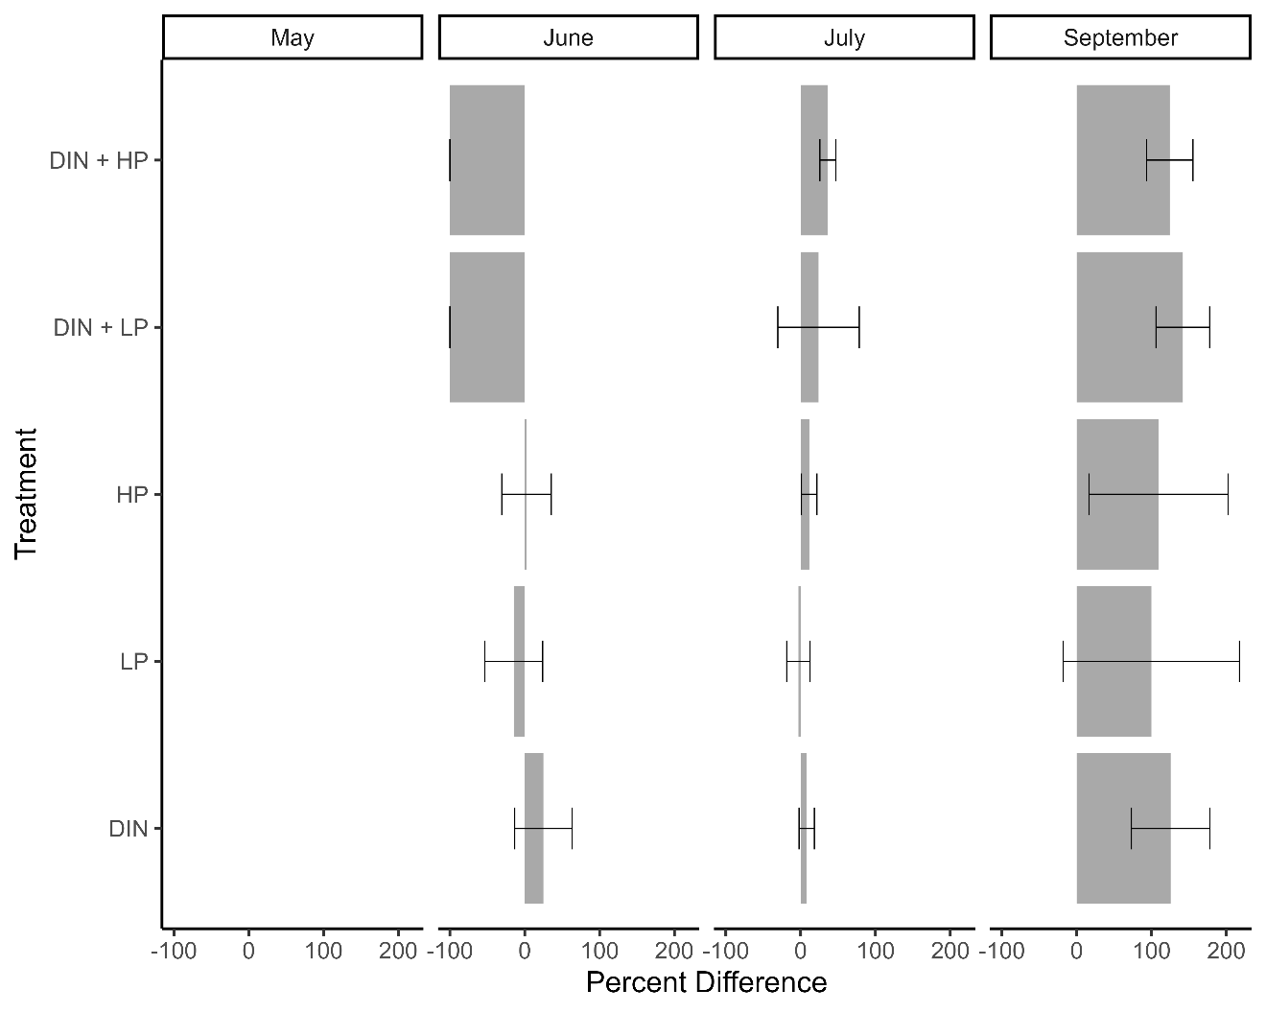
Figure S1. Percent difference in cyanobacteria biomass relative to the control across all bioassays. Error bars represent standard deviation. Cyanobacteria were undetected in the control and nutrient amended groups in the May bioassay. An RCB two-way ANOVA suggested differences in percent difference from control between nutrient enrichment groups (F = 0.956, p = 0.438). Values were derived from HPLC and phytoclass analysis.

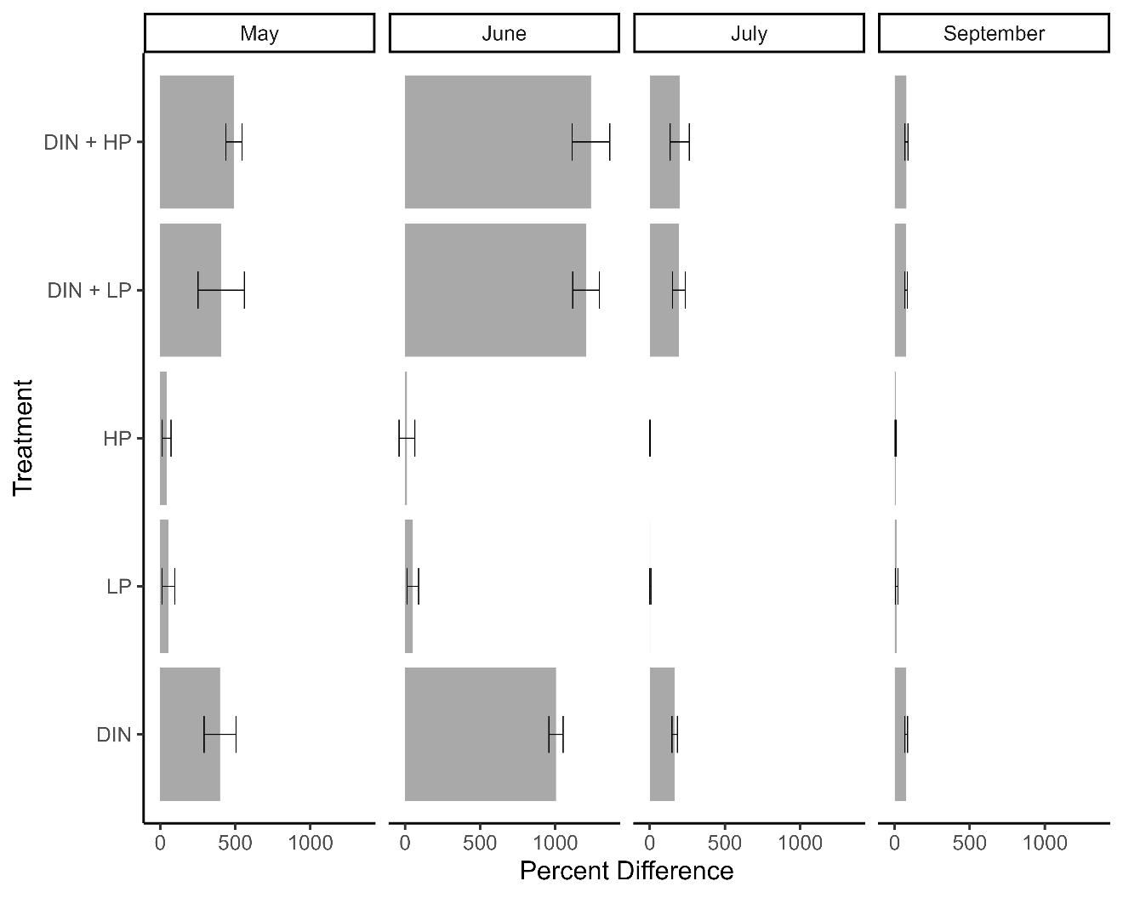
Figure S2. Percent difference in cryptophyte biomass relative to the control across all bioassays. Error bars represent standard deviation. An RCB two-way ANOVA suggested differences in percent difference from control between nutrient enrichment groups (F = 24.46, p < 0.001). Values were derived from HPLC and phytoclass analysis.

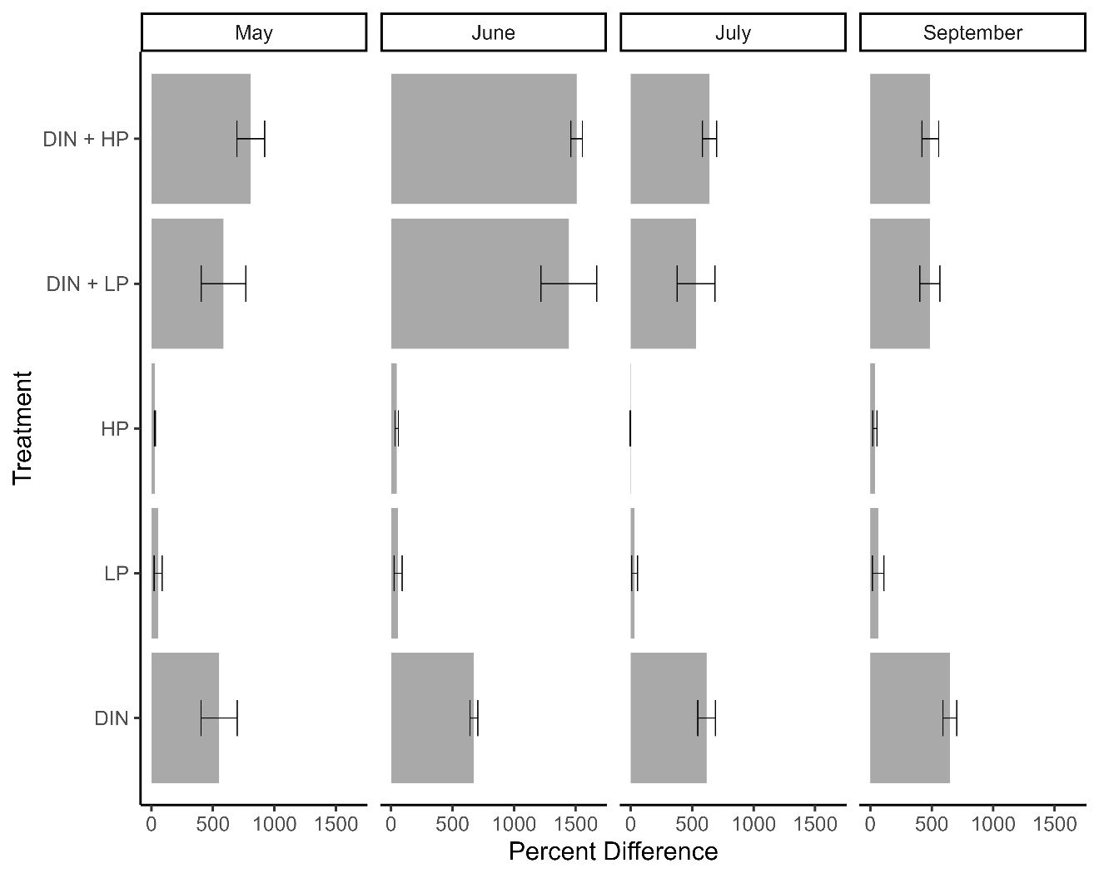
Figure S3. Percent difference in diatom and haptophyte biomass relative to the control across all bioassays. Error bars represent standard deviation. An RCB two-way ANOVA suggested differences in percent difference from control between nutrient enrichment groups (F = 68.28, p < 0.001). Values were derived from HPLC and phytoclass analysis.

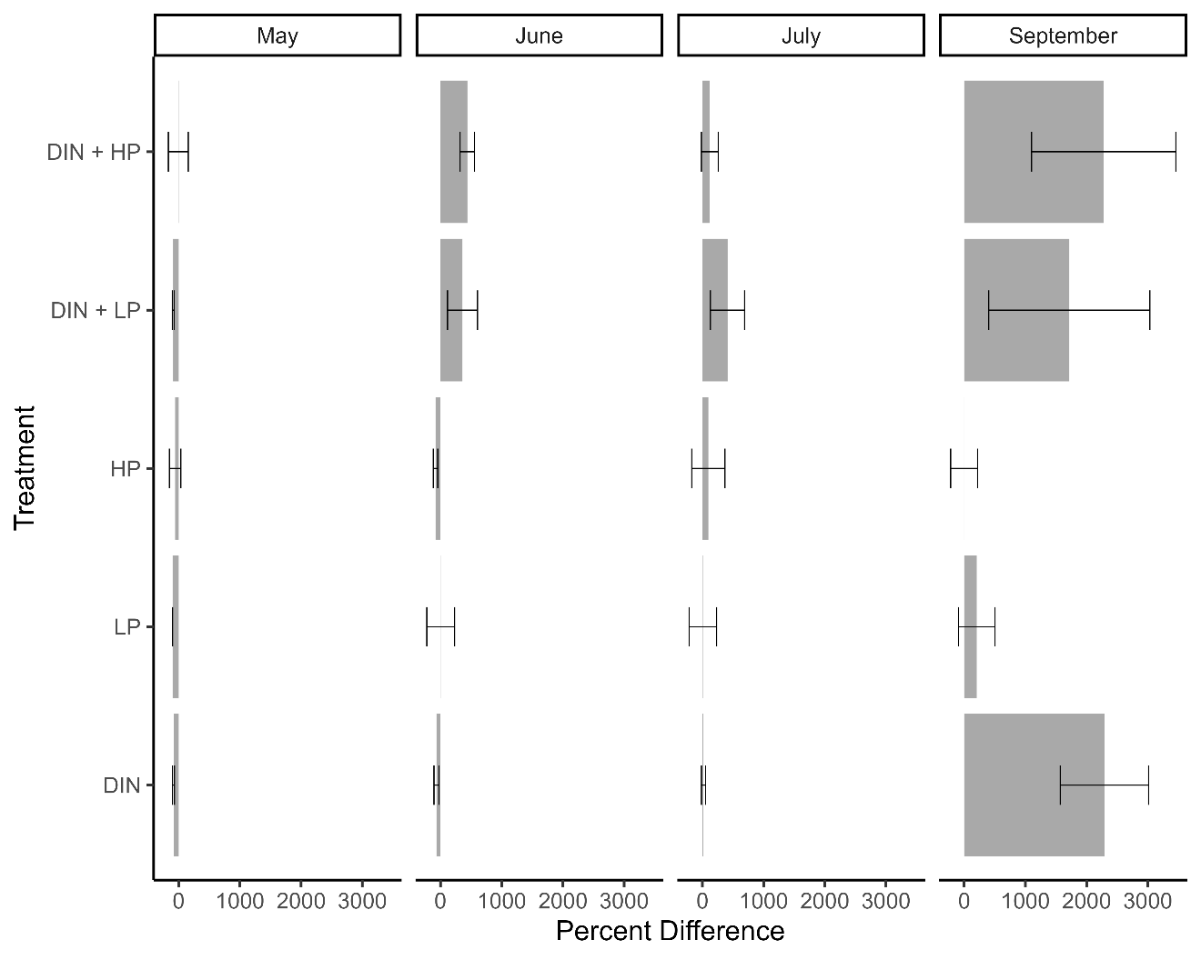
Figure S4. Percent difference in dinoflagellate biomass relative to the control across all bioassays. Error bars represent standard deviation. An RCB two-way ANOVA suggested differences in percent difference from control between nutrient enrichment groups (F = 6.12, p < 0.001). Values were derived from HPLC and phytoclass analysis.

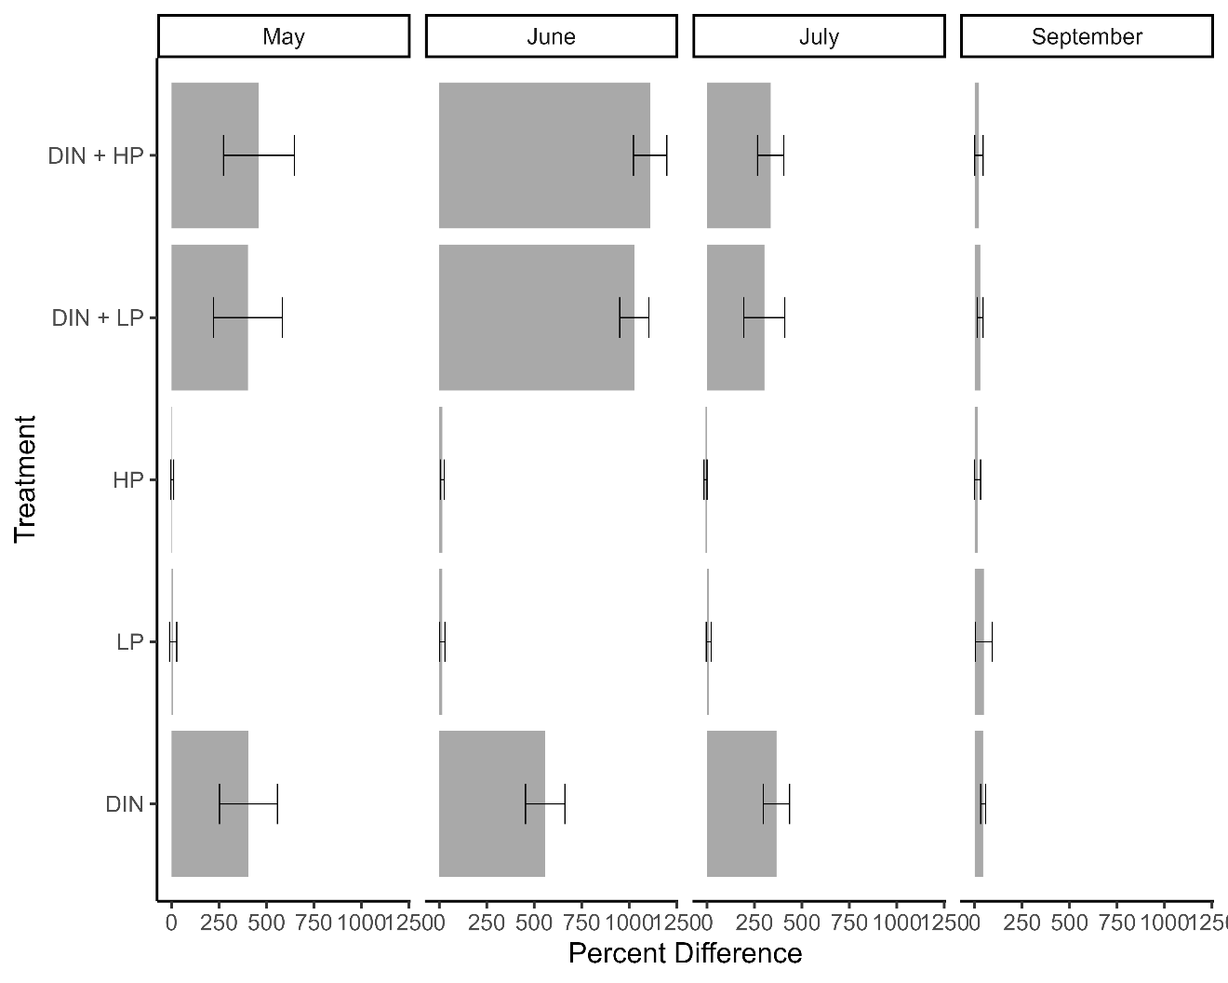
Figure S5. Percent difference in green algae biomass relative to the control across all bioassays. Error bars represent standard deviation. An RCB two-way ANOVA suggested differences in percent difference from control between nutrient enrichment groups (F = 26.47, p < 0.001). Values were derived from HPLC and phytoclass analysis.

