Electronic Supplemental Material

The importance of local scale factors in restoration planning: a case study with an indicator species for salt marsh ecosystems

Submitted January 23, 2026

*Grace McCulloch, University of New Hampshire, Department of Natural Resources, Durham, NH, USA,
Chris S. Elphick, University of Connecticut, Department of Ecology & Evolutionary Biology and Center of Biological Risk, Storrs, CT, USA
Remington J. Moll, University of New Hampshire, Department of Natural Resources, Durham, NH, USA; ORCID: 0000-0002-0681-2646
**Rachel Stevens, Great Bay National Estuarine Research Reserve, Greenland, NH, USA.
***Adrienne I. Kovach, University of New Hampshire, Department of Natural Resources, Durham, NH, ORCID: 0000-0002-6791-0610

*current address: New Hampshire Audubon, 84 Silk Farm Road, Concord, NH, USA.
**current address: Birch Tree Conservation Consulting, 99 Dame Road, Durham NH 03824
***corresponding author: akovach@unh.edu

Key words: saltmarsh sparrow, habitat characteristics, tidal marsh bird, occupancy modeling, spatial scale

Table S1. Model results, including the number of parameters (k), log-likelihood, Akaike’s information criterion corrected for small sample sizes (AIC_{c}), Δ AIC_{c}, model weight (w_{i}), and cumulative model weight (cumulative w_{i}) for models of saltmarsh sparrow (Ammospiza caudacuta) detection during point count surveys (May–August 2022) in New Hampshire, USA.
Model | k | Log-Likelihood | AIC_{c} | Δ AIC_{c} | w_{i} | Cumulative w_{i}
Date | 3 | -83.69 | 173.39 | 0.00 | 0.66 | 0.66
Date + Noise | 4 | -83.61 | 175.23 | 1.84 | 0.26 | 0.93
Null | 2 | -87.26 | 178.53 | 5.14 | 0.05 | 0.98
Noise | 3 | -87.16 | 180.33 | 6.94 | 0.02 | 1.00

Table S2. Parameter estimates, standard error (SE), and lower (LCI) and upper (UCI) 85 percent confidence intervals for saltmarsh sparrow (Ammospiza caudacuta) detection models based on point count surveys conducted in New Hampshire from May–August 2022. Bold values indicate a covariate’s 85 percent confidence interval did not span zero.
Model | Parameter | Estimate | SE | LCI | UCI
Date | Intercept | 0.962 | 0.394 | 0.394 | 1.530
Date | Date | 0.815 | 0.334 | 0.335 | 1.295
Date + Noise | Intercept | 0.971 | 0.396 | 0.401 | 1.541
Date + Noise | Date | 0.819 | 0.337 | 0.334 | 1.303
Date + Noise | Noise | -0.156 | 0.391 | -0.719 | 0.406
Null | Intercept | 0.887 | 0.361 | 0.368 | 1.407
Noise | Intercept | 0.889 | 0.361 | 0.370 | 1.409
Noise | Noise | -0.179 | 0.391 | -0.741 | 0.384

Table S3. Parameter estimates, standard error (SE), and lower (LCI) and upper (UCI) 85 percent confidence intervals for univariate saltmarsh sparrow (Ammospiza caudacuta) occupancy models based on point count surveys conducted in New Hampshire from May– August 2022. Models investigate the effect of covariates from the Great Bay National Estuarine Research Reserve’s Saltmarsh Sparrow Model. All models included a detection covariate, date. Parameter estimates for the detection covariate are not shown. Bold values indicate a covariate’s 85 percent confidence interval did not span zero.

Model | Parameter | Estimate | SE | LCI | UCI
Area | Intercept | -0.503 | 0.261 | -0.879 | -0.127
Area | Area | 0.680 | 0.248 | 0.323 | 1.037
% High Marsh | Intercept | -0.717 | 0.336 | -1.201 | -0.234
% High Marsh | % High Marsh | 1.395 | 0.656 | 0.451 | 2.339
% Phragmites | Intercept | -0.440 | 0.248 | -0.796 | 0.083
% Phragmites | % Phragmites | 0.109 | 0.233 | -0.227 | 0.445
UVVR | Intercept | -0.436 | 0.249 | -0.794 | -0.078
UVVR | UVVR | 0.132 | 0.238 | -0.211 | 0.475
Tidal Range | Intercept | -0.487 | 0.262 | -0.864 | -0.110
Tidal Range | Tidal Range | 0.610 | 0.266 | 0.227 | 0.993
% MTL | Intercept | -0.520 | 0.267 | -0.904 | -0.135
% MTL | % MTL | -0.773 | 0.401 | -1.351 | -0.195
Subsidence Ditch Impact Score | Intercept | -0.443 | 0.250 | -0.804 | -0.083
Subsidence Ditch Impact Score | Subsidence Ditch Impact Score | 0.253 | 0.299 | -0.177 | 0.684
Null | Intercept | -0.437 | 0.248 | -0.793 | -0.081

Table S4. Model results, including the number of parameters (k), log-likelihood, Akaike’s information criterion corrected for small sample sizes (AIC_{c}), Δ AIC_{c}, model weight (w_{i}), and cumulative model weight (cumulative w_{i}) for models of saltmarsh sparrow (Ammospiza caudacuta) occupancy based on point count surveys in New Hampshire conducted in May– August 2022. Models investigate the relative importance of covariates from the Great Bay National Estuarine Research Reserve’s Saltmarsh Sparrow Habitat Model. All models include the detection covariate date (not shown).
Model | k | Log-Likelihood | AIC_{c} | Δ AIC_{c} | w_{i} | Cumulative w_{i}
Area + % High Marsh | 5 | -77.23 | 164.47 | 0.00 | 0.230 | 0.23
% High Marsh | 4 | -78.49 | 164.98 | 0.51 | 0.179 | 0.41
% High Marsh + % MTL | 5 | -78.11 | 166.21 | 1.74 | 0.096 | 0.51
Tidal Range + % High Marsh | 5 | -78.18 | 166.35 | 1.89 | 0.090 | 0.59
Area + % MTL + % High Marsh | 6 | -77.22 | 166.44 | 1.97 | 0.086 | 0.68
Area + % High Marsh + Tidal Range | 6 | -77.22 | 166.44 | 1.97 | 0.086 | 0.77
Area | 4 | -79.70 | 167.39 | 2.92 | 0.053 | 0.82
% High Marsh + %MTL + Tidal Range | 6 | -78.10 | 168.20 | 3.73 | 0.036 | 0.86
% High Marsh + % MTL + Tidal Range + Area | 7 | -77.11 | 168.22 | 3.76 | 0.035 | 0.89
Area + % MTL | 5 | -79.24 | 168.48 | 4.01 | 0.031 | 0.92
Area + Tidal Range | 5 | -79.45 | 168.89 | 4.42 | 0.025 | 0.95
Tidal Range | 4 | -80.78 | 169.57 | 5.10 | 0.018 | 0.97
% MTL | 4 | -81.13 | 170.27 | 5.80 | 0.013 | 0.98
Area + % MTL + Tidal Range | 6 | -79.23 | 170.47 | 6.00 | 0.012 | 0.99
Tidal Range + % MTL | 5 | -80.62 | 171.23 | 6.77 | 0.008 | 1.00
Null | 3 | -83.69 | 173.39 | 8.92 | 0.003 | 1.00

Table S5. Parameter estimates, standard error (SE), and lower (LCI) and upper (UCI) 85 percent confidence intervals for saltmarsh sparrow (Ammospiza caudacuta) occupancy models based on point count surveys conducted in New Hampshire from May–August 2022. Models investigate the relative importance of covariates from the Great Bay National Estuarine Research Reserve’s Saltmarsh Sparrow habitat model. All models included the detection covariate, date. Only models within 2 AIC_{c} units of the top-ranked model are shown. Bold values indicate a covariate’s 85 percent confidence interval did not span zero. Parameter estimates for detection covariate are not shown.
Model | Parameter | Estimate | SE | LCI | UCI
Area + % High Marsh | Intercept | -0.686 | 0.326 | -1.155 | -0.217
Area + % High Marsh | Area | 0.428 | 0.272 | 0.037 | 0.819
Area + % High Marsh | % High Marsh | 1.027 | 0.625 | 0.128 | 1.927
% High Marsh | Intercept | -0.717 | 0.336 | -1.201 | -0.234
% High Marsh | % High Marsh | 1.395 | 0.656 | 0.451 | 2.339
% High Marsh + % MTL | Intercept | -0.731 | 0.340 | -1.219 | -0.242
% High Marsh + % MTL | % High Marsh | 1.244 | 0.673 | 0.275 | 2.213
% High Marsh + % MTL | % MTL | -0.355 | 0.414 | -0.952 | 0.241
Tidal Range + % High Marsh | Intercept | -0.695 | 0.335 | -1.177 | -0.213
Tidal Range + % High Marsh | Tidal Range | 0.241 | 0.306 | -0.200 | 0.682
Tidal Range + % High Marsh | % High Marsh | 1.180 | 0.683 | 0.196 | 2.163
Area + % MTL + % High Marsh | Intercept | -0.690 | 0.328 | -1.161 | -0.218
Area + % MTL + % High Marsh | Area | 0.404 | 0.303 | -0.033 | 0.841
Area + % MTL + % High Marsh | % MTL | -0.079 | 0.459 | -0.740 | 0.581
Area + % MTL + % High Marsh | % High Marsh | 1.011 | 1.587 | 0.094 | 1.927
Area + % High Marsh  + Tidal Range | Intercept | -0.690 | 0.327 | -1.160 | -0.219
Area + % High Marsh  + Tidal Range | Area | 0.459 | 0.334 | -0.022 | 0.940
Area + % High Marsh  + Tidal Range | % High Marsh | 1.056 | 0.651 | 0.120 | 1.993
Area + % High Marsh  + Tidal Range | Tidal Range | -0.062 | 0.380 | -0.609 | 0.485

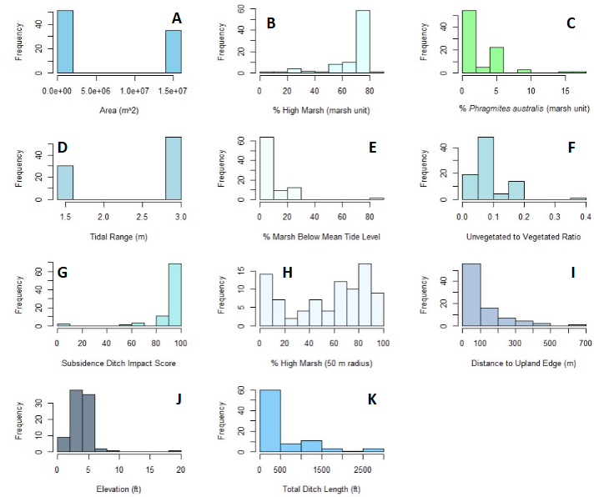
Figure S1. Frequency distributions of habitat covariates examined in saltmarsh sparrow (Ammospiza caudacuta) occupancy models in New Hampshire, USA. (A) Marsh area (m²), (B) Percent high marsh cover within the marsh unit, (C) Percent Phragmites australis cover within the marsh unit, (D) Tidal range (m), (E) Percent marsh below mean tide level, (F) Unvegetated to vegetated ratio, (G) Subsidence ditch impact score, (H) Percent high marsh cover within 50 m of the survey point, (I) Distance from survey point to the nearest upland edge (m), (J) Elevation at the survey point (ft), and (K) Total ditch length within a 50-m radius of the survey point.

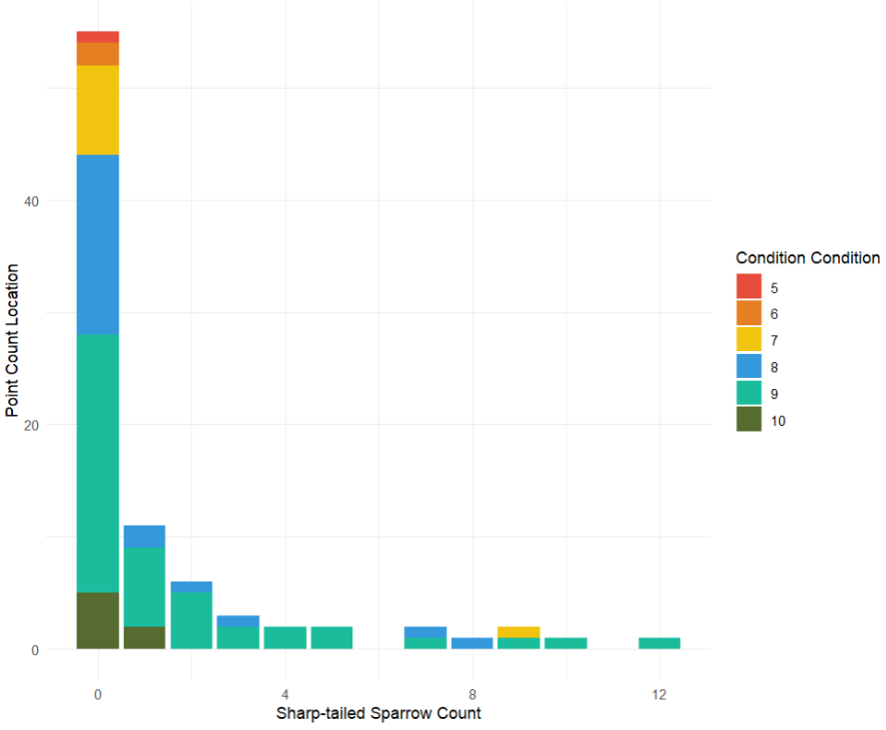
Figure S2. Saltmarsh sparrow occupancy in relation to marsh condition ranking by the Marsh-scale Model. Total number of sharp-tailed sparrows detected during point count surveys at 86 points across New Hampshire, USA, conducted during the 2022 breeding season. These counts reflect the total combined number of Saltmarsh Sparrow (Ammospiza caudacuta) and Nelson’s Sparrow (Ammospiza nelsoni), and their hybrids detected across two survey visits. Bar color represents the current condition rank from the New Hampshire Salt Marsh Plan (Stevens et al. 2023) for each marsh where each survey point was located. This current condition score characterizes overall marsh quality and ranges from 1 (low current condition) to 10 (high current condition). Sparrow occupancy does not correlate well with marsh condition: many marshes with a high condition ranking (8-10) were unoccupied (0 sparrows detected); all of the highest ranked marshes by condition had 0 or 1 sparrows.

