This draft manuscript is distributed solely for purposes of scientific peer review. Its content is deliberative and pre-decisional, so it must not be disclosed or released by reviewers. Because the manuscript has not yet been approved for publication by the U.S. Geological Survey (USGS), it does not represent any official USGS finding or policy.

Supplemental Materials*

Escaping the Density Trap:
Estuarine Connectivity Supports Juvenile River Herring Growth
Julian D. Burgoff^{1*}, Allison H. Roy², Douglas Bishop¹, Jason Stolarski³, Adrian Jordaan⁴
¹Massachusetts Cooperative Fish and Wildlife Research Unit, Department of Environmental Conservation, University of Massachusetts, Amherst, MA
²U.S. Geological Survey, Massachusetts Cooperative Fish and Wildlife Research Unit, Department of Environmental Conservation, University of Massachusetts, Amherst, MA
³Massachusetts Division of Fisheries and Wildlife, Westborough, MA
⁴Department of Environmental Conservation, University of Massachusetts, Amherst, MA
* Corresponding author: Julian D. Burgoff. Email: jburgoff@umass.edu

*Any use of trade, firm, or product names is for descriptive purposes only and does not imply endorsement by the U.S. Government.

Table S1 Juvenile alewife (Alosa pseudoharengus) and blueback herring (A. aestivalis) demographic information by species in the Mystic River watershed. Only individuals > 40 mm in total length were identified to species.

 |  |  | 2021
Habitat | Species | # Fish | Total Length (mm) |  |  |  | Age (days) |  |  |  | Growth Rate (mm/d)
 |  |  | Mean |  |  | Min–Max | Mean |  |  | Min–Max | Mean |  |  | Min–Max
Lake | Blueback | 117 | 55 |  |  | 40–71 | 62 |  |  | 42–82 | 0.83 |  |  | 0.70–1.03
River | Alewife | 9 | 80 |  |  | 53–103 | 69 |  |  | 54–91 | 1.09 |  |  | 0.92–1.21
River | Blueback | 86 | 51 |  |  | 40–61 | 62 |  |  | 46–78 | 0.78 |  |  | 0.67–0.92
Estuary | Alewife | 3 | 82 |  |  | 69–97 | 68 |  |  | 56–84 | 1.16 |  |  | 1.11–1.20
Estuary | Blueback | 26 | 50 |  |  | 44–69 | 56 |  |  | 43–77 | 0.86 |  |  | 0.70–1.10
 |  |  | 2022
Habitat | Species | # Fish | Total Length (mm) |  |  |  | Age (days) |  |  |  | Growth Rate (mm/d)
 |  |  | Mean |  | Min–Max |  | Mean |  | Min–Max |  | Mean |  | Min–Max
Lake | Blueback | 57 | 46 |  | 40–52 |  | 51 |  | 38–65 |  | 0.85 |  | 0.65–1.21
River | Alewife | 2 | 67 |  | 65–68 |  | 55 |  | 49–62 |  | 1.16 |  | 1.04–1.27
River | Blueback | 68 | 47 |  | 41–53 |  | 52 |  | 42–71 |  | 0.84 |  | 0.69–1.06
 |  |  | 2023
Habitat | Species | # Fish | Total Length (mm) |  |  |  | Age (days) |  |  |  | Growth Rate (mm/d)
 |  |  | Mean | Min–Max |  |  | Mean | Min–Max |  |  | Mean | Min–Max
Lake | Blueback | 58 | 69 | 41–93 |  |  | 79 | 41–112 |  |  | 0.86 | 0.68–1.07
River | Alewife | 26 | 82 | 65–107 |  |  | 72 | 57–103 |  |  | 1.11 | 0.68–1.07
River | Blueback | 48 | 57 | 40–83 |  |  | 62 | 40–115 |  |  | 0.88 | 0.64–1.22
Estuary | Alewife | 4 | 105 | 95–115 |  |  | 96 | 82–105 |  |  | 1.08 | 0.94–1.36
Estuary | Blueback | 20 | 74 | 57–116 |  |  | 76 | 56–117 |  |  | 0.92 | 0.77–1.25

Table S2 Parameter estimates for lengh-at-age regressions from an ANCOVA testing how the relationship between length and age changes by habitat type within the Mystic, Weymouth, and Essex watersheds for each sampling year. Different letters indicate significantly different slope coefficients within a year (Tukey post-hoc test p<0.05). In the Mystic watershed, only blueback herring (Alosa aestivalis) (>40 mm) are used in this analysis. Model parameter abbreviations: df_{between}= between group degrees of freedom, df_{within}= within group degrees of freedom, f= test statistic, R²= adjusted r-squared, P= p-value.

Year | Watershed | Habitat |  | Slope | Intercept | df_{between} | df_{within} | f | R² | P
2021 | Mystic | Lake | A | 0.792 | 5.630 | 5 | 223 | 209.6 | 0.82 | < 0.001
2021 | Mystic | River | B | 0.565 | 16.258
2021 | Mystic | Estuary | B | 0.425 | 27.180
2022 | Mystic | Lake | A | 0.101 | 40.539 | 3 | 121 | 10.52 | 0.19 | < 0.001
2022 | Mystic | River | B | 0.282 | 32.425
2023 | Mystic | Lake | A | 0.512 | 28.388 | 5 | 120 | 144.9 | 0.85 | < 0.001
2023 | Mystic | River | A | 0.606 | 19.127
2023 | Mystic | Estuary | B | 1.085 | -8.478
2021 | Weymouth | Lake | A | 0.891 | -0.586 | 3 | 166 | 599.2 | 0.91 | < 0.001
2021 | Weymouth | Estuary | B | 1.374 | -20.386
2022 | Weymouth | Lake | A | 0.823 | 1.214 | 3 | 207 | 1251 | 0.95 | < 0.001
2022 | Weymouth | Estuary | B | 1.278 | -14.989
2023 | Weymouth | Lake | A | 1.539 | -31.292 | 3 | 189 | 745.5 | 0.92 | < 0.001
2023 | Weymouth | Estuary | A | 1.529 | -22.900
2021 | Essex | Lake | A | 1.228 | 1.482 | 3 | 120 | 1178 | 0.97 | < 0.001
2021 | Essex | Estuary | A | 1.284 | -2.695

Table S3 Mean surface water temperature, pH, specific conductivity, dissolved oxygen (DO), Secchi depth, total nitrogen (TN), total phosphorous (TP) and dissolved organic carbon (DOC) by
year for seven sites in coastal Massachusetts. Samples were collected from surface water at dusk prior to fish sampling. Mean and ranges represent water quality
parameters collected during all of the sampling events for each site each year during months June through October. Site numbers are defined in Table 1.

 |  |  |  |  |  |  |  | 2021
Site | Temperature (°C) |  |  |  | pH |  |  | Conductivity (μs/cm) |  |  | DO (mg/L) |  |  |  | Secchi (m) |  |  | TN (mg/L) |  | TP (μg/L) |  |  | DOC (mg C/L)
 | Mean |  |  | Min–Max | Mean |  | Min–Max | Mean | Min–Max |  | Mean |  |  | Min–Max | Mean |  | Min–Max | Mean | Min–Max | Mean |  | Min–Max | Mean |  | Min–Max
1 | 24.5 |  |  | 22–26.2 | 7.59 |  | 6.85–8.08 | 729.6 | 600–877 |  | 8.43 |  |  | 7.69–9.14 | 0.9 |  | 0.6–1.2 | 0.64 | 0.28–1.05 | 33.46 |  | 28.14–37.71 | 9.63 |  | 8.74–10.6
2 | 20.2 |  |  | 19.6–21.6 | 7.86 |  | 7.62–7.96 | 64379.3 | 48196–71604 |  | 6.03 |  |  | 6.02–6.06 | 1.0 |  | 0.8–1.3 | 0.64 | 0.49–0.92 | 46.22 |  | 42.18–55.33 | 16.29 |  | 9.39–31.73
3 | 25.3 |  |  | 24.4–25.8 | 8.12 |  | 8.08–8.17 | 1140.5 | 802–1415 |  | 9.06 |  |  | 8.65–9.75 | 1.3 |  | 1–1.4 | 1.25 | 0.99–1.57 | 27.91 |  | 20.92–31.51 | 5.79 |  | 5.35–7.05
4 | 23.7 |  |  | 23.2–24.5 | 8.17 |  | 7.86–8.37 | 2096.4 | 1976–2173 |  | 10.08 |  |  | 9.8–10.25 | 0.7 |  | 0.5–0.9 | 0.81 | 0.6–0.99 | 41.64 |  | 25.62–64.38 | 9.86 |  | 5.54–14.09
5 | 22.8 |  |  | 21.7–24.5 | 7.85 |  | 7.84–7.86 | 31807.3 | 1976–50165 |  | 7.88 |  |  | 6.7–9.8 | - |  | - | - |  | - |  |  | -
6 | 25.1 |  |  | 23.8–26 | 7.92 |  | 7.8–8.04 | 393.6 | 367.2–413.8 |  | 7.1 |  |  | 6.47–7.45 | 1.1 |  | 0.7–1.3 | 0.74 | 0.68–0.84 | 27.54 |  | 26.21–32.98 | 10.17 |  | 9.67–11.24
7 | 20.3 |  |  | 20.2–20.5 | 7.50 |  | 7.18–8.35 | 49470.9 | 40952–71930 |  | 6.49 |  |  | 5.88–8.1 | 2.7 |  | 2.7–2.7 | 0.3 | 0.29–0.34 | 34.74 |  | 34.73–34.75 | 5.26 |  | 4.77–5.44
 |  |  |  |  |  |  |  | 2022
Site | Temperature (°C) |  |  |  | pH |  |  | Conductivity (μs/cm) |  |  | DO (mg/L) |  |  |  | Secchi (m) |  |  | TN (mg/L) |  | TP (μg/L) |  |  | DOC (mg C/L)
 | Mean |  | Min–Max |  | Mean |  | Min–Max | Mean | Min–Max |  | Mean |  | Min–Max |  | Mean | Min–Max |  | Mean | Min–Max | Mean |  | Min–Max | Mean |  | Min–Max
1 | 24.7 |  | 23.3–27.6 |  | 8.24 |  | 7.85–8.78 | 392.9 | 205.7–585 |  | 7.52 |  | 6.79–8.42 |  | 1.2 | 0.5–2.0 |  | 0.74 | 0.73–0.75 | 31.32 |  | 29.2–35.7 | 7.19 |  | 6.39–7.97
2 | 22.0 |  | 21.4–22.7 |  | 8.13 |  | 7.88–8.25 | 22443.4 | 16310–32142 |  | 9.71 |  | 9.5–10.26 |  | 1.2 | 1.2–1.2 |  | 0.61 | 0.51–0.72 | 77.7 |  | 62.8–83.4 | 9.86 |  | 2.48–25.27
3 | 25.0 |  | 21.3–28.5 |  | 8.86 |  | 7.78–9.55 | 618.4 | 314.5–883 |  | 8.51 |  | 8.32–8.73 |  | 0.3 | 0.3–0.3 |  | 1.18 | 1.06–1.25 | 23.12 |  | 20.4–29.17 | 5.71 |  | 4.24–6.64
4 | 24.6 |  | 22.2–27.2 |  | 8.67 |  | 7.74–9.96 | 8985 | 4585–15012.3 |  | 8.26 |  | 7.07–9.6 |  | - | - |  | 0.81 | 0.69–0.96 | 91.63 |  | 91.2–92 | 5.94 |  | 5.56–6.39
5 | 20.6 |  | 20.5–20.7 |  | 8.37 |  | 7.97–8.77 | 29376.3 | 26719–32034 |  | 8.99 |  | 7.16–10.82 |  | - | - |  | - |  | - |  | - | - |  | -
6 | 25.9 |  | 24–27.4 |  | 8.03 |  | 7.66–8.4 | 187.6 | 137.8–235.6 |  | 7.57 |  | 6.82–8.55 |  | 1.3 | 1.1–1.6 |  | 0.62 | 0.6–0.64 | 25.99 |  | 24.1–30.1 | 6.79 |  | 5.3–7.66
7 | 15.8 |  | 15.8–15.8 |  | 7.98 |  | 7.98–7.98 | 35970.5 | 30970.5-30970.5 |  | 9.40 |  | 9.40–9.40 |  | - | - |  | 0.24 | 0.24–0.25 | 2.17 |  | 1.77–2.64 | 53.36 |  | 47.56–62.24
 |  |  |  |  |  |  |  | 2023
Site | Temperature (°C) |  |  |  | pH |  |  | Conductivity (μs/cm) |  |  | DO (mg/L) |  |  |  | Secchi (m) |  |  | TN (mg/L) |  | TP (μg/L) |  |  | DOC (mg C/L)
 | Mean | Min–Max |  |  | Mean | Min–Max |  | Mean |  | Min–Max | Mean | Min–Max |  |  | Mean |  | Min–Max | Mean | Min–Max | Mean | Min–Max |  | Mean | Min–Max
1 | 25.5 | 24–27.6 |  |  | 8.07 | 7.35–8.52 |  | 415.1 |  | 370–439.3 | 8.03 | 6.89–9.18 |  |  | 1.0 |  | 0.7–1.4 | 0.85 | 0.69–1.21 | 36.87 | 34.54–40.84 |  | 10.25 | 8.79–11.66
2 | 22.8 | 22.5–23 |  |  | 8.08 | 8.01–8.15 |  | 38257.1 |  | 36423–40258 | 8.34 | 7.66–9.08 |  |  | 1.2 |  | 1.1–1.2 | 0.84 | 0.75–0.92 | 57.66 | 49.67–64.98 |  | 36.08 | 1.99–67.32
3 | 24.2 | 21.7–27.1 |  |  | 7.91 | 7.4–8.11 |  | 556.2 |  | 223–755 | 9.47 | 9.15–9.9 |  |  | 1.6 |  | 1.1–2.0 | 1.13 | 0.85–1.42 | 39.23 | 21.48–86.24 |  | 5.44 | 4.44–6.43
4 | 24.0 | 20.7–25.2 |  |  | 8.19 | 7.8–8.65 |  | 5217.4 |  | 484.6–12465 | 9.75 | 7.57–12.04 |  |  | 1.0 |  | 0.4–1.7 | 0.81 | 0.65–0.95 | 67.98 | 32.87–88.94 |  | 4.83 | 4.58–5.56
5 | 17.6 | 14.7–20.5 |  |  | 7.77 | 7.74–7.8 |  | 27350 |  | 22000–32700 | 7.62 | 7.26–7.99 |  |  | - |  | - | - |  | - | - |  | - | -
6 | 25.8 | 24–28.6 |  |  | 7.39 | 7.02–7.66 |  | 231 |  | 222.6–235.6 | 8.33 | 7.6–8.85 |  |  | 1.5 |  | 1.0–1.7 | 0.64 | 0.59–0.69 | 24.45 | 21.99–28.18 |  | 11.01 | 9.81–12.5
7 | 21.8 | 21.2–22.3 |  |  | 7.87 | 7.74–8.01 |  | 38266.3 |  | 36412–40121 | 8.18 | 8.05–8.316 |  |  | 2.1 |  | 1.5–2.7 | 0.62 | 0.62–0.62 | 24.00 | 24.00–24.00 |  | 3.60 | 3.60–3.60

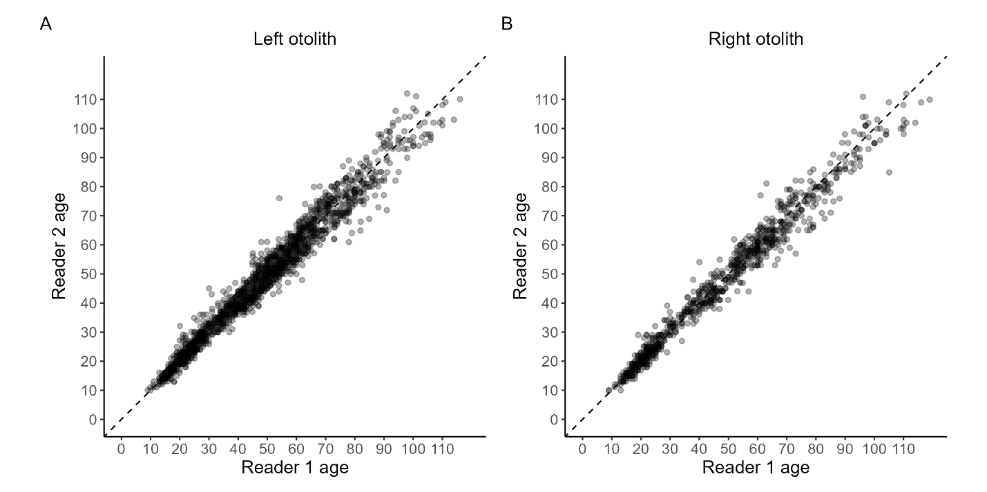

Figure S1 Age-bias plots comparing independent age estimates from Reader 1 and Reader 2 for sagittal otoliths of juvenile alewife (Alosa pseudoharengus) and blueback herring (A. aestivalis). Panels show reader agreement for (A) left otoliths and (B) right otoliths. Each point represents an individual fish aged independently by both readers. The dashed line indicates the 1:1 line representing perfect agreement between readers.

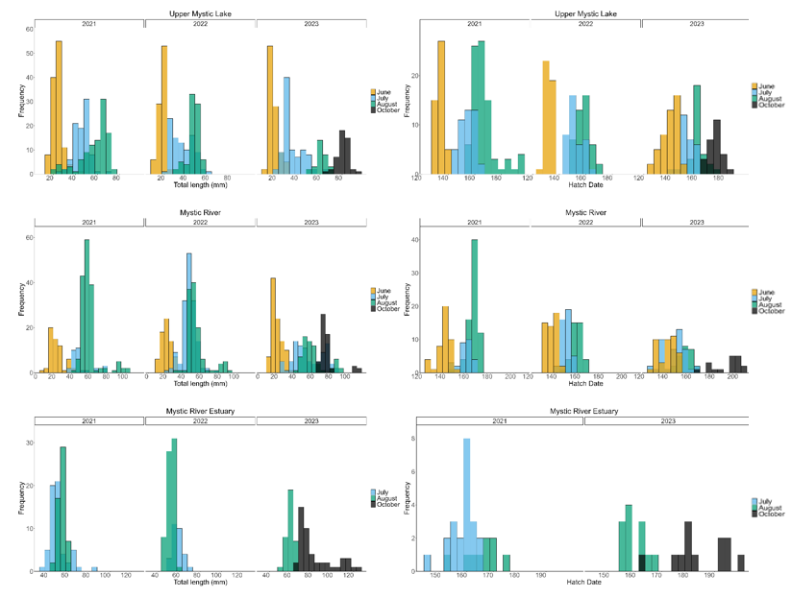
Figure S2 Length and hatch date frequencies of juvenile alewife (Alosa pseudoharengus) and blueback herring (A. aestivalis) derived from otolith-aged individuals collected from lake, river and estuary habitat in the Mystic watershed by year and month of sampling. October samples were collected only in the Mystic watershed during 2023.

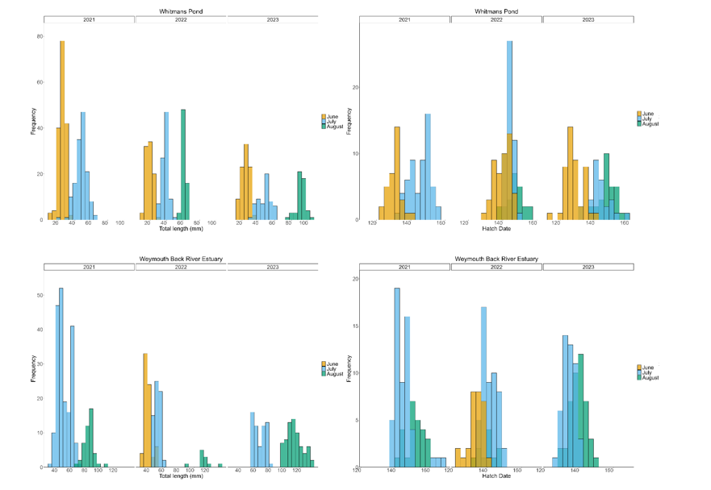
Figure S3 Length and hatch date frequencies of juvenile alewife (Alosa pseudoharengus) derived from otolith-aged individuals collected from and estuary habitat in the Weymouth Back River watershed by year and month of sampling.

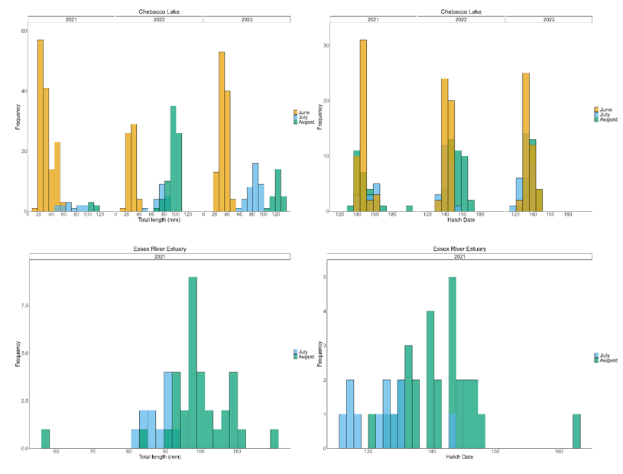
Figure S4 Length and hatch date frequencies of juvenile juvenile alewife (Alosa pseudoharengus) derived from otolith-aged individuals collected from lake and estuary habitat in the Essex River watershed by year and month of sampling.

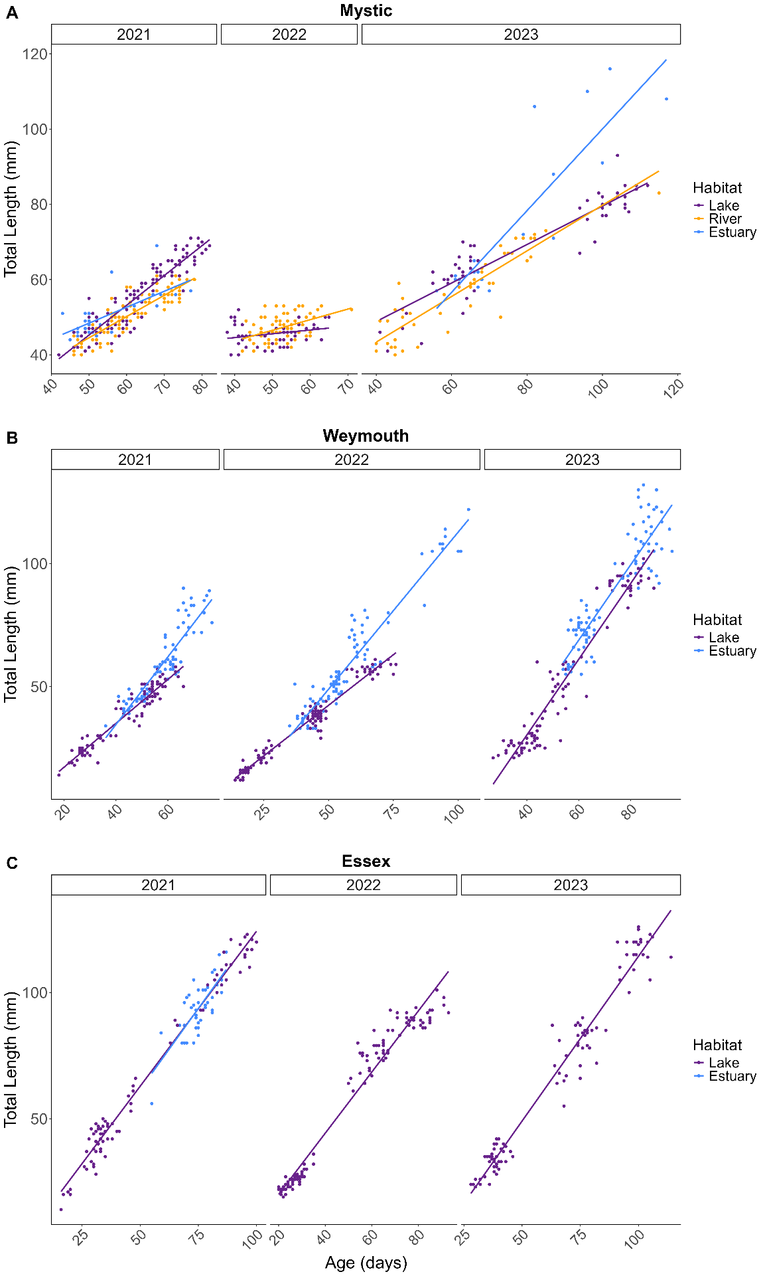
Figure S5 Length–age regressions for juvenile blueback herring (Alosa aestivalis; Mystic watershed) and alewife (A. pseudoharengus; Weymouth and Essex watersheds) by habitat type and year.

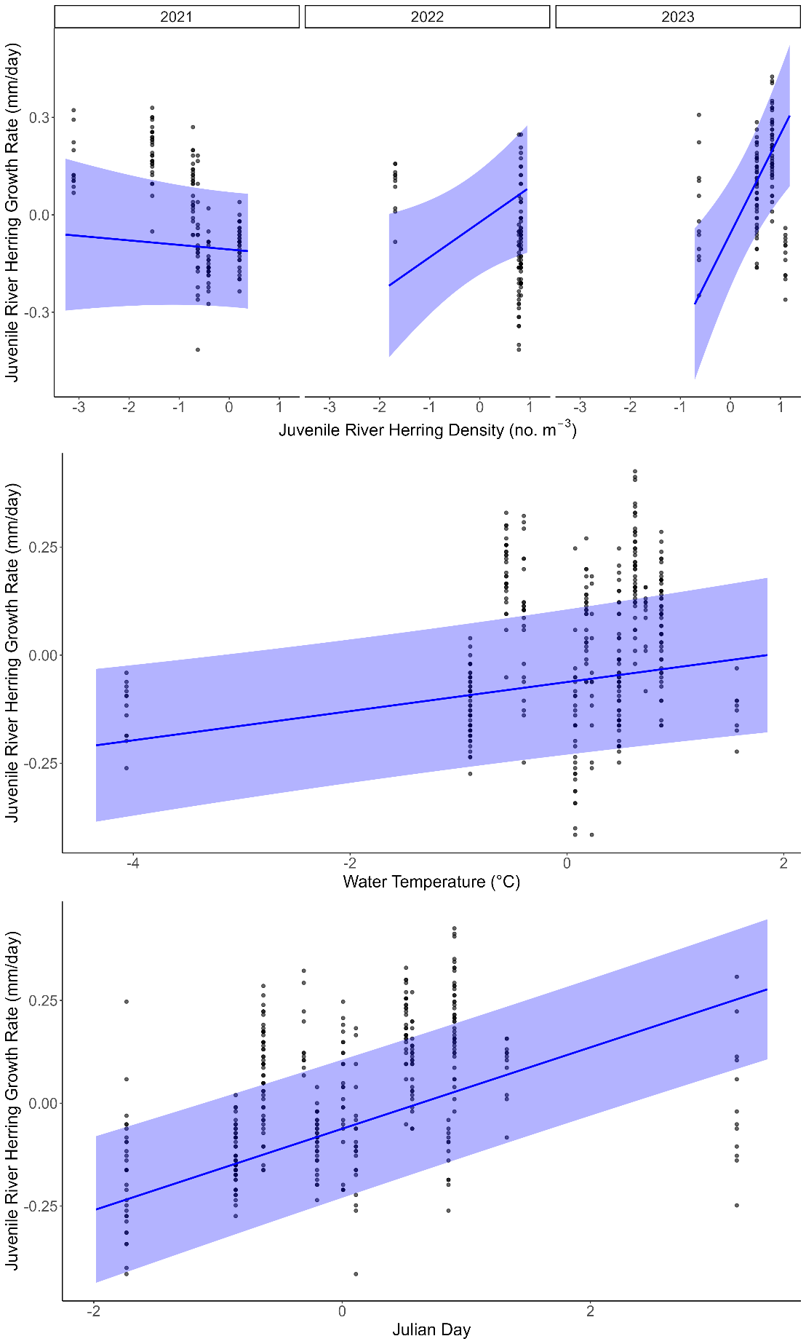
Figure S6: Regressions from the top-performing mixed-effects model predicting juvenile alewife (Alosa pseudoharengus) and blueback herring (A. aestivalis) growth (log transformed and scaled) in response to juvenile river herring density and water temperature and Julian day (log transformed and scaled) in three estuary sites. The blue line represents the fitted mixed-effects regression model, and shaded bands represent 95% confidence intervals.

