Supplementary Information
for
Assessing the status and drivers of phytoplankton blooms along the riverine to freshwater-tidal continuum in a modified delta
Nicholas Framsted (https://orcid.org/0000-0003-3741-2976), Crystal Sturgeon (https://orcid.org/0000-0002-1799-9127), Tamara Kraus (https://orcid.org/0000-0002-5187-8644), Keith Bouma-Gregson* (https://orcid.org/0000-0002-0304-6034)
Submitted to Estuaries and Coasts
  - April 22, 2026
U.S. Geological Survey, 6000 J Street, Placer Hall, Sacramento, CA 95819, USA
*Corresponding author; kbouma-gregson@usgs.gov; https://orcid.org/0000-0002-0304-6034

Any use of trade, firm, or product names is for descriptive purposes only and does not imply endorsement by the U.S. Government.

Text S1
All sondes were secured and deployed at approximately 1-meter depth within polyvinyl chloride pipe housings with several 2.25-inch-diameter holes drilled through the sides of the pipes to allow adequate water flow to the water quality sensors. Sondes were equipped with an integrated central wiping system to prevent biofouling from sediment or algae accumulation on sensors during approximately monthly deployment periods.
Sensors were calibrated prior to deployments. California Environmental Data Exchange Center (CDEC) data was not subjected to any QA/QC procedures and was only used when data from other sources was unavailable. Hydrodynamic data included continuous 15-minute river stage, flow, and water velocity collected with Teledyne RD Instruments 600 kHz Channel Master Acoustic Doppler Current Profilers (ADCPs; Teledyne RD Instruments, Poway, CA) and was measured at stations indicated in Table S1. The ADCP vertical beam is the primary sensor of water level data at each station, while an external pressure transducer is used to collect a secondary set of water level data. ADCPs were inspected every two months to ensure data quality.

Text S2
Discrete sample field collection
Discrete nutrient, chlorophyll a (chl-a), and phytoplankton enumeration samples were collected one meter below the surface of the water with a Van Dorn sampler (CDWR, 2024d). Cyanotoxin samples were surface water grab samples taken from approximately 30 cm deep with a bottle. All discrete samples were stored on ice during transport from the field to the lab and refrigerated at 4 °C. Within 48 hours of collection, cyanotoxin samples were shipped to Greenwater Laboratories (Palatka, Florida, USA), and all other samples were delivered on ice to the California Department of Water Resources (CDWR) Bryte Analytical Laboratory for analysis.
Nutrient analyses
Dissolved nutrient samples were preserved with sulfuric acid (H₂SO₄) to a pH ≤ 2. Ammonia concentrations were analyzed using the United States Environmental Protection Agency (US EPA) method 350.1, Rev 2.0, 199 (minimum detection level [MDL] of 0.01-0.05 mg L⁻¹; Bryte Chemical Laboratory 2024a; US EPA, 1993a), nitrate + nitrite using method SM 4500-NO3-F-2016 (MDL of 0.01-0.05 mg L⁻¹; Bryte Chemical Laboratory 2024b), orthophosphate using US EPA 365.1, Rev 2.0, 1993 (MDL of 0.01-0.05 mg L⁻¹; Bryte Chemical Laboratory 2024c; US EPA, 1993), total phosphorus using US EPA 365.4, 1974 (MDL of 0.01 mg L⁻¹; Bryte Chemical Laboratory 2024d; US EPA, 1983), and chl-a using US EPA 445.0 (MDL of 0.5 ug L⁻¹; Arar and Collins 1997).
Taste & odor and cyanotoxins
Taste and odor samples were analyzed for Geosmin (Geo) and 2-Methylisoborneol (MIB) using two different modified versions of Standard Method 6040 (APHA, 2011a). Samples were analyzed using a solid phase microextraction (SPME) and gas chromatography/mass spectrometry (GC/MS). Samples prior to 2023 were analyzed using an in-house method based on Standard Method 6040E (APHA, 2011a), and after 2023 using a modified Standard Method 6040D (APHA, 2011a).
Greenwater Laboratories screened samples microscopically for potentially toxigenic (PTOX) cyanobacteria (Chapman & Foss, 2019). For the purposes our Delta-specific analyses, PTOX taxa included the genera Microcystis, Aphanizomenon, and Dolichospermum. The PTOX screen consisted of the use of a Sedgewick Rafter cell at 100x magnification via an inverted microscope equipped with phase contrast optics. If PTOX cyanobacteria were present, enzyme linked immunosorbent assay (ELISA) was used to detect and quantify microcystins following EPA Method 546 (US EPA, 2016) and saxitoxins using Abraxis kits (Gold Standard Diagnostics, Horsham, PA; product no. 52255B) using manufacturer instructions (Gold Standard Diagnostics, 2025). Liquid chromatography – mass spectrometry/mass spectrometry (LC – MS/MS) was used to detect and quantify anatoxin-a and cylindrospermopsin following EPA Method 545 (US EPA, 2015).
Phytoplankton enumeration and identification
Phytoplankton enumeration samples were stored in 50 mL amber glass bottles with approximately 2 mL of Lugol’s solution to act as a stain and preservative. Phytoplankton samples were analyzed by BSA Environmental Services, Inc. (Beachwood, Ohio) and identified and enumerated microscopically to the lowest taxonomic level possible using the Utermöhl method and American Public Health Association (APHA) standard methods (APHA, 2011b; Utermöhl, 1958). Aliquots were enumerated at a magnification of 1200X using a Leica DMIL inverted microscope (Leica Microsystems, Wetzlar, Germany). Phytoplankton in randomly chosen transects were counted and taxa were enumerated as they appeared along the transects. A minimum of 400 total algal units were counted and a minimum of 100 algal units of the dominant taxon. Length measurements were performed on 10 algal units of the dominant taxon and up to 5 units of each minor taxon. Biovolume was then calculated for each measured cell.

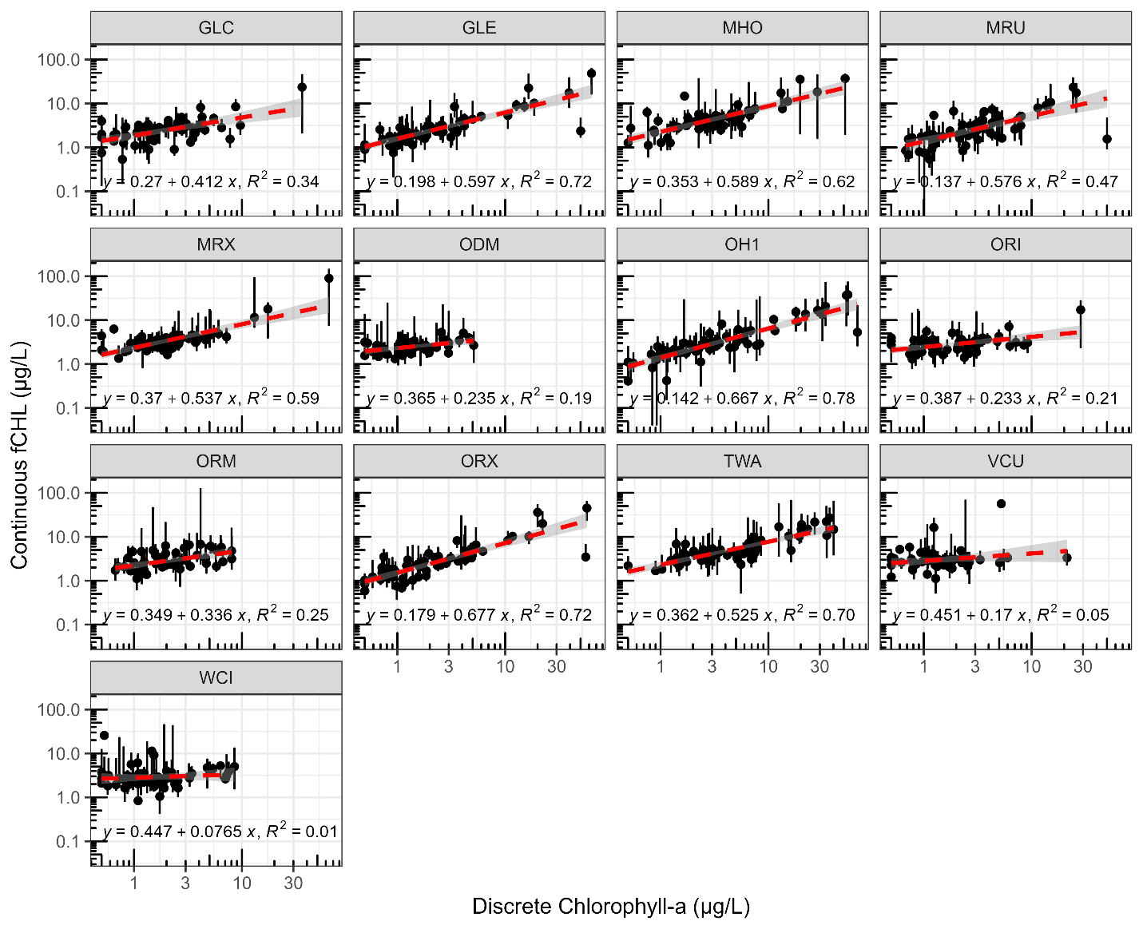
Fig. S1 Scatterplot of 2-hour averaged continuous chlorophyll fluorescence (fCHL) versus coincident discrete chlorophyll (chl-a) in micrograms chl-a per liter (µg/L) in the south Sacramento-San Joaquin Delta of California. Vertical lines through points show the standard deviations of fCHL during the 2-hour window. Regression lines are shown in red, and the associated regression equation and R-squared values are shown at the bottom of each plot. For station locations see Fig. 1, underlying data sources are summarized in Table S1

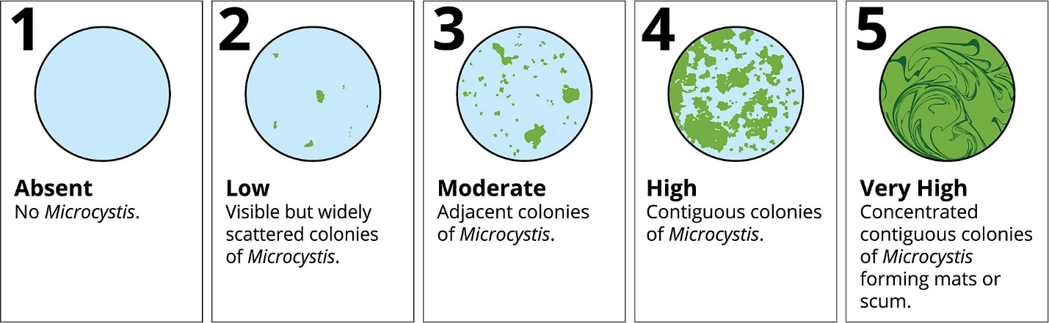
Fig. S2 Microcystis visual Index (MVI) ratings and associated Microcystis abundances. Figure from Flynn et al. 2022

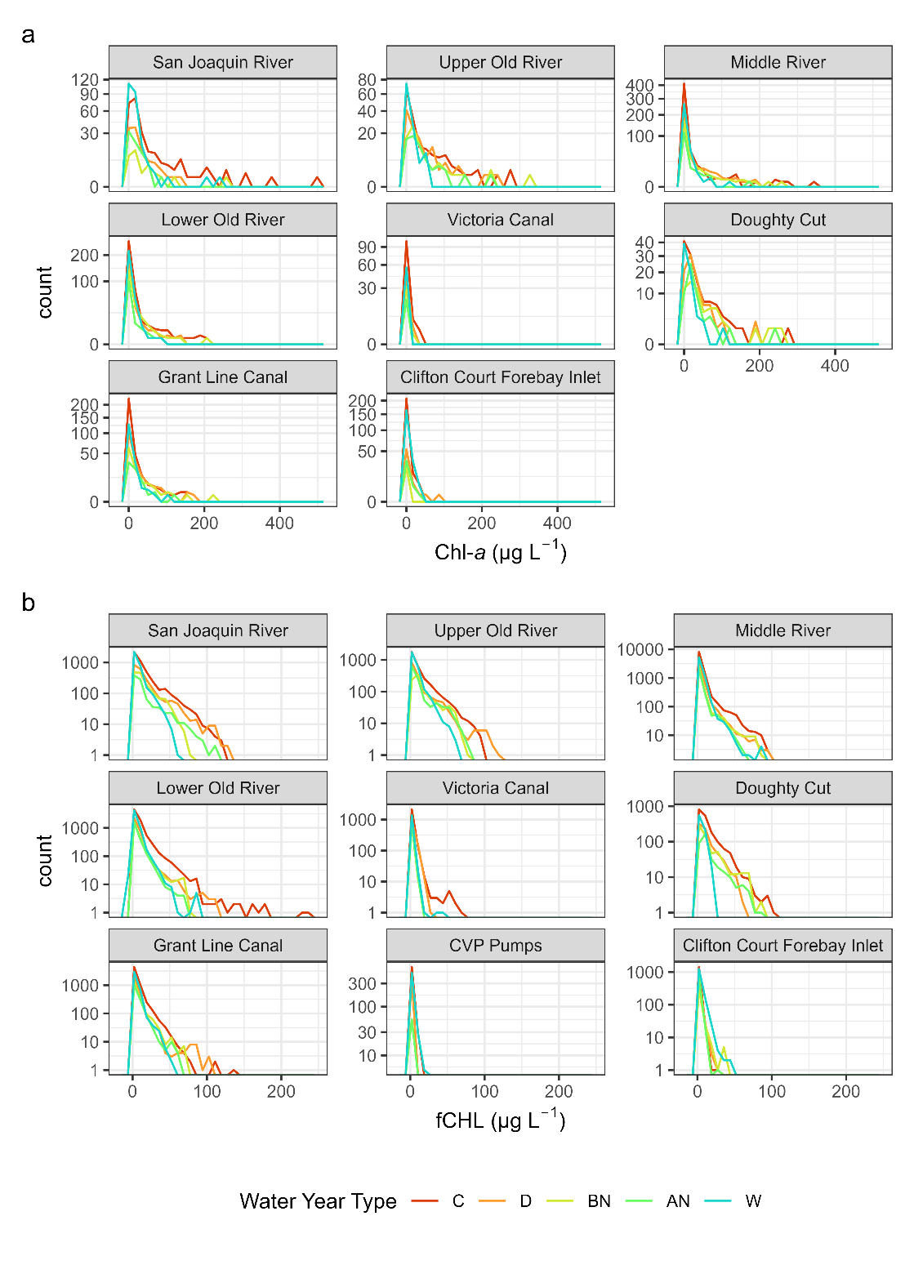
Fig. S3 Frequency plots of (a) discrete chlorophyll-a (chl-a) and (b) continuous chlorophyll-a (fCHL) concentrations in the south Sacramento-San Joaquin Delta of California with colors representing different San Joaquin Valley water year types. Water year types are characterized as follows: C = Critical, D = Dry, BN = Below Normal, AN = Above Normal, W = Wet. For station and region locations see Fig. 1, underlying data sources are summarized in Table S1
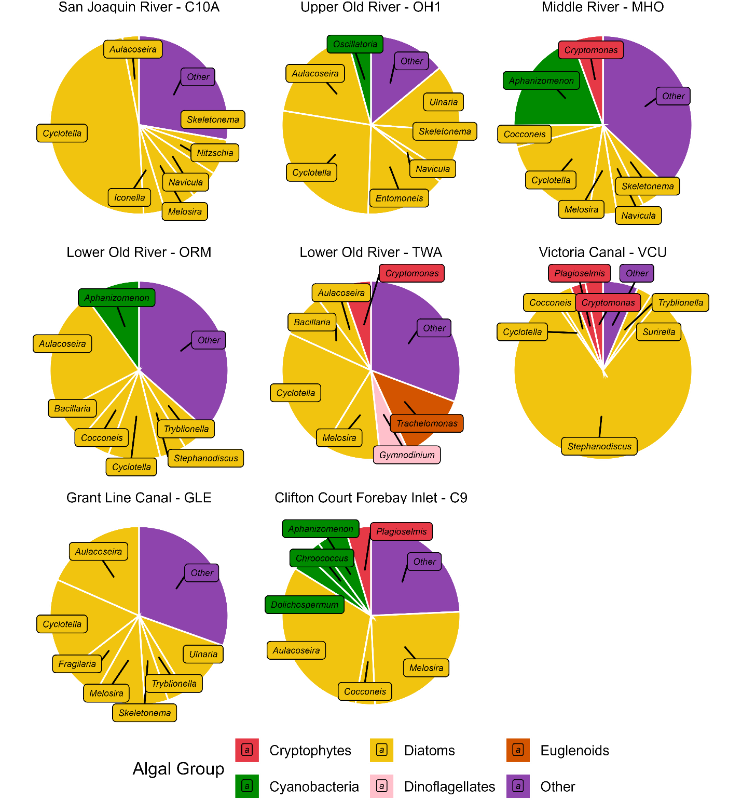
Fig. S4 Pie charts of phytoplankton relative biovolume (%) averaged across all samples collected at each site from 2019-2023 for the 7 most abundant genera at each station in the south Sacramento-San Joaquin Delta of California. Genera are color-coded by their respective algal group classification. The “Other” category combines all other taxa that were present at that station. For station and region locations see Fig. 1, underlying data sources are summarized in Table S1
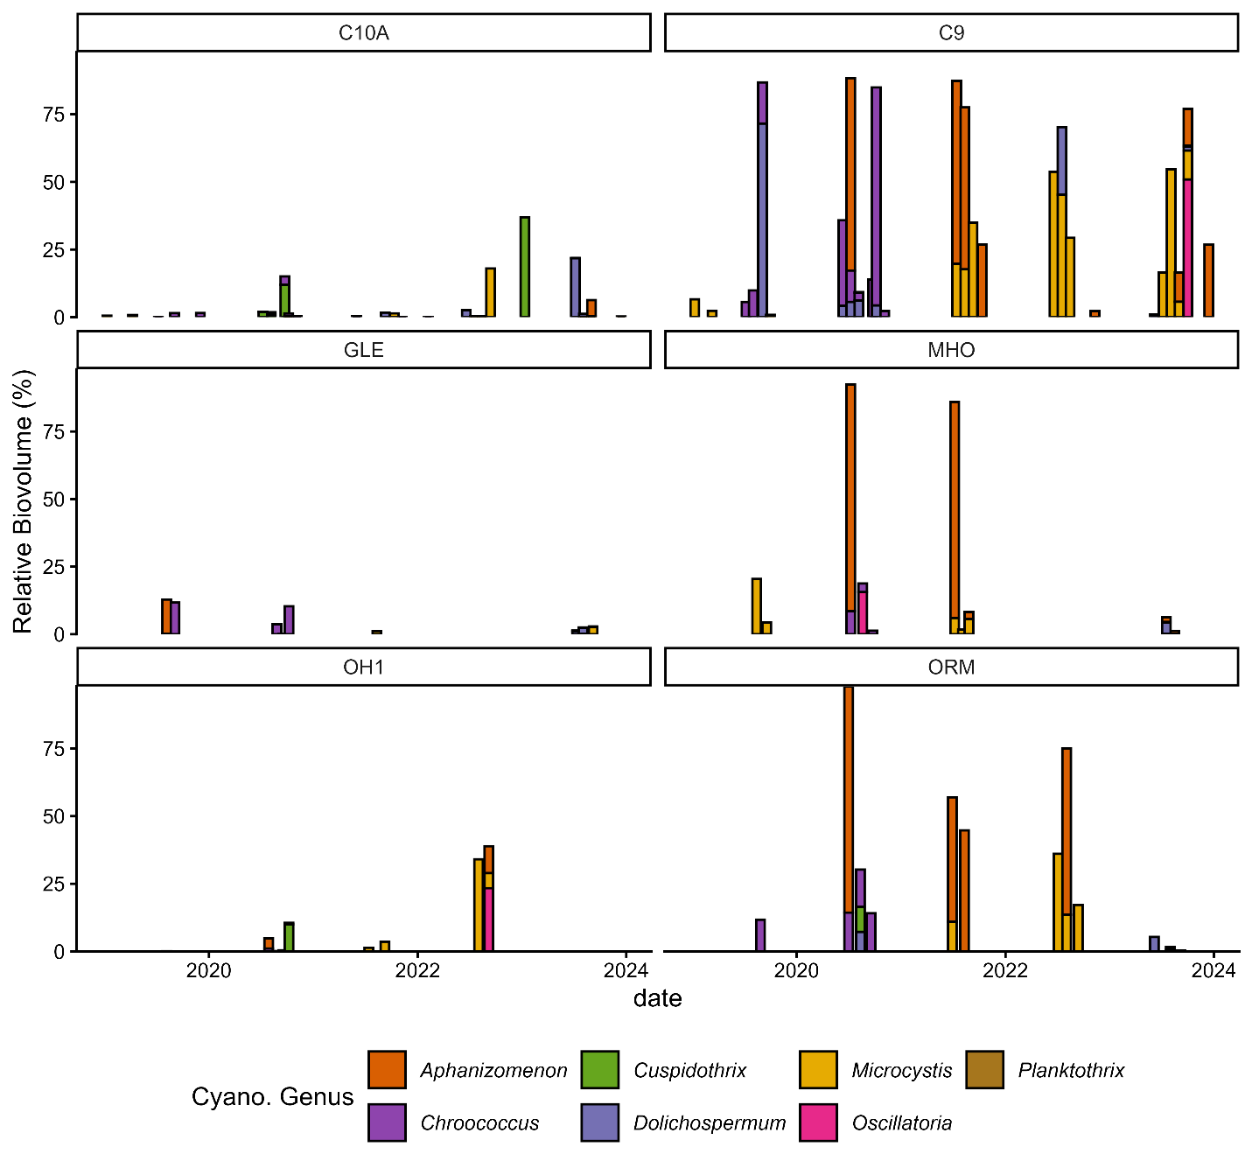
Fig. S5 Barplots of relative biovolume (%) of cyanobacterial genera in the phytoplankton identification and enumeration samples from the south Sacramento-San Joaquin Delta of California. Non-cyanobacteria taxa were not included, and therefore not all bars sum to 100%. For station and region locations see Fig. 1, underlying data sources are summarized in Table S1

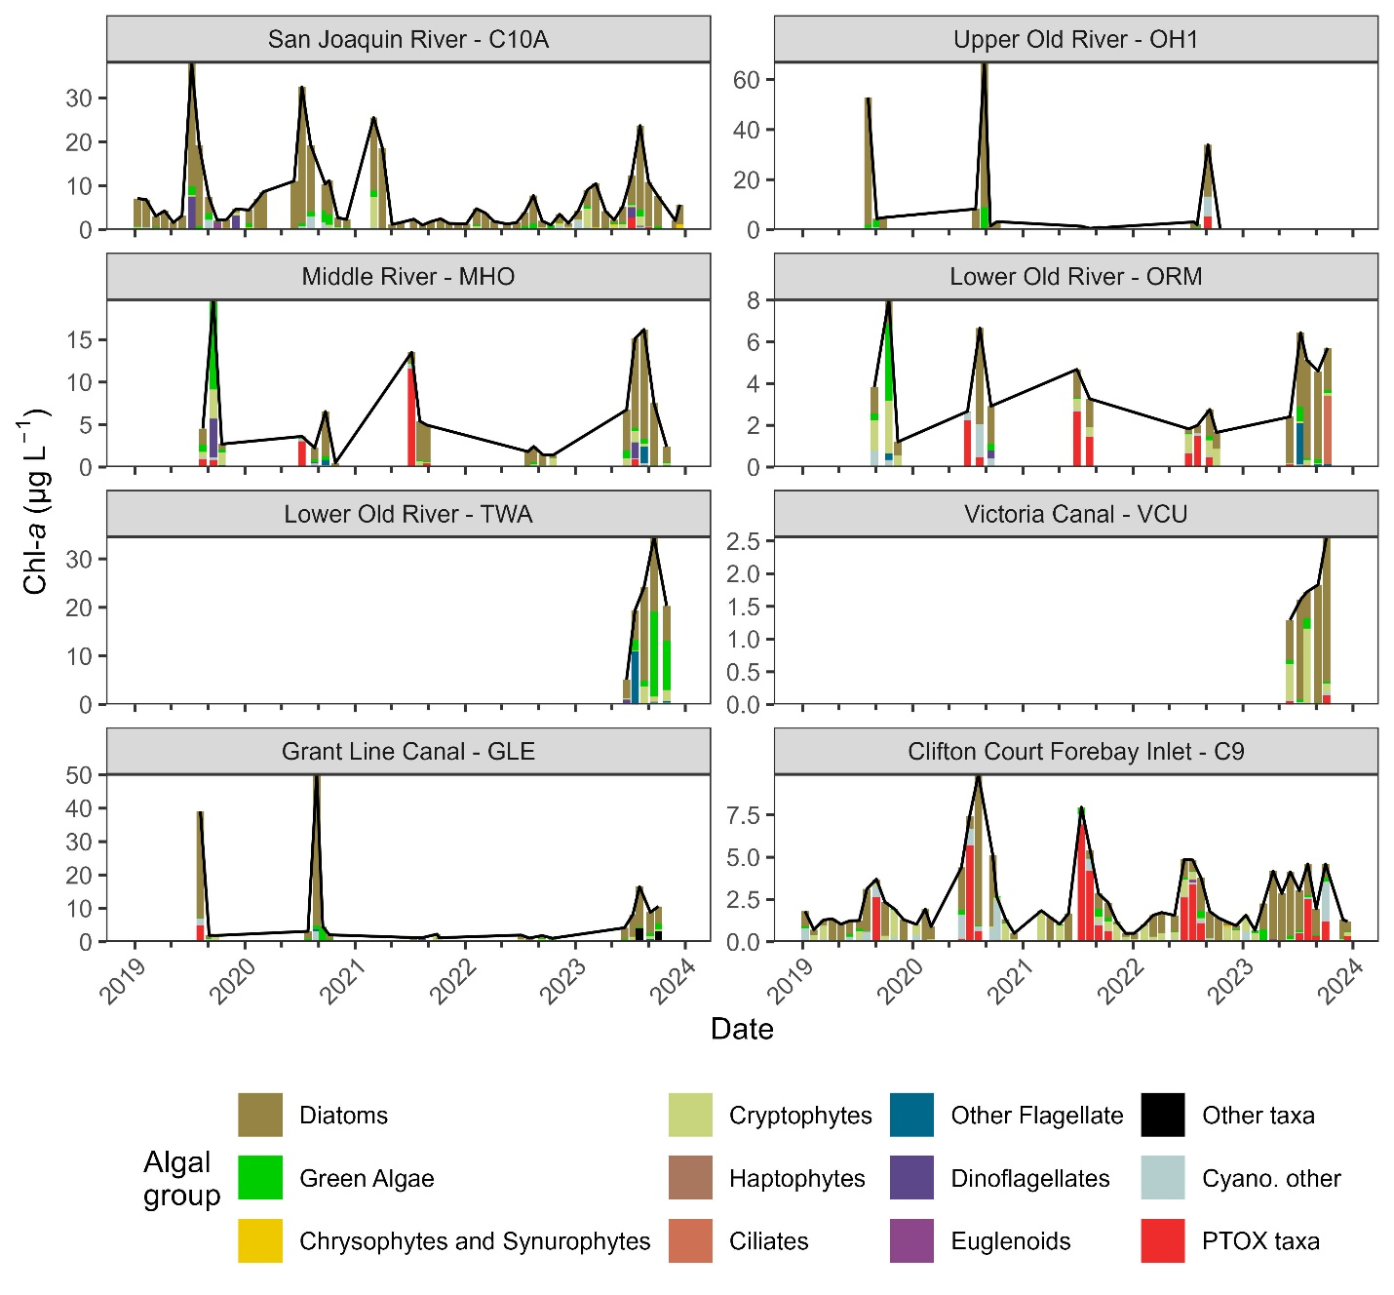
Fig. S6 Bar plot of phytoplankton relative biovolume scaled by discrete chlorophyll-a (chl-a)concentrations at stations in the south Sacramento-San Joaquin Delta of California with the black line denoting discrete chl-a concentrations collected concurrently from 2019-2023. Tick marks on the x-axis scale depict 4-month intervals and denote January, May, and September of each year. The relative biovolume of potentially toxigenic (PTOX) taxa is shown in red, while non-toxigenic taxa (Cyano. other) are shown in light cyan. The algal group PTOX taxa include the genera: Microcystis, Aphanizomenon, and Dolichospermum. The chl-a attributed to each algal group was calculated by multiplying the relative biovolume by the discrete chl-a concentration. This calculation assumes that the chl-a content per unit biovolume is constant across all taxa, which is an oversimplification made for data visualization purposes. For station and region locations see Fig. 1, underlying data sources are summarized in Table S1
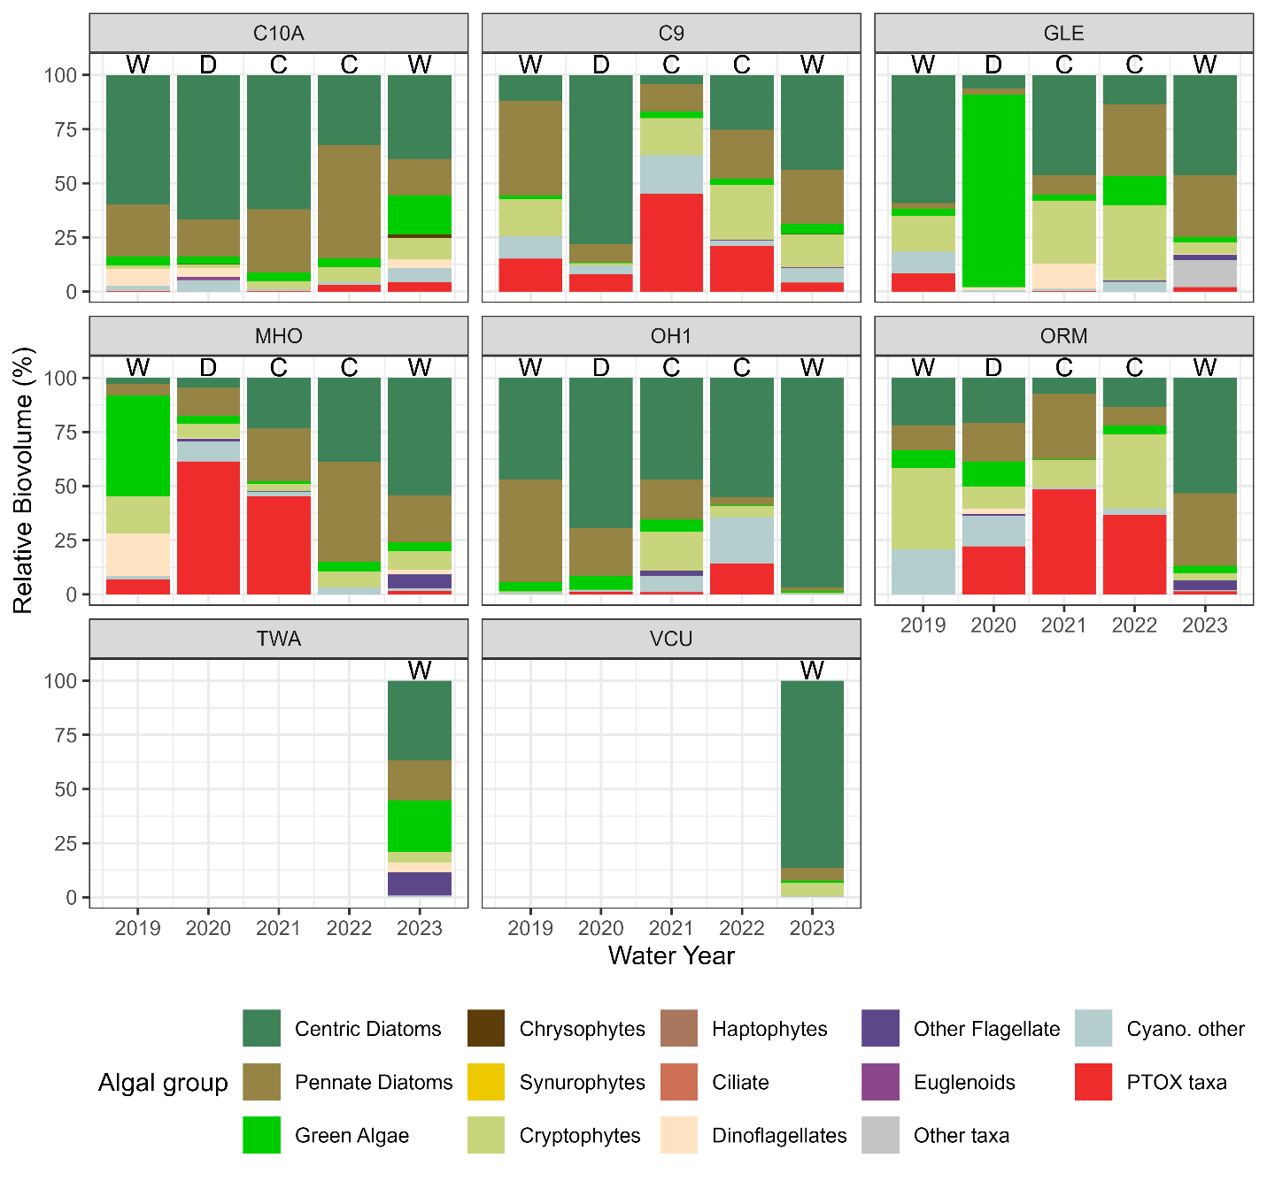
Fig. S7 Relative biovolume for each algal group by water year and station from phytoplankton enumeration data taken between 2019-2023 from the south Sacramento-San Joaquin Delta of California. The relative biovolume of potentially toxigenic (PTOX) taxa is shown in red, while non-toxigenic taxa (Cyano. other) are shown in light cyan. The algal group PTOX taxa include the genera: Microcystis, Aphanizomenon, and Dolichospermum. Water year types are denoted on the figure and are characterized as follows: C = Critical, D = Dry, W = Wet. There were not Below Normal or Above Normal water years between 2019 and 2023, thus they were omitted from the plot. For station and region locations see Fig. 1, underlying data sources are summarized in Table S1

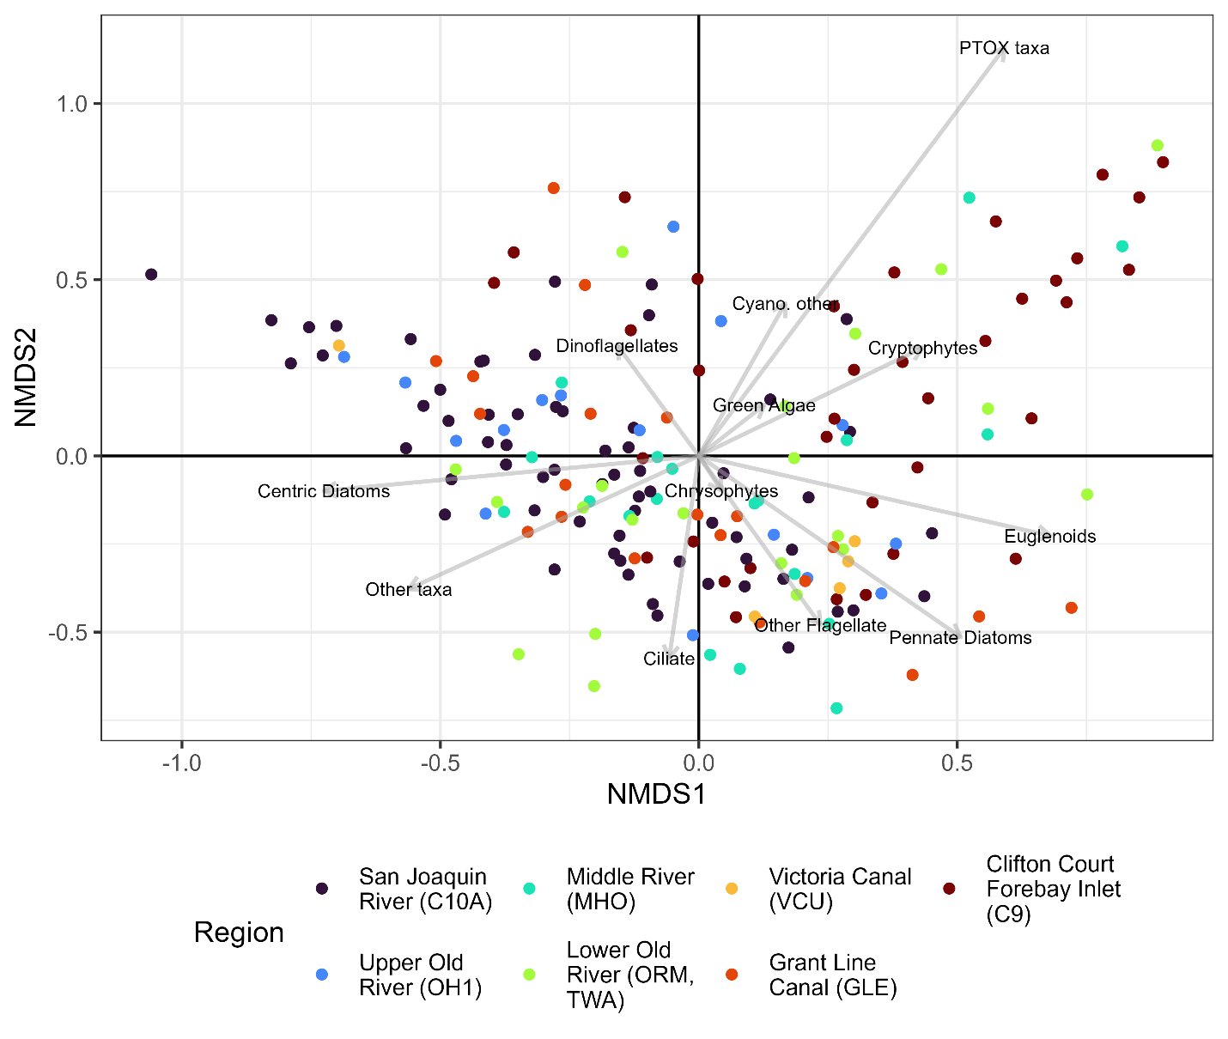
Fig. S8 Non-metric multidimensional scaling (NMDS) biplot of June-October phytoplankton relative biovolume data between 2011-2023 (n = 181) in the south Sacramento-San Joaquin Delta of California. Points are colored by region with the stations included shown in parenthesis. For station and region locations see Fig. 1, underlying data sources are summarized in Table S1

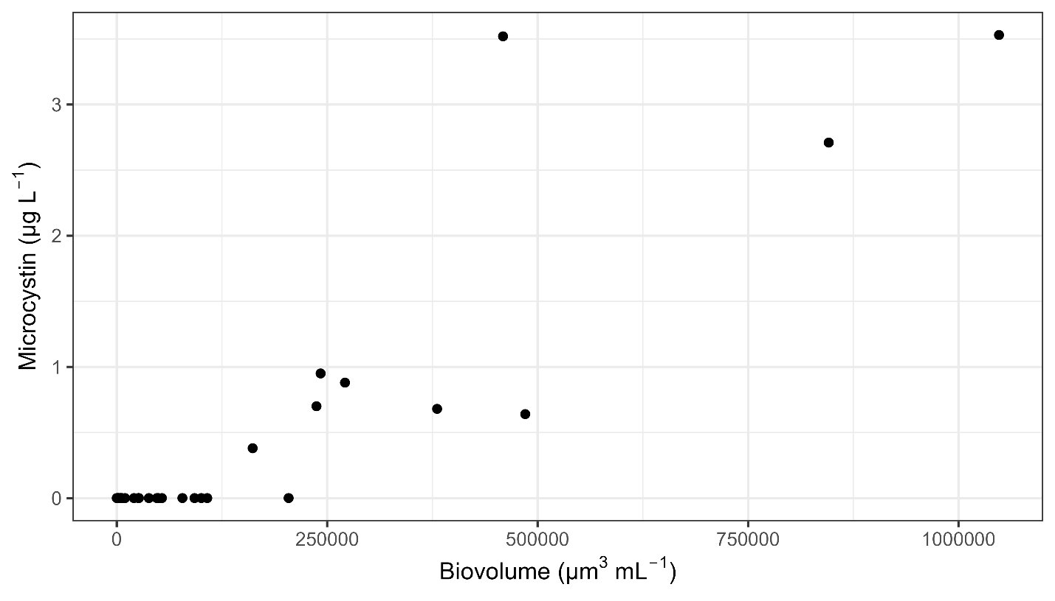
Fig. S9 Scatterplot of microcystin concentrations versus Microcystis biovolume in samples from the south Sacramento-San Joaquin Delta of California. Underlying data sources are summarized in Table S1

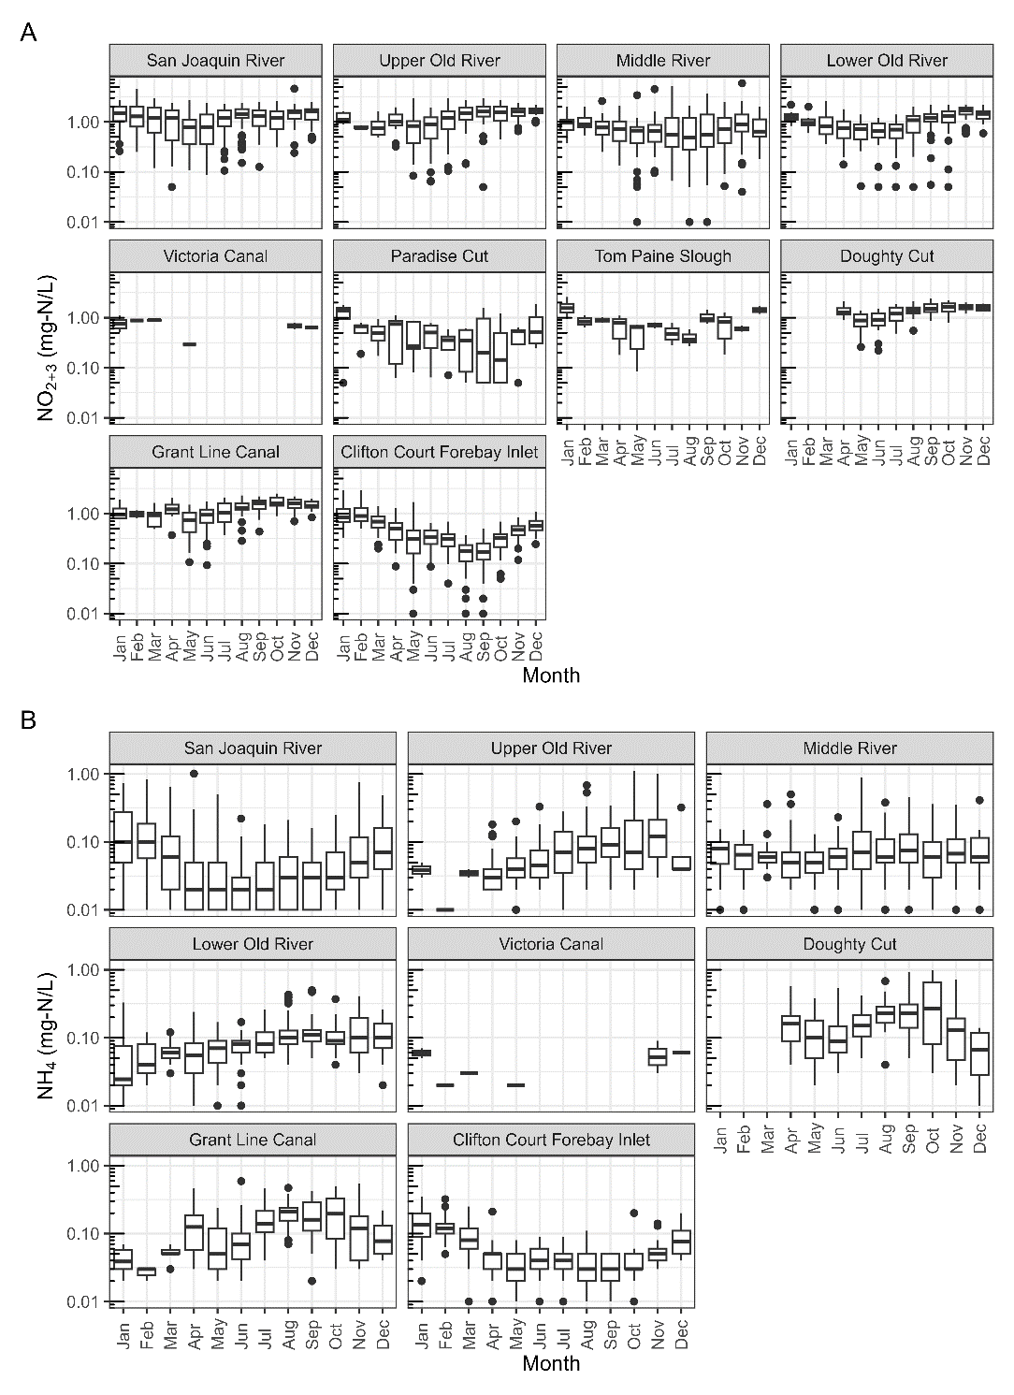
Fig. S10 Monthly boxplots of A) nitrate + nitrite (NO₂ ₊ ₃) and B) ammonium concentrations in (NH₄) mg-N L⁻¹. Boxplots depict the minimum, first quartile, median, third quartile, and maximum, with outliers depicted as single points. These data were collected between 2000-2023 with a gap from 2011-2017 from the south Sacramento-San Joaquin Delta of California. Nutrient concentrations below the reporting limit were displayed as the reporting limit value. For station and region locations see Fig. 1, underlying data sources are summarized in Table S1

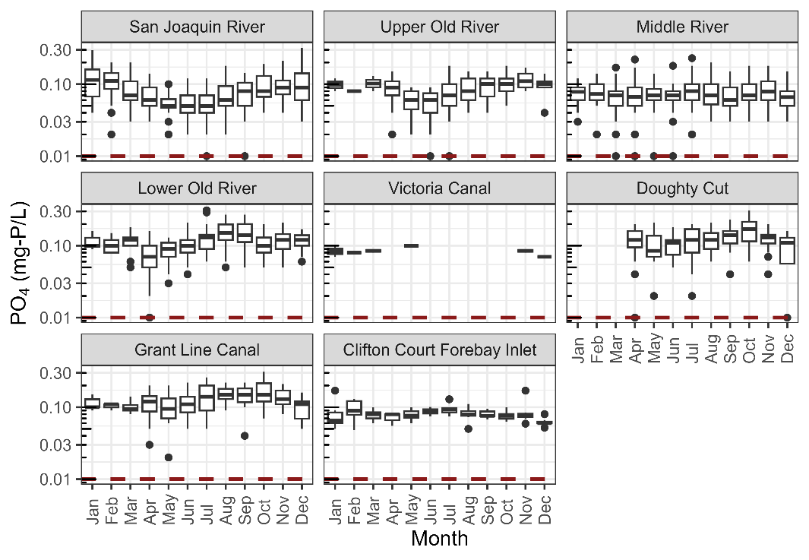
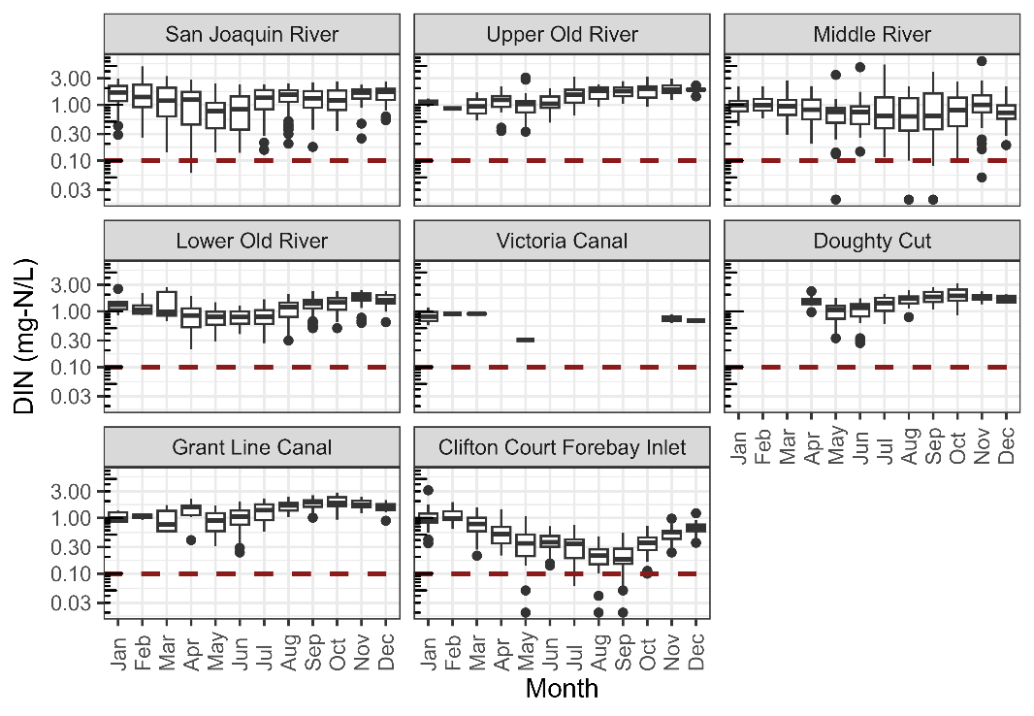
Fig. S11 Boxplots of a) dissolved phosphate (PO₄) concentrations in mg-P L⁻¹and b) dissolved inorganic nitrogen (DIN) concentrations in mg-N L⁻¹ for each month in the south Sacramento-San Joaquin Delta of California facetted by region. Boxplots depict the minimum, first quartile, median, third quartile, and maximum, with outliers depicted as single points. Nutrient data were collected between 2000-2023 with a gap from 2011-2017. The red dashed line indicates the concentration at which the respective nutrient potentially becomes limiting—0.1 mg-N L⁻¹ and 0.01 mg-P L⁻¹ for DIN and PO4, respectively (Chorus & Spijkerman, 2021). Nutrient concentrations below the reporting limit were displayed as the reporting limit value. For station and region locations see Fig. 1, underlying data sources are summarized in Table S1

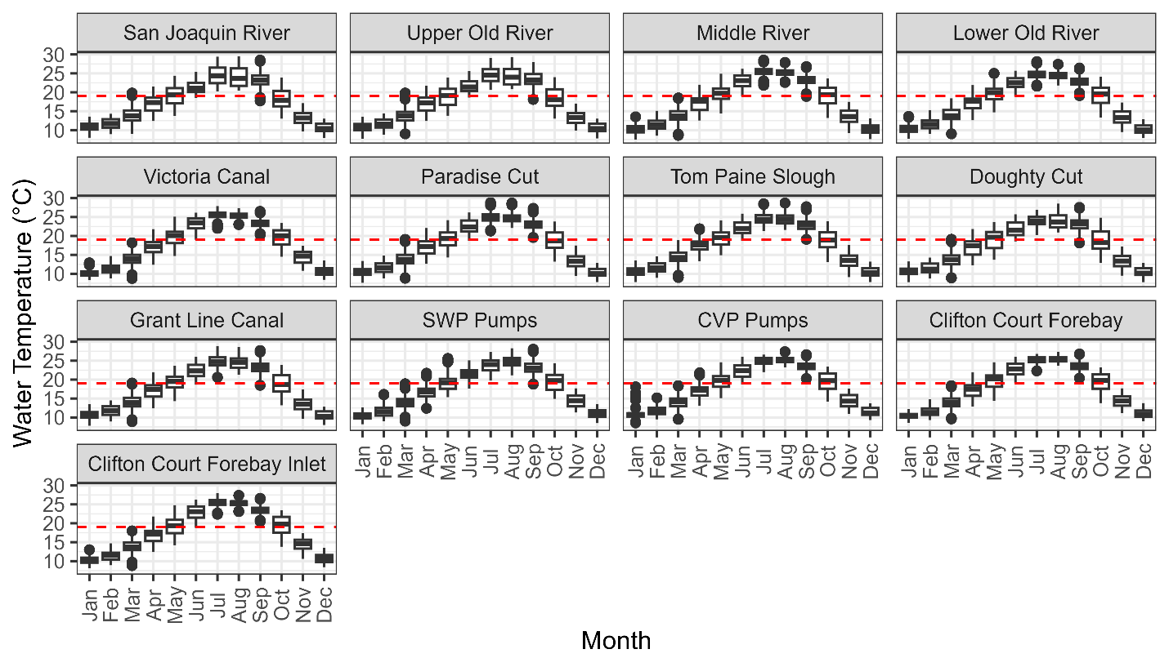
Fig. S12 Boxplots of daily median-filtered continuous water temperature collected between 2019-2023 from different regions of the south Sacramento-San Joaquin Delta (Delta) of California. Boxplots depict the minimum, first quartile, median, third quartile, and maximum, with outliers depicted as single points. Dotted red lines indicate the 19 ⁰C threshold associated with higher Microcystis biomass in the Delta (Lehman et al., 2013). For station and region locations see Fig. 1, underlying data sources are summarized in Table S1

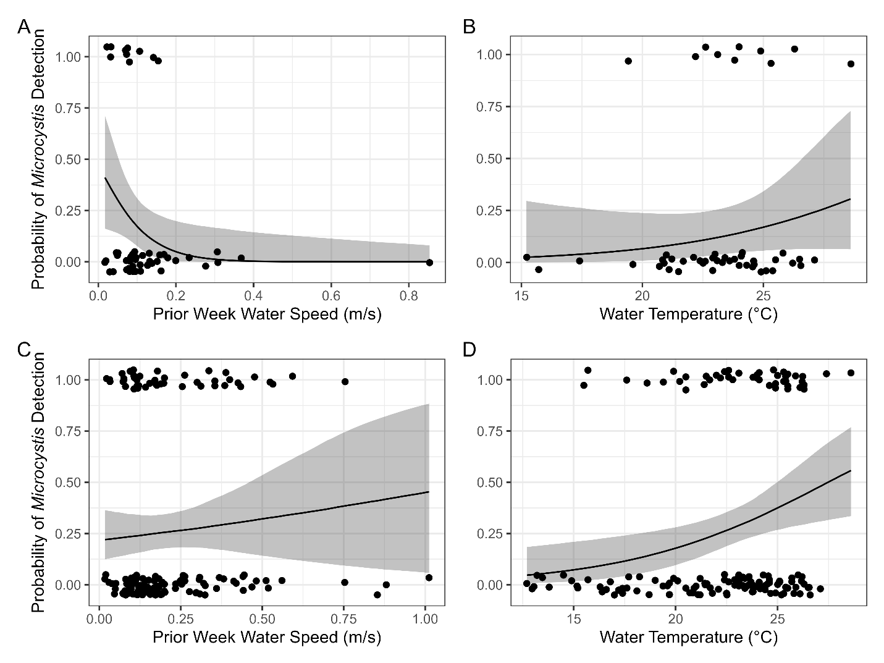
Fig. S13 Conditional effects plots from Bayesian binomial models of A & B) data from the south Sacramento-San Joaquin Delta of California excluding stations C9 and C10A, and C & D) data including stations C9 and C10A. Black lines represent the predicted probability of detecting Microcystis cells in phytoplankton enumeration samples across the range of prior week water speeds and water temperatures with the 95% credible interval shown in grey. Points represent actual data values with y values of 0 indicating absence of Microcystis and values of 1 indicating presence of Microcystis, and they are jittered to avoid concealing points due to the high density of data. For station and region locations see Fig. 1, underlying data sources are summarized in Table S1

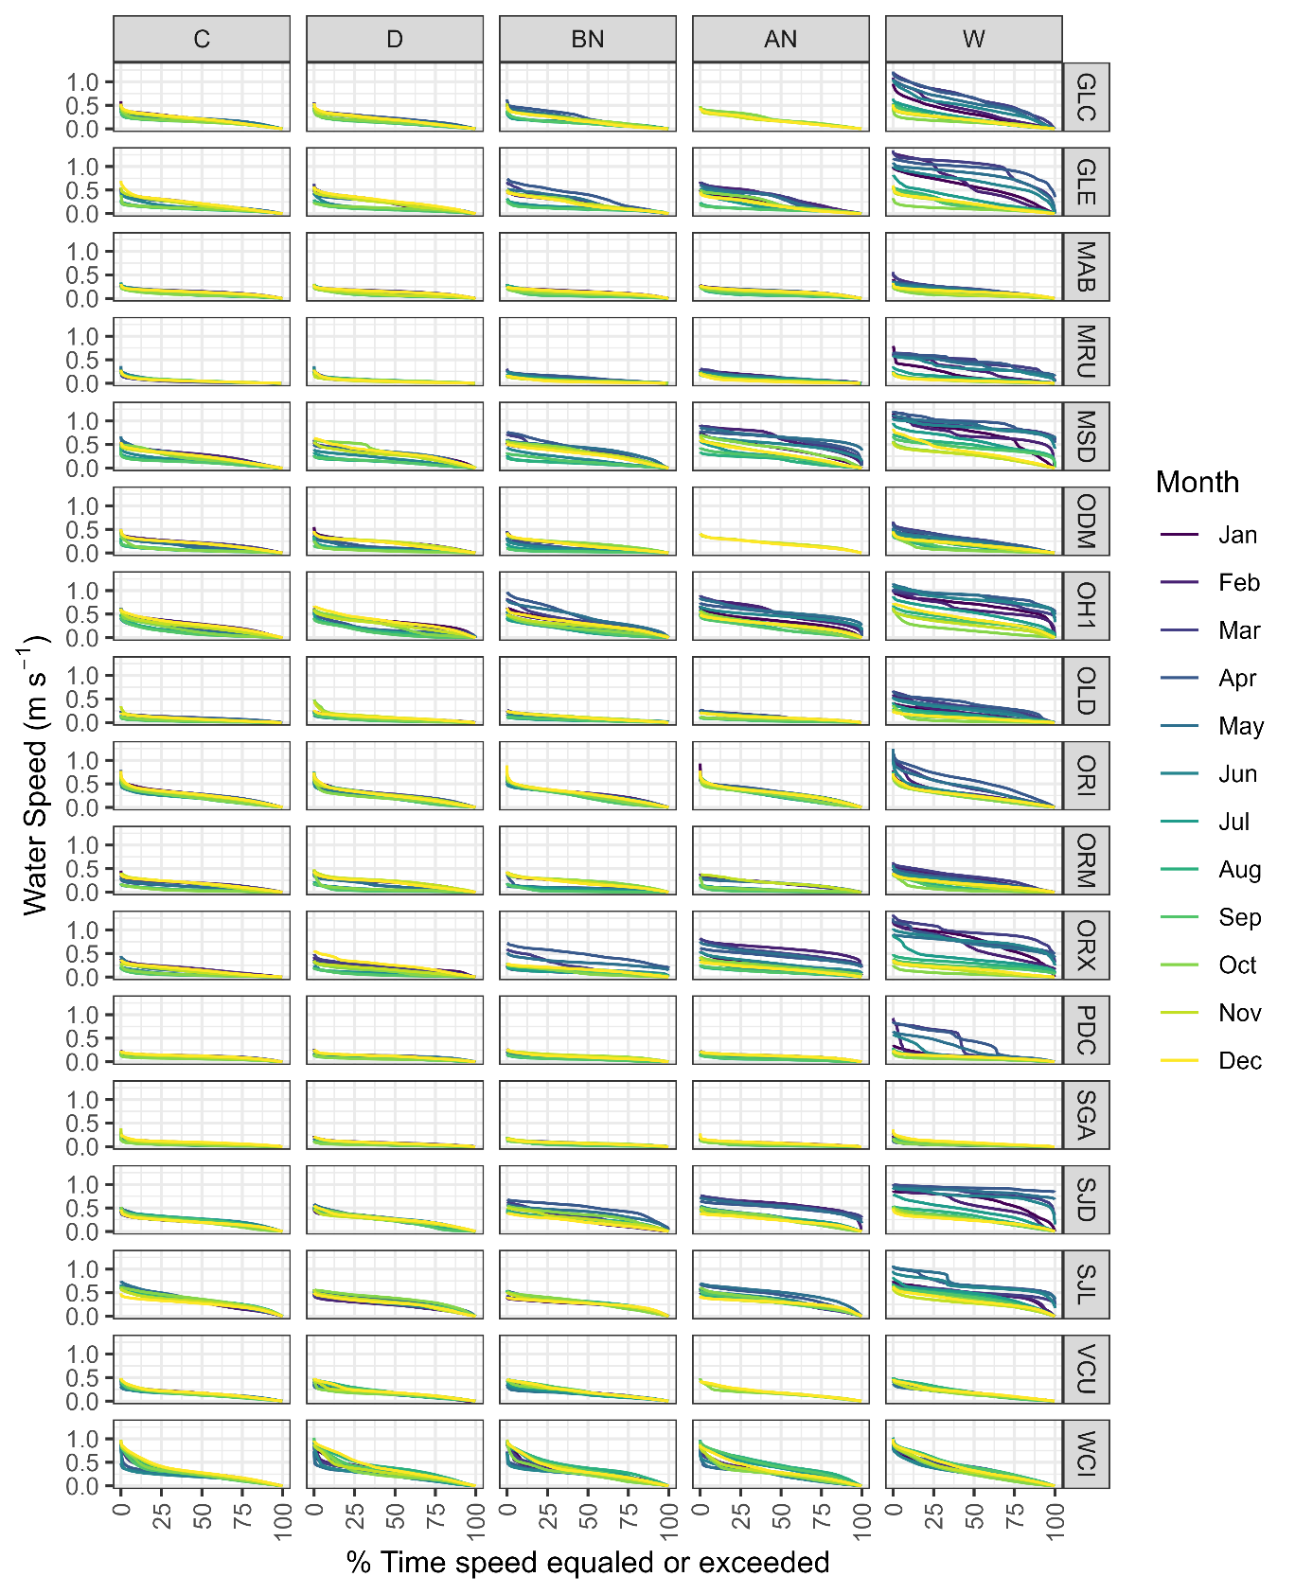
Fig. S14 Lineplots of water speed exceedance curves for each hydrology station of the south Sacramento-San Joaquin Delta of California and each San Joaquin Valley water year type. Water year types were characterized as follows: C = Critical, D = Dry, BN = Below Normal, AN = Above Normal, W = Wet. Water speed is plotted against the percent of time that each water speed value was equaled or exceeded. Colors indicate different months. For station and region locations see Fig. 1, underlying data sources are summarized in Table S1
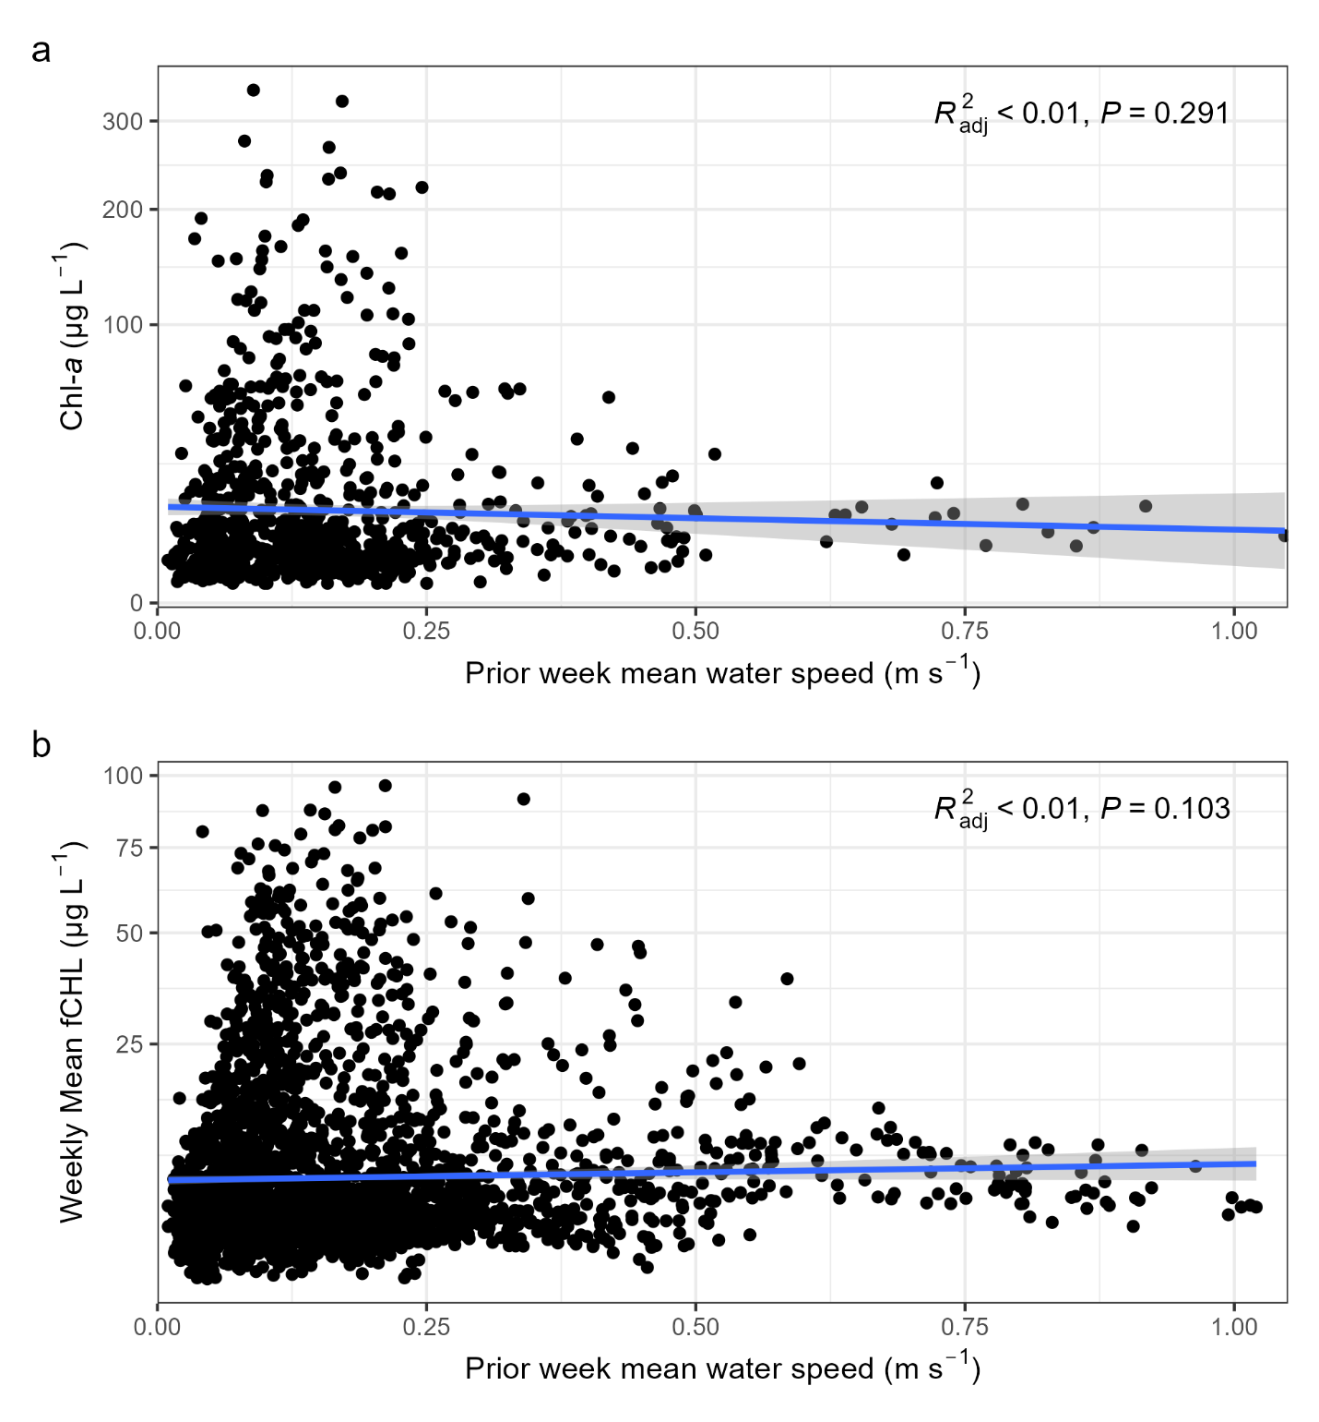
Fig. S15 a) Discrete chlorophyll-a (chl-a) from June-November versus prior week mean water speed for different regions of the south Sacramento-San Joaquin Delta (Delta) of California. Prior week mean water speed was calculated as the mean of the absolute value of the channel velocity of the chl-a sample date and preceding 7 days (a moving 8-day average ending on each MVI sampling date). b) Weekly averaged continuous chlorophyll-a fluorescence (fCHL) from June-November versus prior week mean water speed for different regions of the south Delta. Y-axes on both panels are on the square-root scale. Underlying data sources are summarized in Table S1

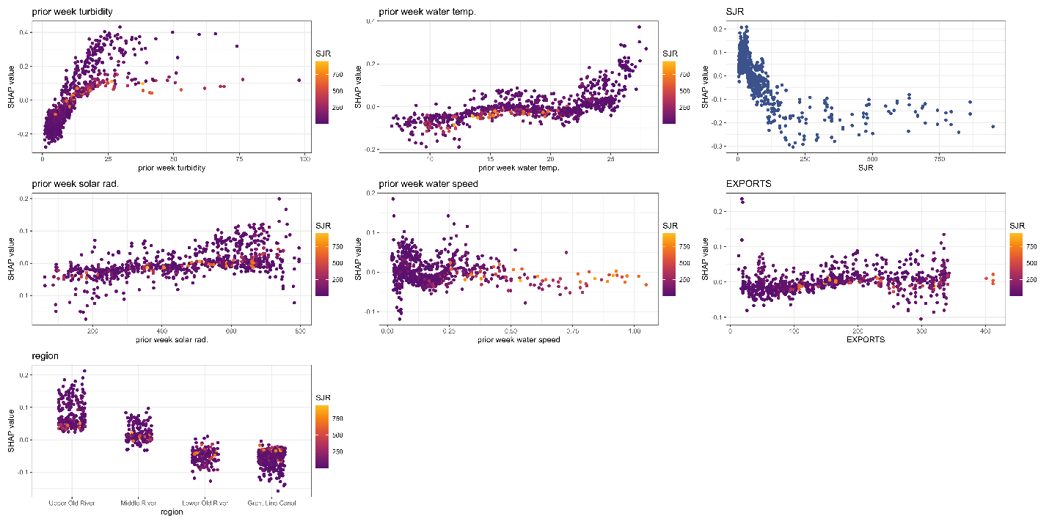
Fig. S16 Partial dependence plots of SHapley Additive exPlanations (SHAP) values from random forest model of chlorophyll a (chl-a) exceedances of the bloom threshold (16 micrograms per liter) in the south Sacramento-San Joaquin Delta of California. SHAP are shown for each environmental variable with points colored by SJR flows (m³ s⁻¹). For region locations see Fig. 1, underlying data sources are summarized in Table S1

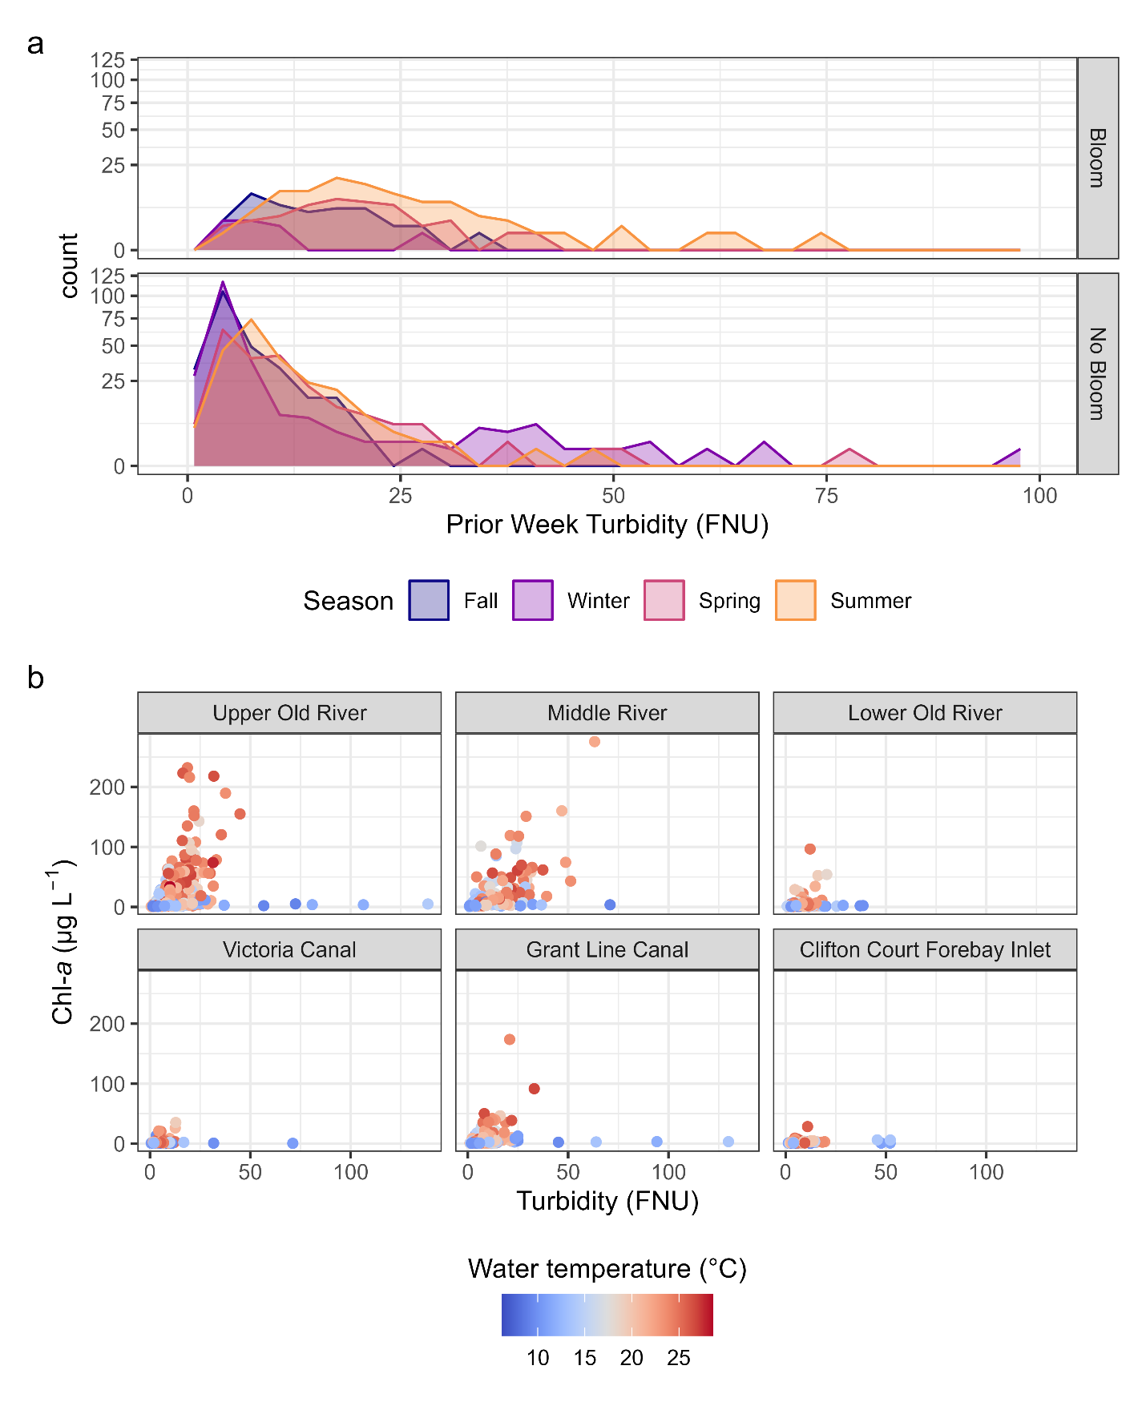
Fig. S17 a) Frequency polygon plots of prior week turbidity with colors indicating seasons for both bloom (discrete chl-a > 16 µg L⁻¹) and non-bloom conditions. b) scatterplots of discrete chl-a and turbidity colored by water temperature for different regions of the south Sacramento-San Joaquin Delta of California. For region locations see Fig. 1, underlying data sources are summarized in Table S1
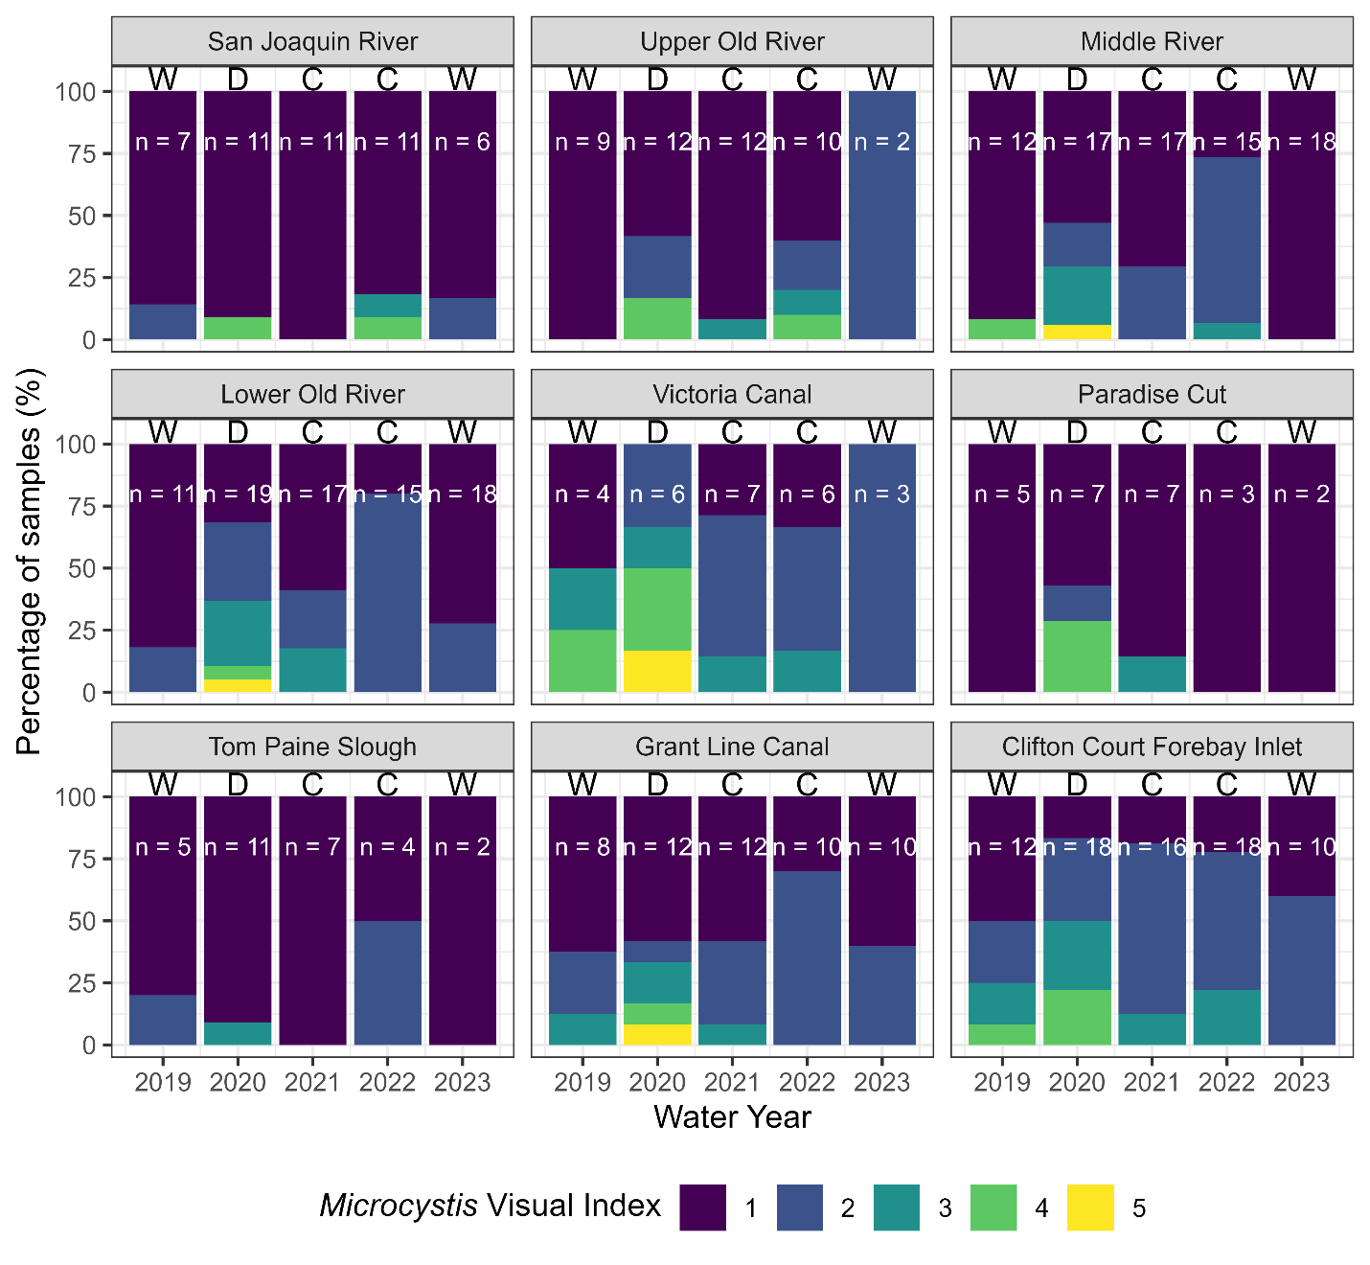
Fig. S18 Percent of samples at each Microcystis Visual Index (MVI) score for summer and fall samples by water year and region in the south Sacramento-San Joaquin Delta of California. Only MVI data from 2019-2023 is shown, and sample counts are given in each column. Nearly all spring and winter samples had ratings of 1 and thus were omitted from the plot. Water year types are denoted above each bar and are characterized as follows: C = Critical, D = Dry, W = Wet. There were not Above Normal or Below Normal water years in the years shown, thus it was omitted from the plot. For station and region locations see Fig. 1, underlying data sources are summarized in Table S1

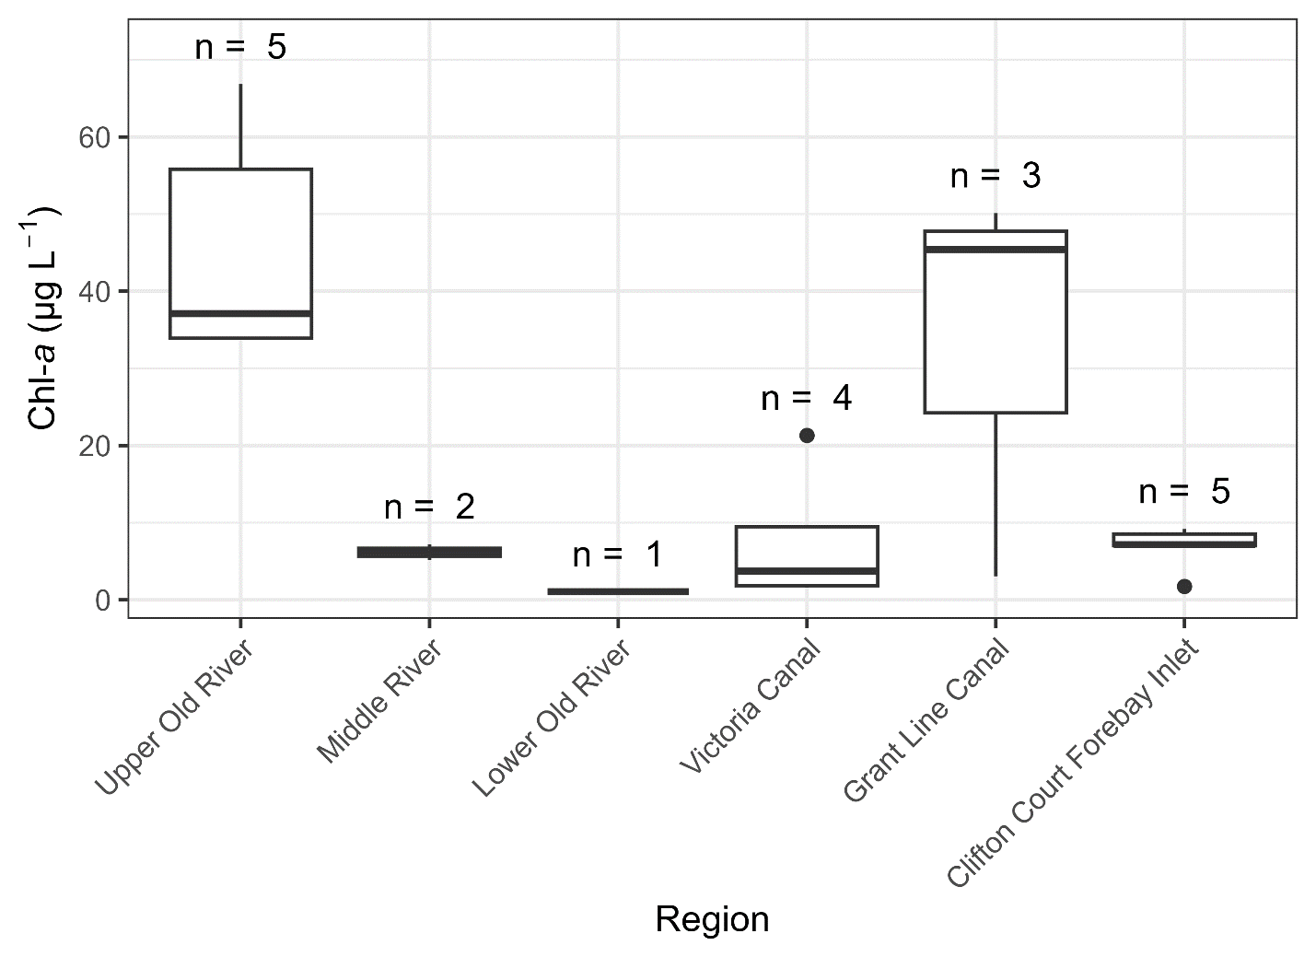
Fig. S19 Boxplot of discrete chl-a concentrations associated with Microcystis Visual Index scores of 4-5 in different regions of the south Sacramento-San Joaquin Delta of California. Boxplots depict the minimum, first quartile, median, third quartile, and maximum, with outliers depicted as single points. Sample sizes are indicated for each region. For station and region locations see Fig. 1, underlying data sources are summarized in Table S1

Table S1 Summary table of monitoring stations and parameters used in analyses of phytoplankton in the south Sacramento-San Joaquin Delta of California along with their associated period of record (POR). Entity abbreviations are as follows: Environmental Monitoring Program (EMP), Department of Water Resources (DWR) North Central Regional Office (NCRO), DWR Division of Integrated Science and Engineering (DISE), DWR Operations and Maintenance (O&M), United States Bureau of Reclamation (USBR), and United States Geological Survey (USGS). For station and region locations see Fig. 1

Station | Data type | Entity | Source | Station ID | Parameters | Frequency | POR
San Joaquin River
C10ª | discrete | EMP | Battey & Perry, 2024 | B9D74051159 | phosphate | 1 month | 1975 - 2005
C10ª | discrete | EMP | Battey & Perry, 2024 | B9D74051159 | chlorophyll a, nitrate + nitrite, specific conductance | 2 week | 1975 - 2005
C10ª | discrete | EMP | Battey & Perry, 2024 | B9D74051159 | ammonium | 1 month | 1979 - 2005
C10A | discrete | EMP | Battey & Perry, 2024 | B9D74081159 | ammonium, chlorophyll a, nitrate + nitrite, phosphate, specific conductance | 1 month | 2005 - 2023
C10A | discrete | EMP | Perry et al., 2024 | B9D74081159 | phytoplankton enumeration | 1 month | 2008 - 2023
C10A | discrete | EMP | Battey & Perry, 2024 | B9D74081159 | Microcystis Visual Index | 1 month | 2015 - 2023
MSD | continuous | EMP | CDWR, 2024b; Nelson & Tran, 2025 | B95820Q | fluorescent chlorophyll-a, specific conductance | 15 minute | 2007 - 2023
MSD | continuous | EMP | CDWR, 2024c; Nelson & Tran, 2025 | B95820Q | water temperature | 15 minute | 2007 - 2023
MSD | continuous | EMP | Nelson & Tran, 2025 | B95820Q | turbidity | 15 minute | 2007 - 2023
MSD | continuous | NCRO | CDWR, 2024c | B95820Q | water velocity | 15 minute | 2005 - 2024
MSD | continuous | NCRO | CDWR, 2024c; Nelson & Tran, 2025 | B95820Q | water temperature | 15 minute | 2005 - 2024
SJD | continuous | NCRO | CDWR, 2024b, 2024c | B9576000 | specific conductance | 15 minute | 2013 - 2024
SJD | continuous | NCRO | CDWR, 2024c | B95760 | water velocity, water temperature | 15 minute | 2013 - 2024
SJD | discrete | NCRO | Frantzich & Rosenow, 2025 | B9576000 | Microcystis Visual Index | 1 month | 2017 - 2022
SJL | continuous | NCRO | CDWR, 2024c | B95765Q | water velocity, water temperature | 15 minute | 2002 - 2013
SJR | continuous | DWR DISE | CDWR, 2024b | NA | nitrate + nitrite | 2 hour | 2012 - 2023
SJR | continuous | EMP | CDWR, 2024b; Nelson & Tran, 2025 | NA | fluorescent chlorophyll-a, specific conductance, water temperature | 15 minute | 2005 - 2023
SJR | continuous | EMP | Nelson & Tran, 2025 | NA | turbidity | 15 minute | 2005 - 2023
Upper Old River
OH1 | continuous | NCRO | CDWR, 2024b, 2024c | B9540000 | specific conductance, turbidity | 15 minute | 2001 - 2024
OH1 | continuous | NCRO | CDWR, 2024c | B9540000 | water temperature | 15 minute | 2001 - 2024
OH1 | continuous | NCRO | CDWR, 2024b, 2024c | B9540000 | fluorescent chlorophyll-a | 15 minute | 2005 - 2024
OH1 | continuous | NCRO | CDWR, 2024c | B95400Q | water velocity | 15 minute | 2005 - 2024
OH1 | discrete | NCRO | CDWR, 2024c | B9D74851200 | ammonium, phosphate | 2 week | 1999 - 2018
OH1 | discrete | NCRO | CDWR, 2024c | B9D74851200 | nitrate + nitrite | 2 week | 1999 - 2023
OH1 | discrete | NCRO | CDWR, 2024c | B9D74851200 | chlorophyll a | 2 week | 1999 - 2024
OH1 | discrete | NCRO | Frantzich & Rosenow, 2025 | B9D74851200 | Microcystis Visual Index | 1 month | 2017 - 2022
OH1 | discrete | NCRO | CDWR, 2024c | B9D74851200 | specific conductance | 1 month | 2018 - 2023
OH1 | discrete | NCRO | Frantzich & Rosenow, 2025 | B9D74851200 | phytoplankton enumeration | 1 month | 2019 - 2022
OH1 | discrete | NCRO | Frantzich & Rosenow, 2025 | B9D74851200 | cyanotoxins | 1 month | 2022 - 2022
ORX | continuous | NCRO | CDWR, 2024c | B95390 | specific conductance, water velocity, water temperature | 15 minute | 2013 - 2024
ORX | continuous | NCRO | CDWR, 2024c | B9539000 | fluorescent chlorophyll-a, turbidity | 15 minute | 2018 - 2024
ORX | discrete | NCRO | CDWR, 2024c | B9D74871232 | specific conductance | 1 month | 2014 - 2023
ORX | discrete | NCRO | Frantzich & Rosenow, 2025 | B9D74871232 | Microcystis Visual Index | 1 month | 2017 - 2022
ORX | discrete | NCRO | CDWR, 2024c | B9D74871232 | chlorophyll a | 1 month | 2018 - 2024
ORX | discrete | NCRO | CDWR, 2024c | B9D74871232 | nitrate + nitrite | 1 month | 2021 - 2023
UNI | continuous | USBR | CDWR, 2024b | NA | water temperature | 1 hour | 2012 - 2023
UNI | continuous | USBR | CDWR, 2024b | NA | specific conductance | 15 minute | 2012 - 2023
Middle River
MAB | continuous | NCRO | CDWR, 2024c | B95502 | water velocity, water temperature | 15 minute | 2013 - 2024
MHO | continuous | NCRO | CDWR, 2024b, 2024c | B9553100 | specific conductance, turbidity, water temperature | 15 minute | 1999 - 2024
MHO | continuous | NCRO | CDWR, 2024b, 2024c | B9553100 | fluorescent chlorophyll-a | 15 minute | 2005 - 2024
MHO | discrete | NCRO | CDWR, 2024c | B9D75261230 | ammonium, phosphate | 2 week | 2002 - 2018
MHO | discrete | NCRO | CDWR, 2024c | B9D75261230 | nitrate + nitrite | 1 month | 2002 - 2023
MHO | discrete | NCRO | CDWR, 2024c | B9D75261230 | chlorophyll a | 1 month | 2002 - 2024
MHO | discrete | NCRO | Frantzich & Rosenow, 2025 | B9D75261230 | Microcystis Visual Index | 1 month | 2017 - 2024
MHO | discrete | NCRO | Frantzich & Rosenow, 2025 | B9D75261230 | phytoplankton enumeration | 1 month | 2019 - 2023
MHO | discrete | NCRO | Frantzich & Rosenow, 2025 | B9D75261230 | cyanotoxins | 1 month | 2022 - 2023
MHO | discrete | NCRO | CDWR, 2024c | B9D75261230 | specific conductance | 1 month | 2023 - 2023
MRU | continuous | NCRO | CDWR, 2024b, 2024c | B9554100 | specific conductance, turbidity | 15 minute | 2002 - 2024
MRU | continuous | NCRO | CDWR, 2024c | B9554100 | water temperature | 15 minute | 2002 - 2024
MRU | continuous | NCRO | CDWR, 2024b, 2024c | B9554100 | fluorescent chlorophyll-a | 15 minute | 2006 - 2024
MRU | continuous | NCRO | CDWR, 2024c | B95541 | water velocity | 15 minute | 2007 - 2024
MRU | discrete | NCRO | CDWR, 2024c | B9D75011230 | ammonium, phosphate | 2 week | 1999 - 2018
MRU | discrete | NCRO | CDWR, 2024c | B9D75011230 | nitrate + nitrite | 2 week | 1999 - 2023
MRU | discrete | NCRO | CDWR, 2024c | B9D75011230 | chlorophyll a | 2 week | 1999 - 2024
MRU | discrete | NCRO | Frantzich & Rosenow, 2025 | B9D75011230 | Microcystis Visual Index | 1 month | 2017 - 2024
MRU | discrete | NCRO | CDWR, 2024c | B9D75011230 | specific conductance | 1 month | 2023 - 2023
MRX | continuous | NCRO | CDWR, 2024b, 2024c | B9550600 | specific conductance, turbidity, water temperature | 15 minute | 2003 - 2024
MRX | continuous | NCRO | CDWR, 2024b, 2024c | B9550600 | fluorescent chlorophyll-a | 15 minute | 2006 - 2024
MRX | discrete | NCRO | CDWR, 2024c | B9D75291280 | chlorophyll a | 1 month | 2006 - 2024
MRX | discrete | NCRO | CDWR, 2024c | B9D75291280 | ammonium, phosphate | 1 month | 2017 - 2018
MRX | discrete | NCRO | CDWR, 2024c | B9D75291280 | nitrate + nitrite | 1 month | 2017 - 2023
MRX | discrete | NCRO | Frantzich & Rosenow, 2025 | B9D75291280 | Microcystis Visual Index | 1 month | 2017 - 2024
MRX | discrete | NCRO | CDWR, 2024c | B9D75291280 | specific conductance | 1 month | 2023 - 2023
MTB | continuous | NCRO | CDWR, 2024b | NA | specific conductance, water temperature | 15 minute | 2012 - 2023
MUP | continuous | NCRO | CDWR, 2024b, 2024c | B9550000 | fluorescent chlorophyll-a, specific conductance, turbidity, water temperature | 15 minute | 2006 - 2018
MUP | discrete | NCRO | CDWR, 2024c | B9D75351292 | ammonium, nitrate + nitrite, phosphate | 2 week | 1982 - 2023
MUP | discrete | NCRO | CDWR, 2024c | B9D75351292 | chlorophyll a | 2 week | 1999 - 2023
MUP | discrete | NCRO | CDWR, 2024c | B9D75351292 | specific conductance | 1 month | 2006 - 2023
MUP | discrete | NCRO | Frantzich & Rosenow, 2025 | B9D75351292 | Microcystis Visual Index | 1 month | 2017 - 2018
VIC | continuous | USBR | CDWR, 2024b | NA | water temperature | 1 hour | 2012 - 2023
VIC | continuous | USBR | CDWR, 2024b | NA | specific conductance | 15 minute | 2012 - 2023
Lower Old River
OAD | continuous | NCRO | CDWR, 2024b, 2024c | B9536600 | specific conductance, water temperature | 15 minute | 2000 - 2017
OAD | continuous | NCRO | CDWR, 2024c | B9536600 | turbidity | 15 minute | 2000 - 2017
OAD | continuous | NCRO | CDWR, 2024b, 2024c | B9536600 | fluorescent chlorophyll-a | 15 minute | 2005 - 2017
OAD | discrete | NCRO | CDWR, 2024c | B9536600 | ammonium, nitrate + nitrite, phosphate | 2 week | 1999 - 2010
OAD | discrete | NCRO | CDWR, 2024c | B9536600 | chlorophyll a | 2 week | 1999 - 2017
OAD | discrete | NCRO | CDWR, 2024c | B9536600 | specific conductance | 1 month | 2008 - 2017
OAD | discrete | NCRO | Frantzich & Rosenow, 2025 | B9536600 | Microcystis Visual Index | 1 month | 2017 - 2017
ODM | continuous | NCRO | CDWR, 2024b, 2024c | B9536500 | fluorescent chlorophyll-a, specific conductance, turbidity, water temperature | 15 minute | 2006 - 2024
ODM | continuous | USGS | CDWR, 2024b | B9536500 | water velocity | 15 minute | 2012 - 2023
ODM | discrete | NCRO | CDWR, 2024c | B9536500 | ammonium, nitrate + nitrite, phosphate | 2 week | 1999 - 2018
ODM | discrete | NCRO | CDWR, 2024c | B9536500 | chlorophyll a | 2 week | 1999 - 2023
ODM | discrete | NCRO | Frantzich & Rosenow, 2025 | B9536500 | Microcystis Visual Index | 1 month | 2017 - 2024
OLD | continuous | DWR O&M | CDWR, 2024b | B95380Q | specific conductance | 15 minute | 2012 - 2023
OLD | continuous | NCRO | CDWR, 2024b, 2024c | B95380Q | water temperature | 15 minute | 2011 - 2024
OLD | continuous | NCRO | CDWR, 2024c | B95380Q | water velocity | 15 minute | 2011 - 2024
ORM | continuous | NCRO | CDWR, 2024c | B95370Q | water velocity, water temperature | 15 minute | 2014 - 2024
ORM | continuous | NCRO | CDWR, 2024b, 2024c | B9537000 | specific conductance | 15 minute | 2015 - 2024
ORM | continuous | NCRO | CDWR, 2024b, 2024c | B9537000 | fluorescent chlorophyll-a, turbidity | 15 minute | 2016 - 2024
ORM | discrete | NCRO | CDWR, 2024c | B9537000 | specific conductance | 1 month | 2015 - 2017
ORM | discrete | NCRO | CDWR, 2024c | B9537000 | chlorophyll a | 1 month | 2016 - 2023
ORM | discrete | NCRO | CDWR, 2024c | B9537000 | ammonium, nitrate + nitrite, phosphate | 1 month | 2017 - 2018
ORM | discrete | NCRO | Frantzich & Rosenow, 2025 | B9537000 | Microcystis Visual Index | 1 month | 2017 - 2024
ORM | discrete | NCRO | Frantzich & Rosenow, 2025 | B9537000 | phytoplankton enumeration | 1 month | 2019 - 2023
ORM | discrete | NCRO | Frantzich & Rosenow, 2025 | B9537000 | cyanotoxins | 1 month | 2022 - 2023
TWA | continuous | NCRO | CDWR, 2024b, 2024c | B9537800 | specific conductance, turbidity, water temperature | 15 minute | 1999 - 2024
TWA | continuous | NCRO | CDWR, 2024b, 2024c | B9537800 | fluorescent chlorophyll-a | 15 minute | 2005 - 2024
TWA | discrete | NCRO | CDWR, 2024c | B9D74821274 | ammonium, phosphate | 2 week | 2002 - 2018
TWA | discrete | NCRO | CDWR, 2024c | B9D74821274 | nitrate + nitrite | 1 month | 2002 - 2023
TWA | discrete | NCRO | CDWR, 2024c | B9D74821274 | chlorophyll a | 1 month | 2002 - 2024
TWA | discrete | NCRO | CDWR, 2024c | B9D74821274 | specific conductance | 1 month | 2014 - 2023
TWA | discrete | NCRO | Frantzich & Rosenow, 2025 | B9D74821274 | Microcystis Visual Index | 1 month | 2017 - 2024
TWA | discrete | NCRO | Frantzich & Rosenow, 2025 | B9D74821274 | cyanotoxins, phytoplankton enumeration | 1 month | 2023 - 2023
Victoria Canal
VCU | continuous | NCRO | CDWR, 2024b, 2024c | B9528500 | fluorescent chlorophyll-a, specific conductance, water temperature | 15 minute | 2007 - 2024
VCU | continuous | NCRO | CDWR, 2024c | B9528500 | turbidity | 15 minute | 2007 - 2024
VCU | continuous | USGS | CDWR, 2024b | B9528500 | water velocity | 15 minute | 2012 - 2023
VCU | discrete | NCRO | CDWR, 2024c | B9D75231318 | chlorophyll a | 1 month | 2007 - 2023
VCU | discrete | NCRO | CDWR, 2024c | B9D75231318 | ammonium, nitrate + nitrite, phosphate | 1 month | 2017 - 2018
VCU | discrete | NCRO | Frantzich & Rosenow, 2025 | B9D75231318 | Microcystis Visual Index | 1 month | 2017 - 2023
VCU | discrete | NCRO | Frantzich & Rosenow, 2025 | B9D75231318 | cyanotoxins, phytoplankton enumeration | 1 month | 2023 - 2023
Paradise Cut
PDC | continuous | NCRO | CDWR, 2024b, 2024c | B9541000 | specific conductance | 15 minute | 2014 - 2024
PDC | continuous | NCRO | CDWR, 2024c | B95410Q | water velocity, water temperature | 15 minute | 2014 - 2024
PDC | discrete | NCRO | CDWR, 2024c | B9D74811247 | specific conductance | 1 month | 2014 - 2023
PDC | discrete | NCRO | Frantzich & Rosenow, 2025 | B9D74811247 | Microcystis Visual Index | 1 month | 2017 - 2022
PDC | discrete | NCRO | CDWR, 2024c | B9D74811247 | nitrate + nitrite | 1 month | 2021 - 2023
PDU | continuous | NCRO | CDWR, 2024c | B9541050 | specific conductance, water temperature | 15 minute | 2015 - 2023
PDU | discrete | NCRO | Frantzich & Rosenow, 2025 | B9D74811224 | Microcystis Visual Index | 1 month | 2017 - 2021
PDU | discrete | NCRO | CDWR, 2024c | B9D74811224 | specific conductance | 1 month | 2018 - 2023
PDU | discrete | NCRO | CDWR, 2024c | B9D74811224 | nitrate + nitrite | 1 month | 2021 - 2023
Tom Paine Slough
SGA | continuous | NCRO | CDWR, 2024c | B95415Q | specific conductance, water velocity, water temperature | 15 minute | 2014 - 2024
SGA | discrete | NCRO | CDWR, 2024c | B9D74761253 | specific conductance | 1 month | 2014 - 2023
SGA | discrete | NCRO | Frantzich & Rosenow, 2025 | B9D74761253 | Microcystis Visual Index | 1 month | 2017 - 2022
SGA | discrete | NCRO | CDWR, 2024c | B9D74761253 | nitrate + nitrite | 1 month | 2021 - 2023
TPI | continuous | NCRO | CDWR, 2024b, 2024c | B9542100 | specific conductance, water temperature | 15 minute | 2014 - 2021
TPI | discrete | NCRO | Frantzich & Rosenow, 2025 | B9542100 | Microcystis Visual Index | 1 month | 2017 - 2021
Doughty Cut
DGL | continuous | NCRO | CDWR, 2024b, 2024c | B9532500 | fluorescent chlorophyll-a, specific conductance, water temperature | 15 minute | 2006 - 2018
DGL | continuous | NCRO | CDWR, 2024c | B9532500 | turbidity | 15 minute | 2006 - 2018
DGL | discrete | NCRO | CDWR, 2024c | B9D74911256 | ammonium, nitrate + nitrite, phosphate | 2 week | 1999 - 2010
DGL | discrete | NCRO | CDWR, 2024c | B9D74911256 | chlorophyll a | 2 week | 1999 - 2018
DGL | discrete | NCRO | Frantzich & Rosenow, 2025 | B9D74911256 | Microcystis Visual Index | 1 month | 2017 - 2018
Grant Line Canal
GCT | continuous | NCRO | CDWR, 2024b, 2024c | B9530000 | fluorescent chlorophyll-a, specific conductance, water temperature | 15 minute | 2006 - 2018
GCT | continuous | NCRO | CDWR, 2024c | B9530000 | turbidity | 15 minute | 2006 - 2018
GCT | discrete | NCRO | CDWR, 2024c | B9D74921269 | ammonium, phosphate | 2 week | 1973 - 2018
GCT | discrete | NCRO | CDWR, 2024c | B9D74921269 | chlorophyll a, nitrate + nitrite | 2 week | 1999 - 2018
GCT | discrete | NCRO | Frantzich & Rosenow, 2025 | B9D74921269 | Microcystis Visual Index | 1 month | 2017 - 2018
GLC | continuous | DWR DISE & USGS | CDWR, 2024b | B9529500 | water velocity | 15 minute | 2012 - 2023
GLC | continuous | NCRO | CDWR, 2024b, 2024c | B9529500 | fluorescent chlorophyll-a, specific conductance, turbidity, water temperature | 15 minute | 2007 - 2024
GLC | discrete | NCRO | CDWR, 2024c | B9D72921327 | chlorophyll a | 1 month | 2007 - 2023
GLC | discrete | NCRO | CDWR, 2024c | B9D72921327 | ammonium, nitrate + nitrite, phosphate | 1 month | 2017 - 2018
GLC | discrete | NCRO | Frantzich & Rosenow, 2025 | B9D72921327 | Microcystis Visual Index | 1 month | 2017 - 2024
GLE | continuous | NCRO | CDWR, 2024b, 2024c | B9532000 | fluorescent chlorophyll-a, specific conductance, turbidity | 15 minute | 2013 - 2024
GLE | continuous | NCRO | CDWR, 2024c | B95320 | water velocity, water temperature | 15 minute | 2013 - 2024
GLE | discrete | NCRO | CDWR, 2024c | B9D74921261 | chlorophyll a | 1 month | 2013 - 2024
GLE | discrete | NCRO | CDWR, 2024c | B9D74921261 | specific conductance | 1 month | 2014 - 2023
GLE | discrete | NCRO | Frantzich & Rosenow, 2025 | B9D74921261 | Microcystis Visual Index | 1 month | 2017 - 2024
GLE | discrete | NCRO | CDWR, 2024c | B9D74921261 | ammonium, phosphate | 2 week | 2018 - 2018
GLE | discrete | NCRO | CDWR, 2024c | B9D74921261 | nitrate + nitrite | 1 month | 2018 - 2023
GLE | discrete | NCRO | Frantzich & Rosenow, 2025 | B9D74921261 | phytoplankton enumeration | 1 month | 2019 - 2023
GLE | discrete | NCRO | Frantzich & Rosenow, 2025 | B9D74921261 | cyanotoxins | 1 month | 2022 - 2023
SWP Pumps
CCOUT | discrete | DWR O&M | Frantzich & Rosenow, 2025 | KA000021 | taste and odor geosmin, taste and odor mib | 1 week | 2009 - 2023
HBP | continuous | DWR O&M | CDWR, 2024b | KA000331 | specific conductance, water temperature | 1 hour | 2012 - 2023
HBP | discrete | DWR O&M | Frantzich & Rosenow, 2025 | KA000331 | taste and odor geosmin, taste and odor mib | 1 week | 2009 - 2023
HRO | continuous | DWR O&M | CDWR, 2024b | NA | nitrate + nitrite | 2 hour | 2012 - 2023
HRO | continuous | DWR O&M | CDWR, 2024b | NA | specific conductance, water temperature | 1 hour | 2019 - 2023
HRO | discrete | DWR O&M | Frantzich & Rosenow, 2025 | NA | cyanotoxins | 2 week | 2013 - 2024
HRO | discrete | DWR O&M | Frantzich & Rosenow, 2025 | NA | phytoplankton enumeration | 2 week | 2020 - 2021
CVP Pumps
TRP | continuous | DWR O&M | CDWR, 2024b | NA | nitrate + nitrite | 2 hour | 2012 - 2023
TRP | continuous | DWR O&M | CDWR, 2024b | NA | water temperature | 1 hour | 2018 - 2023
TRP | continuous | DWR O&M | CDWR, 2024b | NA | fluorescent chlorophyll-a, specific conductance | 1 hour | 2019 - 2023
Clifton Court Forebay
CLC | continuous | DWR O&M | CDWR, 2024b | KA000000 | specific conductance, water temperature | 1 hour | 2012 - 2023
CLC | discrete | DWR O&M | Frantzich & Rosenow, 2025 | KA000000 | taste and odor geosmin, taste and odor mib | 1 week | 2009 - 2023
CLC | discrete | DWR O&M | Frantzich & Rosenow, 2025 | KA000000 | cyanotoxins | 2 week | 2013 - 2024
Clifton Court Forebay Inlet
C9 | discrete | EMP | Battey & Perry, 2024 | B9C74981333 | phosphate | 1 month | 1975 - 2023
C9 | discrete | EMP | Battey & Perry, 2024 | B9C74981333 | chlorophyll a, nitrate + nitrite, specific conductance | 2 week | 1975 - 2023
C9 | discrete | EMP | Battey & Perry, 2024 | B9C74981333 | ammonium | 2 week | 1979 - 2023
C9 | discrete | EMP | Battey & Perry, 2024 | B9C74981333 | Microcystis Visual Index | 1 month | 2016 - 2023
C9 | discrete | EMP | Perry et al., 2024 | B9C74981333 | phytoplankton enumeration | 1 month | 2016 - 2023
ORI | continuous | NCRO | CDWR, 2024b, 2024c | B9534100 | water temperature | 15 minute | 2005 - 2024
ORI | continuous | NCRO | CDWR, 2024c | B95341 | water velocity | 15 minute | 2005 - 2024
ORI | continuous | NCRO | CDWR, 2024b, 2024c | B9534100 | fluorescent chlorophyll-a, specific conductance, turbidity | 15 minute | 2018 - 2024
ORI | discrete | NCRO | Frantzich & Rosenow, 2025 | B9D74971332 | Microcystis Visual Index | 1 month | 2018 - 2022
ORI | discrete | NCRO | CDWR, 2024c | B9D74971332 | chlorophyll a | 1 month | 2018 - 2023
WCI | continuous | NCRO | CDWR, 2024c | B95338 | water velocity, water temperature | 15 minute | 2005 - 2024
WCI | continuous | NCRO | CDWR, 2024b, 2024c | B9533800 | fluorescent chlorophyll-a, specific conductance, turbidity | 15 minute | 2018 - 2024
WCI | discrete | NCRO | Frantzich & Rosenow, 2025 | B9D74991332 | Microcystis Visual Index | 1 month | 2018 - 2022
WCI | discrete | NCRO | CDWR, 2024c | B9D74991332 | chlorophyll a | 1 month | 2018 - 2023
WCI | discrete | NCRO | CDWR, 2024c | B9D74991332 | nitrate + nitrite, specific conductance | 1 month | 2021 - 2023
ªStation discontinued in 2005 and replaced by C10A

Table S2 Table of methods references available for discrete, continuous, and phytoplankton enumeration data from the south Sacramento-San Joaquin Delta of California
Entity | Method | Reference
Environmental Monitoring Program | Discrete data collection | Battey & Perry, 2024
Environmental Monitoring Program | Phytoplankton enumeration | Perry et al., 2024
Environmental Monitoring Program | Continuous data collection | Nelson & Tran, 2025
California Department of Water Resources | Cyanotoxin, phytoplankton enumeration, Microcystis Visual Index, taste and odor compound methods | Frantzich & Rosenow, 2025
California Department of Water Resources | Calibration and Maintenance for Multi-Parameter Water Quality Instruments (EXO) | CDWR, 2024a
California Department of Water Resources | Real Time Water Quality Monitoring Field Methods (EXO) | CDWR, 2023
California Department of Water Resources | Discrete Water Quality Sample Collection | CDWR, 2024d

Table S3 Model coefficients for Bayesian ordinal regression of binned Microcystis Visual Index scores in the south Sacramento-San Joaquin Delta of California with prior week water speed and water temperature included as covariates, with a random slope for station
Characteristic | Beta | 95% CI
(Intercept[Absent:Low]) | -0.34 | -1.5, 0.70
(Intercept[Low:High]) | 3.5 | 2.3, 4.8
Prior Week Water Speed | -0.91 | -1.4, -0.48
Water Temperature | 1.2 | 0.76, 1.6
Abbreviation: CI = Credible Interval

Table S4 Confusion matrix for the final random forest model using training data. Predicted values are the random forest model predictions for phytoplankton blooms with chlorophyll a > 16 µg L⁻¹ in the south Sacramento-San Joaquin Delta of California. True values are the actual data values. Model performance metrics are given below the confusion matrix Underlying data sources are summarized in Table S1
 |  | Predicted
 |  | Training data  No bloom | Bloom | Hold out data  No bloom Bloom
True | No bloom | 509 | 15 | 126 8
True | Bloom | 53 | 86 | 6 27
 |  | Precision: 0.85,  Recall: 0.62,  F1: 0.72,  Cohen’s Kappa: 0.66,  Accuracy: 0.90 |  | Precision: 0.77, Recall: 0.82,  F1: 0.79,  Cohen’s Kappa: 0.74, Accuracy: 0.92

References
APHA. (2011a). 6040 taste and odor compounds. In W. Lipps, T. Baxter, & E. Braun-Howland (Eds.), Standard Methods For the Examination of Water and Wastewater (24th ed.). APHA Press. https://doi.org/10.2105/SMWW.2882.117
APHA. (2011b). 10200 plankton. In W. Lipps, T. Baxter, & E. Braun-Howland (Eds.), Standard Methods For the Examination of Water and Wastewater (24th ed.). APHA Press. https://doi.org/10.2105/SMWW.2882.117
Arar, E., & Collins, G. (1997). Method 445.0 In Vitro Determination of Chlorophyll a and Pheophytin a in Marine and Freshwater Algae by Fluorescence. U.S. Environmental Protection Agency. https://cfpub.epa.gov/si/si_public_record_report.cfm?Lab=NERL&dirEntryId=309417
Battey, M., & Perry, S. (2024). Interagency Ecological Program: Discrete water quality monitoring in the Sacramento-San Joaquin Bay-Delta, collected by the Environmental Monitoring Program, 1975-2023 [Dataset]. Environmental Data Initiative. https://doi.org/10.6073/PASTA/86F51C3D906E26FBBAF1D112A74F8507
Bryte Chemical Laboratory. (2024a). Determination of Ammonia by FIA: EPA 350.1, Revision 2, 1993 (No. Document ID: DES-1-TMD-007 Version 2.0). California Department of Water Resources.
Bryte Chemical Laboratory. (2024b). Determination of Nitrate-Nitrite by FIA: Standard Method 4500 NO3- F - 2011/2016 (No. Document ID: DES-1-TMD-009 Version 3.0). California Department of Water Resources.
Bryte Chemical Laboratory. (2024c). Determination of Orthophosphate by FIA: EPA 365.1, Revision 2, 1993 (No. Document ID: DES-1-TMD-008 Version 2.0). California Department of Water Resources.
Bryte Chemical Laboratory. (2024d). Determination of Total Phosphorus by Automated Colorimetric Analysis: EPA 365.4, 1974 (No. Document ID: DES-1-TMD-011 Version 2.0). California Department of Water Resources.
CDWR. (2023). Real Time Water Quality Monitoring Field Methods (EXO) (Document ID: DWR-1-SOP-025 Version 2). California Department of Water Resources, Division of Integrated Science and Engineering.
CDWR. (2024a). Calibration and Maintenance for Multi-Parameter Water Quality Instruments (EXO) (Document ID: DWR-1-SOP-003 Version 3). California Department of Water Resources, Division of Integrated Science and Engineering.
CDWR. (2024b). California Data Exchange Center. https://cdec.water.ca.gov
CDWR. (2024c). Continuous Data Download Links. https://data.cnra.ca.gov/dataset/fcba3a88-a359-4a71-a58c-6b0ff8fdc53f/resource/cdb5dd35-c344-4969-8ab2-d0e2d6c00821
CDWR. (2024d). Discrete Water Quality Sample Collection (Document ID: DWR-1-SOP-004 Version 4.0). California Department of Water Resources, Division of Integrated Science and Engineering.
Chapman, A., & Foss, A. (2019). GreenWater Laboratories Potentially Toxigenic (PTOX) Cyanobacteria List. https://doi.org/10.13140/RG.2.2.32214.50243/1
Frantzich, J., & Rosenow, B. (2025). Harmful Algal Bloom Monitoring in the Southern Sacramento-San Joaquin Delta [Dataset]. Environmental Data Initiative. https://doi.org/10.6073/PASTA/7EC331C222FC50FC53DFA4C956FA5906
Gold Standard Diagnostics. (2025). ABRAXIS® Saxitoxin (PSP) ELISA Microtiter Plate. https://www.goldstandarddiagnostics.us/media/17882/ifu-21-081-rev-04-abraxis-saxitoxin-elisa_52255b.pdf
Nelson, M. M., & Tran, A. H. (2025). Sacramento-San Joaquin Bay-Delta Continuous (15 Minute) water quality monitoring data collected by the Continuous Environmental Monitoring Program, DWR, 2005- ongoing (Version 7) [Dataset]. Environmental Data Initiative. https://doi.org/10.6073/pasta/2e87b0600305ff3fdd42e387beddf293
Perry, S. E., Brown, T., & Klotz, V. (2024). Interagency Ecological Program: Phytoplankton monitoring in the Sacramento-San Joaquin Bay-Delta, collected by the Environmental Monitoring Program, 2008-2023 (Version 9) [Dataset]. Environmental Data Initiative. https://doi.org/10.6073/pasta/3f08391bdf51583bd4282e697485201d
US EPA. (1983). Method 365.4: Phosphorous, total (Colorimetric, automated, block digester AA II).
US EPA. (1993a). Method 350.1: Determination of ammonia nitrogen by semi-automated colorimetry. Cincinnati, OH: Environmental Monitoring Systems Laboratory, Office of Research and Development. US Environmental Protection Agency.
US EPA. (1993b). Method 365.1: Determination of phosphorus by semi-automated colorimetry. Cincinnati, OH: Environmental Monitoring Systems Laboratory, Office of Research and Development. US Environmental Protection Agency.
US EPA. (2015). Method 545: Determination of Cylindrospermopsin and Anatoxin-a in Drinking Water by Liquid Chromatography Electrospray Ionization Tandem Mass Spectrometry (LC/ESI-MS/MS). EPA 815-R-15-009.
US EPA. (2016). Method 546: Determination of Total Microcystins and Nodularins in Drinking Water and Ambient Water by Adda Enzyme-Linked Immunosorbent Assay. EPA 815-B-16-011.
Utermöhl, H. (1958). Zur Vervollkommnung der quantitativen Phytoplankton-Methodik: Mit 1 Tabelle und 15 abbildungen im Text und auf 1 Tafel. Internationale Vereinigung Für Theoretische Und Angewandte Limnologie: Mitteilungen, 9(1), 1–38. https://doi.org/10.1080/05384680.1958.11904091

