Electronic Supplemental Material
Forecasting Marsh Resilience in the Plum Island Estuary: Integrating Uncertainty to Inform Coastal Management

Ramin Familkhalili ¹, Nicholas M. Enwright ², Jordan E. Cosgrove ³, Christine A. Buckel ¹
¹CSS, Inc, under contract to National Centers for Coastal Ocean Science, National Ocean Service, National Oceanic and Atmospheric Administration, Beaufort, NC, USA
²U.S. Geological Survey, Wetland and Aquatic Research Center, Lafayette, LA, USA
³Lafayette, Louisiana, contracted to the U.S. Geological Survey, Wetland and Aquatic Research Center, Lafayette, LA, USA

Corresponding Author: Ramin Familkhalili, ramin.familkhalili@noaa.gov
Date: April 6, 2026
ORCIDs:
Ramin Familkhalili: 0000-0003-3374-7891
Nicholas M. Enwright: 0000-0002-7887-3261
Jordan E. Cosgrove: 0009-0004-5887-3063
Christine A. Buckel: 0000-0002-3501-1100

S1. DEM Uncertainty Analysis
To quantify vertical error in the baseline topographic data, we compiled a database of RTK GPS observations from studies conducted within the PIE LTER between 2014 and 2023 (Luk et al., 2020; Cramer et al., 2022; Sundberg et al., 2022; Weston et al., 2023), along with a preliminary 2023 LTER dataset. Strict quality control filters were applied to this dataset, excluding observations that lacked elevation values, fell outside the model boundary, or contained fewer than five significant digits (indicating a positional precision > 1.1 m). For soil core datasets, only surface elevations (depth = 0 cm) were retained. Additionally, points within 10 m of the shoreline were removed to avoid potential artifacts from water-land boundary aliasing in the DEM; this proximity was determined by buffering the water class derived from reclassifying the original bare-earth DEM.
To align the validation data with the spatial scale of the error variables—specifically the biomass data—the point observations were aggregated to a 3-m resolution grid by calculating the mean elevation of all in situ elevation observations within each pixel. This aggregation step also eliminated spatial redundancy from repeated measurements at the same plot. The final processed dataset consisted of 314 unique validation pixels in mostly vegetated wetlands, which were randomly split into five different training sets (75%; n = 236) and testing sets (25%; n = 78) (Fig. S1). We calculated the 95th percentile error for each training dataset and then calculated the average value (0.37 m). We employed a Monte Carlo simulation framework to generate an ensemble of potential DEM surfaces. Vertical error assumptions were parameterized based on land cover classification. For non-vegetated areas (barren land, developed areas, and unconsolidated shores), we assumed a vertical RMSE of 0.10 m, consistent with USGS lidar base specifications (USGS, 2022). Open water areas were treated as non-vegetated for error propagation but were not validated due to a lack of bathymetric control points. For vegetated non-wetlands, we assumed a 95th percentile error of 0.30 m (USGS, 2022). Error for vegetated wetlands came from the previously mentioned training datasets, which had an average 95th percentile error estimate of 0.37 m. To account for variability in bias due to vegetation biomass, we scaled the final vegetation error estimate as a function of vegetation density using a 30-m biomass raster from 2015 (Woltz et al., 2023), which was resampled to 3-m to match our analysis grid. We calculated the 25th, 50th, and 75th percentiles of biomass within the wetland mask (879, 949, and 1,021 lbs/acre, respectively) and used these quartiles to reclassify the biomass raster into four distinct error magnitude classes, linearly scaled between a baseline error of 0.15 m and the observed 95th percentile error from our training data (0.37 m).
The simulation involved 1,000 Monte Carlo iterations to generate an ensemble of potential elevation surfaces. For each iteration, a random error field was generated as a mean normal random raster (mean = 0, standard deviation = 1) with a spatial autocorrelation distance of 2,407 m applied to simulate the spatial structure of error inherent in wetland environments. The resulting DEM percentiles were validated against the withheld testing dataset (n = 78) (Fig. S2). We calculated the mean bias error (MBE) and root mean square error (RMSE) of each percentile for each set of testing data and then averaged the results. The 40th percentile (P40) DEM was identified as the optimal "best estimate", achieving a MBE of effectively zero (-0.02 cm) and an RMSE of 12.95 cm. To represent the uncertainty bounds, we selected the 20th percentile (P20) as the lower estimate (MBE = -4.07 cm) and the 80th percentile (P80) as the upper estimate (MBE = +5.21 cm).

Table S1. Initial elevation statistics (mean and standard deviation) by habitat category. Elevations are reported in meters relative to mean sea level. These statistics represent the baseline vertical distribution for the original uncorrected DEM and the representative Monte Carlo ensemble members (DEM20, DEM40, and DEM80)
Habitat Category | Original DEM (Uncorrected) | DEM80 (High) | DEM40 (Best) | DEM20 (Low)
Aggregated Non-Tidal | 3.39 ± 0.91 | 3.37 ± 0.90 | 3.33 ± 0.90 | 3.30 ± 0.90
Freshwater Non-Tidal | 3.14 ± 1.08 | 3.12 ± 1.07 | 3.08 ± 1.06 | 3.06 ± 1.06
Freshwater Tidal | 2.27 ± 0.81 | 2.26 ± 0.80 | 2.20 ± 0.80 | 2.16 ± 0.81
Transitional | 1.57 ± 0.23 | 1.55 ± 0.23 | 1.49 ± 0.23 | 1.45 ± 0.22
Saltmarsh | 1.08 ± 0.65 | 1.04 ± 0.63 | 1.00 ± 0.61 | 0.97 ± 0.60
Low Tidal | -0.32 ± 1.11 | -0.29 ± 1.11 | -0.33 ± 1.11 | -0.35 ± 1.11

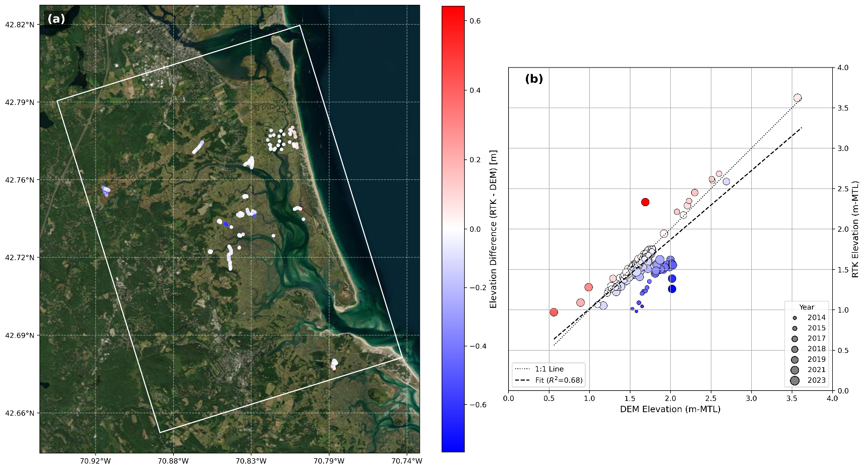
Fig. S1 (a) Elevation differences between the filtered in situ high-accuracy elevation points (n=314) and the original DEM, along with (b) the absolute elevations of both datasets relative to MTL at each observation point. Color coding represents the magnitude and direction of the elevation difference: blue indicates that the DEM overestimates elevation, red indicates underestimation, and white represents no difference (i.e., zero error). The size of the data points (circles) indicates the year the measurements were collected. The dotted diagonal line represents the 1:1 relationship, indicating perfect agreement between in situ elevation observations and DEM values. The black dashed line shows the linear regression trend between the in situ elevation observations and DEM elevations, illustrating any systematic bias or deviation from the ideal
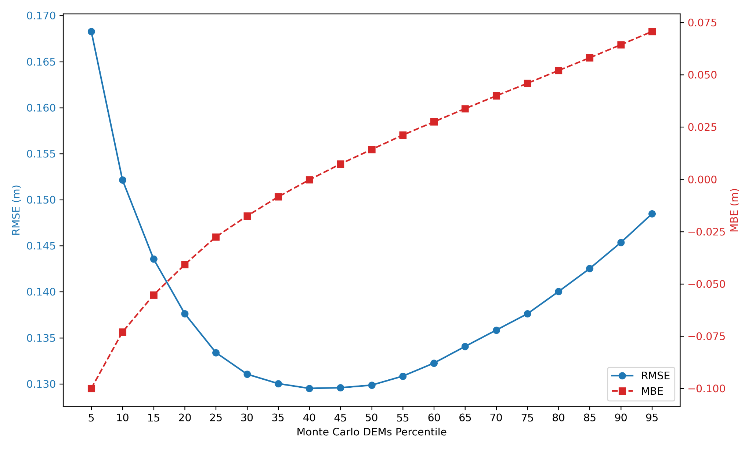
Fig. S2 Root mean square error (RMSE, blue line, left axis) and mean bias error (MBE, red dashed line, right axis) calculated for the Monte Carlo DEM percentiles using the withheld testing dataset. The intersection of the lowest RMSE and near-zero bias (-0.02 cm) confirms that the optimal DEM representation lies at the 40th percentile
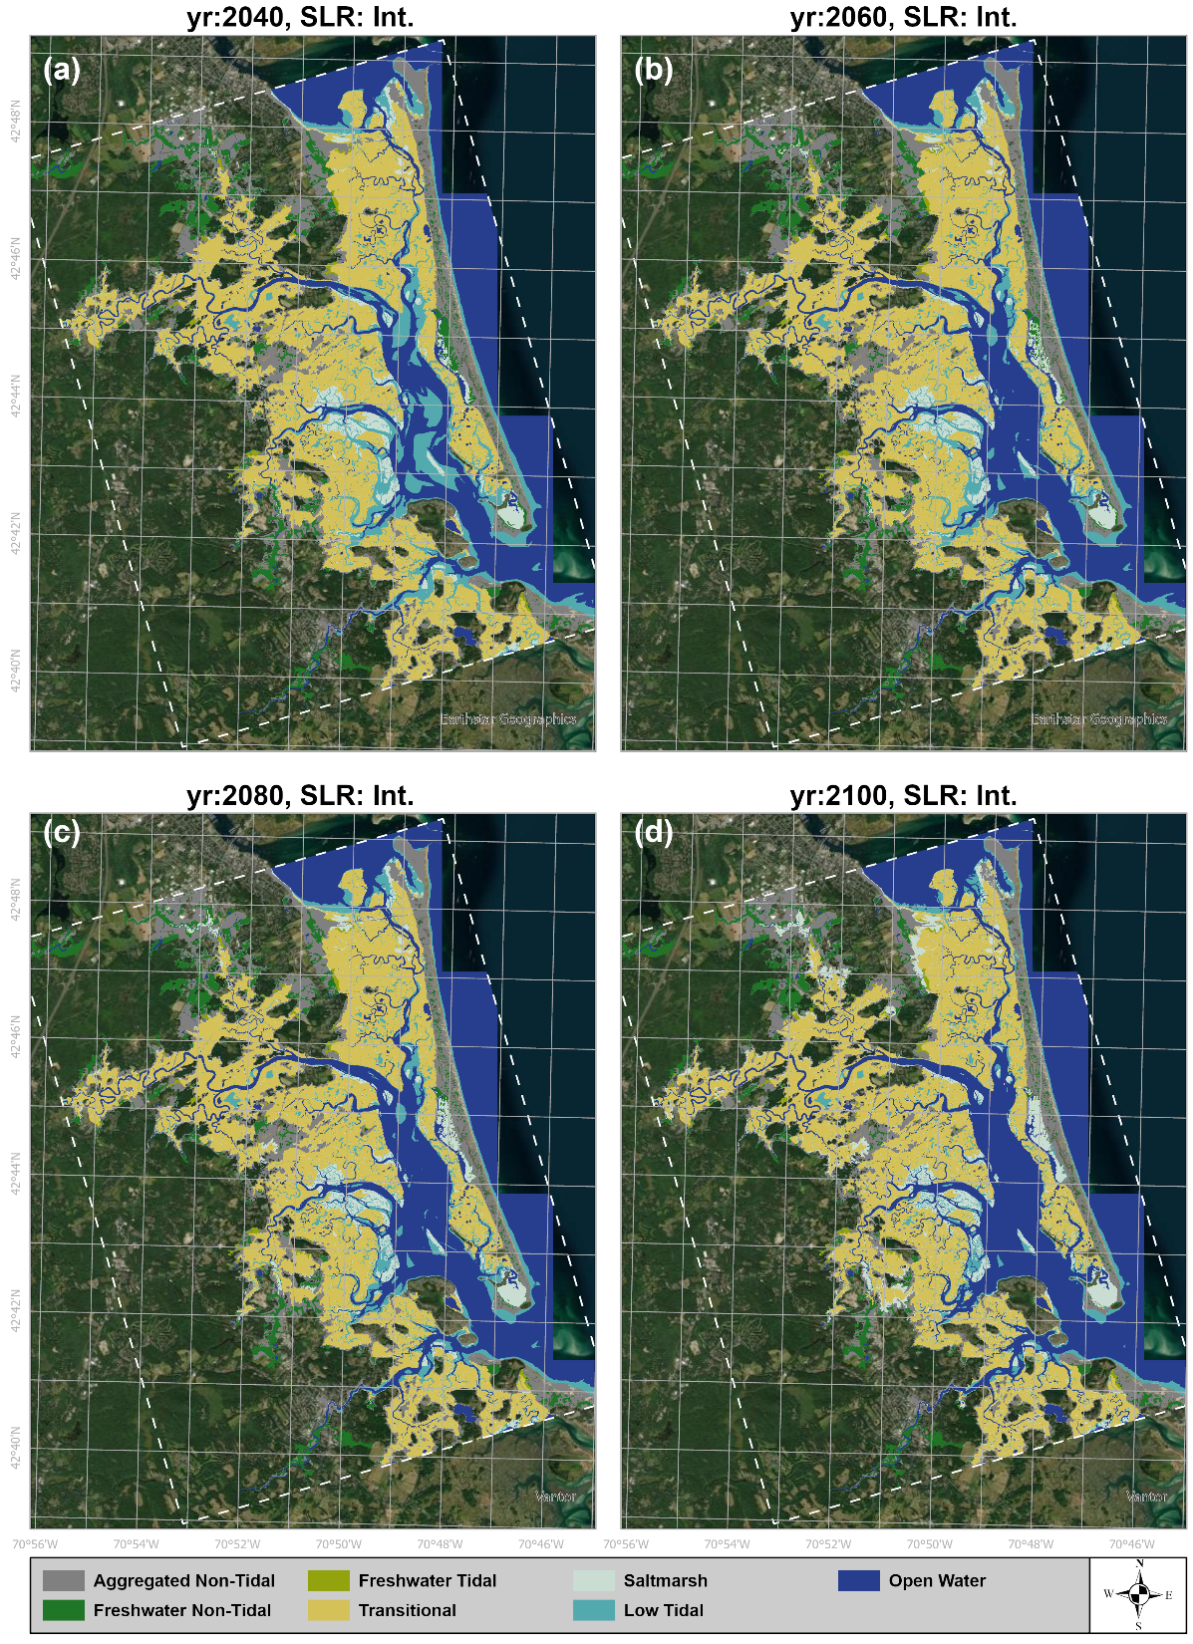
Fig. S3 Spatial projections of land cover change under the Int. SLR scenario, using the best-estimate DEM (P40) and the median (P50) SLR trajectory. The panels show the landscape evolution from (a) 2040, (b) 2060, (c) 2080, to (d) 2100. The results illustrate a gradual landward migration of salt marsh and a moderate expansion of open water
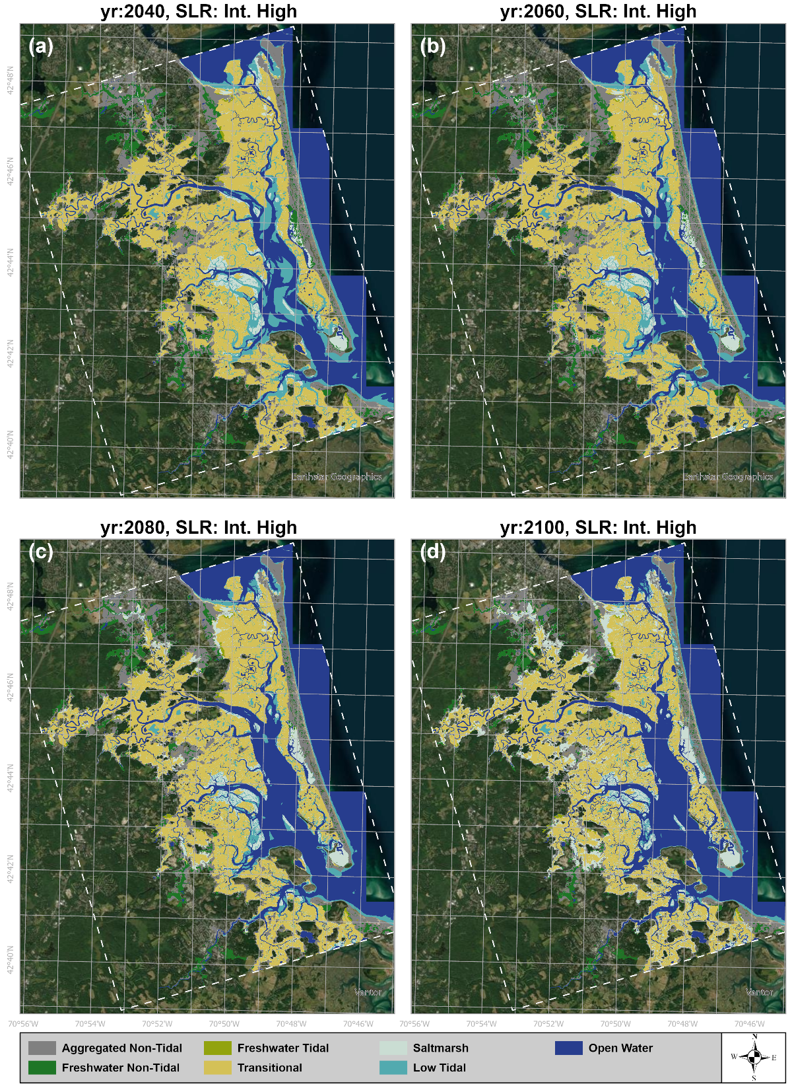
Fig. S4 Spatial projections of land cover change under the Int. High SLR scenario, using the best-estimate DEM (P40) and the median (P50) SLR trajectory. The panels show the landscape evolution for the years (a) 2040, (b) 2060, (c) 2080, and (d) 2100. Unlike the Int. scenario (Fig. S3), this trajectory illustrates a distinct phase of marsh expansion by 2080 and 2100 (c, d), where rapid upland migration offsets incipient losses at the seaward edge. However, compared to Fig. S3, the conversion of salt marsh to low tidal flats and open water is also more pronounced, particularly by the end of the century

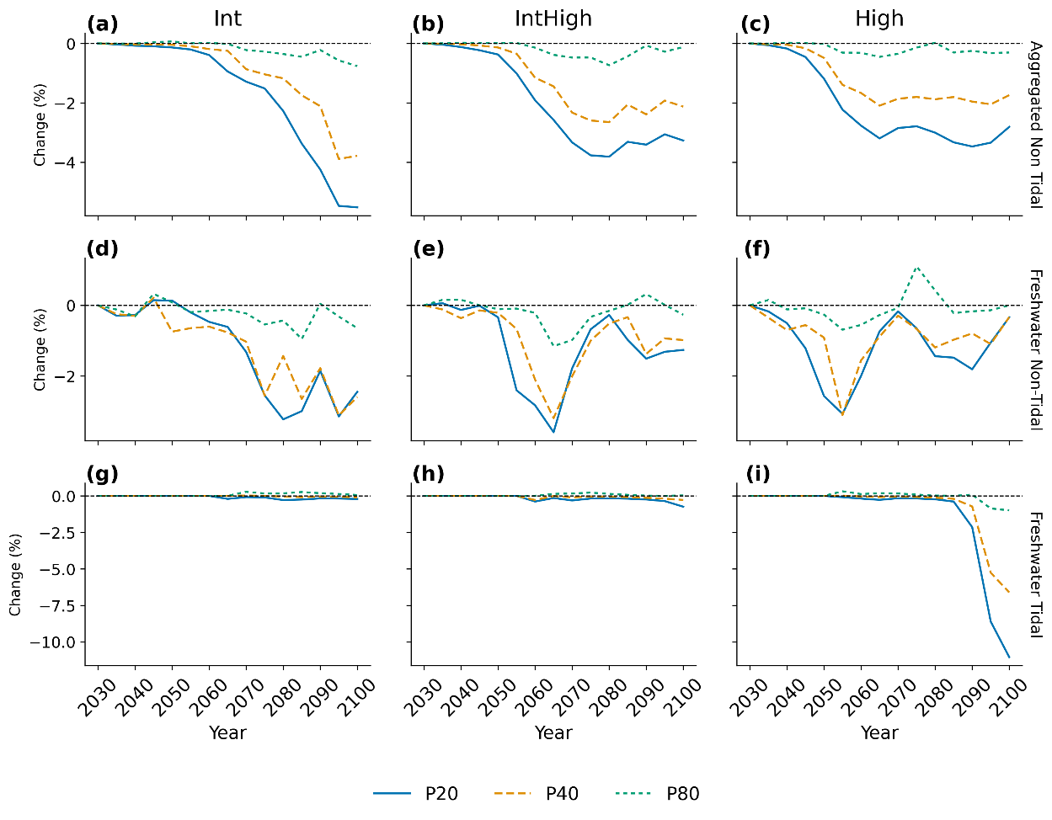
Fig. S5 The effect of topographic uncertainty on projected land cover change for upland and freshwater habitats. The y-axis shows the difference in the projected percent change (from a 2025 baseline) between the DEM percentiles (P20, P40, P80) and the original DEM. The subplot columns represent the Int, Int. High, and High SLR scenarios (P50). This visualization isolates the impact of topographic uncertainty on inland categories, highlighting that the uncertainty-informed DEMs project a more rapid loss of freshwater tidal (i) and aggregated non-tidal (c) habitats compared to the original topographic data
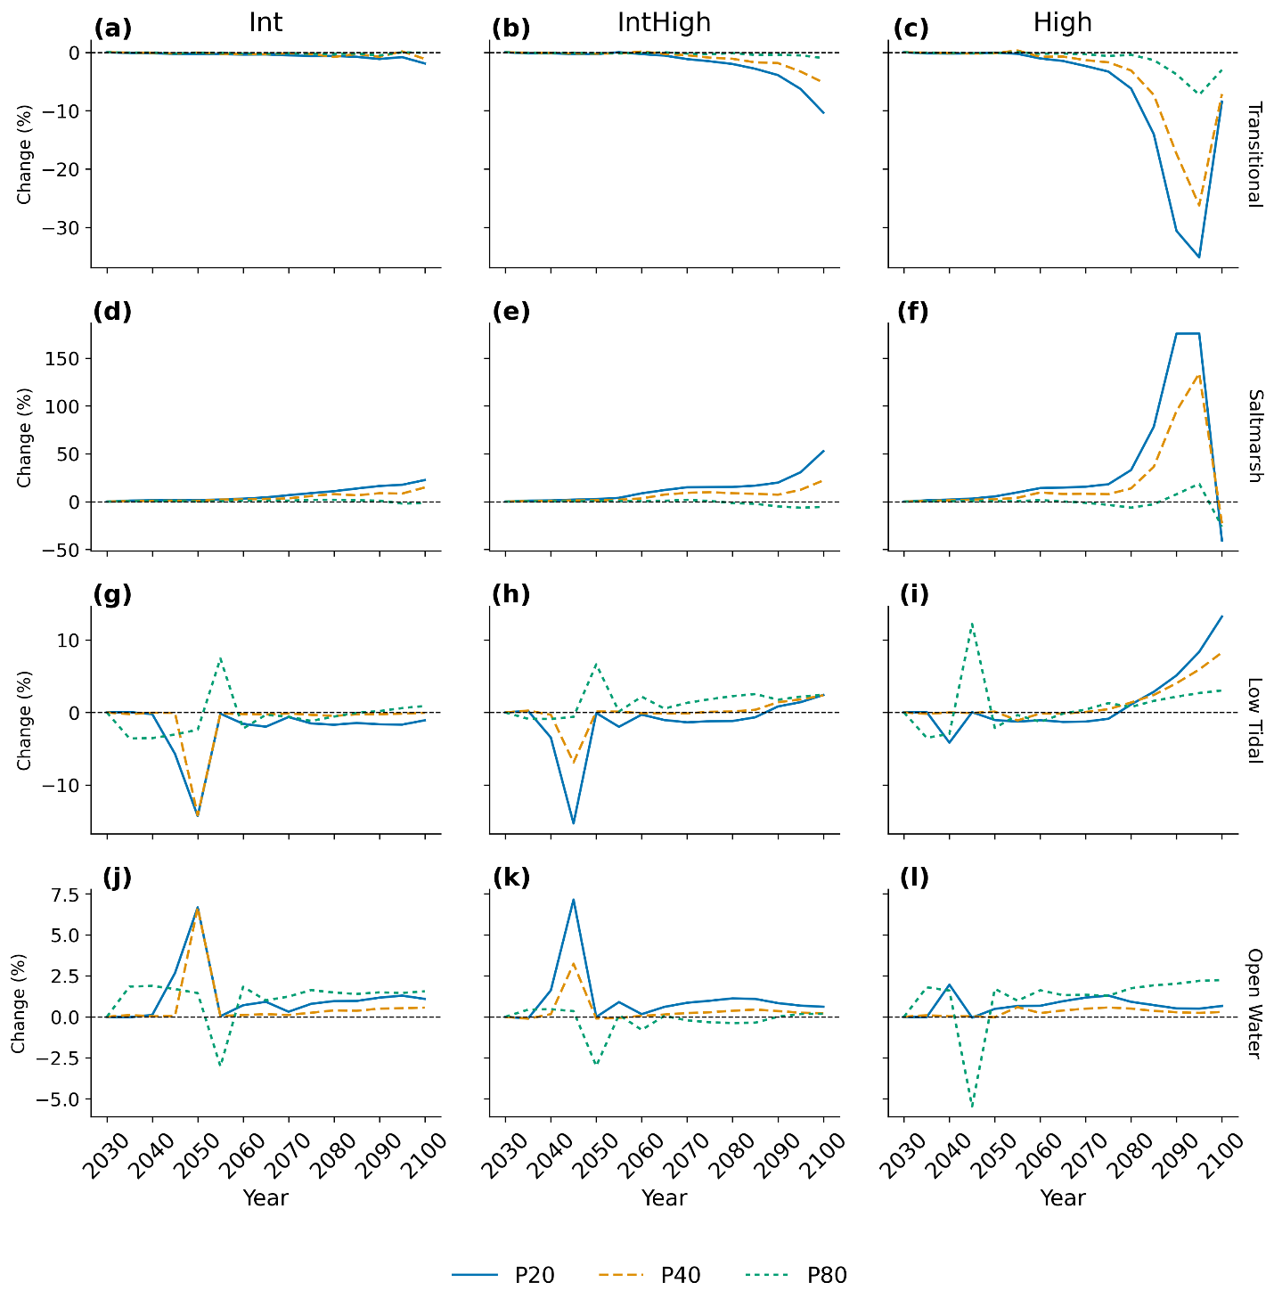
Fig. S6 The effect of topographic uncertainty on projected land cover change for coastal and estuarine habitats. The y-axis shows the difference in the projected percent change (from a 2025 baseline) between the DEM percentiles (P20, P40, P80) and the original DEM. The subplot columns represent the Int, Int. High, and High SLR scenarios (P50). This visualization isolates the impact of topographic uncertainty on coastal ecosystems, highlighting that the uncertainty-informed DEMs project a significantly greater expansion of salt marsh (f) and a more rapid loss of transitional marsh (c) compared to the original topographic data

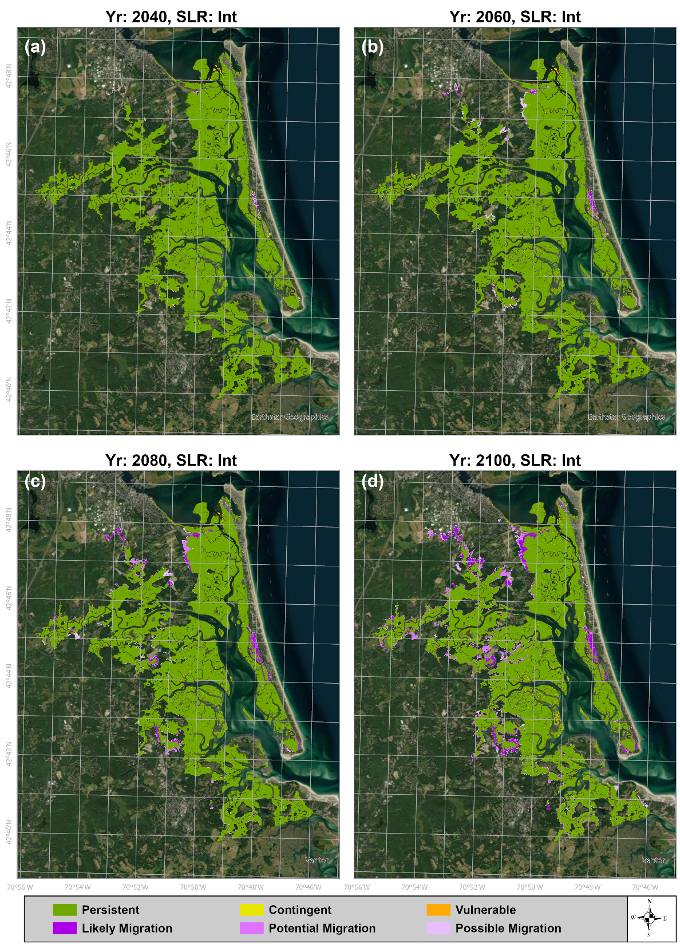
Fig. S7 Projected marsh fate for the PIE under the Int. SLR scenario at four time steps: (a) 2040, (b) 2060, (c) 2080, and (d) 2100. The results depict a highly resilient system where the existing marsh platform remains almost entirely classified as Persistent (dark green) throughout the century. Adaptation to SLR occurs through a gradual expansion of Likely Migration zones (purple) into adjacent uplands, with no significant degradation of the core marsh
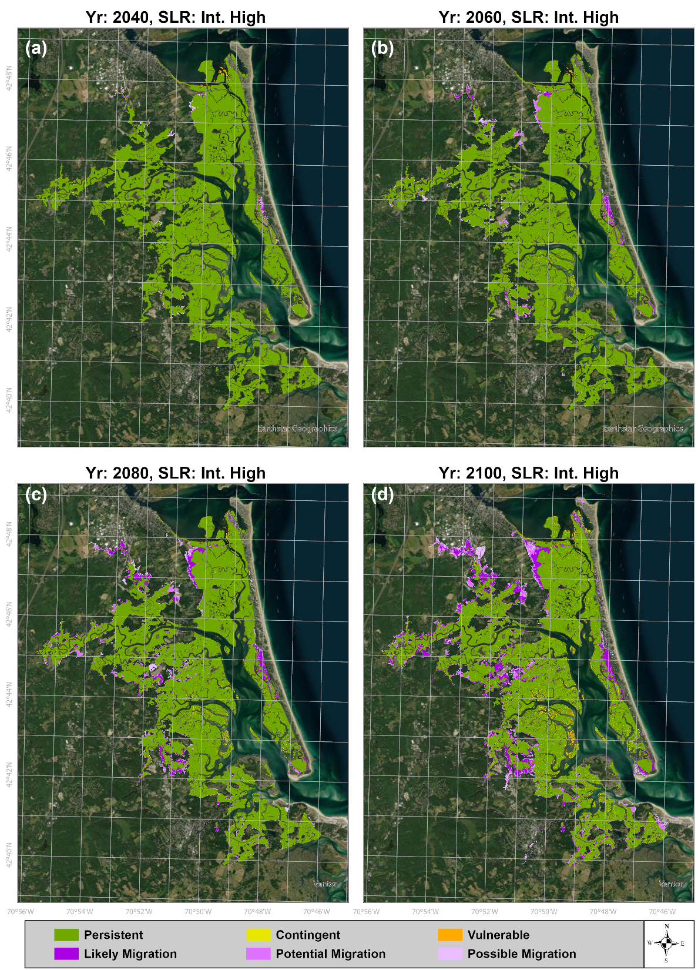
Fig. S8 Projected marsh fate for the PIE under the Int. High SLR scenario at four time steps: (a) 2040, (b) 2060, (c) 2080, and (d) 2100. Under these conditions, the marsh platform remains largely resilient, dominated by Persistent Marsh (dark green). The system adapts primarily through the gradual expansion of Likely Migration zones (purple) into adjacent uplands, particularly after mid-century

References
Cramer, J.M., Huntley, E.C., Brosnahan, S.M., Ganju, N.K., Sturdivant, E.J., Pendleton, E.A., Ackerman, S.D., and Borden, J. (2022). Aerial imagery and ground control points collected during an uncrewed aerial systems (UAS) survey at Plum Island Estuary and Parker River NWR (PIEPR), November 14, 2017 and March 28, 2019: U.S. Geological Survey data release, https://doi.org/10.5066/P9PP35F4.
Luk, S.Y., Spivak, A.C., Eagle, M.J., and O'Keefe-Suttles, J.A., (2020), Collection, analysis, and age-dating of sediment cores from a salt marsh platform and ponds, Rowley, Massachusetts, 2014-15: U.S. Geological Survey data release, https://doi.org/10.5066/P9HIOWKT.
Sundberg, K., I. Forbrich, R. Buchsbaum, and S. Kelsey. (2022). PIE LTER marsh vegetation species composition and elevation along nine transects in 2021 ver 1. Environmental Data Initiative. https://doi.org/10.6073/pasta/d922fe6b08ba186da7e83c23c4904553. Accessed 2025-04-09.
USGS (2022). Lidar Base Specification 2022 rev. A. https://www.usgs.gov/media/files/lidar-base-specification-2022-rev. Accessed 2025-06-10.
Weston, N. (2023). Plant aboveground biomass dry weight record for Space for Time plots in PIE LTER. ver 1. Environmental Data Initiative. https://doi.org/10.6073/pasta/bed84a89b479d6acd588ded3dcde495c. Accessed 2025-04-09.
Woltz, V.L., Stagg, C.L., Byrd, K.B., Windham-Myers, L., Rovai, A.S., and Zhu, Z. (2023). Biomass Carbon Stock and Net Primary Productivity in Tidal Herbaceous Wetlands of the Conterminous United States: U.S. Geological Survey data release, https://doi.org/10.5066/P9I1PCLS.

