Nitrogen uptake varies regionally in the salt marsh plant Spartina alterniflora

Kristen Rabbitt¹, Jennifer Bowen¹, Matthew Costa¹, Anne Giblin², Tessa McClain¹, James Morris³, A. Randall Hughes^{1*}
¹Department of Marine and Environmental Science, Northeastern University, Nahant, MA 01908
²The Ecosystems Center, Marine Biological Laboratory, Woods Hole, MA 02543
³Baruch Institute, University of South Carolina, Columbia, SC 29208
*Corresponding author: ann.hughes@northeastern.edu

Supplementary Material

Figure S1. Schematic of Experiment Setup. Images are as follows: a) picture of uptake chamber, b) chamber design of glass jar with a lid consisting of an open top mason jar lid, silicone, and aluminum foil all with holes for the plant stem and airline c) picture of uptake chambers attached to air pumps in the greenhouse, d) example schematic of individual trial setup with treatments (magenta/dots: NH₄⁺, blue/stripes: NO₃⁻, yellow: control).
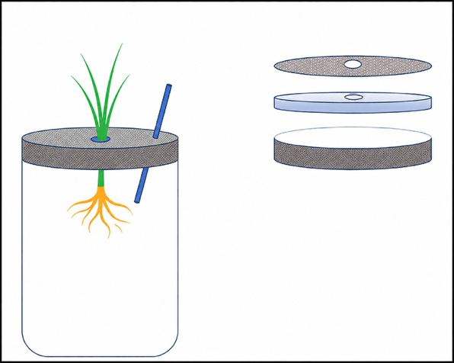
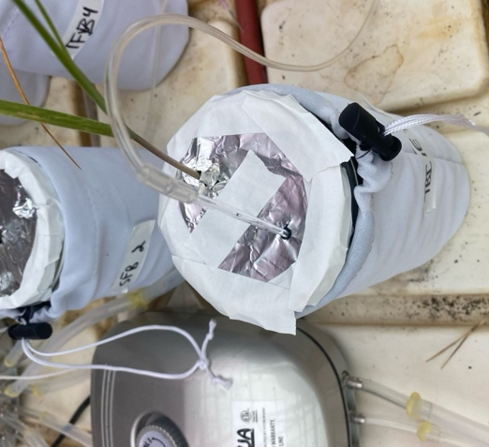
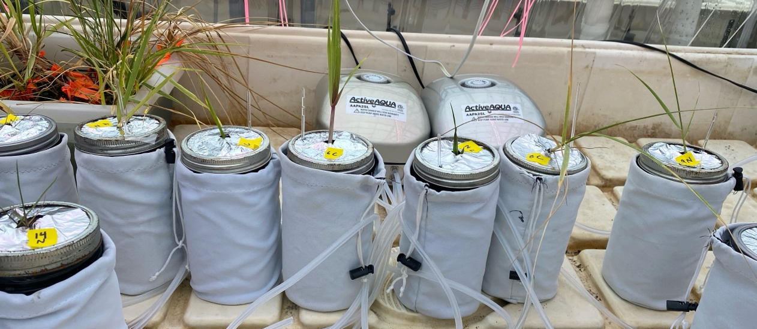
Glass Airline
Aluminum Foil
Silicone Lid
Open Jar Lid
d)
c)
b)
a)
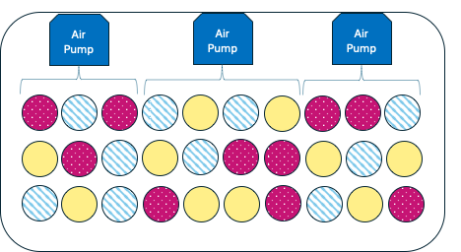
Figure S2. Porewater chemistry through time in field plots in our two plant origin sites: SC (blue) and MA (red): (a) porewater salinity (ppt), (b) porewater sulfide (μM per liter). All values are means + SE. Asterisks (*) denote years with significant differences.

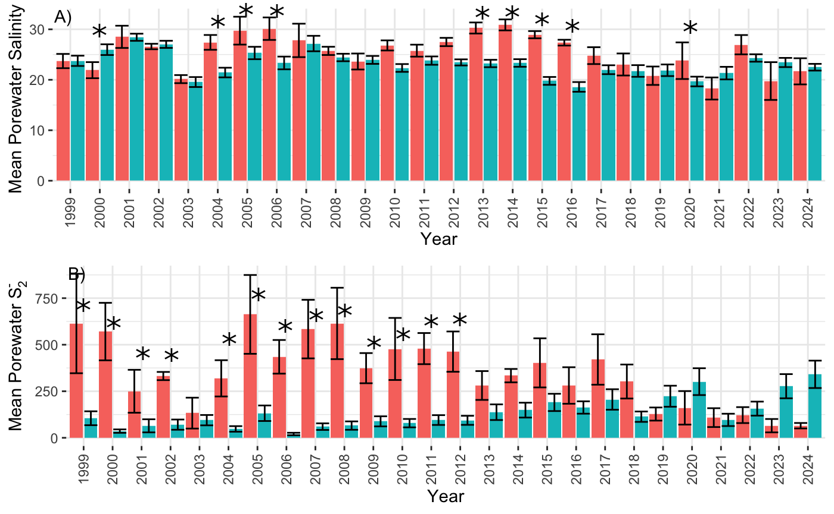
Table S1. GPS coordinates and citations for sediment porewater data.
Estuary | Variable | Data Source | Coordinates
Plum Island Estuary | NH₄⁺ | https://doi.org/10.6073/pasta/f847e38444ab34dcd3baa8d6c7e3c81f | Site: LP  -70.842468261719 °W  42.731742858887 °N  Site: SY  -70.83406111 °W  42.74416389 °N
Plum Island Estuary | Salinity
Plum Island Estuary | Sulfide
Plum Island Estuary | NO₃⁻ | Adjacent Study In Prep | 42.731869°N  -70.841952°W
North Inlet, SC | NH₄⁺ | https://doi.org/10.6073/pasta/6b205ff4b9e756b7e27ef2da720ec556 | Bounding Coordinates  33.35°N  33.32°S  -79.18°E  -79.2°W
North Inlet, SC | Salinity |  | Bounding Coordinates  33.35°N  33.32°S  -79.18°E  -79.2°W
North Inlet, SC | Sulfide |  | Bounding Coordinates  33.35°N  33.32°S  -79.18°E  -79.2°W
North Inlet, SC | NO₃⁻ | Adjacent Study In Prep | 33.331773°N  -79.198321°W

Table S2. Statistical results (Df, Deviance, Residual Df, Residual Deviance, and P value of Chi-Squared) of GLM on nutrient uptake. Inverse gamma GLM with the following factors: Nitrogen Treatment, Plant Origin Site (with population nested within Origin Site), Nitrogen Treatment * Plant Origin Site, and Trial (categorical blocking factor). Significant values are bolded.

Factor | Df | Deviance | Resid. Df | Resid. Dev | Pr(>Chi)
NULL |  |  | 175 | 407.95
Treatment | 2 | 200.71 | 172 | 202.51 | < 0.001
Origin Site | 1 | 4.72 | 174 | 403.22 | 0.04
Trial Number | 5 | 6.22 | 167 | 196.29 | 0.35
Origin Site: Population | 4 | 4.79 | 163 | 191.50 | 0.37
Treatment*Origin Site | 2 | 19.32 | 161 | 172.18 | 0.002
Treatment*Origin Site (nested Population) | 8 | 8.89 | 153 | 163.29 | 0.44

Table S3. Statistical results (Df, Deviance, Residual Df, Residual Deviance, and P value of Chi-Squared) of GLM on porewater N in PIE and NI. GLM with the following factors: Time Frame, Site (with population nested within site), Time Frame * Site. Season was used as a time frame for NO₃⁻, and Year was used as a time frame for NH₄⁺. A) NO₃⁻; Gaussian GLM B) NH₄⁺; Inverse Gamma GLM.
A) NO₃⁻
Factor | Df | Deviance | Resid. Df | Resid. Dev | Pr(>Chi)
NULL |  |  | 62 | 66.608
Season | 4 | 9.7421 | 58 | 56.866 | 0.0428
Site | 1 | 0.7447 | 57 | 56.121 | 0.3852
Season*Site | 4 | 3.7718 | 53 | 52.349 | 0.4311

B) NH₄⁺
Factor | Df | Deviance | Resid. Df | Resid. Dev | Pr(>Chi)
NULL |  |  | 707 | 31.609
Year | 25 | 5.9561 | 682 | 25.653 | < 2.2e-16
Site | 1 | 1.2350 | 681 | 24.418 | 9.800e-11
Year*Site | 25 | 2.1667 | 656 | 22.252 | 1.172e-06

Table S4. Statistical results (Df, Deviance, Residual Df, Residual Deviance, and P value of Chi-Squared) of GLM on porewater chemistry in PIE and NI. GLM with the following factors: Year, Site (with population nested within site), Time Frame * Site: A) Salinity; Gaussian GLM, B) Sulfide, Inverse Gamma GLM

A) Salinity
Factor | Df | Deviance | Resid. Df | Resid. Dev | Pr(>Chi)
NULL |  |  | 736 | 20913
Year | 25 | 3499.0 | 711 | 17414 | < 2.2e-16
Site | 1 | 525.6 | 710 | 16889 | 1.162e-06
Year*Site | 25 | 1659.1 | 685 | 15230 | 7.740e-07

B) Sulfide
Factor | Df | Deviance | Resid. Df | Resid. Dev | Pr(>Chi)
NULL |  |  | 697 | 2715.0
Year | 25 | 70.737 | 672 | 2644.2 | 0.03637
Site | 1 | 59.376 | 671 | 2584.9 | 1.030e-08
Year*Site | 25 | 175.581 | 646 | 2409.3 | 2.041e-10

