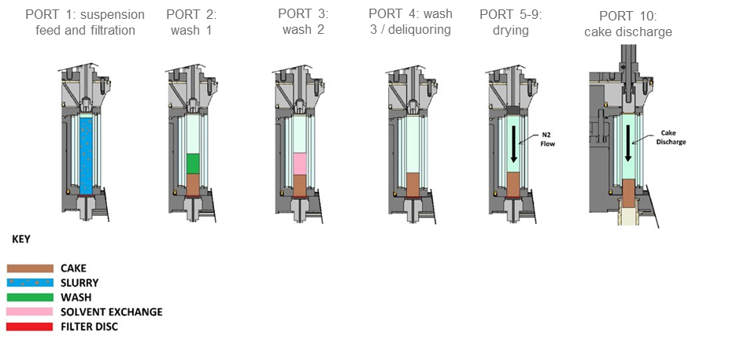
Figure S1 Pictorial representation of AWL CFD25 port operation procedure.

Table S1 Summary of small-scale batch spherical agglomeration experimental conditions investigating operation outside of the acetone:water:MIBK miscible region. Ratios were found based on a qualitative visual inspection of either forming spherical agglomerates particles or pasty materials.
Image in Figure 2(d) | Mass Lovastatin (g) | Mass Water (g) | Mass Acetone (g) | Acetone Fraction  (wt%) | Volume MIBK  (mL) | BSR
(i) | 0.5 | 8 | 0.00 | 0 | 0.15 | 0.30
(ii) | 0.5 | 8 | 0.40 | 5 | 0.18 | 0.36
(iii) | 0.5 | 8 | 0.72 | 9 | 0.20 | 0.40
(iv) | 0.5 | 8 | 1.20 | 15 | 0.50 | 1.00
(v) | 0.5 | 8 | 1.60 | 20 | 0.60 | 1.20
(vi) | 0.5 | 8 | 2.00 | 25 | 0.70 | 1.40
(vii) | 0.5 | 8 | 2.40 | 30 | 0.80 | 1.60

Table S2 Outcome of suspension density filtration experiments.
Suspension density (wt%) | Cake resistance (m/kg) | Flow rate (mL/s)
Suspension density (wt%) | Cake resistance (m/kg) | Filtrate | Wash 1  (water) | Wash 2  (n-heptane) | Wash 3  (n-heptane)
1 | 1.84 x 10⁹ | 3.04 | 3.82 | - | -
1 | 1.22 x 10⁹ | 4.29 | 4.49 | 4.14 | 4.17
10 | 2.72 x 10⁸ | 2.62 | 1.70 | 0.81 | 1.28

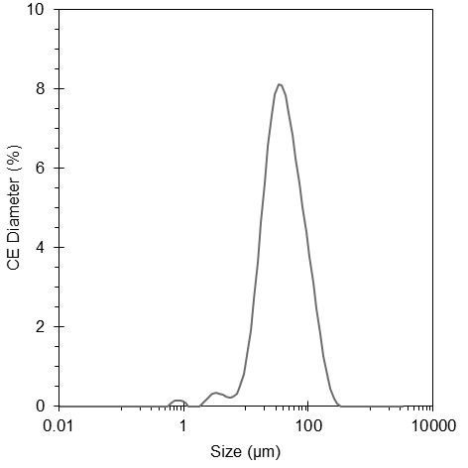
Figure S2 Particle size distribution of commercial lovastatin used as seeds for crystallisation experiments, averaged over three samples run in triplicate.

Table S3 Summary of seed material particle size characterisation data.
Seed Sample No. | Run No. | D₁₀ (µm) | D₅₀ (µm) | D₉₀ (µm)
1 | A | 15.4 | 38.1 | 101.4
1 | B | 15.0 | 37.8 | 102.2
1 | C | 15.3 | 37.9 | 101.6
2 | A | 15.2 | 37.9 | 101.6
2 | B | 15.3 | 38.2 | 102.4
2 | C | 15.1 | 38.7 | 104.8
3 | A | 15.1 | 38.8 | 105.6
3 | B | 15.1 | 40.0 | 112.0
3 | C | 15.0 | 39.1 | 109.4
 | Mean | 15.1 | 38.5 | 104.6
 | Stand. Dev. | 0.13 | 0.69 | 3.62

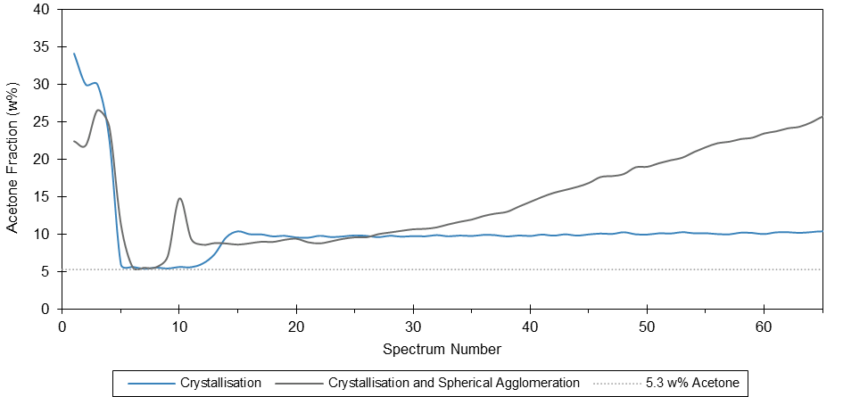
Figure S3 Predicted acetone solvent fraction against IR spectrum number for crystallisation (Exp 1) and crystallisation with spherical agglomeration (Exp 2) experiments compared against the expected 5.3 w% value from the process information summary map (Figure 6). The probe is not initially submerged, hence the high initial predictions. As the predicted acetone solvent fraction deviates from the expected 5.3 w% value after ca. spectrum 10, fouling of the ATR crystal is evidenced by emergence of lovastatin peaks in the spectra, suggesting deposition of solid upon the ATR crystal.

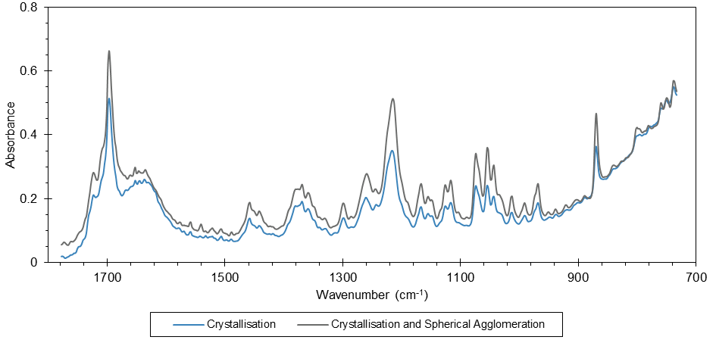
Figure S4 Final IR spectra from crystallisation (Exp 1) and crystallisation with spherical agglomeration (Exp 2) experiments.

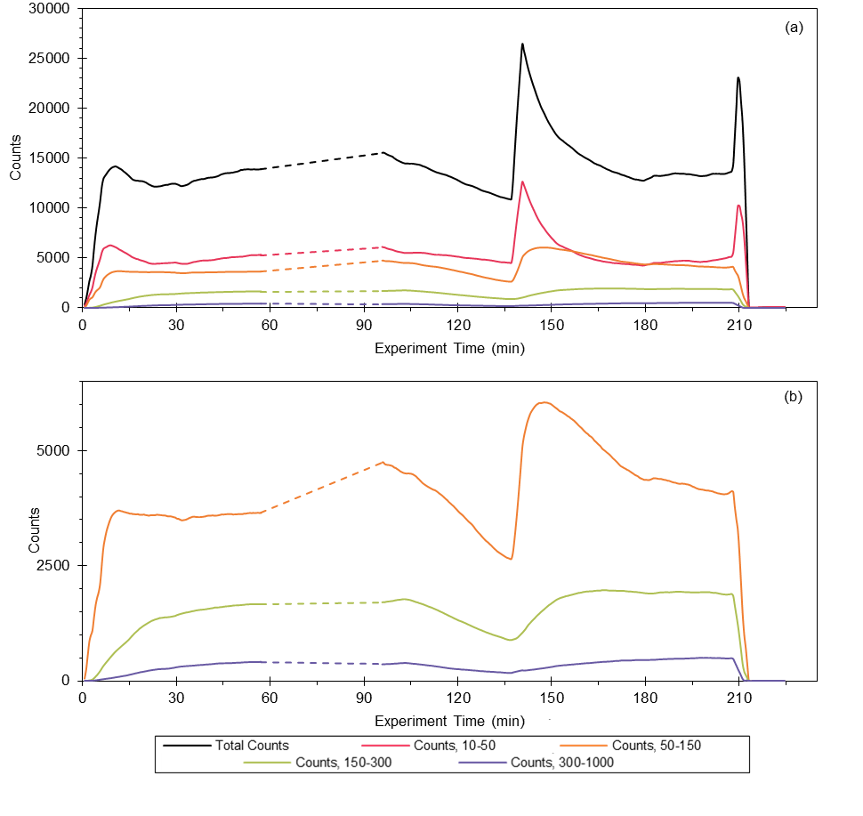
Figure S5 FBRM trends for continuous crystallisation experiment (Exp 1). A 38-minute gap in measurement whilst acoustic emission measurements were made is indicated by the dashed lines in each trend

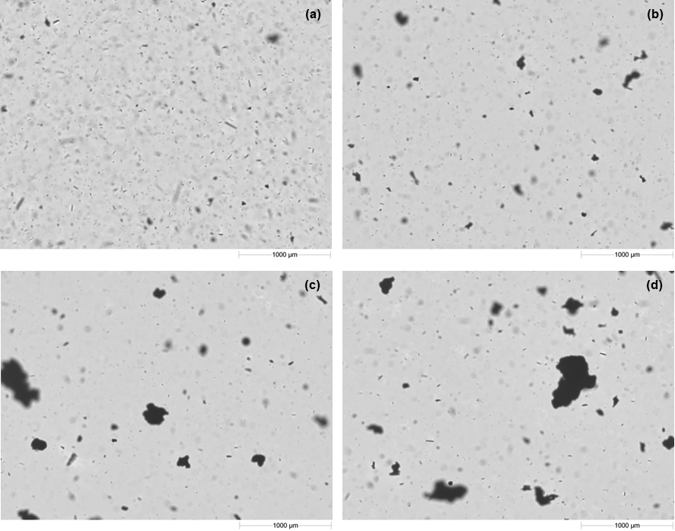
Figure S6 Example Hydro Insight images of sample suspensions from (a) crystallisation-only experiment, sample 3; (b) crystallisation-only experiment, sample 6; (c) crystallisation and agglomeration experiment, sample 6 and (d) crystallisation and agglomeration experiment, sample 7, taken during particle size estimation.

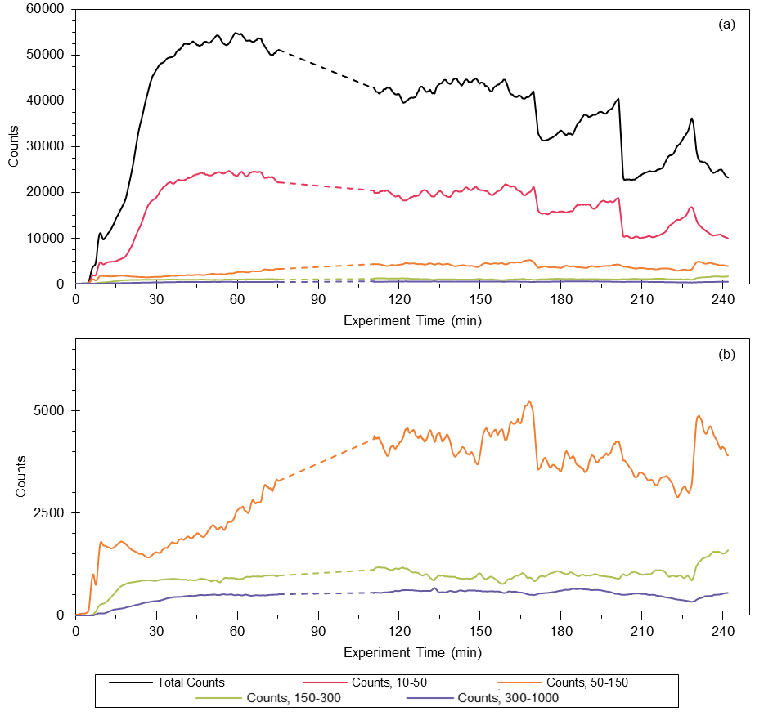
Figure S7 FBRM trends for integrated continuous crystallisation and agglomeration experiment (Exp 2). A 35-minute gap in measurement whilst acoustic emission measurements were made is indicated by the dashed lines in each trend.

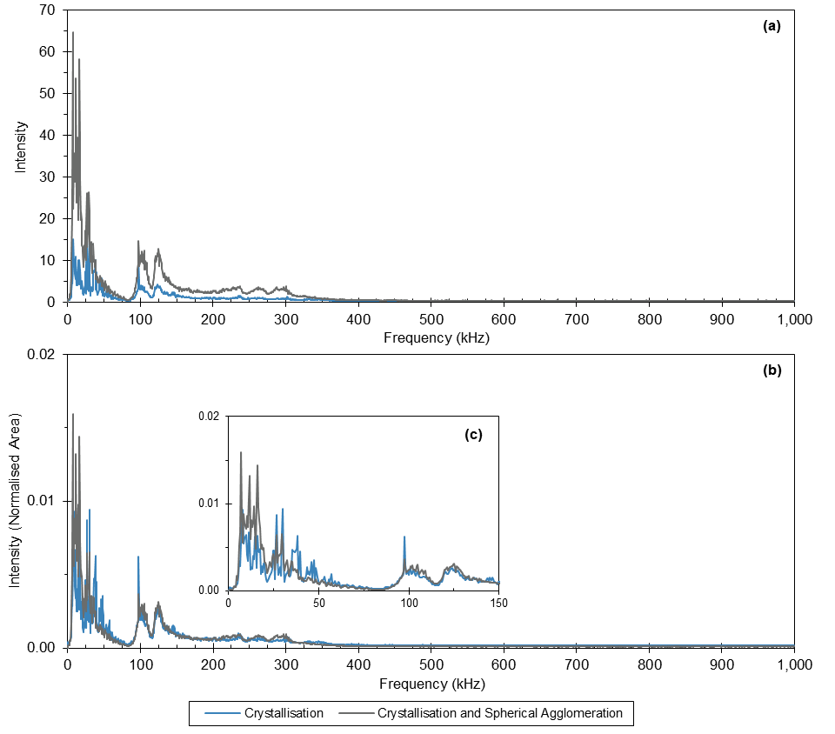
Figure S8 (a) Acoustic emission spectra for the two experiments, summed over a 21 min duration in which FBRM monitoring was paused. (b) Acoustic emission spectra, shown in (a), normalised with respect to area. (c) Expansion of 0 – 150 kHz frequency range of the normalised spectra shown in (b).

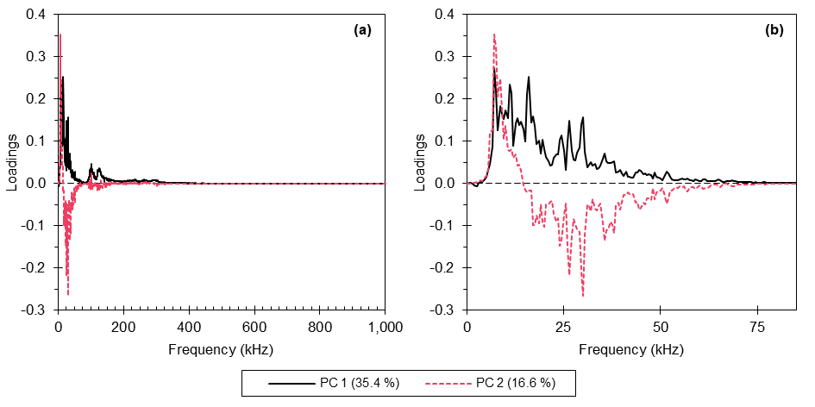
Figure S9 Loadings from principal component analysis performed on the combined acoustic emission data (each composite spectrum comprising 30 co-added spectra corresponding to 1 minute) from both experiments (93 and 102 min of data for crystallisation-only and crystallisation with spherical agglomeration experiments, respectively); (a) complete dataset and (b) expansion of 0 – 85 kHz frequency range

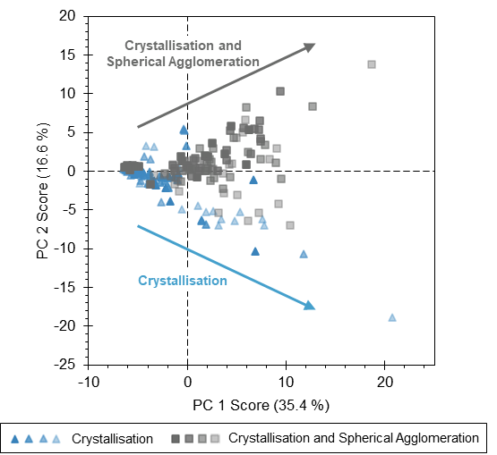
Figure S10 Scores plot of PC 2 vs PC 1 for the combined acoustic signals (each composite spectrum comprising 30 co-added spectra corresponding to 1 minute) from both MicroFactory experiments (93 and 102 min of data for crystallisation-only and crystallisation with spherical agglomeration experiments, respectively). The colour of the markers become lighter as time progresses. The arrows indicate the general trend in the scores with time.

Table S4 Summary of process sample particle size measurements for continuous crystallisation (Exp. 1) and continuous crystallisation with spherical agglomeration (Exp. 2) experiments for comparison. Laser diffraction was used to estimate the particle size distribution. ªOmitted from mean calculation.
Sample Number | Process Time | D₁₀ |  | D₅₀ |  | D₉₀
Sample Number | Process Time | Exp. 1 | Exp. 2 | Exp. 1 | Exp. 2 | Exp. 1 | Exp. 2
1 | 30 | 35.7 | 84.4 | 123 | 195 | 281 | 377
2 | 60 | 57.2 | 118 | 154 | 252 | 332 | 454
3 | 90 | 13.4ª | 128 | 179ª | 277 | 912ª | 497
4 | 120 | 52.7 | 98.4 | 158 | 245 | 431 | 510
5 | 150 | 12.0 | 136 | 99.9 | 270 | 345 | 477
6 | 180 | 48.0 | 97.6 | 148 | 263 | 584 | 527
7 | 210 | 56.7 | 83.4 | 153 | 259 | 349 | 566
8 | 240 | --- | 51.6 | --- | 211 | --- | 609
 | Mean | 43.7 | 99.7 | 139 | 247 | 387 | 502
 | Stand. Dev. | 15.9 | 25.7 | 21.0 | 27.1 | 98.5 | 66.0

Table S5 Summary of product particle size measurements for continuous crystallisation (Exp. 1) and continuous crystallisation with spherical agglomeration (Exp. 2) experiments for comparison. Optical microscopy was used to estimate the particle size distribution.
Product | D₁₀ | D₅₀ | D₉₀ | Span
Crystallised (Exp. 1) | 39.6 | 135 | 352 | 2.31
Agglomerated (Exp. 2) | 168 | 336 | 584 | 1.24

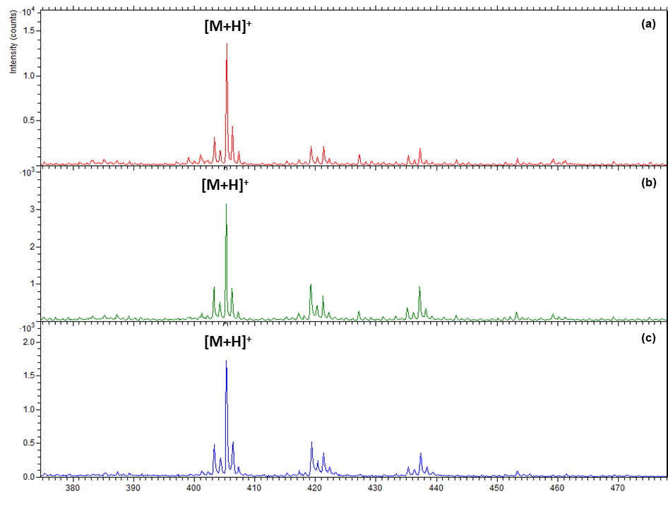
Figure S11 ToF-SIMS spectral comparison between (a) commercial lovastatin, (b) crystallised lovastatin and (c) spherically agglomerated lovastatin in positive ionisation mode. The presence of lovastatin is confirmed from the protonated molecular ion [M+H]⁺ at m/z 405.2.
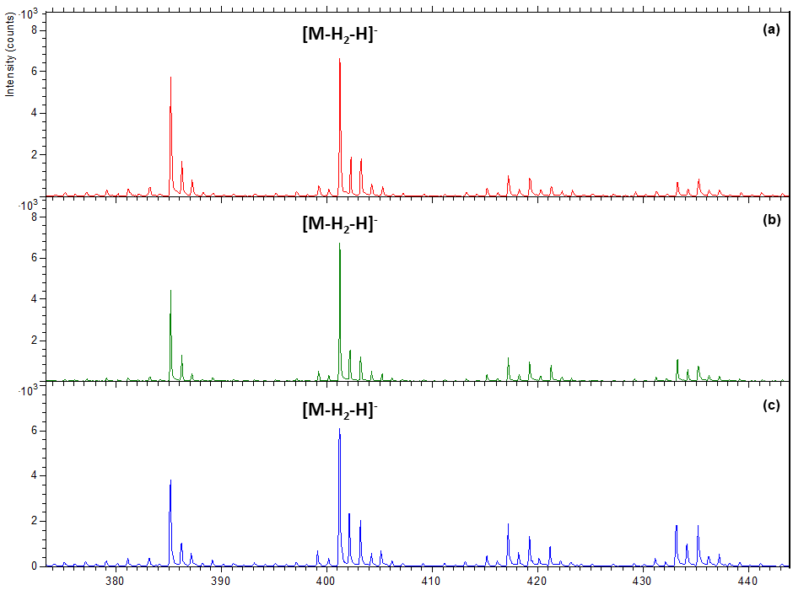
Figure S12 ToF-SIMS spectral comparison between (a) commercial lovastatin, (b) crystallised lovastatin and (c) spherically agglomerated lovastatin in negative ionisation mode.

