Supporting information

Enhanced Zn-Co-Fe Layered Double Hydroxides for Effective Levofloxacin Removal: innovation in reuse of waste adsorbent

Table S1:The thermodynamic parameters ΔHº , ΔSº and ∆G° obtained using Cu-Cyanoguanidine-ZnCoFe/LDH
T K | Ce | Qe | Kd | Ln Kd | 1/T | ΔG | ΔH | ΔS
288 | 18.988 | 16.13909 | 0.849963 | -0.16256 | 0.003472 | 389.0585 | -15158.3 | -54.0424
298 | 22.727 | 15.28932 | 0.672738 | -0.3964 | 0.003356 | 981.6351
308 | 25.829 | 14.58432 | 0.564649 | -0.57155 | 0.003247 | 1462.873
318 | 29.67 | 13.71136 | 0.462129 | -0.77191 | 0.003145 | 2039.838
328 | 33.09 | 12.93409 | 0.390876 | -0.93936 | 0.003049 | 2560.407

Table S2: The thermodynamic parameters ΔHº , ΔSº and ∆G° obtained using LDH
T K | Ce | Qe | Kd | Ln Kd | 1/T | ΔG | ΔH | ΔS
288 | 36.72 | 12.10909 | 0.329768 | -1.10937 | 0.003472 | 2655.021 | -5284.41 | -27.5568
298 | 38.35 | 11.73864 | 0.306092 | -1.18387 | 0.003356 | 2931.709
308 | 39.77 | 11.41591 | 0.287048 | -1.2481 | 0.003247 | 3194.5
318 | 41.193 | 11.0925 | 0.269281 | -1.312 | 0.003145 | 3467.063
328 | 42.761 | 10.73614 | 0.251073 | -1.38201 | 0.003049 | 3766.92

Table S3. The parameter of the multicomponent adsorption isotherm for LEV on ZnCoFe/LDH and Cu-Cyanoguanidine-ZnCoFe/LDH .
Model | Equation | ZnCoFe/LDH |  |  | Cu-Cyanoguanidine-ZnCoFe/LDH
Model | Equation | Parameter Value | Q _{max} | R² | Parameter Value | Q _{max} | R²
Three-parameter
Langmuir–Freundlich isotherm | $$q_{e}=\frac{q_{max}{\left(k_{LF} C_{e}\right)}^{MLF}}{1+{\left(k_{LF }C_{e}\right)}^{MLF}}$$ | KLF=0.010160032 | 82.7 | 0.999 | KLF=0.016426 | 390 | 94.5
Langmuir–Freundlich isotherm |  | MLF=1.23803522 | 82.7 | 0.999 | MLF=1.3380229 | 390 | 94.5
Sips isotherm | $$q_{e}=\frac{{\left(q_{max}k_{s} C_{e}\right)}^{1/n}}{{\left(1+k_{s} C_{e}\right)}^{1/n}}$$ | kS=0.003408174 | 82.1 | 0.995 | kS=0.0041508174 | 245 | 98
Sips isotherm |  | 1/n=1.237996951 | 82.1 | 0.995 | 1/n=1.337996951 | 245 | 98
Redlich-Peterson isotherm | $$q_{e}=\frac{k_{R }C_{e}}{1+a_{R }{C_{e}}^{ᵝ}}$$ | kR=0.552168836 | - | 0.996 | kR=2.1552168836 | - | 98
Redlich-Peterson isotherm | $$q_{e}=\frac{k_{R }C_{e}}{1+a_{R }{C_{e}}^{ᵝ}}$$ | aR=0.001222693 | - | 0.996 | aR=1.191222693 | - | 98
Redlich-Peterson isotherm | $$q_{e}=\frac{k_{R }C_{e}}{1+a_{R }{C_{e}}^{ᵝ}}$$ | ᵝ=1.243617284 | - | 0.996 | ᵝ=2.143617284 | - | 98
Toth isotherm | $$q_{e}=\frac{k_{e} C_{e}}{{\left(1+{\left(k_{L} C_{e}\right)}^{n}\right)}^{1∕n}}$$ | ke=0.686810036 | - | 0.996 | ke=4.586810036 | - | 98
Toth isotherm |  | kL=0.001231665 | - | 0.996 | kL=1.7231665 | - | 98
Toth isotherm |  | n=1.242648826 | - | 0.996 | n=2.12648826 | - | 98
Kahn isotherm | $$q_{e}=\frac{q_{max}{ b}_{k }C_{e}}{{\left(1+b_{k }C_{e}\right)}^{a_{k}}}$$ | bk=0.007164491 | 380 | 0.982 | bk=0.007164491 | 332 | 94.5
Kahn isotherm |  | ak=0.947230577 | 380 | 0.982 | ak=0.6547230577 | 332 | 94.5
Higher parameter four and five-parameter
Baudu isotherm | $$q_{e}=\frac{q_{max}{ b}_{0}{ C_{e}}^{1+X+Y}}{1+b_{0}{ C_{e}}^{1+X}}$$ | bo=0.003407805 | 82.1 | 0.995 | bo=0.008934005 | 92 | 98
Baudu isotherm |  | X=0 | 82.1 | 0.995 | X=0.1745388 | 92 | 98
Baudu isotherm |  | Y=0.238030122 | 82.1 | 0.995 | Y=0.292030122 | 92 | 98
Fritz-Schlunder isotherm | $$q_{e}=\frac{q_{\max_{Fss}}k_{1}{C_{e}}^{m_{1}}}{1+k_{2}{C_{e}}^{m_{2}}}$$ | K1=0.05760068 | 82.2 | 0.935 | K1=0.06760068 | 96.4 | 94.5
Fritz-Schlunder isotherm |  | K2=0.007434606 | 82.2 | 0.935 | K2=0.007434606 | 96.4 | 94.5
Fritz-Schlunder isotherm |  | M1=0.44657 | 82.2 | 0.935 | M1=0.68657 | 96.4 | 94.5
Fritz-Schlunder isotherm |  | M2=0 | 82.2 | 0.935 | M2=0 | 96.4 | 94.5

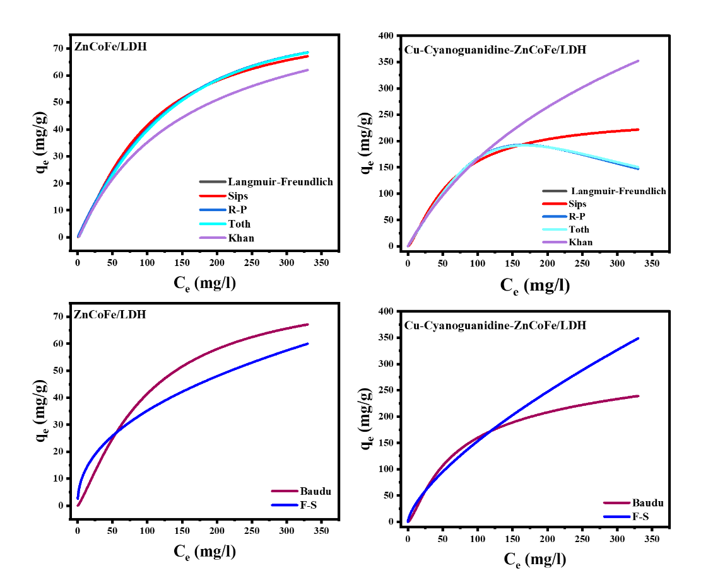

Figure S1. The nonlinear adsorption isotherms of levofloxacin on the synthesized adsorbents using three-parameter, and higher-order isotherm models

Table S4: Summary of the computed error functions associated with the non-linear adsorption isotherm models for ZnCoFe/LDH.
Error function | Langmuir - Freundlich | Sips | RP | Toth | Khan | Baudu | FS
SSE / ERRSQ | 60.399 | 60.399 | 47.612 | 47.612 | 50.261 | 60.399 | 886.493
X² | 8.030 | 8.031 | 15.418 | 15.448 | 18.083 | 8.030 | 329.063
R² | 0.996 | 0.996 | 0.997 | 0.997 | 0.997 | 0.996 | 0.940
Adjusted R² | 0.990 | 0.990 | 0.992 | 0.992 | 0.991 | 0.989 | 0.841
MAE | 1.363 | 1.363 | 1.265 | 1.264 | 1.340 | 1.363 | 6.714
MAPE / ARE | 37.088 | 37.091 | 51.653 | 51.706 | 56.565 | 37.089 | 263.581
RMSE | 1.943 | 1.943 | 1.725 | 1.725 | 1.772 | 1.943 | 7.444
RMSE _2 | 2.155 | 2.155 | 1.914 | 1.914 | 1.966 | 2.243 | 8.595
NRMSE | 0.051 | 0.051 | 0.046 | 0.046 | 0.047 | 0.051 | 0.196
HYBRID | 45.647 | 45.650 | 63.573 | 63.638 | 69.618 | 49.451 | 351.441
HYBRID_2 | 61.770 | 61.778 | 118.603 | 118.832 | 139.101 | 66.919 | 2,742.191
HYBRID_3 | 8.030 | 8.031 | 15.418 | 15.448 | 18.083 | 8.030 | 329.063
MPSD | 132.723 | 132.738 | 201.397 | 201.608 | 218.655 | 138.145 | 885.837
MPSD_2 | 22.900 | 22.905 | 52.729 | 52.840 | 62.153 | 22.901 | 941.648
SAE / EABS | 21.804 | 21.806 | 20.248 | 20.228 | 21.436 | 21.804 | 107.423
RMS | 119.635 | 119.648 | 181.537 | 181.727 | 197.093 | 119.637 | 767.157
NSD | 1.196 | 1.196 | 1.815 | 1.817 | 1.971 | 1.196 | 7.672
ARE_2 | 143.126 | 143.157 | 329.556 | 330.248 | 388.455 | 143.131 | 5,885.299
ARE_3 | 29.909 | 29.912 | 45.384 | 45.432 | 49.273 | 29.909 | 191.789

Table S5: Summary of the computed error functions associated with the non-linear adsorption isotherm models for Cu-Cyanoguanidine-ZnCoFe/LDH.
Error function | Langmuir - Freundlich | Sips | RP | Toth | Khan | Baudu | FS
SSE / ERRSQ | 4,322.544 | 1,479.422 | 1,398.214 | 1,404.112 | 2,393.788 | 1,500.505 | 4,024.208
X² | 46.458 | 41.832 | 94.837 | 97.058 | 170.659 | 36.145 | 525.944
R² | 0.941 | 0.980 | 0.981 | 0.981 | 0.967 | 0.980 | 0.945
Adjusted R² | 0.857 | 0.950 | 0.953 | 0.953 | 0.920 | 0.945 | 0.840
MAE | 10.448 | 7.528 | 7.962 | 7.983 | 10.035 | 7.513 | 13.916
MAPE / ARE | 35.456 | 66.251 | 109.403 | 110.843 | 147.421 | 59.689 | 264.007
RMSE | 16.437 | 9.616 | 9.348 | 9.368 | 12.232 | 9.684 | 15.859
RMSE _2 | 18.235 | 10.668 | 10.371 | 10.393 | 13.570 | 11.182 | 19.127
NRMSE | 0.234 | 0.137 | 0.133 | 0.133 | 0.174 | 0.138 | 0.226
HYBRID | 43.638 | 81.540 | 134.650 | 136.423 | 181.441 | 79.585 | 384.011
HYBRID_2 | 357.367 | 321.785 | 729.516 | 746.596 | 1,312.760 | 301.209 | 4,781.313
HYBRID_3 | 46.458 | 41.832 | 94.837 | 97.058 | 170.659 | 36.145 | 525.944
MPSD | 80.772 | 150.730 | 256.543 | 259.737 | 340.430 | 138.978 | 681.206
MPSD_2 | 8.481 | 29.535 | 85.559 | 87.702 | 150.660 | 23.178 | 510.446
SAE / EABS | 167.168 | 120.448 | 127.387 | 127.726 | 160.560 | 120.212 | 222.649
RMS | 72.807 | 135.866 | 231.245 | 234.124 | 306.859 | 120.358 | 564.826
NSD | 0.728 | 1.359 | 2.312 | 2.341 | 3.069 | 1.204 | 5.648
ARE_2 | 53.009 | 184.596 | 534.742 | 548.139 | 941.625 | 144.862 | 3,190.285
ARE_3 | 18.202 | 33.967 | 57.811 | 58.531 | 76.715 | 30.090 | 141.207

