Supplementary materials
Table S1. Powder properties of spray dried co-process metformin hydrochloride.
Powder properties | Experimental value
Powder properties | Run 1 | Run 2 | Run 3 | Average
Percentage yield (%) | 72.1 | 68.72 | 55.93 | 65.58
Moisture level (%) | 1.56 | 1.56 | 1.52 | 1.55
Carr’s Index | 29.68 | 33.93 | 31.4 | 31.67
Hausner’s ratio | 1.42 | 1.51 | 1.46 | 1.46

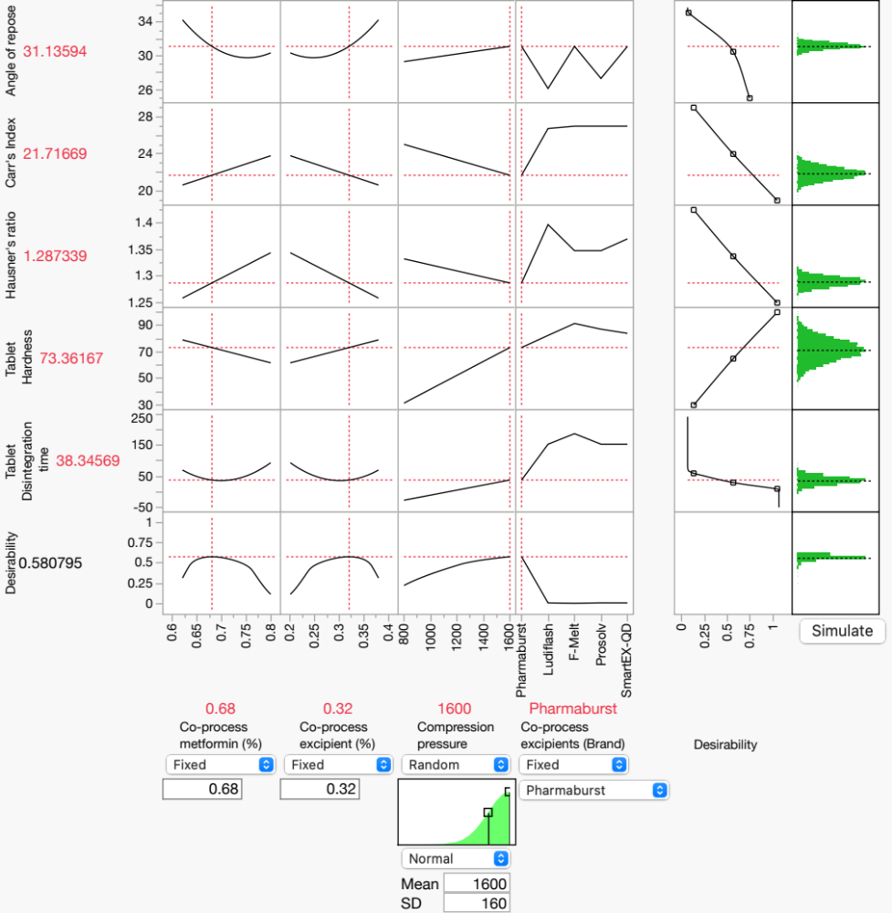
Fig. S1. Predicted process parameters and response Met.HCl ODT formulations predicted by the D-optimal design from prediction profiler.

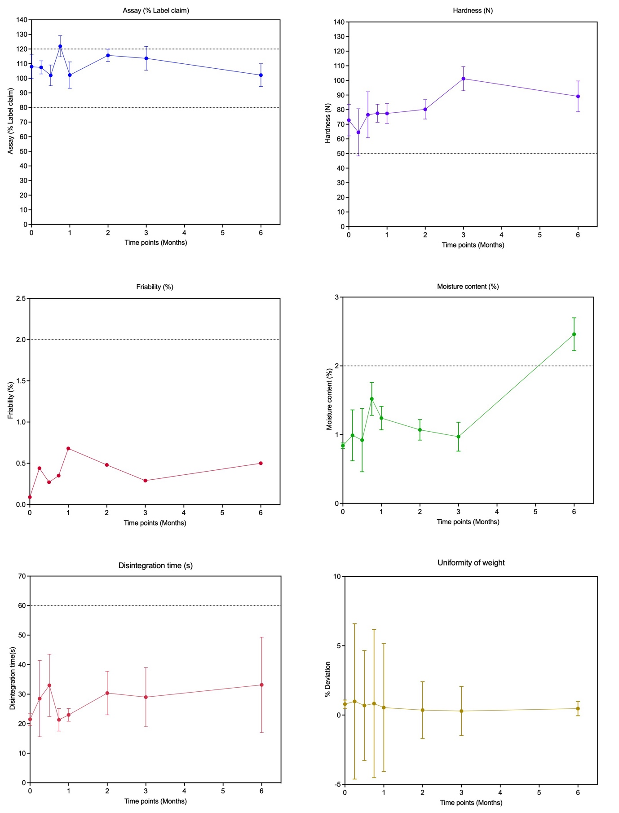
Fig. S2. Stability profile of the optimized Metformin HCl ODT formulation over 3 months under accelerated conditions (40 ± 2 °C / 75 ± 5% RH)

