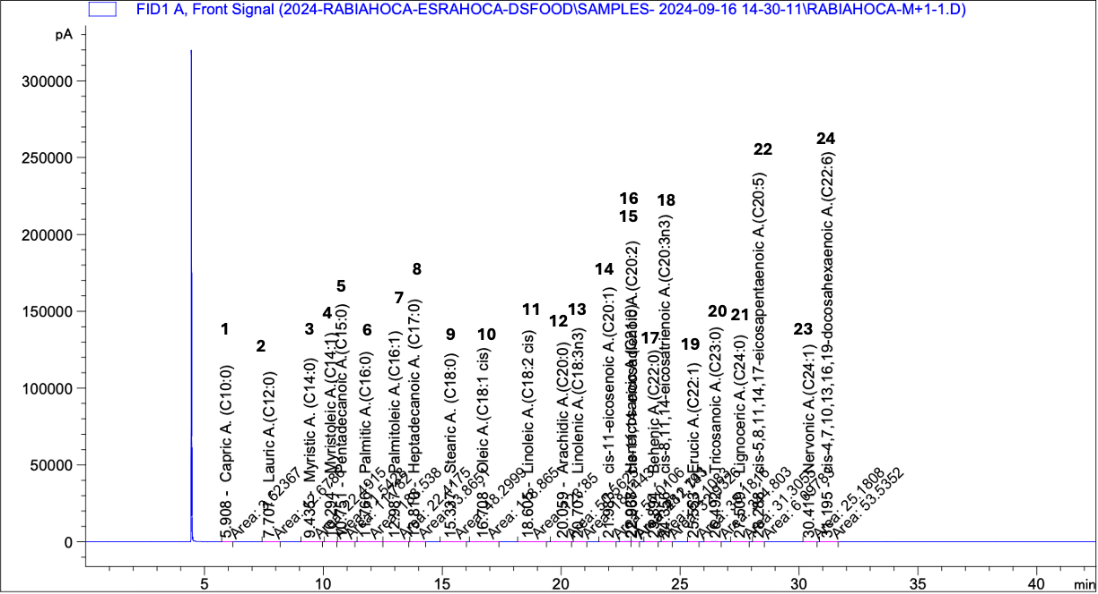

- GC−FID chromatogram of the hexane extract of M. hirsuta subsp. asiatica

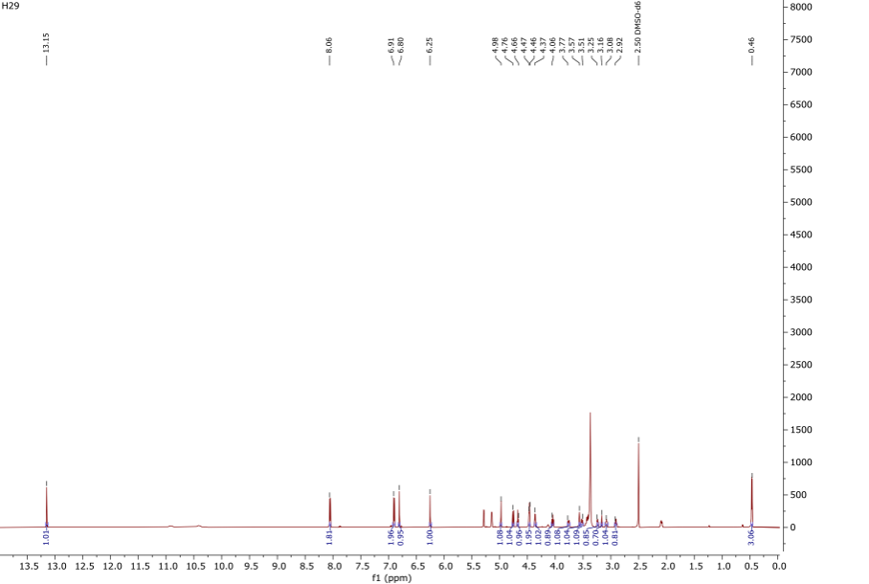
- ¹H- NMR (600 MHz, DMSO-d₆) spectrum of compound 29

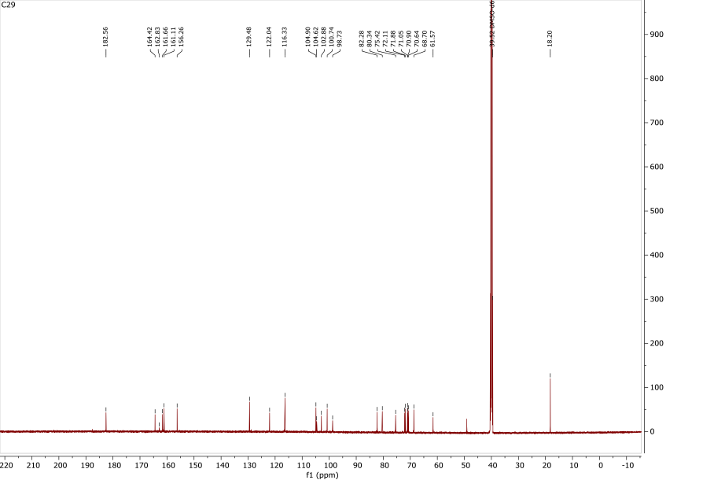
- ¹³C- NMR (125 MHz, DMSO-d₆) spectrum of compound 29

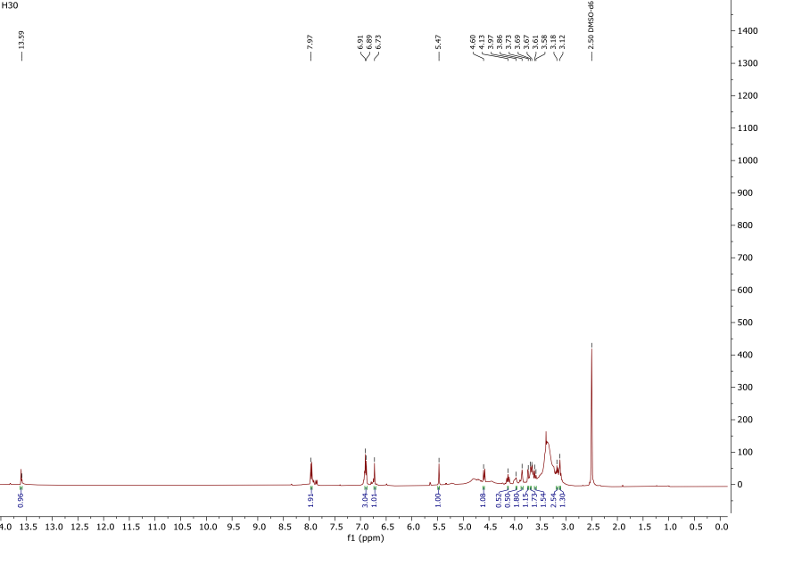
- ¹H- NMR (600 MHz, DMSO-d₆) spectrum of compound 30

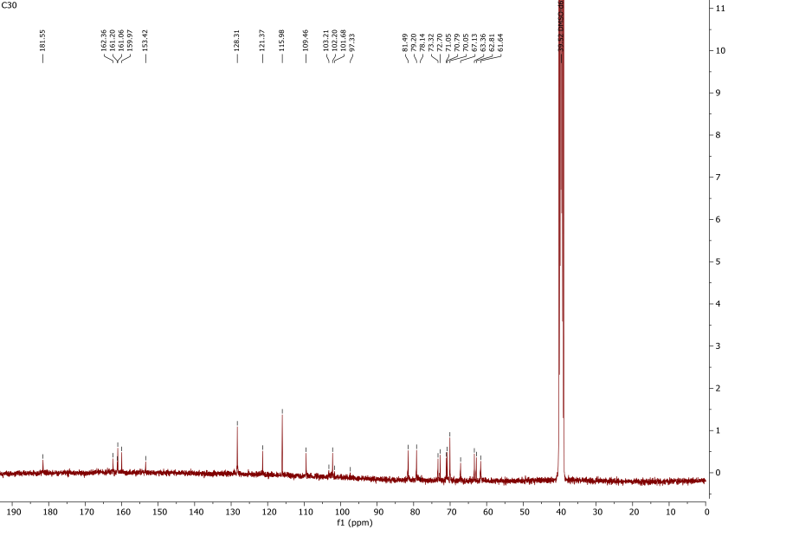
- ¹³C- NMR (125 MHz, DMSO-d₆) spectrum of compound 30

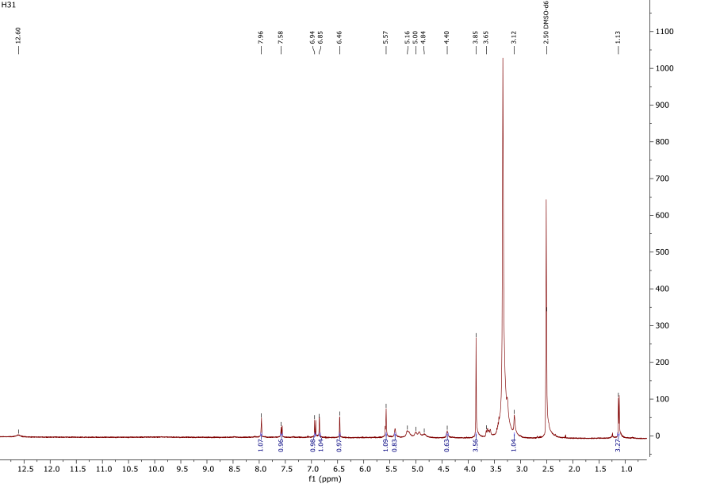
- ¹H- NMR (600 MHz, DMSO-d₆) spectrum of compound 31

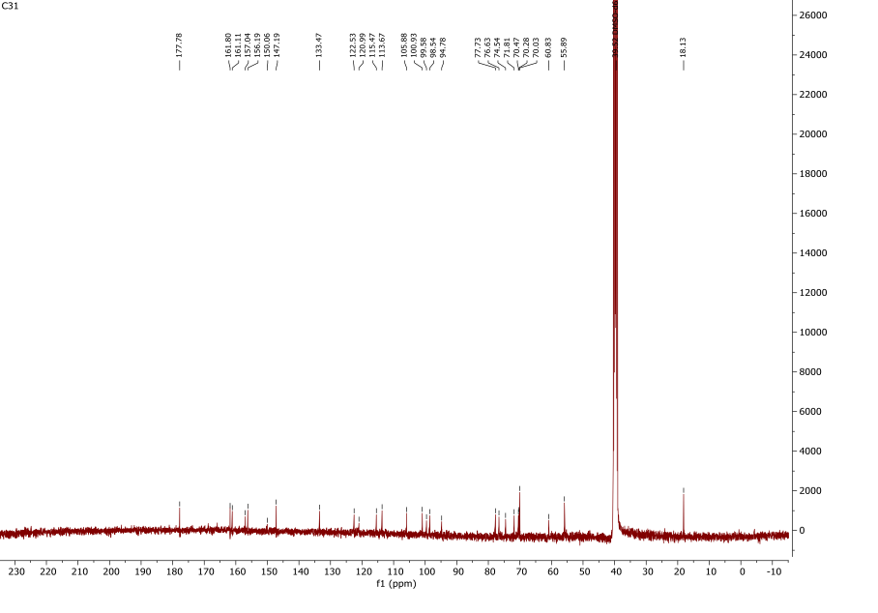
- ¹³C- NMR (125 MHz, DMSO-d₆) spectrum of compound 31

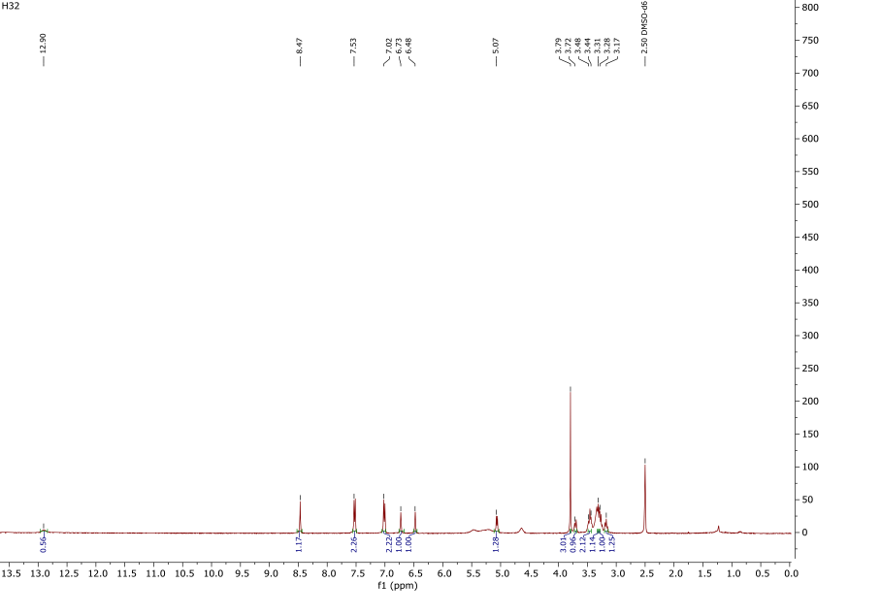
- ¹H- NMR (600 MHz, DMSO-d₆) spectrum of compound 32

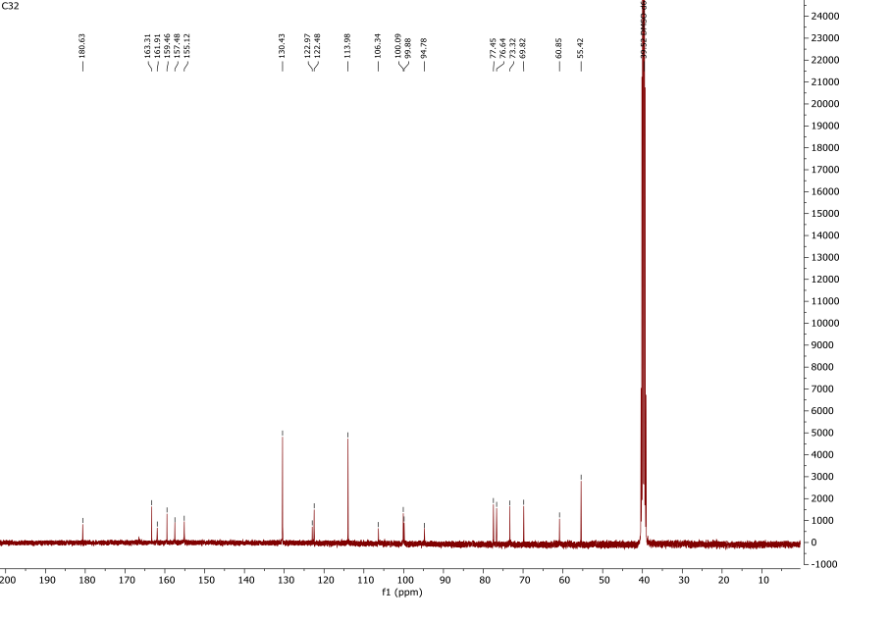
- ¹³C- NMR (125 MHz, DMSO-d₆) spectrum of compound 32

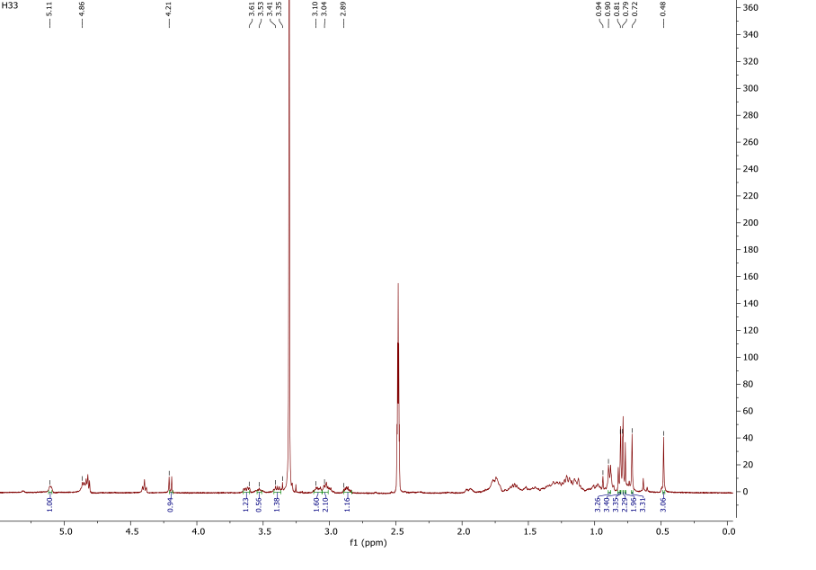
- ¹H- NMR (600 MHz, DMSO-d₆) spectrum of compound 33

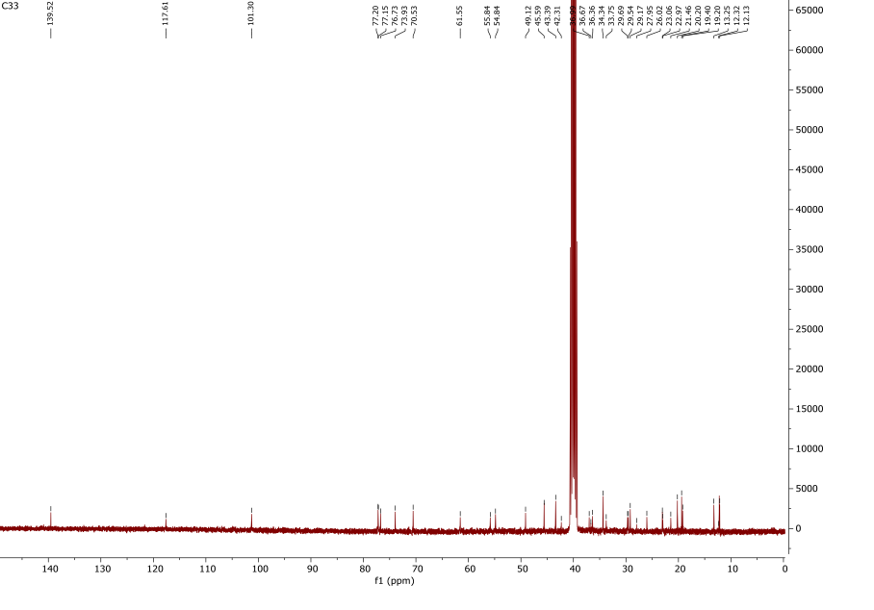
- ¹³C- NMR (125 MHz, DMSO-d₆) spectrum of compound 33

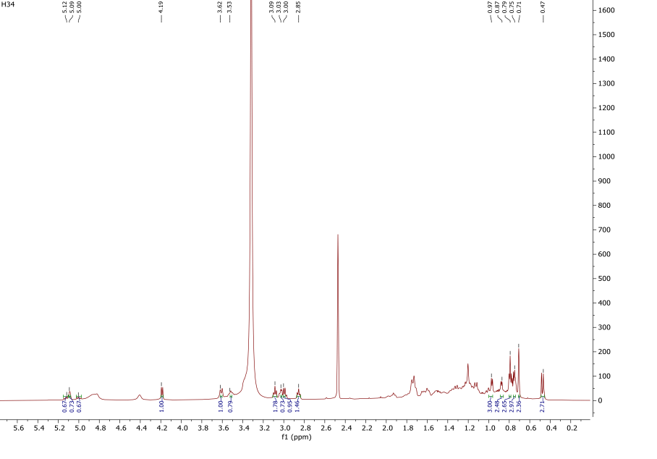
- ¹H- NMR (600 MHz, DMSO-d₆) spectrum of compound 34

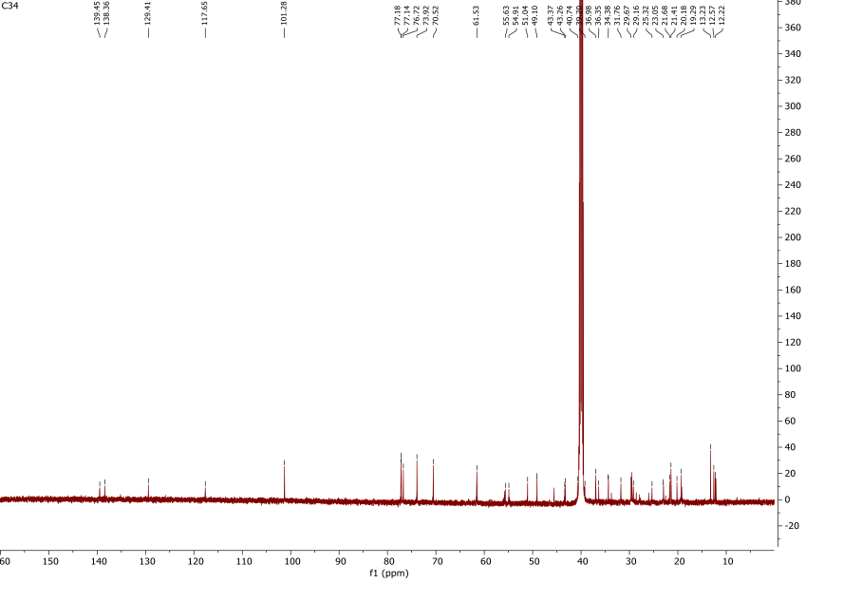
- ¹³C- NMR (125 MHz, DMSO-d₆) spectrum of compound 34

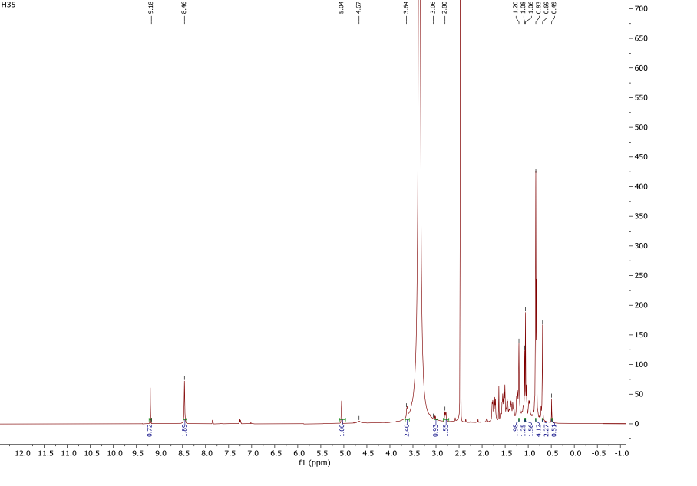
- ¹H- NMR (600 MHz, DMSO-d₆) spectrum of compound 35

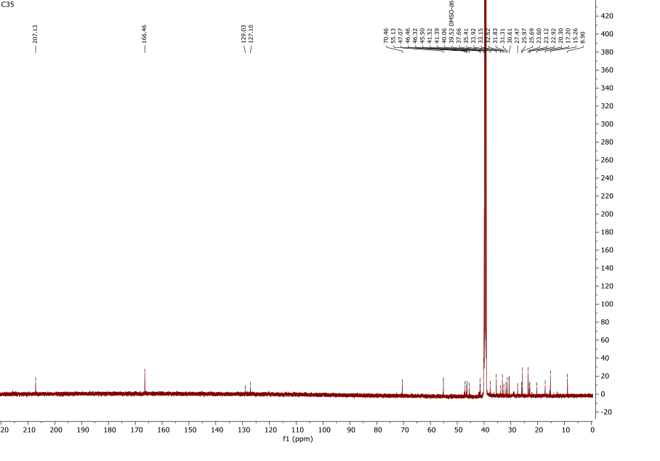
- ¹³C- NMR (125 MHz, DMSO-d₆) spectrum of compound 35
Table S1 ¹³C and ¹H NMR Data of the Aglycone Moieties Compounds 29-32 (125 and 600 MHz, δ ppm, in DMSO-d₆)
 | 29 |  | 30 |  | 31 |  | 32
 | δC | δH (J in Hz) | δC | δH (J in Hz) | δC | δH (J in Hz) | δC | δH (J in Hz)
2 | 164.42 | - | 161.20 | - | 157.04 | - | 155.12 | 8.45, s
3 | 102.88 | 6.80, s | 102.01 | 6.73, s | 133.47 | - | 122.97 | -
4 | 182.56 | - | 181.55 | - | 177.78 | - | 180.63 | -
5 | 161.11 | - | 161.06 | - | 161.11 | - | 163.31 | -
6 | 98.73 | 6.25, s | 109.88 | - | 99.58 | 6.46, d (J = 2.2) | 99.88 | 6.48, s
7 | 162.83 | - | 162.36 | - | 161.80 | - | 161.91 | -
8 | 104.90 | - | 97.33 | 6.91, s | 94.78 | 6.85, d (J = 2.2) | 94.78 | 6.69, s
9 | 156.26 | - | 153.42 | - | 156.45 | - | 157.48 | -
10 | 104.62 | - | 103.21 | - | 105.88 | - | 106.34 | -
1′ | 122.04 | - | 121.37 | - | 120.99 | - | 122.48 | -
2′ | 129.48 | 8.06, d, (J = 8.8) | 128.31 | 7.97, d, (J = 8.8) | 113.92 | 7.96, d, (J = 1.8) | 130.43 | 7.46, d, (J = 8.8)
3′ | 116.33 | 6.91, d, (J = 8.8) | 115.98 | 6.89, d, (J =8.8) | 147.19 | - | 113.98 | 7.01, d, (J = 8.4)
4′ | 161.66 | - | 159.97 | - | 150.06 | - | 159.46 | -
5′ | 116.33 | 6.91, d, (J = 8.8) | 115.98 | 6.89, d, (J =8.8) | 115.47 | 6.94, d, (J = 8.4) | 113.98 | 7.01, d, (J = 8.4)
6′ | 129.48 | 8.06, d, (J = 8.8) | 128.31 | 7.97, d, (J =8.8) | 122.53 | 7.58, dd,(J = 2.2, 8.4) | 130.43 | 7.46, d, (J = 8.8)
3′-OCH₃ |  | - | - | - | 55.89 | 3.85 (3H, s) | - | -
4′-OCH₃ |  | - | - | - | - | - | 55.42 | 3.79 (3H, s)

Table S2 ¹³C and ¹H NMR Data of the Sugar Moieties Compounds 29-32 (125 and 600 MHz, δ ppm, in DMSO-d₆)
 | 29 |  | 30 |  | 31 |  |  |  | 32
 | δC | δH (J in Hz) | δC | δH (J in Hz) | δC | δH (J in Hz) |  |  | δC | δH (J in Hz)
 | C-β-D-Glc (at C-8) |  | C-β-D-Glc (at C-6) |  | O-β-D-Glc (at C-7) |  |  |  | O-β-D-Glc (at C-7)
1″ | 72.11 | 4.75, d, (J = 10.0) | 73.32 | 4.60, d, (J =9.7) | 100.93 |  | 5.57, d, (J = 7.2) | 100.09 |  | 5.07, d, (J = 7.2)
2″ | 75.42 | 3.85-3.11, m | 71.05 | 3.97-3.11, m | 76.63 |  | 3.85-3.11, m | 77.45 |  | 3.44-3.17, m
3″ | 80.34 | 3.85-3.11, m | 79.20 | 3.97-3.11, m | 74.54 |  | 3.85-3.11, m | 76.64 |  | 3.44-3.17, m
4″ | 71.05 | 3.85-3.11, m | 67.13 | 3.97-3.11, m | 70.47-70.03 |  | 3.85-3.11, m | 69.82 |  | 3.44-3.17, m
5″ | 82.68 | 3.85-3.11, m | 81.49 | 3.97-3.11, m | 77.63 |  | 3.85-3.11, m | 73.32 |  | 3.44-3.17, m
6″ | 61.57 | 3.65- 3.60, dd  (J = 7.0, 11.0) | 61.64 | 3.65- 3.60, dd  (J = 7.0, 11.0) | 60.83 |  | 3.77- 3.53, dd  (J = 7.0, 11.0) | 60.85 |  | 3.72- 3.48, dd  (J = 7.0, 11.0)
 | O-α-L-rha (at C-2″glc) |  | O-β-D-Glc (at C-7) |  | O-α-L-rha (at C-2″glc)
1‴ | 100.74 | 4.98, br. s | 101.68 | 5.47 d, (J = 7.2) | 98.54 |  | 5.40, br. s
2‴ | 70.90 | 3.85-3.11, m | 72.70 | 3.97-3.11, m | 70.47-70.03 |  | 3.85-3.11, m
3‴ | 70.64 | 3.85-3.11, m | 70.79 | 3.97-3.11, m | 70.47-70.03 |  | 3.85-3.11, m
4‴ | 71.88 | 3.85-3.11, m | 70.05 | 3.97-3.11, m | 71.8 |  | 3.85-3.11, m
5‴ | 68.70 | 3.85-3.11, m | 78.14 | 3.97-3.11, m | 70.47-70.03 |  | 3.85-3.11, m
6‴ | 18.20 | 0.67, (3H) d  (J = 6.2) | 63.36 | 3.86- 3.73, dd  (J = 7.0, 11.0) | 18.13 |  | 1.12, (3H) d,  (J = 6.2)

Table S3 ¹³C and ¹H NMR Data of the Aglycone Moieties Compounds 33-35 (125 and 600 MHz, δ ppm, in DMSO-d6)
 | 33 |  |  |  | 34 |  |  | 35
 | δC | δH (J in Hz) |  | δC |  |  | δH (J in Hz) |  |  | δC | δH (J in Hz)
1 | 36.67 | … | 36.98 |  |  | … |  |  | 35.41 |  | …
2 | 29.69 | … | 29.67 |  |  | … |  |  | 25.69 |  | …
3 | 76.73 | … | 76.72 |  |  | … |  |  | 70.46 |  | 3.64, dd (11.2, 4.5)
4 | 36.99 | … | 36.35 |  |  | … |  |  | 55.13 |  | -
5 | 42.31 | … | 43.26 |  |  | … |  |  | 47.07 |  | 1.32
6 | 29.54 | … | 29.52 |  |  | … |  |  | 20.30 |  | …
7 | 117.61 | 5.11 | 117.65 |  |  | 5.12 |  |  | 32.62 |  | …
8 | 139.52 | - | 139.45 |  |  | - |  |  | 37.66 |  | -
9 | 49.32 | … | 49.10 |  |  | … |  |  | 46.46 |  | 1.74
10 | 34.34 | - | 34.38 |  |  | - |  |  | 33.92 |  | -
11 | 21.46 | … | 21.68 |  |  | … |  |  | 23.60 |  | …
12 | 39.34 | … | 39.20 |  |  | … |  |  | 127.10 |  | 5.04, s
13 | 43.39 | - | 43.37 |  |  | - |  |  | 129.03 |  | -
14 | 54.84 | … | 54.91 |  |  | … |  |  | 41.52 |  | -
15 | 23.06 | … | 23.05 |  |  | … |  |  | 27.47 |  | …
16 | 27.95 | … | 29.16 |  |  | … |  |  | 22.92 |  | …
17 | 55.84 | … | 55.63 |  |  | … |  |  | 45.50 |  | -
18 | 12.13 | 0.48, s | 12.22 |  |  | 0.47, d (J= 11.0) |  |  | 41.39 |  | 3.06 dd (13.5, 3.8)
19 | 13.25 | 0.70, s | 13.25 |  |  | 0.71, s |  |  | 46.32 |  | …
20 | 36.36 | … | 40.74 |  |  | … |  |  | 30.61 |  | -
21 | 19.20 | 0.94, d, (J= 6.9) | 20.18 |  |  | 0.97, d, (J= 6.9) |  |  | 33.15 |  | …
22 | 33.75 | … | 138.36 |  |  | 5.12 br.d, (J= 6.6) |  |  | 31.31 |  | …
23 | 26.02 | … | 129.41 |  |  | 5.00 br.d, (J= 6.6) |  |  | 207.13 |  | 8.46, s
24 | 45.59 | … | 51.04 |  |  | … |  |  | 8.90 |  | 1.08, s
25 | 29.17 | … | 31.76 |  |  | … |  |  | 15.26 |  | 1.06, s
26 | 20.20 | 0.79, d, (J= 6.3) | 21.43 |  |  | 0.79, d, (J= 6.3) |  |  | 17.20 |  | 0.49, s
27 | 19.40 | 0.74, d, (J= 6.3) | 19.29 |  |  | 0.75, d, (J= 6.3) |  |  | 25.97 |  | 1.20, s
28 | 22.97 | … | 25.32 |  |  | … |  |  | 166.46 |  | 9.18, s
29 | 12.32 | 0.87, t (6.9) | 12.57 |  |  | 0.87, t (6.9) |  |  | 31.83 |  | 0.69, s
30 |  |  |  |  |  |  |  |  | 23.12 |  | 0.83, s
… : Not identified

Table S4 ¹³C and ¹H NMR Data of the Sugar Moieties Compounds 33 and 34 (125 and 600 MHz, δ ppm, in DMSO-d₆)
 | 33 |  |  |  | 34
 | δC |  | δH (J in Hz) |  | δC | δH (J in Hz)
 |  | β-D-glucose at C-7 |  | β-D-glucose at C-7
1′ | 101.30 |  | 4.21, d (J=7.8) |  | 101.28 | 4.19, d (J=7.8)
2′ | 77.20-77.15 |  | 3.53-3.04, m |  | 77.20-77.15 | 3.09-3.00, m
3′ | 77.20-77.15 |  | 3.53-3.04, m |  | 77.20-77.15 | 3.09-3.00, m
4′ | 70.53 |  | 3.53-3.04, m |  | 70.52 | 3.09-3.00, m
5′ | 73.93 |  | 2.89, m |  | 73.92 | 2.85, m
6′ | 61.55 |  | 3.61-3.35, d (J=11.5 Hz) |  | 61.53 | 3.62-3.35, d, (J=11.5 Hz)

