Influence of Formulation Composition and Rheological Properties on the Stability of PnPP19 Peptide in Thermoresponsive Hydrogels
FROHLICH, Anna Lucia^{a,b}; MOREIRA, Magali Portelaª, TRINDADE, Camilla Nunes dos Reis^{c}; NEVES, Gabriela Westerlund Peixoto^{c}; LACATIVA, Paulo Gustavo^{c}; PAESE, Karina^{d}; AGUIRRE, Tanira Alessandra Silveira^{a,b,}*
ªGrupo de Pesquisa em Nanomedicina – TANANO, Universidade Federal de Ciências da Saúde de Porto Alegre. 90050-170, Porto Alegre, RS, Brasil.
^{b}Programa de Pós-Graduação em Biociências, Universidade Federal de Ciências da Saúde de Porto Alegre. 90050-170, Porto Alegre, RS, Brasil.
^{c} Biozeus Biopharmaceutical S.A. Rua Visconde de Pirajá 623, 9 andar. 22410-003, Rio de Janeiro, RJ, Brasil.
^{d}Programa de Pós-Graduação em Ciências Farmacêuticas, Faculdade de Farmácia, Universidade Federal do Rio Grande do Sul. 90610-001, Porto Alegre, RS, Brasil.

*Corresponding author: tanira@ufcspa.edu.br

Supplementary Material

Figure S1: Mean linearity curve. Data fitted with a linear mathematical model. Range 10-100 µg mL⁻¹.
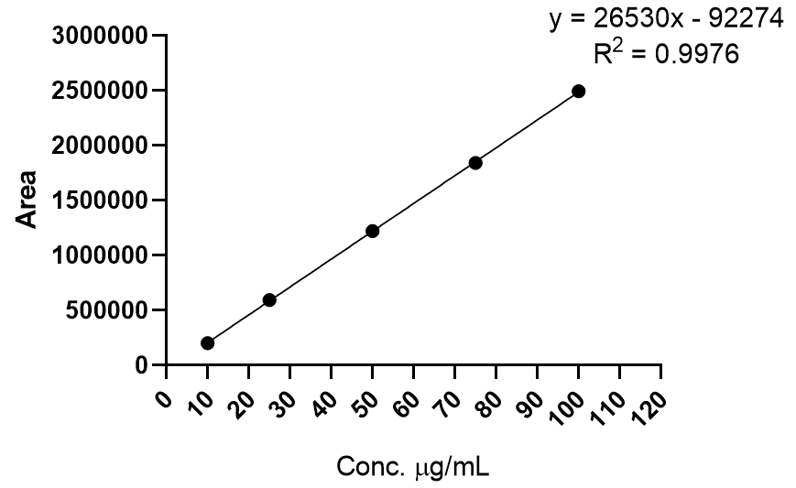

Table S1: Precision, accuracy, work range, limit of detection (LOD), and limit of quantification (LOQ) values.
Precision  (%RSD ± SD) | Inter-day (n=7) | 1.55% ± 0.06
Precision  (%RSD ± SD) | Intra-day (n=14) | 1.66% ± 0.19
Accuracy  (mean ± SD) | Low (25 µg mL⁻¹) (n=3) | 101.18% ± 2.70
Accuracy  (mean ± SD) | Medium (50 µg mL⁻¹) (n=3) | 99.75% ± 0.48
Accuracy  (mean ± SD) | High (75 µg mL⁻¹) (n=3) | 101.01% ± 1.25
Range |  | 10 – 100 µg mL⁻¹
LOQ |  | 10 µg mL⁻¹
LOD |  | 3.33 µg mL⁻¹

Table S2: Statistical analysis of 14F-PEHG, 16F-PEHG, and 17F-PEHG after 1, 3 and 6 months at 25 ºC.
Time (Month) | Comparison |  | p-value*
1 | 17F-PEHG | 14F-PEHG | 0.0175
1 | 17F-PEHG | 16F-PEHG | 0.5775
1 | 14F-PEHG | 16F-PEHG | 0.0376
3 | 17F-PEHG | 14F-PEHG | 0.0003
3 | 17F-PEHG | 16F-PEHG | <0.0001
3 | 14F-PEHG | 16F-PEHG | 0.6771
6 | 17F-PEHG | 14F-PEHG | 0.1655
6 | 17F-PEHG | 16F-PEHG | 0.8321
6 | 14F-PEHG | 16F-PEHG | 0.2446
*ANOVA one-way unpaired with Tukey post-hoc.

Table S3: Statistical analysis of 14S-PEHG vs. 14F-PEHG and 16S-PEHG vs. 16F-PEHG up to 9 months at 25 ºC.
 | p-value*
Time  (Month) | 14S-PEHG vs. 14F-PEHG | 16S-PEHG vs. 16F-PEHG
1 | 0.4149 | 0.0256
2 | 0.0035 | <0.0001
3 | 0.1733 | 0.0024
4 | <0.0001 | 0.0002
5 | 0.0004 | 0.0003
6 | 0.0034 | 0.0004
9 | 0.0028 | 0.0009
*Unpaired t-test with Welch’s correction of p value.

Figure S2: Degradation behavior of selected formulations at 25 ºC.
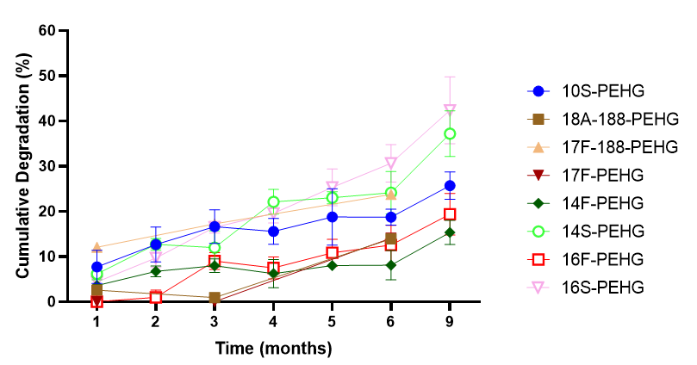

Table S4: Statistical analysis of 10S-PEHG vs. 16F-PEHG up to 9 months at 25 ºC.
Time  (Month) | p-value*
1 | 0.0011
2 | 0.0003
3 | 0.0021
4 | 0.0004
5 | 0.0289
6 | 0.0170
9 | 0.0053
*Unpaired t-test with Welch’s correction of p value
Figure S3: Cumulative percentage degradation of the peptide in formulations 10S-PEHG and 16F-PEHG at 5 (A), 25 (B), and 40 °C (C).
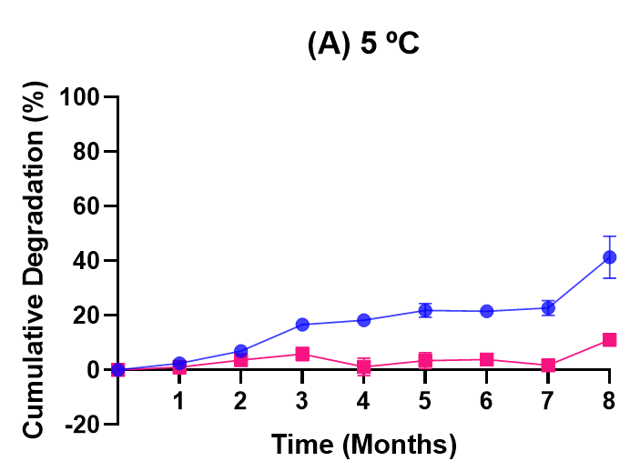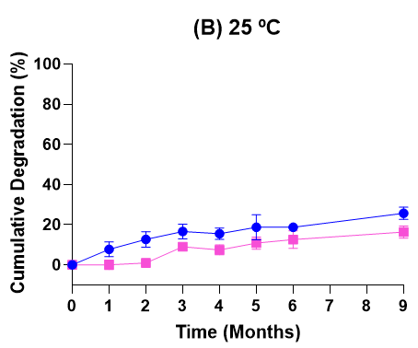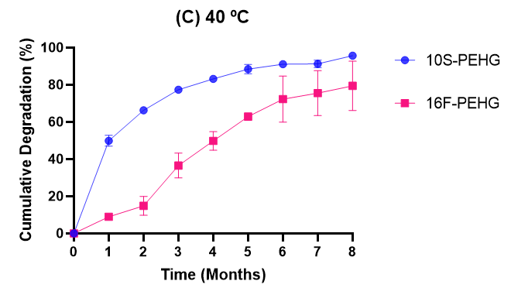

Figure S4: Dynamic light scattering (DLS) size distributions of 10S-PEHG and 16F-PEHG at 5, 25, and 40 °C. Size distributions are presented by intensity, number, and volume. Samples were analyzed without dilution using backscatter detection at 173° (n = 3).
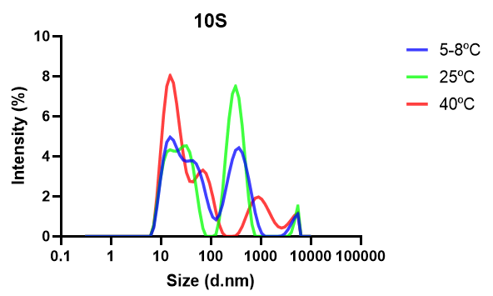 | 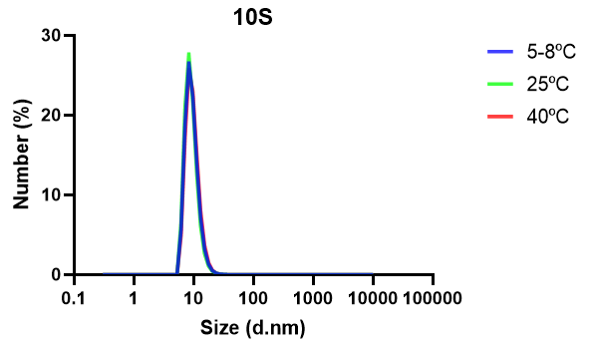 | 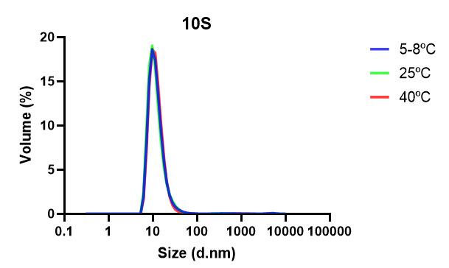
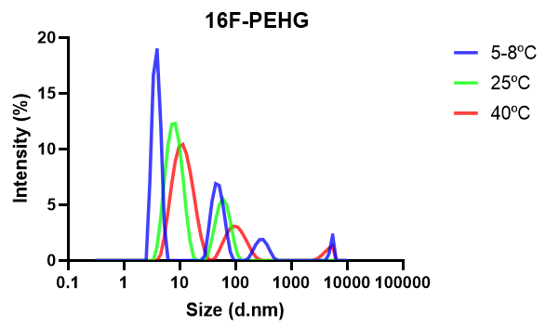 | 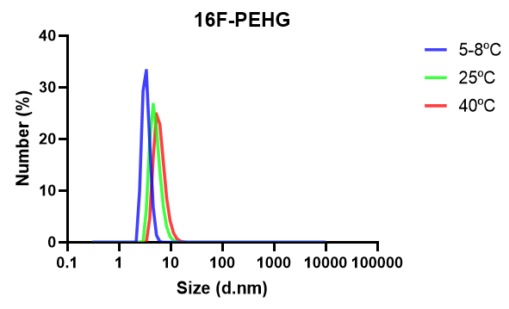 | 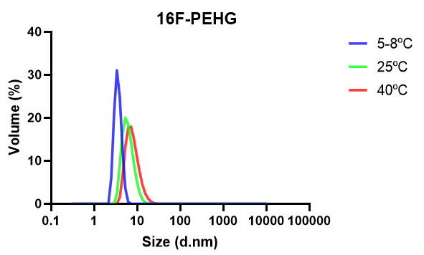

Table S5: Dynamic light scattering (DLS) characterization of 10S-PEHG and 16F-PEHG at 5, 25, and 40 °C. Hydrodynamic size distributions are reported by intensity, number, and volume, together with the polydispersity index (PDI). Results are expressed as mean ± standard deviation (n = 3). Samples were analyzed without dilution.

Formulation 10S-PEHG
Temperature |  |  |  | Hydrodynamic diameter (nm)
(⁰C) | PDI |  |  | Intensity |  |  | Number |  |  | Volume
5 | 0.82 | ± | 0.02 | 112.0 | ± | 162.2 | 10.3 | ± | 0.7 | 13.1 | ± | 0.5
25 | 0.92 | ± | 0.06 | 128.5 | ± | 176.2 | 9.6 | ± | 0.6 | 12.5 | ± | 0.7
40 | 0.53 | ± | 0.03 | 19.2 | ± | 1.3 | 9.7 | ± | 0.1 | 12.5 | ± | 0.1
Formulation 16F-PEHG
Temperature |  |  |  | Hydrodynamic diameter (nm)
(⁰C) | PDI |  |  | Intensity |  |  | Number |  |  | Volume
5 | 0.61 | ± | 0.04 | 4.4 | ± | 1.1 | 3.9 | ± | 1.1 | 4.2 | ± | 1.1
25 | 0.13 | ± | 0.01 | 8.2 | ± | 0.1 | 5.0 | ± | 0.2 | 6.2 | ± | 0.2
40 | 0.30 | ± | 0.17 | 12.3 | ± | 0.4 | 6.3 | ± | 0.6 | 8.0 | ± | 0.5

