Supplementary Information

Fed-batch fermentative bioconversion to valorize lignin aromatics into 2-pyrone-4,6-dicarboxylic acid through engineered Pseudomonas putida KT2440

Jeong Yeon Seong^{1†}, Byoung Wook Jeon^{1†}, Siseon Lee¹, Jong Pyo Kim¹, Young Joo An¹, Inhui Lee², Eun Seo Lee³, Mi Hee Ryu⁴, Ashutosh Pandey⁵, Jungki Ryu^{2,6}, Hyung Chul Kim^{7*}, Si Jae Park^{3*}, and Jeong Chan Joo^{1*}

¹Department of Chemical Engineering, Kyung Hee University, Yongin 17104, Korea
²School of Energy and Chemical Engineering, Ulsan National Institute of Science and Technology (UNIST), Ulsan 44919, Korea
³Department of Chemical Engineering and Materials Science, Graduate Program in System Health Science and Engineering, Ewha Womans University, Seoul 03760, Korea
⁴Green Carbon Research Center, Korea Research Institute of Chemical Technology (KRICT), Daejeon 34114, Korea
⁵Department of Biotechnology & Bioengineering, School of Biosciences & Technology, Galgotias University, Greater Noida, Uttar Pradesh 203201, India
⁶Graduate School of Carbon Neutrality, Ulsan National Institute of Science and Technology (UNIST), Ulsan 44919, Korea
⁷Department of Future Science and Technology Business, Korea University, Seoul 02841, Korea

†These authors contributed equally to this work.

*Corresponding authors
Jeong Chan Joo
Tel: 031-201-3684
E-mail: jcjoo@khu.ac.kr
Si Jae Park
Tel: 02-3277-4756
E-mail: parksj93@ewha.ac.kr
Hyung Chul Kim
Tel: 02-3290-4811
E-mail: kugene@korea.ac.kr

Table S1. Strain information used in this study
Strain | Description | Reference
KT-PDC | Pseudomonas putida KT2440  △pcaGH::ligAB △crc::ligC | Lee et al., 2022
KT-PDCV | P. putida KT-PDC  △ewd::Ptac:vanAB | Lee et al., 2025

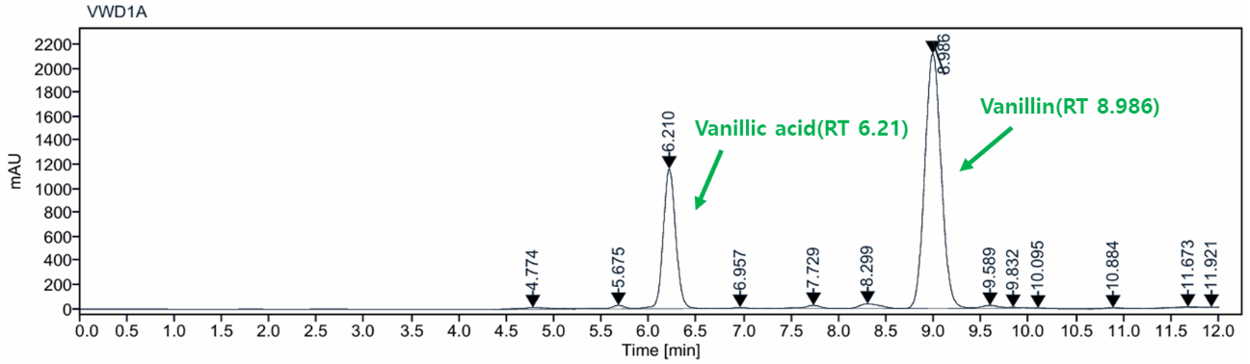

Fig. S1. HPLC chromatograms of real lignin samples exhibited VA (RT 6.21 min) and VN (RT 8.99 min) detected at 280 nm. HPLC: high performance liquid chromatography, VA: vanillic acid, VN: vanillin, RT: retention time (min).

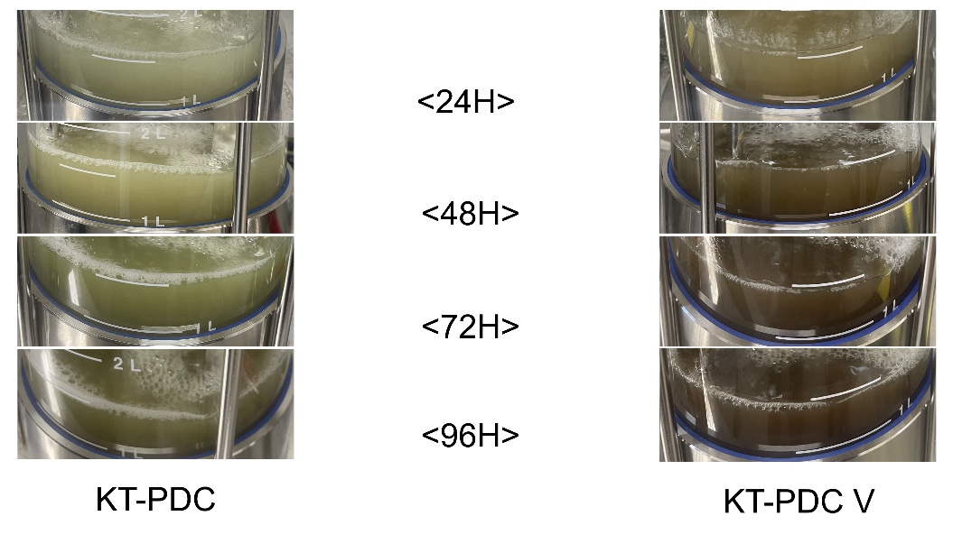

Fig. S2. The change of medium color during the PDC production in the presence of CA, FA, and SA. The overexpression of vanAB strengthened the competitive pathway of gallate, which is a strong oxidative reagent changing brown color. PDC: 2-pyrone-4,6-dicarboxylic acid, CA: coumaric acid, FA: ferulic acid, SA: syringic acid, vanAB: vanillate O-demethylase.

