Supplementary Figure
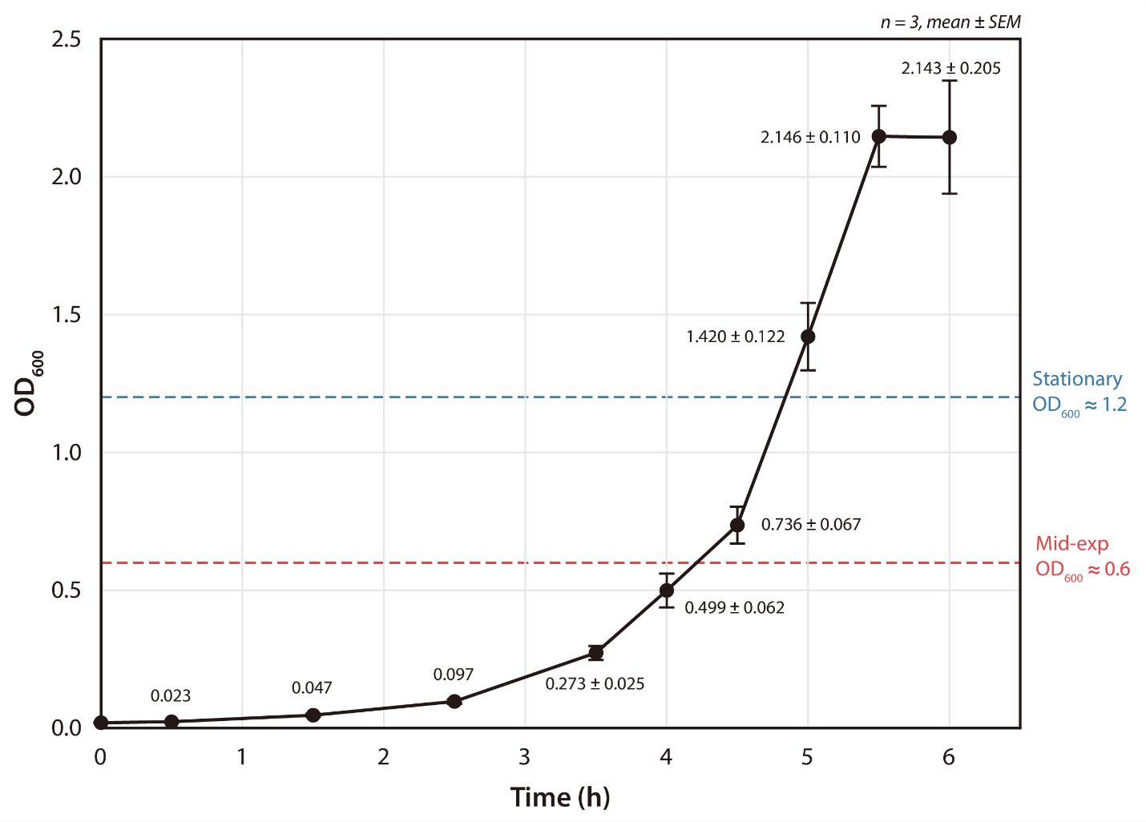
Fig. S1. Growth curve of Klebsiella pneumoniae MGH 78578 in M9 minimal medium with 0.2 % (w/v) glucose. OD₆₀₀ was measured at 30-min intervals over 6 h in three biological replicates (n = 3). Symbols and error bars represent the mean ± standard error of the mean (SEM). Vertical dashed lines mark the ChIP-exo sampling points: mid-exponential phase (OD₆₀₀ ≈ 0.6) and stationary phase (OD₆₀₀ ≈ 1.2). Per-point labels show the mean OD₆₀₀; ± SEM is annotated at the later time points (3.5–6 h, where SEM ≥ 0.01) and omitted at the earlier time points where SEM was below 0.01. ChIP-exo: chromatin immunoprecipitation with exonuclease treatment.

