___________________________________________________________________________
Supplementary Material

Enhancing TGF-β1 production in CHO cells via MS-275 treatment, Bax/Bak knockout, and PACEsol overexpression

Kyungsoo Kim¹*, Kyoung Eun Baek¹, and Gyun Min Lee^{1,2}*

¹Department of Biological Sciences, KAIST, Daejeon 34141, Korea
²Graduate School of Engineering Biology, KAIST, Daejeon 34141, Korea
___________________________________________________________________________
*Correspondence
Kyungsoo Kim
Tel:+82-10-9953-1592
E-mail: kks@glugene.com
Gyun Min Lee
Tel:+82-42-350-2618
E-mail: gyunminlee@kaist.ac.kr
Table S1. Candidate chemical additives tested for enhancing rhTGF-β1 production in rCHO cells
Function | Chemical additives | Dose | Vehicle | References
Antioxidant | Butylated hydroxyanisole (BHA) | 50 μM | DMSO | [1,2]
Antioxidant | N-Acetylcysteine (NAC) | 100 μM | DMSO | [3-6]
Antioxidant | Baicalein | 100 μM | DMSO | [7-8]
Antioxidant | Berberine chloride | 10 μM | DMSO | [7]
Antioxidant | Kaempferol | 10 μM | DMSO | [7]
Antioxidant | Apigenin | 10 μM | DMSO | [7]
Chemical chaperone | 4-Phenylbutyric acid (4-PBA) | 10 mM | Medium | [9-12]
Chemical chaperone | Trimethylamine N-oxide (TMAO) | 10 mM | Medium | [10,12,13]
Chemical chaperone | Proline | 100 mM | Medium | [9]
Chemical chaperone | CuSO₄ | 100 μM | Medium | [14-16]
Chemical chaperone | β-alanine | 1 mM | Medium | [14]
Chemical chaperone | β-cyclodextrin | 1 mM | Medium | [14]
Chemical chaperone | BiP Inducer X (BIX) | 100 μM | DMSO | [1]
Chemical chaperone | Tauroursodeoxycholic acid (TUDCA) | 200 μM | DMSO | [1,10,12]
Chemical chaperone | Carbazole | 5 μM | DMSO | [1]
HDAC  inhibitor | Apicidin | 250 nM | DMSO | [17]
HDAC  inhibitor | CI994 | 10 μM | DMSO | [17]
HDAC  inhibitor | Suberoylanilide hydroxamic acid (SAHA) | 5 μM | DMSO | [17]
HDAC  inhibitor | MS-275 | 5 μM | DMSO | [17]
HDAC  inhibitor | Trichostatin A (TSA) | 500 nM | DMSO | [17]
rhTGF-β1: recombinant human transforming growth factor-β1, rCHO: recombinant Chinese hamster ovary, DMSO: dimethyl sulfoxide, HDAC: histone deacetylase.

Table S2. Raw experimental data and two-way ANOVA summary for maximum viable cell concentration (MVCC) and specific hTGF-β1 productivity (q_{hTGF-β1}) corresponding to Fig. 3
Raw experimental data of MVCC and q _{hTGF-β1}
MS-275 dose | Cell line | Replicate | MVCC  (cells/mL) | q_{hTGF-β1} value (pg/cell/day)
 | Parental | 1 | 7.2E+06 | 0.06
NT control | Parental | 2 | 8.4E+06 | 0.06
 | Parental | 3 | 8.8E+06 | 0.06
 | BBKO#28 | 1 | 7.8E+06 | 0.06
NT control | BBKO#28 | 2 | 7.3E+06 | 0.10
 | BBKO#28 | 3 | 8.1E+06 | 0.05
 | Parental | 1 | 8.2E+06 | 0.08
Vehicle control | Parental | 2 | 7.6E+06 | 0.08
 | Parental | 3 | 8.0E+06 | 0.08
 | BBKO#28 | 1 | 8.0E+06 | 0.08
Vehicle control | BBKO#28 | 2 | 8.1E+06 | 0.11
 | BBKO#28 | 3 | 8.0E+06 | 0.07
 | Parental | 1 | 5.4E+06 | 0.16
5 µM | Parental | 2 | 6.1E+06 | 0.16
 | Parental | 3 | 6.3E+06 | 0.14
 | BBKO#28 | 1 | 6.8E+06 | 0.14
5 µM | BBKO#28 | 2 | 6.1E+06 | 0.18
 | BBKO#28 | 3 | 7.2E+06 | 0.10
 | Parental | 1 | 4.6E+06 | 0.18
7.5 µM | Parental | 2 | 5.1E+06 | 0.17
 | Parental | 3 | 5.1E+06 | 0.17
 | BBKO#28 | 1 | 5.6E+06 | 0.15
7.5 µM | BBKO#28 | 2 | 5.3E+06 | 0.22
 | BBKO#28 | 3 | 6.4E+06 | 0.15
 | Parental | 1 | 4.3E+06 | 0.18
10 µM | Parental | 2 | 4.4E+06 | 0.18
 | Parental | 3 | 5.2E+06 | 0.17
 | BBKO#28 | 1 | 5.8E+06 | 0.16
10 µM | BBKO#28 | 2 | 4.7E+06 | 0.24
 | BBKO#28 | 3 | 5.8E+06 | 0.18
 | Parental | 1 | 4.0E+06 | 0.20
15 µM | Parental | 2 | 4.5E+06 | 0.19
 | Parental | 3 | 4.2E+06 | 0.18
 | BBKO#28 | 1 | 4.3E+06 | 0.19
15 µM | BBKO#28 | 2 | 4.7E+06 | 0.29
 | BBKO#28 | 3 | 5.7E+06 | 0.18
 | Parental | 1 | 4.1E+06 | 0.18
20 µM | Parental | 2 | 3.8E+06 | 0.19
 | Parental | 3 | 4.0E+06 | 0.17
 | BBKO#28 | 1 | 4.3E+06 | 0.18
20 µM | BBKO#28 | 2 | 4.3E+06 | 0.27
 | BBKO#28 | 3 | 4.6E+06 | 0.22
Two-way ANOVA summary
Response | Source of  variation | df (num, den) | F ratio | p value
MVCC | MS-275 dose | (6,28) | 62.98 | < 0.0001
 | Cell line | (1,28) | 9.89 | 0.0039
 | Dose × Cell line | (6,28) | 1.36 | 0.263
q _{hTGF-β1} | MS-275 dose | (6,28) | 22.35 | < 0.0001
 | Cell line | (1,28) | 2.21 | 0.148
 | Dose × Cell line | (6,28) | 0.62 | 0.709
Raw data represent biological replicates (n = 3) of parental and BBKO #28 cells treated with the indicated concentrations of MS-275. BBKO: Bax and Bak knockout, NT: non-treated.
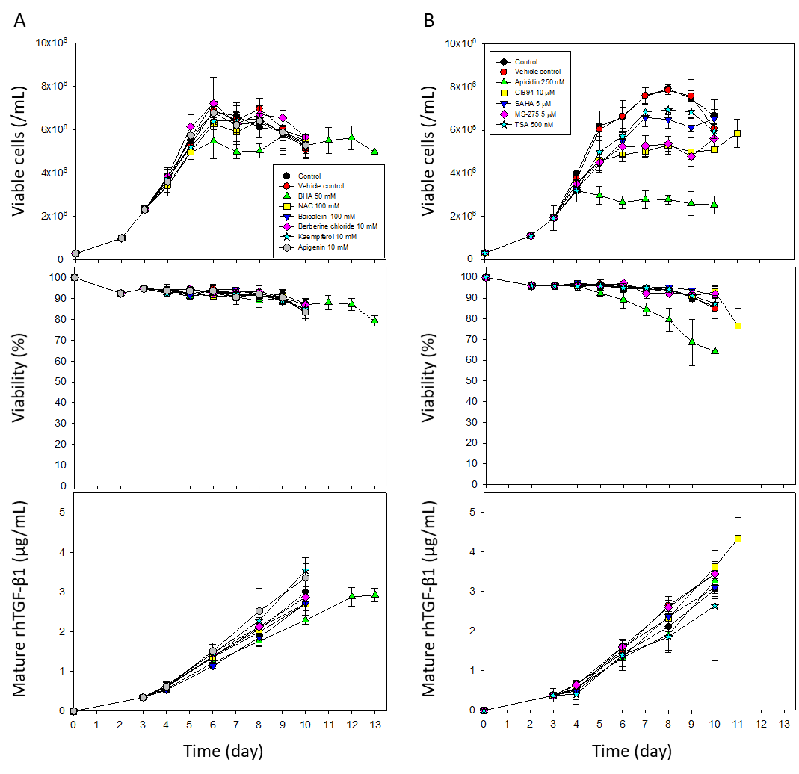
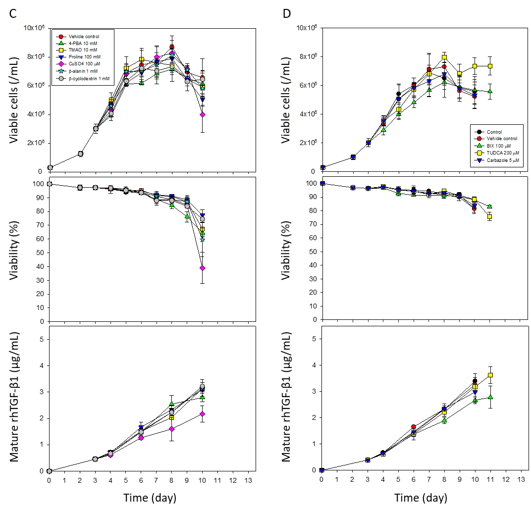
Fig. S1. Profiles of cell growth, cell viability, and mature rhTGF-β1 concentrations during flask cultures of CHO-rhTGF-β1 #35 cells treated with (A) antioxidants, (B) iHDACs, and chemical chaperones dissolved in (C) fresh medium or (D) DMSO. rhTGF-β1: recombinant human transforming growth factor-β1, CHO: Chinese hamster ovary, iHDAC, histone deacetylase inhibitor; DMSO: dimethyl sulfoxide.
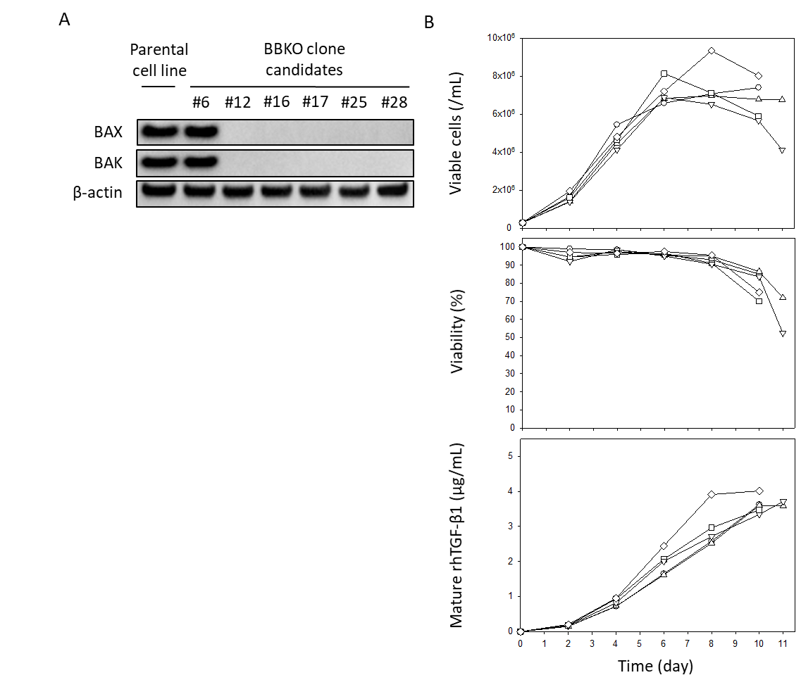
Fig. S2. Bax and Bak double-knockout (BBKO) clones were generated in the CHO-rhTGF-β1 cell line using the CRISPR/Cas9 system. (A) Western blot analysis of Bax and Bak in cell lysates harvested on day 10 of culture in 12-well plates. The parental cell line was included as a positive control for BAX and BAK. β-actin served as the loading control. (B) Cell growth profiles and mature rhTGF-β1 concentrations in flask cultures of BBKO clones: #12 (circle), #16 (triangle), #17 (square), #25 (inverted triangle), and #28 (diamond). rhTGF-β1: recombinant human transforming growth factor-β1, CHO: Chinese hamster ovary.

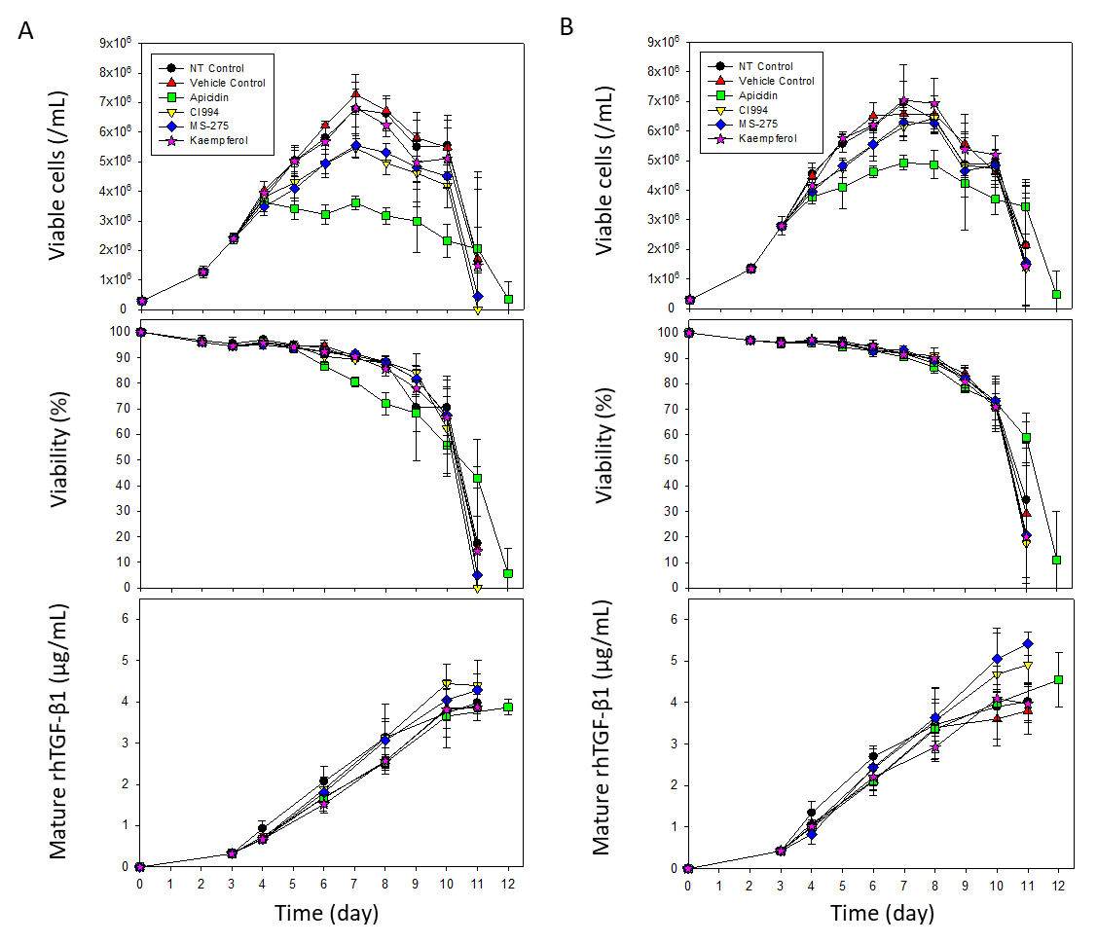
Fig. S3. Profiles of cell growth, cell viability, and mature rhTGF-β1 concentrations during flask cultures of (A) parental and (B) BBKO #28 cell lines treated with chemical additives. Symbols indicate non-treated (NT) control (black circle), vehicle control (red triangle), apicidin (green square), CI994 (yellow inverted triangle), MS-275 (blue diamond), and kaempferol (pink star). rhTGF-β1: recombinant human transforming growth factor-β1, BBKO: Bax and Bak knockout.

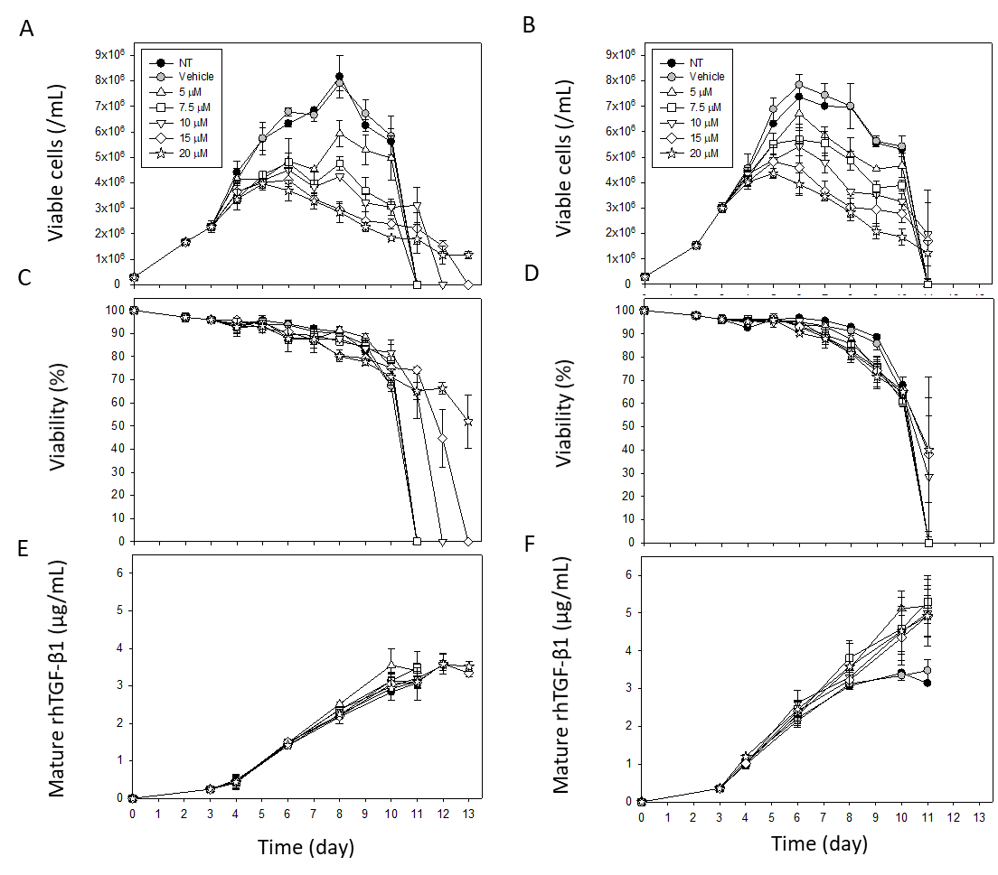
Fig. S4. Profiles of (A, B) cell growth, (C, D) cell viability, and (E, F) mature rhTGF-β1 concentrations in parental and BBKO #28 cells with various concentrations of MS-275. The left panels (A, C, E) represent parental cells, and the right panels (B, D, F) represent BBKO #28 cells. Non-treated (NT) control (black circle), vehicle control (gray circle), MS-275 5 μM (white triangle), 7.5 μM (white square), 10 μM (white inverted triangle), 15 μM (white diamond), and 20 μM (white star) are shown. rhTGF-β1: recombinant human transforming growth factor-β1, BBKO: Bax and Bak knockout.

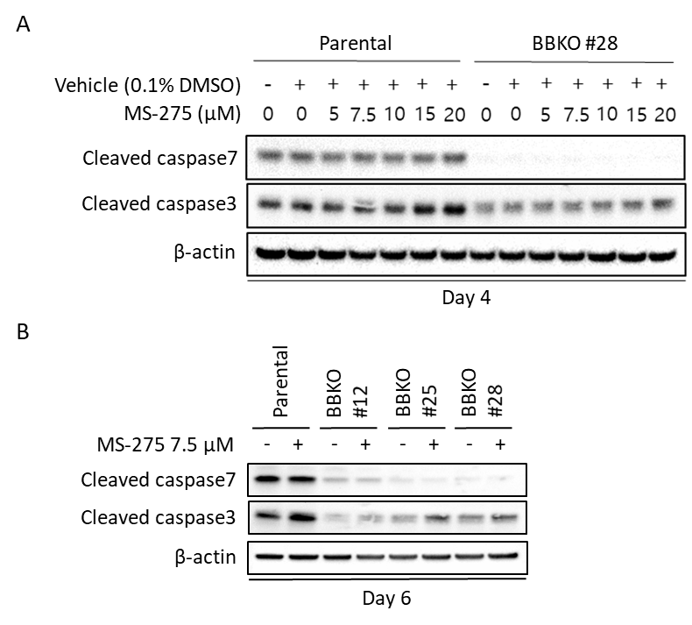
Fig. S5. Western blot analysis of cleaved caspases in cell lysates. (A) Day 4 of batch cultures of parental and BBKO #28 cell lines treated with various concentrations of MS-275. (B) Day 6 of batch cultures of parental and three BBKO clones (#12, #25, #28) treated with 7.5 μM MS-275. β-actin was used as a loading control. BBKO: Bax and Bak knockout.

References
[1] Ha TK, Hansen AH, Kildegaard HF et al (2019) BiP inducer X: an ER stress inhibitor for enhancing recombinant antibody production in CHO cell culture. Biotechnol J 14:e1900130. doi:10.1002/biot.201900130
[2] Malhotra JD, Miao H, Zhang K et al (2008) Antioxidants reduce endoplasmic reticulum stress and improve protein secretion. Proc Natl Acad Sci U S A 105:18525–18530. doi:10.1073/pnas.0809677105
[3] Oh HK, So MK, Yang J et al (2005) Effect of N-Acetylcystein on butyrate-treated Chinese hamster ovary cells to improve the production of recombinant human interferon-beta-1a. Biotechnol Prog 21:1154–1164. doi:10.1021/bp050057v
[4] Wu W, Abraham L, Ogony J et al (2008) Effects of N-acetylcysteine amide (NACA), a thiol antioxidant on radiation-induced cytotoxicity in Chinese hamster ovary cells. Life Sci 82:1122–1130. doi:10.1016/j.lfs.2008.03.016
[5] Tanel A, Averill-Bates DA (2007) Inhibition of acrolein-induced apoptosis by the antioxidant N-acetylcysteine. J Pharmacol Exp Ther 321:73–83. doi:10.1124/jpet.106.114678
[6] Ercal N, Treeratphan P, Lutz P et al (1996) N-actylcysteine protects Chinese hamster ovary (CHO) cells from lead-induced oxidative stress. Toxicology 108:57–64. doi:10.1016/s0300-483x(95)03273-i
[7] Ha TK, Hansen AH, Kol S et al (2018) Baicalein reduces oxidative stress in CHO cell cultures and improves recombinant antibody productivity. Biotechnol J 13:e1700425. doi:10.1002/biot.201700425
[8] Hamada H, Hiramatsu M, Edamatsu R et al (1993) Free radical scavenging action of baicalein. Arch Biochem Biophys 306:261–266. doi:10.1006/abbi.1993.1509
[9] Hwang SJ, Jeon CJ, Cho SM et al (2011) Effect of chemical chaperone addition on production and aggregation of recombinant flag-tagged COMP-angiopoietin 1 in Chinese hamster ovary cells. Biotechnol Prog 27:587–591. doi:10.1002/btpr.579
[10] Chollet ME, Skarpen E, Iversen N et al (20215) The chemical chaperone sodium 4-phenylbutyrate improves the secretion of the protein CA267T mutant in CHO-K1 cells trough the GRASP55 pathway. Cell Biosci 5:57. doi:10.1186/s13578-015-0048-4
[11] Andersen E, Chollet ME, Baroni M et al (2019) The effect of the chemical chaperone 4-phenylbutyrate on secretion and activity of the p.Q160R missense variant of coagulation factor FVII. Cell Biosci 9:69. doi:10.1186/s13578-019-0333-8
[12] Jiang X, Fang G, Dong L et al (2018) Chemical chaperone 4-phenylbutyric acid alleviates the aggregation of human familial pulmonary fibrosis-related mutant SP-A2 protein in part through effects on GRP78. Biochim Biophys Acta Mol Basis Dis 1864:3546–3557. doi:10.1016/j.bbadis.2018.08.014
[13] Dopp E, Hartmann LM, Florea AM et al (2004) Uptake of inorganic and organic derivatives of arsenic associated with induced cytotoxic and genotoxic effects in Chinese hamster ovary (CHO) cells. Toxicol Appl Pharmacol 201:156–165. doi:10.1016/j.taap.2004.05.017
[14] Mortazavi M, Shokrgozar MA, Sardari S et al (2019) Using chemical chaperones to increase recombinant human erythropoietin secretion in CHO cell line. Prep Biochem Biotechnol 49:535–544. doi:10.1080/10826068.2018.1479865
[15] Chaderjian WB, Chin ET, Harris RJ et al (2005) Effect of copper sulfate on performance of a serum-free CHO cell culture process and the level of free thiol in the recombinant antibody expressed. Biotechnol Prog 21:550–553. doi:10.1021/bp0497029
[16] Qian Y, Khattak SF, Xing Z et al (2011) Cell culture and gene transcription effects of copper sulfate on Chinese hamster ovary cells. Biotechnol Prog 27:1190–1194. doi:10.1002/btpr.630
[17] Kim D, Yoon C, Lee GM (2022) Small molecule epigenetic modulators for enhancing recombinant antibody production in CHO cell cultures. Biotechnol Bioeng 119:820–831. doi:10.1002/bit.28013

