SUPPLEMENTARY FIGURES

Figure S1. Location of deleterious variants within protein domains in HCM stratified by age. Each protein is linearly depicted with uniprot domain information. Non-random distribution of variants within each protein was assessed using Kolmogorov–Smirnov goodness-of-fit test. Light salmon bars show the constrained coding region scores across the entire protein. (a) MYH7 showing head, neck and rod/tail regions. Deleterious variants were non-uniformly distributed with significant clustering within head and neck domains in pediatric patients. (b) MYBPC3 showing the immunoglobulin and fibronectin type 3 domains. Deleterious variant distribution did not differ between pediatric and adult patients. (c) TTN showing the four regions and all domains. The light blue bars under titin show the transcript count index. (d) OBSCN LoF variants were uniformly distributed across protein domains.
HCM, hypertrophic cardiomyopathy; CCR, Constrained coding region; TCI, transcript count index; LoF, loss of function

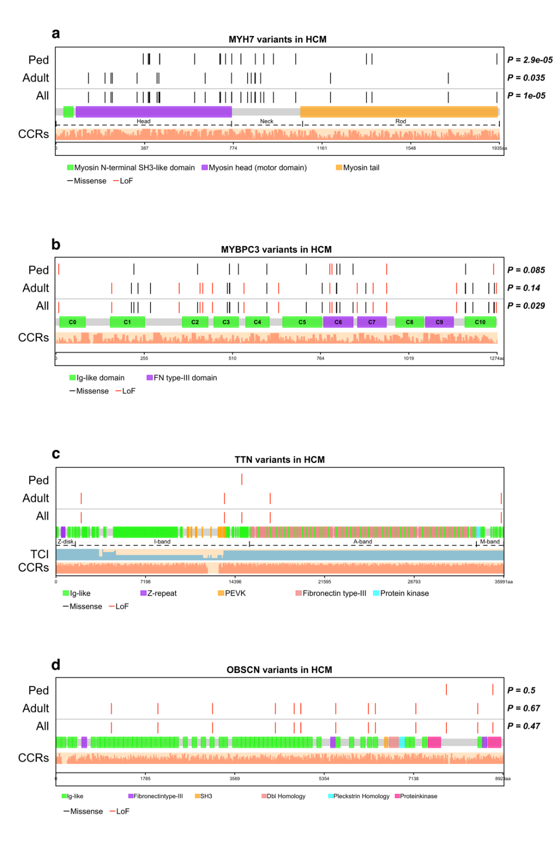
Figure S2. Location of deleterious variants within protein domains in DCM stratified by age. Each protein is linearly depicted with uniprot domain information. Non-random distribution of variants within each protein was assessed using Kolmogorov–Smirnov goodness-of-fit test. Light salmon bars show the constrained coding region scores across the entire protein. (a) MYH7 showing head, neck and rod/tail regions. Deleterious variants were more frequent in the neck and tail domains in pediatric and adult patients. (b) MYBPC3 showing the immunoglobulin and fibronectin type 3 domains. (c) TTN showing the four regions and all domains. The light blue bars under titin show the transcript count index. TTN variants clustered in the A-band particularly in adults. (d) OBSCN LoF variants were uniformly distributed across protein domains.
DCM, dilated cardiomyopathy; CCR, Constrained coding region; TCI, transcript count index; LoF, loss of function

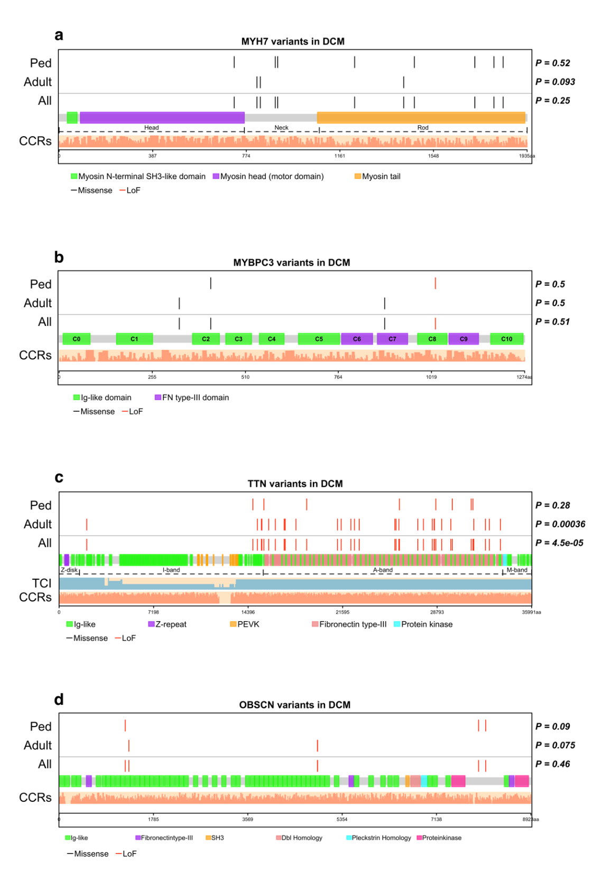

Figure S3. Location of deleterious variants within protein domains in HCM stratified by sex. Each protein is linearly depicted with uniprot domain information. Non-random distribution of variants within each protein was assessed using Kolmogorov–Smirnov goodness-of-fit test. Light salmon bars show the constrained coding region scores across the entire protein. (a) MYH7 showing head, neck and rod/tail regions. Deleterious variants were non-uniformly distributed with significant clustering within head and neck domains, especially in adults. (b) MYBPC3 showing the immunoglobulin and fibronectin type 3 domains. Deleterious variant distribution did not differ between pediatric and adult patients. (c) TTN showing the four regions and all domains. The light blue bars under titin show the transcript count index. (d) OBSCN LoF variants were uniformly distributed across protein domains.
HCM, hypertrophic cardiomyopathy; CCR, Constrained coding region; TCI, transcript count index; LoF, loss of function

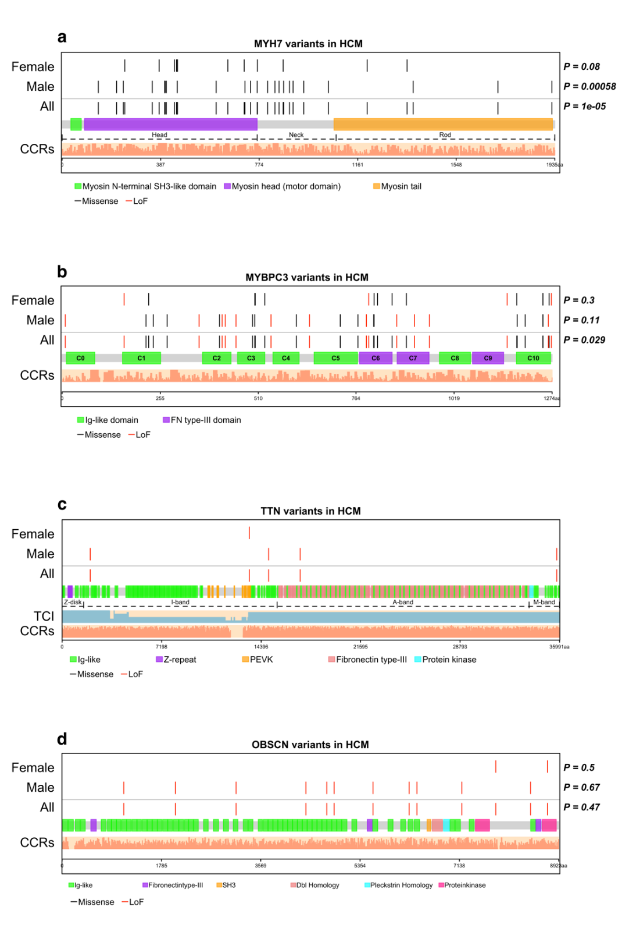

Figure S4. Location of deleterious variants within protein domains in DCM stratified by sex. Each protein is linearly depicted with uniprot domain information. Non-random distribution of variants within each protein was assessed using Kolmogorov–Smirnov goodness-of-fit test. Light salmon bars show the constrained coding region scores across the entire protein. (a) MYH7 showing head, neck and rod/tail regions. (b) MYBPC3 showing the immunoglobulin and fibronectin type 3 domains. (c) TTN showing the four regions and all domains. The light blue bars under titin show the transcript count index. TTN variants clustered in the A-band particularly in adults. (d) OBSCN LoF variants were uniformly distributed across protein domains.
DCM, dilated cardiomyopathy; CCR, Constrained coding region; TCI, transcript count index; LoF, loss of function

