Supplementary materials

Journal of Cardiovascular Translational Research

Past Trends and Future Directions of Cardiac Regenerative Medicine – A Systematic Analysis of Clinical Trial Registries

Maaike Wulfse*¹ BSc, Mats T. Vervoorn*¹ MD, Jantijn J.G.J. Amelink¹ BSc, Elisa M. Ballan^{1,2,3} MSc, Saskia C.A. De Jager³ PhD, Joost P.G. Sluijter^{3,4} PhD, Pieter A. Doevendans^{2,5} MD PhD, Peter-Paul M. Zwetsloot^{3,5} MD PhD, Niels P. Van der Kaaij¹ MD PhD

*Both authors contributed equally
¹University Medical Center Utrecht. Department of Cardiothoracic Surgery. Division of Heart & Lungs. Utrecht, The Netherlands
²Netherlands Heart Institute. Utrecht, The Netherlands
³University Medical Center Utrecht. Department of Cardiology, Laboratory of Experimental Cardiology. Division of Heart & Lungs. Utrecht, The Netherlands
⁴Regenerative Medicine Utrecht, Circulatory Health Research Center, University Utrecht, Utrecht, The Netherlands
⁵University Medical Center Utrecht. Department of Cardiology. Division of Heart & Lungs. Utrecht, The Netherlands

Supplementary files

Supplementary table 1
Supplementary table 1A. Other primary outcomes
Other primary outcome measures | Number
Feasibility | 11
Hospitalization (unspecified) | 8
VO2 max | 6
Wall thickness | 5
Heart failure hospitalization | 4
Heart failure (unspecified) | 3
Laboratory parameters (unspecified) | 3
Myocardial viability | 3
VO2 | 3
Clinical events (unspecified) | 2
Coronary atherosclerotic burden | 2
Hypersensitivity | 2
Inflammation | 2
Maximum tolerated dose | 2
Morbidity | 2
Myocardial infarction | 2
Myocarditis | 2
Myocardium metabolic | 2
Number of tolerated LVAD weans | 2
Recurrence of myocardial infarction | 2
RVEDV & RVESV | 2
Tumors | 2
Toxicity | 2
Anti-adenovirus antibodies | 1
Atherosclerosis | 1
Biodistribution of the vector | 1
Cardiac arrest | 1
Clinical stabilization of cardiomyopathy | 1
Complications with drug administration method | 1
ECG parameters | 1
Evaluation of cardiomyocyte histologic correction | 1
Immune sensitization | 1
Intervention for graft failure | 1
Interventions (unspecified) | 1
Intraoperative hemostasis | 1
Ischemic score | 1
LV dimensions | 1
LV filling pressure | 1
MLHFQ score | 1
MSC identification | 1
Myocardial innervation | 1
Myocardial rupture | 1
Pharmacodynamics & pharmacokinetics | 1
Post-operative complication | 1
Procedure success | 1
Pulmonary capillary wedge pressure | 1
Restenosis | 1
Risk of surgery | 1
RVEF | 1
Survival benefit | 1
Temperature | 1
Time to 1 mm ST depression during exercise-stress testing | 1
Time to onset of ischemic ECG changes during ETT | 1
Tolerability (unspecified) | 1
Total atheroma volume | 1
Tricuspid regurgitation | 1
Troponin | 1
Tumor markers | 1
Uncontrolled systemic infection | 1
Unplanned myocardial revascularization surgery/angioplasty | 1
Unstable angina hospitalization | 1
VEGF-levels | 1

Supplementary table 1B. Other outcome additional imaging or tests
Other outcome additional imaging or tests
Advanced imaging | 1
Biopsy | 2
Cardiopulmonary testing | 1
Image analyses | 1
Intravascular ultrasound | 2
Scintigraphy | 1
Tc-sestamibi scintigraphy | 1
Thallium scintigraphy | 1
Ventriculography | 1

Supplementary table 2

Table 2A. Cell types and donor-origin in regenerative cardiac cell therapy
Cell type | Number (%) | Chart
Bone marrow-derived | 130 (45.8) | ||||||||||||||||||||||||||||||||||||||||||||||||||||||||||||||||||||||||||||||||||||||||||||||||||||||||||||||||||||||||||||||||||
Cardiac-associatedª | 29 (10.2) | |||||||||||||||||||||||||||||
Umbilical cord-derived | 24 (8.5) | ||||||||||||||||||||||||
Adipose tissue-derived | 17 (6.0) | |||||||||||||||||
Skelet muscle-derived | 5 (1.8) | |||||
Unspecified | 77 (27.1) | |||||||||||||||||||||||||||||||||||||||||||||||||||||||||||||||||||||||||||||
Other^{b} | 2 (0.7) | ||
Donor-origin | Number (%) | Chart
Autologous | 191 (67.3) | |||||||||||||||||||||||||||||||||||||||||||||||||||||||||||||||||||||||||||||||||||||||||||||||||||||||||||||||||||||||||||||||||||||||||||||||||||||||||||||||||||||||||||||||||||||||||||||||
Allogeneic | 63 (22.2) | |||||||||||||||||||||||||||||||||||||||||||||||||||||||||||||||
Ex vivo cultured | 4 (1.4) | ||||
Unspecified | 26 (9.2) | ||||||||||||||||||||||||||
ªA cardiac associated cell was either derived from cardiac tissue or altered to become a cardiomyocyte of cardiomyocyte-progenitor.
^{b}Other modalities of cell therapy included extracellular vesicle-enriched secretome of cardiovascular progenitor cells differentiated from induced pluripotent stem cells and autologous mesenchymal stem cell derived exosomes and mitochondria.

Supplementary table 2B. Stem cells utilized in regenerative cardiology registrated clinical trials
Cell | Number | Chart
Unspecified | 91 | |||||||||||||||||||||||||||||||||||||||||||||||||||||||||||||||||||||||||||||||||||||||||||
AC 133+ | 2 | ||
Cardiac-associated | 29 | |||||||||||||||||||||||||||||
CD 133+ | 15 |  | |||||||||||||||
CD 34+ | 18 | ||||||||||||||||||
Mononuclear | 45 | |||||||||||||||||||||||||||||||||||||||||||||
DC | 1 | |
G-CSF | 5 | |||||
Ixmyelocel-T | 3 | |||
Mesenchymal | 70 | ||||||||||||||||||||||||||||||||||||||||||||||||||||||||||||||||||||||
Skeletal muscle cell | 5 | |||||
Mesenchymal stem cell derived exosomes and mitochondria | 1 | |

Supplementary table 2C. Cardiac-associated stem cells utilized in regenerative cardiology registrated clinical trials
Cardiac-associated stem cells
Allogeneic cardiac stem cells
Allogeneic cardiosphere-derived cells | 4x
Allogeneic iPS Cell-derived cardiomyocytes | 2x
Allogenic human pluripotent stem cell-derived cardiomyocytes
Autologous CardAP-cells
Autologous cardiac progenitor cell transplantation
Autologous cardiac stem cells
Autologous cardiac stem cells (JRM-001) | 2x
Autologous cardiac stem cells derived from right atrium | 2x
Autologous cardiosphere-derived stem cells
Autologous human cardiac-derived stem cells
Bone marrow mesenchymal cardiopoietic cells | 3x
Bone marrow-derived cardiopoietic cells
C-kit+ cardiac stem cells
Cardiac progenitor cells
Cardiosphere-derived cells
Extracellular vesicle-enriched secretome of cardiovascular progenitor cells
Human embryonic stem cells derived cardiomyocytes
Human Pluripotent stem cell-derived cardiomyocytes
iPS differentiated cardiomyocytes | 5x

Supplementary table 3

Supplementary table 3. Heterogeneity of terms for cell therapy administration method used in clinical trial registration
Cell therapy method specified
Cell mobilization | 4
Cell transfusion | 1
Endocardial implantation | 2
Endocardial injection | 3
Endomyocardial injection | 5
Epicardial injection | 3
Gelatin Hydrogel Sheet | 1
Infusion into coronary sinus | 3
Injection in left axillary lymph node | 1
Intracardiac cell infusion | 2
Intracardiac administration | 1
Intracoronary administration | 10
Intracoronary infusion | 59
Intracoronary injection | 28
Intracoronary transfer | 5
Intracoronary transplantation | 9
Intramuscular injection | 1
Intramyocardial administration | 4
Intramyocardial implantation | 9
Intramyocardial infusion | 2
Intramyocardial injection | 81
Intramyocardial transplantation | 4
Intrapericardial injection | 1
Intravenous | 21
Intraventricular injection | 1
Laser channels | 1
MyoStar® (Biosense Webster) injection catheter | 1
Single injection of 0.1-0.2 ml around each laser channel | 1
Transendocardial injection | 13

Supplementary table 4

Supplementary table 4. Gene therapies in clinical trial registries
Type | Vector | Gene/coding for | Number of trials
AAV1/SERCA2a | Adeno-associated virus serotype 1 capsid | SERCA2A |  | 7
Ad5FGF-4 | Adenovirus 5 | FGF 4 |  | 4
AAVrh.10hFXN | Rh.10 adeno-associated virus | Fraxatin |  | 2
Ad5.hAC6 | Adenovirus 5 | Adenylyl cyclase type 6 |  | 2
VM202RY | Hybrid dna | HGF |  | 2
AAV2i8 | Adeno-associated virus serotype 2 synthetic capsid variant | Protein phosphatase inhibitor 1 |  | 2
AAV9.LAMP2B | Adeno-associated virus serotype 9 | Lysosome-associated membrane protein 2 isoform B transgene |  | 1
AAVRH.74 | Rh. 74 adeno-associated virus | Human Plakophillin-2a |  | 1
ACRX-100 | Plasmid DNA | Stromal Cell-Derived Factor 1 (SDF-1) |  | 1
Ad-HGF | Adenovirus | HGF |  | 1
ADGVVEGF121.10NH | Adenovirus | VEGF 121 |  | 1
AdKCNH2-G628S | Adenovirus | Genetic mutation in the KCNH2 gene (hERG potassium channel) |  | 1
AdVEGF-All6A+ | Adenovirus | VEGF |  | 1
AdVEGF-D | Adenovirus | VEGF D (Dimutase homolog) |  | 1
AdVEGFXC1 | Adenovirus | VEGF |  | 1
hVEGF165 | Not specified | VEGF 165 |  | 1
INXN-4001 | Plasmid DNA | Stromal Cell-Derived Factor 1α, VEGF 165, and S100A1 calcium-binding protein |  | 1
NTLA-2001 | Lipid nanoparticles | CRISPR/Cas9 gene editing system |  | 1
pVGI.1(VEGF2) | Plasmid DNA | VEGF 2 |  | 1
TN-201 | Adeno-associated virus serotype 9 | Myosin binding protein C3 |  | 1
VEGF | Not specified | VEGF |  | 1
VEGF | Plasmid DNA | VEGF |  | 1
VEGF-A165/bFGF | Plasmid DNA | VEGF and FGF |  | 1
VEGF-D | Adenovirus | VEGF D (Dimutase homolog) |  | 1
VEGF1 | Plasmid DNA | VEGF 1 |  | 1
VEGF165 | Not specified | VEGF 165 |  | 1
VM202 | Plasmid DNA | HGF |  | 1
Abbreviations: FGF = Fibroblast growth factor; HGF = Hepatocyt growth factor; VEGF = Vascular endothelial growth factor

Supplementary table 5

Supplementary table 5. Tissue engineering in clinical trial registries
Investigated tissue engineering
ADR-002K administered through cell spray
Alginate hydrogel (2x)
Algisyl device
Allogeneic umbilical cord Wharton’s jelly-derived adult mesenchymal stem cells colonized on human pericardial matrix
Atrial Appendage Micrograft Transplant patch
Autologous atrial appendage micrografts with fibrin gel
Autologous myoblast sheet
Collagen patches with adipose-derived stem cells
CorMatrix extracellular matrix biomaterial
Engineered heart muscle
Epicardial delivery of a fibrin patch embedding human embryonic stem cell-derived CD15+ Isl-1+ progenitors
Extracellular matrix patch with cultured Wharton’s jelly mesenchymal stem cells
Gelatin hydrogel sheet incorporating with basic fibroblast growth factor
Heart patch developed from amnion bilayer seeded with amnion epithelial stem cells and patient’s autologous cardiomyocytes
Human (allogeneic) iPS cell-derived cardiomyocyte sheet
Human umbilical cord-derived mesenchymal stem cells with injectable collagen scaffold
Tissue engineered vascular grafts
VentriGel

Supplementary figure 1
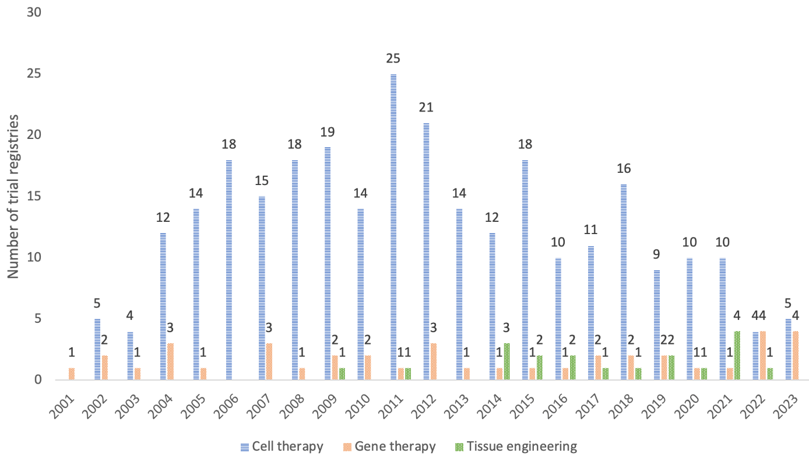
1b
1a
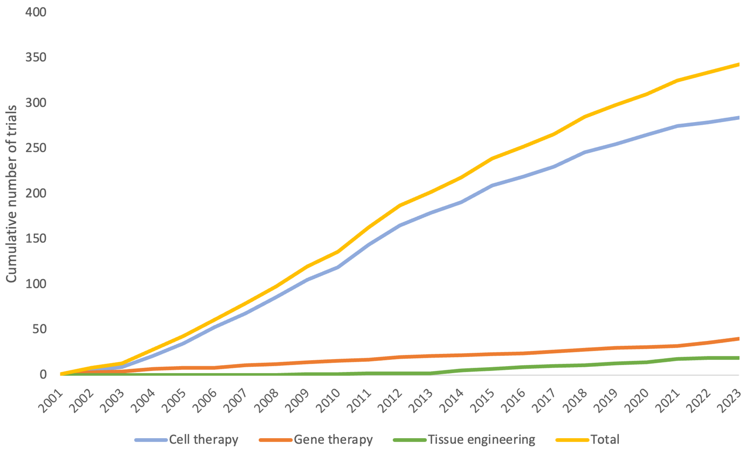
Supplementary fig. 1 Regenerative cardiology categories over time; 1A: yearly number of trials within the three different regenerative cardiology categories; 1B cumulative number of trials within regenerative cardiology

Supplementary figure 2
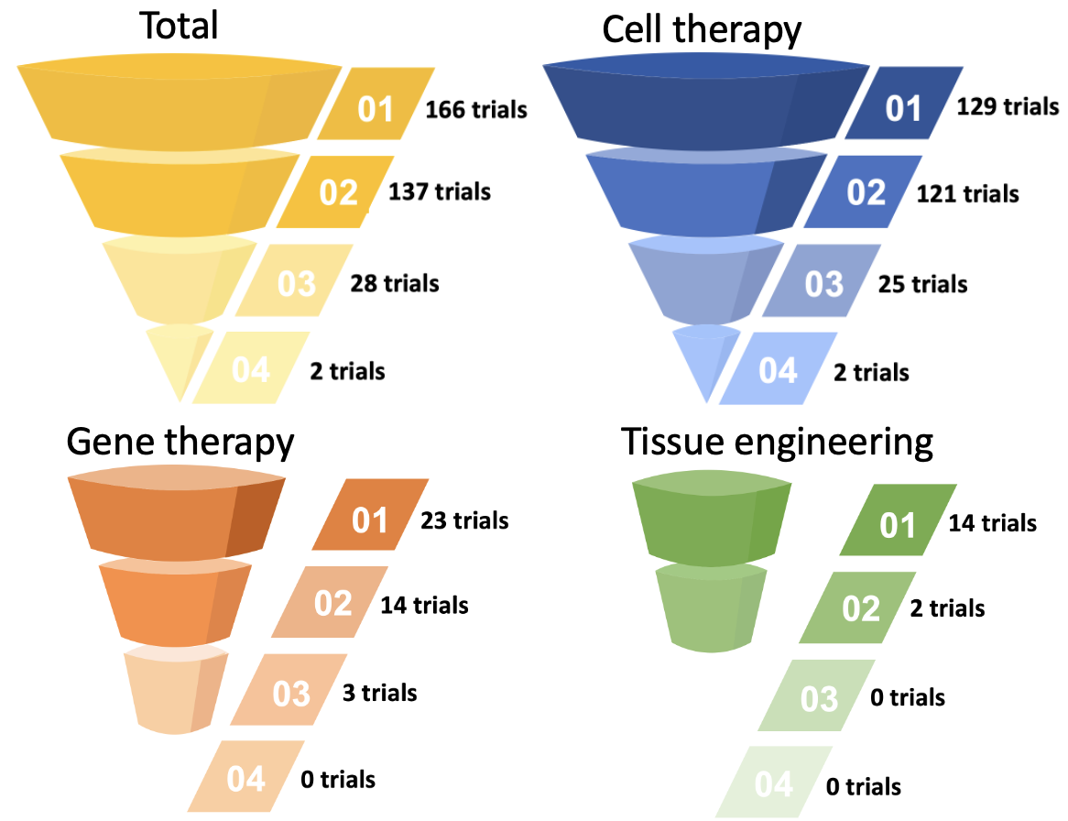
Supplementary fig. 2 Study phases for all clinical trials and for the individual categories of cell therapy, gene therapy, and tissue engineering

Supplementary figure 3
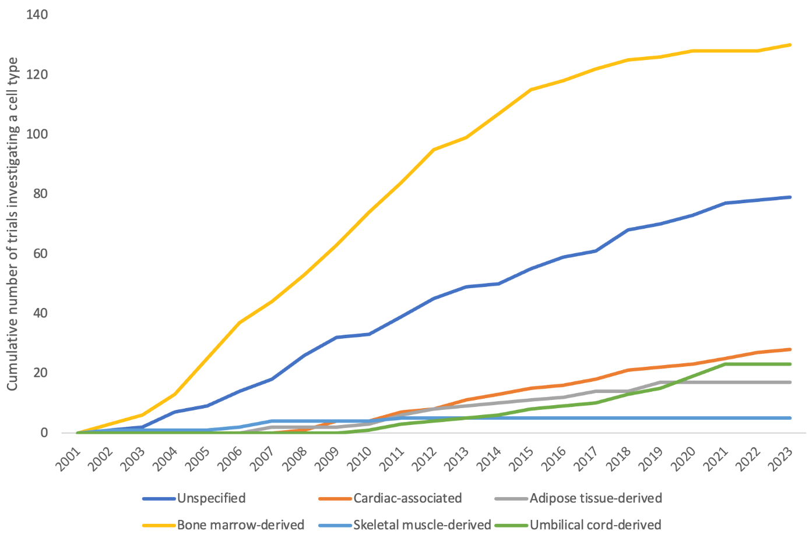
Supplementary fig. 3 Stem cells used within regenerative cardiac therapy over time

Supplementary figure 4
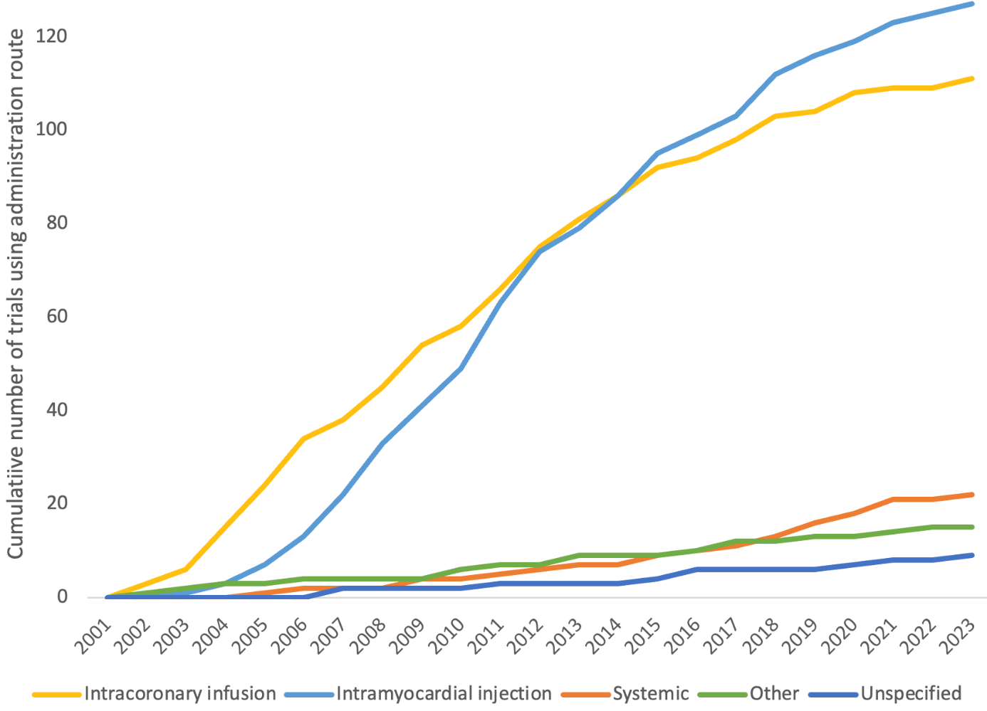
Supplementary fig. 4 Cell therapy administration routes over time.
Other methods of administration included cell mobilization (4 trials), coronary sinus infusion (3 trials), intracardiac infusion (3 trials), laser channel (2 trials), intramuscular injection (1 trial), intrapericardial injection (1 trial), and injection in a left axillary lymph node (1 trial).

Appendix 1

Clinicaltrials.gov
Regenerative medicine OR cell therapy OR genetic therapy OR gene therapy OR tissue engineering | Heart Diseases OR Heart Failure

Cochrane libraby/CENTER
((MeSH descriptor: [Heart Diseases]) OR (MeSH descriptor: [Heart Failure])) AND ((regenerative medicine):ti,ab,kw OR (cell therapy):ti,ab,kw OR (gene therapy):ti,ab,kw OR (tissue engineering):ti,ab,kw)

EU clinical trials register
(“heart failure” OR “heart disease”) AND (“gene therapy” OR gene OR cell OR “tissue engineering” OR “genetic therapy” OR “cell therapy” OR “stem cell”)

World Health Organization International Clinical Trials Registry platform (WHO ICTRP)
(Heart disease OR heart failure) AND (regenerative medicine OR cell therapy OR gene therapy OR tissue engineering OR genetic therapy)

Clinicaltrials.gov Tissue Engineering
Tissue engineering OR biofibrication OR sheet OR hydrogel OR extracellular matrix | Heart Diseases OR Heart Failure
Appendix 2

Appendix 2 table 1. List of clinical trial registries and identification number.
Clinical trial registry title | Trial identification number
Efficacy and Safety of Intracoronary Ad5FGF-4 in Patients With Stable Angina (AGENT-3) | NCT00346437
Study to Examine the Safety and Effectiveness of Implanted Skeletal Muscle Cells (Cells Removed From the Thigh Muscle) Into Scarred Areas of Heart Muscle After Heart Attack. | NCT00102128
Bone Marrow Transfer to Enhance ST-Elevation Infarct Regeneration | NCT00224536
Efficacy Study of Intramuscular or Intracoronary Injection of Autologous Bone Marrow Cells to Treat Scarred Myocardium | NCT00560742
Stem Cell Mobilization to Treat Chest Pain and Shortness of Breath in Patients With Coronary Artery Disease | NCT00043628
Cell Therapy for Coronary Heart Disease | NCT00289822
NOGA Angiogenesis Revascularization Therapy: Evaluation by RadioNuclide Imaging - The Northern Trial | NCT00143585
Safety and Efficacy of Intracoronary Ad5FGF-4 in Patients With Stable Angina | NCT00185263
Stem Cells in Myocardial Infarction | NCT00135928
Autologous Stem Cell Transplantation in Acute Myocardial Infarction | NCT00199823
Bone Marrow-Derived Stem Cell Transfer in Acute Myocardial Infarctions | NCT00264316
Long Term Follow-up of Autologous Bone Marrow Mononuclear Cells Therapy in STEMI | NCT00626145
The Effect of Mobilized Stem Cell by G-CSF and VEGF Gene Therapy in Patients With Stable Severe Angina Pectoris | NCT00135850
Bone Marrow Stem Cell Mobilisation Therapy for Acute Myocardial Infarction (AMI)(REVIVAL-2) | NCT00126100
BONAMI (BOne Marrow in Acute Myocardial Infarction) | NCT00200707
Autologous Stem Cells for Cardiac Angiogenesis (FOCUS HF) | NCT00203203
REPAIR-AMI: Intracoronary Progenitor Cells in Acute Myocardial Infarction (AMI) | NCT00279175
Progenitor Cell Therapy in Dilative Cardiomyopathy | NCT00284713
Myocardial Regeneration and Angiogenesis in Myocardial Infarction With G-CSF and Intra-Coronary Stem Cell Infusion-3-DES | NCT00291629
Myocardial Regeneration and Angiogenesis in Myocardial Infarction With G-CSF and Intra-Coronary Stem Cell Infusion | NCT00307879
Stem Cell Therapy to Improve Myocardial Function in Patients With Acute Myocardial Infarction | NCT00316381
CD133+ Autologous Cells After Myocardial Infarction | NCT00400959
Autologous Transplantation of Bone Marrow Mononuclear Stem-Cells by Mini-Thoracotomy | NCT00615394
Stem Cell Study for Patients With Heart Disease | NCT00081913
EPC by Intracoronary Injection in Patients With Chronic Stable Angina | NCT00384514
To Find the Best Dose of pVGI.1(VEGF2) to Benefit Angina Patients When Given With an Experimental Injection Catheter | NCT00090714
Endothelial Modulation for Angiogenic Therapy | NCT00134433
Angiogenesis Using VEGF-A165/bFGF Plasmid Delivered Percutaneously in No-option CAD Patients; a Controlled Trial | NCT00620217
Safety Study of Adult Mesenchymal Stem Cells (MSC) to Treat Acute Myocardial Infarction | NCT00114452
Autologous/Allogeneic Progenitor Stem Cell Therapy for Congestive Heart Failure | NCT00128258
Stem Cell Therapy in Chronic Ischemic Heart Failure | NCT00235417
Bone Marrow Stem Cell Infusion Following a Heart Attack | NCT00268307
Bone Marrow Cells in Myocardial Infarction | NCT00363324
Myocardial Stem Cell Administration After Acute Myocardial Infarction (MYSTAR) Study | NCT00384982
Safety and Efficacy of Bone Marrow Cell Transplantation in Humans Myocardial Infarction | NCT00437710
Autologous Bone Marrow Transplanted Via Transendocardial Catheter to Chronic Myocardial Infarct Border Zone | NCT00507468
Intracoronary Stem Cell Therapy in Patients With Acute Myocardial Infarction (SCAMI) | NCT00669227
Autologous Transplantation of Bone Marrow Mononuclear Stem-Cells for Dilated Cardiomyopathy | NCT00743639
Bone Marrow Derived Adult Stem Cells for Chronic Heart Failure | NCT00747708
Randomized Evaluation of Intracoronary Transplantation of Bone Marrow Stem Cells in Myocardial Infarction | NCT00874354
Stem Cell Study for Patients With Heart Disease | NCT00221182
Stem Cell Therapy for Vasculogenesis in Patients With Severe Myocardial Ischemia | NCT00260338
A Study to Treat Patients Whose Chronic Angina Symptoms Are Not Relieved by Medication and Have an Area of the Heart That Cannot be Treated by Standard Therapies | NCT00215696
Safety and Effects of Implanted (Autologous) Skeletal Myoblasts (MyoCell) Using an Injection Catheter = SEISMIC Trial | NCT00375817
Treatment of Myocardial Infarction With Bone Marrow Derived Stem Cells | NCT00275977
Cell Repair in Heart Failure | NCT00285454
Intra-coronary Infusion of Bone Marrow Derived Autologous CD34+ Selected Cells in Patients With Acute Myocardial Infarction | NCT00313339
Cell-Wave Study: Combined Extracorporal Shock Wave Therapy and Intracoronary Cell Therapy in Chronic Ischemic Myocardium | NCT00326989
Cell Therapy In Dilated Cardiomyopathy | NCT00333827
Cell Therapy in Chagas Cardiomyopathy | NCT00349271
Cell Therapy in Myocardial Infarction | NCT00350766
SWiss Multicenter Intracoronary Stem Cells Study in Acute Myocardial Infarction (SWISS-AMI) | NCT00355186
Cell Therapy in Chronic Ischemic Heart Disease | NCT00362388
Intracoronary Stem Cells in Large Myocardial Infarction | NCT00389545
Combined CABG and Stem-Cell Transplantation for Heart Failure | NCT00418418
ACPs Combined With CABG in Patients With CHF | NCT00523224
Safety and Efficacy Study of Stem Cell Transplantation to Treat Dilated Cardiomyopathy | NCT00629018
ACT34-CMI -- Adult Autologous CD34+ Cells | NCT00300053
Intramyocardial Injection of Autologous Aldehyde Dehydrogenase-Bright Stem Cells for Therapeutic Angiogenesis (FOCUS Br) | NCT00314366
Safety and Efficacy of Autologous, Intracoronary Stem Cell Injections in Total Coronary Artery Occlusions | NCT00365326
Percutaneous Randomised Infusion of Marrow Aspirate To Improve Ventricular Efficiency | ISRCTN74381875
Bone Marrow Cell Transplantation to Improve Heart Function in Individuals With End-Stage Heart Failure | NCT00383630
Randomized Clinical Trial of Adipose-Derived Stem Cells in the Treatment of Pts With ST-elevation Myocardial Infarction | NCT00442806
Congestive Heart Failure Surgical Treatmment With Autologous Stem Cell Therapy | NCT00480961
MAGIC Cell-5-Combicytokine Trial | NCT00501917
To Assess Safety and Efficacy of Myoblast Implantation Into Myocardium Post Myocardial Infarction | NCT00526253
A Trial Using CD133 Enriched Bone Marrow Cells Following Primary Angioplasty for Acute Myocardial Infarction | NCT00529932
Combination Stem Cell (MESENDO) Therapy for Utilization and Rescue of Infarcted Myocardium | NCT00548613
Prospective Randomized Study of Mesenchymal Stem Cell Therapy in Patients Undergoing Cardiac Surgery (PROMETHEUS) | NCT00587990
Endocardial Stem Cells Approach Efficacy | NCT00841958
Study of the Efficacy of Percutaneous Implantation of Autologous Myoblasts in Patients With Old Infarction | NCT00908622
Stem Cell Therapy to Improve Myocardial Function in Patients Undergoing Coronary Artery Bypass Grafting (CABG) | NCT00395811
Vescell(TM) for the Treatment of Patients With Severe Anginal Syndrome With or Without Heart Failure | NCT00416663
A Randomized Clinical Trial of Adipose-derived Stem Cells in Treatment of Non Revascularizable Ischemic Myocardium | NCT00426868
Bypass Surgery and CD133 Marrow Cell Injection for Treatment of Ischemic Heart Failure | NCT00462774
Stem Cell Therapy as Adjunct to Revascularization | NCT00463853
Angiogenesis in Women With Angina Pectoris Who Are Not Candidates for Revascularization | NCT00438867
Efficacy and Safety Study of Genetically Targeted Enzyme Replacement Therapy for Advanced Heart Failure | NCT00454818
Induced Angiogenesis by Genic Therapy in Advanced Ischemic Cardiomyopathy | NCT00744315
Safety Study of Allogeneic Mesenchymal Precursor Cells (MPCs) in Subjects With Recent Acute Myocardial Infarction | NCT00555828
Stem Cell Study for Subjects With Congestive Heart Failure | NCT00620048
Intracoronary Infusion of Autologous Bone Marrow Cells for Treatment of Idiopathic Dilated Cardiomyopathy | NCT00629096
Autologous Mesenchymal Stromal Cell Therapy in Heart Failure | NCT00644410
Use of Adult Autologous Stem Cells in Treating People Who Have Had a Heart Attack (The TIME Study) | NCT00684021
Use of Adult Autologous Stem Cells in Treating People 2 to 3 Weeks After Having a Heart Attack (The Late TIME Study) | NCT00684060
By Pass Surgery With Stem Cell Therapy in Chronic Ischemic Cardiopathy | NCT00690209
Effects of Intracoronary Progenitor Cell Therapy on Coronary Flow Reserve After Acute MI | NCT00711542
A Phase II Dose-escalation Study to Assess the Feasibility and Safety of Transendocardial Delivery of Three Different Doses of Allogeneic Mesenchymal Precursor Cells (MPCs)in Subjects With Heart Failure | NCT00721045
Intracoronary Autologous Stem Cell Transplantation in ST Elevation Myocardial Infarction: TRACIA STUDY. | NCT00725738
Bone Marrow Derived Adult Stem Cells for Acute Anterior Myocardial Infarction | NCT00765453
Use of Ixmyelocel-T (Formerly Cardiac Repair Cell [CRC] Treatment) in Patients With Heart Failure Due to Dilated Cardiomyopathy (IMPACT-DCM) | NCT00765518
The Transendocardial Autologous Cells (hMSC or hBMC) in Ischemic Heart Failure Trial (TAC-HFT) | NCT00768066
Stem Cells and Resynchronization Cardiac | NCT00800657
C-Cure Clinical Trial | NCT00810238
Combination Stem Cell Therapy for the Treatment of Severe Coronary Ischemia | NCT00643981
Safety and Efficacy of Autologous Endothelial Progenitor Cell CD 133 for Therapeutic Angiogenesis | NCT00694642
Phase II Combination Stem Cell Therapy for the Treatment of Severe Coronary Ischemia(CI) | NCT00790764
Stem Cell Mobilization and VEGF Gene Transfer for Heart Failure | NCT00279539
Prochymal® (Human Adult Stem Cells) Intravenous Infusion Following Acute Myocardial Infarction (AMI) | NCT00877903
Cardiac Stem Cell Infusion in Patients With Ischemic CardiOmyopathy (SCIPIO) | NCT00474461
Safety and Efficacy on Cell-based Therapy in Patients With Recent Large Acute Myocardial Infarction | NCT00691834
Effectiveness of Stem Cell Treatment for Adults With Ischemic Cardiomyopathy (The FOCUS Study) | NCT00824005
Ex Vivo Cultured Bone Marrow Derived Allogenic MSCs in AMI | NCT00883727
CArdiosphere-Derived aUtologous Stem CElls to Reverse ventricUlar dySfunction | NCT00893360
Effect of Intramyocardial Injection of Mesenchymal Precursor Cells on Heart Function in People Receiving an LVAD | NCT00927784
Intracoronary Injection of Autologous Bone Marrow Cells in Patients With Chronic Heart Failure: Five Years Follow up | NCT00933621
The Enhanced Angiogenic Cell Therapy - Acute Myocardial Infarction Trial | NCT00936819
Bone Marrow Derived Mononuclear Cells For Myocardial Regeneration | NCT00938847
Alster Stem Cells - Intramyocardial Stem Therapy | NCT00939042
Strengthening Transplantation Effects of Bone Marrow Mononuclear Cells With Atorvastatin in Myocardial Infarction | NCT00979758
AutoLogous Human CArdiac-Derived Stem Cell to Treat Ischemic cArdiomyopathy (ALCADIA) | NCT00981006
Trial of Hematopoietic Stem Cells in Acute Myocardial Infarction | NCT00984178
Use of Ixmyelocel-T (Formerly Catheter-based Cardiac Repair Cell [CRC]) Treatment in Patients With Heart Failure Due to Dilated Cardiomyopathy | NCT01020968
Intramyocardial Transplantation of Bone Marrow Stem Cells in Addition to Coronary Artery Bypass Graft (CABG) Surgery | NCT00950274
IMPACT-CABG Trial: IMPlantation of Autologous CD133+ sTem Cells in Patients Undergoing CABG | NCT01033617
Injection of Autologous Bone Marrow Cells into Damaged Myocardium of No-option Patients with Ischemic Heart Failure: a randomized placebo controlled trail. - Cell therapy for ischemic heart failure | EUCTR2009-016364-36-NL
Comparison of intracoronary selected CD 133+ bone marrow stem cells in cardiac recovery after acute myocardial infarct and left ventricular dysfunction: COMPARE-AMI a randomized controlled double blind clinical study | ACTRN12609001045202
EndocardialVascularEndothelialGrowth Factor D(VEGF-D)Gene Therapy for the Treatment of Severe Coronary Heart Disease | NCT01002430
Gene Therapy for the Treatment of Chronic Stable Angina | NCT01002495
A Pilot Study Investigating the Clinical Use of Tissue Engineered Vascular Grafts in Congenital Heart Surgery | NCT01034007
Stem Cell Study for Patients With Heart Failure | NCT00346177
CD133+ Cell Therapy for Refractory Coronary Heart Disease | NCT01049867
Prospective, Controlled and Randomized Clinical Trial on Cardiac Cell Regeneration With Laser and Autologous Bone Marrow Stem Cells, in Patients With Coronary Disease and Refractory Angina | NCT01214499
BMAC Enhanced Coronary Artery Bypass Grafting (CABG) | NCT01061580
Feasibility Study of BMAC Enhanced CABG | NCT01074099
Mesenchymal Stem Cells and Myocardial Ischemia | NCT01076920
Bone Marrow Derived Mononuclear Cells for Ischemic Cardiomyopathy | NCT01144221
Direct Endomyocardial Injection of Autologous Bone Marrow Cells to Treat Ischaemic Heart Failure | NCT01150175
Autologous Bone Marrow Derived Stem Cells for Acute Myocardial Infarction | NCT01167751
Bone Marrow Derived AC 133+ and Mono-Nuclear Cells (MNC) Implantation in Myocardial Infarction (MI) Patient | NCT01187654
Safety and Efficacy of Adipose Derived Regenerative Cells (ADRCs) Delivered Via the Intracoronary Route in the Treatment of Patients With ST-elevation Acute Myocardial Infarction (AMI) | NCT01216995
Intramuscular Injection of Mesenchymal Stem Cell for Treatment of Children With Idiopathic Dilated Cardiomyopathy | NCT01219452
Clinical Study of Hypoxia-Stressed Bone Marrow Mononuclear Cell Transplantation to Treat Heart Diseases | NCT01234181
Cell Therapy in Patients With Chronic Ischemic Heart Disease Undergoing Cardiac Surgery | NCT01267331
AC6 Gene Transfer for CHF | NCT00787059
Study to Evaluate the Safety of a Single Escalating Dose of ACRX-100 in Adults With Ischemic Heart Failure | NCT01082094
Plasmonic Photothermal and Stem Cell Therapy of Atherosclerosis Versus Stenting | NCT01436123
MesenchYmal STROMAL CELL Therapy in Patients With Chronic Myocardial Ischemia (MyStromalCell Trial) | NCT01449032
Stem Cell Therapy in Patients With Severe Heart Failure & Undergoing Left Ventricular Assist Device Placement | NCT00869024
Efficacy assessment of repeat intramyocardial injection of autologous bone marrow cells in previously responding no-option patients with residual refractory angina pectoris and documented ischemia | EUCTR2009-017924-18
Transcoronary Infusion of Cardiac Progenitor Cells in Patients With Single Ventricle Physiology | NCT01273857
Intracoronary Human Wharton's Jelly- Derived Mesenchymal Stem Cells (WJ-MSCs) Transfer in Patients With Acute Myocardial Infarction (AMI) | NCT01291329
Retrograde Delivery of BMAC (Bone Marrow Aspirate Concentrate) for Congestive Heart Failure | NCT01299324
Bone Marrow Derived Adult Stem Cells for Dilated Cardiomyopathy | NCT01302171
Intra-coronary Versus Intramyocardial Application of Enriched CD133pos Autologous Bone Marrow Derived Stem Cells | NCT01337011
Safety and Efficacy Study of Intramyocardial Stem Cell Therapy in Patients With Dilated Cardiomyopathy | NCT01350310
Autologous Cell Therapy for Ischemic Heart Failure | NCT01353690
Intramyocardial Multiple Precision Injection of Bone Marrow Mononuclear Cells in Myocardial Ischemia | NCT01354678
Safety and Efficacy of Intracoronary Adult Human Mesenchymal Stem Cells After Acute Myocardial Infarction | NCT01392105
PercutaneOus StEm Cell Injection Delivery Effects On Neomyogenesis in Dilated CardioMyopathy (The POSEIDON-DCM Study) | NCT01392625
ESTIMATION Study for Endocardial Mesenchymal Stem Cells Implantation in Patients After Acute Myocardial Infarction | NCT01394432
The Effect of Intramyocardial Injection of Mesenchymal Precursor Cells on Myocardial Function in Patients Undergoing LVAD Implantation | NCT01442129
Safety and Feasibility Study of Umbilical Cord Blood Cells for Infants With Hypoplastic Left Heart Syndrome | NCT01445041
Intracoronary Infusion of Bone Marrow Mononuclear Cells in Patients With Previous Myocardial Infarction. | NCT01454323
Allogeneic Heart Stem Cells to Achieve Myocardial Regeneration | NCT01458405
IMPACT-CABG Trial: IMPlantation of Autologous CD133+ sTem Cells in Patients Undergoing Coronary Artery Bypass Grafting | NCT01467232
NBS10 (Also Known as AMR-001) Versus Placebo Post ST Segment Elevation Myocardial Infarction | NCT01495364
REgenerative CardiOsphere iNjection to STRengthen dysfUnCTional Hearts | NCT01496209
Safety and Efficacy of Adipose Derived Stem Cells for Non-Ischemic Congestive Heart Failure | NCT01502501
Safety and Efficacy of Adipose Derived Stem Cells for Congestive Heart Failure | NCT01502514
Intra-coronary freshly isolated bone marrow cells transplantation improve cardiac function in patients with ischemic heart disease | ISRCTN54510226
Safety Study of Gene Therapy for Ischemic Heart Disease in Korea | NCT01422772
A Randomized, Controlled Study to Evaluate Algisyl-LVR™ as a Method of Left Ventricular Augmentation for Heart Failure | NCT01311791
Efficacy and Safety of Targeted Intramyocardial Delivery of Auto CD34+ Stem Cells for Improving Exercise Capacity in Subjects With Refractory Angina | NCT01508910
Stem Cell Injection to Treat Heart Damage During Open Heart Surgery | NCT01557543
Intracardiac CD133+ Cells in Patients With No-option Resistant Angina | NCT01660581
Stem Cell Implantation in Patients Undergoing CABG | NCT01721902
Autologous Stem Cells in Pediatric Patients With Dilated Cardiomyopathy | NCT01504594
Rapid Delivery of Autologous Bone Marrow Derived Stem Cells in Acute Myocardial Infarction Patients. | NCT01536106
Safety and Feasibility Trial of Adipose-Derived Regenerative Cells in the Treatment of Chronic Myocardial Ischemia | NCT01556022
BAMI. The Effect of Intracoronary Reinfusion of Bone Marrow-derived Mononuclear Cells(BM-MNC) on All Cause Mortality in Acute Myocardial Infarction | NCT01569178
Implantation of Peripheral Stem Cells in Patient With Ischemic Cardiomyopathy | NCT01615250
Stem Cell Therapy in Patients With Myocardial Infarction and Persistent Total Occlusion of Infarct Related Artery | NCT01625949
To Evaluate the Efficacy and Safety of Hearticelgram®-AMI in Patients With Acute Myocardial Infarction. | NCT01652209
METHOD - Bone Marrow Derived Mononuclear Cells in Chronic Ischemic Disease | NCT01666132
An Efficacy, Safety and Tolerability Study of Ixmyelocel-T Administered Via Transendocardial Catheter-based Injections to Subjects With Heart Failure Due to Ischemic Dilated Cardiomyopathy (IDCM) | NCT01670981
Compare the Effects of Single Versus Repeated Intracoronary Application of Autologous Bone Marrow-derived Mononuclear Cells on Mortality in Patients With Chronic Post-infarction Heart Failure | NCT01693042
Clinical Trial of Autologous Adipose Tissue Derived Stromal Cell Therapy for Ischemic Heart Failure | NCT01709279
Intracoronary Autologous Mesenchymal Stem Cells Implantation in Patients With Ischemic Dilated Cardiomyopathy | NCT01720888
Cell Therapy in Severe Chronic Ischemic Heart Disease | NCT01727063
Randomized Clinical Trial of Intravenous Infusion Umbilical Cord Mesenchymal Stem Cells on Cardiopathy | NCT01739777
The Long-term and Short-term Efficacy and Safety of Transplantation Autologous Bone Marrow Cells (BMCs) in Patients With the First STEMI (ST Segment Elevation Myocardial Infarction) | NCT01748383
Allogeneic Stem Cells Implantation Combined With Coronary Bypass Grafting in Patients With Ischemic Cardiomyopathy | NCT01753440
Efficacy and Safety of Bone Marrow-Derived Mesenchymal Cardiopoietic Cells (C3BS-CQR-1) for the Treatment of Chronic Advanced Ischemic Heart Failure | EUCTR2011-001117-13
A Study of Genetically Targeted Enzyme Replacement Therapy for Advanced Heart Failure | NCT01643330
Efficacy and Safety of Ad5FGF-4 for Myocardial Ischemia in Patients With Stable Angina Due to Coronary Artery Disease | NCT01550614
Administration of AdVEGF-All6A+ to Myocardium of Individuals With Diffuse CAD Via Minimally Invasive Surgery | NCT01757223
Study Protocol of Intramyocardial Injection of Autologous Bone Marrow Stem Cells for Refractory Angina | NCT01966042
Transplantation of Autologous Cardiac Stem Cells in Ischemic Heart Failure | NCT01758406
Left Ventricular Assist Device Combined With Allogeneic Mesenchymal Stem Cells Implantation in Patients With End-stage Heart Failure. | NCT01759212
Safety and Efficacy of Autologous Cardiopoietic Cells for Treatment of Ischemic Heart Failure. | NCT01768702
A Study of Allogeneic Mesenchymal Bone Marrow Cells in Subjects With ST Segment Elevation Myocardial Infarction (STEMI) | NCT01770613
Safety Study of Allogeneic Mesenchymal Precursor Cell Infusion in Myocardial Infarction | NCT01781390
Cardiac Progenitor Cell Infusion to Treat Univentricular Heart Disease (PERSEUS) | NCT01829750
Safety Study of Autologous Umbilical Cord Blood Cells for Treatment of Hypoplastic Left Heart Syndrome | NCT01883076
Mesenchymal Stem Cells to Treat Ischemic Cardiomyopathy | NCT01913886
Umbilical Cord Derived Mesenchymal Stem Cells Therapy in Ischemic Cardiomyopathy | NCT01946048
STem cElls Mobilization in Acute Myocardial Infarction Outcome Trial | NCT01969890
Study to Assess the Safety and Cardiovascular Effects of Autologous Adipose-Derived Stromal Cells Implantation In Patients During the Acute Recovery Phase of ST-Elevation Myocardial Infarction | NCT01974128
Intracoronary Infusion of Mononuclear Cells Autologous Bone Marrow in Patients With Chronic Coronary Occlusion and Ventricular Dysfunction, Previously Revascularized. | NCT02022514
AAV1-CMV-Serca2a GENe Therapy Trial in Heart Failure | NCT01966887
The TRansendocardial Stem Cell Injection Delivery Effects on Neomyogenesis STudy (The TRIDENT Study) | NCT02013674
Autologous Bone Marrow Mononuclear Cells in the Combined Treatment of Coronary Heart Disease | NCT02059512
Efficacy and Safety of Allogeneic Mesenchymal Precursor Cells (Rexlemestrocel-L) for the Treatment of Heart Failure. | NCT02032004
Infusion Intracoronary of Mononuclear Autologous Adult no Expanded Stem Cells of Bone Marrow on Functional Recovery in Patients With Idiopathic Dilated Cardiomyopathy and Heart Failure. | NCT02033278
Safety & Efficacy of Adipose-Derived Regenerative Cells in the Treatment of Chronic Myocardial Ischemia (ATHENA II) | NCT02052427
Transplantation of Human Embryonic Stem Cell-derived Progenitors in Severe Heart Failure | NCT02057900
Phase I Trial of Endocavitary Injection of Bone Marrow Derived CD133+ Cells in Ischemic Refractory Cardiomyopathy (RECARDIO Trial) | NCT02059681
Repetitive Intramyocardial CD34+ Cell Therapy in Dilated Cardiomyopathy (REMEDIUM) | NCT02248532
Intracoronary Transplantation of Bone Marrow Derived Mononuclear Cells in Pediatric Cardiomyopathy | NCT02256501
A Phase 2 Trial of AMI MultiStem® Therapy in Subjects With Non-ST Elevation Acute Myocardial Infarction | NCT02277613
Dilated cardiomYopathy iNtervention With Allogeneic MyocardIally-regenerative Cells (DYNAMIC) | NCT02293603
Congestive Heart Failure Cardiopoietic Regenerative Therapy (CHART-2) Trial - THE CHART-2 TRIAL | NCT02317458
Human Umbilical Cord Stroma MSC in Myocardial Infarction | NCT02323477
Impact of Intracoronary Injection of Autologous BMMC for LV Contractility and Remodeling in Patients With STEMI | NCT02323620
Investigation of the Safety and Feasibility of AAV1/SERCA2a Gene Transfer in Patients With Chronic Heart Failure | NCT00534703
Novel Regenerative Therapy with Autologus Myoblast Sheet for Pediatric Heart Failure patients | JPRN-UMIN000013941
Mesenchymal Stem Cell Administration in the Treatment of Coronary Graft Disease in Heart Transplant Patients | NCT02472002
Safety & Efficacy of Intramyocardial Injection of Mesenchymal Precursor Cells on Myocardial Function in LVAD Recipients | NCT02362646
Intracoronary or Intravenous Infusion Human Wharton' Jelly-derived Mesenchymal Stem Cells in Patients With Ischemic Cardiomyopathy | NCT02368587
CSCC_ASC Therapy in Patients With Severe Heart Failure | NCT02387723
Allogeneic hMSC Injection in Patients With Hypoplastic Left Heart Syndrome | NCT02398604
Bone Marrow Derived Mesenchymal Stem Cells in Improving Heart Function in Patients With Heart Failure Caused by Anthracyclines | NCT02408432
Timing for Bone Marrow Mononuclear Cells After Acute Myocardial Infarction | NCT02425358
CardiAMP™ Cell Therapy Heart Failure Trial | NCT02438306
Safety and Efficacy Evaluation of Intracoronary Infusion of Allogeneic Human Cardiac Stem Cells in Patients With AMI | NCT02439398
Human Umbilical-Cord-Derived Mesenchymal Stem Cell Therapy in Ischemic Cardiomyopathy | NCT02439541
Bone Marrow-derived Mesenchymal Stem Cells (MSC) Administration in Weaning From Left Ventricular Assist Device | NCT02460770
Administration of Mesenchymal Stem Cells in Patients With Chronic Ischemic Cardiomyopathy (MESAMI2) | NCT02462330
A Study to Assess the Effect of Intravenous Dose of (aMBMC) to Subjects With Non-ischemic Heart Failure | NCT02467387
A Trial of Autologous Bone Marrow Derived Stem Cells in Paediatric Heart Failure | NCT02479776
Combination of Mesenchymal and C-kit+ Cardiac Stem Cells as Regenerative Therapy for Heart Failure | NCT02501811
The Transendocardial Autologous Cells (hMSC) or (hMSC) and (hCSC) in Ischemic Heart Failure Trial. | NCT02503280
Therapy of Preconditioned Autologous BMMSCs for Patients With Ischemic Heart Disease | NCT02504437
Phase I Safety and Feasibility Study of Intracoronary Delivery of Autologous Bone Marrow Derived Mononuclear Cells | NCT02549625
A Phase 1/2 Study of High-dose Genetically Targeted Enzyme Replacement Therapy for Advanced Heart Failure | NCT02346422
Human Umbilical Cord-derived Mesenchymal Stem Cells With Injectable Collagen Scaffold Transplantation for Chronic Ischemic Cardiomyopathy | NCT02635464
Clinical trial on the safety of myocardium regenerative therapy for ischemic heart disease using biodegradable polymeric carrier and basic fibroblast growth factor | JPRN-UMIN000018709
Safety and Exploratory Efficacy Study of UCMSCs in Patients With Ischemic Heart Disease (SEESUPIHD) | NCT02666391
EXCELLENT (EXpanded CELL ENdocardiac Transplantation) | NCT02669810
A Study of Allogeneic Low Oxygen Mesenchymal Bone Marrow Cells in Subjects With Myocardial Infarction | NCT02672267
Stem Cell Therapy in IschEmic Non-treatable Cardiac Disease | NCT02673164
Cardiac Stem/Progenitor Cell Infusion in Univentricular Physiology (APOLLON Trial) | NCT02781922
Stem Cells Therapy in Advanced Heart Failure | NCT02871466
Study of Autologous Bone Marrow Derived Mononuclear Cells for Treatment of Ebstein Anomaly | NCT02914171
Cell Therapy in HFpEF | NCT02923609
Regression of Fibrosis & Reversal of Diastolic Dysfunction in HFPEF Patients Treated With Allogeneic CDCs | NCT02941705
Donor Bone Marrow Derived Mesenchymal Stem Cells in Controlling Heart Failure in Patients With Cardiomyopathy Caused by Anthracyclines | NCT02962661
Ad-HGF Treatment for Myocardial Infarction | NCT02844283
Autologous Atrial Appendage Derived Cells in the Treatment of Heart Failure | NCT02672163
Stem Cell Heart Injections During Laser Revascularization Surgery for Treatment of Chronic Ischemic Heart Disease | NCT03043742
Transplantation Efficacy of Autologous Bone Marrow Mesenchymal Stem Cells With Intensive Atorvastatin in AMI Patients | NCT03047772
Mesoblast Stem Cell Therapy for Patients With Single Ventricle and Borderline Left Ventricle | NCT03079401
Allogeneic Stem Cell Therapy in Heart Failure | NCT03092284
Transcoronary Infusion of Cardiac Progenitor Cells in Pediatric Dilated Cardiomyopathy | NCT03129568
ICMNC-HF. IntraCoronary Bone Marrow MonoNuclear Cells in Heart Failure (HF) Patients | NCT03145402
The Study of Heart Failure With Human Umbilical Cord Mesenchymal Stem Cells (19#iSCLife®-HF) | NCT03180450
IMMNC-HF: IntraMyocardial Injection of Bone Marrow MonoNuclear Cells in Heart Failure (HF) Patients | NCT03227198
Study to Assess Safety & Effects of Autologous ADSCs During Recovery Phase of ST-Elevation MI Effects of Autologous ADSC Implantation During Subacute Recovery Phase of ST-Elevation Myocardial Infarction | NCT03272191
Japanese OMI Treatment With Kit-positive Cells for Enhanced Regeneration | NCT03351400
Retrograde Application of Bone Marrow Aspirate Concentrate | NCT03372954
Adenovirus Vascular Endothelial Growth Factor D (AdvVEGF-D) Therapy for Treatment of Refractory Angina Pectoris | NCT03039751
AC6 Gene Transfer in Patients With Reduced Left Ventricular Ejection Fraction Heart Failure | NCT03360448
A Pivotal Trial to Establish the Efficacy and Safety of Algisyl in Patients With Moderate to Severe Heart Failure | NCT03082508
Study of Intracoronary CD34+ Cell Administration in Patients With Early Coronary Atherosclerosis | NCT03471611
Safety and Potential Bioactivity of CLBS16 in Patients With Coronary Microvascular Dysfunction and Without Obstructive Coronary Artery Disease | NCT03508609
A Phase IIB Study of the Efficacy and Safety of Intramyocardial Injection of Allogeneic Human Immunomodulatory Progenitor (iMP) cells in Patients Undergoing Coronary Artery Bypass Graft (CABG) Surgery. | NCT03515291
Sequential Treatment of Extra-Corporeal Shock Wave Combined With aUtologous Bone marRow Mesenchymal Stem Cells on Patients With ischEmic Heart Disease : the S-CURE Study | NCT03397095
Cardiovascular Clinical Project to Evaluate the Regenerative Capacity of CardioCell in Patients With Acute Myocardial Infarction (AMI) | NCT03404063
The CHILD Trial: Hypoplastic Left Heart Syndrome Study. | NCT03406884
Randomized Clinical Trial to Evaluate the Regenerative Capacity of CardioCell in Patients With Chronic Ischaemic Heart Failure (CIHF) | NCT03418233
Safety of Autologous Cord Blood Cells in HLHS Patients During Norwood Heart Surgery | NCT03431480
CardiAMP Cell Therapy Chronic Myocardial Ischemia Trial | NCT03455725
Lomecel-B Delivered During Stage II Surgery for Hypoplastic Left Heart Syndrome (ELPIS) | NCT03525418
Intravenous MSC Therapy on Ischemia-Reperfusion Injury in Patients With Myocardial Infarction | NCT03533153
In Vivo Tracking of USPIO Labeled MSC in the Heart | NCT03651791
IPS Differentiated Cardiomyocytes Vein Transplantation for Chronic Heart Failure | NCT03759405
Treating Heart Failure With hPSC-CMs | NCT03763136
Intramyocardial Injection of Autologous Umbilical Cord Blood Derived Mononuclear Cells During Surgical Repair of Hypoplastic Left Heart Syndrome | NCT03779711
Safety and Efficacy Study of Gene Therapy for Acute Myocardial Infarction in Korea | NCT03404024
Novel INXN-4001 Triple Effector Plasmid in Heart Failure | NCT03409627
Use of Bone Marrow Derived Stem Cell and G-CSF With Circulatory Assistance in the Treatment of DCM | NCT03572660
First in Humans to Evaluate Collagen Patches With Stem Cells in Patients With Ischemic Left Ventricular Dysfunction | NCT03746938
Adipose Stromal Cells Injection in the Myocardium for Induction of Revascularization | NCT04005989
MCRcI® Stem Cell Treatment for Diffuse Coronary Artery Disease | NCT04052191
Stem Cell Therapy in Non-IschEmic Non-treatable Dilated CardiomyopathiEs II: a Pilot Study | NCT03797092
UC-MSC Transplantation for Left Ventricular Dysfunction After AMI | NCT03902067
Serial Infusions of Allogeneic Mesenchymal Stem Cells in Cardiomyopathy Patients With Left Ventricular Assist Device | NCT03925324
MiSaver® Stem Cell Treatment for Heart Attack (Acute Myocardial Infarction) | NCT04050163
Evaluate the Safety and Explore Efficacy of Umbilical Cord Mesenchymal Stem Cells in Acute Myocardial Infarction | NCT04056819
Safety of autologous CardAP-cells in patients with dilatative cardiomyopathy: an open, monocentric, double-arm, 3+3 dose escalation, phase I/II study | EUCTR2014-003457-34
Allogeneic adipose derived stromal cell therapy in patients with ischemic heart failure | EUCTR2019-002511-26-DK
Gene Therapy for Male Patients With Danon Disease (DD) Using RP-A501; AAV9.LAMP2B | NCT03882437
Epicardial Delivery of XC001 Gene Therapy for Refractory Angina Coronary Treatment (The EXACT Trial) | NCT04125732
Pericardial Matrix With Mesenchymal Stem Cells for the Treatment of Patients With Infarcted Myocardial Tissue | NCT03798353
Randomized Study of Coronary Revascularization Surgery With Injection of WJ-MSCs and Placement of an Epicardial Extracellular Matrix | NCT04011059
WJMSCs Anti-inflammatory Therapy in Coronary Artery Disease | NCT04551456
A Placebo-Controlled Trial of CLBS16 in Subjects With Coronary Microvascular Dysfunction | NCT04614467
Mesenchymal Stromal Cells for Infants With Congenital Heart Disease (MedCaP) | NCT04236479
The Application of the Umbilical Cord Mesenchymal Stem Cells in the Complex Treatment of Chronic Heart Failure of Non-ischemic Etiology | NCT04325594
Stem Cell in Acute Myocardial Infarction | NCT04340609
Bone Marrow Mesenchymal Stem Cells Transfer in Patients With ST-segment Elevation Myocardial Infarction | NCT04421274
Transendocardial Injection of Allogeneic-MSC in Patients With Non-Ischemic Dilated Cardiomyopathy | NCT04476901
WJMSCs Anti-inflammatory Therapy in Acute Myocardial Infarction | NCT04551443
Safety study of induced pluripoteint stem cell-derived cardiac spheres transplantation | JPRN-jRCTa032200189
Heart regeneration therapy by autologous Adipose Tissue Derived Stromal Cells | JPRN-jRCTb040190115
Study to Evaluate Safety, Tolerability, Pharmacokinetics, and Pharmacodynamics of NTLA-2001 in Patients With Hereditary Transthyretin Amyloidosis With Polyneuropathy (ATTRv-PN) and Patients With Transthyretin Amyloidosis-Related Cardiomyopathy (ATTR-CM) | NCT04601051
Safety and Efficacy of Induced Pluripotent Stem Cell-derived Engineered Human Myocardium as Biological Ventricular Assist Tissue in Terminal Heart Failure | NCT04396899
Allogeneic Mesenchymal Human Stem Cell Infusion Therapy for Endothelial DySfunctiOn in Diabetic Subjects With Symptomatic Ischemic Heart Disease. (ACESO-IHD) | NCT04776239
Clinical Trial of Human (Allogeneic) iPS Cell-derived Cardiomyocytes Sheet for Ischemic Cardiomyopathy | NCT04696328
New Horizons for the Treatment of Cardiomyopathy in Children | NCT04893629
Intramyocardial Injection of Autologous UCB-MNC During Fontan Surgery for SRV Dependent CHD | NCT04907526
Evaluation of Lomecel-B™ Injection in Patients With Hypoplastic Left Heart Syndrome: A Phase IIb Clinical Trial. | NCT04925024
Treatment of Heart Failure Using Human Umbilical Cord Mesenchymal Stem Cells(hUC-MSC) | NCT04939077
Treating Congestive HF With hiPSC-CMs Through Endocardial Injection | NCT04982081
Multi-intravenous Infusion of Umbilical Cord Mesenchymal Stem Cells in Heart Failure With Reduced Ejection Fraction（PRIME-HFrEF Study） | NCT04992832
MSCs for Prevention of MI-induced HF | NCT05043610
Human Embryonic Stem Cell-Derived Cardiomyocyte Therapy for Chronic Ischemic Left Ventricular Dysfunction | NCT05068674
Safety of Cultured Allogeneic Adult Umbilical Cord Derived Mesenchymal Stem Cells for Heart Disease | NCT05147766
Calcium Up-Regulation by Percutaneous Administration of Gene Therapy In Cardiac Disease | NCT04703842
ADR-002K for Patients With Ischemic Cardiomyopathy Who Undergo Coronary Artery Bypass Surgery | NCT04695522
Heart Patch for Myocardial Infarction COVID-19 | NCT04728906
Treating Heart Failure With hiPSC-CMs | NCT05223894
AMI-DC in Patients With Anterior Wall Myocardial Infarction | NCT05554484
Allogeneic iPSC-derived Cardiomyocyte Therapy in Patients With Worsening Ischemic Heart Failure | NCT05566600
Gene Therapy for Post-Operative Atrial Fibrillation | NCT05223725
Phase IA Study of AAVrh.10hFXN Gene Therapy for the Cardiomyopathy of Friedreich's Ataxia | NCT05302271
Gene Therapy for Cardiomyopathy Associated With Friedreich's Ataxia | NCT05445323
A Phase 2, Adaptive, Double-blinded, Placebo Controlled, Randomized, Multicenter Trial to Evaluate the Efficacy, Safety and Tolerability of Intracoronary Infusion of NAN-101 in Adult Subjects With New York Heart Association (NYHA) Class III Heart Failure and Non-ischemic Cardiomyopathy | NCT05598333
A Study of VentriGel in Post-MI Patients | NCT02305602
Epicardial Infarct Repair Using CorMatrix®-ECM: Clinical Feasibility Study | NCT02887768
First in Man Study of Implantable Alginate Hydrogel | NCT04781660
Atrial Appendage Micrograft Transplants to Assist Heart Repair After Cardiac Surgery | NCT05632432
Cell Therapy and Myocardial Recovery in Heart Failure Patients Undergoing Left Ventricular Assist Device Support | NCT06154044
Phosphatase Inhibition by Intracoronary Gene Therapy in Subjects With Non-Ischemic NYHA Class III Heart Failure | NCT05598333
Modulation of SERCA2a of Intra-myocytic Calcium Trafficking in Heart Failure With Preserved Ejection Fraction | NCT06061549
Clinical Trial of Human Allogenic Culture-expanded Bone Marrow-derived Mesenchymal Stem Cells (CardiALLO) | NCT05925608
Treatment of Non-ischemic Cardiomyopathies by Intravenous Extracellular Vesicles of Cardiovascular Progenitor Cells | NCT05774509
A Phase 1, Dose Escalation Trial of RP-A601 in Subjects With PKP2 Variant-Mediated Arrhythmogenic Cardiomyopathy (PKP2-ACM) | NCT05885412
Evaluate the Efficacy and Safety of Allogeneic Umbilical Cord Mesenchymal Stem Cells as an Add-On Treatment for Acute ST-elevation Myocardial Infarction (STEMI) Patients | NCT06147986
Autologous Induced Pluripotent Stem Cells of Cardiac Lineage for Congenital Heart Disease | NCT05647213
Study of Safety and Tolerability of TN-201 in Adults With Symptomatic MYBPC3 Mutation-associated HCM | NCT05836259
Co-transplantation of Mesenchymal Stem Cell Derived Exosomes and Autologous Mitochondria for Patients Candidate for CABG Surgery | NCT05669144

