Supplementary materials

Protein accession | Protein description | Gene name | Ratio  (HCEVs/NCEVs) | P value | Type
P00451 | Coagulation factor VIII | F8 | 6.932 | 0.0079121 | Up
Q13093 | Platelet-activating factor acetylhydrolase | PLA2G7 | 3.006 | 0.002753 | Up
V9GZ78 | C-1-tetrahydrofolate synthase, cytoplasmic | MTHFD1 | 2.56 | 0.0232117 | Up
A0A0D9SF54 | Spectrin alpha chain, non-erythrocytic 1 | SPTAN1 | 2.409 | 0.041271 | Up
P00746 | Complement factor D | CFD | 2.044 | 0.0016715 | Up
P40189 | Interleukin-6 receptor subunit beta | IL6ST | 1.936 | 0.0098522 | Up
P02751 | Fibronectin | FN1 | 0.793 | 0.0221518 | Down
D3DSM0 | Integrin beta | ITGB2 | 0.715 | 0.027881 | Down
Q15582 | Transforming growth factor-beta-induced protein ig-h3 | TGFBI | 0.696 | 0.0309769 | Down
Q14520 | Hyaluronan-binding protein 2 | HABP2 | 0.602 | 0.0113982 | Down
Q9Y624 | Junctional adhesion molecule A | F11R | 0.51 | 0.0203295 | Down
Q12907 | Vesicular integral-membrane protein VIP36 | LMAN2 | 0.492 | 0.005125 | Down
F5GZG1 | Ras-related protein Rap-1b (Fragment) | RAP1B | 0.466 | 0.0036696 | Down
P23141 | Liver carboxylesterase 1 | CES1 | 0.214 | 0.0223185 | Down
A0A075B6K6 | Immunoglobulin lambda variable 4-3 | IGLV4-3 | 0.146 | 0.0089645 | Down
Supplemental Table 1. The different CEVs proteins in CNEVs and CHEVs identified by quantitative mass spectrometry
A change in differential expression of more than 1.2 was used as the threshold of change for significant upregulation and less than 1/1.2 as the threshold of change for significant downregulation. Significant test for the intergroup variables were analyzed with the Student’s t-test with p≤ 0.05 considered statistically significant.
Supplemental figure 1. GO analysis of differentially expressed proteins.
GO analysis of all differentially proteins (A), up-regulated proteins (B) and down-regulated proteins (C).
Supplemental figure 2. GO analysis of differentially expressed proteins.
Biological processes functional enrichment analysis of up-(A) and down-regulated (B) proteins.
Supplemental figure 3. HCEVs failed to promote TAG hydrolysis and apoptosis.
(A) Representative TUNEL (Red) stain images. Bar=5 μm (B) Quantification of TUNEL positive cells (n=6). (C) The assays of LC3B, caspase3 and GAPDH after 3-MA (5mM) pretreatment was analyzed by WB.

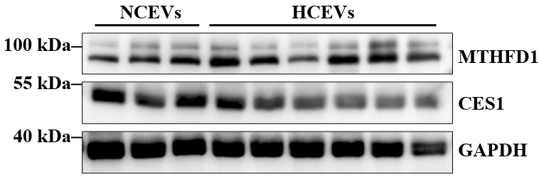
Supplemental figure 4. Validation of CEVs differential proteins.
The protein expression levels of MTHFD1 and CES1 in NCEVs and HCEVs were detected by WB.

