Supplementary Material
Supplementary Fig. 1 Expression plot of ELISA-detected OD values for three autoantibodies in the verification phase
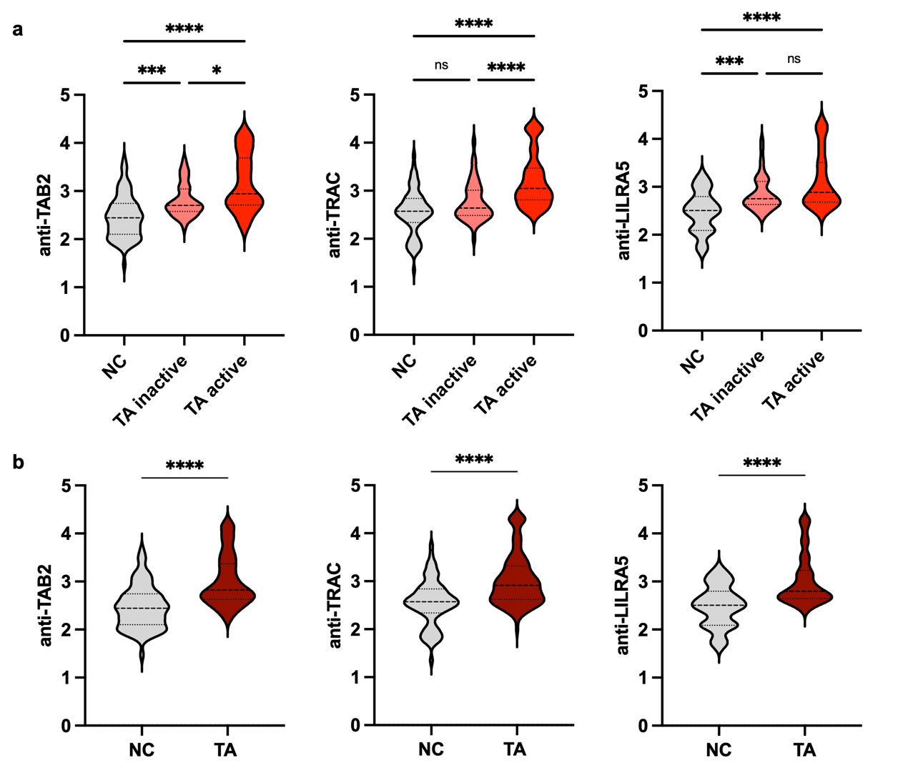
(a) Comparison between patients with active TA, patients with inactive TA, and healthy controls. (b) Comparison between patients with TA and healthy controls. *P ≤ 0.05, ***P ≤ 0.001, ****P ≤ 0.0001, ns: no significance. HC: healthy control, TA: Takayasu arteritis.

Supplementary Fig. 2 Diagnostic performance of three autoantibodies in the verification phase
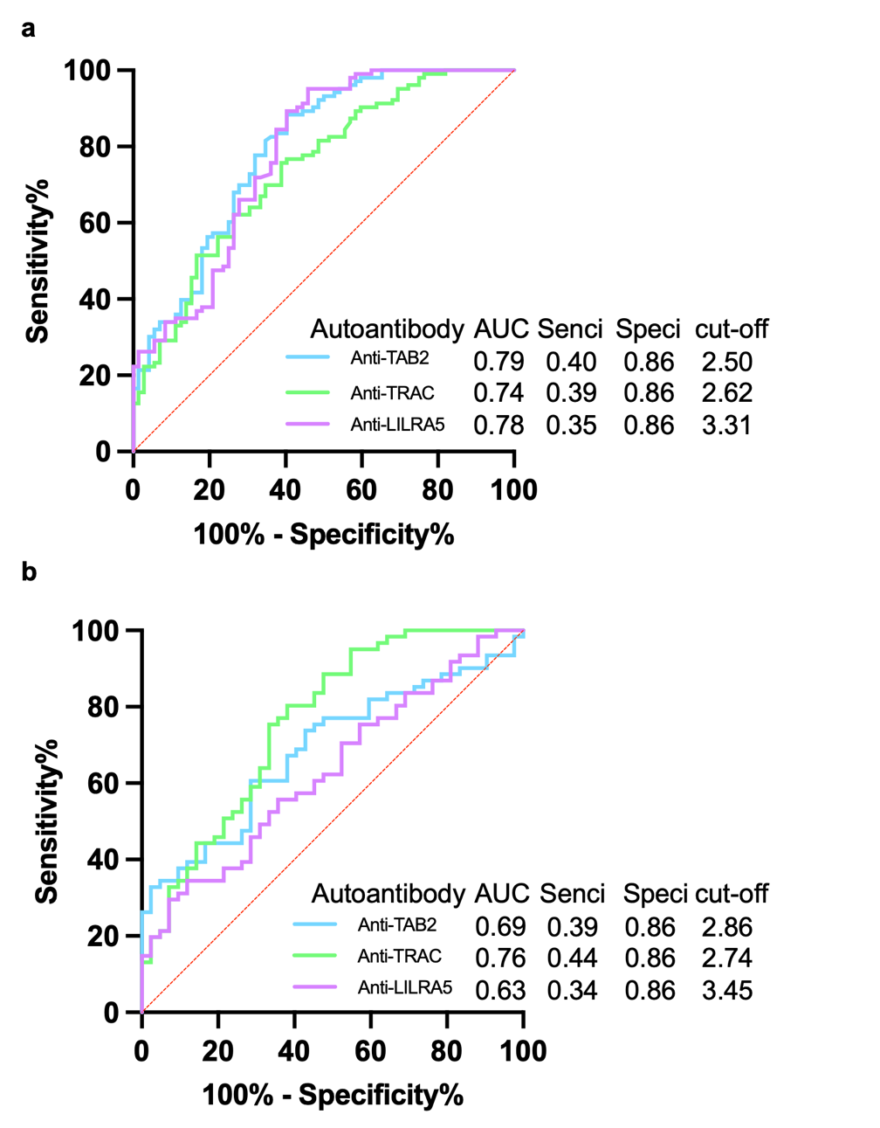
(a) ROC curve analysis of the three autoantibodies for distinguishing between patients with TA and healthy controls. (b) ROC curve analysis of the three autoantibodies for distinguishing between patients with active TA and patients with inactive TA. AUC: area under the curve, CI: confidence interval, ROC: receiver operating characteristic, TA: Takayasu arteritis.

Supplementary Fig. 3 Expression plot of ELISA-detected OD values for three autoantibodies in treatment‑naïve and treated TA patients
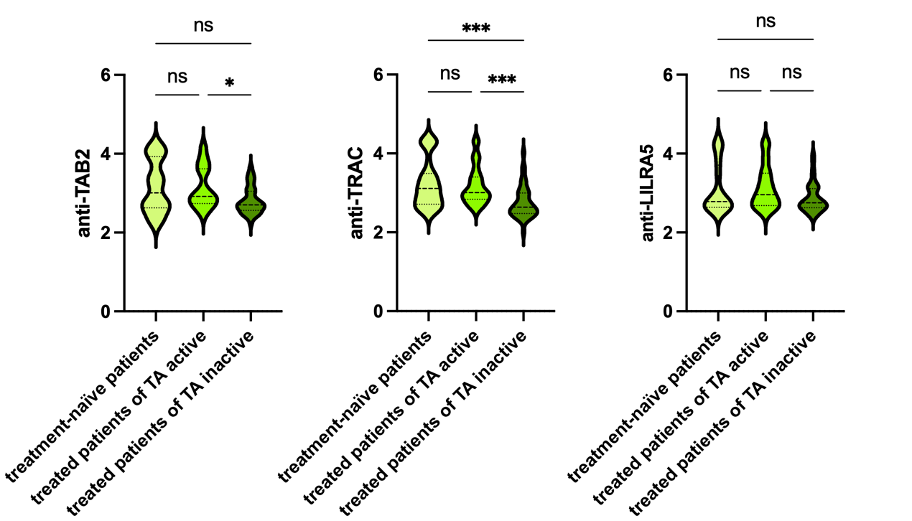
**P ≤ 0.01, ns: no significance; TA: Takayasu arteritis.

Supplementary Table 1 Diagnostic value of 12 candidate proteins in the HuProt array.
Proteins | Sensitivity | Specificity | AUC
TAB2 | 0.56 | 0.90 | 0.74
TRAC | 0.44 | 0.90 | 0.76
LILRA5 | 0.33 | 0.90 | 0.74
FOSL1 | 0.44 | 0.90 | 0.59
TRIP6 | 0.33 | 0.90 | 0.69
ANTXR1 | 0.44 | 0.90 | 0.69
POLR3K | 0.44 | 0.90 | 0.54
POLR1C | 0.33 | 0.90 | 0.67
CLDN16 | 0.33 | 0.90 | 0.59
HLA-DQA1 | 0.33 | 0.90 | 0.53
IL1B | 0.22 | 0.90 | 0.69
CD8B | 0.33 | 0.90 | 0.63
AUC: area under the curve.

Supplementary Table 2 Correlation analysis between disease duration and autoantibody titers.
Proteins | r | P value
TAB2 | 0.03 | 0.76
TRAC | -0.06 | 0.51
LILRA5 | 0.02 | 0.86

