Supplementary material
- A375 Cell-based assay (Dose-response curves of compounds 9a-i & sorafenib)
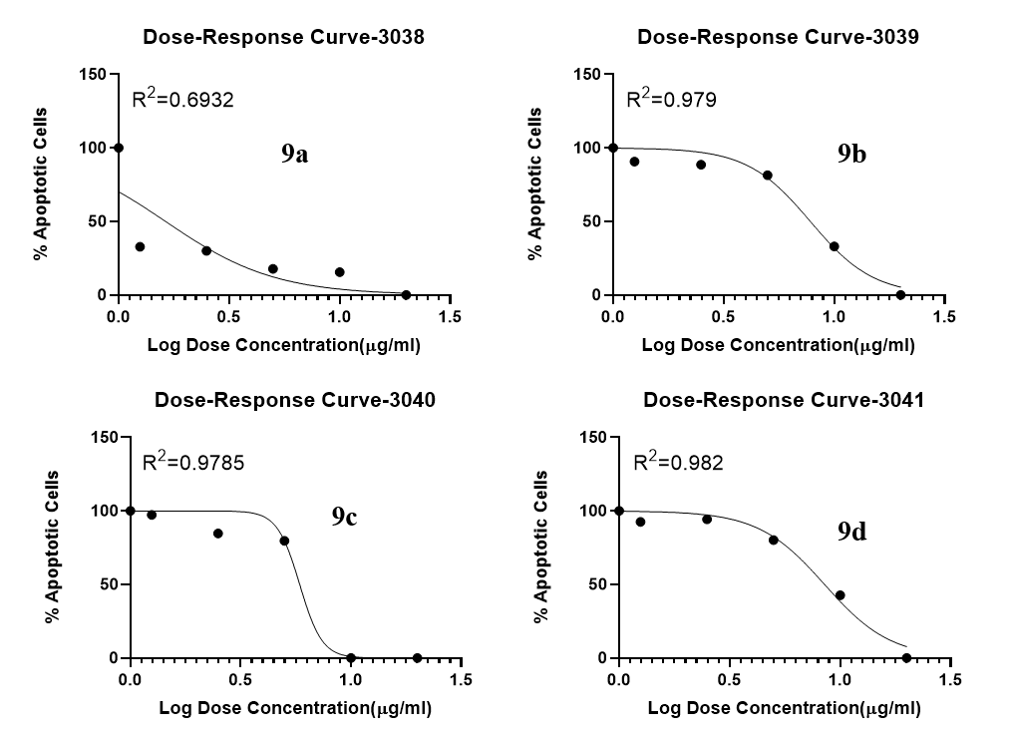
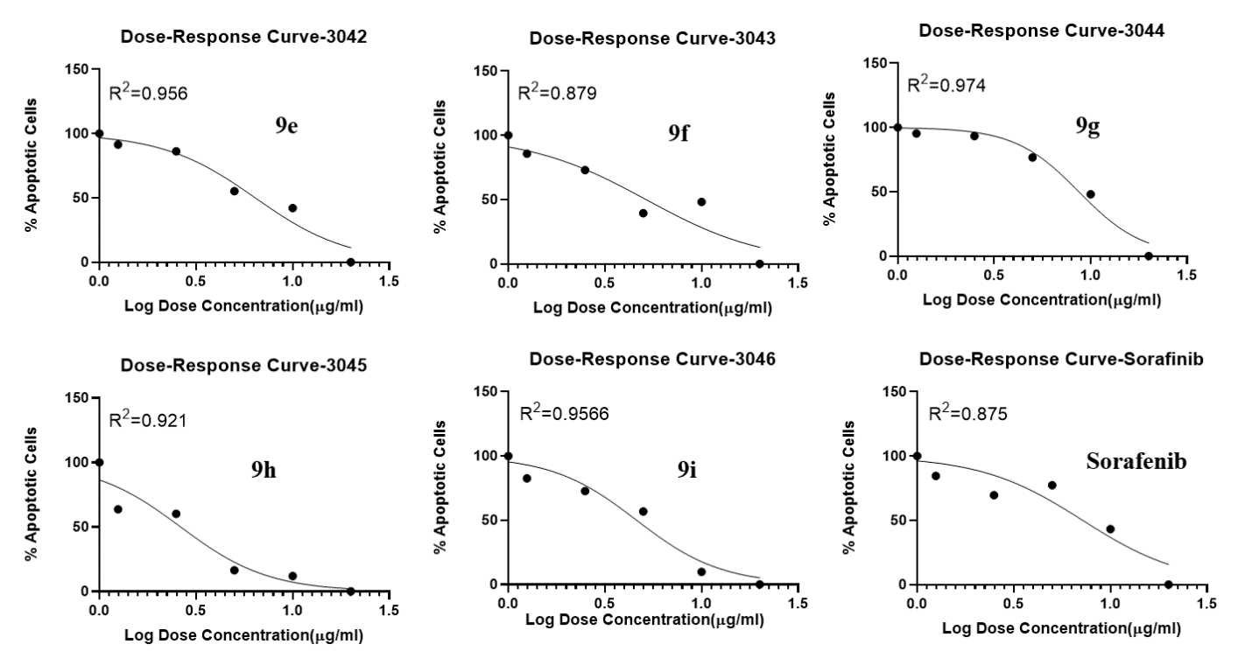

- Kinase-based assay (Dose-response curves of compound 9a over Raf isoforms)

