Electronic Supplementary Material

Supplemental Table 1. Demographic and baseline characteristics by NLR group.

Characteristic, n (%) | Eribulin (n=475) |  | TPCª (n=238)
Characteristic, n (%) | NLR <3  (n=230) | NLR ≥3  (n=245) | NLR <3  (n=114) | NLR ≥3  (n=124)
Geographical region
North America/Western Europe/Australia | 130 (57) | 184 (75) | 68 (60) | 92 (74)
Eastern Europe | 70 (30) | 37 (15) | 31 (27) | 20 (16)
Latin America/South Africa | 30 (13) | 24 (10) | 15 (13) | 12 (10)
HER2 status
Positive | 40 (17) | 38 (16) | 16 (14) | 20 (16)
Negative | 163 (71) | 190 (78) | 89 (78) | 96 (77)
Unknown | 27 (12) | 17 (7) | 9 (8) | 8 (6)
Prior capecitabine treatment
Yes | 164 (71) | 188 (77) | 82 (72) | 99 (80)
No | 66 (29) | 57 (23) | 32 (28) | 25 (20)
ECOG performance status
0 | 112 (49) | 92 (38) | 54 (47) | 46 (37)
≥1 | 117 (51) | 146 (60) | 60 (53) | 75 (60)
Age group
<65 years | 197 (86) | 188 (77) | 95 (83) | 91 (73)
≥65 years | 33 (14) | 57 (23) | 19 (17) | 33 (27)
ER status
Positive | 152 (66) | 169 (69) | 78 (68) | 86 (69)
Negative | 63 (27) | 71 (29) | 31 (27) | 36 (29)
Unknown | 15 (7) | 5 (2) | 5 (4) | 2 (2)
PgR status
Positive | 114 (50) | 128 (52) | 57 (50) | 59 (48)
Negative | 84 (37) | 101 (41) | 43 (38) | 54 (44)
Unknown | 32 (14) | 16 (7) | 14 (12) | 11 (9)
HR status
Positive | 157 (68) | 175 (71) | 84 (74) | 87 (70)
Negative | 54 (23) | 63 (26) | 25 (22) | 34 (27)
Unknown | 19 (8) | 7 (3) | 5 (4) | 3 (2)
Triple negative
Triple negative | 41 (18) | 47 (19) | 21 (18) | 28 (23)
Non-triple negative | 189 (82) | 198 (81) | 93 (82) | 96 (77)
Site of disease
Visceral disease | 188 (82) | 202 (82) | 88 (77) | 111 (90)
Non-visceral disease | 42 (18) | 42 (17) | 24 (21) | 13 (10)
Number of organs involved
≤2 | 185 (80) | 166 (68) | 82 (72) | 73 (59)
>2 | 45 (20) | 78 (32) | 30 (26) | 51 (41)
Number of prior chemotherapy regimens
≤3 | 121 (53) | 99 (40) | 56 (49) | 47 (38)
>3 | 107 (47) | 146 (60) | 57 (50) | 77 (62)
Number of prior chemotherapy regimens for locally advanced or metastatic disease
≤3 | 185 (80) | 180 (73) | 83 (73) | 84 (68)
>3 | 45 (20) | 65 (27) | 30 (26) | 40 (32)
Refractory to taxanes^{b}
Yes | 173 (75) | 207 (84) | 91 (80) | 102 (82)
No | 57 (25) | 38 (16) | 23 (20) | 22 (18)

ªTPC was defined as any single-agent chemotherapy, or hormonal or biological therapy, approved for the treatment of cancer.
^{b}Disease progression on or within 6 months of taxane treatment.
ECOG, Eastern Cooperative Oncology Group; ER, oestrogen receptor; HER2, human epidermal growth factor receptor-2; HR, hormone receptor; NLR, neutrophil-to-lymphocyte ratio; PgR, progesterone receptor; TPC, treatment of physician’s choice.

Supplemental Table 2. Cut-off value of ALC as a predictive factor of the effect of eribulin on OS.

ALC Cut-off (/μl) | Treatment | n | Median (months) | HR (Eribulin/TPC) | 95% CI (Lower) | 95% CI (Upper) | Interaction  P-value
≥1300 | Eribulin | 258 | 15.0 | 0.743 | 0.578 | 0.957 | 0.3982
 | TPC | 131 | 11.4
<1300 | Eribulin | 242 | 11.1 | 0.865 | 0.673 | 1.112
 | TPC | 120 | 9.1
≥1400 | Eribulin | 234 | 15.7 | 0.641 | 0.490 | 0.840 | 0.0136
 | TPC | 112 | 11.4
<1400 | Eribulin | 266 | 11.1 | 0.993 | 0.783 | 1.258
 | TPC | 139 | 10.1
≥1500 | Eribulin | 199 | 15.6 | 0.586 | 0.437 | 0.784 | 0.0031
 | TPC | 92 | 11.4
<1500 | Eribulin | 301 | 11.6 | 1.002 | 0.800 | 1.253
 | TPC | 159 | 10.3
≥1600 | Eribulin | 172 | 15.7 | 0.578 | 0.418 | 0.799 | 0.0042
 | TPC | 72 | 10.5
<1600 | Eribulin | 328 | 11.8 | 0.964 | 0.780 | 1.193
 | TPC | 179 | 10.7
≥1700 | Eribulin | 149 | 15.7 | 0.633 | 0.444 | 0.903 | 0.0326
 | TPC | 62 | 10.5
<1700 | Eribulin | 351 | 12.3 | 0.907 | 0.739 | 1.114
 | TPC | 189 | 10.7
≥1800 | Eribulin | 130 | 14.9 | 0.629 | 0.425 | 0.931 | 0.0681
 | TPC | 51 | 10.5
<1800 | Eribulin | 370 | 12.5 | 0.873 | 0.715 | 1.066
 | TPC | 200 | 10.7

ALC, absolute lymphocyte count; CI, confidence interval; HR, hazard ratio; OS, overall survival; TPC, treatment of physician’s choice.

Electronic Supplementary Material
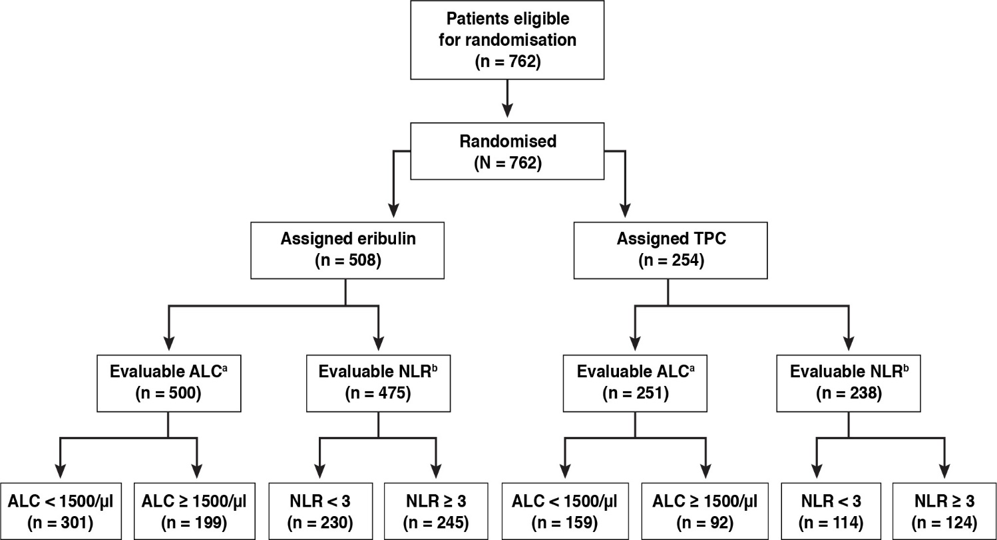
Supplemental Fig. 1 CONSORT diagram of study population in EMBRACE

ªData from 8 patients in the eribulin arm and 3 patients in the TPC arm were omitted due to missing baseline ALCs.
^{b}Data from 33 patients in eribulin arm and 16 patients in the TPC arm were omitted due to missing baseline NLRs.
ALC, absolute lymphocyte count; NLR, neutrophil-to-lymphocyte ratio; TPC, treatment of physician’s choice.

Supplemental Fig. 2 Interaction between treatment and baseline ALC (<1500/µl/ ≥1500/µl) on PFS (Independent review)
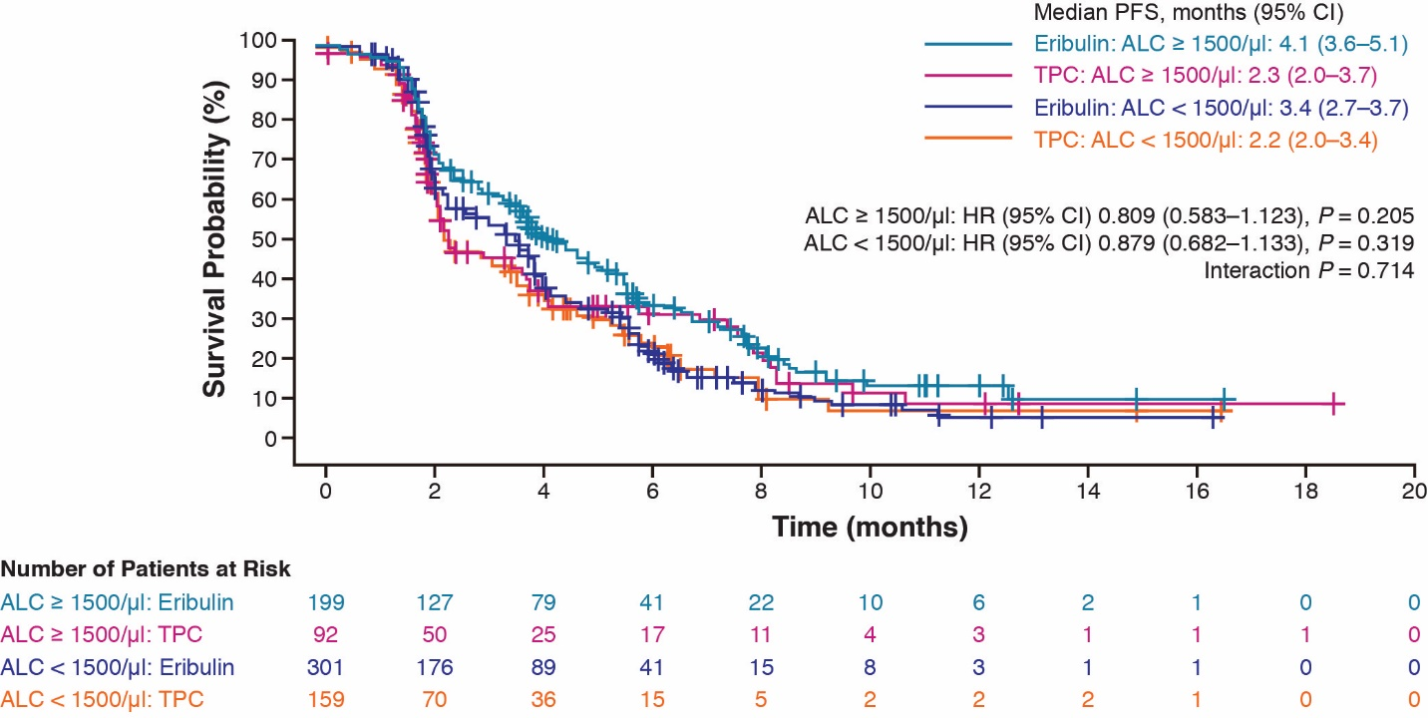

ALC, absolute lymphocyte count; CI, confidence interval; HR, hazard ratio; PFS, progression-free survival; TPC, treatment of physician’s choice.

Supplemental Fig. 3 Interaction between treatment and baseline NLR (<3/≥3) on PFS (Independent review)
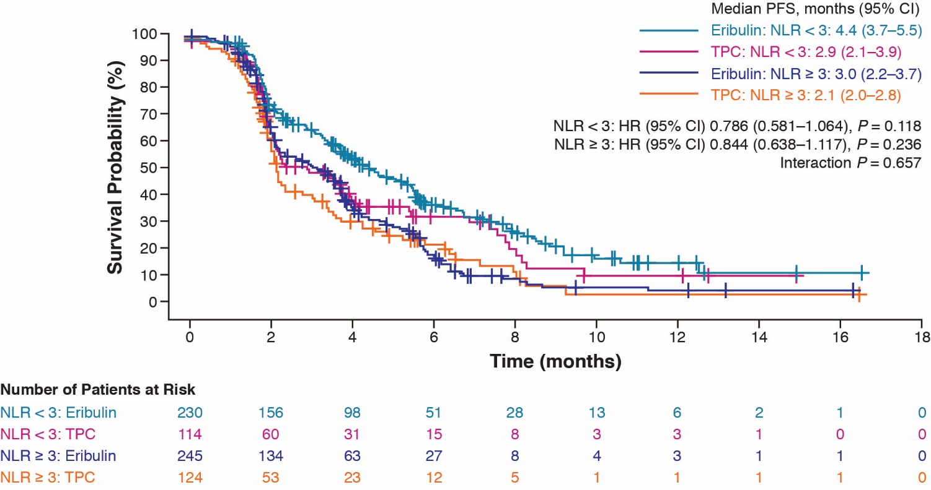

CI, confidence interval; HR, hazard ratio; NLR, neutrophil-to-lymphocyte ratio; PFS, progression-free survival; TPC, treatment of physician’s choice.

Supplemental Fig. 4 Forest plot for baseline ALC (<1500/µl vs ≥1500/µl) effects on OS for the TPC arm
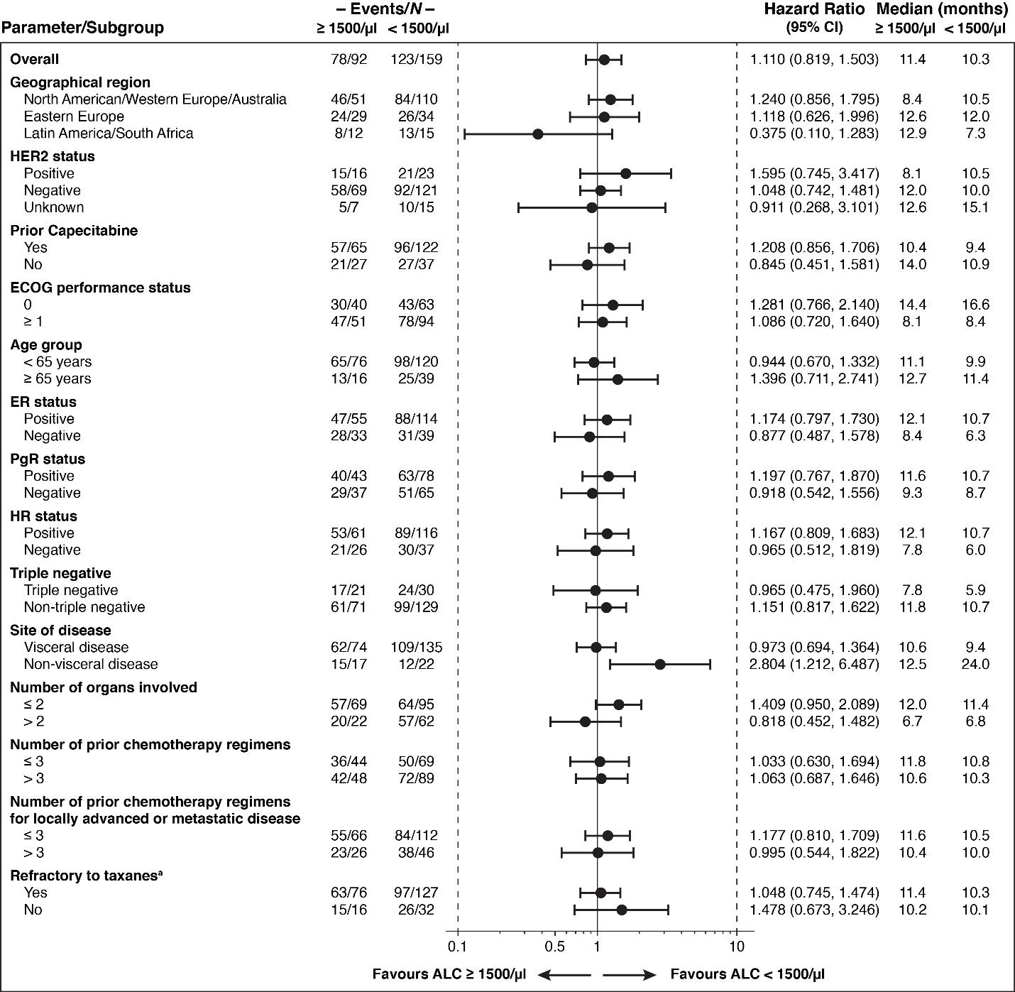
ªDisease progression on or within 6 months of taxane treatment.
ALC, absolute lymphocyte count; CI, confidence interval; ER, oestrogen receptor, HR, hormone receptor; OS, overall survival; PgR, progesterone receptor; TPC, treatment of physician’s choice.

