Online Resource 1.
Disposition of Asian patients as of data cut-off (January 11, 2022).
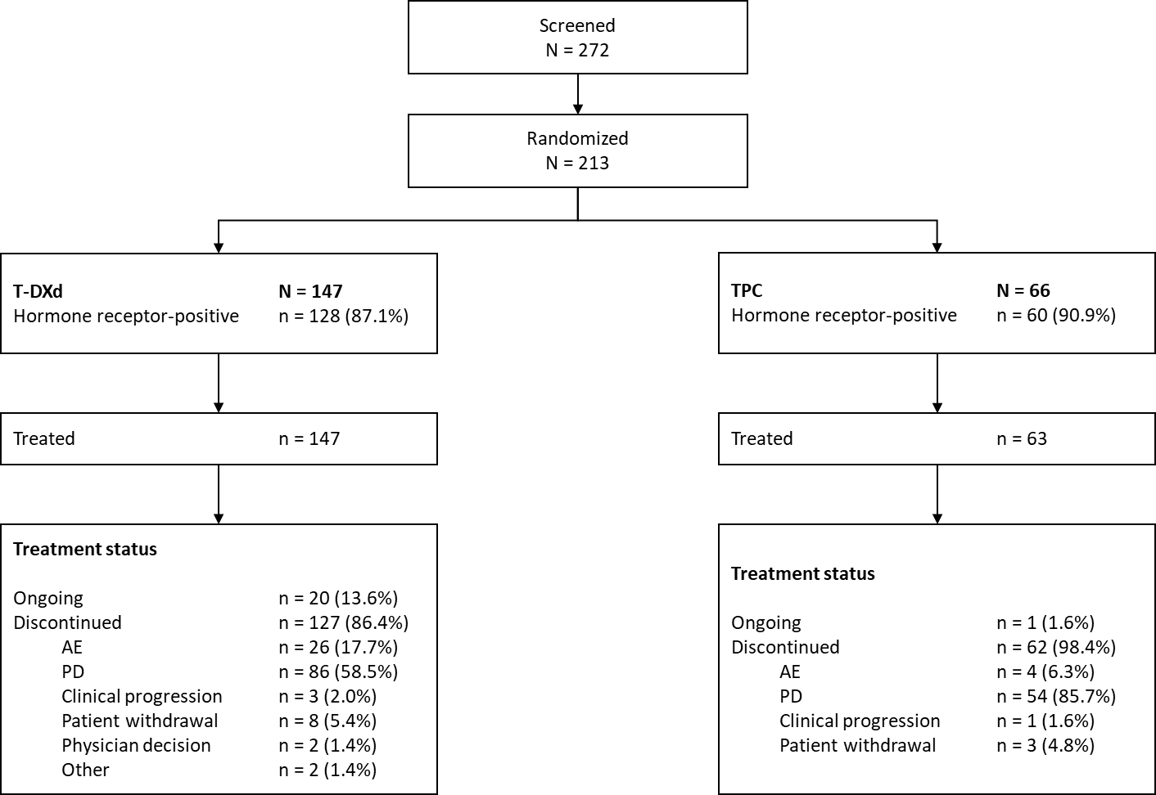
AE, adverse event; PD, progressive disease; T-DXd, trastuzumab deruxtecan; TPC, treatment of physician’s choice.

