Supplementary Appendix

Supplementary Table 1. Search strategies on PubMed/MEDLINE and the Cochrane Library

No | Search Strategy on PubMed/MEDLINE | Result
#01 | "Breast Neoplasms/radiotherapy"[Mesh] OR ("Breast Neoplasms/therapy"[Mesh] AND "Radiotherapy"[Mesh]) | 20,211
#02 | "Mammaplasty"[Mesh] | 14,682
#03 | "Tissue Expansion Devices"[Mesh] OR "Breast Implants"[Mesh] | 6,654
#04 | #1 AND #2 AND #3 | 272
#05 | (Breast[TIAB] OR Mammary[TI]) AND (Tumo*[TIAB] OR Cancer*[TIAB] OR Carcinoma*[TIAB] OR Neoplasm*[TW]) AND (mammaplast*[TIAB] OR mammoplast*[TIAB] OR reconstruction[TIAB]) AND (Radiotherapy[TIAB] OR "radiation therapy"[TIAB] OR irradiation[TIAB]) AND ("Tissue Expansion Device"[TIAB] OR "Tissue Expansion Devices"[TW] OR implant*[TIAB]) | 682
#06 | #4 OR #5 | 764
#07 | #6 AND 2016/1:2021/3[DP] | 329
#08 | #7 AND (JAPANESE[LA] OR ENGLISH[LA]) | 320
#09 | #8 AND ("Meta-Analysis"[PT] OR "Meta-Analysis as Topic"[Mesh] OR "meta-analysis"[TIAB]) | 11
#10 | #8 AND ("Cochrane Database Syst Rev"[TA] OR "Systematic Review"[PT] OR "Systematic Reviews as Topic"[Mesh] OR "systematic review"[TIAB]) | 12
#11 | #8 AND ("Practice Guideline"[PT] OR "Practice Guidelines as Topic"[Mesh] OR "Consensus"[Mesh] OR "Consensus Development Conferences as Topic"[Mesh] OR "Consensus Development Conference"[PT] OR guideline*[TI] OR consensus[TI]) | 7
#12 | #9 OR #10 OR #11 | 23
#13 | #8 AND ("Randomized Controlled Trial"[PT] OR "Randomized Controlled Trials as Topic"[Mesh] OR (random*[TIAB] NOT medline[SB])) | 7
#14 | #8 AND ("Clinical Trial"[PT] OR "Clinical Trials as Topic"[Mesh] OR "Observational Study"[PT] OR "Observational Studies as Topic"[Mesh] OR (("clinical trial"[TIAB] OR "case control"[TIAB] OR "case comparison"[TIAB]) NOT medline[SB])) | 24
#15 | (#13 OR #14) NOT #12 | 26
#16 | #8 AND ("Epidemiologic Methods"[Mesh] OR "Comparative Study"[PT] OR "Multicenter Study"[PT] OR "Validation Study"[PT] OR ((cohort*[TIAB] OR "comparative study"[TIAB] OR "follow-up"[TIAB] OR "prospective study"[TIAB] OR "Retrospective study"[TIAB]) NOT medline[SB])) | 222
#17 | #16 NOT (#12 OR #15) | 190

No. | Search Strategy on the Cochrane Library | Result
#1 | (Breast:ti OR Mammary:ti) AND (Tumo*:ti,ab,kw OR Cancer*:ti,ab,kw OR Carcinoma*:ti,ab,kw OR Neoplasm*:ti,ab,kw OR oncology:ti,ab,kw) | 29,262
#2 | Radiotherapy:ti OR radiation:ti OR irradiation:ti | 20,971
#3 | (mammaplast*:ti,ab,kw OR mammoplast*:ti,ab,kw OR reconstruction:ti,ab,kw) AND ("Tissue Expansion Device":ti,ab,kw OR "Tissue Expansion Devices":ti,ab,kw OR implant*:ti,ab,kw) | 885
#4 | #1 AND #2 AND #3 | 11
#5 | #3 publication date from Jan 2016 to Mar 2021 | 9
#6 | #4 CDSR | 0
#7 | #4 CCRCT | 9

Supplementary Table 2. Time intervals between primary surgery (tissue expander insertion), postmastectomy radiation therapy, and permanent implant exchange in the included studies

Study | Interval from TE insertion* to PMRT (days) | Interval from PMRT to PI exchange (days) | Interval from PI exchange to PMRT (days) | Interval from TE insertion* to PI exchange (days)
Lentz, R. 2013 | TE group: 188  PI group: 220
Collier, P. 2014 | TE group: 113  PI group: 213 |  |  | TE group: 251  PI group: 165
Ogita, M. 2018 | TE group: 51  PI group: NA | TE group: 248 | PI group: 29

*TE insertion was performed at the time of primary surgery.

TE: tissue expander; PMRT: postmastectomy radiation therapy; PI: permanent implant; NA: not applicable

TE group represents irradiation to TE. PI group represents irradiation to PI.
Supplementary Table 3. Risk of bias assessment for major complications

Outcomes |  | Major complications requiring a surgical intervention and/or hospitalization
Individual study |  | Risk of bias
 |  | Selection bias | Performance bias | Detection bias | Attrition bias | Others |  |  | Factors that can increase the certainty of the evidence |  |  |  | Indirectness |  |  |  |  |  |  |  | Number at risk (outcome rate)
Study code | Study design | Differences between baseline characteristics | Differences between groups in the care | Differences between groups in how outcomes are determined | Differences between groups in withdrawals | Inadequate adjustment for confounding | Others | Summary | Dose-response gradient | Effect of potential residual confounding factors | Large magnitude of effect | Summary | Participants |  | Intervention |  | Comparison |  | Outcome | Summary | The denominator for comparison arm | The numerator for comparison arm | (%) | The denominator for intervention arm | The numerator for intervention arm | (%) | Effect measures | An estimate of effect | Confidence interval
Anderson, PR. 2009 | Retrospective cohort | 0 | 0 | -2 | 0 | -2 | 0 | -1 | 0 | 0 | 0 | 0 | 0 |  | 0 |  | 0 |  | 0 | 0 | 12 | 0 | 0 | 62 | 3 | 4.8 | OR | 1.47 | 0.07–30.29
Lentz, R. 2013 | Retrospective cohort | -2 | 0 | -2 | 0 | -2 | 0 | -1 | 0 | 0 | 0 | 0 | 0 |  | 0 |  | 0 |  | 0 | 0 | 22 | 12 | 54.5 | 34 | 16 | 47.1 | OR | 0.74 | 0.25–2.17
Yan, C. 2016 | Retrospective cohort | -1 | 0 | -2 | 0 | -2 | 0 | -1 | 0 | 0 | 0 | 0 | 0 |  | 0 |  | 0 |  | 0 | 0 | 11 | 0 | 0 | 41 | 12 | 29.3 | OR | 9.75 | 0.53–178.48
Ogita, M. 2018 | Retrospective cohort | -2 | 0 | -2 | 0 | -2 | 0 | -1 | 0 | 0 | 0 | 0 | 0 |  | 0 |  | 0 |  | 0 | 0 | 49 | 6 | 12.2 | 32 | 5 | 15.6 | OR | 1.33 | 0.37–4.78
Yoon, AP. 2020 | Multicenter prospective | 0 | -1 | -2 | 0 | -2 | 0 | -1 | 0 | 0 | 0 | 0 | 0 |  | 0 |  | 0 |  | 0 | 0 | 80 | 26 | 32.5 | 237 | 82 | 34.6 | OR | 1.1 | 0.64–1.88
Comment
Anderson, PR. 2009 |  |  |  | Unblinded |  | No adjustment for confounding was performed.
Lentz, R. 2013 |  | Significant difference in the follow-up period. |  | Unblinded |  | No adjustment for confounding was performed.
Yan, C. 2016 |  | TNM status unknown. |  | Unblinded |  | No adjustment was performed in the multivariate analysis.
Ogita, M. 2018 |  | Significant difference in cStage. |  | Unblinded |  | No adjustment for confounding was performed.
Yoon, AP. 2020 |  |  | The details of chemotherapy were not specified. | Unblinded |  | No TNM adjustment was performed in the multivariate analysis.

Supplementary Table 4. Risk of bias assessment for reconstruction failure

Outcomes |  | Reconstruction failure
Individual study |  | Risk of bias
 |  | Selection bias | Performance bias | Detection bias | Attrition bias | Others |  |  | Factors that can increase the certainty of the evidence |  |  |  | Indirectness |  |  |  |  | Number at risk (outcome rate)
Study code | Study design | Differences between baseline characteristics | Differences between groups in the care | Differences between groups in how outcomes are  determined | Differences between groups in withdrawals | Inadequate adjustment for confounding | Others | Summary | Dose-response gradient | Effect of potential residual confounding factors | Large magnitude of effect | Summary | Participants | Intervention | Comparison | Outcome | Summary | The denominator for comparison arm | The numerator for comparison arm | (%) | The denominator for intervention arm | The numerator for intervention arm | (%) | Effect measures | An estimate of effect | Confidence interval
Nava, MB. 2011 | Case-control study | 0 | -1 | -2 | 0 | -1 | 0 | -1 | 0 | 0 | 0 | 0 | 0 | 0 | 0 | 0 | 0 | 109 | 7 | 6.4 | 50 | 20 | 40.0 | OR | 9.71 | 3.75–25.17
Lentz, R. 2013 | Retrospective cohort | -2 | 0 | -2 | 0 | -2 | 0 | -1 | 0 | 0 | 0 | 0 | 0 | 0 | 0 | 0 | 0 | 22 | 3 | 13.6 | 34 | 7 | 20.6 | OR | 1.64 | 0.38–7.17
Collier, P. 2014 | Retrospective cohort | -1 | -1 | -2 | 0 | -2 | 0 | -1 | 0 | 0 | 0 | 0 | 0 | 0 | 0 | 0 | 0 | 22 | 1 | 4.5 | 32 | 2 | 6.3 | OR | 1.4 | 0.12–16.46
Cordeiro, PG. 2015 | Retrospective cohort | -1 | -1 | -2 | 0 | -2 | 0 | -1 | 0 | 0 | 0 | 0 | 0 | 0 | 0 | 0 | 0 | 210 | 26 | 12.4 | 94 | 17 | 18.1 | OR | 1.56 | 0.80–3.04
Fowble, B. 2015 | Retrospective cohort | -1 | -1 | -2 | 0 | -2 | 0 | -1 | 0 | 0 | 0 | 0 | 0 | 0 | 0 | 0 | 0 | 13 | 1 | 7.7 | 86 | 17 | 19.8 | OR | 2.96 | 0.36–24.33
Yan, C. 2016 | Retrospective cohort | -1 | 0 | -2 | 0 | -2 | 0 | -1 | 0 | 0 | 0 | 0 | 0 | 0 | 0 | 0 | 0 | 11 | 0 | 0.0 | 41 | 5 | 12.2 | OR | 3.47 | 0.18–67.55
Ogita, M. 2018 | Retrospective cohort | -2 | 0 | -2 | 0 | -2 | 0 | -1 | 0 | 0 | 0 | 0 | 0 | 0 | 0 | 0 | 0 | 49 | 5 | 10.2 | 32 | 5 | 15.6 | OR | 1.63 | 0.43–6.16
Yuce Sari S, 2019 | Retrospective cohort | -1 | -1 | -2 | 0 | -2 | 0 | -1 | 0 | 0 | 0 | 0 | 0 | -1 | -1 | 0 | -1 | 154 | 28 | 18.2 | 17 | 4 | 23.5 | OR | 1.38 | 0.42–4.57
Yoon, AP. 2020 | Multicenter prospective | 0 | -1 | -2 | 0 | -2 | 0 | -1 | 0 | 0 | 0 | 0 | 0 | 0 | 0 | 0 | 0 | 80 | 8 | 10.0 | 237 | 47 | 19.8 | OR | 2.23 | 1.00–4.94
Comment
Nava, MB. 2011 |  |  | Not specified. | Unblinded |  | Some confounding factors were adjusted.
Lentz, R. 2013 |  | Significant difference in the follow-up period. |  | Unblinded |  | No adjustment for confounding was performed.
Collier, P. 2014 |  | Not specified, except for age. | Not specified. | Unblinded |  | No adjustment for confounding was performed.
Cordeiro, PG. 2015 |  | TNM status unknown. | The details of chemotherapy were not specified. | Unblinded |  | No adjustment was performed in the multivariate analysis.
Fowble, B. 2015 |  | Not specified. | Not specified. | Unblinded |  | No adjustment for confounding was performed.
Yan, C. 2016 |  | TNM status unknown. |  | Unblinded |  | No adjustment was performed in the multivariate analysis.
Ogita, M. 2018 |  | Significant difference in cStage. |  | Unblinded |  | No adjustment for confounding was performed.
Yuce Sari S, 2019 |  | TNM status unknown. | The details of chemotherapy were not specified. | Unblinded |  | No adjustment was performed in the multivariate analysis. |  |  |  |  |  |  |  | Includes chest wall only and 2D irradiation. | Includes chest wall only and 2D irradiation.
Yoon, AP. 2020 |  |  | The details of chemotherapy were not specified. | Unblinded |  | No TNM adjustment was performed in the multivariate analysis.

Supplementary Table 5. Risk of bias assessment for capsular contracture

Outcomes |  | Capsular contracture with Baker grade III or IV and/or requiring additional surgery
Individual study |  | Risk of bias
 |  | Selection bias | Performance bias | Detection bias | Attrition bias | Others |  |  | Factors that can increase the certainty of the evidence |  |  |  |  |  | Indirectness |  |  |  |  |  |  |  | Number at risk (outcome rate)
Study code | Study design | Differences between baseline characteristics | Differences between groups in the care | Differences between groups in how outcomes are  determined | Differences between groups in withdrawals | Inadequate adjustment for confounding | Others | Summary | Dose-response gradient |  | Effect of potential residual confounding factors |  | Large magnitude of effect | Summary | Participants |  | Intervention |  | Comparison |  | Outcome | Summary | The denominator for comparison arm |  | The numerator for comparison arm |  | (%) |  | The denominator for intervention arm |  | The numerator for intervention arm |  | (%) | Effect measures | An estimate of effect | Confidence interval
Cordeiro, PG. 2015 | Retrospective cohort | -1 | -1 | -2 | 0 | -2 | 0 | -1 | 0 |  | 0 |  | 0 | 0 | 0 |  | 0 |  | 0 |  | 0 | 0 | 184 |  | 94 |  | 51.1 |  | 77 |  | 13 |  | 16.9 | OR | 0.19 | 0.10–0.38
Lentz, R. 2013 | Retrospective cohort | -2 | 0 | -2 | 0 | -2 | 0 | -1 | 0 |  | 0 |  | 0 | 0 | 0 |  | 0 |  | 0 |  | 0 | 0 | 22 |  | 9 |  | 40.9 |  | 34 |  | 4 |  | 11.8 | OR | 0.19 | 0.05–0.74
Nava, MB. 2011 | Case-control | 0 | -1 | -2 | 0 | -1 | 0 | -1 | 0 |  | 0 |  | 0 | 0 | 0 |  | 0 |  | 0 |  | 0 | 0 | 107 |  | 62 |  | 57.9 |  | 30 |  | 16 |  | 53.3 | OR | 0.83 | 0.37–1.87
Comment
Cordeiro, PG. 2015 |  | TNM status unknown. | The details of chemotherapy were not specified. | Unblinded |  | No adjustment was performed in the multivariate analysis.
Lentz, R. 2013 |  | Significant difference in the follow-up period. |  | Unblinded |  | No adjustment for confounding was performed.
Nava, MB. 2011 |  |  | Not specified. | Unblinded |  | Some confounding factors were adjusted.
Supplementary Table 6. Risk of bias assessment for cosmesis

Outcomes |  | Decline in cosmesis (less than "good")
Individual study |  | Risk of bias
 |  | Selection bias | Performance bias | Detection bias | Attrition bias | Others |  |  | Factors that can increase the certainty of the evidence |  |  |  | Indirectness |  |  |  |  | Number at risk (outcome rate)
Study code | Study design | Differences between baseline characteristics | Differences between groups in the care | Differences between groups in how outcomes are  determined | Differences between groups in withdrawals | Inadequate adjustment for confounding | Others | Summary | Dose-response gradient | Effect of potential residual confounding factors | Large magnitude of effect | Summary | Participants | Intervention | Comparison | Outcome | Summary | The denominator for comparison arm | The numerator for comparison arm | (%) | The denominator for intervention arm | The numerator for intervention arm | (%) | Effect measures | An estimate of effect | Confidence interval
Yuce Sari, S. 2019 | Retrospective cohort | -1 | -1 | -2 | 0 | -2 | 0 | -1 | 0 | 0 | 0 | 0 | 0 | -1 | -1 | 0 | -1 | 154 | 57 | 37.0 | 17 | 3 | 17.7 | OR | 0.36 | 0.10–1.32
Cordeiro, PG. 2015 | Retrospective cohort | -1 | -1 | -2 | 0 | -2 | 0 | -1 | 0 | 0 | 0 | 0 | 0 | 0 | 0 | 0 | 0 | 136 | 19 | 14.0 | 43 | 3 | 7.0 | OR | 0.46 | 0.13–1.64
Nava, MB. 2011 | Case-control | 0 | -1 | -2 | 0 | -1 | 0 | -1 | 0 | 0 | 0 | 0 | 0 | 0 | 0 | 0 | 0 | 90 | 43 | 47.8 | 26 | 14 | 53.9 | OR | 1.28 | 0.53–3.06
Anderson, PR. 2009 | Retrospective cohort | 0 | 0 | -2 | 0 | -2 | 0 | -1 | 0 | 0 | 0 | 0 | 0 | 0 | 0 | 0 | 0 | 12 | 2 | 16.7 | 62 | 6 | 9.7 | OR | 0.54 | 0.09–3.04
Comment
Yuce Sari, S. 2019 |  | TNM status unknown. | The details of chemotherapy were not specified. | Unblinded |  | No adjustment was performed in the multivariate analysis. |  |  |  |  |  |  |  | Includes chest wall only and 2D irradiation. | Includes chest wall only and 2D irradiation.
Cordeiro, PG. 2015 |  | TNM status unknown. | The details of chemotherapy were not specified. | Unblinded |  | No adjustment was performed in the multivariate analysis.
Nava, MB. 2011 |  |  | Not specified. | Unblinded |  | Some confounding factors were adjusted.
Anderson, PR. 2009 |  |  |  | Unblinded |  | No adjustment for confounding was performed.

Supplementary Table 6. Body of evidence by each outcome

 |  |  |  |  |  |  |  |  |  |  |  |  | Number at risk (outcome rate)
Outcomes | Study design /Number of studies | Risk of bias | Inconsistency |  | Imprecision |  |  | Indirectness |  | Others (Publication bias) |  | Factors that can increase the certainty of the evidence | The denominator for comparison arm | The numerator for comparison arm | (％) | The denominator for intervention arm | The numerator for intervention arm | (％) | Effect measures | An estimate of effect | 95%  Confidence interval | Certainty of evidence | Importance
Major complications | Cohort /5 | -1 | 0 |  | -1 |  |  | 0 |  | -1 |  | 0 | 174 | 44 | 25.3 | 406 | 118 | 29.1 | OR | 1.11 | 0.72–1.73 | Low (C) | 8
Reconstruction failure | Cohort /8,  Case-control /1 | -1 | 0 |  | 0 |  |  | 0 |  | 0 |  | 0 | 670 | 79 | 11.8 | 623 | 124 | 19.9 | OR | 2.33 | 1.43–3.82 | Low (C) | 8
Capsular contracture | Cohort /2,  Case-control /1 | -1 | -1 |  | 0 |  |  | 0 |  | -1 |  | 0 | 313 | 165 | 52.7 | 141 | 33 | 23.4 | OR | 0.33 | 0.12–0.92 | Low (C) | 8
Decline in cosmesis | Cohort /3,  Case-control /1 | -1 | 0 |  | -1 |  |  | 0 |  | -1 |  | 0 | 392 | 121 | 30.9 | 148 | 26 | 17.6 | OR | 0.69 | 0.37–1.30 | Low (C) | 7

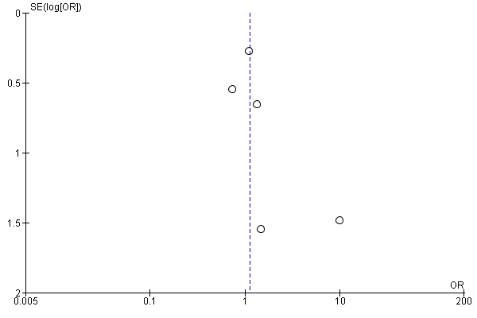
Supplementary Figure 1. Funnel plot evaluating publication bias for major complications

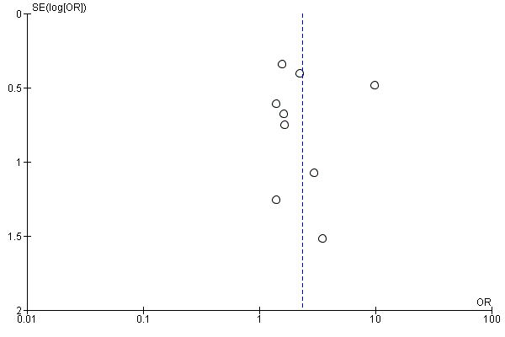
Supplementary Figure 2. Funnel plot evaluating publication bias for reconstruction failure

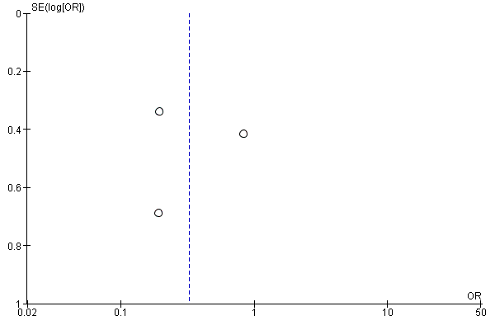
Supplementary Figure 3. Funnel plot evaluating publication bias for capsular contracture

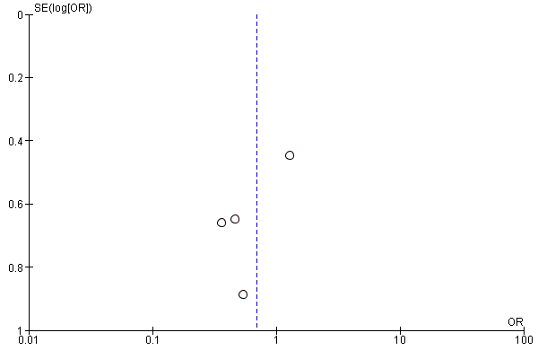
Supplementary Figure 4. Funnel plot evaluating publication bias for cosmesis

