Trampoline size (m) |  | Springs |  |  |  |  |  |  |  |  |  |  |  |  |  |  |  |  |  | Frame Height (mm)
 |  | Length (mm) |  |  | Quantity
 |  | 140 | 180 | 220 | 42 | 45 | 48 | 54 | 56 | 60 | 64 | 66 | 70 | 72 | 80 | 84 | 88 | 90 | 600 |  | 700 | 760 | 790 | 800 | 820 | 890
2.44 | A | X |  |  | X |  |  |  |  |  |  |  |  |  |  |  |  |  | X
2.44 | B | X |  |  | X |  |  |  |  |  |  |  |  |  |  |  |  |  | X
2.44 | C | X |  |  |  | X |  |  |  |  |  |  |  |  |  |  |  |  | X
2.44 | D |  | X |  |  |  | X |  |  |  |  |  |  |  |  |  |  |  |  |  |  |  | X
3.05 | A | X |  |  |  |  |  | X |  |  |  |  |  |  |  |  |  |  |  |  |  | X
3.05 | B | X |  |  |  |  |  |  |  | X |  |  |  |  |  |  |  |  |  |  |  |  | X
3.05 | C | X |  |  |  |  |  |  | X |  |  |  |  |  |  |  |  |  |  |  | X
3.05 | D |  | X |  |  |  |  |  |  |  | X |  |  |  |  |  |  |  |  |  |  |  | X
3.05 | E |  | X |  |  |  |  |  |  |  |  | X |  |  |  |  |  |  |  |  | X
3.66 | A | X |  |  |  |  |  |  |  |  |  |  |  | X |  |  |  |  |  |  |  |  |  |  | X
3.66 | B |  | X |  |  |  |  |  |  |  |  |  |  | X |  |  |  |  |  |  |  |  |  |  |  | X
3.66 | C | X |  |  |  |  |  |  |  |  |  |  | X |  |  |  |  |  |  |  |  |  |  | X
3.66 | D |  |  | X |  |  |  |  |  |  |  |  |  |  | X |  |  |  |  |  |  |  |  |  |  | X
3.66 | E |  |  | X |  |  |  |  |  |  |  |  |  |  | X |  |  |  |  |  |  |  |  |  |  | X
4.27 | A | X |  |  |  |  |  |  |  |  |  |  |  |  |  | X |  |  |  |  |  |  |  |  | X
4.27 | B |  | X |  |  |  |  |  |  |  |  |  |  |  | X |  |  |  |  |  |  |  |  |  |  | X
4.27 | C | X |  |  |  |  |  |  |  |  |  |  |  |  |  | X |  |  |  |  |  |  |  | X
4.27 | D |  |  | X |  |  |  |  |  |  |  |  |  |  |  |  |  | X |  |  |  |  |  |  |  | X
4.27 | E |  |  | X |  |  |  |  |  |  |  |  |  |  |  |  | X |  |  |  |  |  |  |  |  | X
Table 1. Trampoline mechanistic specifications

Table 2. Spring specifications (mean ± standard deviation) of 10 springs from one batch

Nominal (mm) | Spring Length (mm) | Spring Diameter (mm) | Wire thickness (mm) | Elastic limit length (mm) | Spring Constant (N.mm⁻¹)
140 | 133.7 ± 0.5 | 22.1 ± 0.1 | 3.2 | 213 ± 0.3 | 8.09 ± 0.44
180 | 174.2 ± 0.3 | 24.9 ± 0.1 | 3.2 | 298 ± 0.6 | 4.13 ± 0.14
220 | 216.0 ± 0.6 | 24.8 ± 0.1 | 3.2 | 422 ± 0.9 | 2.75 ± 0.64

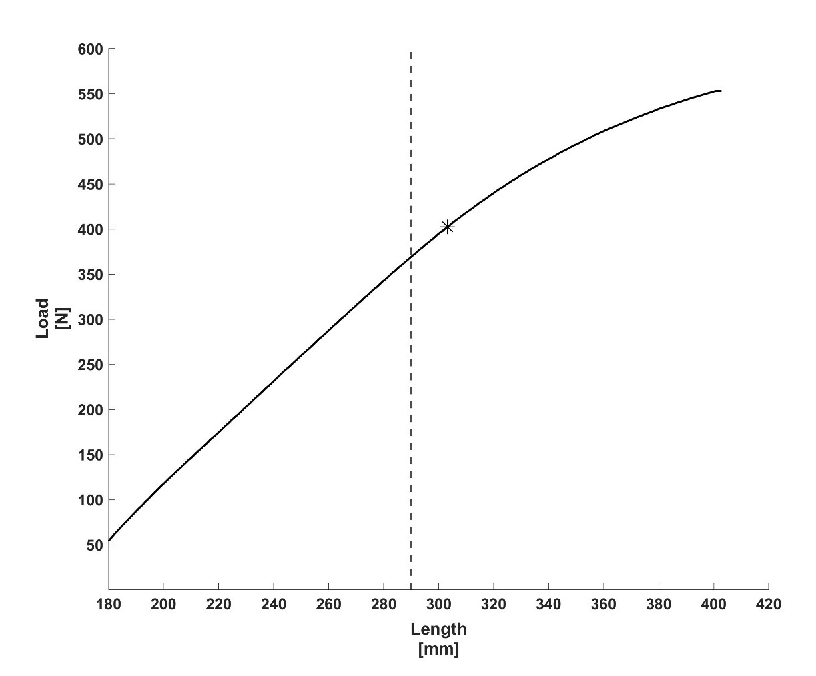

Fig 1. Load length plot from the tensile test for the 180 mm spring. The elastic limit is depicted by * and ultimate tensile strength at the end of the curve. Elastic limit was identified using a piecewise based regression method [27]. The maximum spring extension for the spring when on a 4.27 m (14 ft) trampoline is shown by the dotted line. Data starts with an initial load of 50 N.

