Manuscript title: Validation of a LiDAR-based player tracking system during football-specific tasks.

Online Resource 1: Comparison of up-sampling the LIDAR-based system (sportlight) from 10 to 100 Hz and down-sampling the 3D motion analysis system (vicon) from 100 to 10 Hz.

In the present study, the LiDAR-based system data were up-sampled from 10 to 100 Hz in accordance with previous literature [7].
The function, ‘InterpolatedUnivariateSpline’ from the scipy Python library was used (documentation available at https://docs.scipy.org/doc/scipy/reference/generated/ scipy.interpolate.InterpolatedUnivariateSpline.html) for this purpose as follows:
Interpolate the sportlight data to "new_length" samples
- Define sportlight array: ‘sy’
- Determine length of sportlight array: ‘sportlight_length’
- Calculate target length of up-sampled array: ‘target_length’
- Generate array of values from 1 to ‘sportlight_length’ in intervals of 1: ‘x’
- Generate target array of values from 1 to ‘target_length’: ‘target_x’
- Interpolate ‘sy’:
InterpolatedUnivariateSpline(‘x’, ‘sy’)(‘target_x’)
Exemplar comparison of up-sampled vs down-sampled results plotted below:
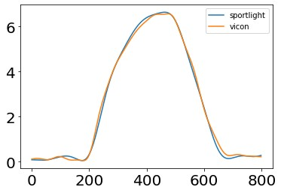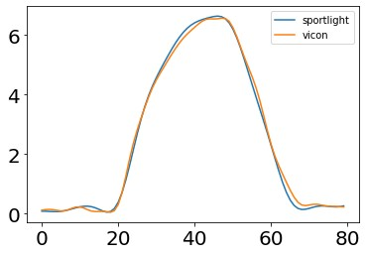
Left: Up-sampled sportlight data (RMSE: 0.129927976880182); Right: down-sampled Vicon data (RMSE: 0.13080798173983). Difference in RMSE outcomes (0.00088000485) is negligible. x-axis: sample index; y-axis: velocity.

