Online resources for “Exploration of optimal aerodynamic design space for discus”

Kazuya Seo, Ryota Kikuchi and Thomas Allen

Online Resource-3 - Supplementary Information (SI) –

CFD
The CFD analysis was done using ANSYS 2024 R1, Design Modeler, Meshing, and Fluent.
The full-size geometry of the men’s discus was modeled using Design Modeler as shown in Figure S3.1. The diameter is 220.5 mm, while the maximum thickness is 45.0 mm. The dimensions of the computational domain (enclosure) were 6000 × 6000 × 6000 mm in the vertical and lateral directions, respectively.

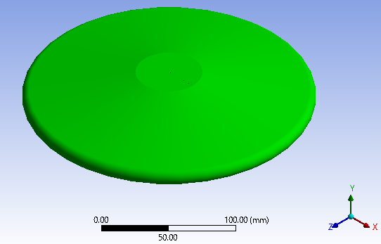
Fig. S3.1 An example of the geometry of the men's discus

Meshing was performed for the computational domain. Each element was generated using a tetrahedral ("Tet4", tetrahedral pyramidal) element. The maximum global mesh size within the computational domain was set to 200 mm. A smooth transition was applied to the inflation layer, from a fine mesh near the surface of the discus to a coarser mesh further from the discus. The transition ratio, which defines the rate of increase relative to the adjacent layer, was set to 0.272. The growth rate, which defines the relative thickness of adjacent inflation layers, was set to 1.2, and the maximum number of inflation layers created was five. As a result, about 0.9 million elements were generated. The maximum skewness was 0.79 (with 0 being ideal, and values greater than 0.9 indicating a need for improved meshing), and the maximum aspect ratio (longest edge / shortest edge) was 9.4 (with 1 being ideal, and values greater than 10 indicating a need for improved meshing).
Fluent was used to solve the 3D Reynolds-Averaged Navier–Stokes (RANS) equations and the continuity equation using the finite volume method. The second-order upwind scheme was applied to each scalar equation (momentum, energy, turbulent kinetic energy, and specific dissipation rate) in the pressure-based solver. The SST k-ω model was employed for turbulence modeling. Dirichlet boundary conditions were applied at both the inlet and outlet. At the inlet, velocity inlet boundary conditions were used to define the inflow velocity as 25 m/s, while at the outlet, pressure outlet boundary conditions were applied to define the static pressure. The remaining four boundaries of the computational domain were set as slip walls. A no-slip condition was applied to the surface of the discus.

Online Resource-4 - Supplementary Information (SI) –
Definitions

Definitions of aerodynamic forces
Figure S4.1 shows the definitions of aerodynamic forces acting on the discus in flight. The angle of attack (AoA) is the angle between the discus planform and the direction of the flight path. The aerodynamic forces (drag: D, lift: L, and pitching moment: m) are converted into the drag coefficient (C_{D}), the lift coefficient (C_{L}), and the pitching moment coefficient (C_{m}). The definitions are provided in Equations (S4.1), (S4.2) and (S4.3), respectively. Here, the reference area is the cross-sectional area of the discus planform, $A=\left(π{d_{d}}^{2}\right)/4$, and the reference length is the diameter of the discus planform, d_{d}.

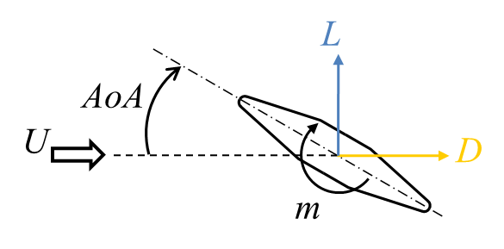
Fig. S4.1 The definitions of aerodynamic forces acting on the discus in flight.

$$C_{D}=\frac{D}{0.5ρU^{2}A}$$ | (S4.1)
$$C_{L}=\frac{L}{0.5ρU^{2}A}$$ | (S4.2)
$$C_{m}=\frac{m}{0.5ρU^{2}Ad_{d}}$$ | (S4.3)

Definitions Euler angles
To estimate the flight trajectory, the body-fixed coordinate system should be converted into the inertial coordinate system. Both coordinate systems are linked by Euler angles. Assuming the origin of the inertial coordinate system (X_{E}, Y_{E}, Z_{E}) is displaced without any rotation to the center of gravity of the discus, the new reference frame is defined as (X₀, Y₀, Z₀). The sequence of rotations conventionally used to describe the instantaneous attitude with respect to an inertial coordinate system is shown in Figure S4.2. Starting with the inertial coordinate system, the following sequence is followed; 1: Rotate about the Z_{E} axis, nose right (positive yaw Ψ), 2: Rotate about the y₁ axis, nose up (positive pitch Θ), 3: Rotate about the x_{b} axis, right wing down (positive roll Φ).

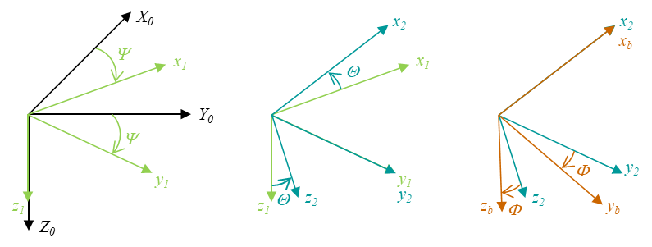
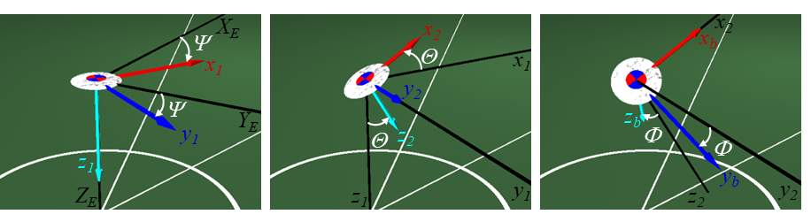
(a) Definition of Ψ. (b) Definition of Θ. (c) Definition of Φ.
Fig. S4.2 Definitions of Euler angles that are used to describe the instantaneous attitude with respect to the inertial coordinate system.

Online Resource-5 - Supplementary Information (SI) –

Aerodynamic characteristics around the stalling angle of the women’s discus [16]
A commercially available women’s discus was tested in a low-speed wind tunnel with a 0.7 × 0.7 m rectangular nozzle. It was set at ω = 0 (non-spin) revolutions per second. The angle of attack (AoA), defined as the angle between the discus planform and the direction of the flight path, was varied around the stalling angle of 30°.
2D-PIV measurements were conducted along the centerline of the women's discus. Micro-droplet particles with a diameter of 1 μm were generated by an aerosol generator (PivPart40, PivTec) and introduced into the flow via the sirocco fan in the wind tunnel. A high repetition-rate pulsed ND:YAG laser (LDP-100MQG, Lee Laser) illuminated the micro-droplet particles. A high-speed camera (Memrecam GX-8, Nac) was used to record TIFF images at a sampling frequency of 1000 Hz. The wind speed was set to 20 m/s. Figure S5.1(a) shows a picture taken before the run, while Figure S5.1(b) shows a picture taken during the run.

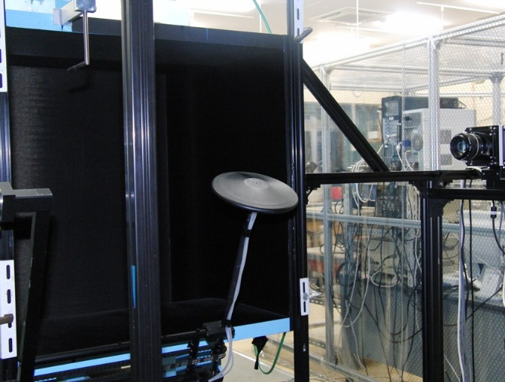 |  | 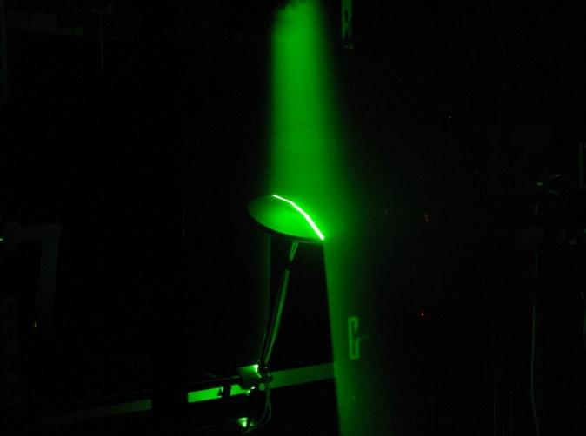
(a) Before the run; | (b) During the run
Figure S5.1 Experimental set-up of PIV measurement.

The results of 2D-PIV measurements at 20 m/s are shown in Figure S5.2. The flow direction is from left to right. The color bar represents the magnitude of the velocity. The discus is located near the bottom of each image. The AoA increases from Figure S5.2 (a) and (b). The corresponding plots for Figure S5.2 are shown in Figure S5.3, where the oil flow observations are displayed.

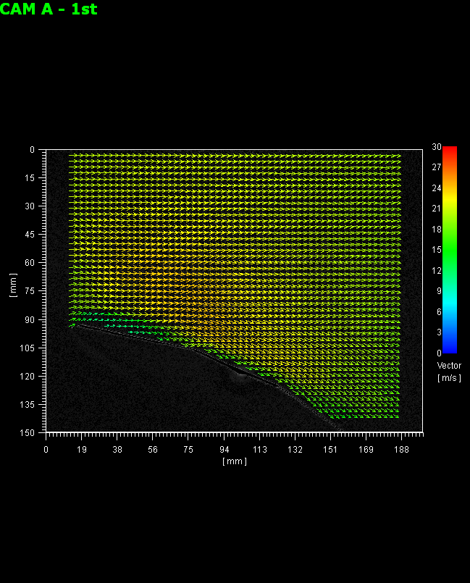  U | 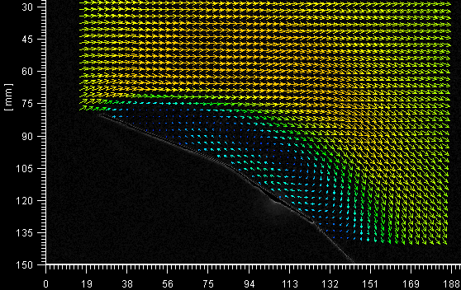
- 25° | - 35°
Figure S5.2 Experimental results of PIV measurement for women’s discus.

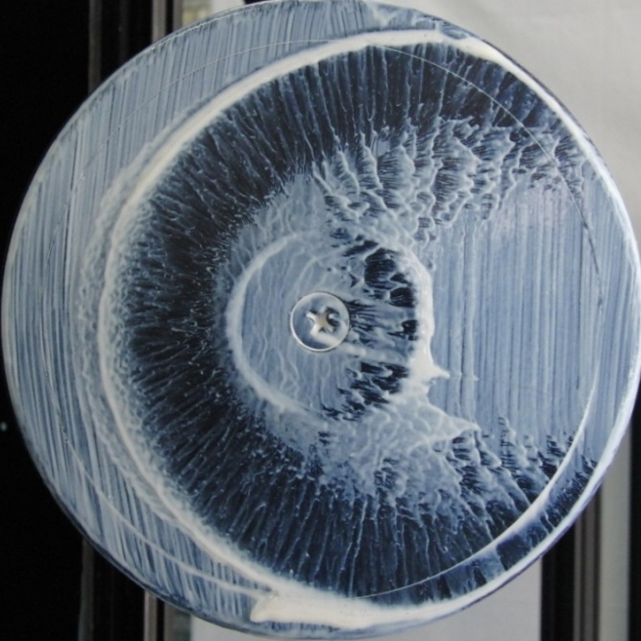  U | 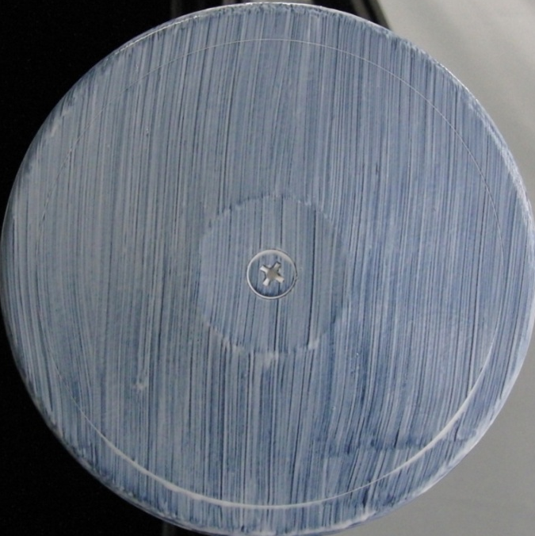
- 25° | - 35°
Figure S5.3 Oil flow observations of suction side for women’s discus.

It can be observed that the flow follows almost the entire suction side of the discus at 25° (Figure S5.2(a)). At 25° (Figures S5.2(a)), a low-velocity region is observed on the downstream side of the leading edge. Since the velocity gradient in this region is small, the viscous force is also small, allowing the oil to remain near the leading edge, as seen in Figures S5.3(a). This region may correspond to the laminar separation bubble. Outside this low-velocity region, the flow velocity increases. Re-attachment occurs around the convex point (flat center area) of the discus at 25°. At 35° (Figure S5.2(b)), the boundary layer separation occurs. The high-speed flow region is too far from the convex point (flat center area) to reattach. As a result, the oil remains over the entire suction side, as shown in Figure S5.3(b), indicating that no re-attachment occurs.

Online Resource-6 - Supplementary Information (SI) –

How to estimate aerodynamic forces in the body-fixed coordinate system
The definitions of aerodynamic forces (D and L), the velocity vector components (U, V, W) and the angular velocity vector components (P, Q, R) in the body-fixed coordinate system are also shown in Figure S6.1. The z_{b}-axis is taken as the spinning transverse axis, while other axes (x_{b} and y_{b}) are taken as the longitudinal axes on the discus planform.

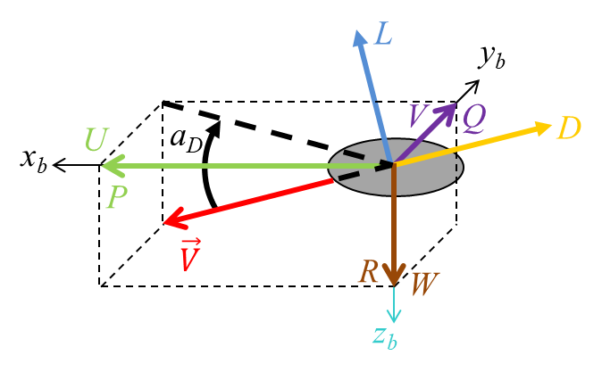
Fig. S6.1 The definitions of aerodynamic forces (D & L), the velocity vector components (U,V,W) and the angular velocity vector components (P,Q,R).

The direction of the drag is defined as opposite to the velocity vector. The unit vector of the drag, $\hat{D},$ is defined in the opposite direction of the velocity vector, as shown in Equation (S6.1). Here, $\left({\hat{x}}_{b}, {\hat{y}}_{b}, {\hat{z}}_{b}\right)$ represents the unit vector in the body-fixed coordinate system.

$$\hat{D}=-\frac{1}{\left|\vec{V}\right|}\left\{U{\hat{x}}_{b}+V{\hat{y}}_{b}+W{\hat{z}}_{b}\right\}$$ | (S6.1)

The unit vector of the side force, $\hat{Y},$ is defined to be perpendicular to ${\hat{z}}_{b}$ and $\vec{V}$.
Therefore, $\hat{Y}$ can be calculated as the vector product of ${\hat{z}}_{b}$ and $\vec{V}$, as shown in Equation (S6.2). Here, $α_{D}$ is the angle between the velocity vector and the discus planform as shown in Figure S6.1.

$$\hat{Y}=\frac{{\hat{z}}_{b}×\vec{V}}{\left|\vec{V}\right|\sin\left(\frac{π}{2}-α_{D}\right)}=\frac{1}{\left|\vec{V}\right|\cos\left(α_{D}\right)}\left\{-V{\hat{x}}_{b}+U{\hat{y}}_{b}\right\}$$ | (S6.2)

The unit vector of the lift, $\hat{L},$ is perpendicular to $\hat{D}$ and $\hat{Y}$, as shown in Equation (S6.3).

$$\hat{L}=\hat{D}×\hat{Y}=\frac{1}{{\left|\vec{V}\right|}^{2}\cos\left(α_{D}\right)}\left\{UW{\hat{x}}_{b}+VW{\hat{y}}_{b}-\left(U^{2}+V^{2}\right){\hat{z}}_{b}\right\}$$ | (S6.3)

It is now ready to convert the drag, the lift and the side force into the components of aerodynamic forces (X_{a}, Y_{a}, Z_{a}) in the body-fixed coordinate system, as shown in Equation (S6.4).

$$X_{a}{\hat{x}}_{b}+Y_{a}{\hat{y}}_{b}+Z_{a}{\hat{z}}_{b}$$  $$=-\frac{\left|D\right|}{\left|\vec{V}\right|}\left\{U{\hat{x}}_{b}+V{\hat{y}}_{b}+W{\hat{z}}_{b}\right\}$$  $$+\frac{\left|L\right|}{{\left|\vec{V}\right|}^{2}\cos\left(α_{D}\right)}\left\{UW{\hat{x}}_{b}+VW{\hat{y}}_{b}-\left(U^{2}+V^{2}\right){\hat{z}}_{b}\right\}$$  $$+\frac{\left|Y\right|}{\left|\vec{V}\right|\cos\left(α_{D}\right)}\left\{-V{\hat{x}}_{b}+U{\hat{y}}_{b}\right\}$$  $$=\frac{1}{\left|\vec{V}\right|}\left\{-\left|D\right|U+\left|L\right|\frac{UW}{\left|\vec{V}\right|\cos\left(α_{D}\right)}-\left|Y\right|\frac{V}{\cos\left(α_{D}\right)}\right\}{\hat{x}}_{b}$$  $$+\frac{1}{\left|\vec{V}\right|}\left\{-\left|D\right|V+\left|L\right|\frac{VW}{\left|\vec{V}\right|\cos\left(α_{D}\right)}+\left|Y\right|\frac{U}{\cos\left(α_{D}\right)}\right\}{\hat{y}}_{b}$$  $$+\frac{1}{\left|\vec{V}\right|}\left\{-\left|D\right|W-\left|L\right|\frac{\left(U^{2}+V^{2}\right)}{\left|\vec{V}\right|\cos\left(α_{D}\right)}\right\}{\hat{z}}_{b}$$ | (S6.4)
It is also possible to convert the rolling moment, l, the pitching moment, m, and the yawing moment, n, into the components of aerodynamic moments (L_{a}, M_{a}, N_{a}) in the same manner, as shown in Equation (S6.5). The positive sign of the moments is defined in the right-hand screw direction around x_{b}, y_{b} and z_{b}, respectively.

$$L_{a}{\hat{x}}_{b}+M_{a}{\hat{y}}_{b}+N_{a}{\hat{z}}_{b}$$  $$=\frac{\left|l\right|}{\left|\vec{V}\right|}\left\{U{\hat{x}}_{b}+V{\hat{y}}_{b}+W{\hat{z}}_{b}\right\}$$  $$+\frac{\left|m\right|}{\left|\vec{V}\right|\cos\left(α_{D}\right)}\left\{-V{\hat{x}}_{b}+U{\hat{y}}_{b}\right\}$$  $$-\frac{\left|n\right|}{{\left|\vec{V}\right|}^{2}\cos\left(α_{D}\right)}\left\{UW{\hat{x}}_{b}+VW{\hat{y}}_{b}-\left(U^{2}+V^{2}\right){\hat{z}}_{b}\right\}$$  $$=\frac{1}{\left|\vec{V}\right|}\left\{\left|l\right|U-\left|m\right|\frac{V}{\cos\left(α_{D}\right)}-\left|n\right|\frac{UW}{\left|\vec{V}\right|\cos\left(α_{D}\right)}\right\}{\hat{x}}_{b}$$  $$+\frac{1}{\left|\vec{V}\right|}\left\{\left|l\right|V+\left|m\right|\frac{U}{\cos\left(α_{D}\right)}-\left|n\right|\frac{VW}{\cos\left(α_{D}\right)}\right\}{\hat{y}}_{b}$$  $$+\frac{1}{\left|\vec{V}\right|}\left\{\left|l\right|W+\left|n\right|\frac{\left(U^{2}+V^{2}\right)}{\left|\vec{V}\right|\cos\left(α_{D}\right)}\right\}{\hat{z}}_{b}$$ | (S6.5)

The side force, Y, in Equation (S6.4), the rolling moment, l, and the yawing moment, n, in Equation (S6.5), were assumed to be zero.
To investigate the Magnus effect when the discus rotates about the z_{b}-axis, the side force acting on the women’s discus was measured. Figure S6.2 shows the side force coefficients as a function of the angle of attack (AoA). The spin rate was taken as a parameter, with values of 0, 3, and 7 revolutions per second. It can be seen that C_{Y} is almost zero, independent of both the spin rate and the AoA.

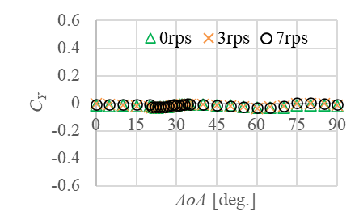
Fig. S6.2 The measured side force coefficient of women’s discus as a function of the AoA. The spin rate about the z_{b}-axis was taken as a parameter, with values of 0, 3, and 7 revolutions per second.

Online Resource-7 - Supplementary Information (SI) –

How to estimate the expected value μ and its uncertainty σ
Let the N known design sets be denoted by X = (x₁, x₂, … , x_{n}, …, x_{N}), and the corresponding objective function (the maximum attainable flight distance) by y = (y₁, y₂, … , y_{n}, …, y_{N}), respectively. Since the design set x_{n} is a vector, X consists of vectors as its components.
The covariance matrix K is expressed using matrix component $k\left(x_{n},x_{n'} \right)$, as shown in the following equation:

$$K=\left(\begin{matrix}k\left(x_{1},x_{1}\right) & k\left(x_{1},x_{2}\right) & \begin{matrix}… & k\left(x_{1},x_{N}\right)\end{matrix} \\ k\left(x_{2},x_{1}\right) & k\left(x_{2},x_{2}\right) & \begin{matrix}… & k\left(x_{2},x_{N}\right)\end{matrix} \\ \begin{matrix}⋮ \\ k\left(x_{N},x_{1}\right)\end{matrix} & \begin{matrix}⋯ \\ ⋯\end{matrix} & \begin{matrix}\begin{matrix}⋯ \\ ⋯\end{matrix} & \begin{matrix}⋮ \\ k\left(x_{N},x_{N}\right)\end{matrix}\end{matrix}\end{matrix}\right)$$ | (S7.1)

Here, $k\left(x_{n},x_{n'} \right)$ is defined by Eq. (S7.2).

$$k\left(x_{n},x_{n'} \right)=θ_{1}\exp\left(-\frac{{\left\|x_{n}-x_{n'}\right\|}^{2}}{θ_{2}}\right)$$ | (S7.2)

The component $k\left(x_{n},x_{n'} \right)$ is known as the Radial Basis Function (RBF) kernel, which is the most used robust kernel in Gaussian Process Regression (GPR). The exponential term on the right-hand side is in the same form as a Gaussian distribution (bell curve). In other words, when the Euclidean distance between two known design sets, x_{n}​ and x_{n’} ​, is small, $k\left(x_{n},x_{n'} \right)$ becomes large. Conversely, when the distance is large, $k\left(x_{n},x_{n'} \right)$ becomes small. This implies that "the smaller the Euclidean distance between two design sets, the closer the values of the objective function (and vice versa)." This relationship is captured using the RBF kernel.
The parameters $θ=\left(θ_{1}, θ_{2}\right)$​ are called hyperparameters. The former, $θ_{1}$​, is the scaling factor of the exponential function. The latter, $θ_{2}$​, determines the width of the Gaussian distribution (bell curve), with a smaller value resulting in a narrower width. Since $k\left(x_{n},x_{n'} \right)$ depends on θ, the covariance matrix K also depends on θ, meaning that K is denoted as K(θ).
The hyperparameters θ are determined by maximizing the log-likelihood function. The likelihood refers to the plausibility of the observed data given the model. For a set of known design sets X, assuming a Gaussian distribution, the probability p of observing the known objective function 𝑦 (the longest attainable flight distance) is expressed as:

$$p\left(y | X,θ\right)=N\left(y | 0,K\right)=\frac{1}{{\left(2π\right)}^{N/2}}\frac{1}{{\left|K\right|}^{1/2 }}\exp\left(-\frac{1}{2}y^{T}K^{-1}y\right)$$ | (S7.4)

Here, p is called the conditional probability. In other words, when X, y and $θ$ are given, p represents the probability of observing y, which is the likelihood.
The hyperparameters that maximize the likelihood are sought. While we can use Eq. (S7.4) directly, it is common practice to take the logarithm of the likelihood function. The log-likelihood function is expressed as:

$$\log_{e}{p}=-\frac{N}{2}\log_{e}\left(2π\right)-\frac{1}{2}\log\left(\left|K\left(θ\right)\right|\right)-\frac{1}{2}y^{T}{K\left(θ\right)}^{-1}y$$ | (S7.5)

Simplifying:

$$\log_{e}{p}∝-\log\left(\left|K\left(θ\right)\right|\right)-y^{T}{K\left(θ\right)}^{-1}y$$ | (S7.6)

In the program, the hyperparameters are determined by maximizing the right-hand side of Eq. (S7.6) using the genetic algorithm.
Once $θ$ are determined via Maximum Likelihood Estimation, K can be calculated. The predicted objective function value μ for a new arbitrary design set $x_{**}$ is given by the following Eq. (S7.7):

$$μ=k_{**}^{T}K^{-1}y$$ | (S7.7)

where $k_{**}$​ is defined as Eq. (S7.8) and represents the kernel function k($x_{**}$, x_{n}) between x** and the known design vectors X =(x₁, x₂,…, x_{n}, …, x_{N}):

$$k_{**}=\left(\begin{matrix}k\left(x_{**},x_{1}\right) \\ k\left(x_{**},x_{2}\right) \\ \begin{matrix}⋮ \\ k\left(x_{**},x_{N}\right)\end{matrix}\end{matrix}\right)$$ | (S7.8)

The uncertainty σ is expressed as follows in Eq. (S7.9):

$$σ=\sqrt{k_{nn}-k_{**}^{T}K^{-1}k_{**}}$$ | (S7.9)

In Eq. (S7.9), k_{nn}​ the self-kernel value of $θ_{1}$, derived from Eq. (S7.2).

Summary:
- Hyperparameters $θ$ are determined via Maximum Likelihood Estimation.
- The RBF kernel is used to calculate the correlation (covariance matrix K) between the known design sets.
- The correlation between a new arbitrary design set and the known design sets is calculated, and from this, the predicted objective function values (μ) and the prediction variance (σ) for a new arbitrary design set is determined.

Online Resource-8 - Supplementary Information (SI) –

Validation of Bayesian optimization for one objective function
The Bayesian optimization is the optimization of the acquisition function. Several types of the acquisition functions exist [19]. In this study, the lower confidence boundary a_{LCB}, shown in Equation (S8.1), was employed:

$$a_{LBC}\left(x\right)=μ-\left(\sqrt{\frac{logN}{N}}\right)σ$$ | (S8.1)

The first term on the right-hand side is the expected value $μ$ with respect to x, while the second term is the standard deviation $σ$, which quantifies the uncertainty. The square root in the second term reflects the influence of the data size N. When N is small, the weight of the second term becomes more significant, i.e., more data reduces uncertainty.
To validate how Bayesian optimization works, the test function in Equation (S8.2) was employed:

$$y=x∙\sin{x} 0≤x≤8$$ | (S8.2)

Here, x is considered as a design set, which is a scalar in this problem.
The question is to determine the value of x that minimizes y. Figure S8.2 shows y as a function of x. It can be seen that x should be about 5 to minimize y.

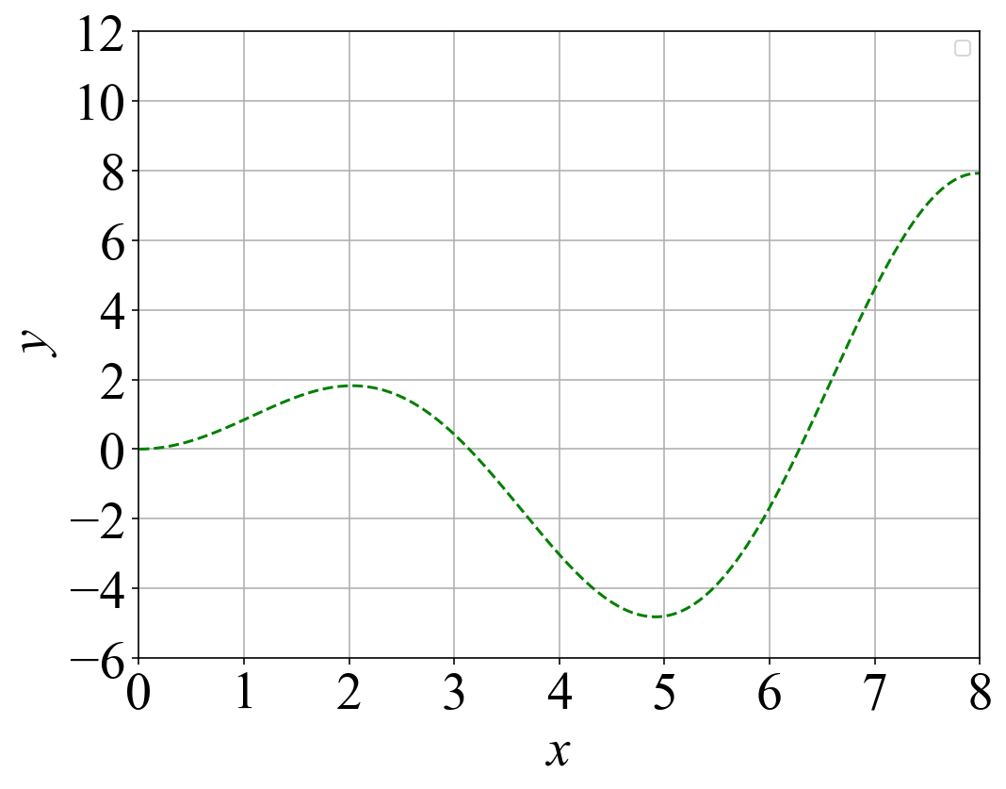
$$y=x∙sin{x}$$
Fig. S8.2 Test function, $y=x∙\sin{x}$
The value of x should be about 5 to minimize y.

Bayesian optimization is applied to solve this problem.

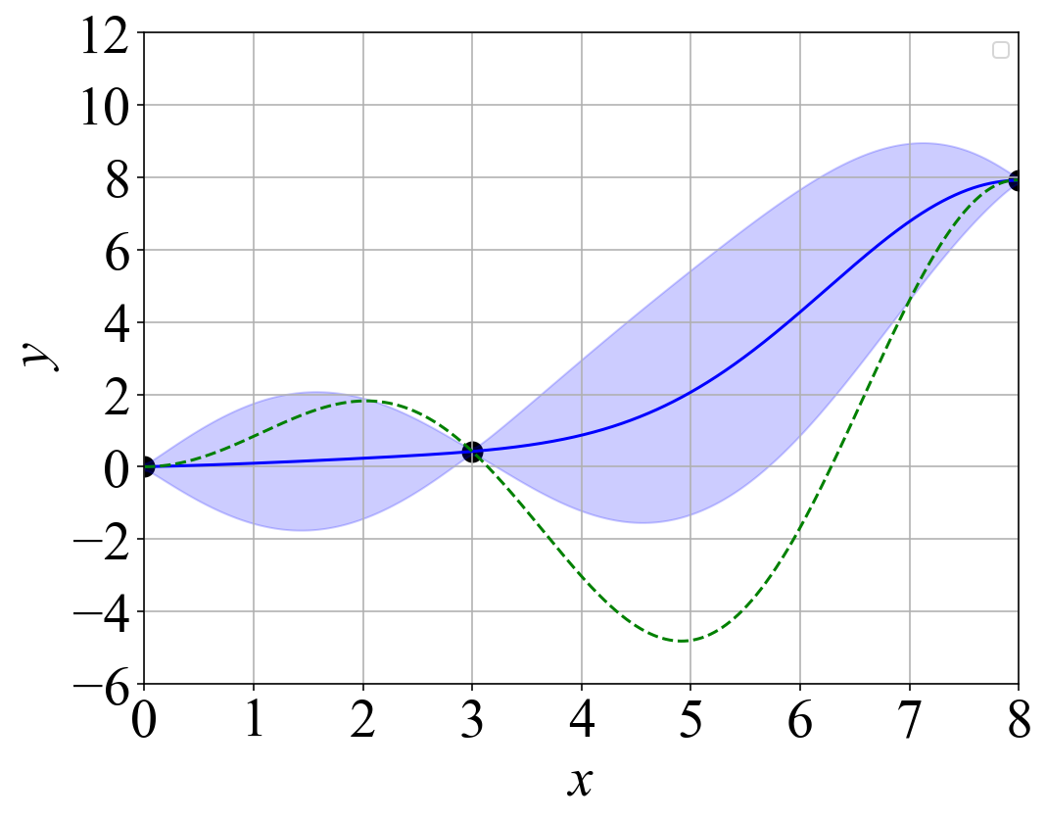 | 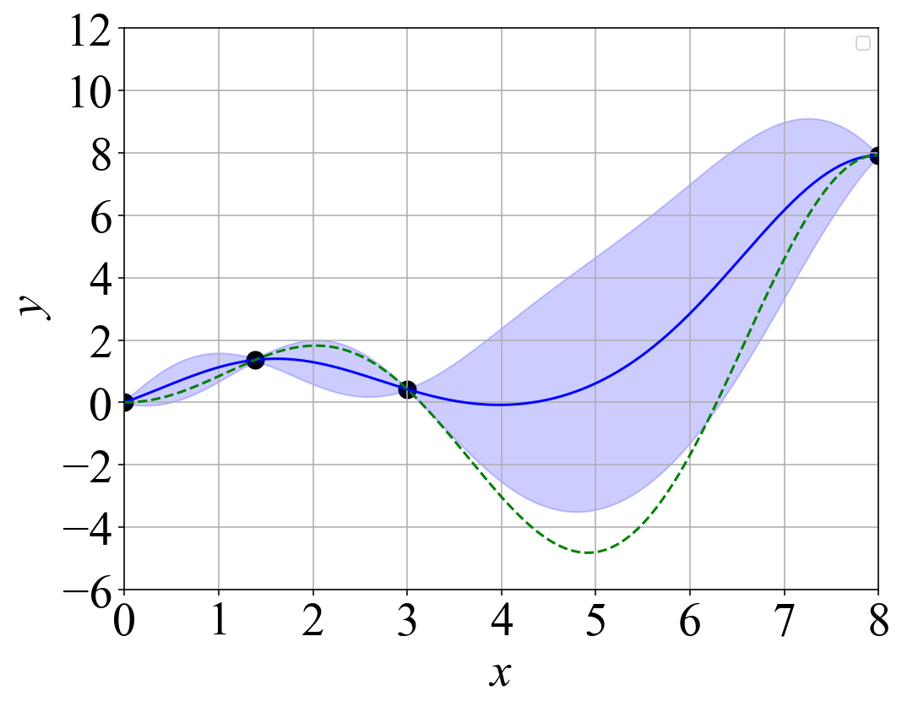
- Three known sample points and a promising x | - Four known sample points and a promising x
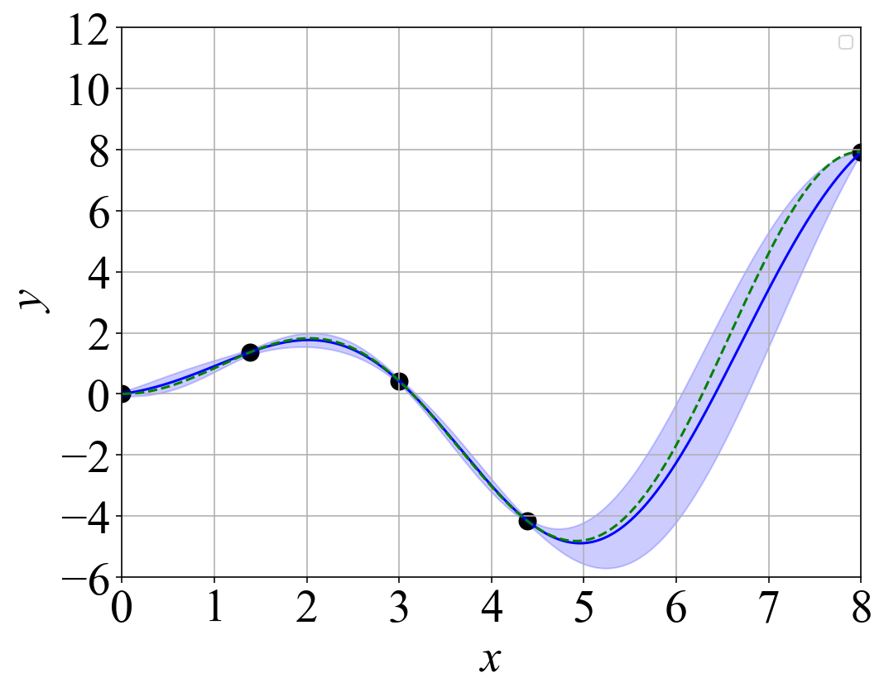 | 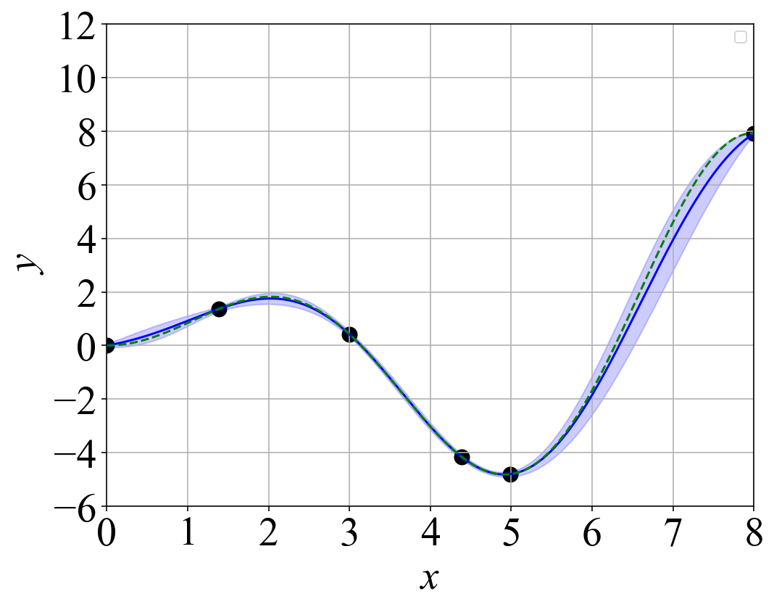
- Five known sample points and a promising x | - Six known sample points and a promising x
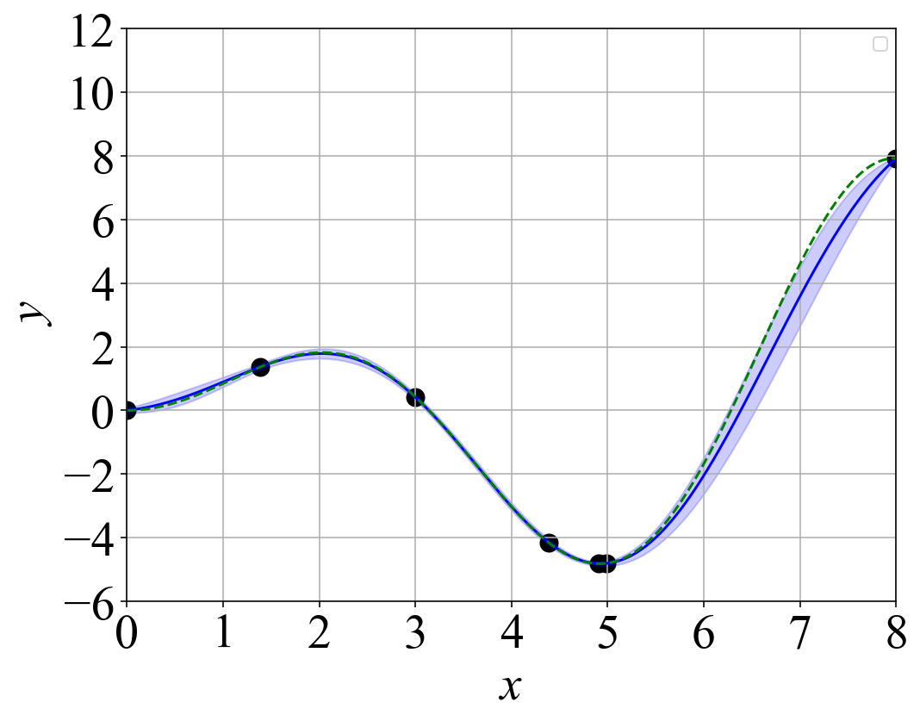 | 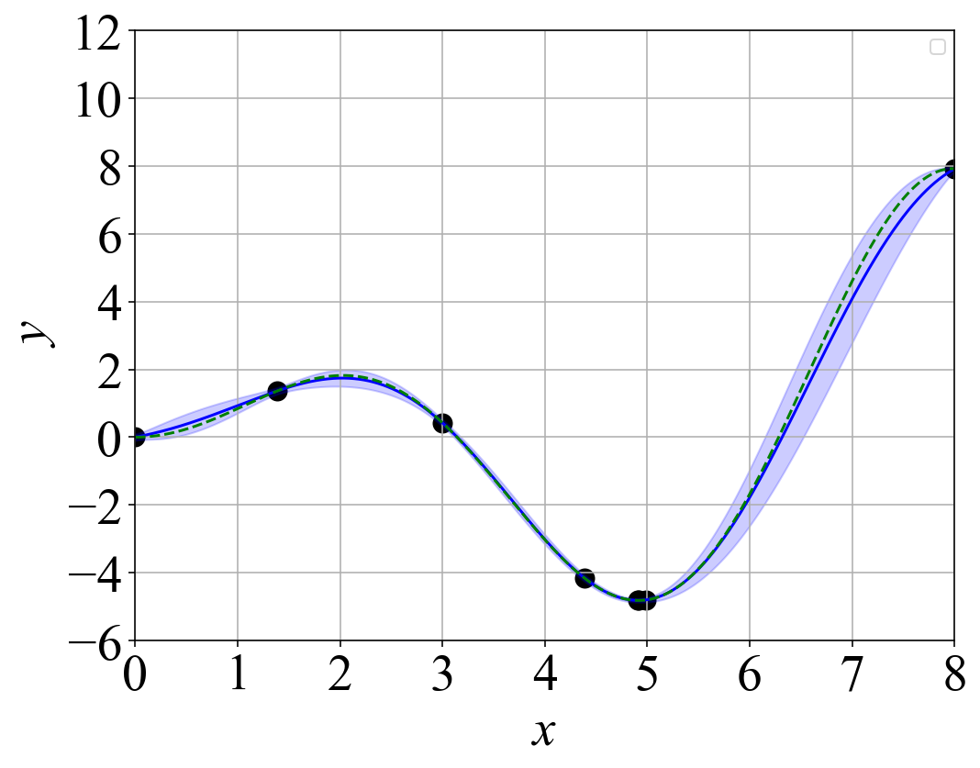
- Seven known sample points and a promising x | - Eight known sample points and a promising x
Fig. S8.3 The process of Bayesian optimization. It shows how a promising 𝑥*, which minimizes 𝑦, is proposed. The closed circles represent known sample points, while the red cross indicates a promising candidate. The broken green line represents the analytical value of y, the blue line represents the Gaussian process regression. The shaded area represents the uncertainty 𝜎.

Let us assume that there are three initial sample points, represented by closed circles in Figure S8.2-(a). The blue line denotes the regression curve obtained using Gaussian Process Regression (GPR) based on these three known sample points. The shaded area, also derived from GPR, represents the uncertainty $σ$ with respect to any arbitrary x. It is assumed that the three known sample points have no uncertainty, while the other 𝑥-values have associated uncertainties. It can be seen that for these three initial sample points the estimated $\hat{y}$ denoted by the blue line, reaches its minimum (~0) at 𝑥 = 1.4. Moreover, the uncertainty $σ$ in $\hat{y}$ at x = 1.4 is large (~2). Therefore, the acquisition function a_{LCB}, as shown in Equation (S8.1), reaches its minimum at 𝑥 = 1.4, represented by the red cross. This indicates that x = 1.4 is the most promising candidate to minimize y. This new promising point, x* = 1.4, is then examined by calculating y using Equation (S8.2). The result shows that the corresponding y-value is 1.4, which is not the minimum. Next, the set (x, y) = (1.4, 1.4) is added to the known sample points, as shown in Figure S8.2-(b).
Now, there are four known sample points in Figure S8.2-(b), and a new GPR model is constructed based on these four points. The uncertainty at 𝑥 = 1.4 becomes 0, due to the new known sample point at this location. This time, the acquisition function a_{LCB} reaches its minimum at x = 4.4. The corresponding y-value is calculated as -4.2, which is not the minimum. Next, the set (x, y) = (4.4, -4.2) is added to the known sample points, as shown in Figure S8.2-(c).
Now, there are five known sample points in Figure S8.2-(c), and a new GPR model is constructed based on these five points. This time, the acquisition function a_{LCB} reaches its minimum at x = 5.0. The corresponding y-value is calculated as -4.8, which is nearly the minimum. Next, the set (x, y) = (5.0, -4.8) is added to the known sample points, as shown in Figure S8.2-(d).
Now, there are six known sample points in Figure S8.2-(d), and a new GPR model is constructed based on these six points. This time, the acquisition function a_{LCB} reaches its minimum at x = 5.0. The corresponding y-value is calculated as -4.8, which is nearly the minimum. The set (x, y) = (4.9, -4.8) is then added to the known sample points in the next step. In subsequent steps, as shown in Figure S8.2-(e) and (f), similar x-values close to x = 5.0 are derived.
In summary, Bayesian optimization effectively identifies promising design sets. In this test function, the third promising x-value in Figure S8.3-(c) reaches the minimum y, and the method then efficiently searches only near the optimal solution. The same program was applied to the discus in this study.

Online Resource-9 - Supplementary Information (SI) –

Initial discus design sets and their corresponding optimal launch conditions and objective function values
Table S9.1 shows the initial three design-sets and their corresponding optimal launch conditions and objective function values. These three design sets cover the entire design space defined by the regulations for the men’s discus (0: in Figure 1). None of these correspond to the discus tested in the wind tunnel, which just served to validate the CFD model. Although the design-sets among the initial three are different, the optimal release conditions are similar (with slight differences in Θ₀ and Ψ₀). The optimal γ₀ is about 40°, and the optimal R is almost at the maximum of 7 revolutions per second for the initial three design-sets. As a result, the attainable maximum flight distances only range between 62.8 meters and 63.1 meters (3: in Figure 1).

Table S9.1 Initial discus design-sets and their corresponding optimal launch conditions and objective function values
No. | Symbol | Design set 1 | Design set 2 | Design set 3
dv1 | d_{d} [mm] | 219.1 | 219.7 | 220.7
dv2 | d_{f} [mm] | 54.8 | 54.6 | 50.4
dv3 | thk [mm] | 44.1 | 45.9 | 45.1
dv4 | r_{m} [mm] | 6.32 | 5.89 | 6.06
cv1 | γ₀ [°] | 40.0 | 40.2 | 40.0
cv2 | χ₀ [°] | 14.2 | 13.6 | 14.3
cv3 | Ψ₀ [°] | 10.3 | 13.0 | 22.2
cv4 | Θ₀ [°] | 27.4 | 24.2 | 17.8
cv5 | Φ₀ [°] | 42.5 | 42.2 | 43.7
cv6 | P₀ [rev./sec.] | -0.112 | -0.109 | -0.109
cv7 | Q₀ [rev./sec.] | 0.149 | 0.142 | 0.135
cv8 | R₀ [rev./sec.] | 6.50 | 6.81 | 6.75
 | F [m] | -63.1 | -62.8 | -63.0

