Appendix 1

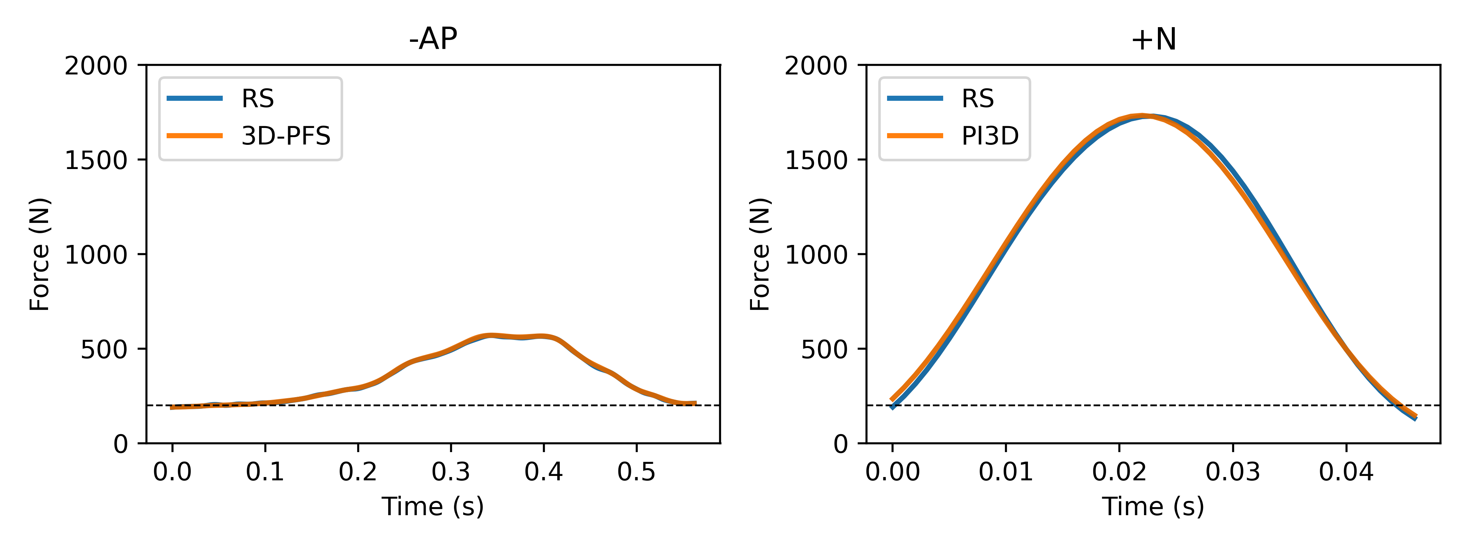
Figure 1: Example of functional loading across different conditions.

The functional loading cycles differed between test conditions due to varying target forces and application methods. All conditions aimed for a target force of 600 N, except for the +N condition, which targeted 2000 N. In the 600 N conditions, the additional load was applied manually over approximately 0.6 s, corresponding to the duration of a pedal stroke at around 100 rpm. In contrast, the +N condition involved dropping the load from a few centimeters to generate a high-magnitude force with higher-frequency impact. As a result, the force application patterns experienced by the sensor varied between conditions (Figure 1).

