In-situ Classification of Football Sports Surfaces: Leveraging Machine Learning for Enhanced Surface Analysis - Supplementary Figure Captions
Conlan M. Burbrink¹, Kyley H. Dickson¹, Emine N. Fidan², Kellie J. Walters¹, and John C. Sorochan¹

¹University of Tennessee, Department of Plant Sciences, Knoxville, TN, 37996
²University of Tennessee, Department of Biosystems Engineering and Soil Science, Knoxville, TN, 37996
Keywords:
Sport surface classification, Synthetic turf, Natural turfgrass, Machine learning, Traction testing, Player-surface interaction, Artificial turf, Soccer

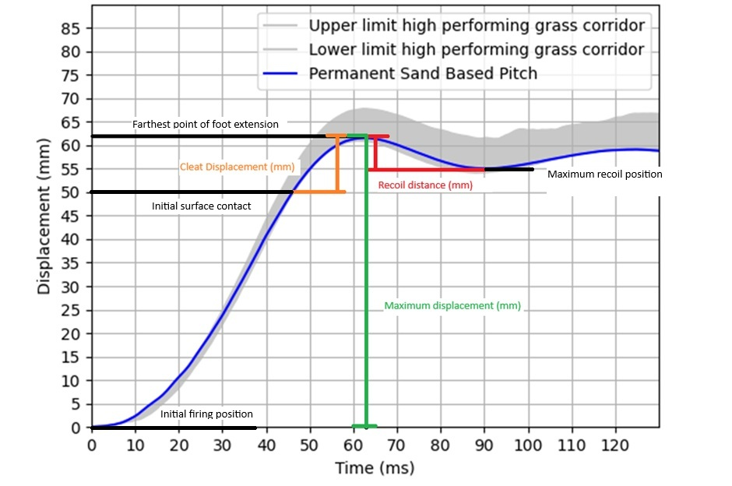
Figure S1. Cleat movement vs time exemplar plot on a sand-based rootzone pitch. Cleat displacement (orange) represents the distance travelled by the foot from initial surface contact to its maximum travel. Maximum displacement (green) indicates the total distance the foot moves from the initial firing position (zero) to its farthest point travelled. Recoil distance (red) is the distance the foot travels as it moves back from its maximum travel toward the spring, reaching its maximum recoil position.

Figure S2. Decision tree for classifying surface type using acceleration-format data. Each node shows the splitting variable, class distribution, and predicted class. Node colour indicates the dominant surface type: orange for cool-season turf, purple for warm-season turf, and green for synthetic turf. Darker shades represent greater node purity, meaning a higher proportion of samples belong to the predicted class.

Figure S3. Decision tree for classifying surface type using deceleration-format data. Each node shows the splitting variable, class distribution, and predicted class. Node colour indicates the dominant surface type: orange for cool-season turf, purple for warm-season turf, and green for synthetic turf. Darker shades represent greater node purity, meaning a higher proportion of samples belong to the predicted class.
Table S3. Median values of the seven parameters collected by fLEX, with median absolute deviations in parentheses, shown by surface type.
 | Warm-season | Cool-Season | Synthetic turf
Peak Vertical Force (N)
Acceleration Format | 2339.4 (121.1) | 1815.5 (315.3) | 2420.5 (261.4)
Deceleration Format | 2282.3 (410.7) | 2712.1 (789.5) | 2800.8 (1096.1)
Horizontal Force (N)
Acceleration Format | 1650.7 (126.0) | 2939.5 (654.1) | 1697.3 (242.0)
Deceleration Format | 408.2 (114.0) | 752.3 (385.7) | 1019.9 (126.7)
Medial Force (N)
Acceleration Format | 659.6 (88.0) | 518.5 (243.7) | 719.3 (123.9)
Deceleration Format | 129.2 (106.3) | 105.3 (102.0) | 273.6 (98.6)
Shear Force (N)
Acceleration Format | 1703.6 (119.9) | 2939.5 (654.8) | 1858.6 (268.9)
Deceleration Format | 603.2 (161.7) | 765.2 (399.2) | 1151.7 (199.4)
Recoil Distance (mm)
Acceleration Format | 18.2 (3.4) | 16.7 (2.6) | 22.9 (3.4)
Deceleration Format | 10.7 (3.3) | 11.4 (2.6) | 19.4 (4.7)
Maximum Displacement (mm)
Acceleration Format | 68.9 (4.8) | 66.3 (4.5) | 65.9 (3.3)
Deceleration Format | 63.6 (7.0) | 57.9 (7.1) | 63.1 (6.6)
Cleat Penetration Depth (mm)
Acceleration Format | 10.2 (2.3) | 9.5 (1.7) | 11.0 (2.9)
Deceleration Format | 6.4 (2.3) | 8.2 (3.1) | 9.8 (3.1)

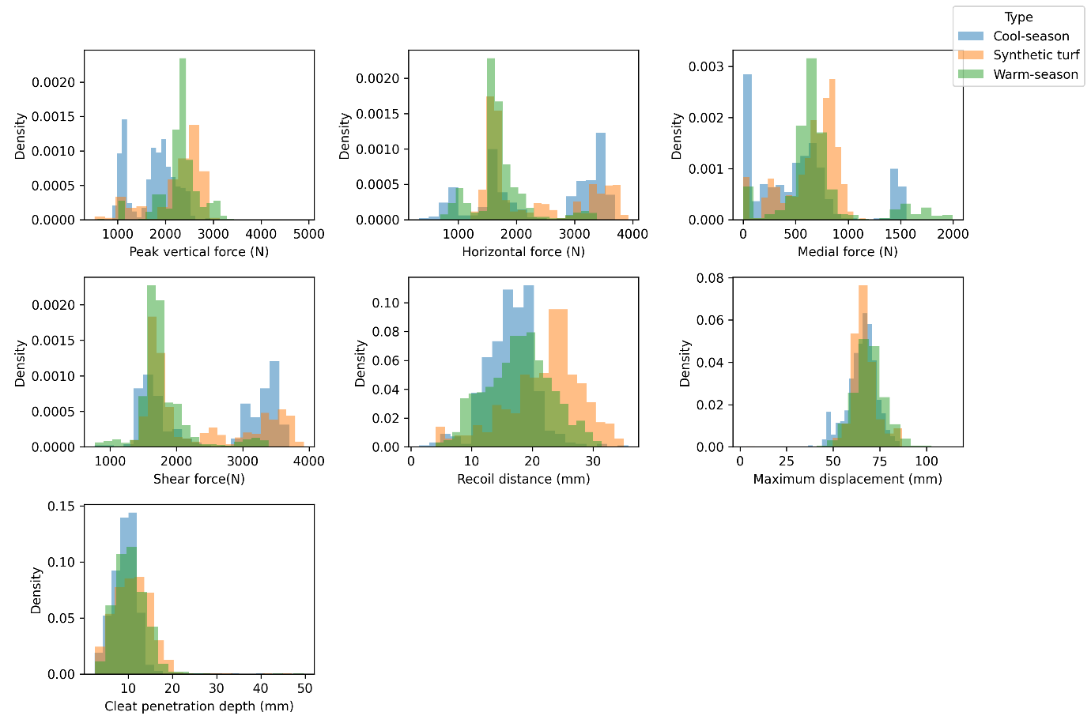Figure S4. Histogram of each fLEX parameter in the acceleration format by surface type.

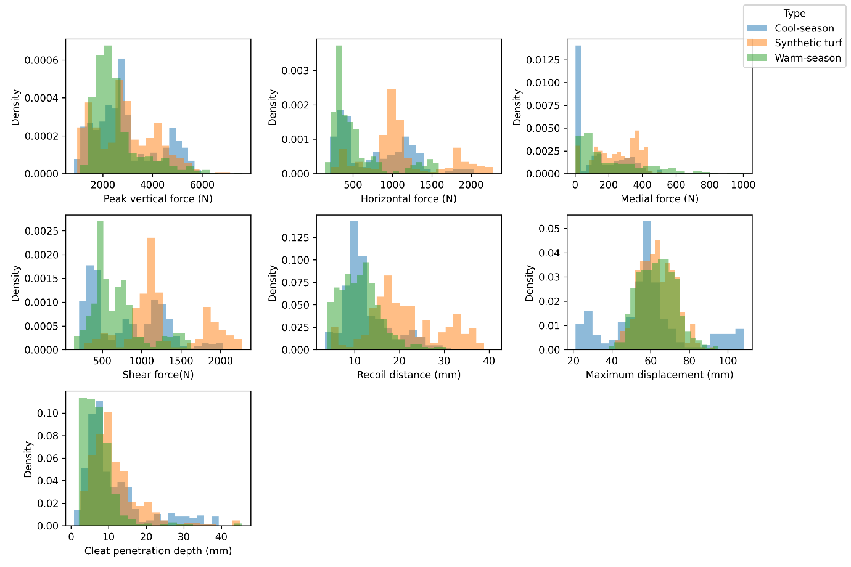Figure S5. Histogram of each fLEX parameter in the deceleration format by surface type.

